1. After splash screen
2. Start up screen (login or register)
3. Phone num verification (Ph)



Country should be loaded automaticaly

1. Verification code

Code verification page should be look like this follow the sequence according to the images



1. Select Account type in this screen you have to put two buttons School And Teacher and Logo

In the top

1. 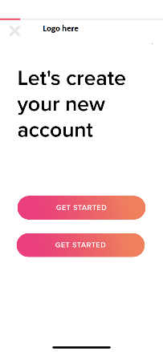
2. Keep the registration wizard as it is
3. Teachers cards should be look like this

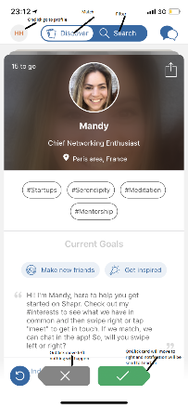  

1. User profile should be like this this can be scrollable downward to see more info



1. Search filter settings for School or Teacher

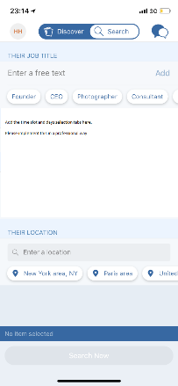

1. App settings

