**Name:** Muhammad Hammad Khalid

**Reg#:** FA19-BCS-047

**Class:** BCS-4A

**Submitted to:** Mr. Qasim Malik

**DATABASE-1 PROJECT:**

**Table of Contents**

Abstract 2

1. Introduction 2

2. Proposed System 2

3. Advantages/Benefits of Proposed System 2

4. Scope 3

5. Modules 3

5.1 Module 1: Registration 3

5.2 Module 2: Edit Profile 3

5.3 Module 3: Notification 3

5.4 Module 4: Post Feed 3

5.5 Module 5: News Feed 3

5.6 Module 6: Followers and Following 3

6. System Limitations/Constraints 4

7. Tools and Technologies 4

8. Conclusion 4

9. References 5

**Project Category: (**Select the major domain of proposed project**)**

**A-**Desktop Application

# Abstract

The project described in the document is Cash and Carry Management System. It a shop system where a buyer can add products of different categories, can update their quantity or price, and can also remove items. Buyer can add the products to cart and purchase them from the cart. When items are purchased a purchase history is generated.

# Introduction

In this digital life, everything is accessed by the touch of a button. Computers have taken place of manual labor in every department. Even in large cash and carries, instead of a log to keep record, a computer is used. The computer can perform everything that was done using registers and logs.

This application will provide users with an app that can be used by admin to add, remove, update products. Admin can also add their own information to keep a record of admins using the app. Similarly, a record of buyer is maintained. Buyer can purchase items depending upon their balance.

# Proposed System

With this application, a lot of time and effort can be saved and the record of large items can be maintained easily.

# Advantages/Benefits of Proposed System

* This app is user friendly
* User will be able to check their purchase history.
* If a user removes his account, all his data from database will be removed this keeping his privacy secure.

# Scope

If an Admin wants to use app, he can go to admin portal and create an account, if using for the first time. After account is created, he will then sign in. After signing in, admin can then edit or update his information, add products in different categories and then view them from View Inventory button. After viewing inventory, admin can then use different filters to only view a particular category, or items of different price range. Admin can then select an item and update its price, quantity or remove it. If user has an item in the cart and admin removes the item, the item will be removed from the cart as well. Admin can also create another admin account.

If User wants to use app, he will create an account and sign in. Then user can also update his information, create another account from app, purchase items and view history. After selecting Purchase Item button, user will be able to select the category to display items from or select All to display items from all categories. From there user can add item to cart. From cart user will select purchase to buy. If user balance is greater than the total sum of items only then can he buy items.

# Modules

## Module 1: Registration

User/Admin will be asked to sign-up or sign-in. If user selects signup, he will be asked to provide his/her personal information. After that he will be asked to sign in to use the app.

## Module 2: Edit Profile

User/Admin will be able to edit his personal information. He will be able to edit username, password, name, email.

## Module 3: Inventory

Admin will be able to add items to inventory and also view and update them. Admin can also remove items.

## Module 4: Payment Information

User will be able to add payment information like bank balance, account number. This will be used to purchase items.

## Module 5: Buy from Cart

The users will go to cart after purchasing items from there if the user balance is greater than total sum of the items then user will be able to purchase, otherwise he will be prompted to remove items or add more amount in balance.

## Module 6: View Purchase history

After purchasing item, the username and the total items purchased, total sum of the price of items and the date will be stored in the purchase history. User can view his history any time from the app.

# System Limitations/Constraints

* This application does not have a proper monetary system
* The orders are not shipped, only bought from the app
* There are only limited categories from user to buy from

# Tools and Technologies

Mention all the hardware/software tools and technologies with version number which will be used in implementation of the project. Write about the language(s), DBMS which you will use for implementation.

Example:

Table 1 Tools and Technologies for Proposed Project

|  |  |  |  |
| --- | --- | --- | --- |
| **Tools**  **And**  **Technologies** | **Tools** | **Version** | **Rationale** |
| MS Visual Studio | 2021 | IDE |
| Oracle SQL Server | 11g | DBMS |
| MS Word | 2019 | Documentation |
| **Technology** | **Version** | **Rationale** |
| Java | 16 | Programming language |
| SQL | 2013 | Query Language |
| Java Swing | 1.4.2 | Front End |

# Conclusion

This software will help the large cash and carry managers to manage their inventory and also for the user to purchase items easily from a click of a button.

# Entity Relation Diagram

## Logical Model

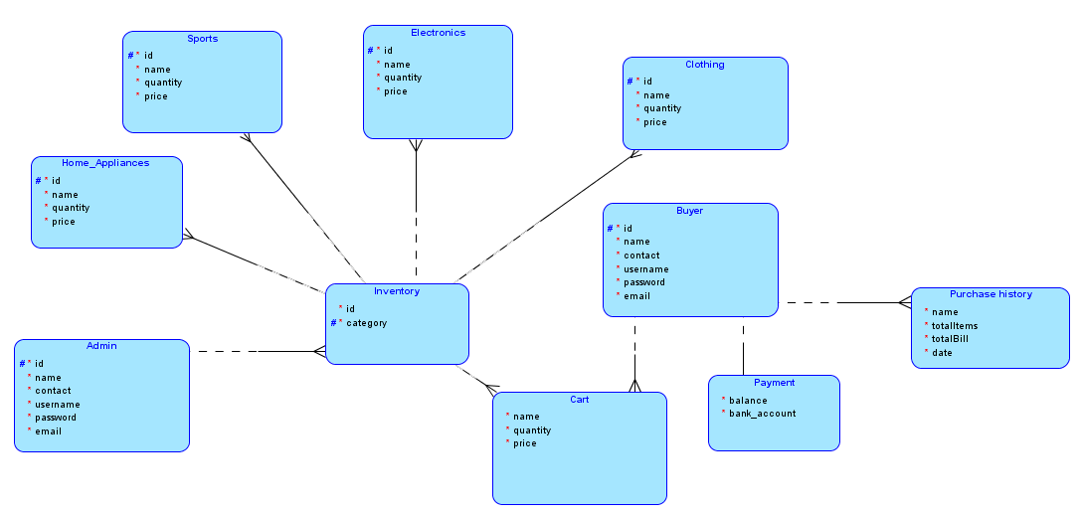

## Logical Model

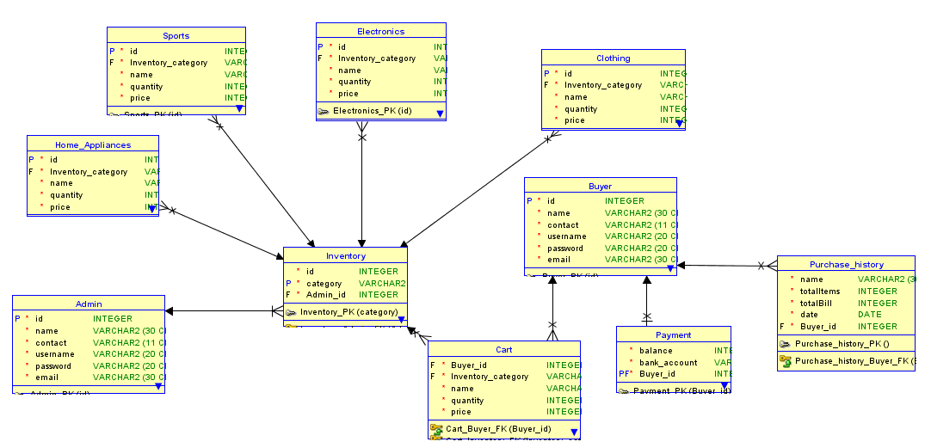

# Implementation Details:

1. Oracle database is used to store and retrieve data.
2. Java Swing is used to Design the UI
3. All the coding is done using Java.
4. Object Oriented Programming.
5. Use of proper SQL queries.

# Problems Faced:

* Creation of a proper ERD diagram with proper schemas for the tables.
* Managing primary and Foreign keys.
* Too many exceptions while using queries.
* App breaking bugs

# User Manual:

* User must have Oracle database installed. Preferably Oracle 11g
* Create a connection in the database using commands in the connection.txt file provided.
* Now connect to the database using sqlplus or sqldeveloper and create tables using the DDL script provided named script.ddl.
* Extract the zip file and go to the admin class.
* Go to every single class and replace the connection type, name, and password according to the one you used to create the database connection.
* Repeat this procedure for every class in the Userclass folder as well.
* Now run the app using Runner.java in the Main folder.

Drive Link for the Project: