this is the pricing table .I have want exactly same in the form of plugin .

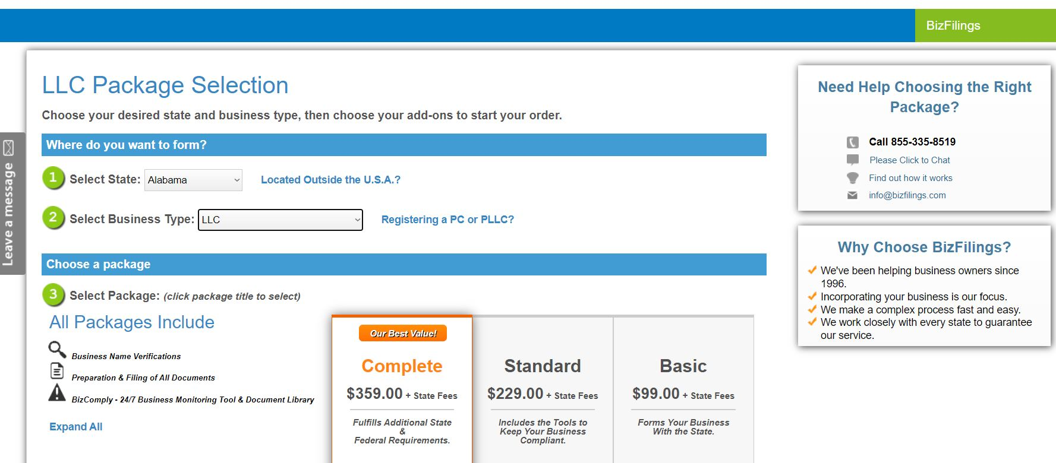

This is the link for the table   
  
https://secure.bizfilings.com/PackageSelect.aspx?EntityTypeId=167&IsCCorp=0&_gl=1*1cqmhef*_gcl_aw*R0NMLjE2NTMzMTkxMTEuQ2p3S0NBanc0YXlVQmhBNEVpd0FUV3lCcmd3LTFLc0FVdURVN0lWWTRaWm1YYklwRWxfUTV4cU96Y2xPMUFQd3dCMFhLUFdIMDBYVlpSb0NxUEFRQXZEX0J3RQ..*_gcl_dc*R0NMLjE2NTMzMTkxMTEuQ2p3S0NBanc0YXlVQmhBNEVpd0FUV3lCcmd3LTFLc0FVdURVN0lWWTRaWm1YYklwRWxfUTV4cU96Y2xPMUFQd3dCMFhLUFdIMDBYVlpSb0NxUEFRQXZEX0J3RQ..&_ga=2.187984737.834318367.1653319115-1436972194.1653319115&_gac=1.195626846.1653320021.CjwKCAjw4ayUBhA4EiwATWyBrgw-1KsAUuDU7IVY4ZZmXbIpEl_Q5xqOzclO1APwwB0XKPWH00XVZRoCqPAQAvD_BwE