QAONBOARD Project Report

# OBJECTIVE:

The project was built for a testing company to the betterment and their contribution in the IT world, to ensure their work process and for further speed and upgradation and work ease the userpanel and adminpanel were also made in backend process on clients demand.

# Working of project

# For User interface:

Wordpress

Custom template

Custom Css nd etc.

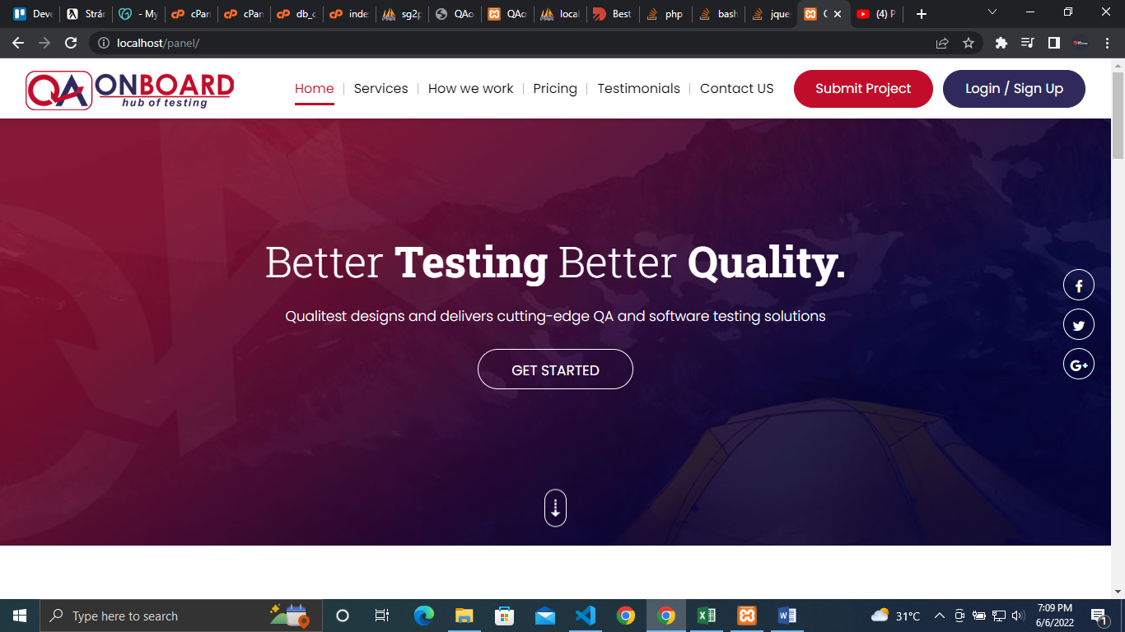

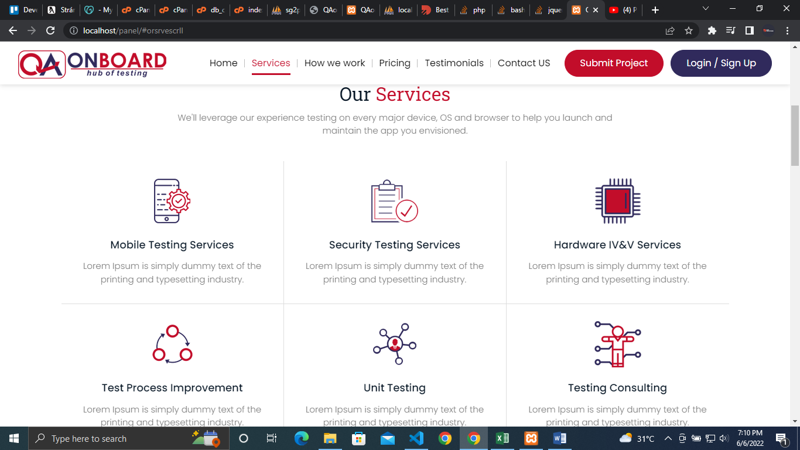

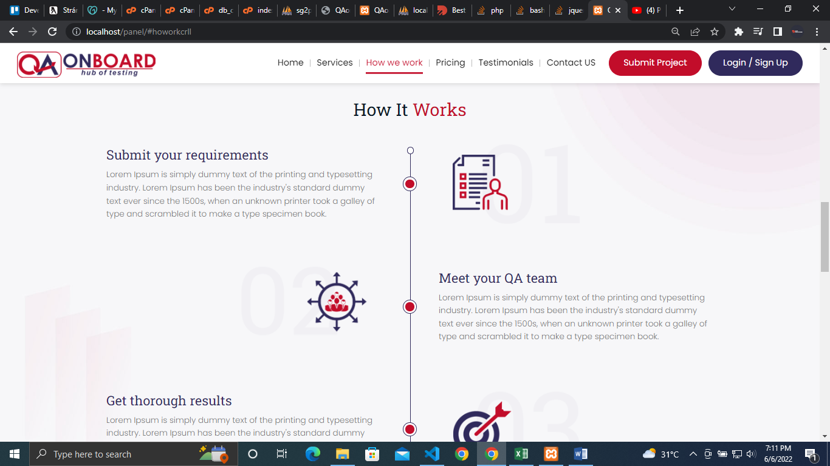

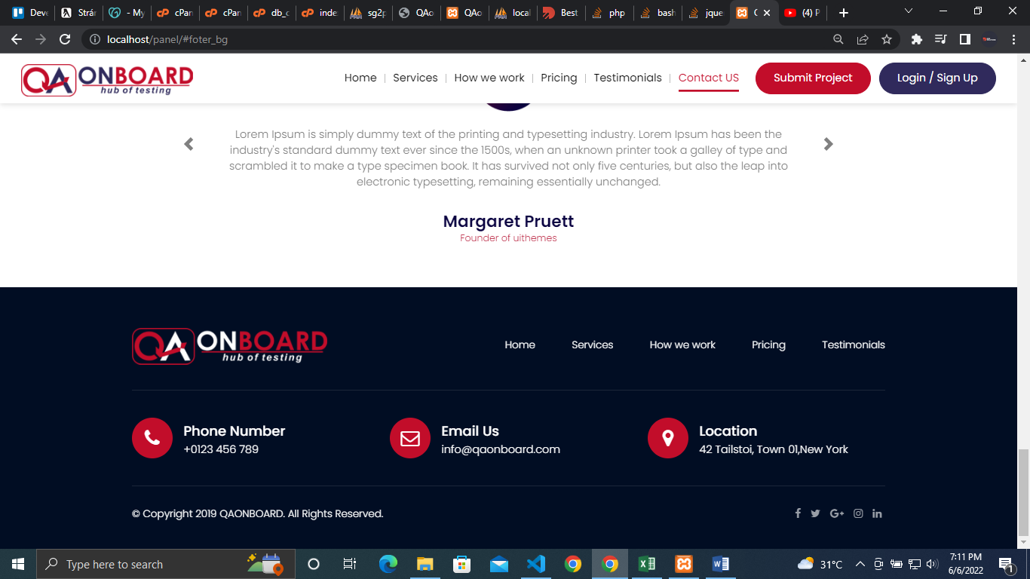

All units were tested and cleared.

Whole projects responsiveness tested on laptop, tab, android, iphone etc.

UI Cleared.

Languages used in Custom Project Evaluation system of QAonboard :

PHP

Html5

Css3

Bootstrap

JQuery

Javascript

Ajax

For Libararies following languages and formats are used

JSON

XML

Register and Login panel were connected with adminpanel as well and whole data of clients. Projects and feedbacks were sent to adminpanel for further requirements nd etc.

User Dashboard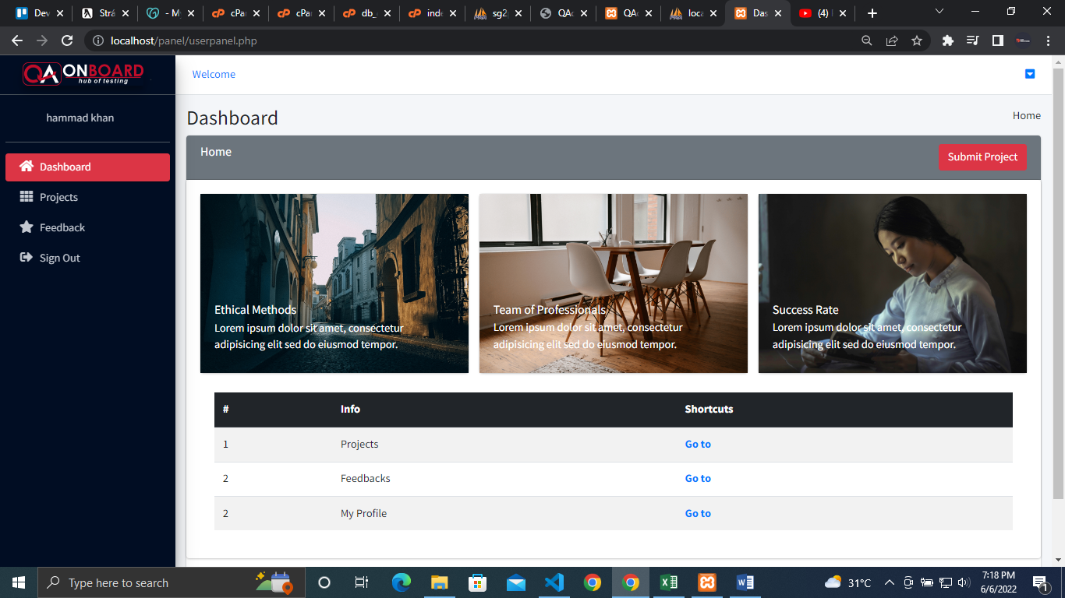

Project History

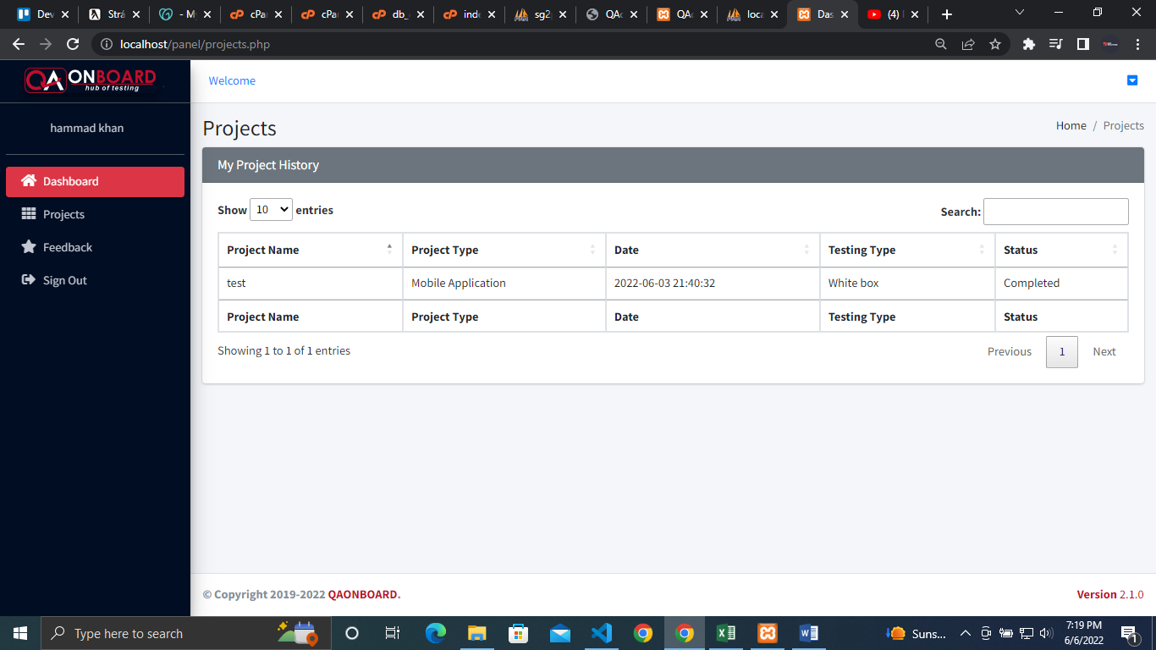

Feedback section

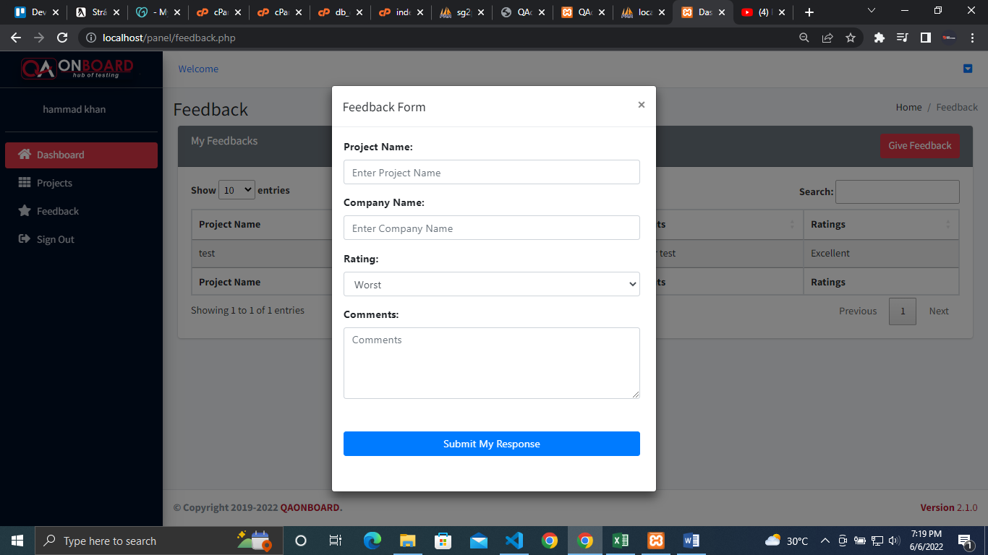

User info section

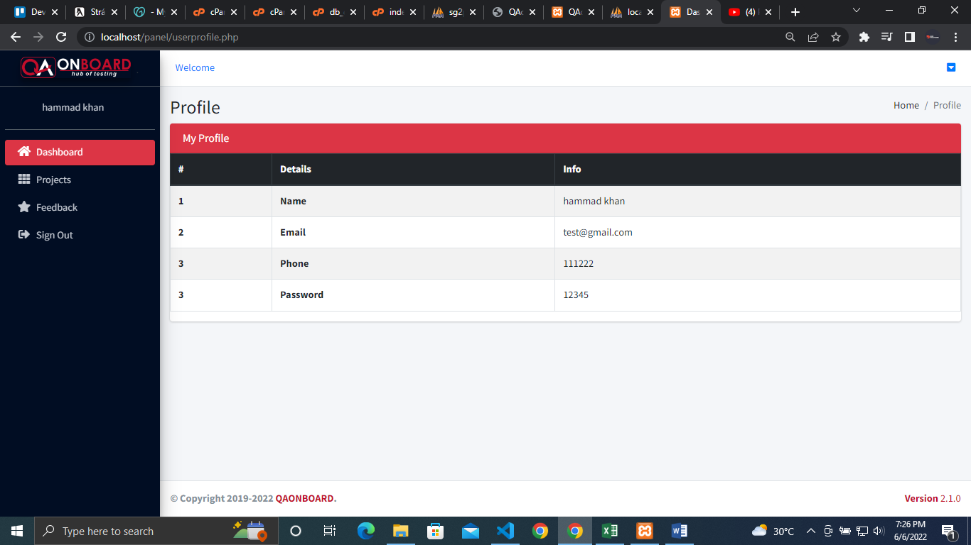

ADMINPANEL SECTION

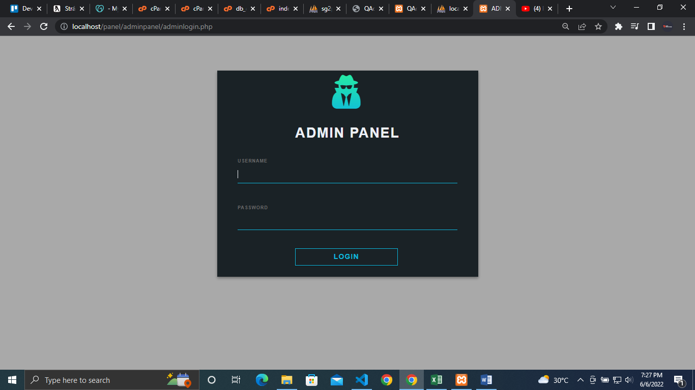

Dashboard

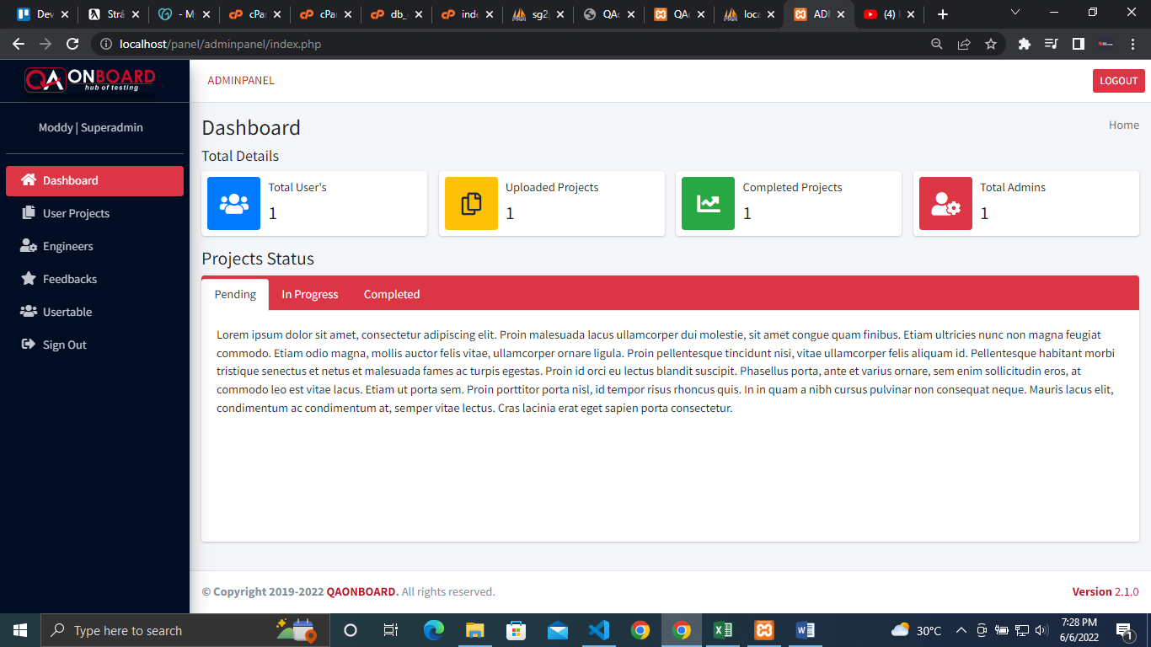

# TESTING

Testing and Evaluation was done by QA team

The project was cleared and forwarded to client

# REMARKS

Changes and upgradation may be subjected on client’s referral. (by developer)

Cleared (by QA).