MUHAMMAD HAMMAD

WEEK_13

SUB-QUERIES

* SELECT first_name, salary FROM `employees` WHERE SALARY = (SELECT max(SALARY) FROM employees);

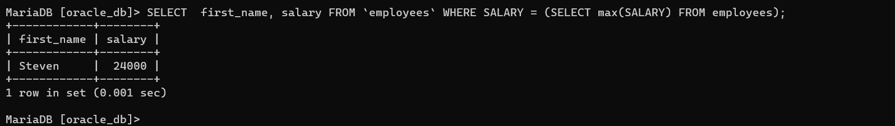

* SELECT employee_id, salary FROM `employees` WHERE SALARY > (SELECT avg(SALARY) FROM employees);

* SELECT distinct(country_name) FROM countries join locations using(country_id)WHERE location_id >any (SELECT location_id from locations);

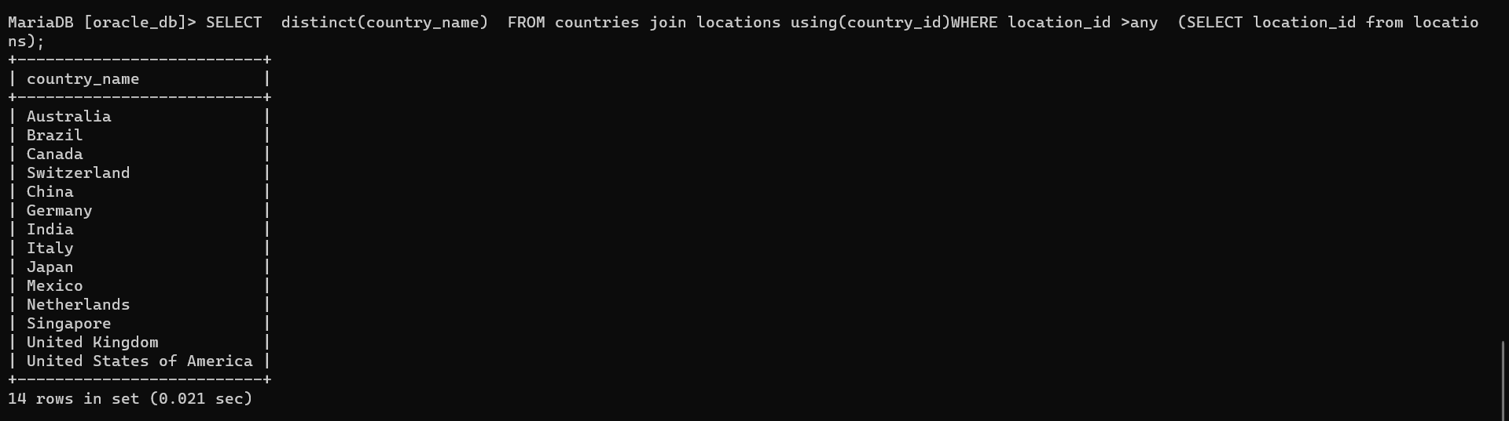

* select first_name from employees where manager_id = 'shelley';
* select first_name,department_id from employees join departments using(department_id) where employees.manager_id>any (select first_name from employees);

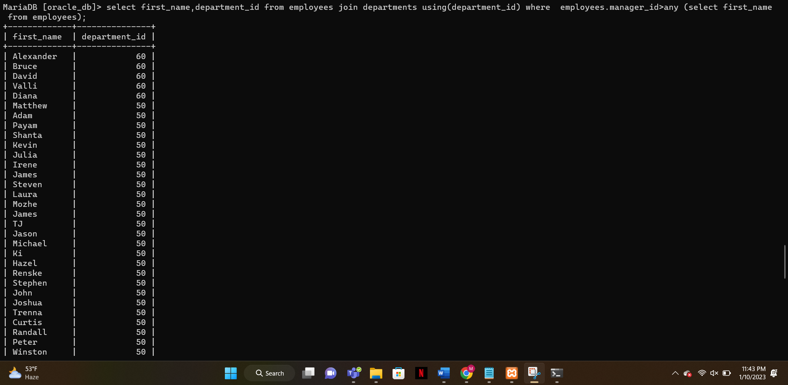

* SELECT e.department_id, e.employee_id, (e.salary/SUM(e.salary)OVER (PARTITION BY e.department_id))*100 AS salary_percentage FROM employees e ORDER BY e.department_id, salary_percentage DESC;

