**Group Members:**

**Hammad Shabbir, 22I-1140**

**Iqrash Qureshi, 22I-1174**

**Haider Zia, 22I-1196**

***DEVOPS PROJECT***

**Apply Devops Tools:**

* *Github Repo*
* *Docker*
* *Kubernetes*
* *CI-CD Pipeline*
* *ARGO CD*
* *Terraform*
* *Ansible*

1. ***Gitub Repo***

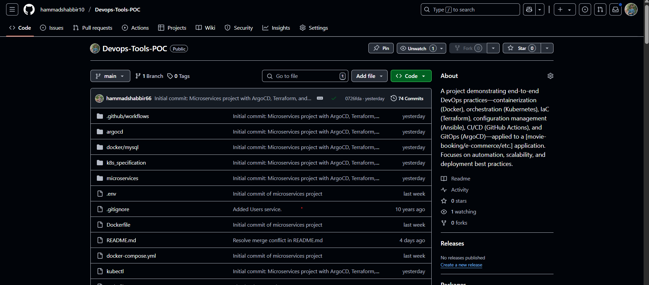

1. ***Docker***

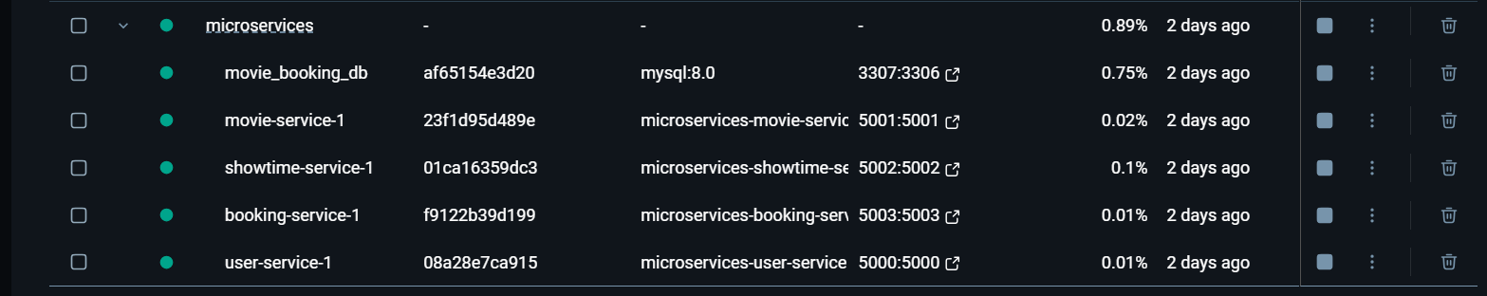

*docker ps -a:*

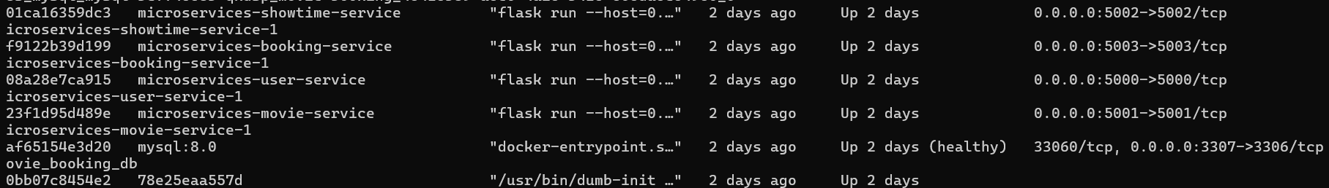

*docker images*

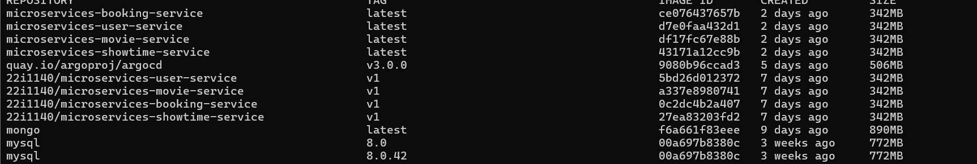

1. ***Kubernetes***

***Kubectl create namespace movie-booking***

***Kubectl apply -f k8s_specifications/***

*kubectl get namespace*

*my- namespace is kube-system & movie-booking*

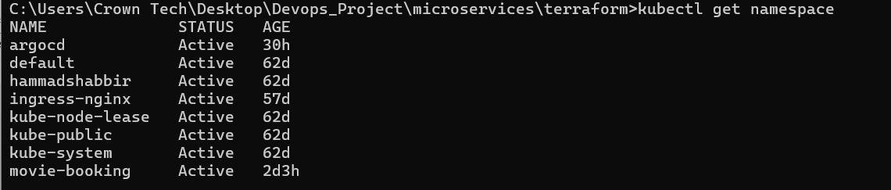

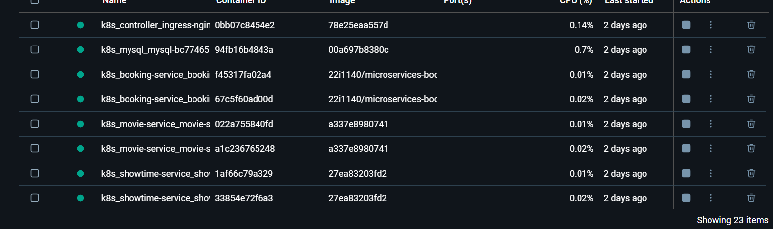

Kubectl get pods -n movie-booking

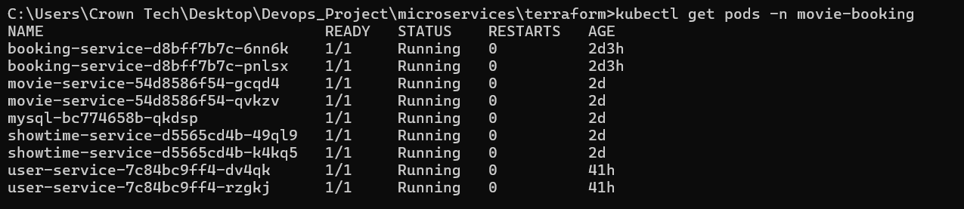

Kubectl get pv,pvc -n movie-booking

Kubeclt get svc -n movie-booking

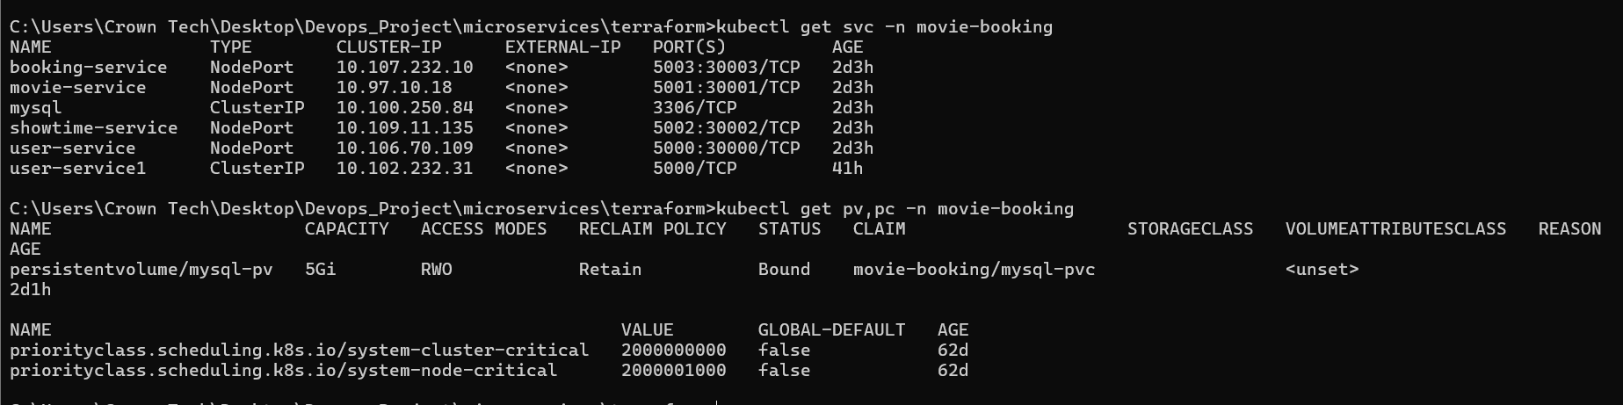

Kubeclt get ingress -n movie-booking



Kubectly get deployments -n movie-booking

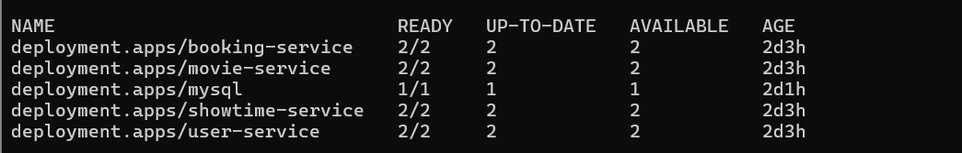

Kubectl get scerts -n movie booking



K8s_Specification (kubernestes folders)

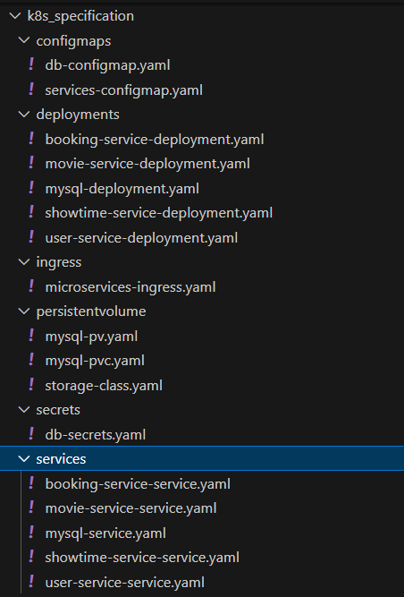

**BACKEND-ENTERIES IN KUBERNETES THROUGH POSTMAN**

**kubectl port-forward svc/mysql 3307:3306 -n movie-booking**

**kubectl exec -it mysql-bc774658b-qkdsp -n movie-booking -- mysql -uroot -pmypassword**

**For USERS**

**url:** [**http://localhost:30000/users**](http://localhost:30000/users)

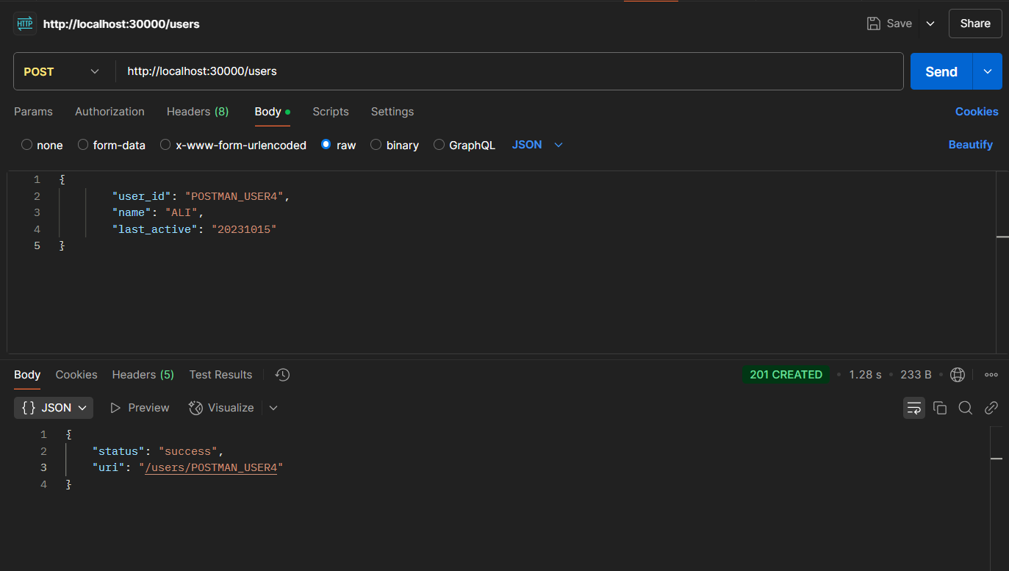

**kubectl port-forward svc/user-service 5000:5000 -n movie-booking**

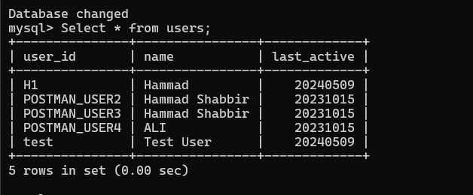

**New user has been entered.**

**FOR MOVIES**

**url:** [**http://localhost:30001/movies**](http://localhost:30001/movies)

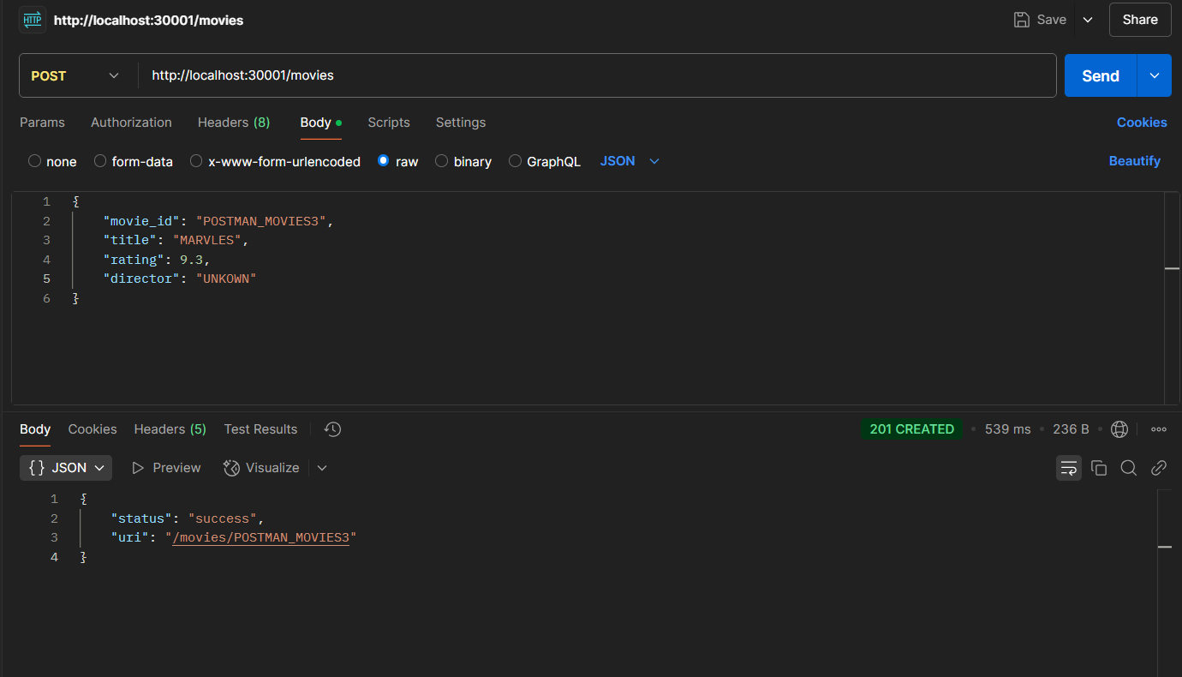

**kubectl port-forward svc/movie-service 5001:5001 -n movie-booking**

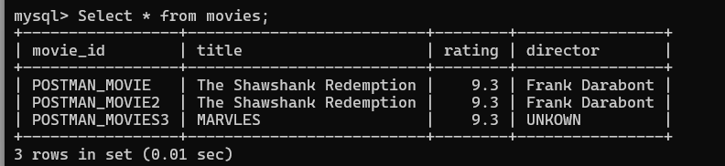

**For Showtime**

**url:** [**http://localhost:30001/showtimes**](http://localhost:30001/showtimes)

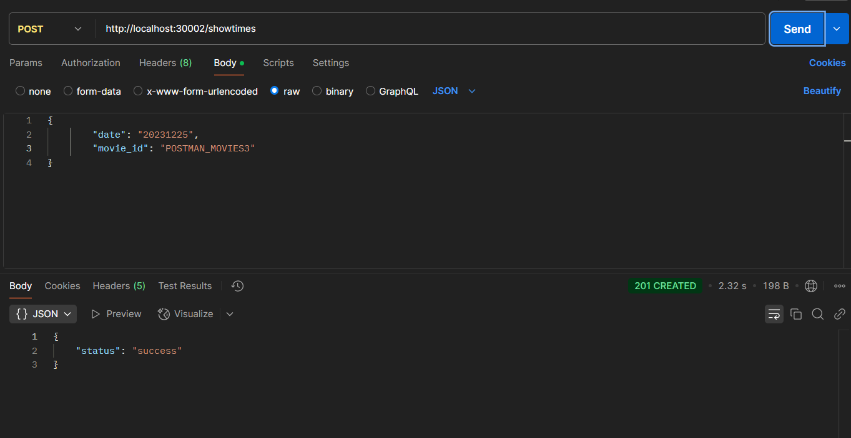

**kubectl port-forward svc/showtime-service 5002:5002 -n movie-booking**

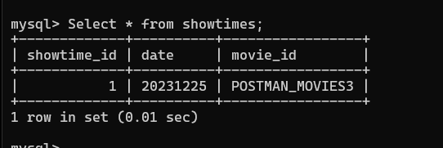

**For Bookings;**

**url:** [**http://localhost:30003/bookings**](http://localhost:30003/bookings)

**kubectl port-forward svc/booking-service 5003:5003 -n movie-booking**

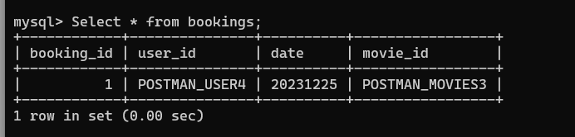

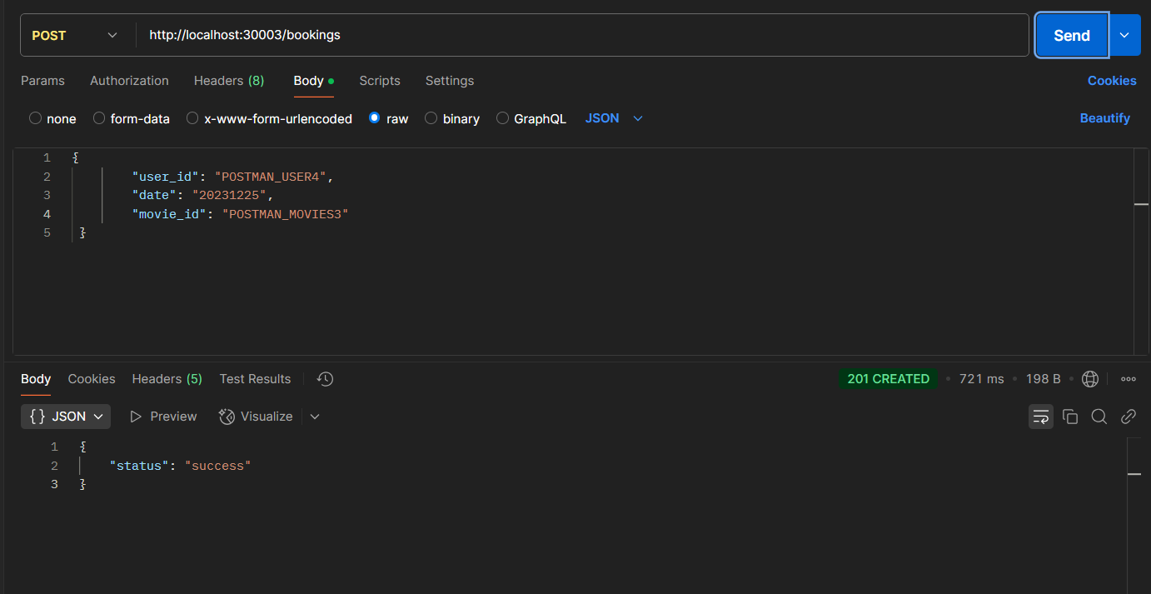

1. **ARGO-CD**

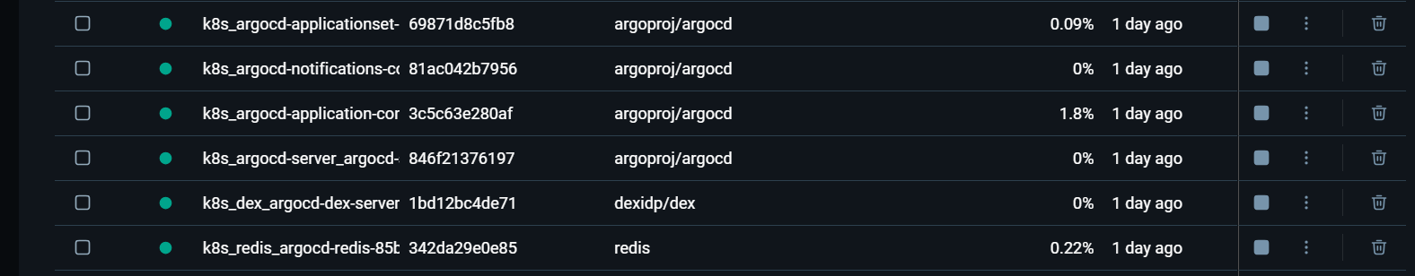

**kubectl apply -f argocd/movie-booking-app.yaml**

**kubectl port-forward svc/argocd-server -n argocd 8080:443**

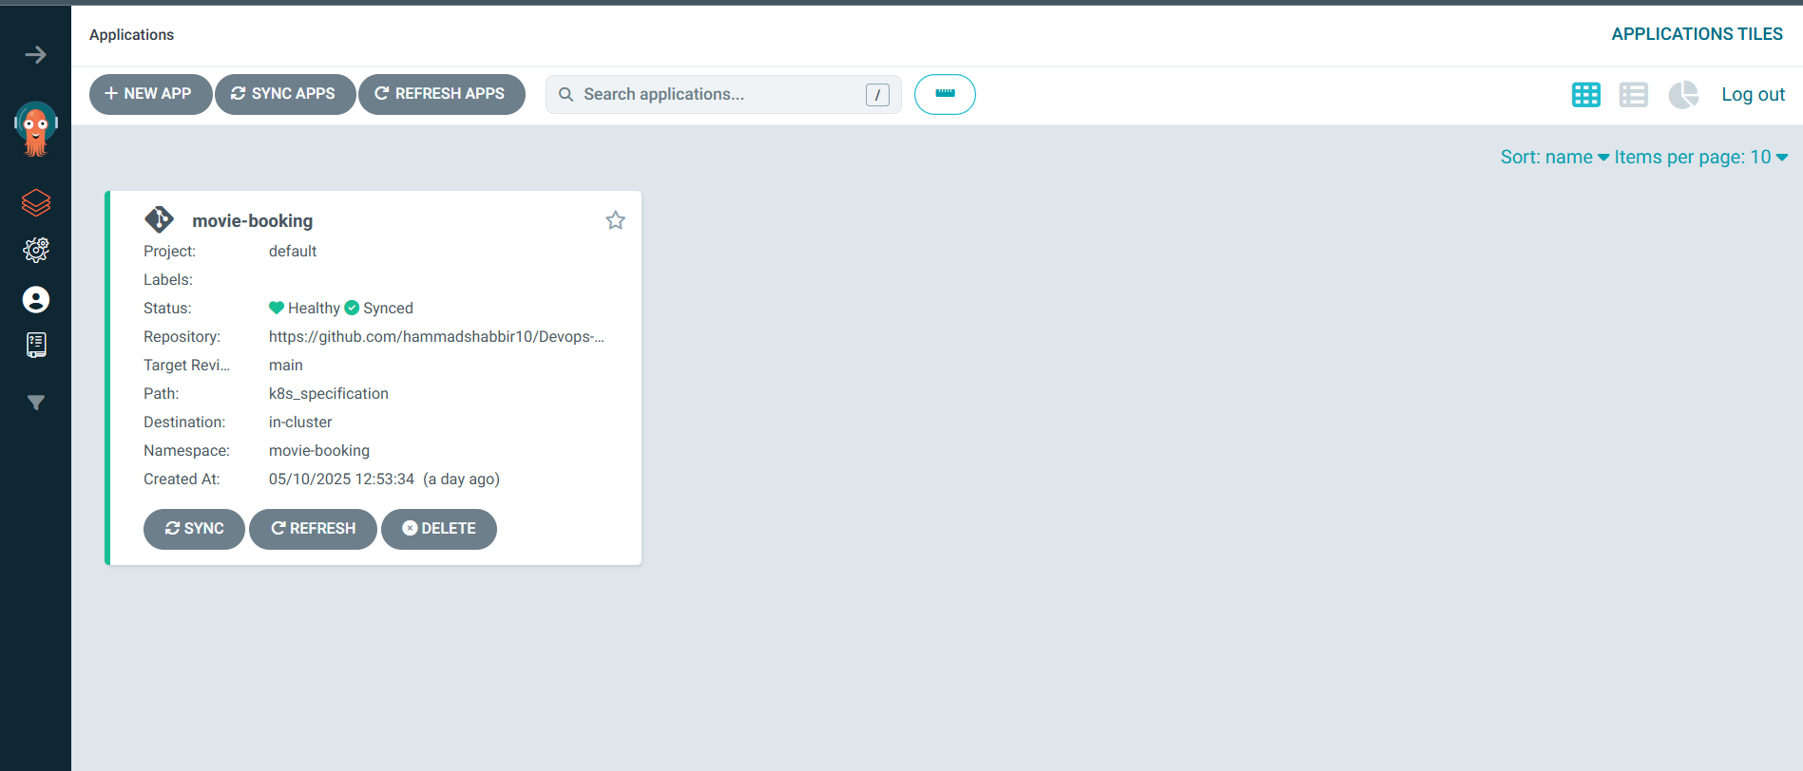

**kubectl get pods -n argocd**

**https://localhost:8080**

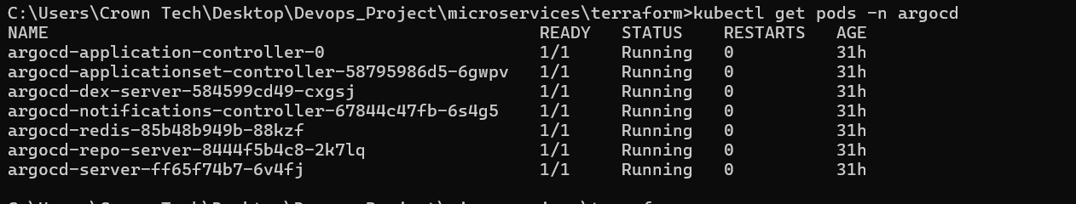

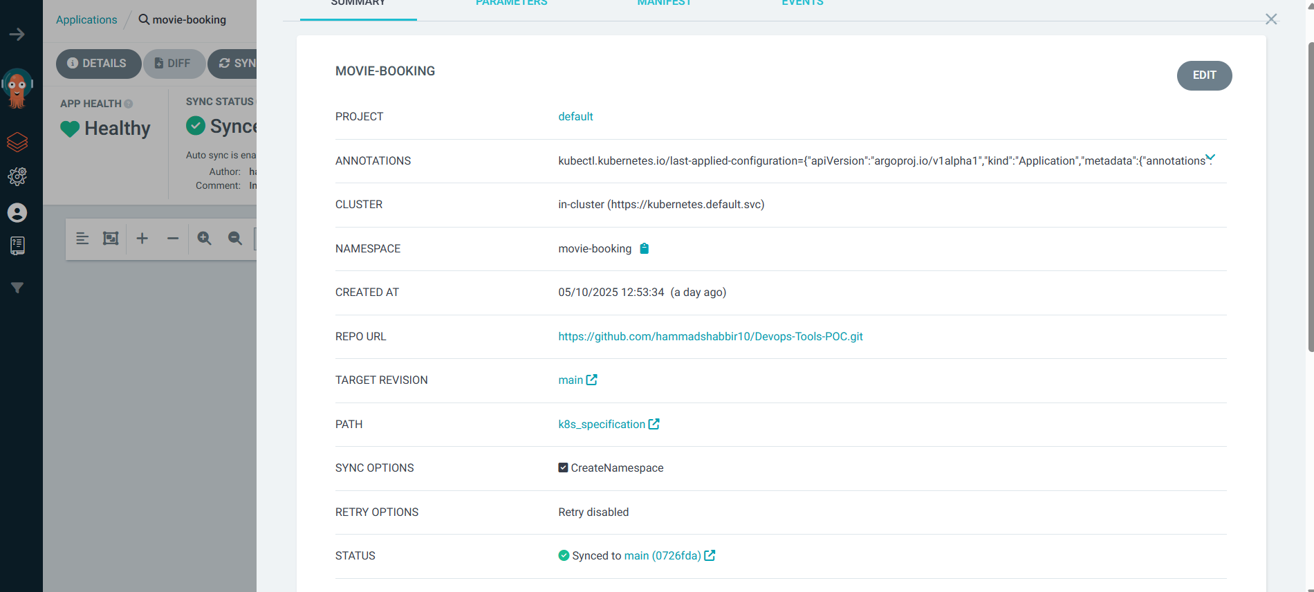

1. **CI-CD PIPLINE**

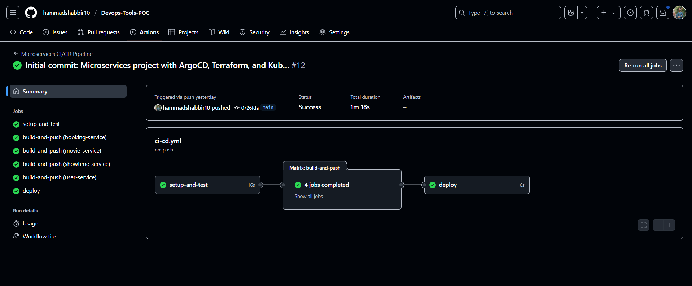

1. **Terraform**

* **Terraform init**
* **Terraform plan**

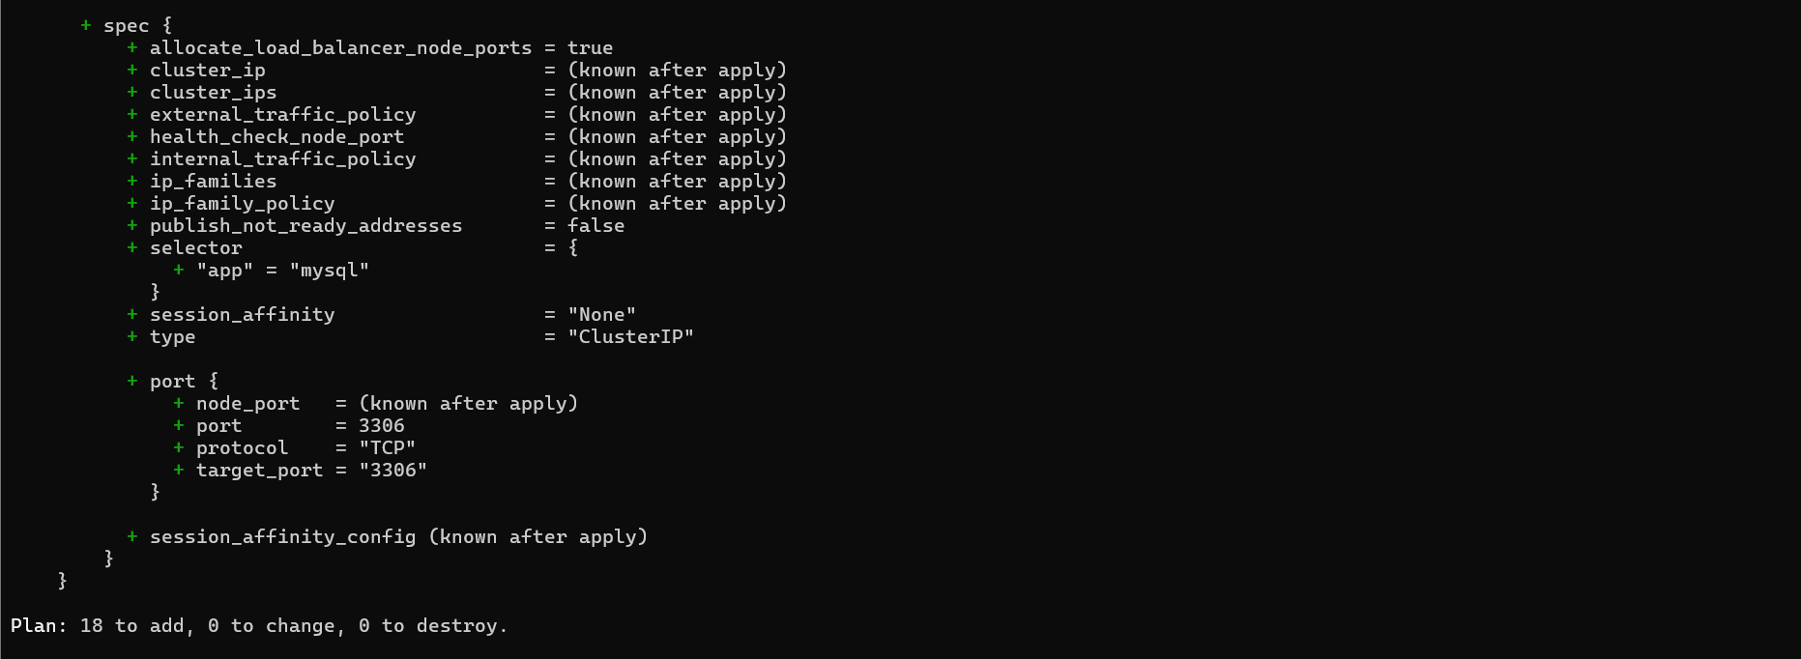

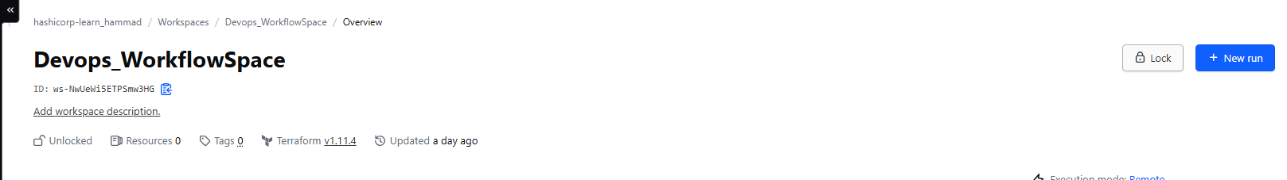

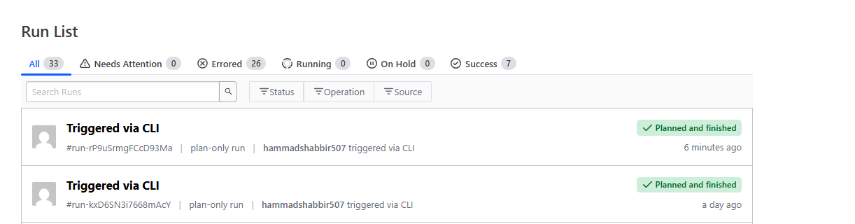

**MY KEYS**

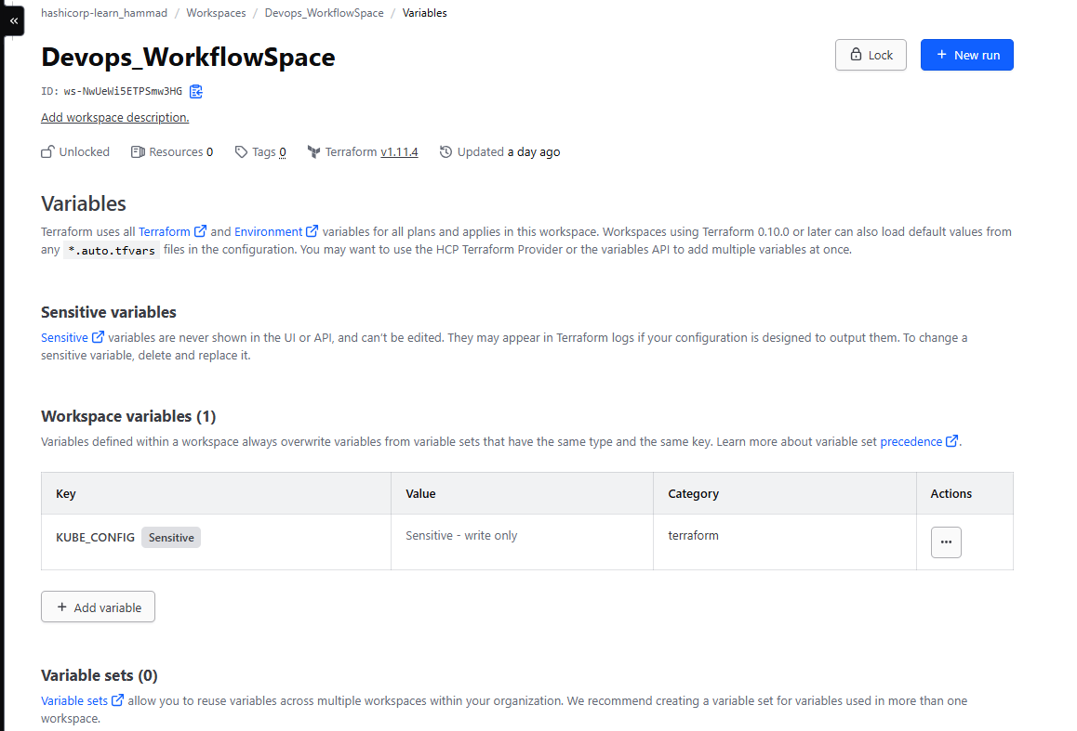

1. **ANSIBLE**

* pip install kubernetes
* pip install ansible
* pip install openshift
* ansible-galaxy collection install kubernetes.core
* ansible-galaxy collection install community.general