Group Members:
Hammad Shabbir, 22I-1140
Iqrash Qureshi, 22I-1174
Haider Zia, 22I-1196

DEVOPS PROJECT

Apply Devops Tools:
- Github Repo
- Docker
- Kubernetes
- CI-CD Pipeline
- ARGO CD
- Terraform
- Ansible

- Gitub Repo
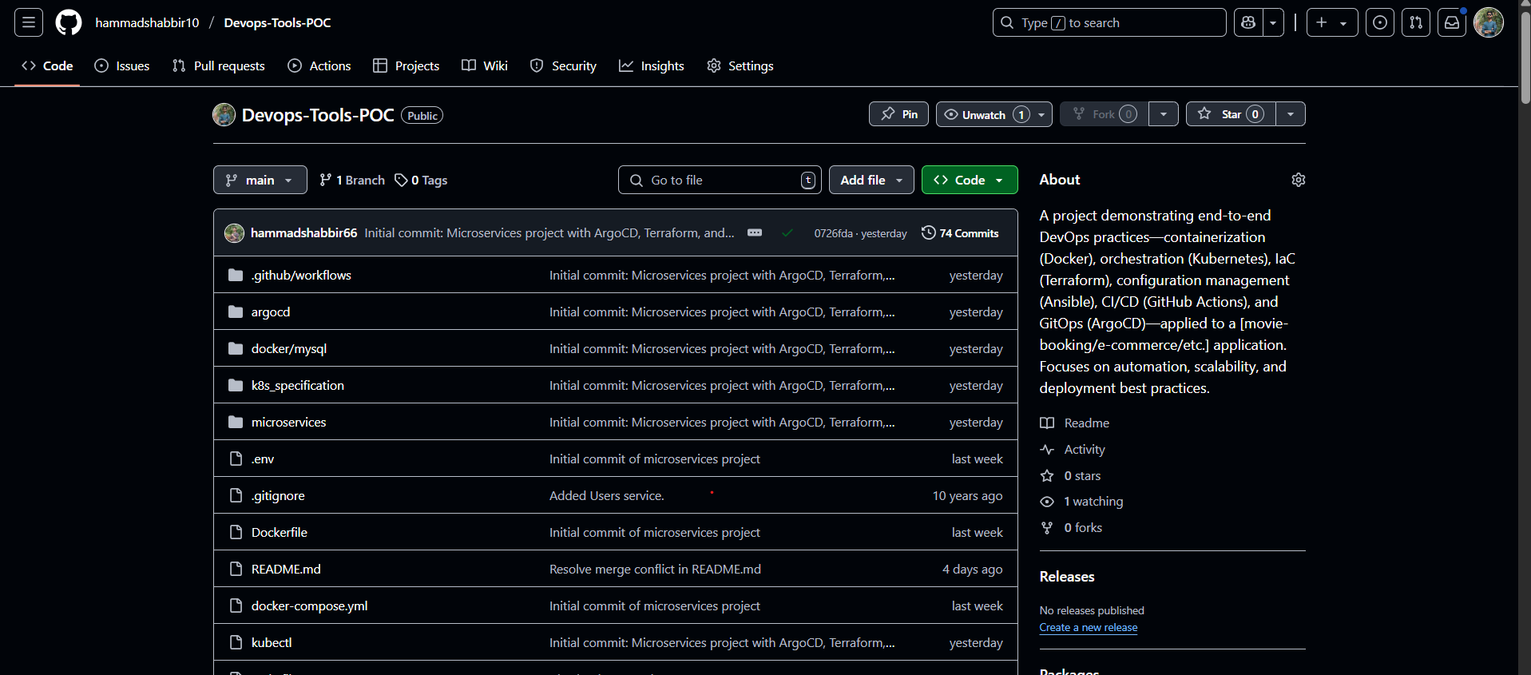
- Docker
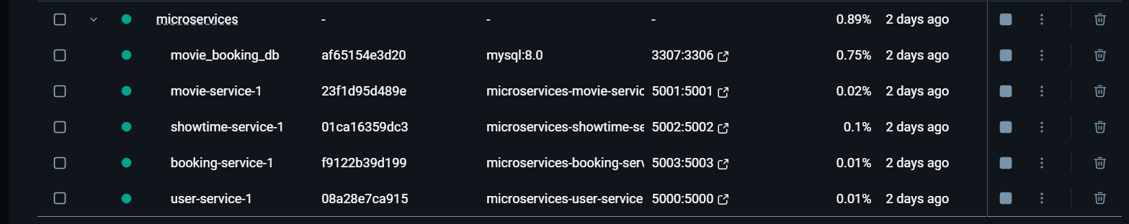
docker ps -a:
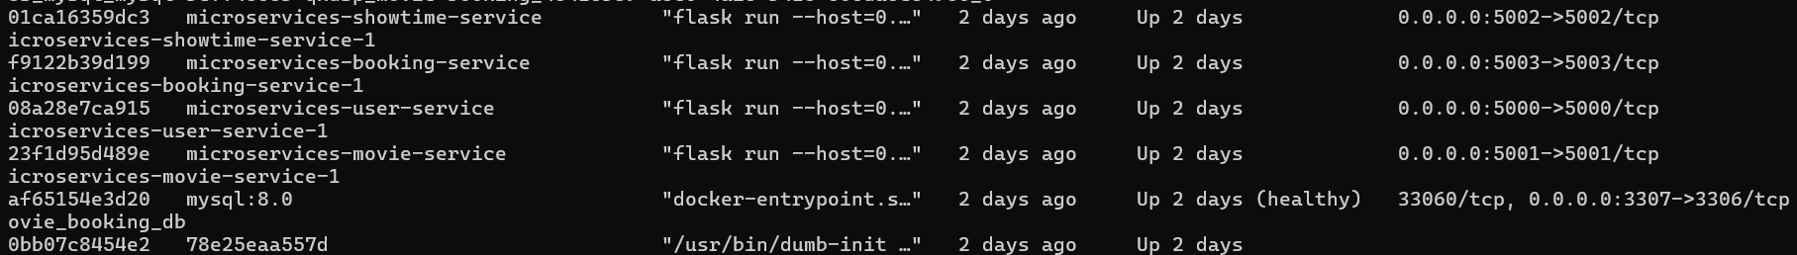
docker images
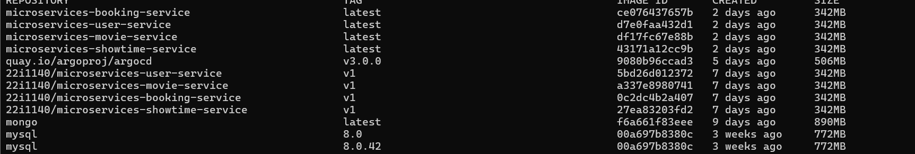

- Kubernetes
Kubectl create namespace movie-booking
Kubectl apply -f k8s_specifications/

kubectl get namespace
my- namespace is kube-system & movie-booking
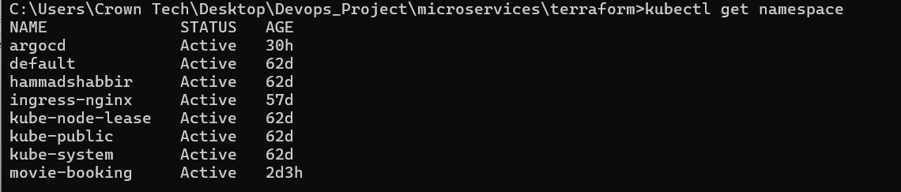
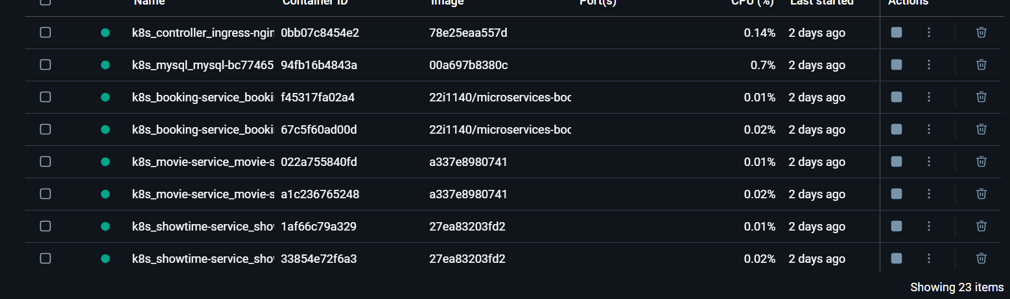
Kubectl get pods -n movie-booking
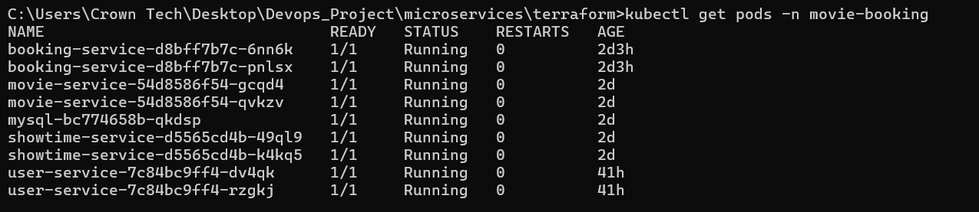
Kubectl get pv,pvc -n movie-booking
Kubeclt get svc -n movie-booking
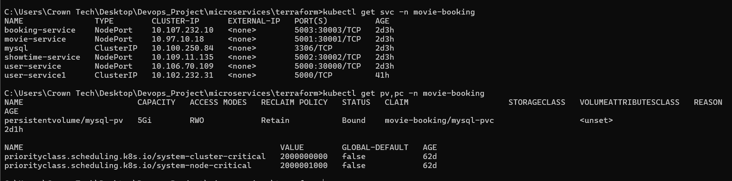
Kubeclt get ingress -n movie-booking

Kubectly get deployments -n movie-booking
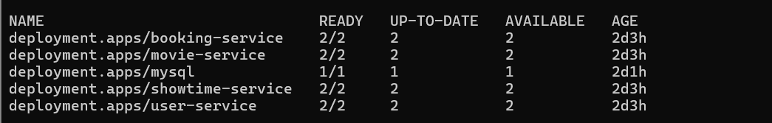
Kubectl get scerts -n movie booking

K8s_Specification (kubernestes folders)
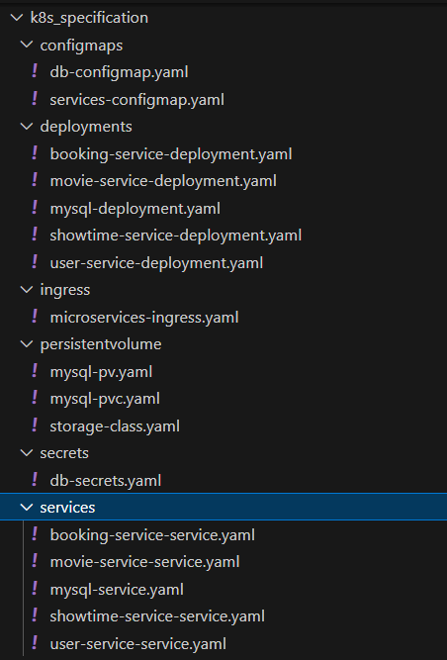

BACKEND-ENTERIES IN KUBERNETES THROUGH POSTMAN
kubectl port-forward svc/mysql 3307:3306 -n movie-booking
kubectl exec -it mysql-bc774658b-qkdsp -n movie-booking -- mysql -uroot -pmypassword

For USERS
url: http://localhost:30000/users

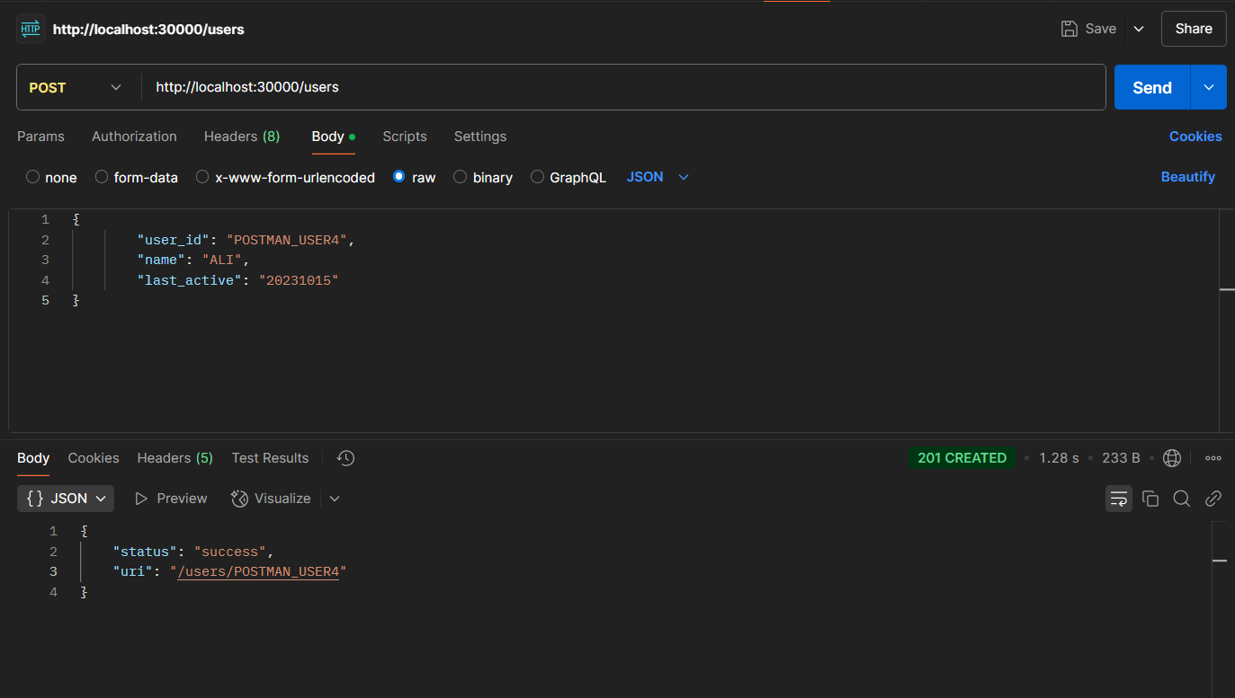
kubectl port-forward svc/user-service 5000:5000 -n movie-booking
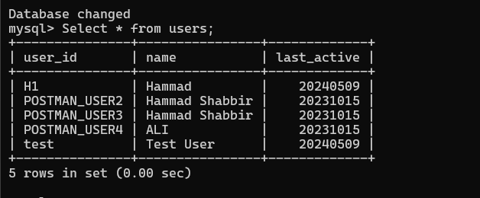
New user has been entered.
FOR MOVIES
url: http://localhost:30001/movies

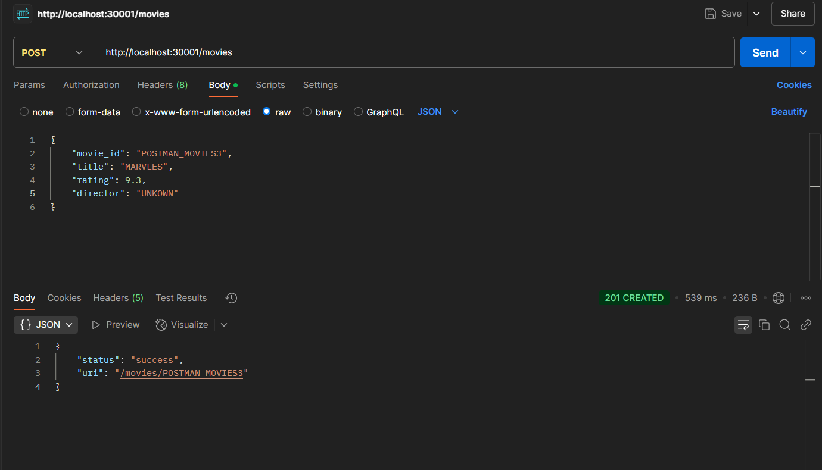

kubectl port-forward svc/movie-service 5001:5001 -n movie-booking
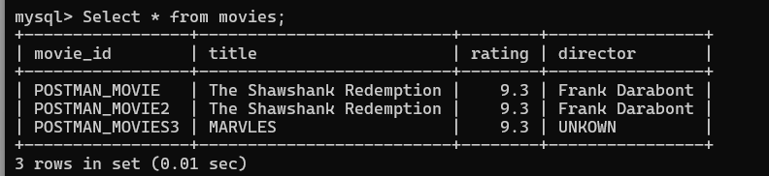

For Showtime
url: http://localhost:30001/showtimes

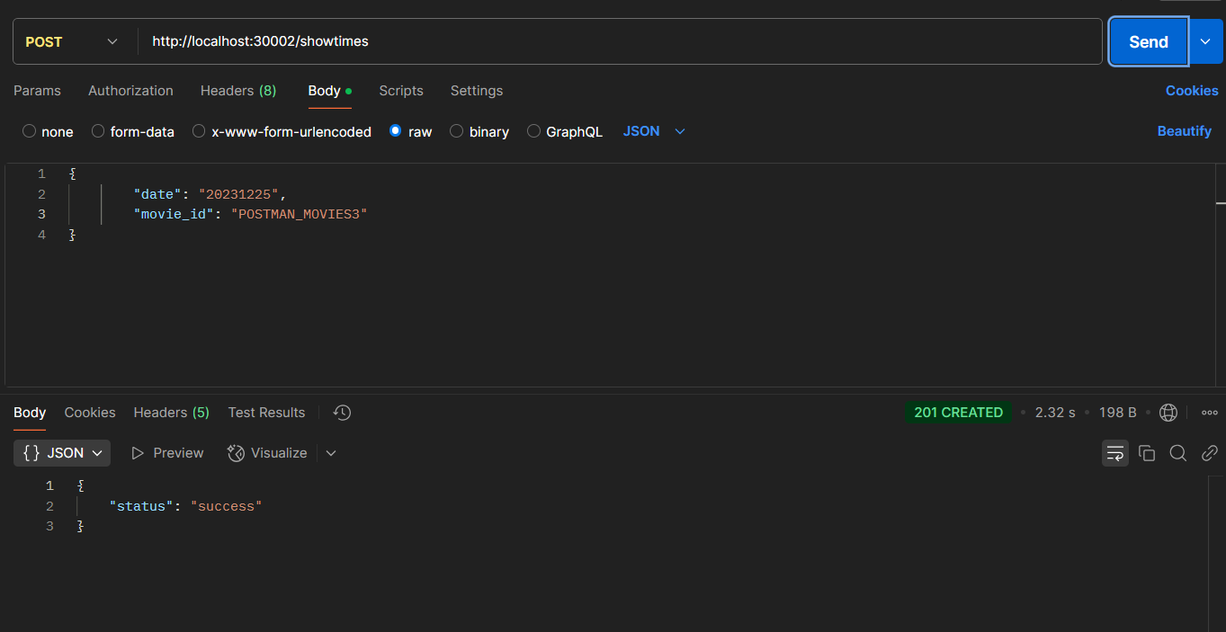
kubectl port-forward svc/showtime-service 5002:5002 -n movie-booking

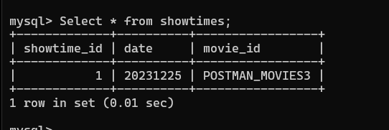

For Bookings;
url: http://localhost:30003/bookings
kubectl port-forward svc/booking-service 5003:5003 -n movie-booking

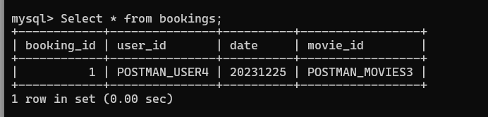

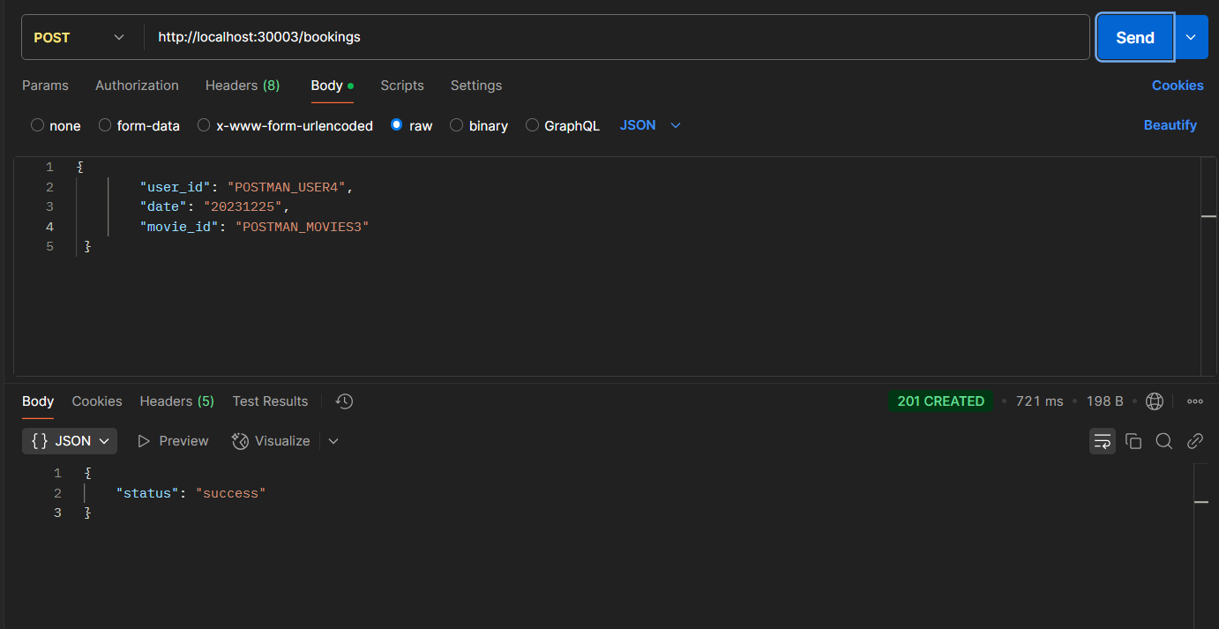

- ARGO-CD
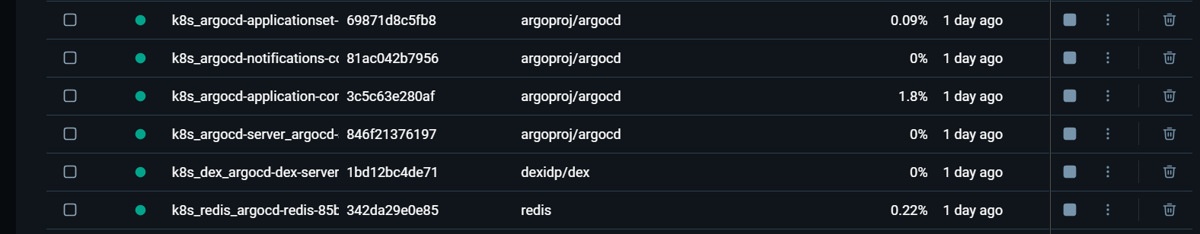
kubectl apply -f argocd/movie-booking-app.yaml
kubectl port-forward svc/argocd-server -n argocd 8080:443
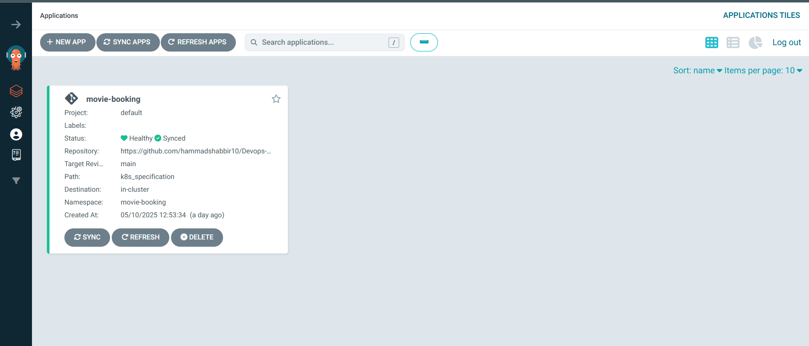
kubectl get pods -n argocd
https://localhost:8080
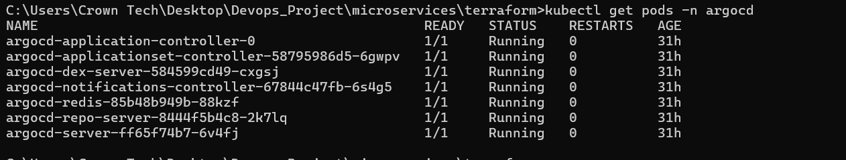
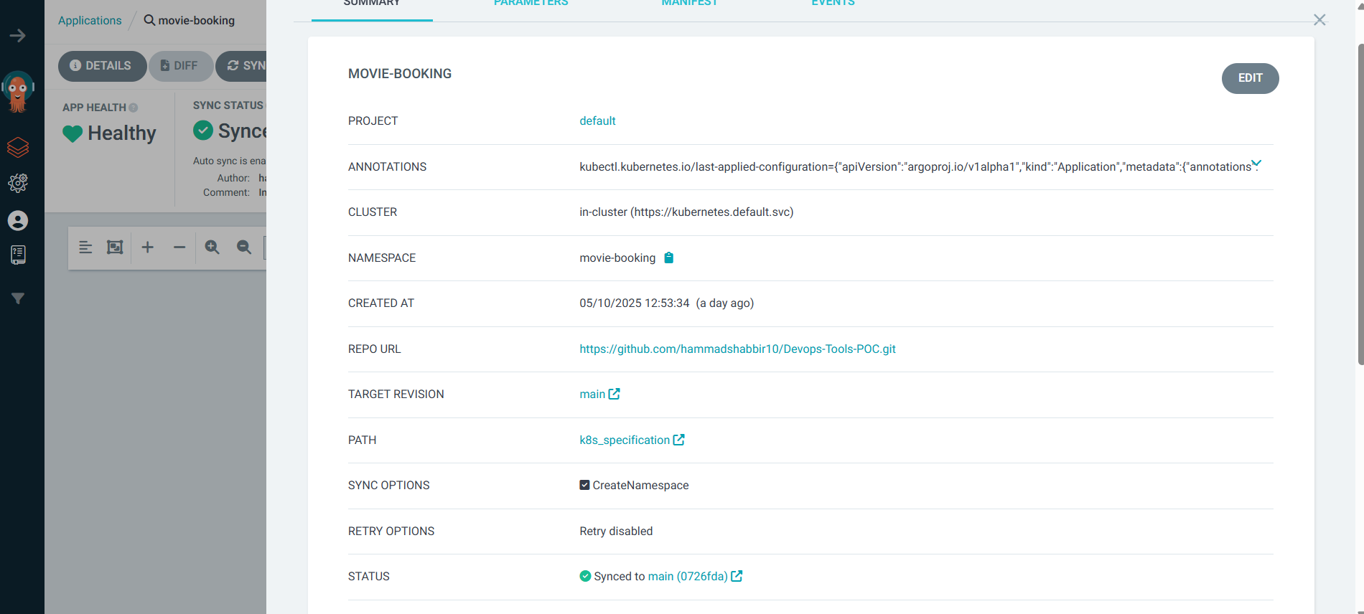

- CI-CD PIPLINE

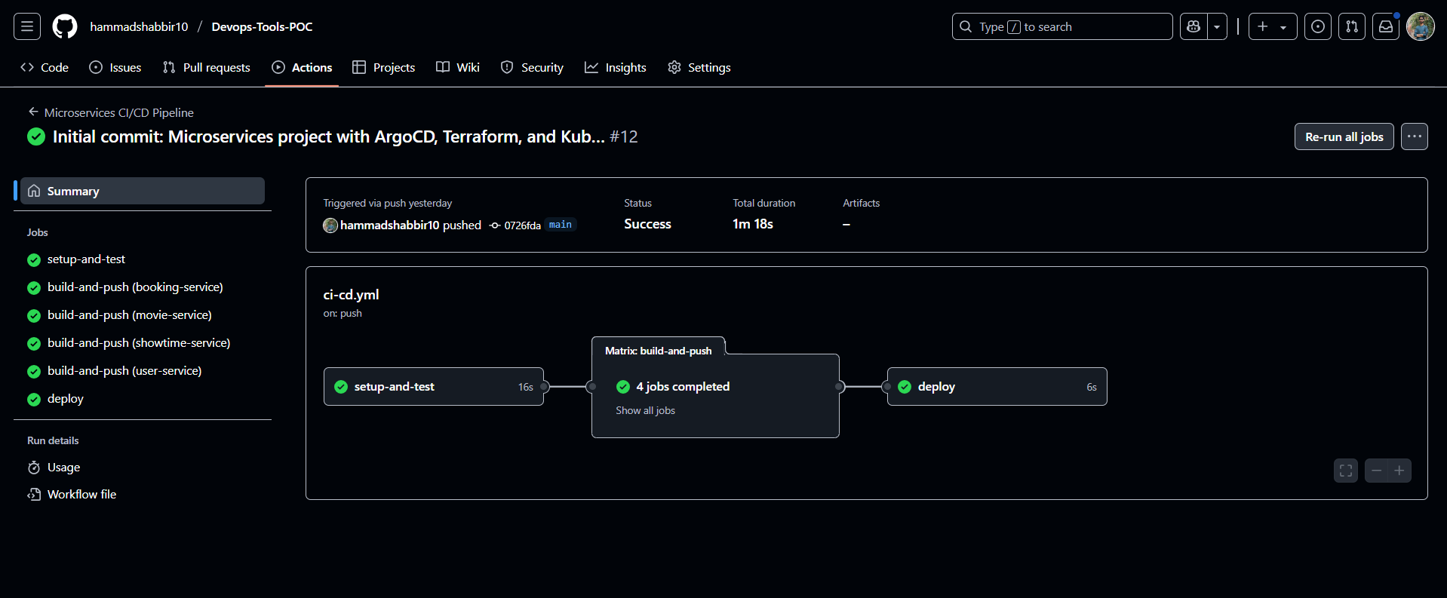

- Terraform
- Terraform init
- Terraform plan

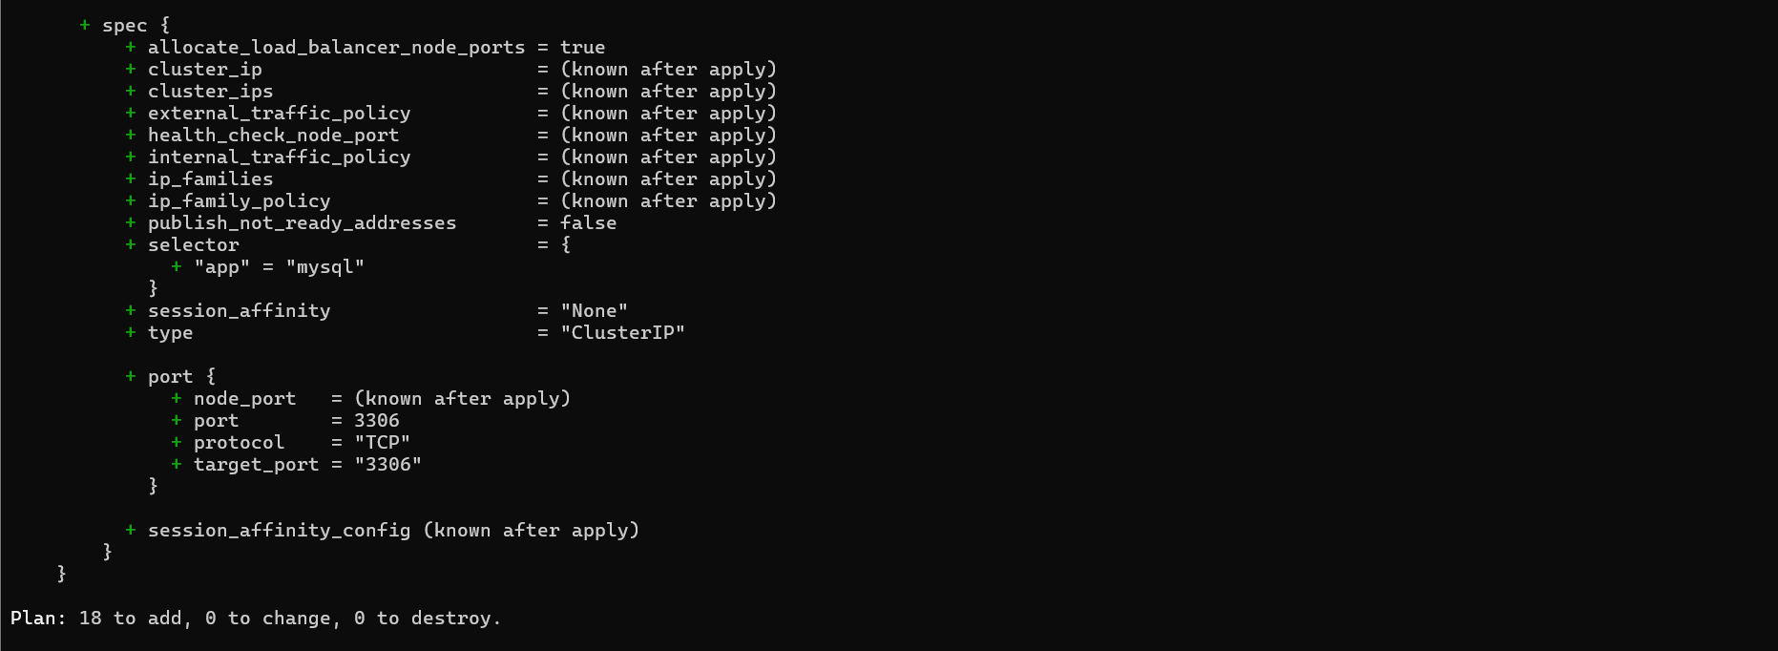

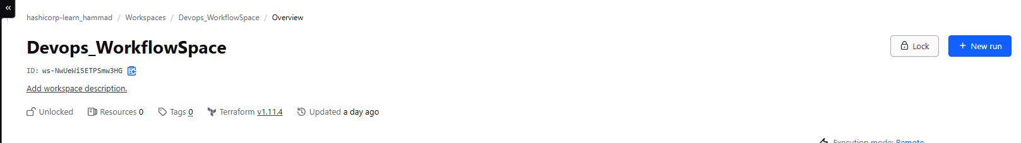

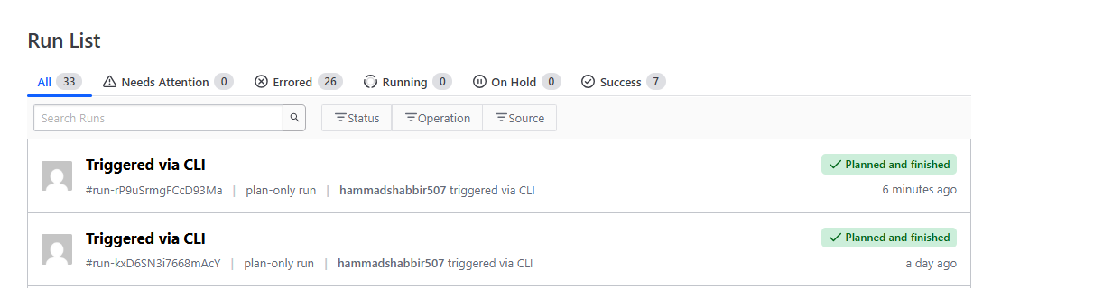

MY KEYS
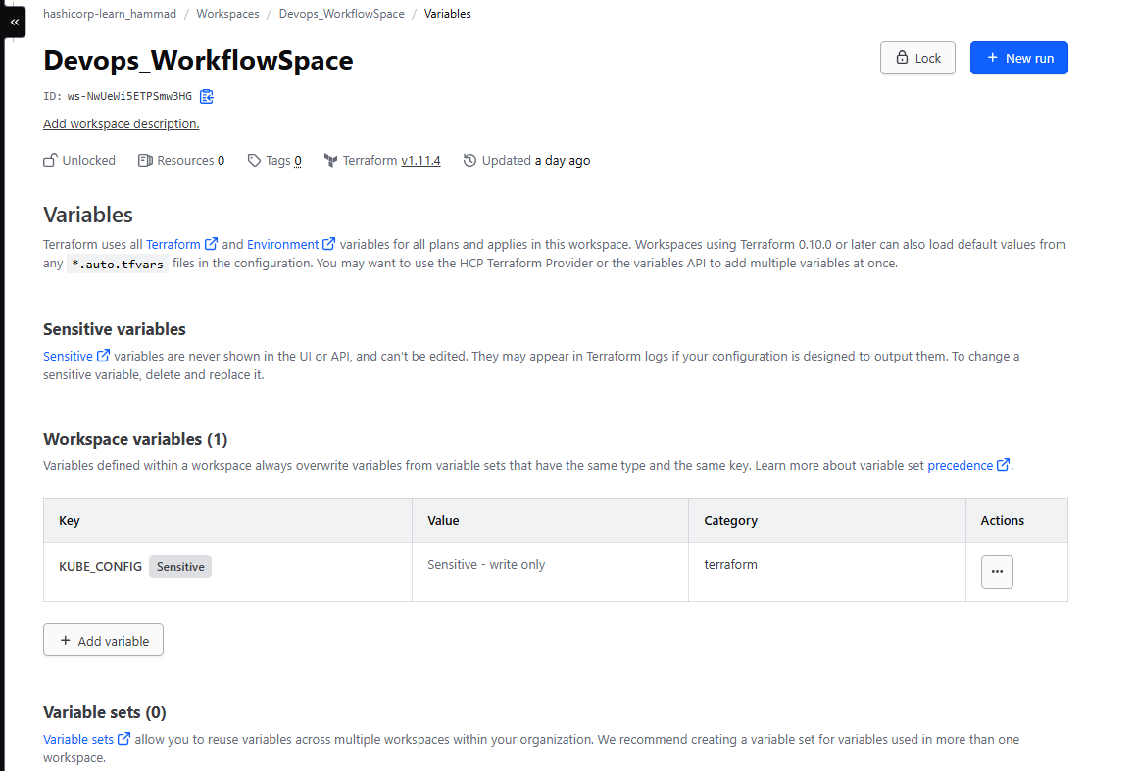

- ANSIBLE
- pip install kubernetes
- pip install ansible
- pip install openshift
- ansible-galaxy collection install kubernetes.core
- ansible-galaxy collection install community.general

