**PDC PROJECT**

**Group Members:**

**Hammad Shabbir: 22I-1140  
Iqrash Qureshi: 22i-1174  
Haider Zia: 22i-1196**

**Single Source Shortest Path**

**Sequential Analysis:**

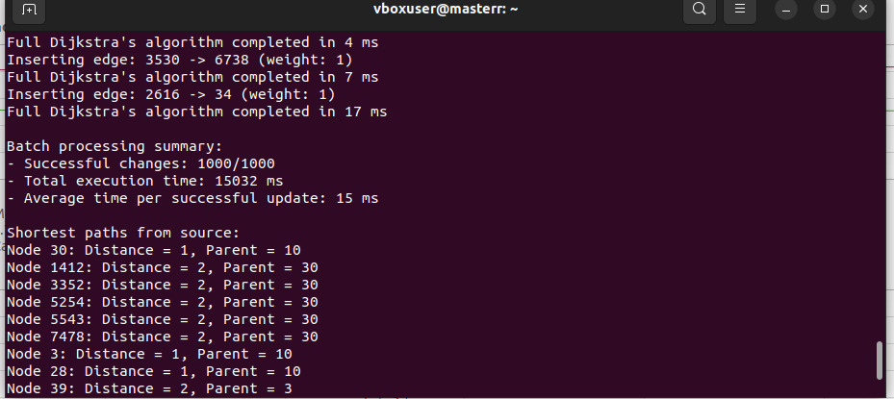

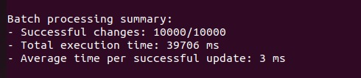

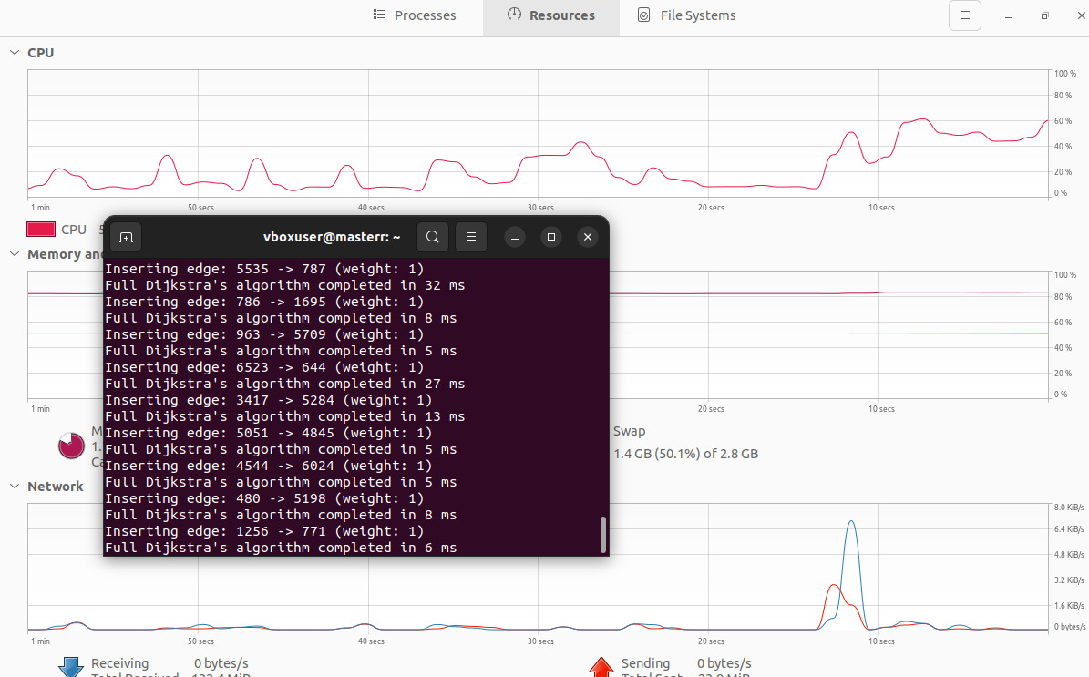

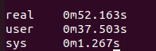

**MPI Analysis:**

Mpi execution time is better than Sequential.

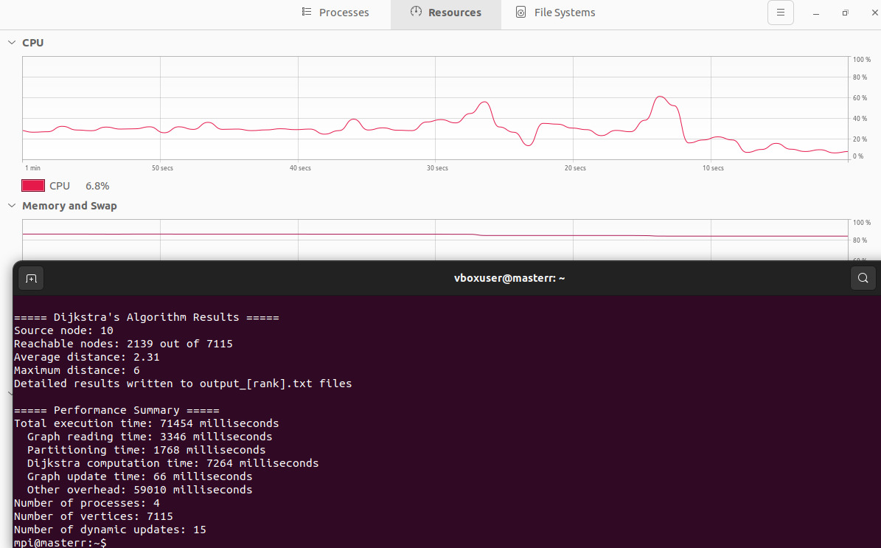

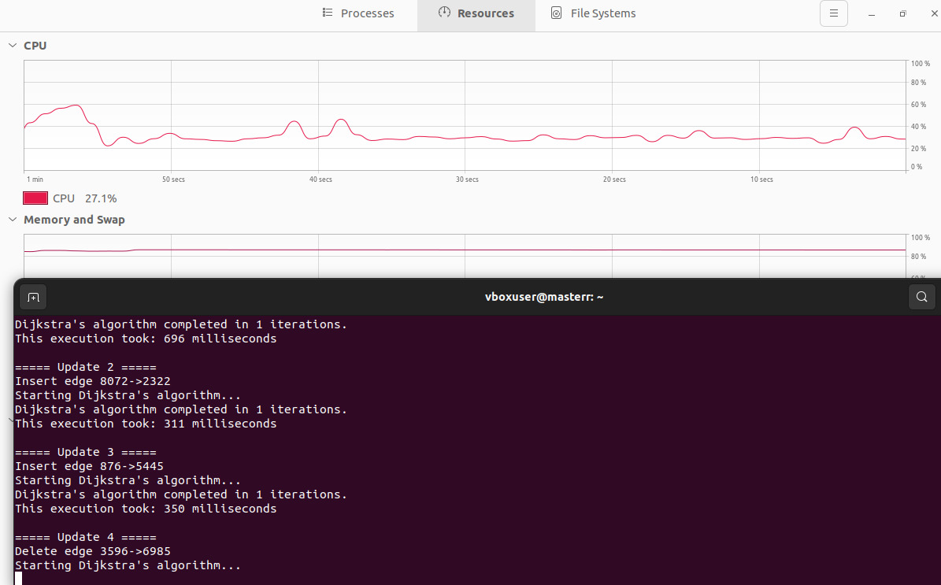

**MPI with Slave/Master Analysis:**

This graph shows that, our process divide on master and slave 2 in each, and their performance graph as given below.

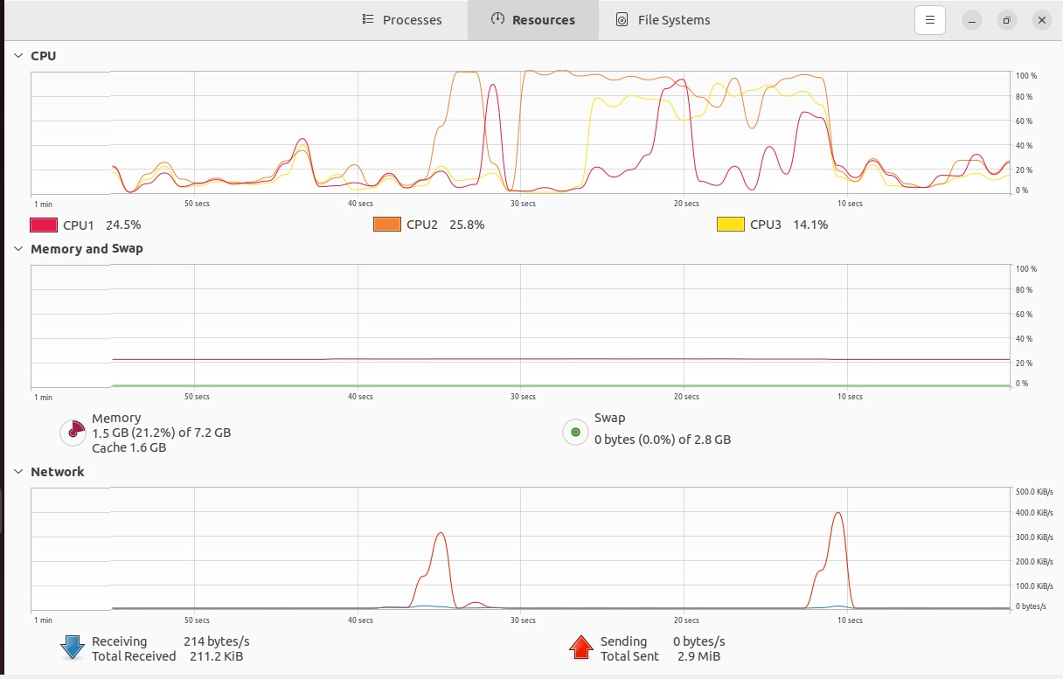

**OpenMP:**

Open-Mp improves the execution time as compare to MPI!!!

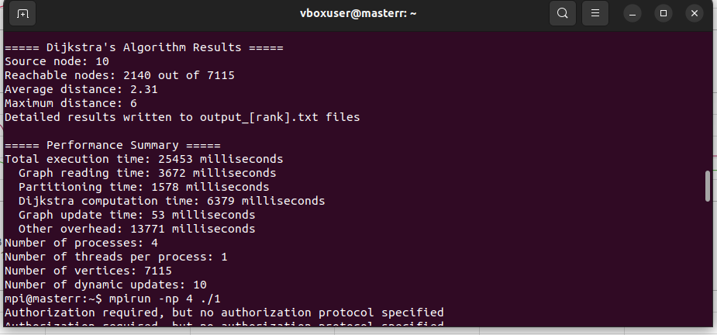

**4 Master & 4 Slave.**

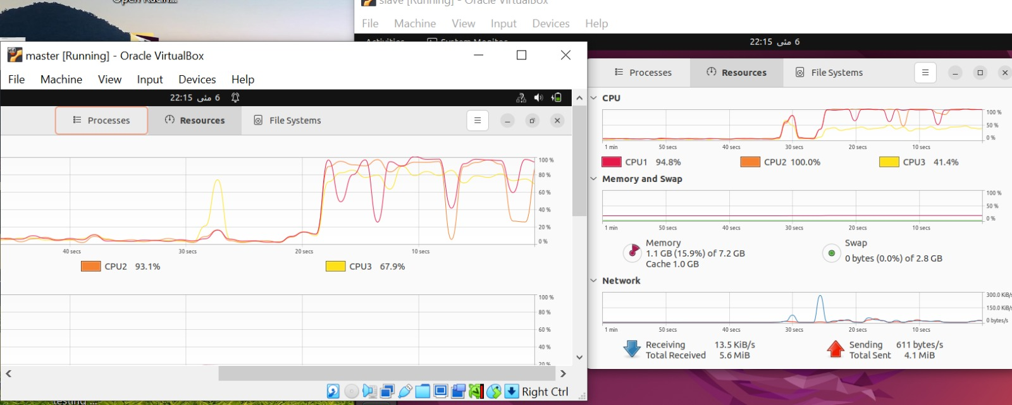

**2 Master & 2 Slave**

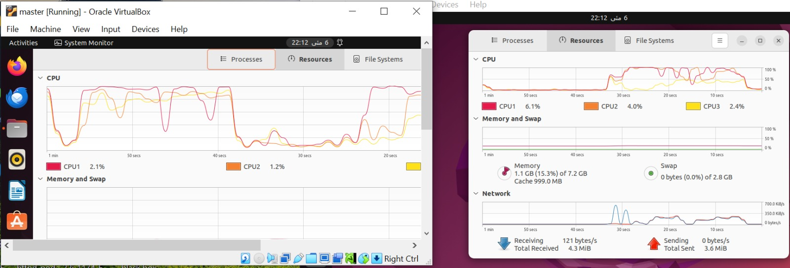

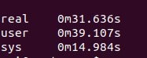

**OpenMP > MpI > Sequential**