TTTGameData
Version Control Document - DB Lab

Group Name | TTTGameData
Project | Super Tic-Tac-Toe Multiplayer Database
Members listed in source doc | Muhammad Hammad Shakeel Sikandar Khaleel  Aurshia Mudassar
GitHub Repository Link | https://github.com/hammadshakeelai/Game-Database-Project

Version Control Log

Milestone | Date | Version | Remarks
ERD + Schema | 24 / 4 / 2026 | V1.0 | Initial schema; improvement required
Schema Improvement | 29 / 4 / 2026 | V1.1 | M2 preparation
M2: 3NF | 5 / 5 / 2026 | V2.0 | Normalized ERD and table justification
M3: CSVs | 12 / 5 / 2026 | V3.0 | Clean synthetic dataset and dataflow
M4: DDL | 15 / 5 / 2026 | V3.0 | DDL scripts and EER verification
M5: DML | 17 / 5 / 2026 | V4.0 | Data population and validation queries

Project Overview
The database supports a Super Tic-Tac-Toe multiplayer platform with ranked games, tournaments, friends, groups, chat, notifications, and leaderboard features. Core entities include PLAYER, GAMETYPE, TOURNAMENT, GAME, GAME_HISTORY, GROUP_T, GROUP_LIST, CHAT, and MESSAGE. Junction tables are used for many-to-many relationships, and foreign keys maintain referential integrity across gameplay and social features.

Updated ERD Diagram
Final normalized ERD used for the DB Lab submission. The design is normalized up to 3NF and includes lookup, core, event, bridge, log, communication, notification, and leaderboard tables.
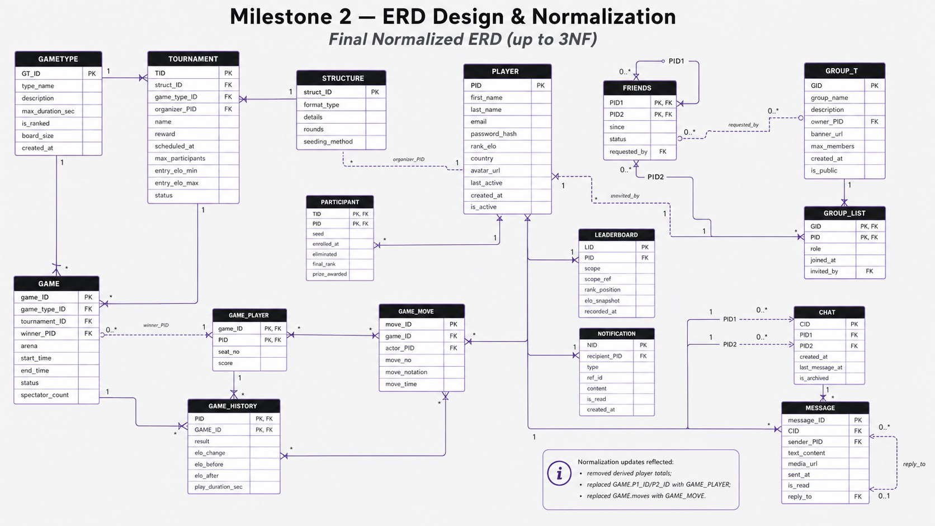
Figure 1. Final normalized ERD for the Super Tic-Tac-Toe database.

Normalization Walkthrough
The final ERD is treated as the source of truth. The goal of normalization is to reduce redundancy, prevent update anomalies, and keep each table focused on one entity or relationship.

Normal Form | Justification and changes made
1NF | All fields are atomic. Repeating groups and multi-valued fields were separated into child tables. In particular, the previous GAME.moves list was replaced with GAME_MOVE, and message details are stored as individual MESSAGE rows.
2NF | Composite-key tables store only attributes that depend on the full key. PARTICIPANT(TID, PID) stores enrollment details, GAME_PLAYER(game_ID, PID) stores seat/score details, GAME_HISTORY(PID, GAME_ID) stores game outcome details, GROUP_LIST(GID, PID) stores membership details, and FRIENDS(PID1, PID2) stores relationship details.
3NF | Non-key attributes depend only on the key. Derived player totals were removed from PLAYER because they can be calculated from GAME_HISTORY. Reusable game variant rules are stored in GAMETYPE, tournament formats are stored in STRUCTURE, and profile details are not duplicated in relationship tables.

Important 3NF Changes Reflected in the ERD
- Removed derived player totals from PLAYER so wins/losses/draws can be calculated from GAME_HISTORY.
- Replaced fixed GAME.P1_ID and GAME.P2_ID columns with GAME_PLAYER for flexible participation.
- Replaced the multi-valued GAME.moves attribute with GAME_MOVE for one row per atomic move.
- Separated GROUP_T from GROUP_LIST and TOURNAMENT from PARTICIPANT to keep membership/enrollment attributes out of parent tables.
Main Table Groups

Category | Tables | Reason
Reference / lookup | GAMETYPE, STRUCTURE | Reusable rule and format definitions without repeating them in event rows.
Core actor | PLAYER | One profile row per account, referenced by gameplay, social, and communication features.
Event records | TOURNAMENT, GAME | Stores scheduled competitions and individual match instances.
Associative tables | PARTICIPANT, GAME_PLAYER, GAME_HISTORY, FRIENDS, GROUP_LIST | Resolves many-to-many and self-referencing relationships while storing relationship-specific attributes.
Detail / log tables | GAME_MOVE, MESSAGE, NOTIFICATION, LEADERBOARD, CHAT, GROUP_T | Stores detailed activity, communication, group metadata, and snapshots separately.

Dataflow Description
Data enters through registration, game-type setup, tournament creation, gameplay activity, groups, friendships, chat messages, and notifications. The normalized flow loads parent/reference data before dependent child and bridge tables.

Reference and user data enters first
PLAYER stores registered users. GAMETYPE stores available game modes. STRUCTURE stores tournament formats such as single elimination, round robin, Swiss, and double elimination.

Tournament data depends on parent tables
TOURNAMENT references GAMETYPE, STRUCTURE, and the organizer PLAYER. PARTICIPANT then links players to tournaments with the composite key TID + PID and stores enrollment state.

Gameplay data flows into game tables
GAME records match instances. GAME_PLAYER stores the players in each game, GAME_MOVE stores the move sequence, and GAME_HISTORY stores each player result and Elo change after completion.

Social data flows through groups and friendships
GROUP_T stores group metadata and owner. GROUP_LIST connects players to groups and stores roles/join dates. FRIENDS stores player-to-player relationship records with requested_by and status.

Communication and notifications
CHAT stores a conversation between two players. MESSAGE stores each message, sender, optional media, read state, and reply reference. NOTIFICATION stores system messages caused by game results, friend requests, group invites, tournament invites, and rank updates.

Database outputs
Tournament standings, player match history, ranking reports, social/group reports, chat feeds, notification feeds, and future AI/recommendation inputs can be produced by joining the normalized tables.

Recommended Load Order
player -> gametype -> structure -> tournament -> participant -> game -> game_player -> game_move -> game_history -> group_t -> group_list -> friends -> leaderboard -> notification -> chat -> message

GitHub Repository and Submission Checklist

GitHub Repository Link | https://github.com/hammadshakeelai/Game-Database-Project
Filename | TTTGameData_Version_Control_Doc_DBLab.pdf

Requirement | Included in this PDF
Group name and member names | Yes - cover page
Updated ERD diagram | Yes - final normalized ERD page
Normalization walkthrough | Yes - 1NF, 2NF, and 3NF with justifications
Dataflow description | Yes - reference/user, tournament, gameplay, social, communication, outputs
GitHub repository link | Yes - https://github.com/hammadshakeelai/Game-Database-Project

Validation Notes
  - The schema contains 16 core tables matching the final normalized ERD.
  - Primary keys, composite keys, foreign keys, uniqueness rules, and check constraints are used to preserve integrity.
  - After the DML update/delete demo, validation queries should confirm no key-column nulls and no orphaned foreign-key references.

