PROJECT NEXUS

GROUP MEMBERS:
Muhammad Hammad Shakeel
Sikandar Khaleel
Aurshia Mudassar

MILESTONE | DATE | VERSION | REMARKS
ERD + SCHEMA | 24 / 4 / 2026 | V1.0

SCHEMA:

TABLE: GAMETYPE
Column | Data Type | Constraint / Notes
GT_ID | VARCHAR(50) | PRIMARY KEY

TABLE: TOURNAMENT
Column | Data Type | Constraint / Notes
TID | VARCHAR(50) | PRIMARY KEY
reward | VARCHAR(255)
time | DATETIME | NOT NULL

TABLE: STRUCTURE
Column | Data Type | Constraint / Notes
struct_ID | VARCHAR(50) | PRIMARY KEY
details | VARCHAR(255)

TABLE: GAME
Column | Data Type | Constraint / Notes
ID | VARCHAR(50) | PRIMARY KEY
Game_type_ID | VARCHAR(50) | NOT NULL -- FK → GAMETYPE(GT_ID)
start_time | DATETIME | NOT NULL
end_time | DATETIME
moves | TEXT | -- stored as CSV
Winner | VARCHAR(50)
P1_ID | VARCHAR(50) | NOT NULL -- FK → PLAYER(PID)
P2_ID | VARCHAR(50) | NOT NULL -- FK → PLAYER(PID)
Arena | VARCHAR(255)
points | INT
 |  | FOREIGN KEY (Game_type_ID) REFERENCES GAMETYPE(GT_ID)

TABLE: PLAYER
Column | Data Type | Constraint / Notes
PID | VARCHAR(50) | PRIMARY KEY
first_name | VARCHAR(100) | NOT NULL
last_name | VARCHAR(100) | NOT NULL
Gmail | VARCHAR(255) | UNIQUE
rank_elo | VARCHAR(50) | -- stores rank / elo

TABLE: GROUP
Column | Data Type | Constraint / Notes
GID | VARCHAR(50) | PRIMARY KEY

TABLE: FRIENDS
Column | Data Type | Constraint / Notes
PID1 | VARCHAR(50) | NOT NULL -- FK → PLAYER(PID)
PID2 | VARCHAR(50) | NOT NULL -- FK → PLAYER(PID)
 |  | PRIMARY KEY (PID1, PID2)
 |  | FOREIGN KEY (PID1) REFERENCES PLAYER(PID)
 |  | FOREIGN KEY (PID2) REFERENCES PLAYER(PID)

TABLE: GROUP_LIST
Column | Data Type | Constraint / Notes
GID | VARCHAR(50) | NOT NULL -- FK → GROUP(GID)
PID | VARCHAR(50) | NOT NULL -- FK → PLAYER(PID)
 |  | PRIMARY KEY (GID, PID)
 |  | FOREIGN KEY (GID) REFERENCES `GROUP`(GID)
 |  | FOREIGN KEY (PID) REFERENCES PLAYER(PID)

TABLE: PARTICIPANT
Column | Data Type | Constraint / Notes
TID | VARCHAR(50) | NOT NULL -- FK → TOURNAMENT(TID)
PID | VARCHAR(50) | NOT NULL -- FK → PLAYER(PID)
 |  | PRIMARY KEY (TID, PID)
 |  | FOREIGN KEY (TID) REFERENCES TOURNAMENT(TID)
 |  | FOREIGN KEY (PID) REFERENCES PLAYER(PID)

TABLE: CHAT
Column | Data Type | Constraint / Notes
CID | VARCHAR(50) | PRIMARY KEY
PID1 | VARCHAR(50) | NOT NULL -- FK → PLAYER(PID)
PID2 | VARCHAR(50) | NOT NULL -- FK → PLAYER(PID)
 |  | FOREIGN KEY (PID1) REFERENCES PLAYER(PID)
 |  | FOREIGN KEY (PID2) REFERENCES PLAYER(PID)

TABLE: OUR_CHATS
Column | Data Type | Constraint / Notes
message_ID | VARCHAR(50) | PRIMARY KEY
CID | VARCHAR(50) | NOT NULL -- FK → CHAT(CID)
media | VARCHAR(255)
text_additions | TEXT
 |  | FOREIGN KEY (CID) REFERENCES CHAT(CID)

TABLE: GAME_HISTORY
Column | Data Type | Constraint / Notes
PID | VARCHAR(50) | NOT NULL -- FK → PLAYER(PID)
GAME_ID | VARCHAR(50) | NOT NULL -- FK → GAME(ID)
 |  | PRIMARY KEY (PID, GAME_ID)
 |  | FOREIGN KEY (PID) REFERENCES PLAYER(PID)
 |  | FOREIGN KEY (GAME_ID) REFERENCES GAME(ID)

2. Relationship Summary

Entity A | Notation | Entity B | Description
GAMETYPE | ||--o{ | GAME | defines
TOURNAMENT | ||--o{ | GAME | includes
TOURNAMENT | ||--|| | STRUCTURE | has
TOURNAMENT | }o--o{ | PLAYER | via PARTICIPANT (enrolls as)
PLAYER | }o--o{ | PLAYER | via FRIENDS (is friend)
PLAYER | ||--o{ | GAME | has (as P1/P2)
PLAYER | }o--o{ | GROUP | via GROUP_LIST (member of)
GROUP | ||--o{ | CHAT | contains / initiates/receives
CHAT | ||--o{ | OUR_CHATS | contains messages
PLAYER | }o--o{ | GAME | via GAME_HISTORY (recorded in)

Look for Erd below |
V

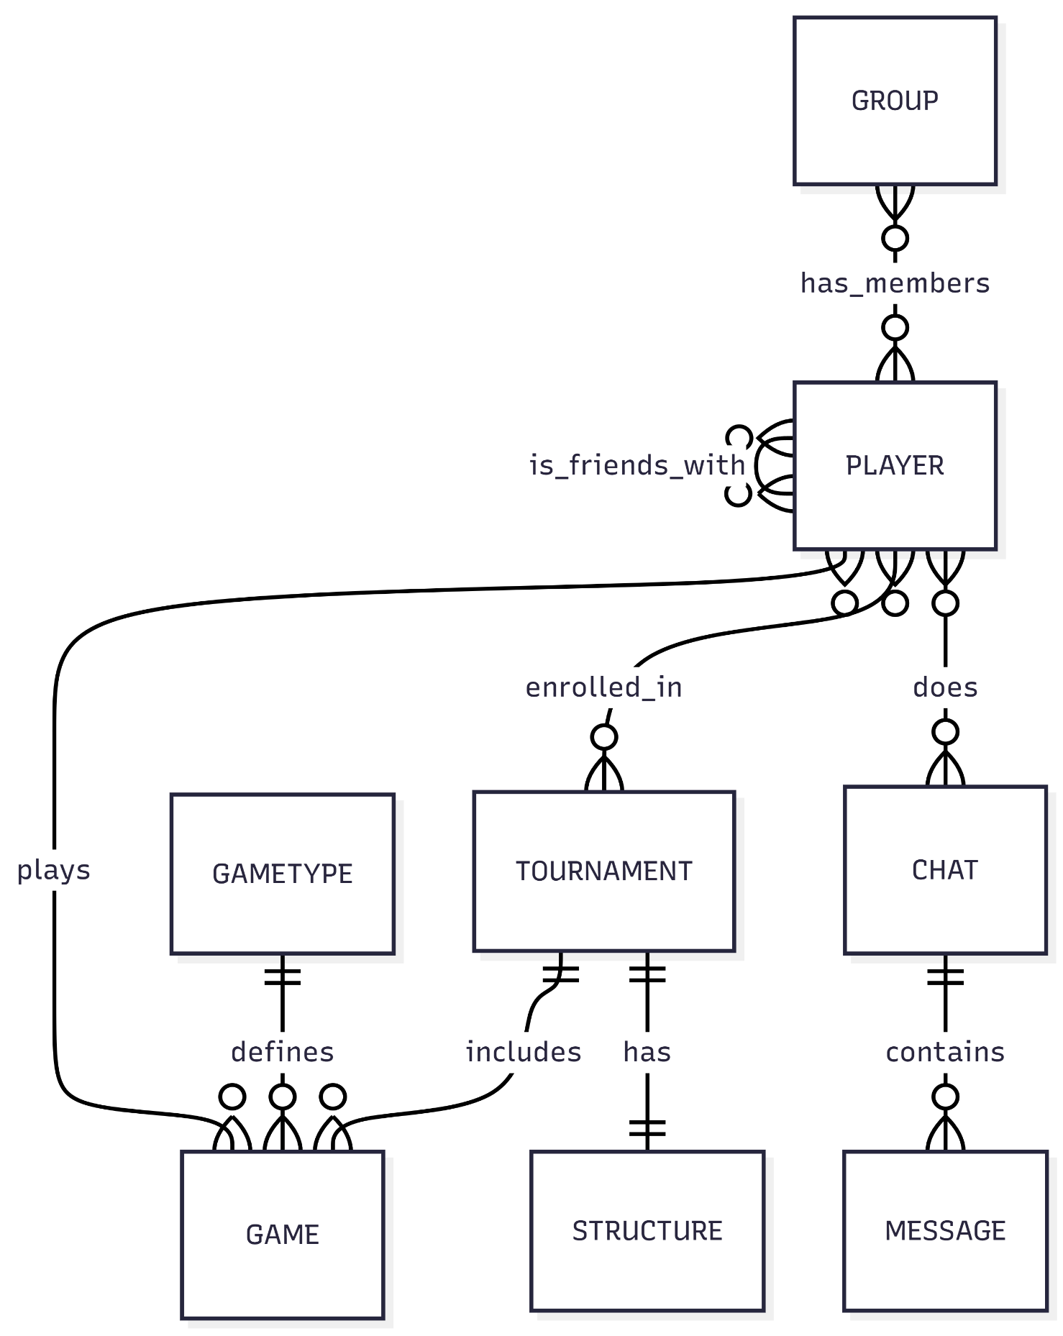
ERD:

