Super Tic-Tac-Toe
Multiplayer Platform
Milestone 1 — Database Design & ERD
Version Control Document | April 2026
GROUP MEMBERS
Muhammad Hammad Shakeel
Sikandar Khaleel
Aurshia Mudassar
MILESTONE | DATE | VERSION | REMARKS
ERD + SCHEMA | 24 / 4 / 2026 | V1.0

1. System Overview
Super Tic-Tac-Toe is a competitive online multiplayer platform extending classic Tic-Tac-Toe into a strategic, skill-based game with ranked play, tournaments, social features, and real-time chat. The platform supports multiple game variants, group communities, and a persistent ELO-based rating system.

1.1 Core Modules
• Game Engine — manages game types, game instances, moves, and outcomes.
• Tournament System — organises competitive brackets, enrolls participants, and links games.
• Social Layer — handles friend connections, player groups, and direct messaging.
• Player Profile — stores identity, ELO ranking, and full game history.
2. Entity-Relationship Diagrams
Two ERDs are provided: a high-level conceptual ERD showing entity relationships, and a detailed coloured ERD showing all attributes, keys, and cardinality between every table.
2.1 Conceptual ERD (Crow's-Foot Notation)
The diagram below shows all entities and their relationships using crow's-foot cardinality notation. Junction tables are shown implicitly through the many-to-many connections.

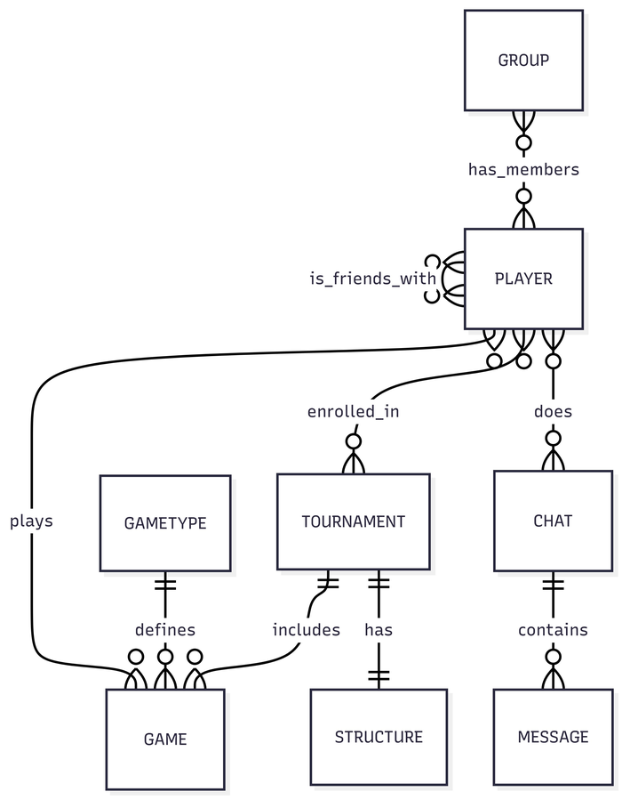
Figure 1 — Conceptual ERD: entities and relationships (crow's-foot notation)
2.2 Detailed Relational ERD
The coloured ERD below shows every table with its attributes, data types, primary keys (PK), and foreign keys (FK). Junction tables are shown explicitly with their composite primary keys.

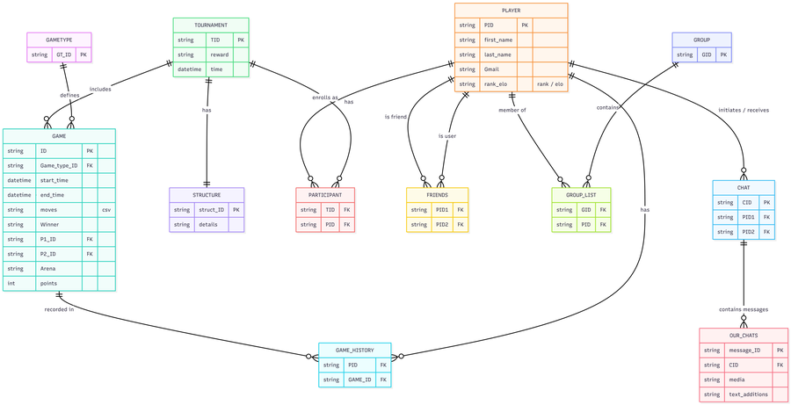
Figure 2 — Detailed Relational ERD: all attributes, PKs & FKs
2.3 Alternative Conceptual View
The diagram below provides a second high-level view showing the same entity relationships with a dark theme, making the connection lines and crow's-foot markers easy to read at a glance.

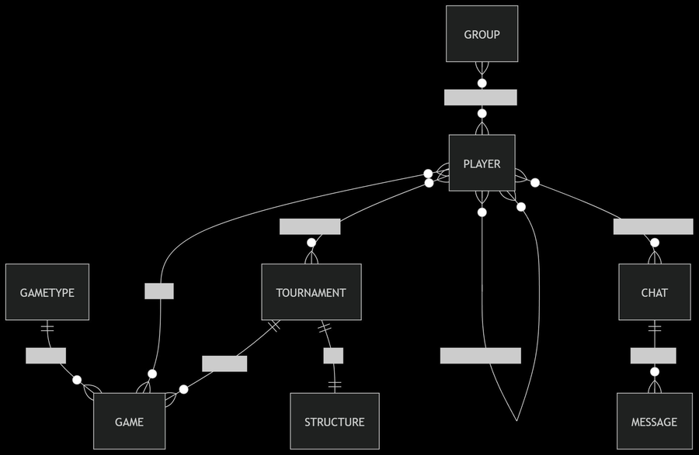
Figure 3 — Alternative Conceptual ERD (dark theme)
3. Relational Database Schema
This section describes every table — its purpose, all attributes, data types, constraints, and relationships. The schema supports ranked play, tournaments, social features, and chat.

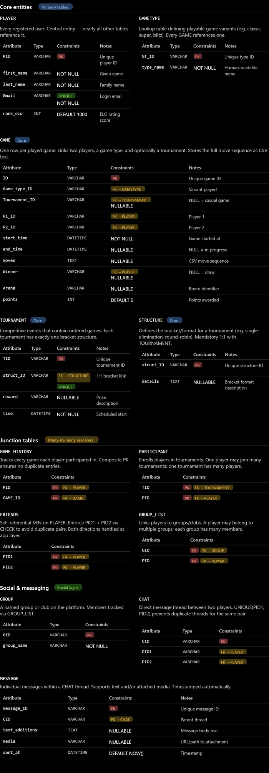
Figure 4 — Full Schema Reference: all tables with attributes, types, and constraints
3.1 GAMETYPE
Lookup table defining every playable variant of Tic-Tac-Toe available on the platform (e.g. Classic, Blitz, Super, Ultimate). Every game instance references one game type, keeping the GAME table normalised and variant rules centralised.

Attribute | Type | Constraint | Description
GT_ID | VARCHAR(50) | PRIMARY KEY | Unique identifier for the game variant (e.g. 'GT_CLASSIC')
type_name | VARCHAR(100) | NOT NULL | Human-readable name (e.g. 'Classic 3×3', 'Blitz', 'Super')
description | TEXT | NULLABLE | Brief description of rules and differences from standard play
max_duration_sec | INT | DEFAULT 300 | Maximum allowed game duration in seconds
is_ranked | BOOLEAN | DEFAULT TRUE | Whether ELO rating changes apply to games of this type

3.2 PLAYER
Central entity representing every registered user. Almost all other tables reference PLAYER. Stores identity, login credentials (email), and the ELO rating that drives the competitive ranking system.

Attribute | Type | Constraint | Description
PID | VARCHAR(50) | PRIMARY KEY | Unique player identifier (UUID or slug, e.g. 'PLR_00421')
first_name | VARCHAR(100) | NOT NULL | Player's given name
last_name | VARCHAR(100) | NOT NULL | Player's family name
Gmail | VARCHAR(255) | UNIQUE, NOT NULL | Login email — must be unique across all players
rank_elo | INT | DEFAULT 1000 | ELO rating score; higher = stronger player
country | VARCHAR(100) | NULLABLE | Player's country for regional leaderboards
avatar_url | VARCHAR(255) | NULLABLE | URL to the player's profile picture
created_at | DATETIME | DEFAULT NOW() | Timestamp when the account was registered
is_active | BOOLEAN | DEFAULT TRUE | Soft-delete flag; FALSE = account deactivated

3.3 GAME
Records every single game instance played on the platform. Links two players, a game type, and optionally a tournament. Stores the full move sequence as CSV-encoded text for replay and analytics. A NULL end_time means the game is still in progress.

Attribute | Type | Constraint | Description
ID | VARCHAR(50) | PRIMARY KEY | Unique game identifier
Game_type_ID | VARCHAR(50) | FK → GAMETYPE, NOT NULL | Which variant is being played
Tournament_ID | VARCHAR(50) | FK → TOURNAMENT, NULLABLE | Owning tournament; NULL = casual/unranked game
P1_ID | VARCHAR(50) | FK → PLAYER, NOT NULL | Player occupying seat 1 (usually moves first)
P2_ID | VARCHAR(50) | FK → PLAYER, NOT NULL | Player occupying seat 2
start_time | DATETIME | NOT NULL | UTC timestamp when the game began
end_time | DATETIME | NULLABLE | UTC timestamp when finished; NULL = in progress
moves | TEXT | NULLABLE | CSV-encoded move sequence for replay (e.g. '0,4,1,5…')
Winner | VARCHAR(50) | FK → PLAYER, NULLABLE | PID of winner; NULL = draw or in-progress
Arena | VARCHAR(255) | NULLABLE | Board/arena identifier for themed sessions
points | INT | DEFAULT 0 | ELO points awarded to winner from this game
status | VARCHAR(50) | DEFAULT 'active' | Lifecycle: active | finished | abandoned

3.4 GAME_HISTORY (Junction Table)
Resolves the many-to-many relationship between PLAYER and GAME. Each row records one player's participation in one game along with the outcome and ELO change. The composite PK (PID, GAME_ID) prevents duplicate entries.

Attribute | Type | Constraint | Description
PID | VARCHAR(50) | PK, FK → PLAYER | The participating player
GAME_ID | VARCHAR(50) | PK, FK → GAME | The game the player participated in
result | VARCHAR(20) | NULLABLE | Outcome for this player: win | loss | draw
elo_change | INT | NULLABLE | Net ELO points gained or lost in this game

3.5 TOURNAMENT
Represents a competitive event containing an ordered set of games. Each tournament has exactly one bracket structure (1:1 with STRUCTURE), an optional prize, and a scheduled start time.

Attribute | Type | Constraint | Description
TID | VARCHAR(50) | PRIMARY KEY | Unique tournament identifier
struct_ID | VARCHAR(50) | FK → STRUCTURE, UNIQUE | Bracket definition — UNIQUE enforces 1:1 with STRUCTURE
name | VARCHAR(255) | NOT NULL | Display name (e.g. 'Spring Open 2026')
reward | VARCHAR(255) | NULLABLE | Prize or reward description
time | DATETIME | NOT NULL | Scheduled UTC start time of the tournament
max_participants | INT | NULLABLE | Player cap; NULL = unlimited / open enrollment
status | VARCHAR(50) | DEFAULT 'upcoming' | Lifecycle: upcoming | ongoing | completed | cancelled

3.6 STRUCTURE
Defines the bracket or format of a tournament (e.g. single-elimination, round-robin, Swiss). Kept as a separate table to allow format reuse and to keep TOURNAMENT normalised. Has a mandatory 1:1 relationship with TOURNAMENT.

Attribute | Type | Constraint | Description
struct_ID | VARCHAR(50) | PRIMARY KEY | Unique structure identifier
format_type | VARCHAR(100) | NOT NULL | Format: single-elim | round-robin | swiss | double-elim
details | TEXT | NULLABLE | Full description or JSON config of the bracket
rounds | INT | NULLABLE | Total number of rounds (if applicable to format)

3.7 PARTICIPANT (Junction Table)
Resolves the many-to-many relationship between PLAYER and TOURNAMENT, tracking which players are enrolled in which tournaments. The composite PK (TID, PID) prevents duplicate registrations.

Attribute | Type | Constraint | Description
TID | VARCHAR(50) | PK, FK → TOURNAMENT | Tournament the player is enrolled in
PID | VARCHAR(50) | PK, FK → PLAYER | The enrolled player
seed | INT | NULLABLE | Seeding position within the bracket
enrolled_at | DATETIME | DEFAULT NOW() | Timestamp of enrolment
eliminated | BOOLEAN | DEFAULT FALSE | TRUE once the player is knocked out

3.8 FRIENDS (Junction Table — Self-Referential)
Resolves the many-to-many self-referential relationship on PLAYER to model bilateral friendships. The convention PID1 < PID2 (enforced via CHECK constraint) avoids storing both orderings of the same friendship pair, halving storage.

Attribute | Type | Constraint | Description
PID1 | VARCHAR(50) | PK, FK → PLAYER | First player (lower PID by convention — PID1 < PID2)
PID2 | VARCHAR(50) | PK, FK → PLAYER | Second player (higher PID by convention)
since | DATETIME | DEFAULT NOW() | Timestamp when the friendship was formed
status | VARCHAR(50) | DEFAULT 'accepted' | State: pending | accepted | blocked

3.9 GROUP
Represents a named club or community within the platform. Players can belong to multiple groups and each group can have many members, managed via the GROUP_LIST junction table. The owner is tracked separately from ordinary members.

Attribute | Type | Constraint | Description
GID | VARCHAR(50) | PRIMARY KEY | Unique group identifier
group_name | VARCHAR(255) | NOT NULL | Display name of the group
description | TEXT | NULLABLE | Purpose or description of the group
owner_PID | VARCHAR(50) | FK → PLAYER, NOT NULL | PID of the player who created and owns the group
created_at | DATETIME | DEFAULT NOW() | Timestamp of group creation
is_public | BOOLEAN | DEFAULT TRUE | TRUE = open to join; FALSE = invite-only

3.10 GROUP_LIST (Junction Table)
Resolves the many-to-many relationship between PLAYER and GROUP, tracking group membership and each member's role. The composite PK (GID, PID) prevents duplicate memberships.

Attribute | Type | Constraint | Description
GID | VARCHAR(50) | PK, FK → GROUP | The group
PID | VARCHAR(50) | PK, FK → PLAYER | The member player
role | VARCHAR(50) | DEFAULT 'member' | Member's role: owner | admin | member
joined_at | DATETIME | DEFAULT NOW() | Timestamp when the player joined

3.11 CHAT
Represents a direct message thread between exactly two players. A UNIQUE constraint on (PID1, PID2) prevents duplicate threads for the same pair. All messages in a thread are stored in the MESSAGE table and linked via CID.

Attribute | Type | Constraint | Description
CID | VARCHAR(50) | PRIMARY KEY | Unique chat thread identifier
PID1 | VARCHAR(50) | FK → PLAYER | Initiating player
PID2 | VARCHAR(50) | FK → PLAYER | Receiving player
created_at | DATETIME | DEFAULT NOW() | When the chat thread was opened
last_message_at | DATETIME | NULLABLE | Timestamp of most recent message (for inbox sorting)

3.12 MESSAGE
Stores individual messages within a CHAT thread. Supports both text messages and media attachments (images, files). Automatically timestamped at insertion. The sender_PID column clearly identifies who sent each message.

Attribute | Type | Constraint | Description
message_ID | VARCHAR(50) | PRIMARY KEY | Unique message identifier
CID | VARCHAR(50) | FK → CHAT | Parent chat thread
sender_PID | VARCHAR(50) | FK → PLAYER | PID of the player who sent the message
text_additions | TEXT | NULLABLE | Text content of the message
media | VARCHAR(255) | NULLABLE | URL or path to an attached image or file
sent_at | DATETIME | DEFAULT NOW() | UTC timestamp when the message was sent
is_read | BOOLEAN | DEFAULT FALSE | TRUE once the recipient has opened the message

4. Relationship Summary
All many-to-many relationships are resolved using junction tables. One-to-many and one-to-one relationships are managed through foreign key columns on the dependent table.

Entity A | Cardinality | Entity B | Description | Junction
GAMETYPE | 1 : M | GAME | Defines game variant | —
PLAYER | M : N | GAME | Plays games | GAME_HISTORY
PLAYER | M : N | TOURNAMENT | Enrolls in | PARTICIPANT
PLAYER | M : N (self) | PLAYER | Is friends with | FRIENDS
PLAYER | M : N | GROUP | Member of | GROUP_LIST
PLAYER | 1 : M | CHAT | Initiates/receives | —
TOURNAMENT | 1 : M | GAME | Includes games | —
TOURNAMENT | 1 : 1 | STRUCTURE | Has bracket | —
CHAT | 1 : M | MESSAGE | Contains messages | —

5. Design Decisions & Notes
• GAME stores moves as CSV text to keep the schema simple. A separate MOVE table could be added for advanced analytics.
• ELO history is tracked per-game via GAME_HISTORY.elo_change, enabling full rating history reconstruction.
• FRIENDS uses PID1 < PID2 convention to avoid storing both directions of each friendship, halving storage.
• GROUP separates the owner (owner_PID FK) from ordinary membership tracked in GROUP_LIST for fine-grained role management.
• TOURNAMENT.max_participants is nullable to support open-enrollment events without a hard cap.
• MESSAGE was renamed from OUR_CHATS and a sender_PID FK was added to clearly identify the message sender.
• All junction table FKs should use ON DELETE CASCADE to maintain referential integrity automatically.
• PLAYER.rank_elo should be updated atomically after each ranked game via a database transaction.

