Software Engineering
Design Artifacts

Packages, Package Diagram & CRC Cards
Logical Packaging and Class–Responsibility–Collaborator Analysis for UTOS

University Timetable Optimization & Management System (UTOS)
Project: Optimize Flow · Team Hakari Bankai

Submitted by
Muhammad Hammad Shakeel
Team Hakari Bankai
4th Semester · Spring 2026

Submitted to
Dr. Sajid Anwar

1. Introduction
This document supplements the analysis and design artifacts with two further views of the UTOS architecture: a package diagram that groups the system's classes into cohesive, loosely-coupled layers, and CRC cards that summarise the responsibilities of the principal classes and the collaborators they rely on.

Logical Packages
UTOS is organised into seven packages arranged as a strict dependency stack: higher layers depend only on the layers beneath them. This keeps coupling low (each package exposes a small interface) and cohesion high (each package has a single, clear responsibility).

Presentation «user interface»
Vanilla HTML/CSS/JS single-page client: index.html, api.js, state.js, render.js, main.js. Renders role-based views and calls the Web API over JSON.

Web API «controller»
server.py — a stdlib ThreadingHTTPServer that routes REST requests, enforces role permissions (X-User-Id), validates input, and returns JSON.

Application Services «service»
bootstrap_service (initial payload) and timetable_service (solver orchestration + persistence). Coordinates repositories and the solver.

Solver «algorithm»
timetable_solver — a constructive/backtracking scheduler behind a clean solve(problem) → result contract, swappable for OR-Tools CP-SAT.

Repositories «data access»
master_data, timetable_repository, and system (notifications, audit). Encapsulate all SQL behind intention-revealing functions.

Domain Model «entities»
The conceptual classes — Person hierarchy, CourseOffering, Timetable, ClassSession, Room, SchedulingPolicy, ChangeRequest, and so on.

Persistence «infrastructure»
database.py, schema.sql, seed.py, migrate.py — SQLite connection, schema, seeding, and additive migrations run safely on startup.

Package Dependencies
Client package | depends on | Server / responsibility
Presentation | → calls | Web API (JSON over HTTP)
Web API | → delegates to | Application Services, Solver
Application Services | → uses | Repositories, Solver, Domain Model
Solver | → reads/writes | Domain Model
Repositories | → map | Domain Model ↔ Persistence
Persistence | → stores | (no outgoing dependency — lowest layer)

Package Diagram
The figure below shows the seven packages as UML package (folder) symbols. Dashed arrows are dependency relationships («import / call»); every arrow points downward, confirming the acyclic layered structure.
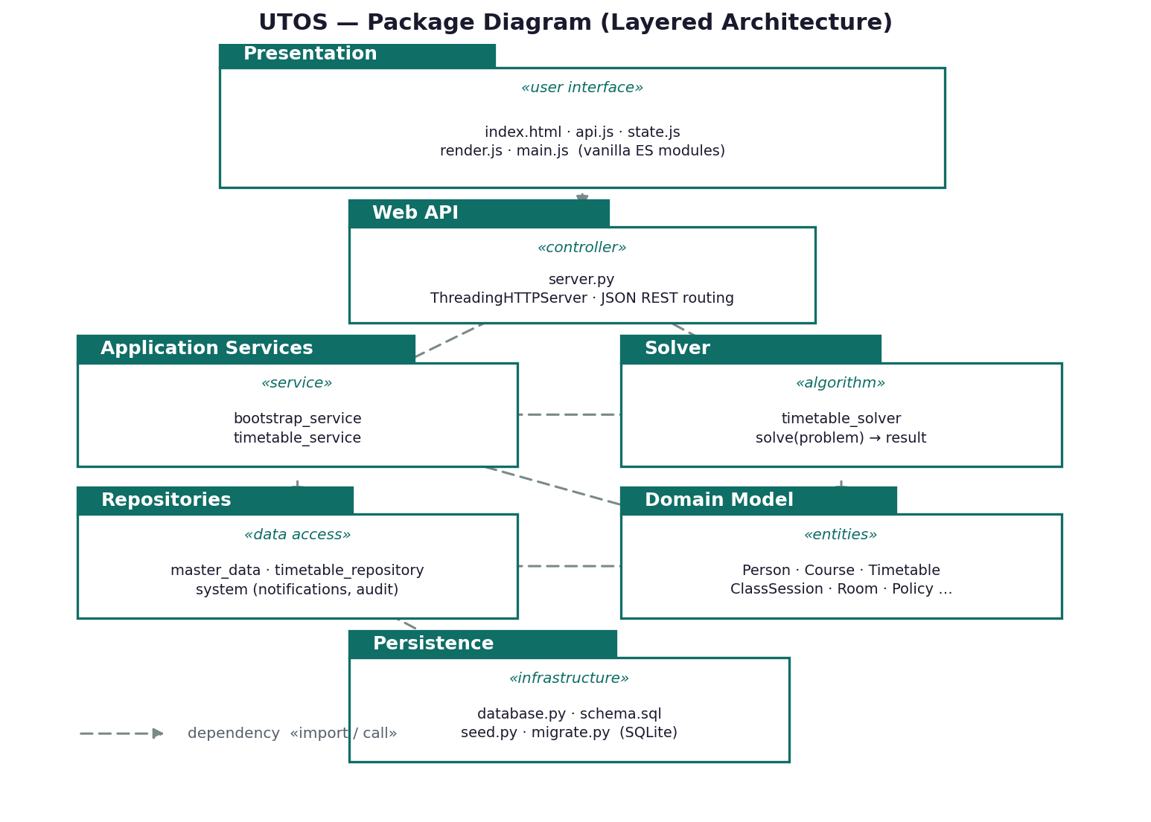
Figure P-1. UTOS package diagram — layered architecture with «import/call» dependencies.

CRC Cards
Each card lists a class, its responsibilities (what it knows and does), and its collaborators (the classes it must work with). The cards were derived from the domain model and the class diagram and were used to validate that responsibilities are well distributed before detailed design.

TimetableAdministrator «control / actor»
Responsibilities | Collaborators
• Generate, review, and publish official timetables  • Manage master data and lock fixed entries  • Approve, reject, and implement change requests | • Timetable  • TimetableService  • MasterData Repositories  • ChangeRequest

CourseOffering «entity»
Responsibilities | Collaborators
• Bind a Course to a Teacher, StudentSection, and AcademicTerm  • Know weekly session count and required room type  • Spawn the ClassSessions that must be scheduled | • Course  • Teacher  • StudentSection  • AcademicTerm  • ClassSession

Timetable «entity»
Responsibilities | Collaborators
• Hold all scheduled ClassSessions for a term  • Track status, score, hard conflicts, and soft penalty  • Support publish and export | • ClassSession  • TimetableVersion  • CourseOffering

ClassSession «entity»
Responsibilities | Collaborators
• Represent one placeable session of an offering  • Know its assigned Room and Timeslot and lock state  • Detect clashes with another session | • Room  • Timeslot  • CourseOffering  • Timetable

Timeslot «entity»
Responsibilities | Collaborators
• Define a weekly day + start/end time band  • Report duration and morning / last-slot flags | • ClassSession  • TeacherAvailability

Room «entity»
Responsibilities | Collaborators
• Know capacity, type, features, and building  • Report availability for a timeslot and utilization | • Building  • ClassSession

SchedulingPolicy «entity»
Responsibilities | Collaborators
• Hold hard constraints and weighted soft preferences  • Score a candidate placement and flag infeasibility | • Timetable  • ClassSession  • TimetableSolver

TeacherAvailability «entity»
Responsibilities | Collaborators
• Record whether a Teacher is free at a Timeslot | • Teacher  • Timeslot

ChangeRequest «entity»
Responsibilities | Collaborators
• Capture a requested change with reason and urgency  • Track status (pending/approved/rejected/implemented)  • Carry the coordinator recommendation note | • Teacher  • DepartmentCoordinator  • Timetable  • Notification

TimetableVersion «entity»
Responsibilities | Collaborators
• Snapshot a generated or repaired timetable  • Compute the diff (added/removed/changed) vs another version | • Timetable  • ClassSession

Notification «entity»
Responsibilities | Collaborators
• Deliver an event message to a recipient  • Track read/unread state | • Person  • ChangeRequest  • Timetable

AuditLog «entity»
Responsibilities | Collaborators
• Record every state-changing action  • Store actor, entity, and old/new values with a timestamp | • Person  • Repositories

TimetableService «control»
Responsibilities | Collaborators
• Build the solver problem and run the solver  • Persist the resulting version and reports  • Drive re-optimization preserving locked entries | • TimetableSolver  • TimetableRepository  • Timetable

TimetableSolver «control / algorithm»
Responsibilities | Collaborators
• Assign sessions to rooms and timeslots satisfying hard constraints  • Minimize weighted soft penalty  • Explain why each unplaced session could not be scheduled | • SchedulingPolicy  • ClassSession  • Room  • Timeslot

