Software Engineering
Assignment 05

Class Diagram
Classes, Attributes, Methods, and Multiplicities for UTOS

University Timetable Optimization & Management System (UTOS)
Project: Optimize Flow · Team Hakari Bankai

Submitted by
Muhammad Hammad Shakeel
Team Hakari Bankai
4th Semester · Spring 2026

Submitted to
Dr. Sajid Anwar

Assignment 05

Class Diagram for University Timetable Optimization and Management System
Project: UTOS
Instructor | Sajid Anwar
Submitted by | Muhammad Hammad Shakeel
Date | May 2026
Assignment | Develop a detailed class diagram: classes, attributes, methods, multiplicities

Class Catalogue
The table below lists every class with its layer, key attributes, and key methods.
Class | Layer | Key Attributes | Key Methods
Person | Role | name: String, email: String | login(), logout(), getProfile()
Teacher | Role | employeeNumber: String, maxDailyLoad: Integer | submitAvailability(), requestChange(), viewPersonalTimetable()
Student | Role | registrationNumber: String | viewTimetable(), viewExamSchedule()
TimetableAdministrator | Role | authorityLevel: Integer | generateTimetable(), publishTimetable(), approveChangeRequest(), exportTimetable()
DepartmentCoordinator | Role | responsibilityArea: String | reviewTimetable(), approveChangeReq(), validateDeptData()
FacilityManager | Role | responsibilityArea: String | manageRoom(), viewUtilization(), updateRoomStatus()
SystemAdministrator | Role | (inherits Person) | manageUsers(), assignRole(), viewAuditLogs(), configureSystem()
University | Academic | name: String, campusName: String | getFaculties(): List, getDepartments(): List
Faculty | Academic | name: String | getDepartments(): List, getCourses(): List

Department | Academic | name: String, code: String | getTeachers(), getSections(), getCourses(), getTimetables()
AcademicTerm | Academic | name: String, startDate: Date, endDate: Date | getTimeslots(), getHolidays(), isActive(): Boolean
Course | Academic | code: String, title: String, creditHours: Integer | getOfferings(): List, getDepartment(): Department
StudentSection | Academic | name, program, semester, batch, size: Integer | getStudents(): List, getOfferings(): List
CourseOffering | Scheduling | weeklySessions: Integer, requiredRoomType: String, sessionDuration: Integer | getSessions(), getTeacher(), getSection(), getTerm()
Timetable | Scheduling | name, status: TimetableStatus, qualityScore: Float, hardConflictCount: Integer, unplacedSessionCount: Integer, createdAt: DateTime | generate(), publish(), getConflicts(), getQualityReport(), compareTo(), export(format)
ClassSession | Scheduling | sessionNumber: Integer, status: SessionStatus, locked: Boolean | assignRoom(room), assignTimeslot(ts), lock(), unlock(), getConflicts()
Timeslot | Scheduling | day: DayOfWeek, startTime: Time, endTime: Time, isMorning: Boolean, isLastSlot: Boolean | getDuration(): Integer, clashesWith(other): Boolean
TeacherAvailability | Scheduling | isAvailable: Boolean, note: String | getTimeslot(): Timeslot, getTeacher(): Teacher
SchedulingPolicy | Scheduling | name, policyType, priority: Integer, weight: Float, isHardConstraint: Boolean, isEnabled: Boolean | apply(session): Boolean, getPenalty(session): Float, validate(): Boolean
ChangeRequest | Scheduling | requestType, reason, urgency, status: RequestStatus, createdAt: DateTime | approve(note), reject(note), getSubmitter(): Person
Holiday | Scheduling | name: String, date: Date, reason: String | isOnDate(d: Date): Boolean
Building | Facility | name: String, location: String | getRooms(): List, getRoomCount(): Integer
Room | Facility | code, floor: Integer, capacity: Integer, roomType: RoomType, maintenanceStatus: Boolean | isAvailable(timeslot): Boolean, getUtilization(): Float
TimetableVersion | System | versionNumber: Integer, createdAt: DateTime, changeSummary: String | compareTo(other): VersionDiff, getChangedEntries(): List

Notification | System | message: String, notificationType, createdAt: DateTime, read: Boolean | markRead(), getRecipient(): Person
AuditLog | System | entityType, action, oldValue, newValue: String, timestamp: DateTime, performedBy: String | getActor(): Person

Relationships and Multiplicity
The following table documents every relationship in the class diagram with its type and multiplicity.
Relationship | Type | Multiplicity | Notes
Person → Teacher, Student, TimetableAdministrator, DeptCoordinator, FacilityManager, SystemAdministrator | Inheritance | 1:1 (IS-A) | Person is abstract base; login/logout common to all
University → Faculty | Association | 1 to 1..* | University has at least one Faculty
Faculty → Department | Association | 1 to 1..* | Faculty has at least one Department
Department → Teacher | Association | 1 to 0..* | Department employs zero or more Teachers
Department →  StudentSection | Association | 1 to 0..* | Sections belong to one Department
Department → Course | Association | 1 to 0..* | Department owns courses it offers
Department →  Timetable | Association | 1 to 0..* | Department has its own timetables per term
AcademicTerm →  CourseOffering | Association | 1 to 0..* | Offerings are scoped to a term
AcademicTerm →  Timeslot | Association | 1 to 1..* | Term defines its available timeslots
AcademicTerm →  Holiday | Association | 1 to 0..* | Term may have zero or more holidays
AcademicTerm →  Timetable | Association | 1 to 0..* | Multiple timetable drafts per term allowed
Course →  CourseOffering | Association | 1 to 0..* | Course description reused across offerings
Teacher →  CourseOffering | Association | 1 to 0..* | Teacher may be assigned to multiple offerings
StudentSection →  CourseOffering | Association | 1 to 0..* | Section attends multiple course offerings

StudentSection →  Student | Association | 1 to 0..* | Section contains enrolled students
Teacher →  TeacherAvailability | Association | 1 to 0..* | Teacher may declare availability for many timeslots
TeacherAvailability →  Timeslot | Association | 1 to 1 | Each availability record covers exactly one timeslot
Timetable →  ClassSession | Composition | 1 to 0..* | Sessions exist only within a timetable
CourseOffering →  ClassSession | Association | 1 to 1..* | At least one session per offering per week
ClassSession →  Timeslot | Association | 1 to 0..1 | 0..1 allows unplaced sessions without a timeslot
ClassSession → Room | Association | 1 to 0..1 | 0..1 allows unplaced sessions without a room
Timetable →  SchedulingPolicy | Association | 1 to 0..* | Timetable is guided by active policies
Timetable →  TimetableVersion | Association | 1 to 1..* | Every saved timetable has at least one version
Building → Room | Composition | 1 to 1..* | Rooms exist inside a building
FacilityManager →  Room | Association | 1 to 0..* | Manager is responsible for rooms
Person →  ChangeRequest | Association | 1 to 0..* | Any person can submit change requests
DeptCoordinator →  ChangeRequest | Dependency | 1 to 0..* | Coordinator reviews requests (behavioral coupling)
Timetable → Notification | Dependency | 1 to 0..* | Publish/change events trigger notifications
TimetableAdministrator  → AuditLog | Dependency | 1 to 0..* | Admin actions are recorded in audit log

Enumerations
The following enumerations are used as attribute types throughout the class diagram.
Enumeration | Values
TimetableStatus | DRAFT, UNDER_REVIEW, PUBLISHED, ARCHIVED, REGENERATING
SessionStatus | PLACED, UNPLACED, LOCKED
RoomType | LECTURE_HALL, SEMINAR_ROOM, LAB, EXAM_ROOM, AMPHITHEATER
RequestStatus | PENDING, UNDER_REVIEW, APPROVED, REJECTED, WITHDRAWN
UrgencyLevel | LOW, MEDIUM, HIGH, CRITICAL
PolicyType | HARD_CONSTRAINT, SOFT_PREFERENCE

Key Design Decisions
Decision | Rationale
Person as abstract base | Centralises identity (name, email, login/logout) and avoids duplication across six actor types. All role-specific classes simply extend Person.
ClassSession 0..1 to Room and Timeslot | Allows unplaced sessions to exist as valid objects inside a draft timetable, supporting partial generation and conflict reporting.
CourseOffering separate from Course | Course is a reusable description; CourseOffering ties it to a specific term, teacher, and section. Same course can be offered multiple times across terms without duplication.
Timetable composes ClassSession | ClassSession only makes sense inside a Timetable. Composition signals that sessions are deleted if the timetable is removed.
TimetableVersion as separate class | Supports UC15 (Compare Timetable Versions) and provides an audit trail for timetable changes over time.
AuditLog as standalone class | Decouples logging from domain classes. Any entity change can be logged without modifying the entity itself.
SchedulingPolicy carries weight and isHardConstraint | Unifies hard and soft constraint configuration into one class, matching the constraint screen in the UI. isHardConstraint determines enforcement vs. penalisation.
Enumerations over raw Strings | TimetableStatus, SessionStatus, RoomType etc. prevent invalid attribute values and make the design implementation-ready.

Class Diagram
The full interactive class diagram is included in the interactive HTML submission and in the figure below. It is organised in six horizontal bands:
Roles and people — Person hierarchy at the top
Academic structure — University, Faculty, Department, AcademicTerm, Course, StudentSection
Scheduling core — CourseOffering, Timetable, ClassSession, Timeslot, TeacherAvailability
Policy and constraints — SchedulingPolicy, Holiday
Facility — Building, Room
System-wide — ChangeRequest, Notification, TimetableVersion, AuditLog, enumerations
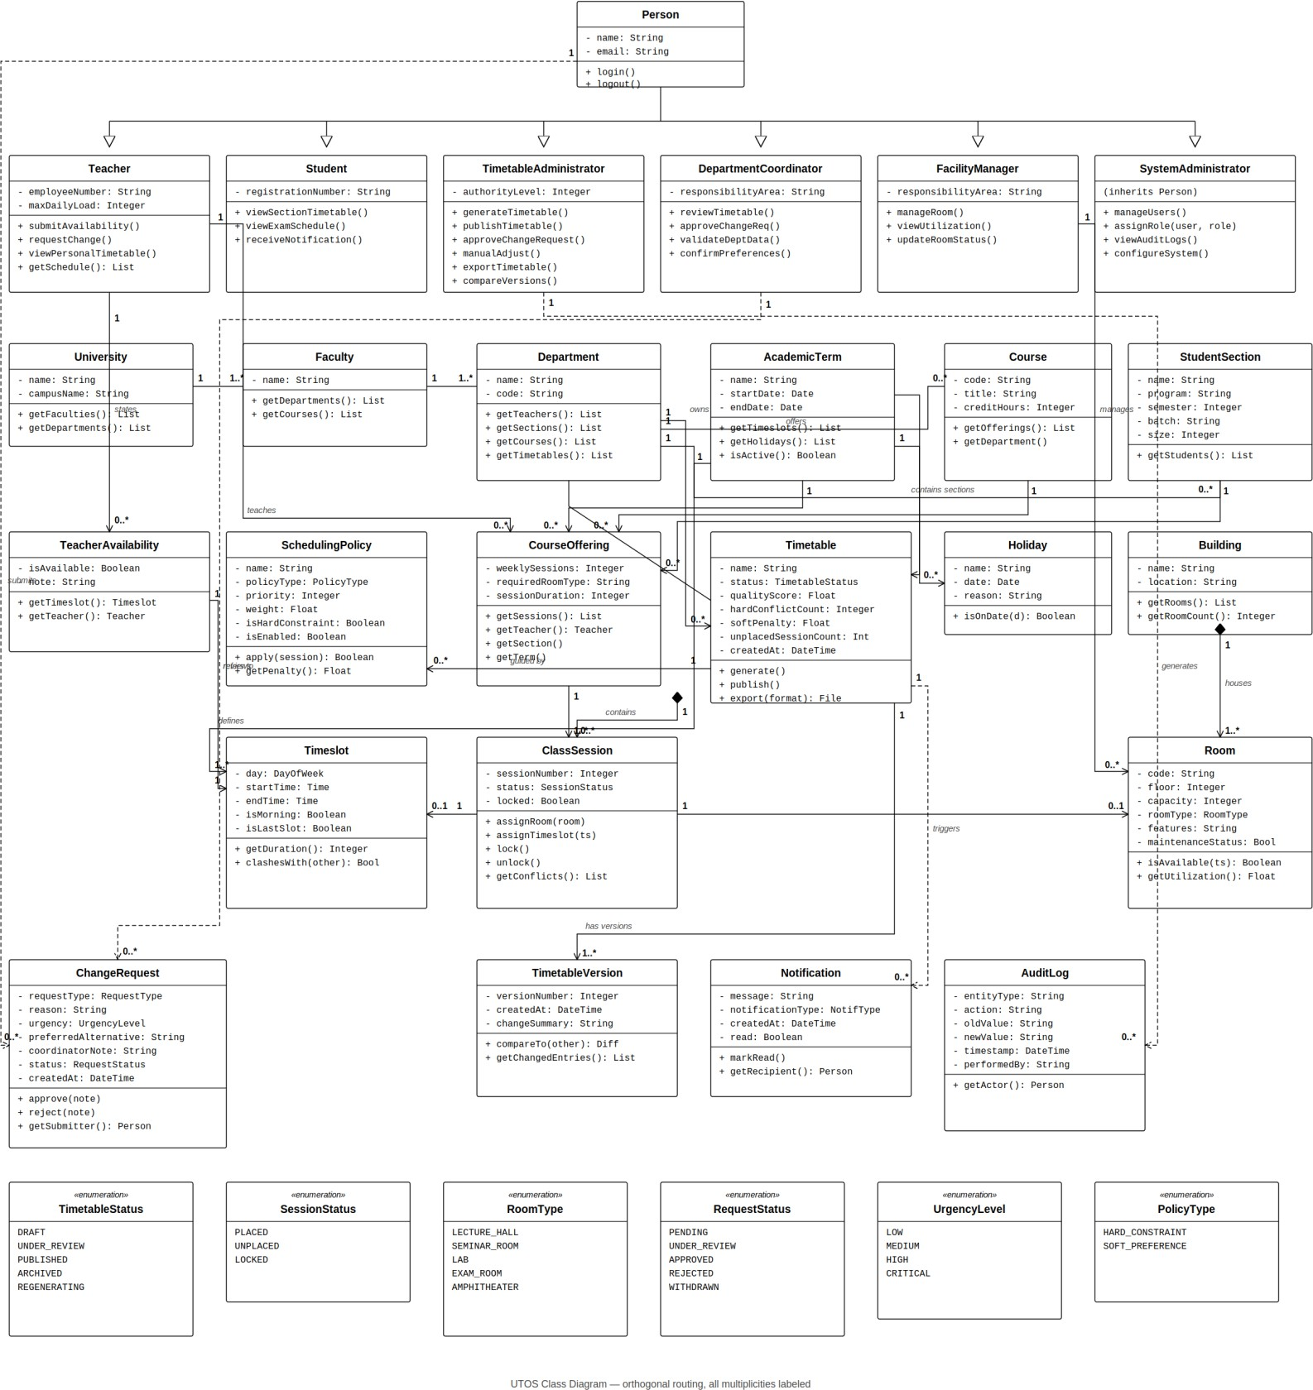
Figure 1. UTOS class diagram (all multiplicities labelled).

