Software Engineering
Assignment 06

System Sequence Diagrams
SSDs for the Essential Expanded Use Cases of UTOS (UC00–UC22)

University Timetable Optimization & Management System (UTOS)
Project: Optimize Flow · Team Hakari Bankai

Submitted by
Muhammad Hammad Shakeel
Team Hakari Bankai
4th Semester · Spring 2026

Submitted to
Dr. Sajid Anwar

Introduction
This document presents the System Sequence Diagrams (SSDs) for all 23 use cases identified in the UTOS Use Case Analysis. Each SSD illustrates the interactions between external actors and the UTOS system boundary for the main success scenario of each use case, derived from the uploaded generator metadata and organized in the same UC00–UC22 sequence.

Notation Key
- Solid arrow → System operation message (initiator → system)
- Dashed arrow ⇢ System response / return value
- Vertical dashed line = Actor / object lifeline
- Stick figure = Human actor / user role
- Named box = System or subsystem actor

Use Case Index
# | Use Case | # | Use Case
UC00 | UC00 — Authenticate and Login [System-wide] | UC12 | UC12 — View Personal or Section Timetable [Class Timetabling]
UC01 | UC01 — Maintain Organization Hierarchy [System-wide] | UC13 | UC13 — Export Class Timetable [System-wide]
UC02 | UC02 — Maintain Academic Calendar [Class Timetabling] | UC14 | UC14 — Manage Notifications [System-wide]
UC03 | UC03 — Manage Master Data [Class Timetabling] | UC15 | UC15 — Compare Timetable Versions [System-wide]
UC04 | UC04 — Define Constraints and Preferences [Class Timetabling] | UC16 | UC16 — Manage Exam Rooms [Exam Timetabling]
UC05 | UC05 — Generate Class Timetable [Class Timetabling] | UC17 | UC17 — Manage Student Hierarchy [Exam Timetabling]
UC06 | UC06 — Review Timetable Quality [Class Timetabling] | UC18 | UC18 — Manage Exam Courses [Exam Timetabling]
UC07 | UC07 — Manually Adjust and Lock Timetable [Class Timetabling] | UC19 | UC19 — Schedule Exams [Exam Timetabling]
UC08 | UC08 — Submit Change Request [Class Timetabling] | UC20 | UC20 — View Exam Schedule and Invigilation Duties [Exam Timetabling]
UC09 | UC09 — Approve or Reject Change Request [Class Timetabling] | UC21 | UC21 — Manage Users and Roles [Administration]
UC10 | UC10 — Re-optimize Timetable [Class Timetabling] | UC22 | UC22 — View System Reports and Audit Logs [Administration]
UC11 | UC11 — Publish Timetable [Class Timetabling]

UC00 — Authenticate and Login
Module: System-wide | Actors: All users, System Administrator | Type: Primary
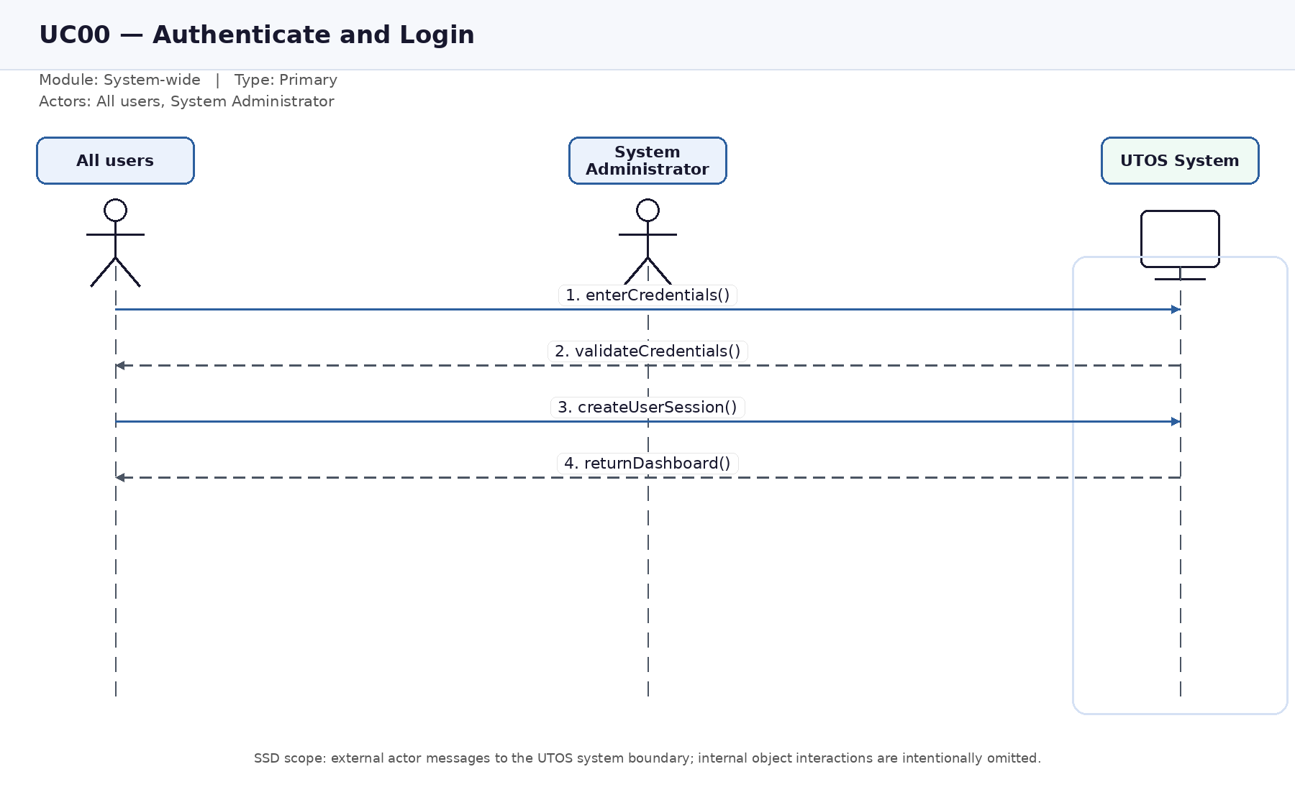
Figure UC00. System sequence diagram for Authenticate and Login.

UC01 — Maintain Organization Hierarchy
Module: System-wide | Actors: Timetable Administrator | Type: Primary
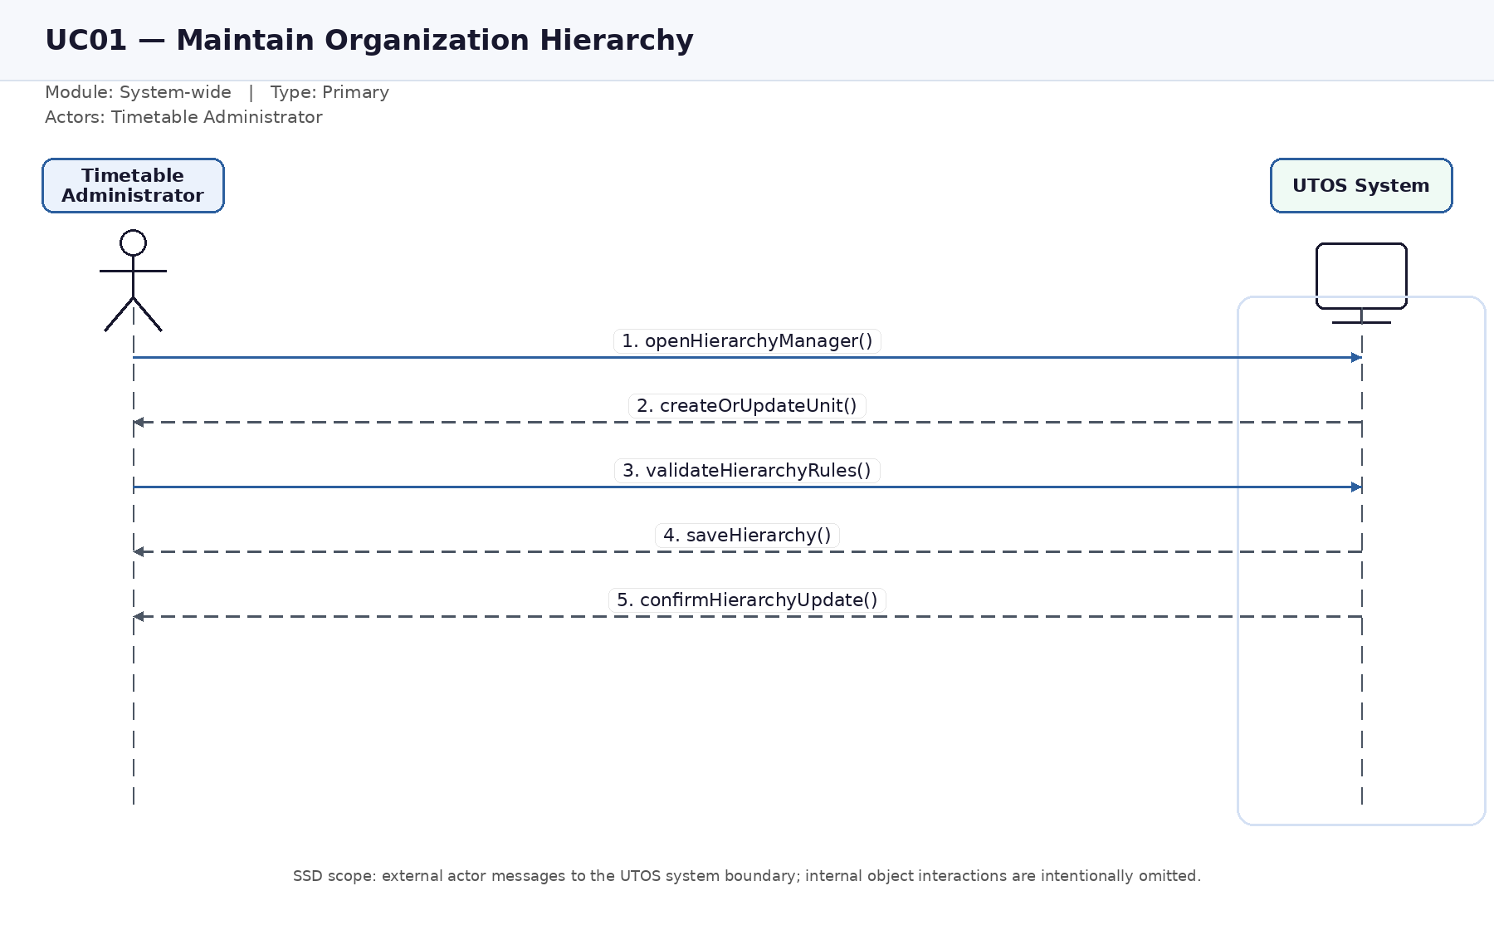
Figure UC01. System sequence diagram for Maintain Organization Hierarchy.

UC02 — Maintain Academic Calendar
Module: Class Timetabling | Actors: Timetable Administrator | Type: Primary
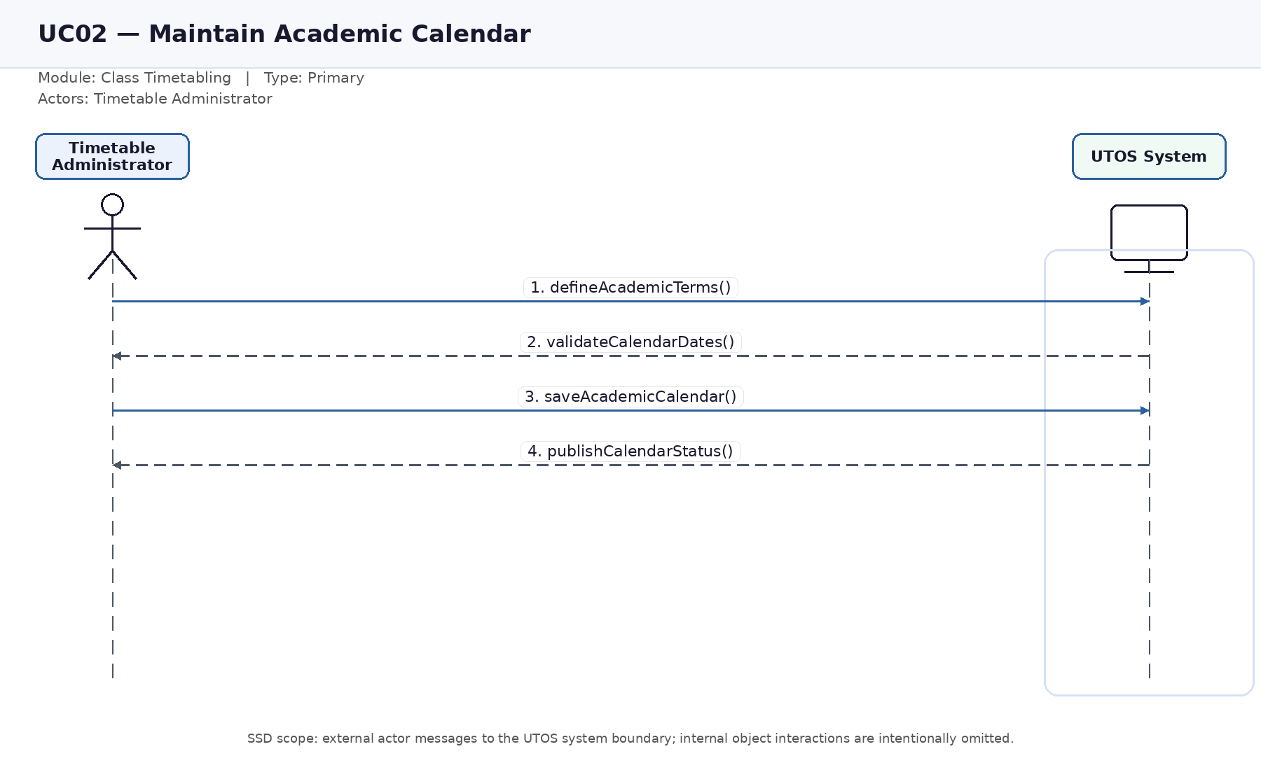
Figure UC02. System sequence diagram for Maintain Academic Calendar.

UC03 — Manage Master Data
Module: Class Timetabling | Actors: Timetable Administrator, Department Coordinator, Facility Manager | Type: Primary
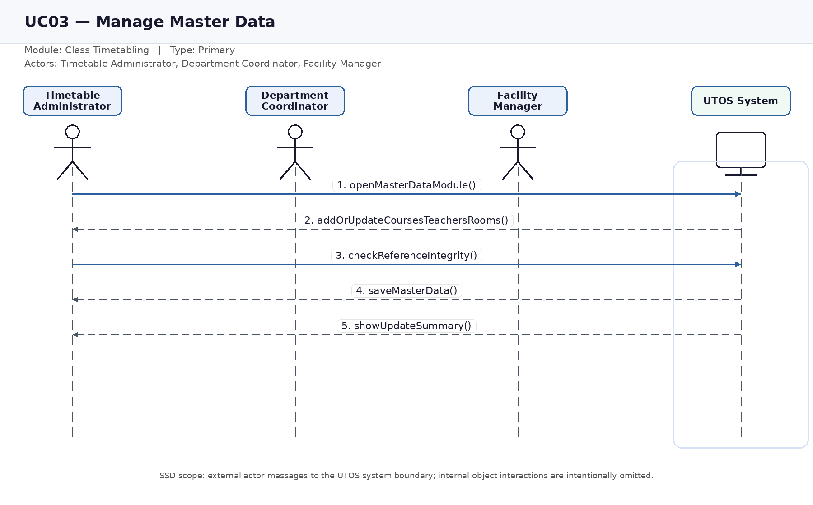
Figure UC03. System sequence diagram for Manage Master Data.

UC04 — Define Constraints and Preferences
Module: Class Timetabling | Actors: Timetable Administrator, Department Coordinator, Teacher | Type: Primary
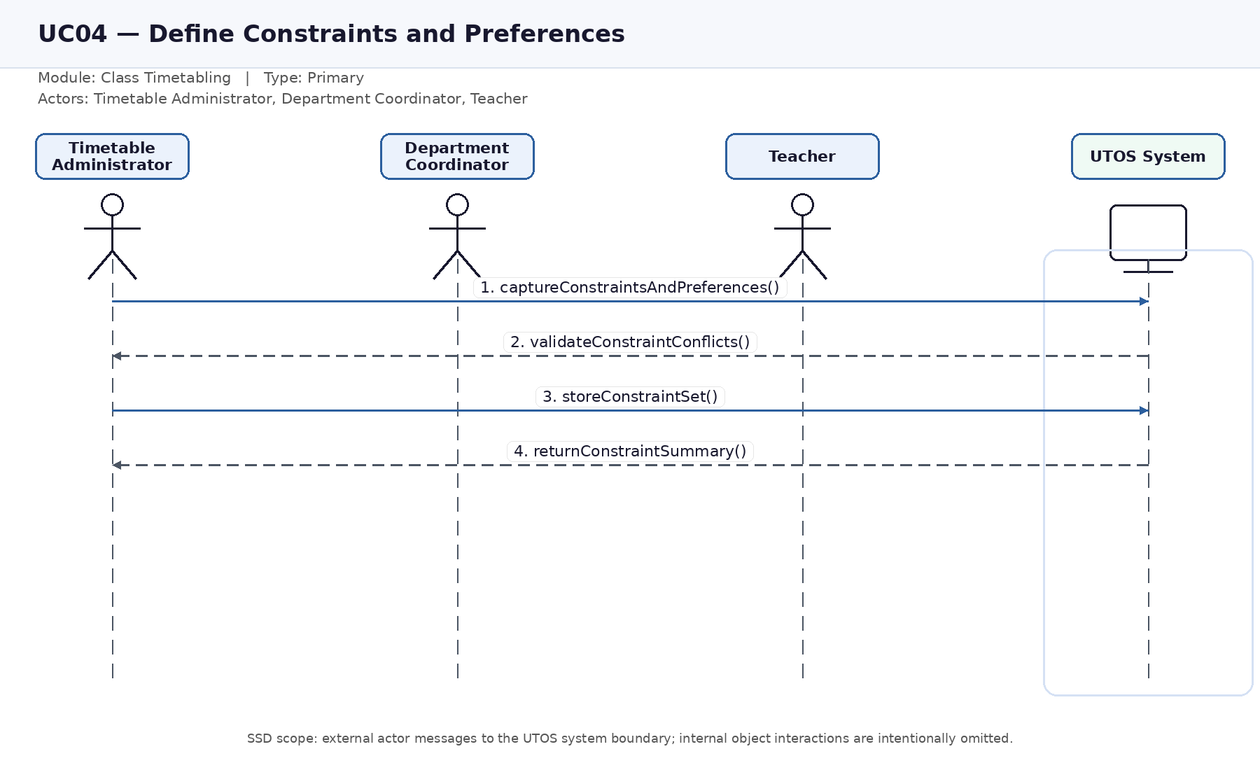
Figure UC04. System sequence diagram for Define Constraints and Preferences.

UC05 — Generate Class Timetable
Module: Class Timetabling | Actors: Timetable Administrator, Solver Engine | Type: Primary
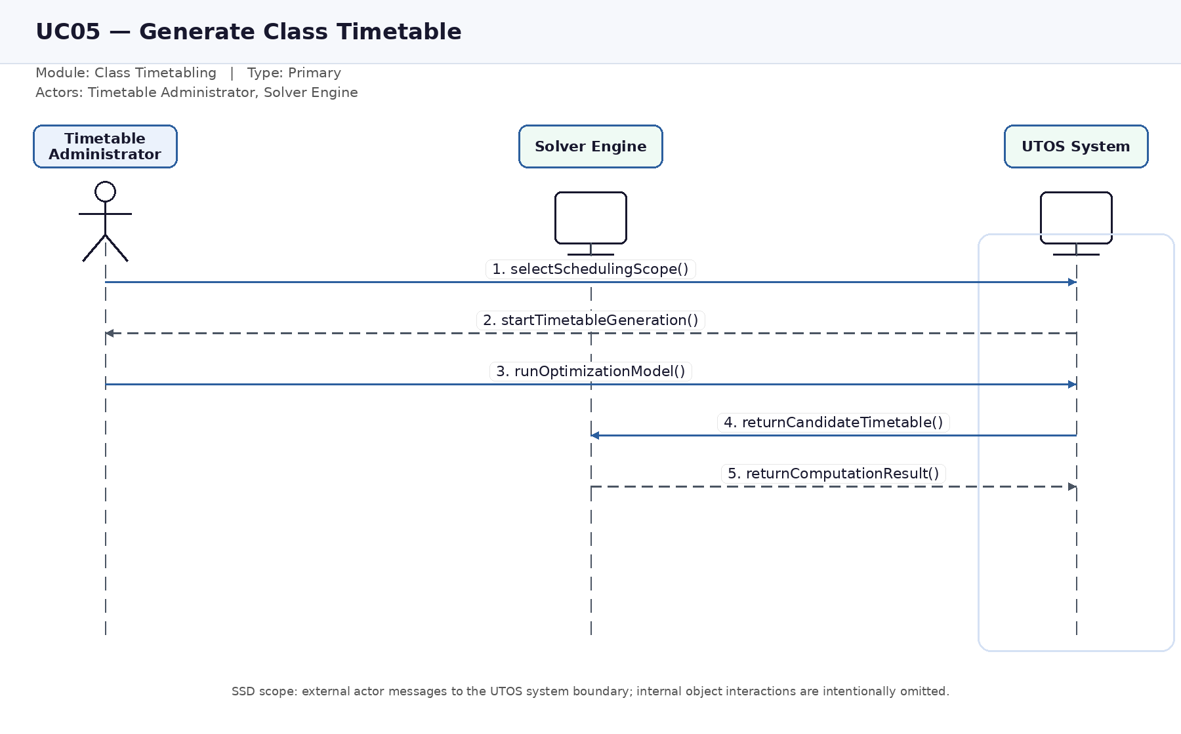
Figure UC05. System sequence diagram for Generate Class Timetable.

UC06 — Review Timetable Quality
Module: Class Timetabling | Actors: Timetable Administrator, Department Coordinator, Facility Manager | Type: Primary
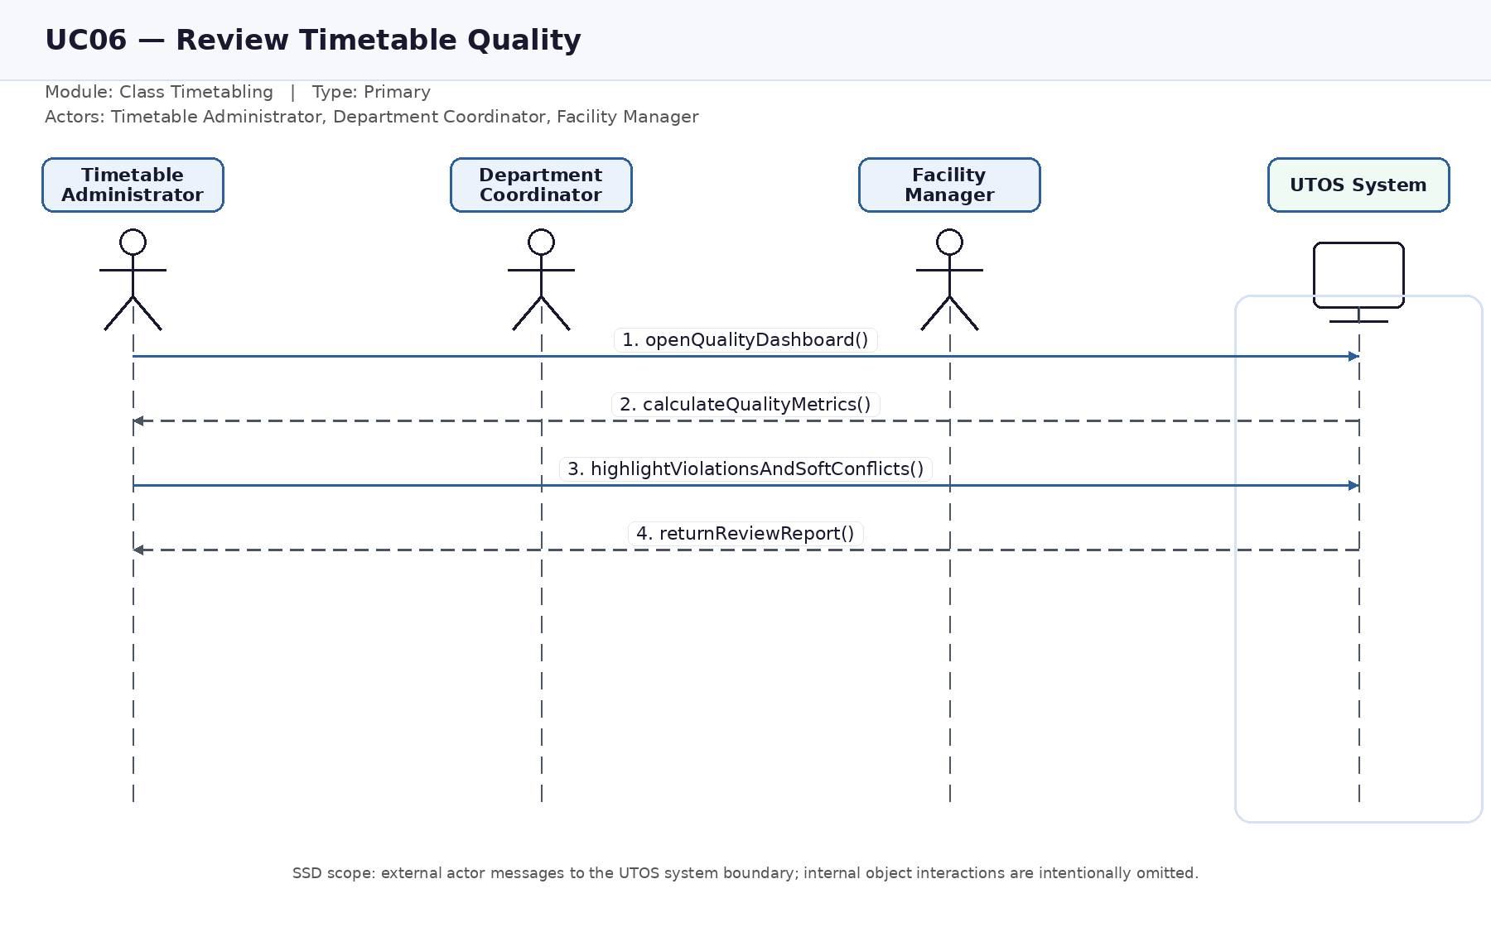
Figure UC06. System sequence diagram for Review Timetable Quality.

UC07 — Manually Adjust and Lock Timetable
Module: Class Timetabling | Actors: Timetable Administrator, Department Coordinator | Type: Primary
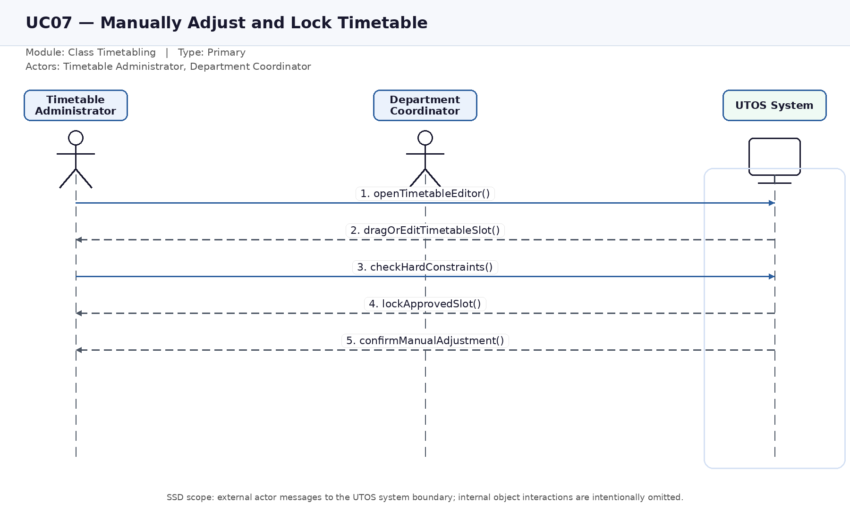
Figure UC07. System sequence diagram for Manually Adjust and Lock Timetable.

UC08 — Submit Change Request
Module: Class Timetabling | Actors: Teacher, Department Coordinator | Type: Primary
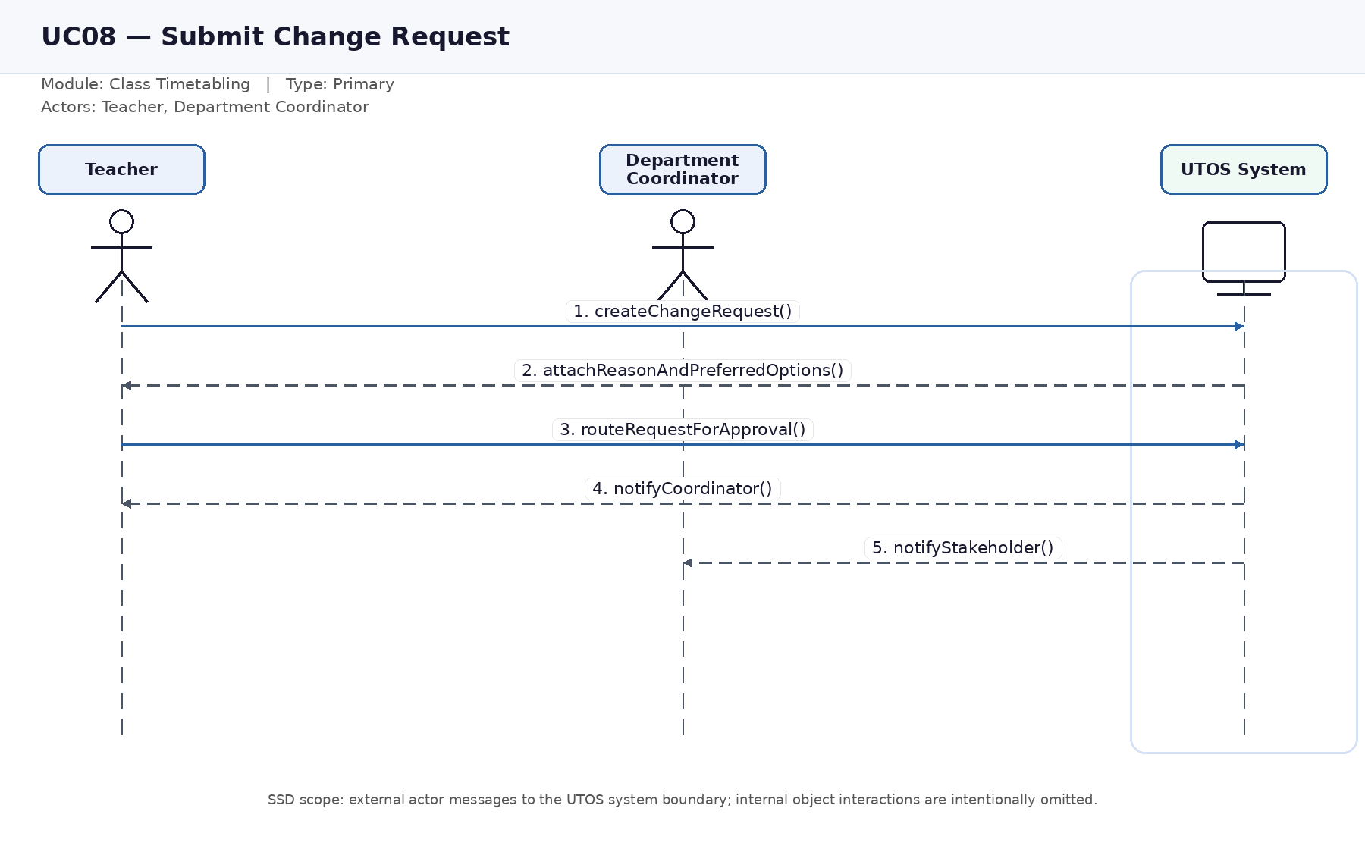
Figure UC08. System sequence diagram for Submit Change Request.

UC09 — Approve or Reject Change Request
Module: Class Timetabling | Actors: Department Coordinator, Timetable Administrator, Teacher | Type: Primary
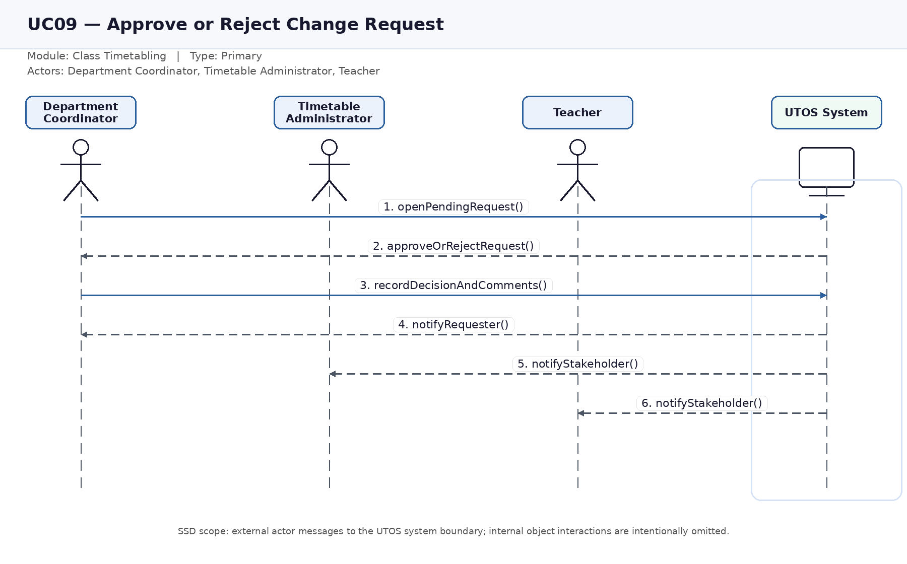
Figure UC09. System sequence diagram for Approve or Reject Change Request.

UC10 — Re-optimize Timetable
Module: Class Timetabling | Actors: Timetable Administrator, Solver Engine | Type: Primary
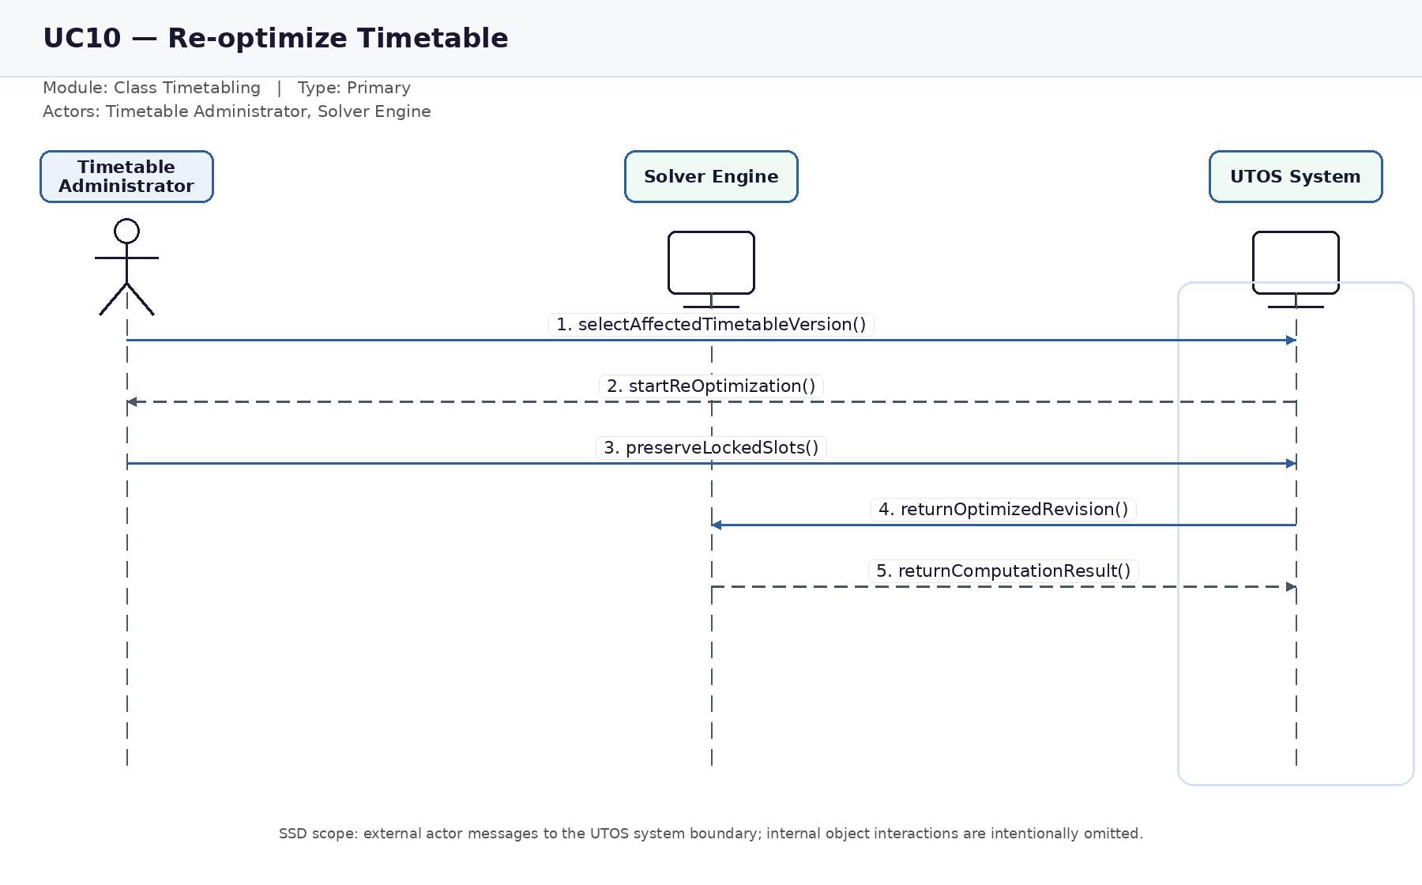
Figure UC10. System sequence diagram for Re-optimize Timetable.

UC11 — Publish Timetable
Module: Class Timetabling | Actors: Timetable Administrator, Department Coordinator, Teacher, Student | Type: Primary
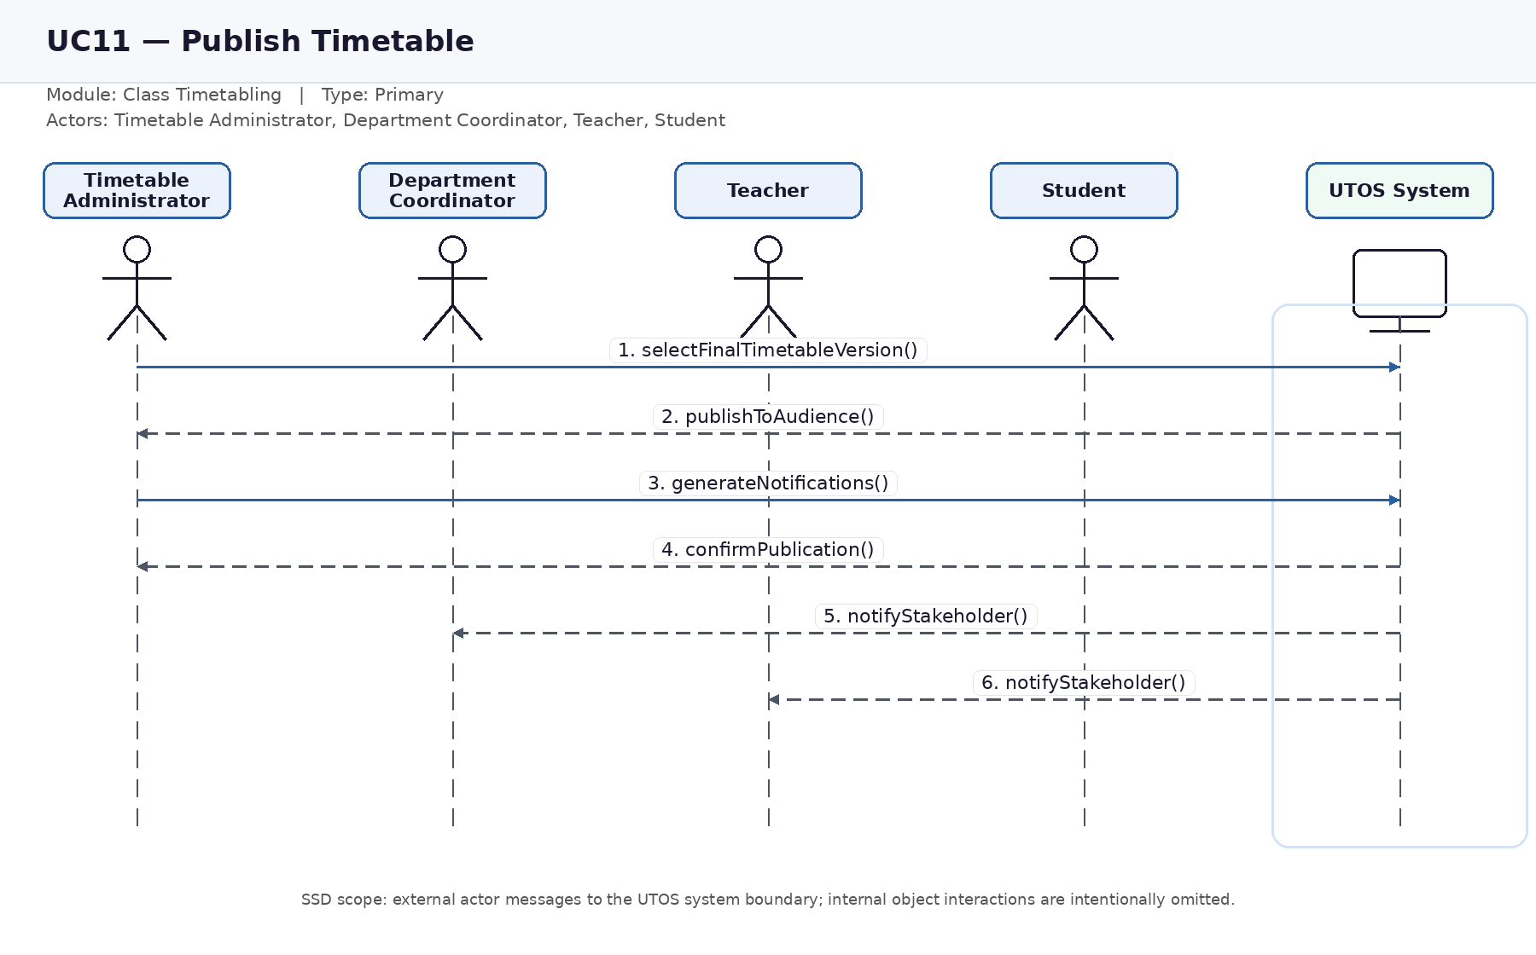
Figure UC11. System sequence diagram for Publish Timetable.

UC12 — View Personal or Section Timetable
Module: Class Timetabling | Actors: Teacher, Student | Type: Primary
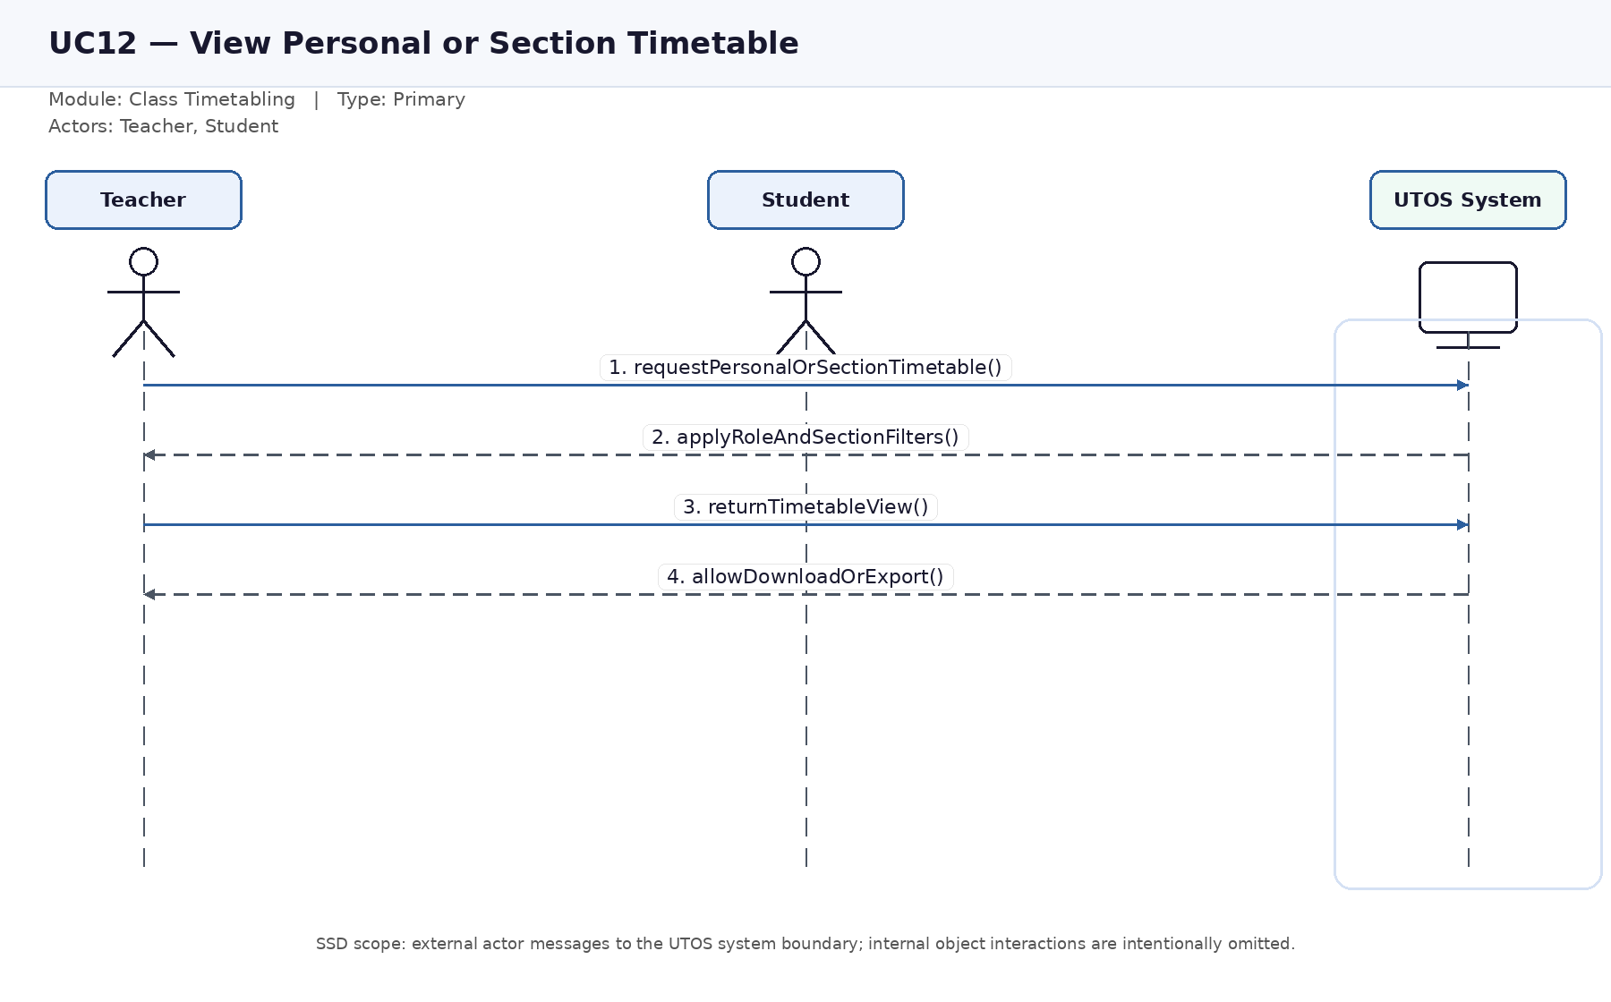
Figure UC12. System sequence diagram for View Personal or Section Timetable.

UC13 — Export Class Timetable
Module: System-wide | Actors: Timetable Administrator, Teacher, Student | Type: Secondary
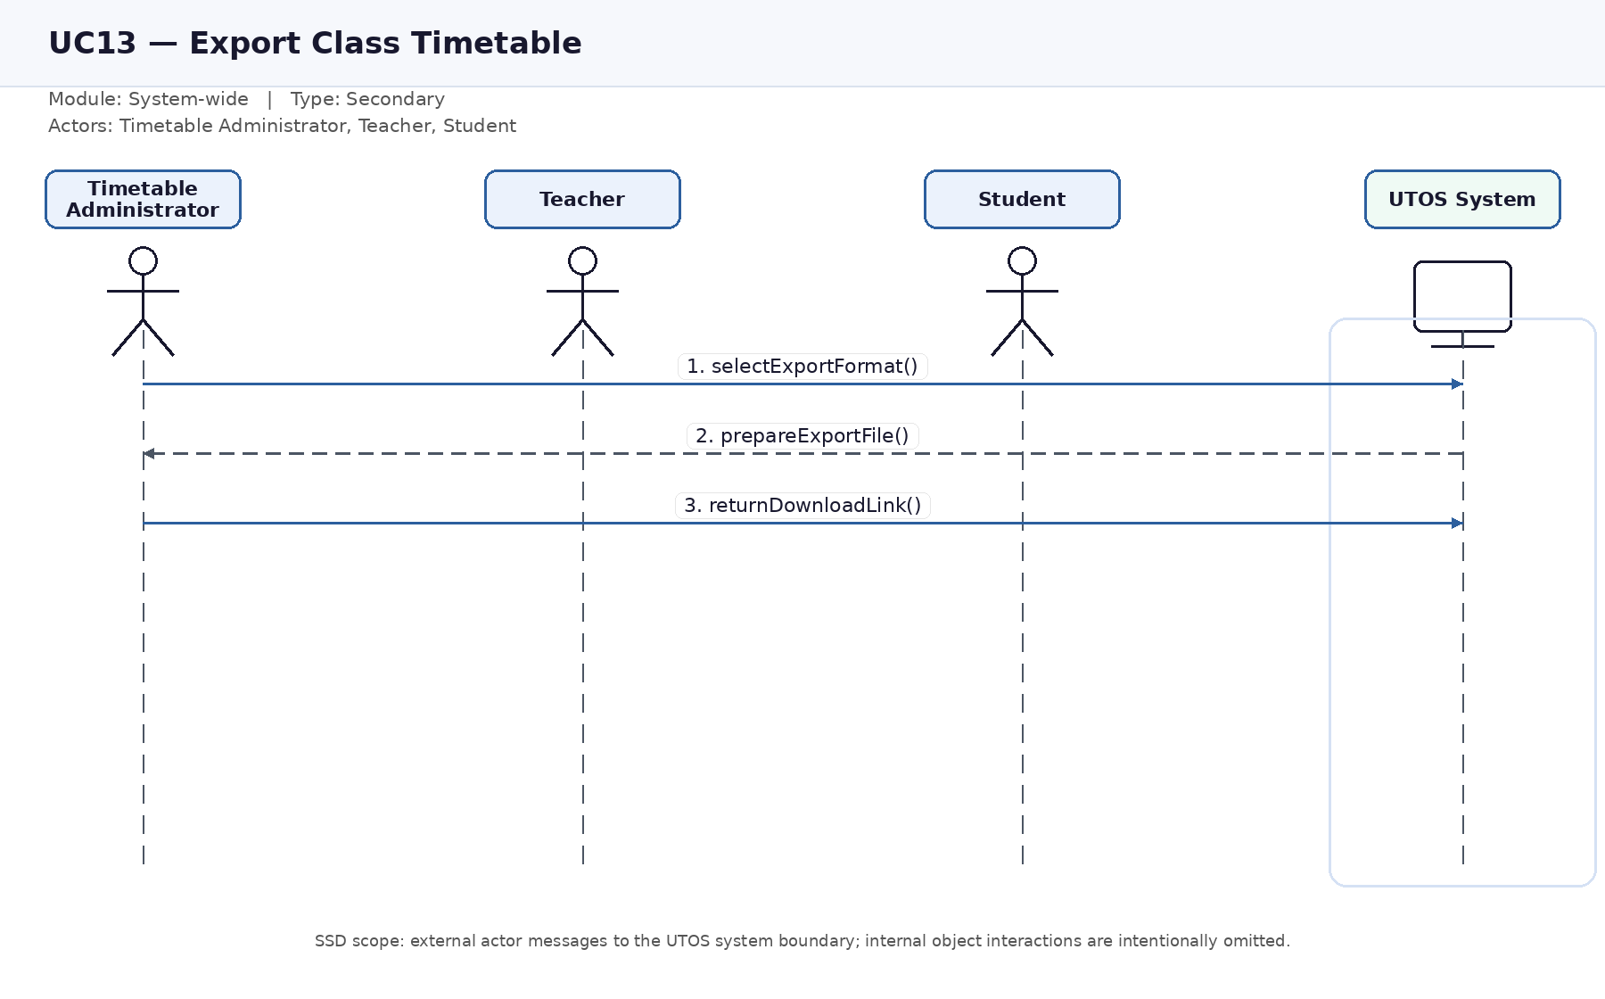
Figure UC13. System sequence diagram for Export Class Timetable.

UC14 — Manage Notifications
Module: System-wide | Actors: All users, System | Type: Secondary
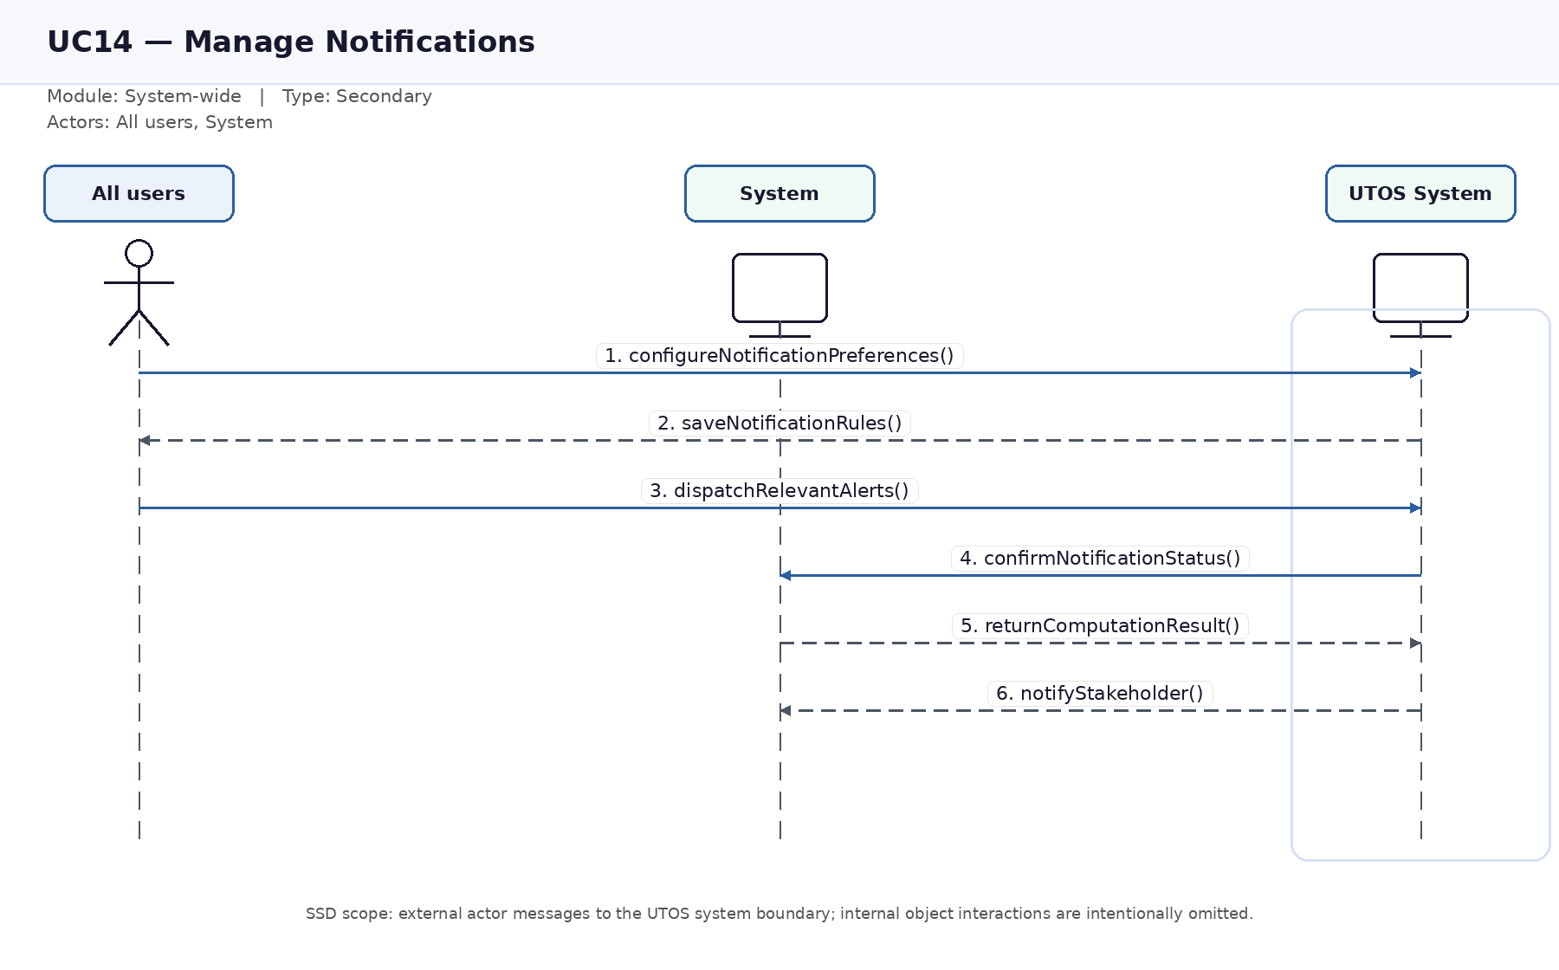
Figure UC14. System sequence diagram for Manage Notifications.

UC15 — Compare Timetable Versions
Module: System-wide | Actors: Timetable Administrator, Department Coordinator | Type: Secondary
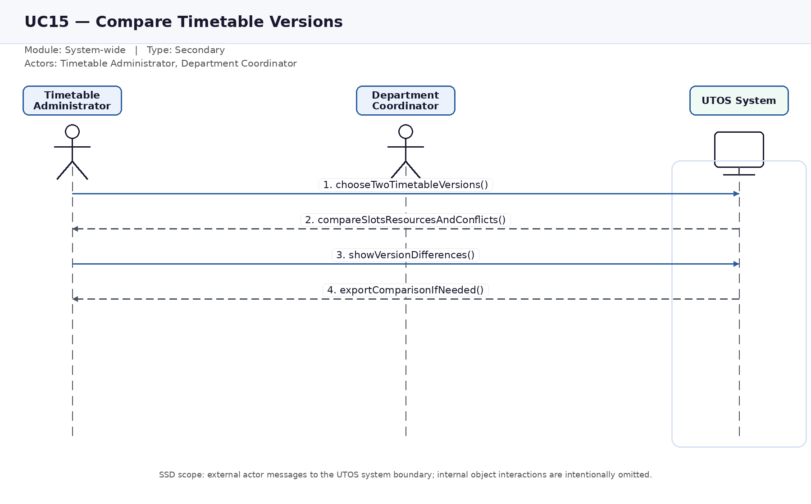
Figure UC15. System sequence diagram for Compare Timetable Versions.

UC16 — Manage Exam Rooms
Module: Exam Timetabling | Actors: Timetable Administrator, Facility Manager | Type: Primary
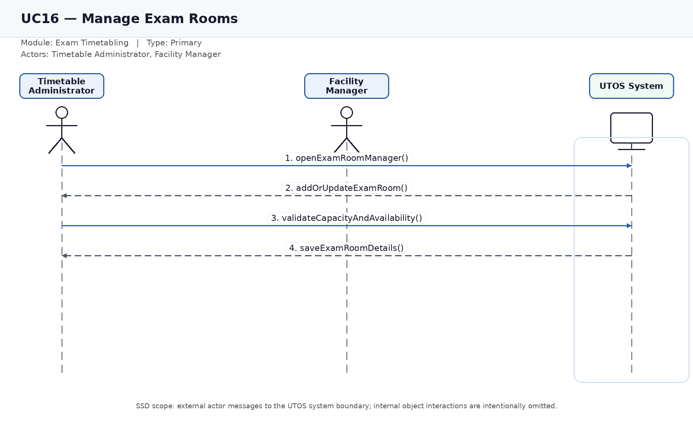
Figure UC16. System sequence diagram for Manage Exam Rooms.

UC17 — Manage Student Hierarchy
Module: Exam Timetabling | Actors: Timetable Administrator | Type: Primary
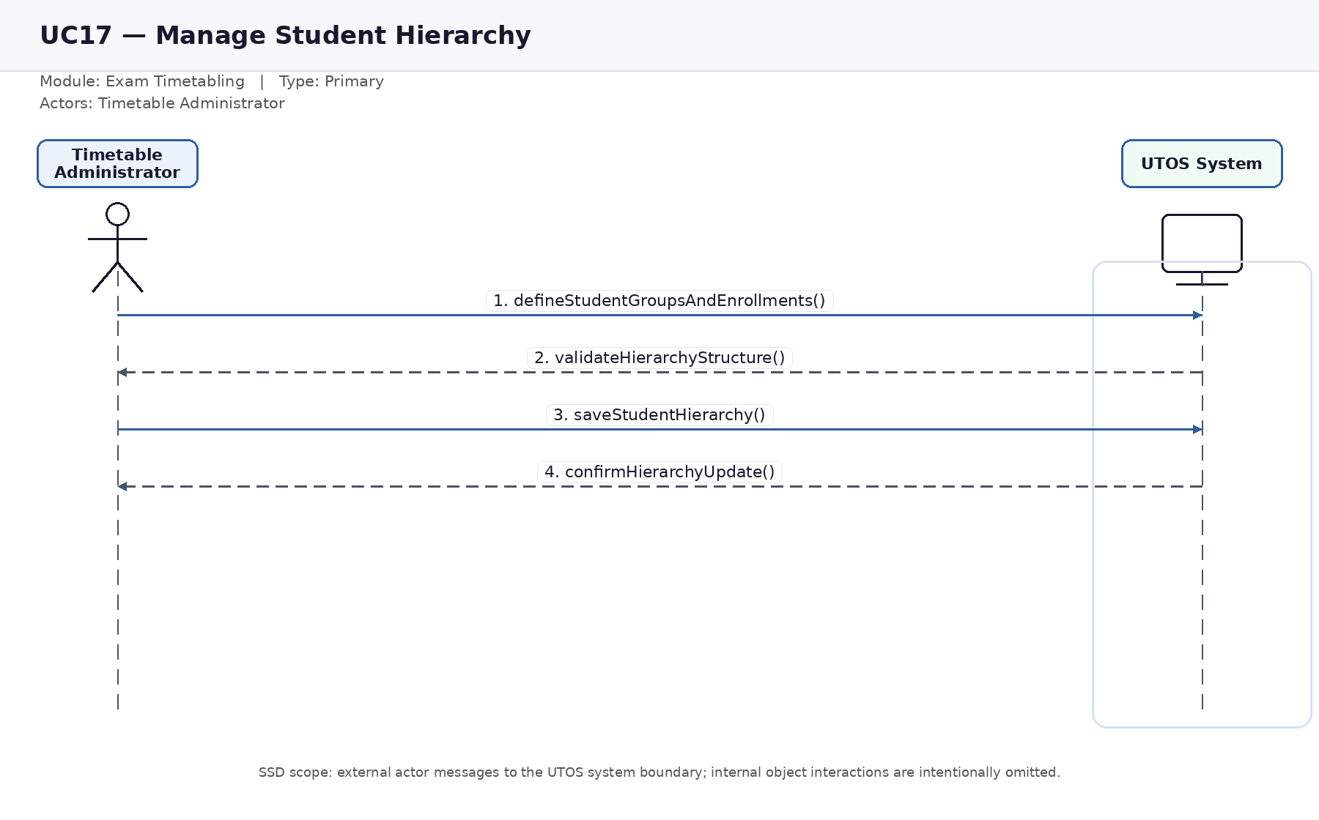
Figure UC17. System sequence diagram for Manage Student Hierarchy.

UC18 — Manage Exam Courses
Module: Exam Timetabling | Actors: Timetable Administrator | Type: Primary
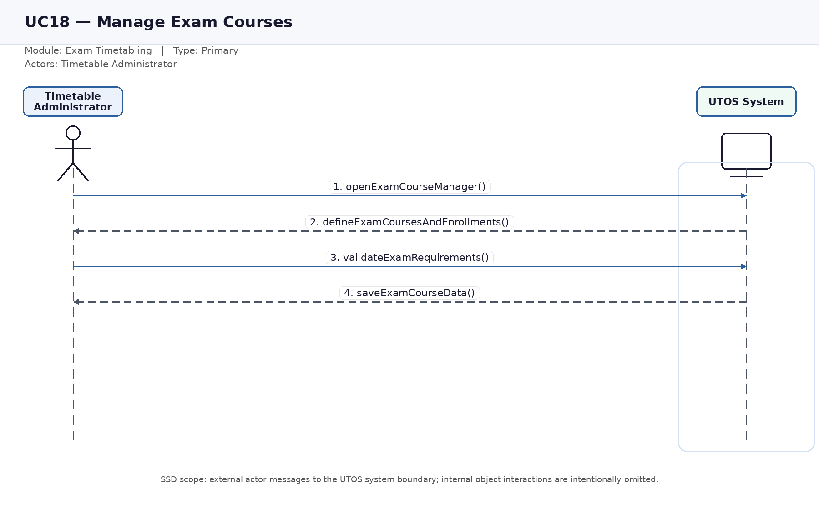
Figure UC18. System sequence diagram for Manage Exam Courses.

UC19 — Schedule Exams
Module: Exam Timetabling | Actors: Timetable Administrator, Student, Teacher, Facility Manager | Type: Primary
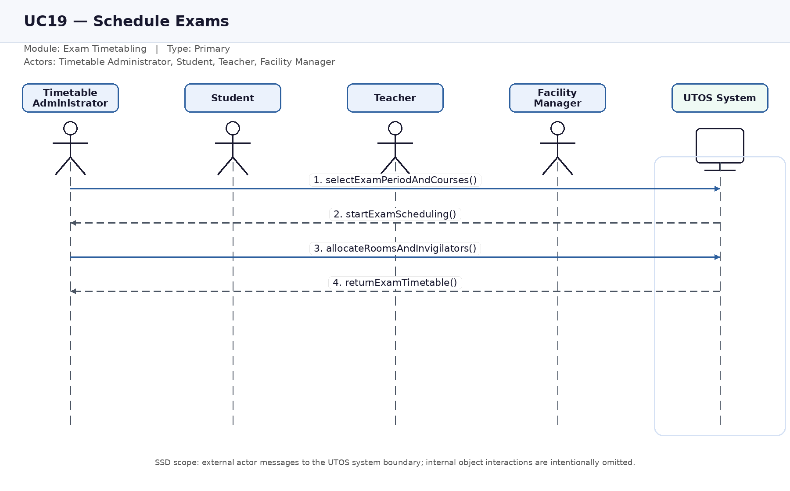
Figure UC19. System sequence diagram for Schedule Exams.

UC20 — View Exam Schedule and Invigilation Duties
Module: Exam Timetabling | Actors: Student, Teacher, Facility Manager | Type: Secondary
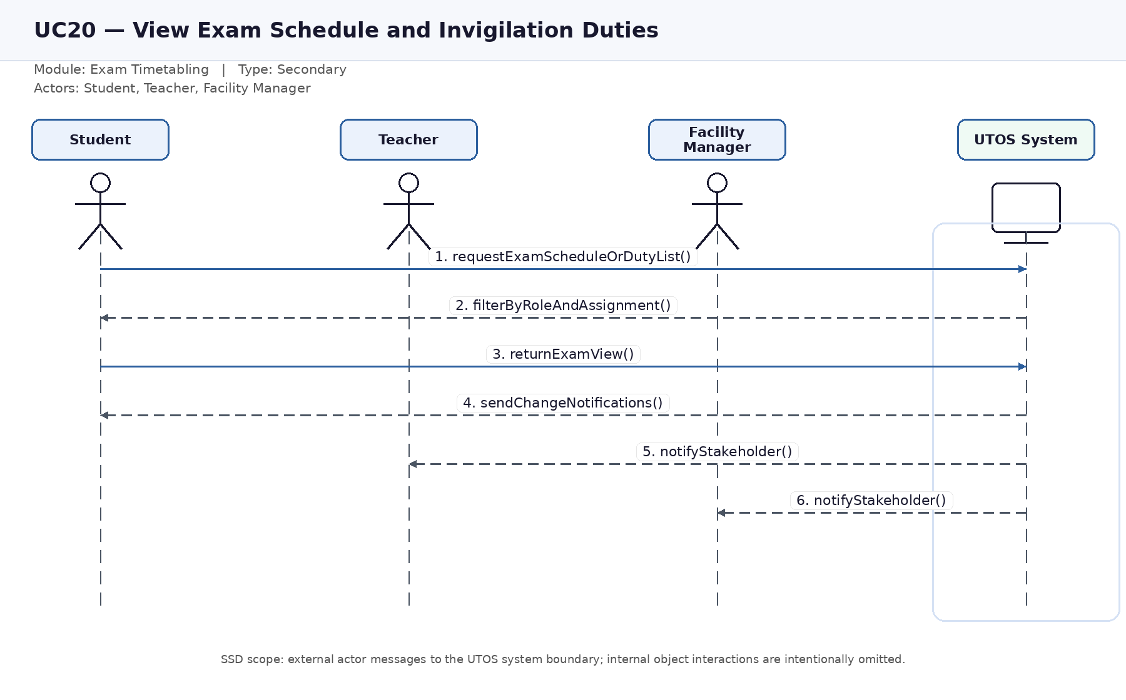
Figure UC20. System sequence diagram for View Exam Schedule and Invigilation Duties.

UC21 — Manage Users and Roles
Module: Administration | Actors: System Administrator | Type: Primary
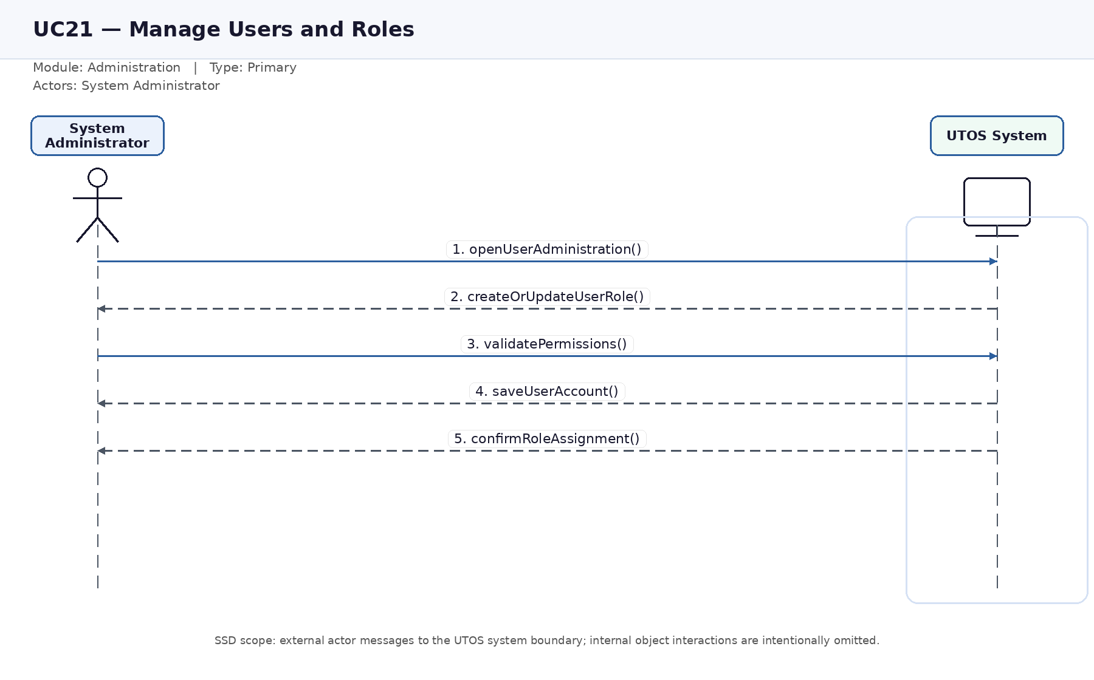
Figure UC21. System sequence diagram for Manage Users and Roles.

UC22 — View System Reports and Audit Logs
Module: Administration | Actors: Timetable Administrator, Facility Manager, System Administrator, Department Coordinator | Type: Secondary
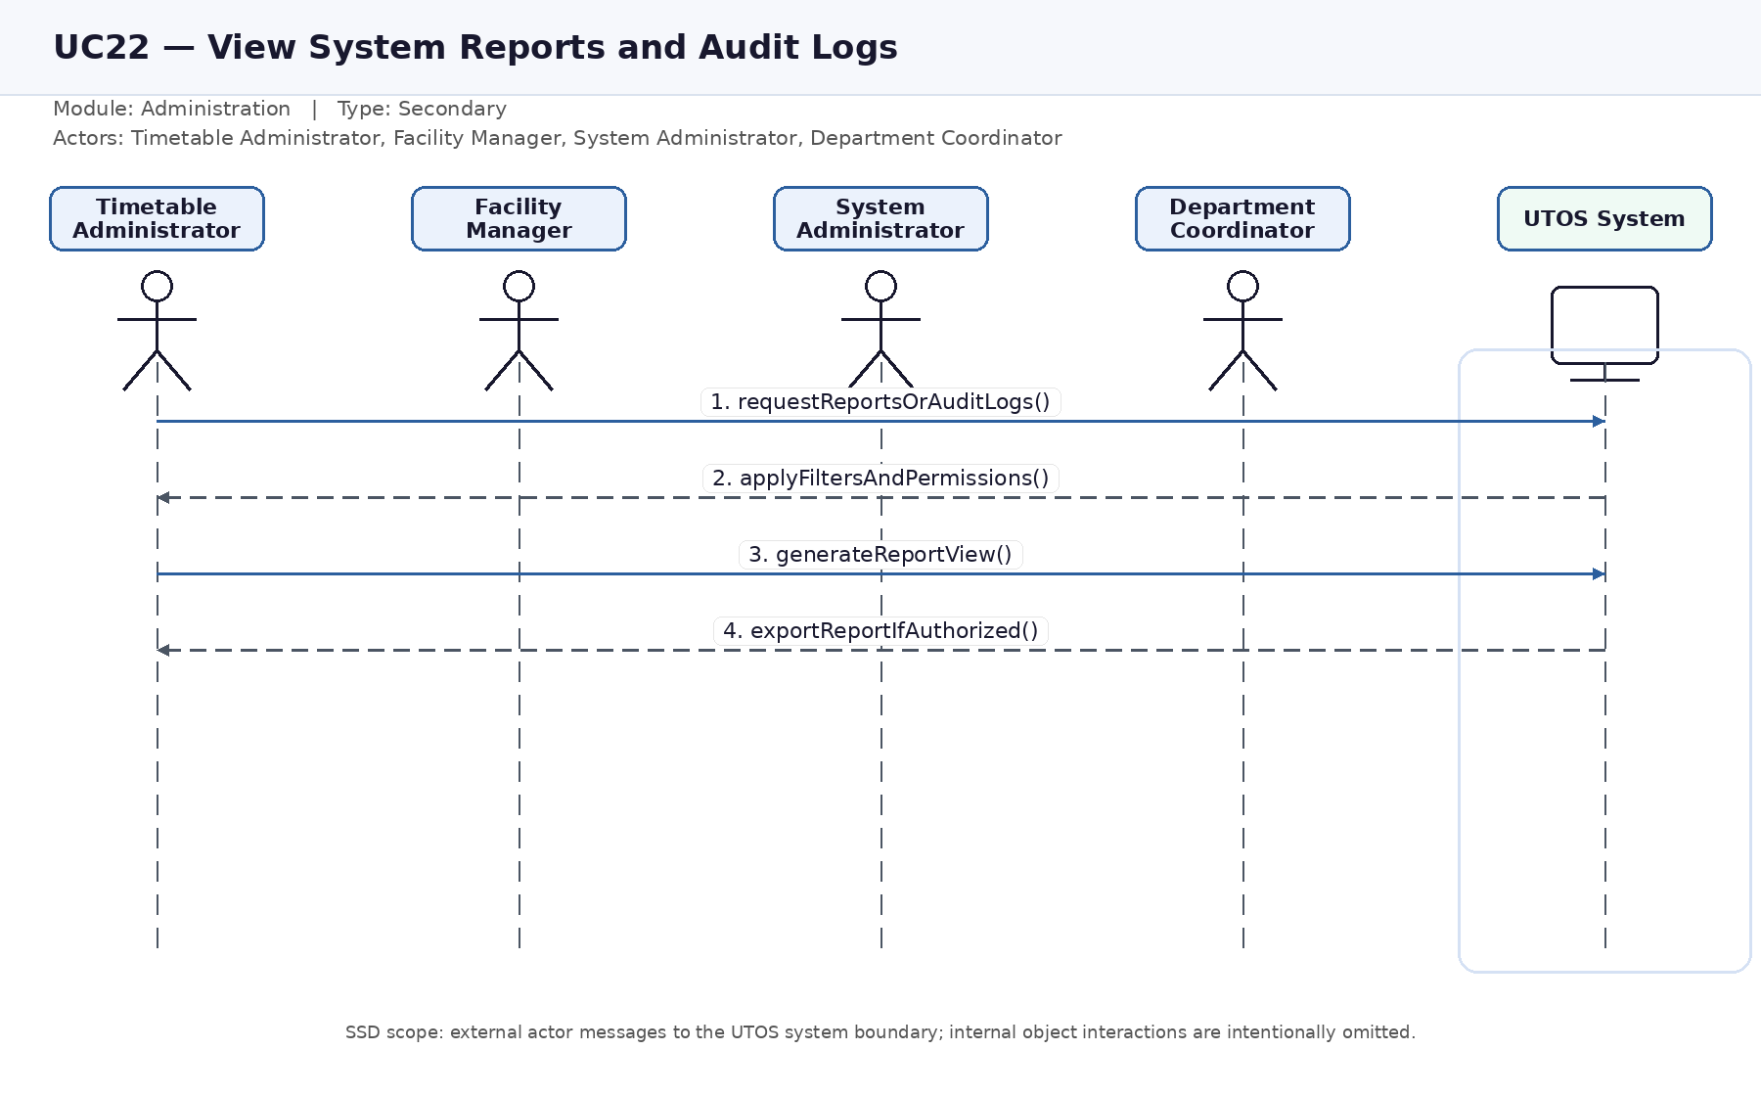
Figure UC22. System sequence diagram for View System Reports and Audit Logs.

