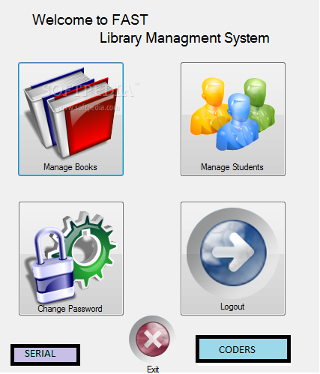  
***LIBRARY MANAGEMENT SYSTEM***

DEVELOPED BY : SERIAL CODERS

***MAIN FEATURES OF PROGRAM:***

* SECURITY
* MANAGE ACCOUNT
* MANAGE BOOKS
* SECTIONS
* MANAGE STUDENT RECORDS
* USER FRIENDLY
* EXTRAS

**SECURITY:**

There are two types of accounts, one for student and one for head of of the library. Students can login with ID: student and PASSWORD: fast.

There is also a master id password for regestrarion, master id: SERIAL and master password: CODERS. Head have to create account according to his/her need. There are 4 tries for both head and student, if they will be unable to write the correct id or password , the program will be closed. Head can also change information of their account.

**MANAGE ACCOUNT:**

Manage accounts is only for head, if head lost his/her password or username so he can get it by giving answer of a secret question selected by head at the time of registration. Also change of username and password is possible.

**MANAGE BOOKS:**

The authority of adding book is in the hand of head only, the information consist of book name , book author and book edition.

**SECTIONS:**

The library consists of following sections:

1. Science
2. Computers
3. Novels
4. Physics
5. Other subjects

**MANAGE STUDENT RECORDS:**

Student records can be added or subtracted by head only, this can contain roll no of student, book name, author name, book edition. Every student can issue 1 book at a time of any section.

**USER FRIENDLY:**

This program is user friendly, i.e in every section there is a option to go back to previous menu and exit from library.

**EXTRAS:**

There is also a bonus for user this is extras section, in this there are following things:

1. Scientific calculator
2. Tic tac toe game
3. Rock paper scissor game