AI-216 – Programming for Artificial Intelligence

Assignment 01: Python Logic & Problem Solving

Weightage: As per course policy

Submission Mode: GitHub (Mandatory)

1. Assignment Purpose (Read Carefully)
This assignment is a direct continuation of Lab 02. While the lab focused on guided practice, this assignment evaluates your independent problem-solving ability using Python basics.
The goal is to assess how well you can:
- Translate problem statements into logical steps
- Use variables, conditionals, and loops correctly
- Write clean, readable, and well-structured Python code
No external libraries are allowed.

2. Learning Outcomes Assessed
This assignment assesses the following course learning outcomes:
- CLO-1: Understand and apply fundamental Python constructs
- CLO-2: Apply programming constructs for data representation and analysis

3. Assignment Rules & Integrity Notice
Important Academic Integrity Rules
- You may use ChatGPT or similar tools only for understanding concepts or logic planning
- You must NOT generate complete solutions using AI tools
- You must be able to explain every line of your code if asked
- Code copied from peers or the internet without understanding will be penalized
Violations may result in grade reduction or disciplinary action.

4. Problem Set

Problem 1: Monthly Budget Analyzer (Basic)
A student tracks monthly expenses under the following categories:
- Rent
- Food
- Transport
- Utilities
Write a Python program that:
- Stores each expense in a variable
- Calculates total monthly expense
- Displays whether the student is Within Budget or Over Budget
Budget Limit: 60,000 PKR
Concepts Tested:
- Variables
- Arithmetic operations
- Simple conditional logic
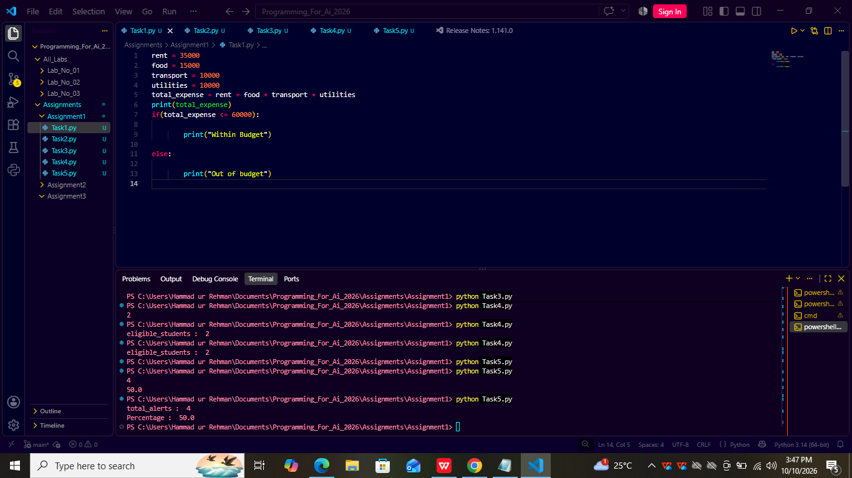

Problem 2: Electricity Bill Estimator (Intermediate)
Electricity charges are calculated as follows:
- Units ≤ 100 → Basic Rate
- Units 101–300 → Standard Rate
- Units above 300 → High Usage Rate
Write a program that:
- Takes number of units as input
- Determines the applicable rate category
- Displays the billing category clearly
Concepts Tested:
- User input
- Multiple conditions (if–elif–else)
- Logical completeness
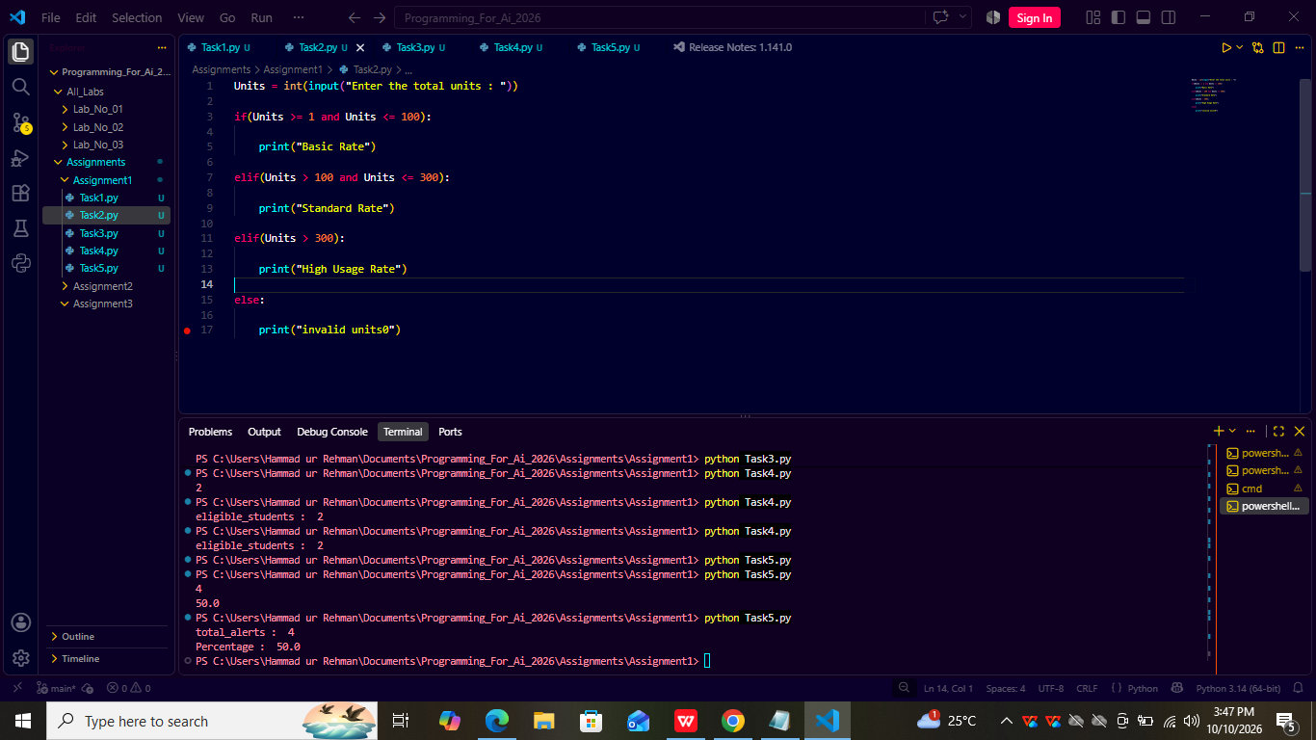

Problem 3: Class Attendance Analysis (Intermediate)
Given a list representing attendance percentages of students:
[72, 85, 90, 60, 40, 78, 88]
Write a program that:
- Iterates through the list
- Counts how many students meet the attendance requirement (≥ 75%)
- Counts how many do not
Concepts Tested:
- Loops
- Counters
- Conditional logic inside loops
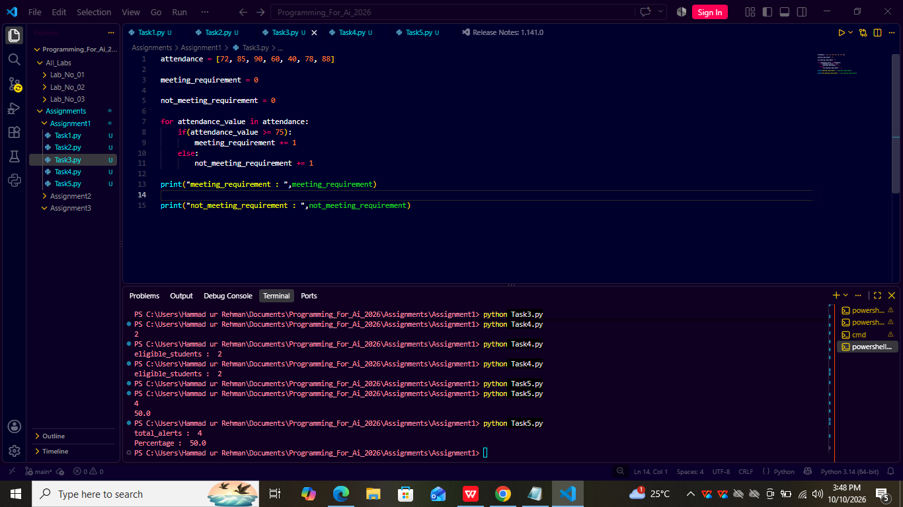

Problem 4: Scholarship Eligibility System (Advanced)
A scholarship is awarded based on the following rules:
- CGPA ≥ 3.5
- Family income ≤ 80,000 PKR
Given two lists:
- CGPAs of students
- Monthly family incomes
Write a program that:
- Iterates through student records
- Determines scholarship eligibility using compound conditions
- Counts the total number of eligible students
Concepts Tested:
- Compound conditions (and)
- Loop + decision integration
- Real-world rule modeling
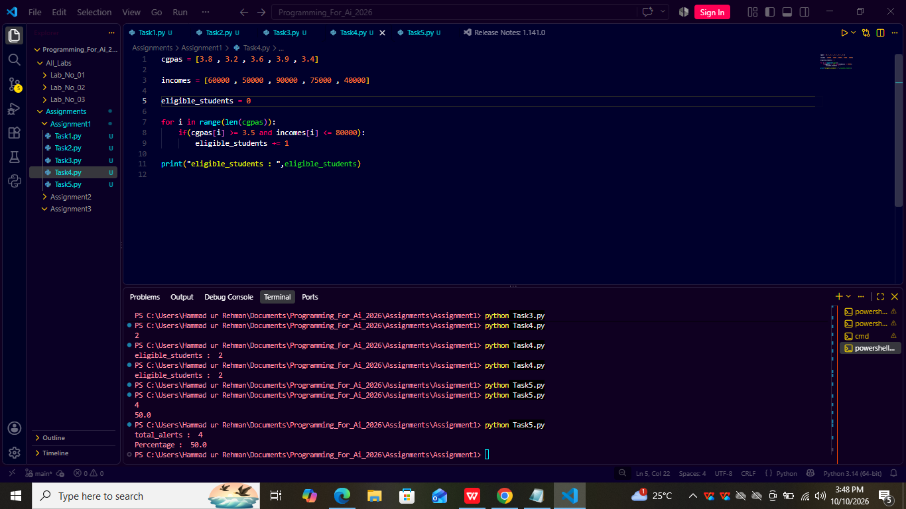

Problem 5 (Bonus): Sensor Alert System
A monitoring system records sensor values.
Given a list of readings:
- Identify readings outside the safe range (20–80)
- Count total alerts
- Calculate the percentage of alert readings
Concepts Tested:
- Accumulators
- Analytical thinking
- Output interpretation
