Lab 02: Python Logic & Control Structures

Week #: 02

Topic: Variables, Data Types, Conditionals & Loops for Problem Solving

1. Objective :
The objective of this lab is to strengthen logical thinking using Python fundamentals. Students will practice converting real-world problem statements into:
- Variables and data representations
- Decision-making logic using conditional statements
- Repetition using loops
This lab directly supports AI programming by reinforcing the input → process → output mindset used in data analysis and machine learning workflows.

2. Background :
In AI systems, programs constantly:
- Read values (data)
- Apply rules or conditions
- Repeat operations over many records
- Produce meaningful outputs
Before working with datasets, models, or libraries, it is essential to master core programming logic. This lab focuses on writing clean, readable Python code that solves small but realistic problems using:
- Variables and data types
- if / elif / else
- for and while loops

3. Tools & Libraries :
- Python 3.x
- VS Code or Jupyter Notebook
- GitHub (mandatory for submission)
No external libraries are required for this lab.

4. Tasks

Task 1: Daily Expense Tracker (Basic)
Problem Statement
A student wants to track daily expenses.
Write a Python program that:
- Stores expenses for food, transport, and stationery in variables
- Calculates the total daily expense
- Checks whether the total exceeds a daily budget of 1500 PKR
Focus Concepts
- Variables and numeric data types
- Arithmetic operations
- Simple if-else decision

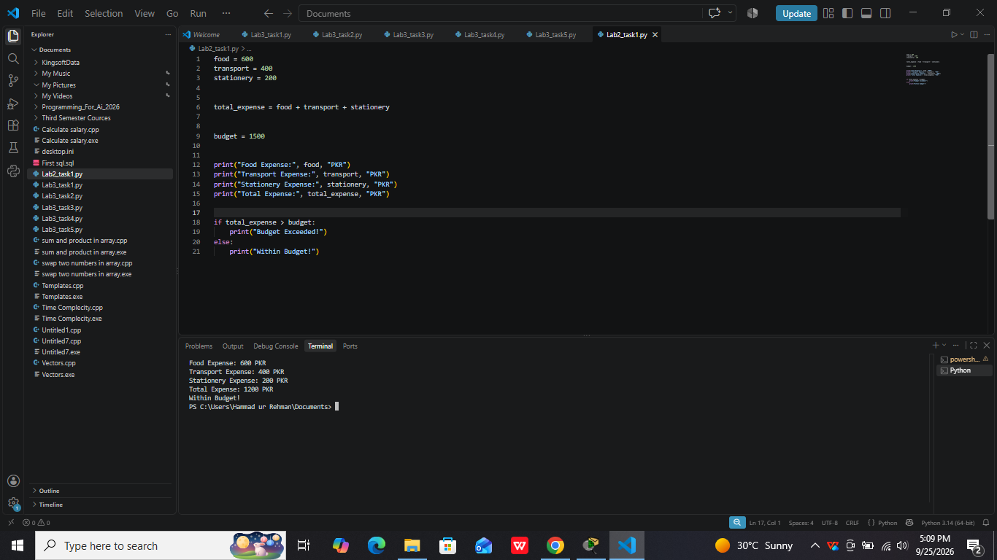

Task 2: Internet Data Package Advisor (Intermediate)
Problem Statement
An internet company provides packages based on data usage.
Rules:
- Usage ≤ 5 GB → Basic Package
- Usage between 6–15 GB → Standard Package
- Usage above 15 GB → Premium Package
Write a program that:
- Takes data usage (GB) as input
- Determines the correct package using conditional statements
- Displays the recommended package
Focus Concepts
- Input handling
- Multiple conditions (if–elif–else)
- Logical completeness
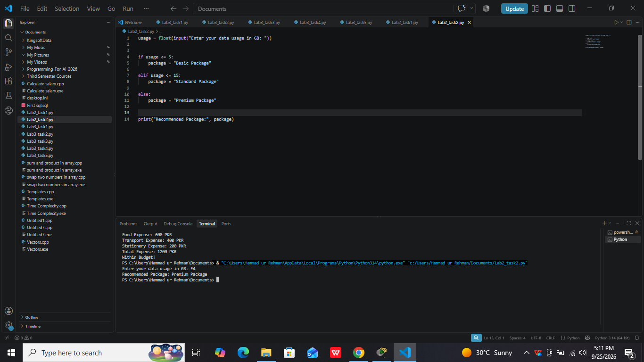

Task 3: Temperature Monitoring System (Intermediate)
Problem Statement
A system records temperature readings throughout the day.
Given a list of temperatures, write a program that:
- Iterates through the list
- Counts how many readings are:
  - Normal (15–30°C)
  - High (above 30°C)
Focus Concepts
- for loop
- Counters
- Conditional logic inside loops

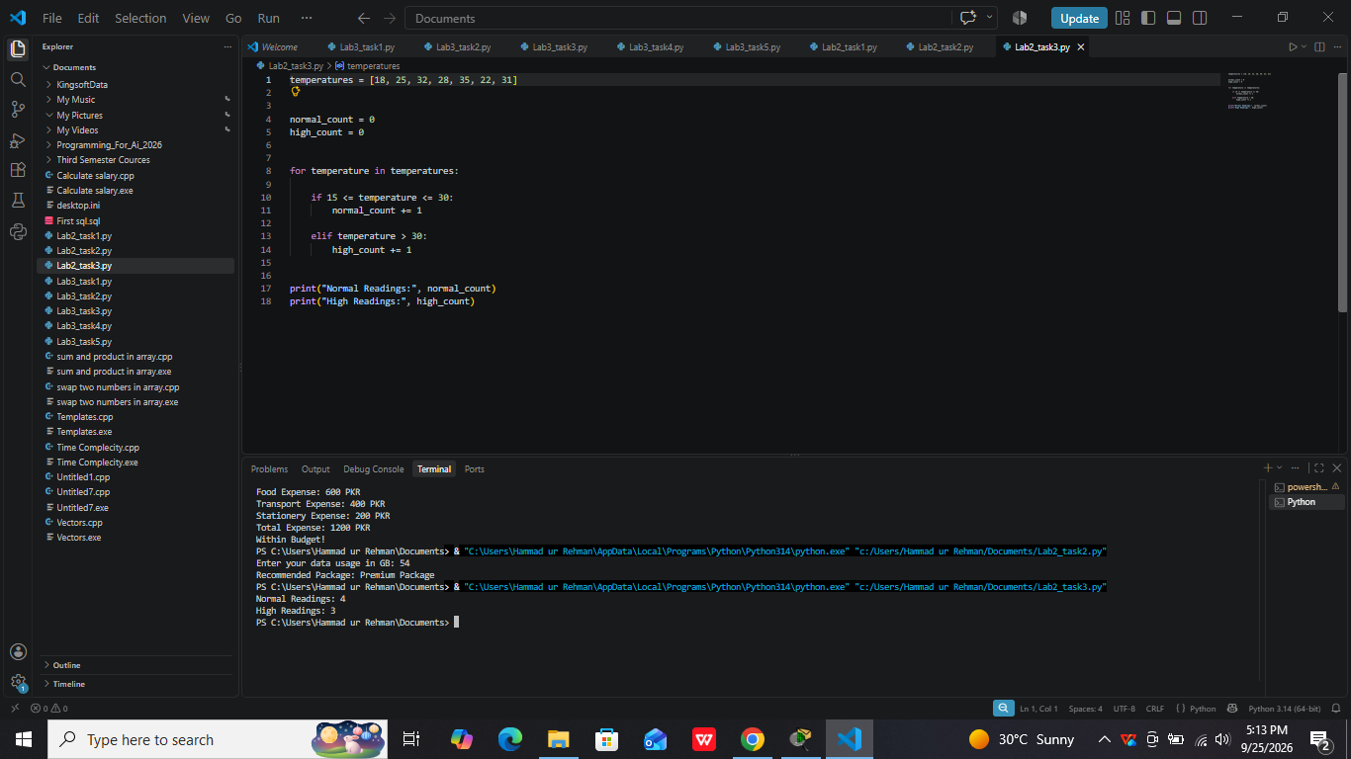

Task 4: Loan Eligibility Simulation (Advanced)
Problem Statement
A bank approves loans based on the following conditions:
- Monthly income ≥ 60,000 PKR
- Employment status = Employed
Given lists of applicants’ incomes and employment statuses, write a program that:
- Iterates through applicants
- Checks eligibility using compound conditions
- Counts how many applicants qualify for the loan
Focus Concepts
- Compound conditions (and)
- Loop + decision integration
- Real-world rule modeling

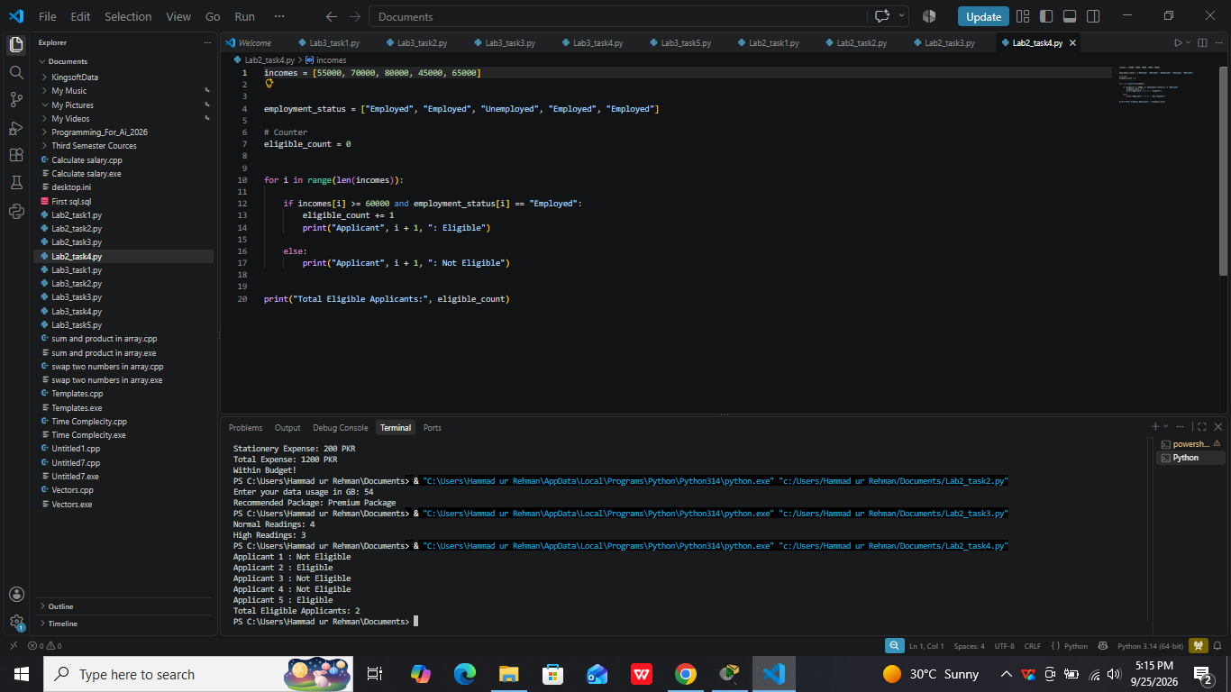

Task 5 :(Optional Challenge): Traffic Speed Analysis
Problem Statement
A traffic monitoring system records vehicle speeds.
Write a program that:
- Identifies overspeeding vehicles (speed > 80 km/h)
- Counts total violations
- Calculates the percentage of violating vehicles
Focus Concepts
- Accumulators
- Percentage calculation
- Analytical thinking

