Lab 03: Functions & Object-Oriented Programming (OOP)

Week #: 03

Topic: Functions, Modular Code & Object-Oriented Programming

1. Objective :
The objective of this lab is to help students transition from linear scripts to structured programs using:
- Functions for modular logic
- Classes and objects for organizing data and behavior
This lab reinforces the mindset that AI systems are built from interacting components, not single long scripts.

2. Background :
Modern AI and machine learning systems are written using structured and modular code. Instead of writing everything in one file:
- Functions are used to break large problems into smaller steps
- Classes are used to represent real-world or AI-related entities (datasets, models, evaluators)
This lab focuses on:
- Designing meaningful functions
- Creating simple classes with attributes and methods
- Understanding how objects manage their own data

3. Tools & Libraries :
- Python 3.x
- VS Code or Jupyter Notebook
- GitHub (mandatory for submission)
No external libraries are required.

4. Tasks :

Task 1: Data Cleaning Functions (Basic)
Problem Statement
You are given raw numeric data collected from a sensor.
Sample Data (for reference)
sensor_readings = [45, 78, -12, 90, 105, 66, 88]
Write Python functions to:
- Remove invalid readings (values below 0 or above 100)
- Calculate the average of the cleaned data
Focus Concepts
- Function definition
- Parameters and return values
- Modular data processing
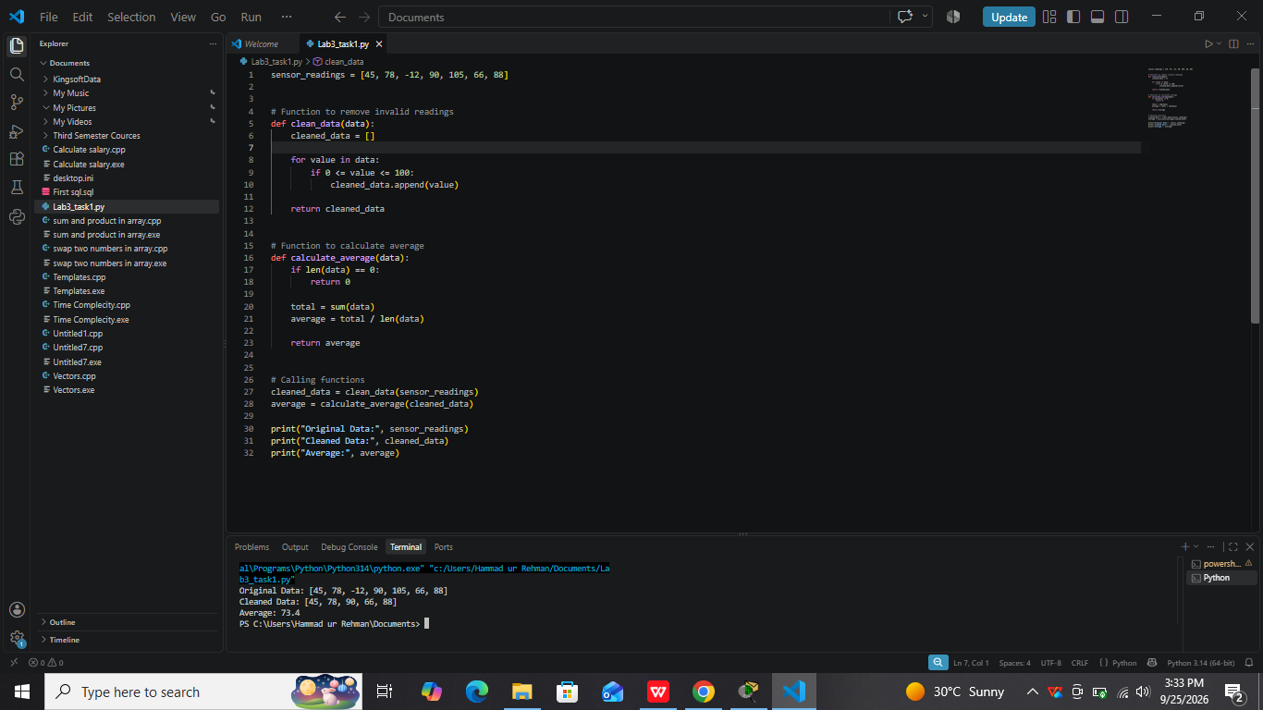

Task 2: Student Record Processor (Intermediate)
Problem Statement
Each student has a name and a list of quiz marks.
Sample Data (for reference)
students = {
"Ali": [65, 70, 80],
"Sara": [90, 85, 88],
"Ahmed": [40, 55, 60]
}
Write a program using functions that:
- Calculates the average marks of a student
- Determines whether the student has passed (average ≥ 50)
- Displays a clear summary for each student
Focus Concepts
- Functions calling other functions
- Logical separation of tasks
- Reusable code

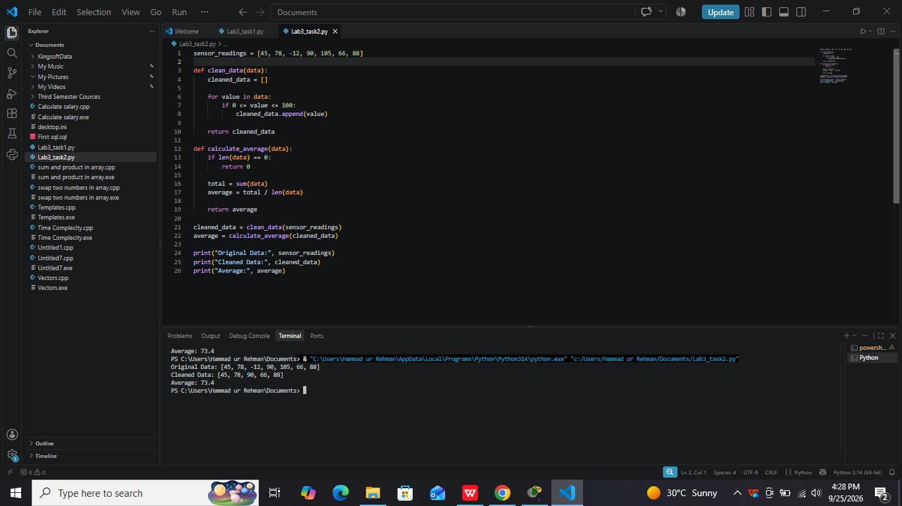

Task 3: Simple Dataset Class (Intermediate)
Problem Statement
Create a class that represents a small numeric dataset.
Sample Data (for reference)
data_values = [12, 18, 25, 30, 22, 27]
The class should:
- Store a list of values as an attribute
- Have a method to return the number of data points
- Have a method to calculate and return the average
Focus Concepts
- Class definition
- Attributes and methods
- Object-based data handling

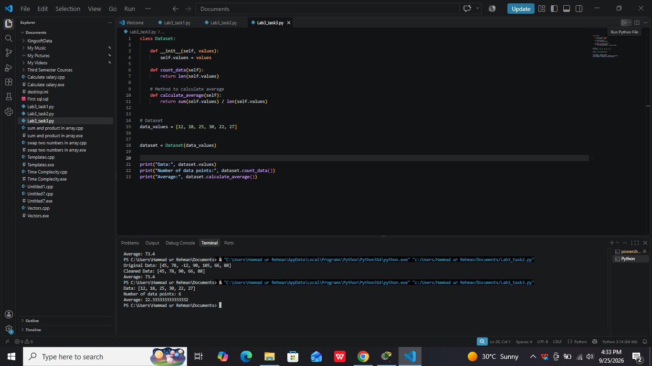

Task 4: Rule-Based Classifier (Advanced)
Problem Statement
You are required to simulate a very simple rule-based classifier.
Sample Data (for reference)
threshold = 60
values = [45, 72, 88, 30, 65]
Create a class that:
- Stores a threshold value
- Has a method that classifies a single value as True/False based on the threshold
- Has another method that classifies a list of values
Focus Concepts
- OOP design thinking
- Methods operating on internal state
- ML-inspired abstraction

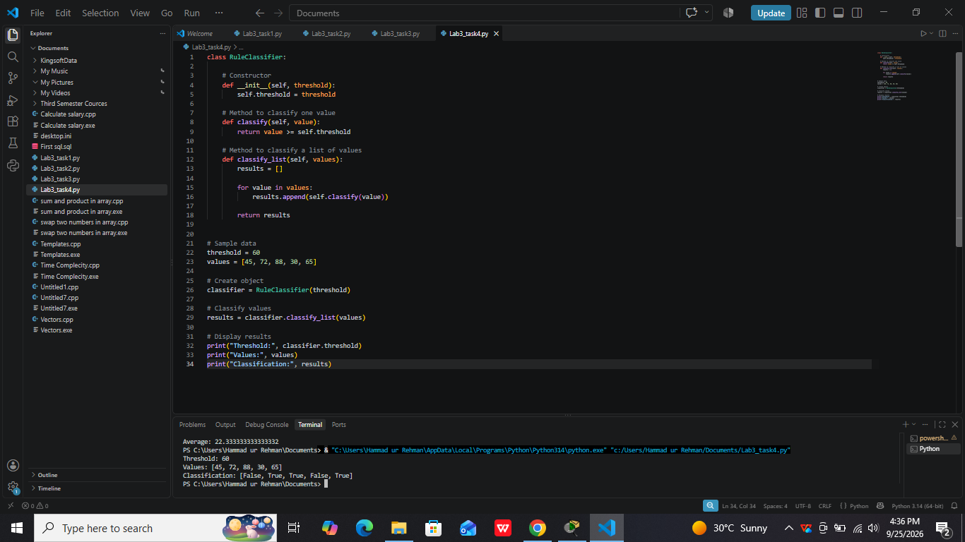

Task 5 :(Optional Challenge): Modular Data Analysis Pipeline
Problem Statement
Design a small program that:
- Uses functions to clean numeric data
- Uses a class to store cleaned data
- Uses class methods to compute summary statistics
Sample Data (for reference)
raw_data = [10, 55, -3, 78, 120, 66, 92]
Focus Concepts
- Combining functions and classes
- End-to-end structured program design
- AI-style workflow thinking

