Final Year Project Report
Project Name: AI-Powered Zero-Trust Network Access Control (Z-NAC) System.

Project Advisor: Muhammad Sarwar

Submitted By:
Aalian Ahmad
Ahmad Wahaj
Hammad-ur-Rahman
Muhammad Taha Ahmad

Session
2026-2027

University of Management and Technology
C-II Johar Town Lahore Pakistan

Dedication

Final Approval

- Head of Department ______________________
Department of Informatics & Systems
School of Systems & Technology
UMT Lahore

- Director (Final Year Projects-CS) ______________________
Department of Computer Science.
School of Systems & Technology
UMT Lahore

- Supervisor ______________________
- Department of Informatics & Systems.
- School of Systems & Technology
UMT Lahore

- Co-Supervisor ______________________

Acknowledgment

Project Title
Objective

Undertaken by

Supervised by
Starting Date

Completion Date

Tools Used
Operating System
Documentation

Plagairism Report
Abstract

Revision Chart
This chart contains a history of this document’s revisions. The entries below are provided solely for illustration purposes. Those entries should be deleted until the revision/s they refer to have actually been created.
The document itself should be stored in revision control, and a brief description of each version should be entered in the Revision Control System. A brief description can be repeated in this section. Revisions need not be described elsewhere in the document, unless they explain the document.

Version | Primary Author(s) | Description of Version | Date Completed
Draft | TBD | Initial draft created for distribution and review comments | (To be decided) TBD
Preliminary | TBD | Second draft incorporating initial review comments, distributed for final review | TBD
Final | TBD | First complete draft, which is placed under change control | TBD
Revision 1 | TBD | Revised draft, revised according to the change control process and maintained under change control | TBD
Revision 2 | TBD | Revised draft, revised according to the change control process and maintained under change control | TBD
Etc. | TBD | TBD | TBD

Contents
New paragraphs formatted as Heading 1, Heading 2, and Heading 3 will be added to the table automatically. To update this table of contents in Microsoft Word, put the cursor anywhere in the table and press F9. If you want the table to be easy to maintain, do not change it manually.
Contents 1
Definitions and Acronyms 3
List of Figures 4
List of Tables 5
1. Introduction 6
1.1 Motivations 6
1.2 Project Overview 6
1.3 Problem Statement 6
1.4 Objectives 6
2. Domain Analysis 7
2.1 Customer 7
2.2 Stakeholders 7
2.3 Affected Groups with social or economic impact 7
2.4 Dependencies/ External Systems 7
2.5 Reference Documents 7
2.5.1 Related Projects 7
2.5.2 Feature Comparison 8
3. Requirements analysis 9
3.1 Requirements 9
3.2 List of Actors 10
3.3 List of use cases 10
3.4 System use case diagram 10
3.5 Extended use cases 10
3.6 User interfaces (mock screens) 12
4. Data flow diagram (optional) 13
4.1 Data Flow Diagram Level 0 13
4.2 Data Flow Diagram Level 1 13
4.3 Data Flow Diagram Level 2 13
5. System Design 15
5.1 System Architecture Diagram 15
5.2 Class Diagram 16
5.3 Collaboration Diagrams 17
5.4 Other UMLs 18
5.5 ERD 18
5.6 Data Dictionary 18
6. Implementation details 19
6.1 Development Setup 19
6.2 Deployment setup 19
6.3 Algorithms 19
6.4 Constraints 19
6.4.1 Assumptions 19
6.4.2 System constraints 19
6.4.3 Restrictions 19
6.4.4 Limitations 19
7. Testing 20
7.1 Extended Test Cases 20
7.2 Decision Table 20
7.2.1 Code snippet 20
7.2.2 Decision coverage table 20
7.3 Traceability Matrix 21
7.3.1 RID vs UCID (requirements vs use cases) 21
7.3.2 Prototypes (RID vs PID) 22
7.3.3 Test Cases (RID vs TID) 22
7.3.4 Coverage (UCID vs TID) 22
8. Results/Output/Statistics 23
8.1 %completion 23
8.2 %accuracy 23
8.3 %correctness 23
9. Conclusion 24
10. Future work 25
11. Bibliography 26
11.1 Books 26
11.2 Journals 26
11.3 Articles 26
11.4 Research papers 26
11.5 Other References 26
12. Appendix 27
12.1 Glossary of terms 27
12.2 Pre-requisites 27

Definitions and Acronyms
Provide definitions or references to all the definitions of the special terms and acronyms used within this document
e.g
Acronym | Definition
UMT | University of Management and Technology
POS | Point of Sale
Table 1: table of acronyms and definitions

List of Figures
New figures that are given captions will be added to the table automatically.
- Insert caption:
  - select picture
  - right click
  - select “insert caption”
  - under “options”, choose label as “figure”
  - Under “caption”, an automatic insertion of “figure no” will appear. Give your figure an appropriate caption
- Update list of figures:To update this list in Microsoft Word, put the cursor anywhere in the table and press F9.
- Note: If you want the table to be easy to maintain, do not change it manually.

Figure 1: sample use case diagram with explanation 10
Figure 2: System Architecture 15

List of Tables
New Tables that are given captions will be added to the table automatically.
- Insert caption:
  - select picture
  - right click
  - select “insert caption”
  - under “options”, choose label as “table”
  - Under “caption”, an automatic insertion of “table no” will appear. Give your table an appropriate caption
- Update table: To update this table of contents in Microsoft Word, put the cursor anywhere in the table and press F9.
- Note: If you want the table to be easy to maintain, do not change it manually.
Table 1: table of acronyms and definitions 3
Table 2: list of stakeholders 7

Introduction
This chapter introduces the proposed final year project, an AI-Powered Zero-Trust Network Access Control (Z-NAC) system designed for organizational Wi-Fi networks. The project focuses on improving the way devices are evaluated after connecting to a network by combining passive device fingerprinting, machine learning based risk classification, access control enforcement, and guided remediation. The purpose of this chapter is to explain the motivation behind the project, provide an overview of the system to be developed, define the problem being addressed, and list the major objectives expected to be achieved by the completion of the project.

Motivations
Modern organizations depend heavily on wireless networks for daily operations. Employees, students, guests, and administrators often connect laptops, mobile phones, and other devices to the same organizational network using shared or assigned Wi-Fi credentials. Although this makes access convenient, it also creates a major security risk: a device may have valid credentials but still be unsafe because it is infected with malware, controlled through a remote access Trojan, or behaving abnormally on the network.
Traditional authentication mechanisms mainly verify whether a user or device is allowed to connect. They do not always verify whether the connected device is healthy after authentication. As a result, a compromised device can become a bridge between an external attacker and the organization’s internal systems. This is especially dangerous because the real device owner may be innocent and unaware that their machine is being misused.
Enterprise-level NAC products such as Cisco ISE and Aruba ClearPass address some of these problems, but they are often expensive, complex to deploy, and unsuitable for many small or mid-sized organizations. Static firewall rules also fail to adapt to changing threat behavior. This project is motivated by the need for a lower-cost, intelligent, and practical NAC prototype that can evaluate device risk dynamically and respond in a way that protects the organization without immediately punishing the innocent user.
A further motivation for this project comes from a real cybersecurity incident that affected the University of Management and Technology (UMT) in 2024. During the attack, university servers and online services became unavailable, causing significant disruption for students and staff. Many students were unable to access the university portal and had to visit the campus physically to use university-provided computer terminals. Long waiting times and difficulties in course registration highlighted how dependent modern institutions have become on secure and reliable network infrastructure. As students who witnessed the impact of this incident, we recognized the importance of developing stronger mechanisms for detecting and containing security threats before they can spread across an organization's network. This experience reinforced the need for an intelligent access control system capable of identifying potentially compromised devices, limiting their access, and helping prevent security incidents from affecting critical services.
Another motivation is to bring artificial intelligence into the post-authentication stage of network access control. By using device fingerprinting and machine learning, the proposed system can move beyond simple allow-or-deny decisions and introduce a more flexible response: trusted devices receive access, suspicious devices are isolated and guided through remediation, and clearly dangerous devices are blocked.

Project Overview
The proposed project is an AI-Powered Zero-Trust Network Access Control (Z-NAC) system for organizational Wi-Fi networks. The system will monitor devices at or near the point of network admission, collect passive fingerprinting and traffic-related features, classify device risk using machine learning models, and apply an access decision based on the calculated threat level.
The system will divide connecting devices into three access outcomes. A device assessed as clean and trusted will be granted full access to the internal network. A suspicious device will be moved into a sandboxed or isolated VLAN where it cannot directly access sensitive internal resources. A high-risk device showing active threat indicators will be blocked from the network. This tiered enforcement model provides a more balanced approach than a simple binary access policy.
A key part of the project is the remediation portal. When a device is placed in the sandboxed network, the user will be redirected to a guided portal that explains the issue in understandable language and provides recommended cleanup steps. After completing the remediation flow, the device may be reassessed for possible re-admission. This makes the system useful not only for administrators but also for normal users who may not understand network security alerts.
The project will be implemented and validated in a controlled virtual environment using VirtualBox-based machines. The major components include a device fingerprinting module, a traffic monitoring module, a machine learning risk engine, a firewall/VLAN enforcement layer, a remediation portal, and an admin dashboard. Technologies planned for implementation include Python, Nmap, p0f, Scapy, tshark, scikit-learn, Flask, Chart.js, and pfSense or OPNsense APIs.
From an academic perspective, the project also applies a re-engineering approach to the IEEE 802.1X network access control process. The original 802.1X standard focuses on authentication, while the proposed redesign extends the post-authentication stage by adding AI-based device health assessment and dynamic access enforcement.

Problem Statement
Organizations often allow any device with valid Wi-Fi credentials to connect to the internal network without checking whether the device is compromised. If such a device is infected with malware or controlled by an attacker, it can be used to access internal servers, databases, and services. Existing static firewall rules and costly enterprise NAC solutions are not suitable for many organizations. There is a need for a low-cost, AI-driven NAC system that can assess device risk after authentication, classify devices dynamically, isolate suspicious devices, block high-risk devices, and guide innocent users through remediation.

Objectives
- To design a passive device fingerprinting module that identifies device characteristics such as operating system type, open ports, and observable network behavior without requiring an agent to be installed on the target device.
- To develop a machine learning based risk classification engine that evaluates device threat level using fingerprinting features and labelled network traffic datasets such as CICIDS 2017 and CICIDS 2018.
- To implement a composite risk scoring mechanism that combines OS/device classification and anomaly detection outputs into a clear 0-100 device risk score.
- To implement a three-tier network enforcement mechanism that grants full access to trusted devices, places suspicious devices in a sandboxed VLAN, and blocks devices with high-risk threat indicators.
- To develop a user-facing remediation portal that explains detected issues and provides guided cleanup instructions for devices placed in the sandboxed network.
- To develop an admin dashboard that allows administrators to view device status, risk scores, access decisions, and security events in a clear and manageable format.
- To re-engineer the post-authentication stage of IEEE 802.1X by extending it with AI-driven device health assessment and dynamic access control logic.
- To validate the complete prototype in a controlled VM-based environment using realistic scenarios, including clean devices, suspicious behavior, and active threat simulation.
- To evaluate the system using measurable criteria such as detection accuracy, precision, recall, F1 score, false positive rate, remediation completion rate, and access decision latency.

Domain Analysis
This chapter analyzes the domain in which the proposed system will operate. The project belongs to the cybersecurity and network management domain, specifically Network Access Control (NAC), endpoint/device profiling, intrusion detection, access policy enforcement, and user remediation. The proposed system is not only a machine learning model and not only a firewall rule engine; it is a complete product-oriented prototype that connects authentication context, device behavior, risk scoring, network isolation, and user guidance into one workflow.
The domain is shaped by a practical security gap: many networks authenticate users or devices but do not continuously assess whether an authenticated device is safe. IEEE 802.1X provides a strong foundation for port-based access control, but the proposed project extends the post-authentication stage by adding passive fingerprinting, machine learning based risk classification, and dynamic enforcement. Commercial NAC platforms such as Cisco ISE, HPE Aruba ClearPass, and FortiNAC show that this problem is important in real organizations, while datasets such as CIC-IDS2017 and CSE-CIC-IDS2018 provide a research basis for evaluating network threat-detection models [R1-R6].

Customer
There is no single contracted client for this project. The intended customer is a small or mid-sized organization that operates an internal Wi-Fi network and needs a practical way to reduce the risk of compromised devices entering the trusted network. A university department, school, office, software house, hospital unit, or small enterprise can be considered a representative customer.
The proposed prototype is especially suitable for organizations that cannot afford or do not need a full enterprise NAC deployment but still require better control than a shared Wi-Fi password and static firewall rules. In the context of the final year project, the University of Management and Technology can be considered the academic environment in which the prototype will be designed, tested, and demonstrated. However, the system is generalized enough to apply to other organizational Wi-Fi networks.
Customer Type | Need / Pain Point | How the Proposed System Helps
University or academic lab | Many student and staff devices connect to shared wireless infrastructure. | Provides risk-based access decisions and isolates suspicious devices without fully denying innocent users.
Small or mid-sized organization | Enterprise NAC products may be costly or difficult to deploy. | Offers a low-cost prototype using open-source tools, Python, and virtualized firewall/network components.
IT/network administration team | Limited visibility into device type, behavior, and security state after connection. | Displays device status, risk scores, enforcement actions, and security events through an admin dashboard.
Security-conscious department | Compromised devices can be used for lateral movement inside the network. | Adds post-authentication threat assessment and blocks or sandboxes risky devices before they reach sensitive resources.

Stakeholders
The system affects multiple stakeholders because access control decisions influence both security operations and normal user productivity. The main stakeholders are listed below.
Stakeholder | Role in System
Network administrator | Configures VLANs, firewall rules, network policies, and access tiers. Monitors whether devices are assigned to full access, sandboxed access, or blocked status.
Security administrator / SOC analyst | Reviews detected threats, analyzes abnormal traffic, validates alerts, and tunes risk thresholds to reduce false positives and false negatives.
End user / device owner | Connects a personal or organizational device to Wi-Fi. If the device is suspicious, the user follows the remediation portal guidance before re-admission.
Organization management | Approves security policy, budget, and deployment priorities. Benefits from reduced risk of data loss, service disruption, and internal compromise.
System developer / project team | Implements fingerprinting, traffic monitoring, ML classification, enforcement integration, remediation portal, dashboard, and test environment.
Project supervisor / evaluator | Evaluates the academic contribution, engineering quality, test results, documentation, and final demonstration.
Guests or temporary users | May receive restricted or temporary access depending on policy and device behavior.
Internal servers and services | Protected assets that should not be reachable by compromised or untrusted devices.

Affected Groups with Social or Economic Impact
The deployment of an AI-driven NAC system has both security and usability implications. The design must protect the organization while still treating users fairly, especially when a device is compromised without the user knowing.
Affected Group | Impact
Normal users | Users with clean devices receive smoother access because the system can grant full access automatically. Suspicious devices are not simply rejected; users are redirected to a remediation portal that explains the issue and recommends cleanup steps.
Innocent compromised users | This group is central to the project. A user may have valid credentials but an infected device. The sandbox and remediation workflow reduces blame on the user while still protecting the network.
IT support staff | The remediation portal can reduce repeated manual support requests by giving users structured steps. Administrators can use dashboard evidence instead of guessing why access was restricted.
Organization / institution | The system can reduce the economic impact of malware spread, data leakage, downtime, and incident response by stopping risky devices earlier in the connection lifecycle.
Security team | The project improves visibility into endpoint behavior and gives the security team a repeatable process for triage, isolation, and re-admission.
Visitors and guests | Guests can be given safer limited access without exposing internal resources. This supports openness while preserving network boundaries.
Attackers | A compromised endpoint becomes less useful as an attack path because suspicious behavior can trigger isolation or blocking.

The main social benefit is that the system avoids a harsh deny-only model. It recognizes that the person using the device may not be the attacker. The main economic benefit is reduced dependency on expensive commercial NAC deployments while still demonstrating the core ideas of device visibility, risk scoring, segmentation, and remediation.

Dependencies / External Systems
The prototype depends on several network, software, data, and platform components. These dependencies are selected because they align with the proposed architecture and can be tested in a controlled VM-based lab environment.
Dependency / External System | Purpose in Project | Risk / Note
IEEE 802.1X / RADIUS concept | Provides the access-control foundation being re-engineered at the post-authentication stage. | The prototype may simulate parts of this workflow rather than implementing a full production 802.1X deployment.
Wireless access point / switch / virtual network | Represents the network admission point and VLAN separation layer. | In a university lab, this can be simulated using VirtualBox networks and virtual firewall interfaces.
pfSense or OPNsense firewall | Applies access policy through firewall rules, aliases, VLANs, or API-based automation. | OPNsense has official firewall API documentation; pfSense API may require an additional REST API package [R9, R10].
Nmap | Performs active fingerprinting such as OS and service detection where permitted. | Nmap OS detection requires network conditions such as responsive hosts and suitable open/closed ports [R7].
p0f / passive fingerprinting approach | Supports passive identification of device or OS characteristics based on observed traffic. | Passive tools depend on enough network traffic being visible to the monitoring component.
Scapy / tshark | Captures, inspects, and processes network packets or flows for monitoring and feature extraction. | Packet capture may require administrative privileges and careful filtering to avoid excessive data volume [R8].
CIC-IDS2017 and CSE-CIC-IDS2018 datasets | Provide labelled benign and attack traffic for model training and evaluation. | Dataset behavior may not perfectly match the local virtual lab, so live test scenarios are still required [R5, R6].
scikit-learn | Implements Random Forest classification and Isolation Forest anomaly detection. | Model quality depends on preprocessing, feature selection, class balance, and evaluation design [R11, R12].
Flask web framework | Hosts the remediation portal and admin dashboard backend. | The prototype should avoid storing sensitive information unnecessarily.
Chart.js / browser UI | Displays risk scores, events, and dashboard statistics. | Visual output must stay simple and understandable for administrators.
VirtualBox / Ubuntu VMs | Creates the controlled test environment for clean devices, infected/suspicious devices, firewall, and services. | Virtual hardware behavior may differ from a real campus network but is suitable for FYP validation.

Reference Documents
The following documents and sources were reviewed during domain analysis. They provide the technical and research basis for the chapter.
Ref ID | Reference Document / Source | Relevance
R1 | IEEE 802.1X: Port-Based Network Access Control | Defines the baseline access-control standard and controlled/uncontrolled port concept.
R2 | Cisco Identity Services Engine Solution Overview | Commercial NAC reference for profiling, authentication, authorization, segmentation, and continuous trust.
R3 | HPE Aruba Networking ClearPass Policy Manager | Commercial NAC reference for role-based policy, secure access, posture, onboarding, and endpoint handling.
R4 | Fortinet FortiNAC | Commercial NAC reference for visibility, control, dynamic policy adjustment, and automated response.
R5 | CIC-IDS2017 Dataset - Canadian Institute for Cybersecurity | Labelled benign and attack traffic dataset for IDS/ML model training and evaluation.
R6 | CSE-CIC-IDS2018 Dataset - Canadian Institute for Cybersecurity | Large-scale intrusion detection dataset with profiles, PCAP/logs, and generated attack/benign behavior.
R7 | Nmap OS Detection Reference | Reference for OS fingerprinting and active scanning behavior.
R8 | Scapy Documentation | Reference for packet sending, sniffing, dissecting, and custom network analysis.
R9 | OPNsense Firewall API Documentation | Reference for API-driven firewall interaction and automation.
R10 | pfSense REST API Guide | Reference for REST/GraphQL automation option for pfSense environments.
R11 | scikit-learn RandomForestClassifier Documentation | Reference for supervised Random Forest classification.
R12 | scikit-learn IsolationForest Documentation | Reference for anomaly detection using Isolation Forest.

Related Projects
Several existing systems and standards are related to this project. The proposed system does not attempt to copy a full enterprise NAC platform; instead, it extracts the key domain ideas and implements an academic prototype focused on AI-driven risk scoring and guided remediation.
IEEE 802.1X Port-Based Network Access Control: IEEE 802.1X regulates network access through controlled and uncontrolled ports and uses EAP/EAPOL for authentication. It is a strong baseline for deciding who may connect, but the project focuses on adding a post-authentication device health and risk-assessment layer [R1].
Cisco Identity Services Engine (ISE): Cisco ISE is an enterprise NAC and policy decision platform. It supports discovery, profiling, authentication, authorization, least-privilege access, segmentation, and automated threat containment. The proposed project is related because it also profiles devices and assigns access based on risk, but it is smaller, academic, and explicitly evaluates ML models [R2].
HPE Aruba Networking ClearPass: ClearPass provides authentication, authorization, role-based access control, device profiling, onboarding, guest access, posture assessment, quarantine, and remediation capabilities. It is a strong commercial reference for user/device policy enforcement and endpoint handling [R3].
Fortinet FortiNAC: FortiNAC emphasizes visibility, control, automated response, dynamic policy adjustment, and response to compromised devices or anomalous activity. It is closely related to the proposed enforcement and response workflow [R4].
Traditional firewall and VLAN segmentation: Manual firewall rules and VLANs can isolate traffic, but they usually require static administrator decisions. The proposed system uses the firewall/VLAN layer as an enforcement mechanism while allowing an AI risk engine to drive the decision.
Intrusion Detection Systems using CIC datasets: Many IDS research projects train ML models on CIC-IDS2017 or CSE-CIC-IDS2018 for benign/attack classification. The proposed system uses this IDS research foundation but connects the model result to a NAC enforcement workflow rather than stopping at detection [R5, R6].

Feature Comparison
The table below compares the proposed system with established NAC approaches. The comparison shows that commercial solutions are more complete for enterprise deployment, while the proposed project is valuable as a low-cost, explainable, ML-oriented prototype that focuses on guided remediation for the innocent compromised user scenario.
Feature | Cisco ISE | Aruba ClearPass | FortiNAC | Proposed System
Primary purpose | Enterprise zero-trust NAC and policy decision point | Enterprise role/device-based access control and policy manager | Network visibility, control, and automated response | FYP prototype for AI-driven NAC, sandboxing, and guided remediation
802.1X / authentication support | Strong support | Strong support | Supports NAC integration with network infrastructure | Uses 802.1X as baseline concept and re-engineers post-authentication logic
Device profiling | Yes, endpoint discovery and profiling | Yes, device profiling and endpoint classification | Yes, device visibility and profiling | Yes, using passive fingerprinting and permitted scans
ML / AI role | Uses integrated intelligence and risk-based policy concepts | Uses profiling/visibility and related intelligence features | Uses automated response and anomaly-oriented workflows | Explicit Random Forest, Isolation Forest, and composite risk score
Threat dataset evaluation | Not normally exposed as an academic dataset experiment | Not normally exposed as an academic dataset experiment | Not normally exposed as an academic dataset experiment | Evaluated using CIC-IDS2017/CSE-CIC-IDS2018 and lab scenarios
Access outcomes | Allow, restrict, segment, quarantine, contain | Allow, role-based access, posture actions, quarantine/remediate | Visibility, control, response, isolation workflows | Full access, sandboxed VLAN, complete block
Guided user remediation | Supported through posture/compliance workflows | Supported through OnGuard/remediation and quarantine concepts | Supported through automated response workflows | Central design feature through captive remediation portal
Cost and deployment complexity | Enterprise-level licensing and infrastructure | Enterprise-level licensing and infrastructure | Enterprise-level licensing and infrastructure | Low-cost academic prototype using open-source tools and VMs
Admin dashboard | Enterprise dashboard/reporting | Enterprise dashboard/reporting | Enterprise dashboard/reporting | Flask + Chart.js dashboard for device status and risk events
Main limitation | Cost and complexity for small organizations | Cost and complexity for small organizations | Cost and complexity for small organizations | Prototype scope; not production hardened; VM testing only

From this comparison, the proposed system is positioned as a product-based academic prototype inspired by enterprise NAC systems but narrowed for feasibility. Its main differentiator is the explicit combination of ML risk scoring, three-tier enforcement, and a user-facing remediation portal. This direction fits the project problem statement because the system protects the organization while still giving innocent compromised users a path back to trusted access.

Source URLs Used in This Chapter
R1. IEEE 802.1X: Port-Based Network Access Control. https://1.ieee802.org/security/802-1x/
R2. Cisco Identity Services Engine (ISE) Solution Overview. https://www.cisco.com/c/en/us/products/collateral/security/identity-services-engine/identity-ser-engine-so.html
R3. HPE Aruba Networking ClearPass Policy Manager. https://www.hpe.com/us/en/aruba-clearpass-policy-manager.html
R4. Fortinet FortiNAC Network Access Control. https://www.fortinet.com/products/network-access-control
R5. Canadian Institute for Cybersecurity: CIC-IDS2017. https://www.unb.ca/cic/datasets/ids-2017.html
R6. Canadian Institute for Cybersecurity: CSE-CIC-IDS2018. https://www.unb.ca/cic/datasets/ids-2018.html
R7. Nmap OS Detection Reference. https://nmap.org/book/man-os-detection.html
R8. Scapy Documentation: Introduction. https://scapy.readthedocs.io/en/latest/introduction.html
R9. OPNsense Firewall API Documentation. https://docs.opnsense.org/development/api/core/firewall.html
R10. pfSense REST API Guide. https://pfrest.org/
R11. scikit-learn RandomForestClassifier Documentation. https://scikit-learn.org/stable/modules/generated/sklearn.ensemble.RandomForestClassifier.html
R12. scikit-learn IsolationForest Documentation. https://scikit-learn.org/stable/modules/generated/sklearn.ensemble.IsolationForest.html

Requirements analysis

Requirements
The functional and non-functional requirements of the suggested AI-driven Network Access Control system are described in this chapter. The chapter's goal is to translate the project objectives and problem statement into explicit system functions, actors, use cases, and interface expectations. Later on, system design, implementation, testing, and traceability will be guided by these requirements.

The NAC prototype, device fingerprinting module, traffic monitoring module, AI risk engine, firewall/VLAN enforcement integration, remediation portal, admin dashboard, local data store, and model assessment workflow are all part of the system boundary. The firewall/VLAN platform, packet capture tools, fingerprinting tools, training datasets, and the company or lab network are examples of external systems. In order to map each requirement to use cases, prototypes, and test cases in subsequent chapters, the chapter use requirement IDs and adheres to the product-based FYP template.

Requirements
The criteria for the suggested system are listed in the following table. The grouping of requirement IDs is as follows: Functional requirements are denoted by R1, non-functional needs by R2, data requirements by R3, limitations by R4, and external interface requirements by R5.
RID | Description | Category | Attribute | Details & Boundary Constraints
R1.1 | The system should detect a newly connected device and register its basic connection details. | Functional Requirement | Device Admission | Capture MAC address, IP address, first-seen time, last-seen time, and current access state.
R1.2 | The system should perform device fingerprinting to identify observable device and operating system characteristics. | Functional Requirement | Device Fingerprinting | Use passive observations where possible and permitted active scanning only inside the controlled lab environment.
R1.3 | The system should collect traffic features required for risk analysis. | Functional Requirement | Traffic Monitoring | Extract protocol, port behavior, packet/flow counts, connection attempts, and suspicious activity indicators.
R1.4 | The system should classify the device operating system or device type. | Functional Requirement | OS Classification | Output a predicted OS/device class and confidence or evidence value where available.
R1.5 | The system should detect abnormal traffic behavior using an anomaly detection model. | Functional Requirement | Threat Detection | Flag behavior that deviates from a benign baseline or resembles attack traffic patterns.
R1.6 | The system should calculate a composite risk score for each assessed device. | Functional Requirement | Risk Scoring | Represent score on a 0-100 scale and map it to Low, Medium, or High risk.
R1.7 | The system should assign a network access decision based on the calculated risk score. | Functional Requirement | Access Decision | Low risk receives full access, medium risk receives sandboxed access, and high risk is blocked.
R1.8 | The system should enforce access decisions through firewall or VLAN control. | Functional Requirement | Policy Enforcement | Update firewall/VLAN policy through pfSense/OPNsense API or equivalent lab automation.
R1.9 | The system should redirect sandboxed users to a remediation portal. | Functional Requirement | User Remediation | Explain the detected issue in user-friendly language and display cleanup/recovery steps.
R1.10 | The system should allow reassessment after remediation steps are completed. | Functional Requirement | Re-admission | Rescan or re-evaluate the device before changing sandboxed access to full access.
R1.11 | The system should provide an admin dashboard for monitoring devices and security events. | Functional Requirement | Administration | Display device identity, risk score, OS/device classification, access state, event history, and remediation status.
R1.12 | The system should maintain logs of fingerprinting results, model outputs, enforcement actions, and remediation attempts. | Functional Requirement | Audit Logging | Support troubleshooting and later evaluation of accuracy, false positives, latency, and remediation completion.
R2.1 | The system should complete device assessment within an acceptable time for a lab prototype. | Non-Functional Requirement | Performance | Initial risk decision should be produced within 10-30 seconds under normal VM lab conditions.
R2.2 | The admin dashboard and remediation portal should remain usable during normal test scenarios. | Non-Functional Requirement | Availability | Web components should remain available while the Flask service and VM network are running.
R2.3 | The system should minimize false positives against clean devices. | Non-Functional Requirement | Accuracy | Report accuracy, precision, recall, F1 score, and false positive rate using dataset and lab test results.
R2.4 | The system should protect internal resources from high-risk devices. | Non-Functional Requirement | Security | Blocked and sandboxed devices must not access protected internal services in the lab network.
R2.5 | The system should be modular enough to test components independently. | Non-Functional Requirement | Maintainability | Fingerprinting, monitoring, risk scoring, enforcement, portal, and dashboard modules should be separable.
R2.6 | The system should present understandable messages to non-technical users. | Non-Functional Requirement | Usability | The remediation portal shall avoid unnecessary jargon and provide step-by-step guidance.
R3.1 | The system should store device records. | Data Requirement | Device Data | Records include MAC address, IP address, hostname if available, OS prediction, risk score, and access state.
R3.2 | The system should store event and enforcement history. | Data Requirement | Audit Data | Events include timestamp, event type, evidence, model output, access decision, and user/admin action.
R3.3 | The system should store model evaluation outputs. | Data Requirement | ML Data | Training and testing results include selected features, model version, confusion matrix, and evaluation metrics.
R4.1 | The system must operate in a controlled VM-based test environment for FYP demonstration. | Constraint | Environment Constraint | No physical enterprise Wi-Fi infrastructure is required for the prototype demonstration.
R4.2 | The system must use only authorized scanning and monitoring inside the lab network. | Constraint | Ethical/Security Constraint | The project shall not scan external or unauthorized networks.
R4.3 | The system should use Python-based implementation for core modules. | Constraint | Programming Constraint | Python is required for fingerprinting integration, traffic processing, ML model execution, and Flask web components.
R5.1 | The system should integrate with Nmap/p0f-style fingerprinting tools. | External Interface Requirement | Fingerprinting Interface | Parse tool output or signatures into normalized device features.
R5.2 | The system should integrate with packet capture tools such as Scapy or tshark. | External Interface Requirement | Monitoring Interface | Captured packet/flow features shall be passed to the risk engine in structured form.
R5.3 | The system should integrate with firewall/VLAN enforcement through pfSense/OPNsense API or equivalent automation. | External Interface Requirement | Firewall Interface | Update access policy according to the risk decision.

Functional requirements are the services you ask the system for. Non-functional requirements are quality aspects that are measurable. Data requirements describe information that is kept or processed. Constraints are restrictions placed on the project environment. External interface requirements describe the system’s connections to other tools and components.

List of Actors
The actors below are defined as the system boundary. Human actors interact with Wi-Fi access, the admin dashboard or the remediation portal. System actors are the external tools and internal components that take part in the use cases.
Actor ID | Actor | Description
A1 | End User / Device Owner | Connects a device and follows remediation guidance if sandboxed.
A2 | Network Administrator | Configures access policies, VLAN/firewall settings, and reviews device admission status.
A3 | Security Administrator / Analyst | Reviews risk scores, threat evidence, anomaly events, and false positive/false negative cases.
A4 | AI Risk Engine | Internal system actor that classifies OS/device type, detects anomalies, and generates the risk score.
A5 | Firewall / VLAN Enforcement System | External system actor that applies full access, sandbox, or block policy.
A6 | Remediation Portal | Internal web component that guides sandboxed users through cleanup and reassessment.
A7 | Training Dataset / Model Store | External data source used for model training, evaluation, and model loading.
A8 | System Developer | Designs, implements, trains, and evaluates the ML models and system modules. Runs formal evaluation experiments and records results.

List of Use Cases
The primary interactions needed to operate the proposed NAC system are summarized in the following use cases. The use cases are purposefully short here; all use cases are detailed in Section 3.5 with the template.
Use Case ID | Use Case Name | Primary Actor | Brief Description
UC-01 | Connect Device to Network | End User / Device Owner | A device attempts to join the organizational Wi-Fi or lab network and becomes visible to the NAC system.
UC-02 | Register and Fingerprint Device | NAC System | The system records the device and collects passive or permitted active fingerprinting information.
UC-03 | Monitor Traffic and Extract Features | NAC System | The system observes network traffic and converts relevant behavior into features for analysis.
UC-04 | Calculate Device Risk Score | AI Risk Engine | The risk engine classifies the device and computes a 0-100 composite risk score.
UC-05 | Enforce Access Decision | Firewall / VLAN Enforcement System | The system applies full access, sandboxed VLAN, or block policy according to the risk category.
UC-06 | Complete Guided Remediation | End User / Remediation Portal | A sandboxed user follows cleanup guidance and requests reassessment.
UC-07 | Reassess Device After Remediation | AI Risk Engine / NAC System | The system re-evaluates the remediated device and updates its access state if risk decreases.
UC-08 | Monitor Devices and Events | Network Administrator / Security Administrator | Administrators view device status, risk score, evidence, and enforcement history on the dashboard.
UC-09 | Train or Update ML Model | System Developer / Security Administrator | The project team trains or updates the ML model using labelled network traffic datasets.
UC-10 | Generate Evaluation Results | System Developer / Security Administrator | The system produces accuracy, precision, recall, F1 score, false positive rate, and latency results for reporting.

System Use Case Diagram
The use case diagram of the system in textual form is shown in figure 1. The same structure can be transformed into a UML use case diagram at the final formatting. The system boundary is the NAC system driven by AI. The external human actors are the End User, Network Administrator, Security Administrator and System Developer. External technical actors are trained using the Firewall/VLAN Enforcement System Dataset/Model Store.
Actor | Associated Use Cases
End User / Device Owner | UC-01 Connect Device to Network; UC-06 Complete Guided Remediation; UC-07 Reassess Device After Remediation
Network Administrator | UC-02 Register and Fingerprint Device; UC-05 Enforce Access Decision; UC-08 Monitor Devices and Events
Security Administrator / Analyst | UC-04 Calculate Device Risk Score; UC-08 Monitor Devices and Events; UC-09 Train or Update ML Model; UC-10 Generate Evaluation Results
AI Risk Engine | UC-04 Calculate Device Risk Score; UC-07 Reassess Device After Remediation
Firewall / VLAN Enforcement System | UC-05 Enforce Access Decision
Training Dataset / Model Store | UC-09 Train or Update ML Model; UC-10 Generate Evaluation Results
System Developer | UC-09 Train or Update ML Model; UC-10 Generate Evaluation Results

Figure 1: Textual system use case diagram for the proposed AI-driven NAC system
The fundamental flow of the diagram is: user connects device, system registers and fingerprints device, traffic features are retrieved, AI risk engine calculates score and enforcement layer applies full access, sandbox or block. If the device is sandboxed the remediation portal is interacted with by the user and re-assessment is requested. From the dashboard administrators may monitor all device states and events.
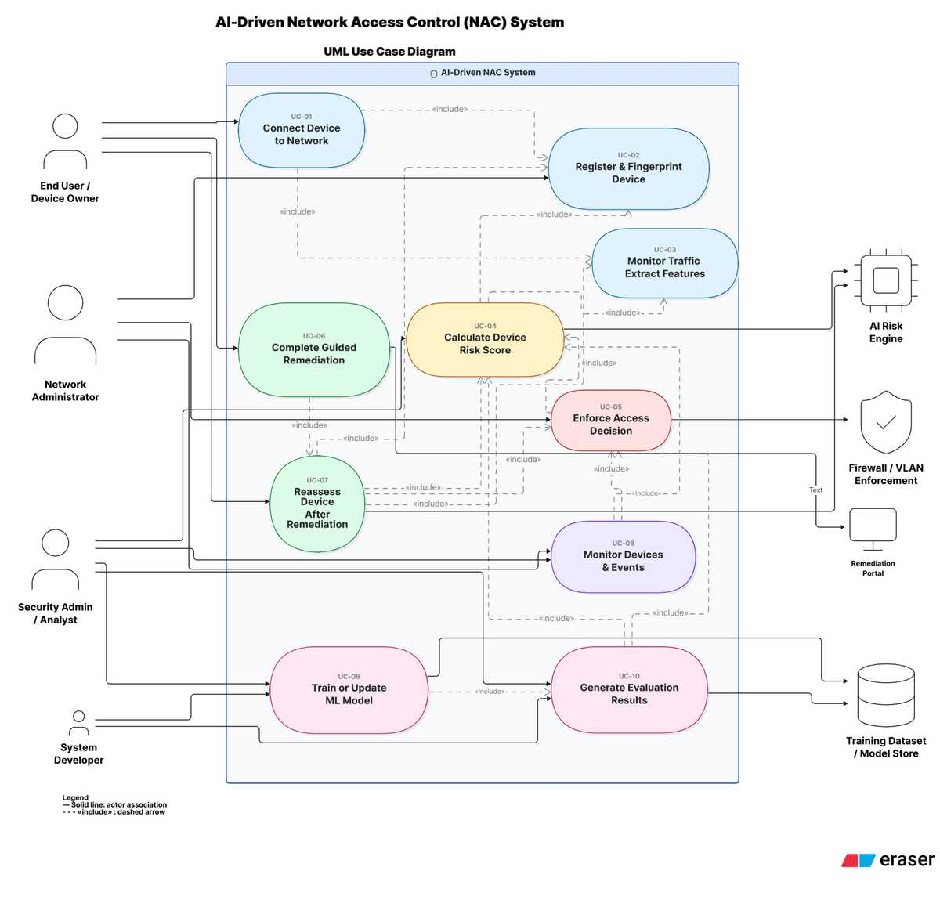

extended use case diagram:

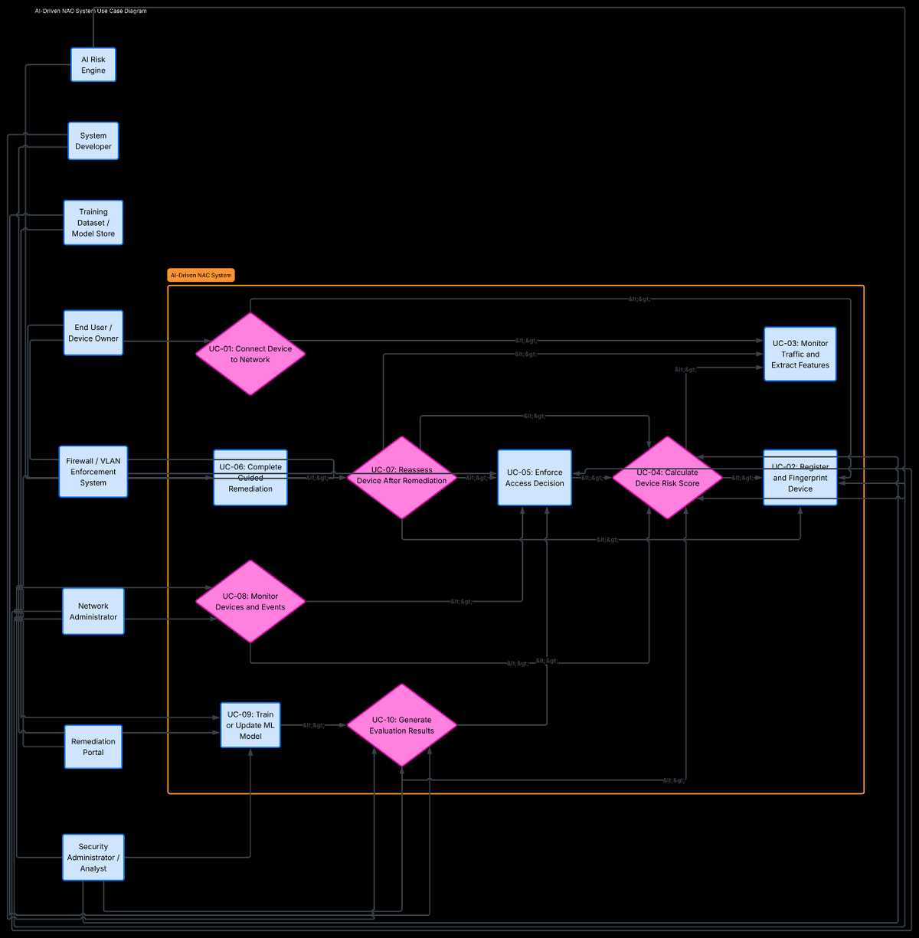

User Interfaces (Mock Screens)
The following prototype IDs indicate the initial interface screens needed for the product: These fake screens can eventually be changed with screenshots or hand-drawn figures when the UI is completed. At this point the goal is to specify what each screen must contain and how it supports the requirements and use cases.

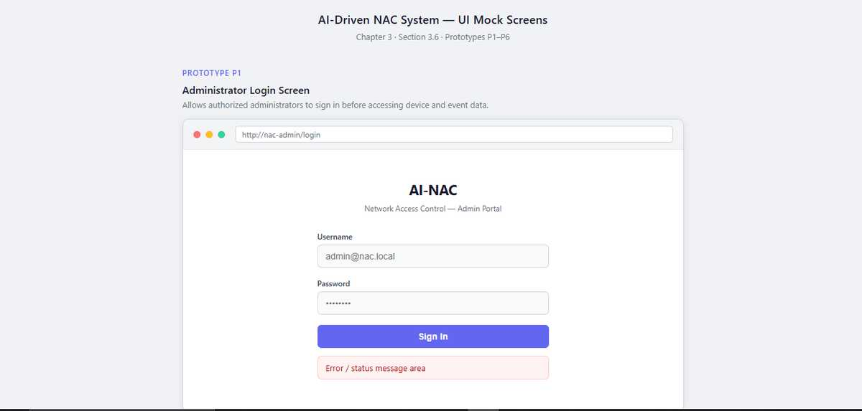
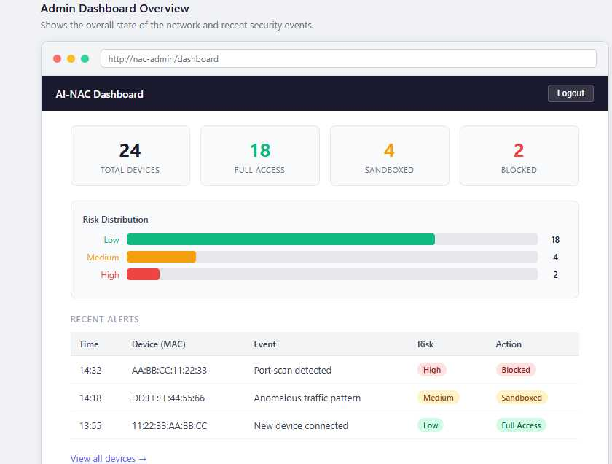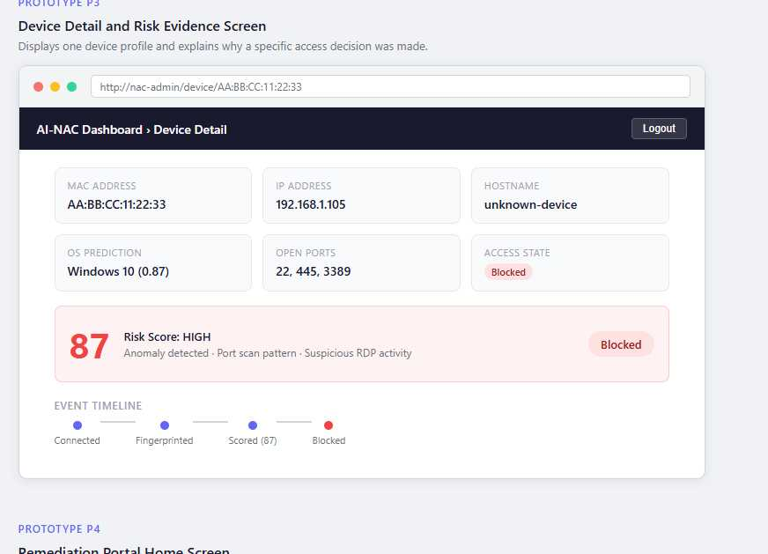
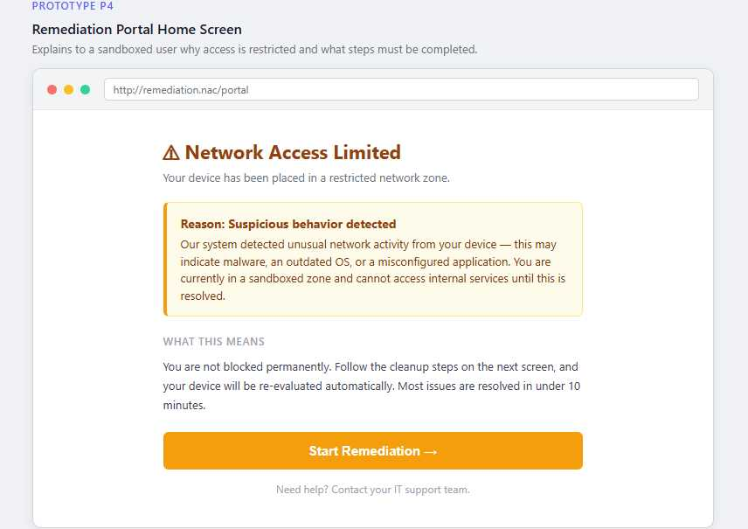
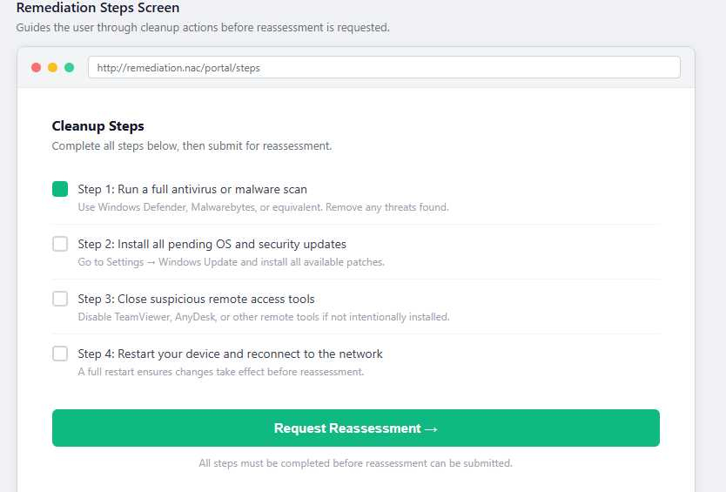
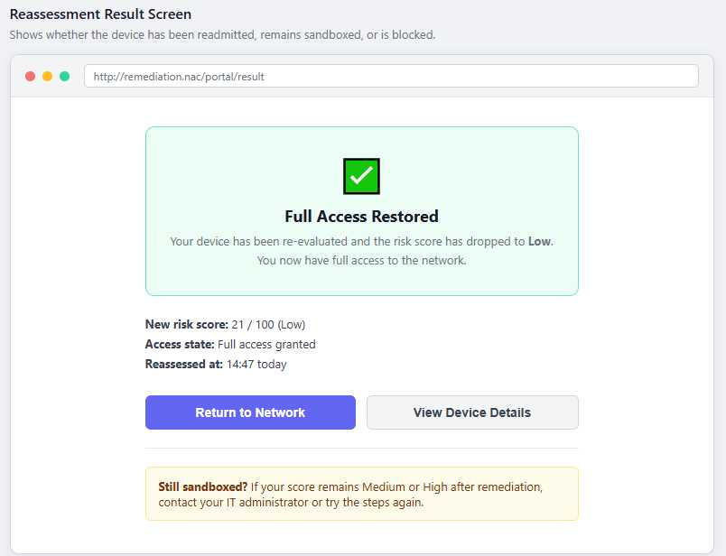

Data flow diagram (optional)

Data Flow Diagram Level 0
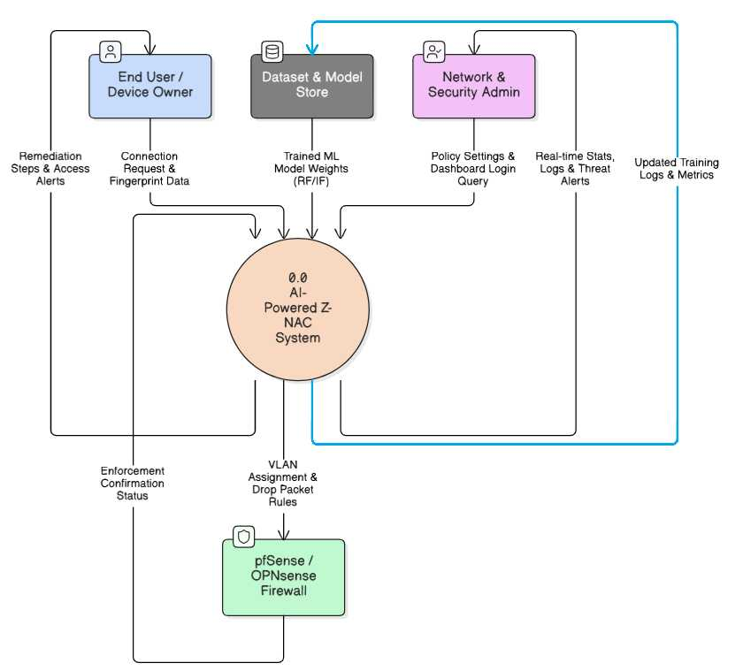

Data Flow Diagram Level 1

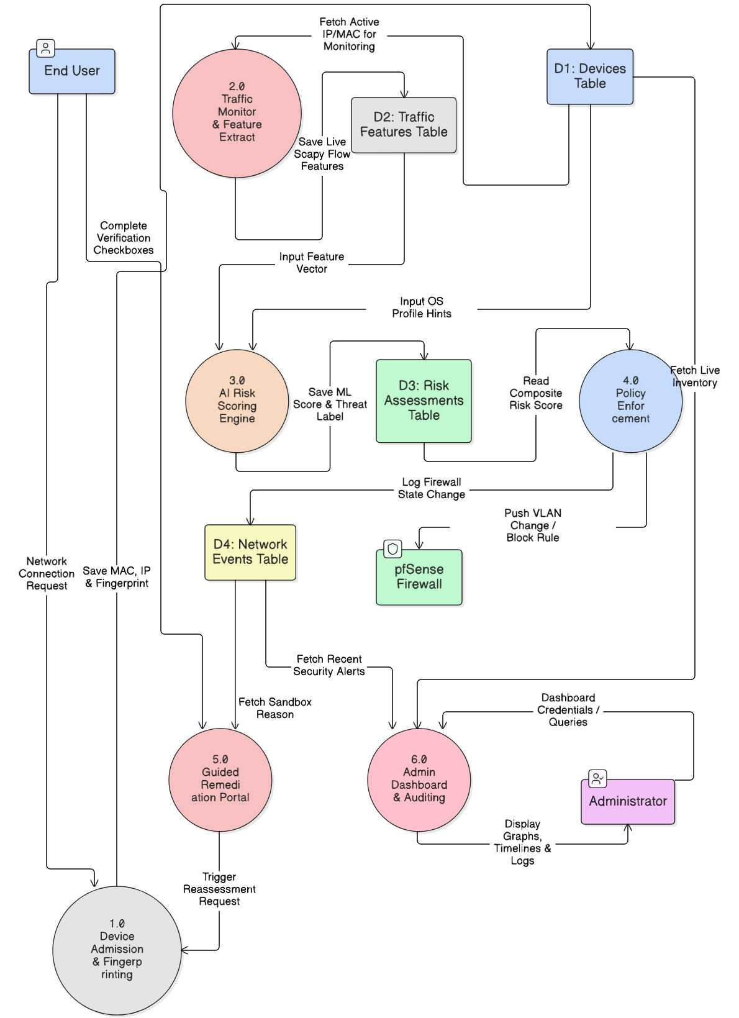

System Design

System Architecture Diagram
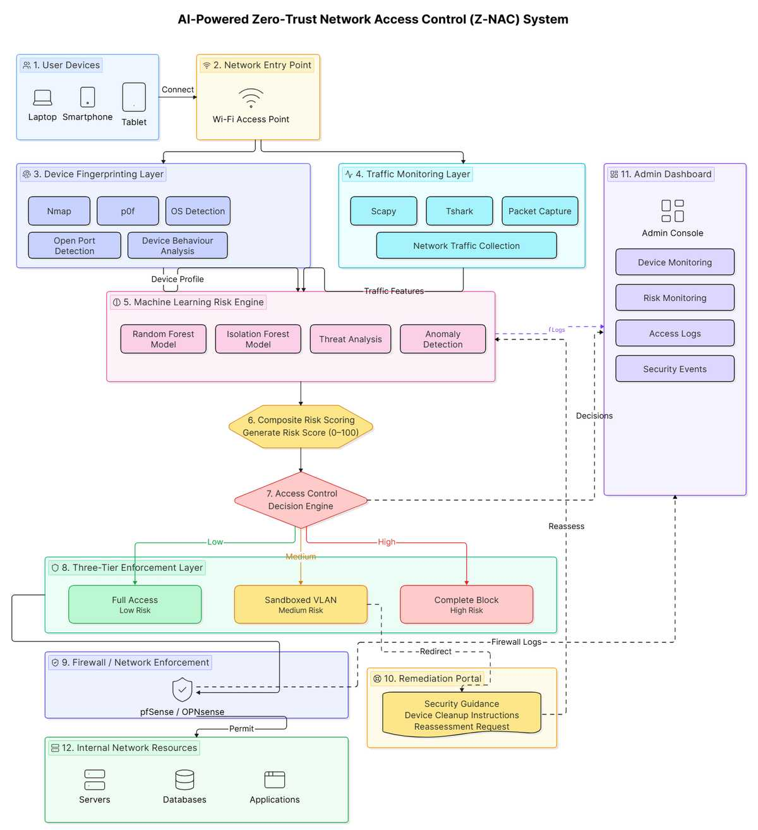
Figure 2: System Architecture

Class Diagram

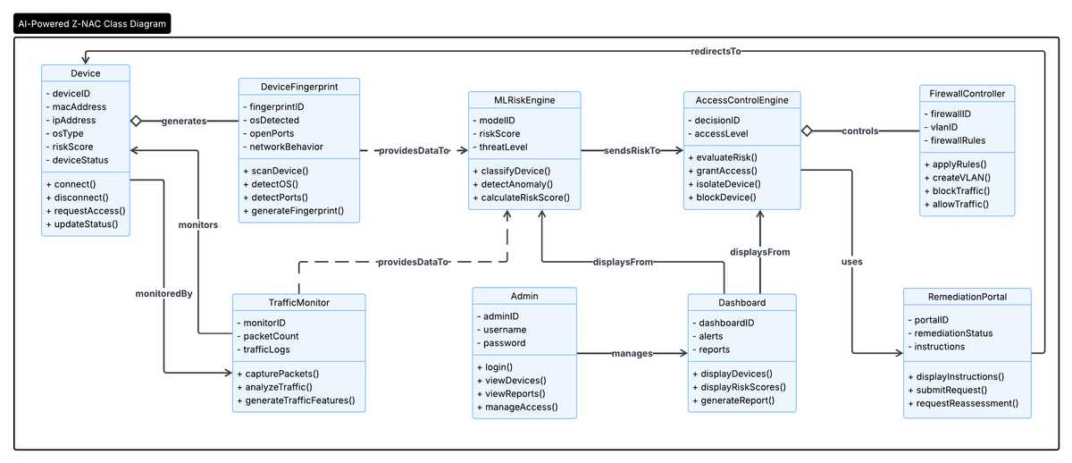

Sequence Diagrams
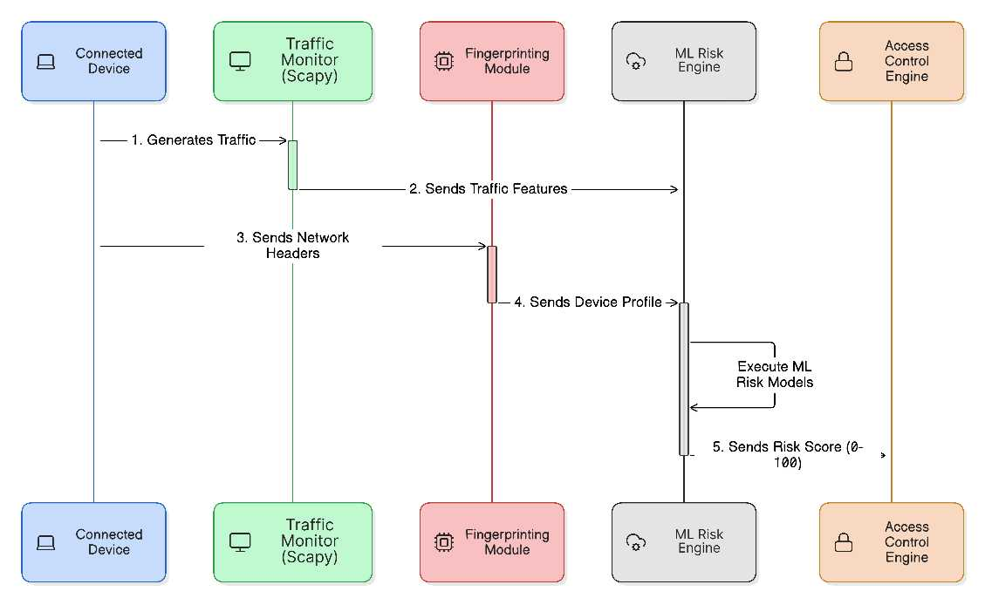
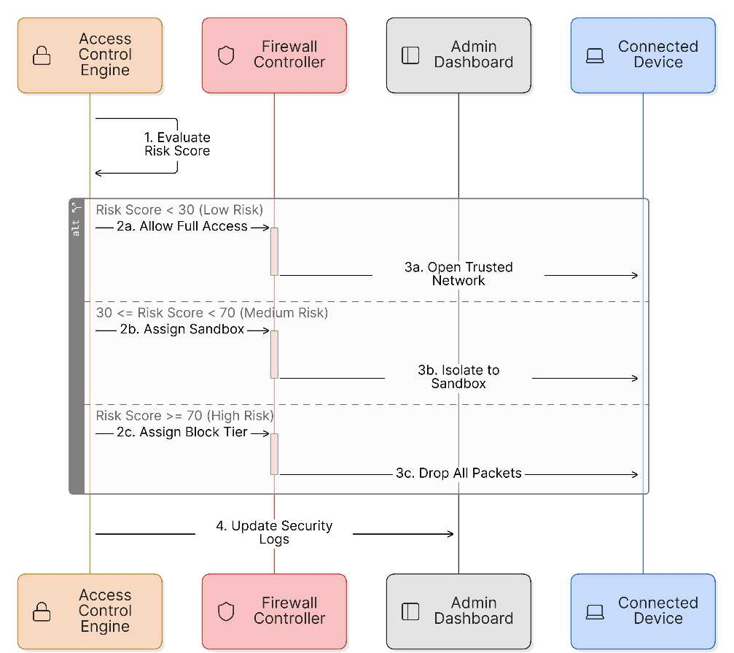
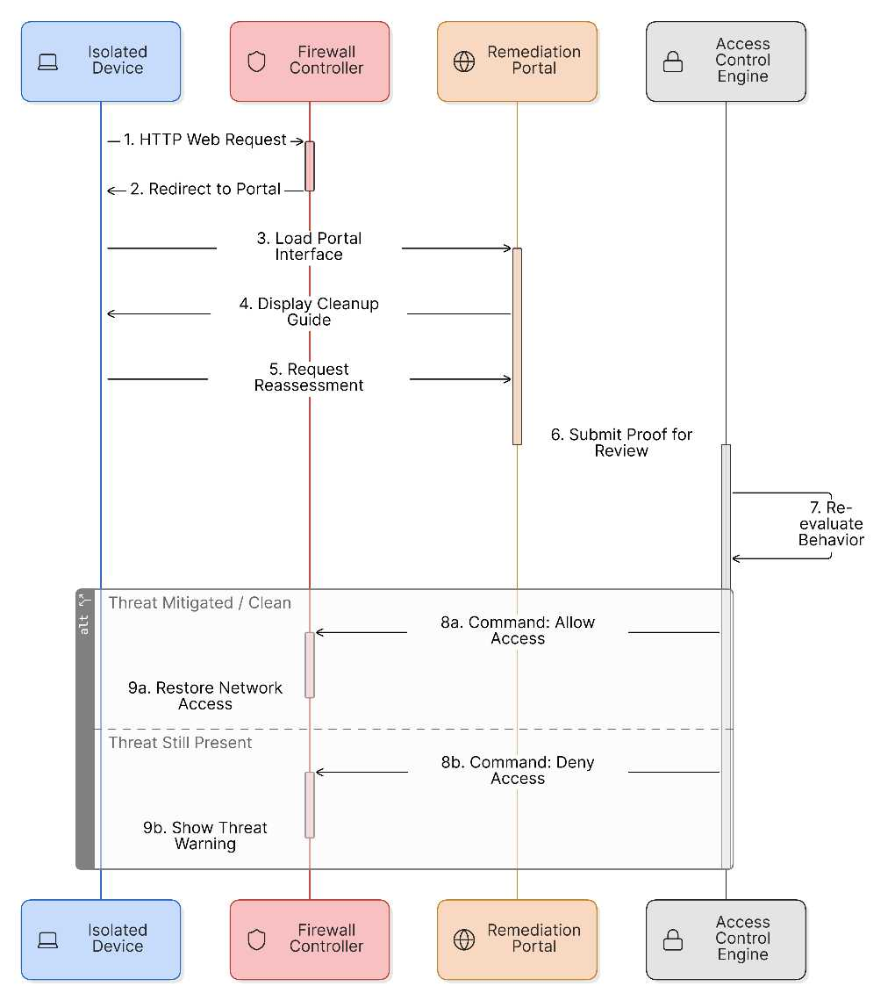

Collaboration Diagrams
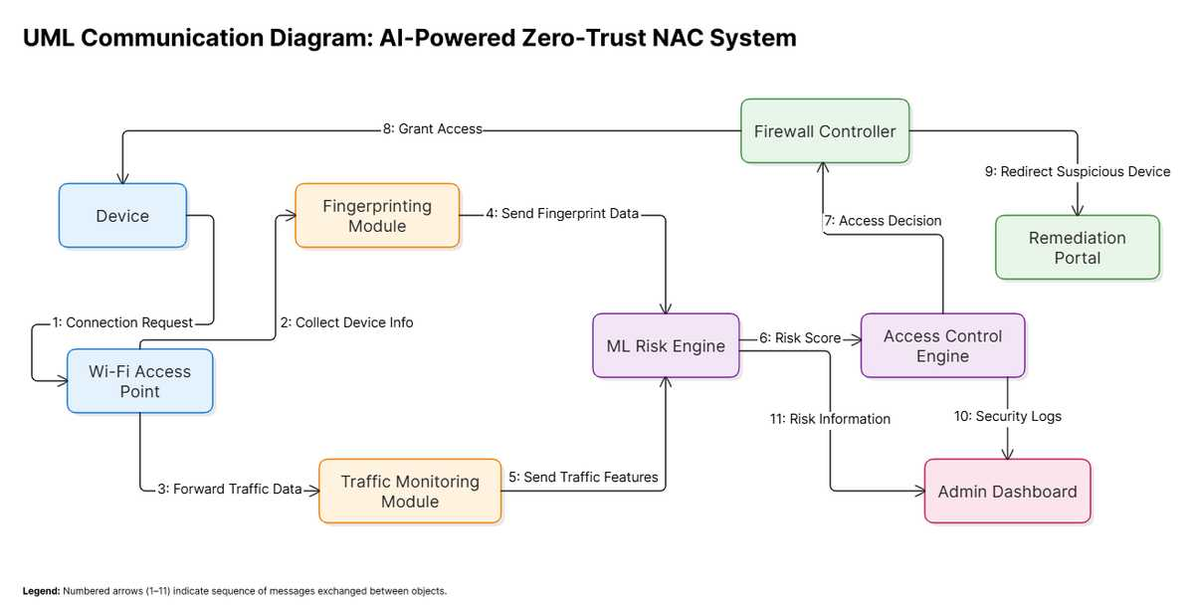

ERD
