Network Traffic Incident Reconstruction
and Alert Analysis Report
Prepared by
Hamma Jaff
Environment | Controlled incident-analysis lab
Primary tools | Wireshark, Snort
Capture set | Four sequential packet captures
Assessment focus | Traffic reconstruction, plaintext credential exposure, alert review, and suspicious activity analysis
Analyzed evidence | Network Incident Analysis - Capture 1 through Capture 4

Executive Summary
This report presents the results of a network traffic analysis conducted across four packet capture files using Wireshark and Snort. The purpose of the assessment was to reconstruct the sequence of network activity, identify suspicious behaviors, review triggered alerts, and document evidence relevant to potential intrusion or misuse within the observed environment.
The analysis covered four captures with varying duration and packet volume. Across the sessions, traffic included ARP, DNS, SSDP, NBNS, TCP, NBSS, SMB, LANMAN, ICMP, DHCPv6, DHCP, ICMPv6, IGMPv3, LLMNR, and Telnet. Particular attention was given to Telnet because it is unencrypted and exposes credentials and session contents in plaintext. The captures also showed evidence of suspicious reconnaissance-style behavior, unencrypted remote login activity, password file access, and multiple Snort alerts related to scanning and attack-response indicators.
The most significant activity was identified in Capture 3, where Telnet login activity from 192.168.57.1 to the Metasploitable host 192.168.57.134 exposed credentials in cleartext, followed by interaction with other internal systems and retrieval of a password file. While some behaviors are clearly suspicious, the report documents them as observed traffic patterns and likely attack stages rather than over-claiming certainty beyond the packet evidence.

Introduction
This assessment was conducted to review four related packet capture files and determine whether the combined traffic indicated suspicious or malicious activity within the monitored office enclave. Wireshark was used to inspect packet contents, reconstruct communication flow, and identify notable protocol behavior, while Snort alert output was reviewed to understand what detection signatures were triggered during the sessions.
The analysis focused on timeline correlation, packet volume, protocol exposure, internal host relationships, suspicious authentication behavior, file-access activity, and alert context. The goal was to produce a defensible incident narrative based on observed network evidence.

Scope
This assessment was limited to review of the following packet capture files:
- Network Incident Analysis - Capture 1.pcapng
- Network Incident Analysis - Capture 2.pcapng
- Network Incident Analysis - Capture 3.pcapng
- Network Incident Analysis - Capture 4.pcapng
The review included session duration comparison, packet and byte counts, protocol identification, network enclave overview, reconstruction of observed events, review of Snort-triggered alerts, and identification of suspicious traffic patterns and likely attack progression. The analysis was conducted in a controlled environment for technical incident review and documentation.

Methodology
The four captures were reviewed sequentially to determine whether the sessions formed a related timeline of activity. Initial analysis compared session length, packet counts, byte volume, and protocols observed in each file. Traffic was then examined for evidence of authentication activity, host-to-host interaction, file access, scanning behavior, and other suspicious patterns.
Particular attention was given to Telnet traffic because plaintext sessions can reveal credentials and command activity directly. Snort alert output associated with each capture was then reviewed to correlate signature-based detection with the observed packet evidence. Findings were documented conservatively, separating directly visible facts from conclusions that would require corroborating endpoint or log data.

Assessment Snapshot
Capture | Duration | Packets | Primary value
Capture 1 | 1m 09s | 83 | Low-significance baseline activity
Capture 2 | 1m 50s | 303 | Suspicious cross-host interaction
Capture 3 | 14m 12s | 3,267 | Primary investigative session
Capture 4 | 2m 31s | 219 | Lower-significance follow-on traffic

Findings and Analysis

1. Session Timeline and Capture Volume
The four packet captures represent separate sessions with different durations: Capture 1 (1 minute 9 seconds), Capture 2 (1 minute 50 seconds), Capture 3 (14 minutes 12 seconds), and Capture 4 (2 minutes 31 seconds). Packet counts also varied significantly, with 83 packets in Capture 1, 303 in Capture 2, 3,267 in Capture 3, and 219 in Capture 4. Byte volume followed a similar pattern, indicating that Capture 3 contains the most operationally significant activity and should be treated as the primary focus of the incident narrative.

2. Correlation Across Captures
The sessions appear sequentially correlated, with traffic from Capture 1 followed by Capture 2 and continuing through later sessions. Based on the described timing and flow, this suggests that the captures reflect different phases of a broader activity chain rather than unrelated isolated sessions.

3. Protocol Exposure
Observed protocols included ARP, DNS, SSDP, NBNS, TCP, NBSS, SMB, LANMAN, ICMP, DHCPv6, DHCP, ICMPv6, IGMPv3, LLMNR, and Telnet. Of these, Telnet is the most security-sensitive because it transmits credentials and session contents in cleartext, making it especially important in an incident review.

4. Office Enclave Overview
The office enclave is centered on the 192.168.57.0 network, with relevant hosts including 192.168.57.1, 192.168.57.130, 192.168.57.134 (Metasploitable host), 192.168.57.135 (Windows Server 2003), 192.168.57.141, and 192.168.57.144 (Windows host). This host mapping helps interpret later internal movement and file-access behavior.

5. Capture 1 Findings
Capture 1 showed no meaningful malicious trace based on the source evidence. Relative to later captures, it appears to represent lower-significance or background activity.

6. Capture 2 Findings
In Capture 2, host 192.168.57.1 appeared to attempt directory creation on a Linux system from a Windows system. This is notable because it suggests cross-host file-system interaction or remote administrative behavior, but it is best documented as suspicious system interaction rather than definitive malicious activity.

7. Capture 3 Findings: Telnet Authentication and File Access
Capture 3 contains the most significant evidence. The packet data shows a Telnet login from 192.168.57.1 to 192.168.57.134, with plaintext credentials visible as msfadmin / msfadmin. After the login, the originating system established communication with 192.168.57.144 and retrieved a password file named passwords.txt. The source material also indicates that credential data was visible in the file and that the file was later copied to another host. Taken together, this sequence strongly suggests insecure credential handling and suspicious internal staging or lateral activity.

8. Capture 4 Findings
Capture 4 does not show significant malicious trace based on the documented evidence. It appears to be lower-significance follow-on traffic after the more notable events in Capture 3.

9. Suspicious Behaviors and Likely Attack Progression
The strongest supported findings are the plaintext Telnet session, credential exposure, password file retrieval, and scan-like behavior reflected in packet observations and alerts. Claims of confirmed ARP spoofing should be softened unless the packet evidence specifically demonstrates duplicate claims, conflicting MAC-to-IP mappings, or other clear spoofing indicators.

10. Snort Alert Review
Snort analysis across the captures triggered multiple alerts, including UPnP discovery attempts, ICMP-related detections, directory-listing alerts, and network-scan indicators. These alerts are useful for triage and support the broader conclusion that suspicious scanning and interaction activity occurred. They should be treated as supporting evidence and correlated with the packet data rather than used alone to prove intent or impact.

Alert Review Summary
- Capture 1 triggered multiple alerts, including UPnP discovery-related detections.
- Capture 2 included both UPnP discovery-related alerts and ICMP-related detections.
- Capture 3 generated more significant alerts, including directory-listing and scan-related detections.
- Later alert output also indicated scan behavior consistent with reconnaissance activity.

Recommendations
- Eliminate use of Telnet and replace it with encrypted remote administration protocols.
- Review systems using default or weak credentials, especially those exposed internally.
- Investigate the origin and contents of passwords.txt and determine whether any exposed credentials remain active.
- Review host activity on 192.168.57.1, 192.168.57.134, 192.168.57.144, and 192.168.57.2 for corroborating endpoint evidence.
- Correlate Snort alerts with packet timestamps, host logs, and authentication logs to validate the full incident sequence.
- Review the network for evidence of scanning, plaintext credential use, and suspicious file transfer activity.
- Do not classify ARP spoofing as confirmed unless the packet evidence specifically supports that conclusion.

Conclusion
This assessment reviewed four related network captures and reconstructed a likely sequence of suspicious activity within the office enclave. While Capture 1 and Capture 4 showed limited investigative value, Capture 2 and especially Capture 3 contained more meaningful evidence. The strongest findings include plaintext Telnet authentication using visible credentials, likely internal host interaction, download of a password file, and subsequent file-transfer behavior. Snort alerts further support the presence of reconnaissance and suspicious network activity.
The evidence is most appropriately characterized as suspicious network activity consistent with reconnaissance, insecure remote access, and sensitive file handling within the enclave. This framing is more accurate and more professionally defensible than asserting confirmed attack categories without corroborating host-level evidence.

Appendix A: Session Evidence
The following figures document notable packet evidence observed during Wireshark review, including suspicious cross-host interaction, plaintext Telnet activity, credential exposure, and password file handling.
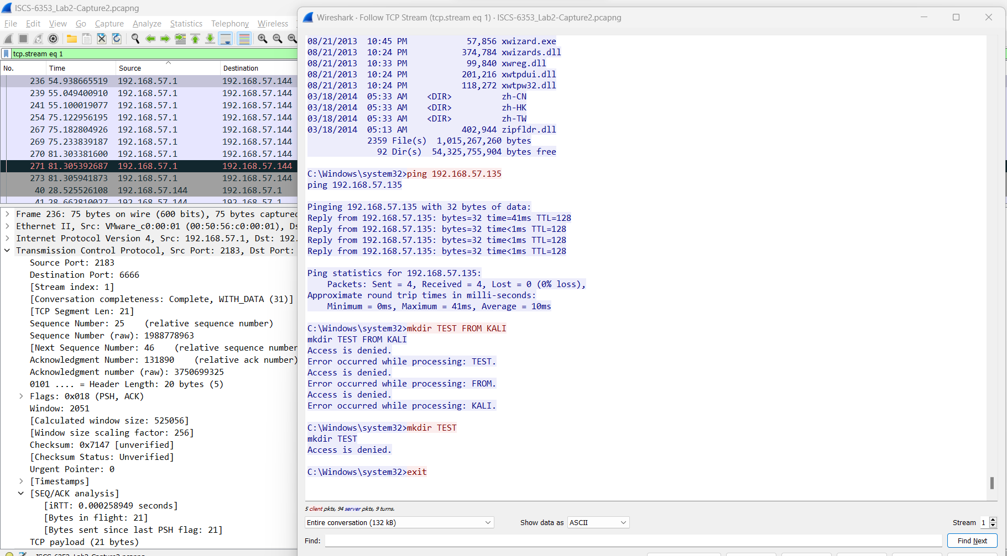
Figure A1. Wireshark review of suspicious directory-creation activity associated with Capture 2.
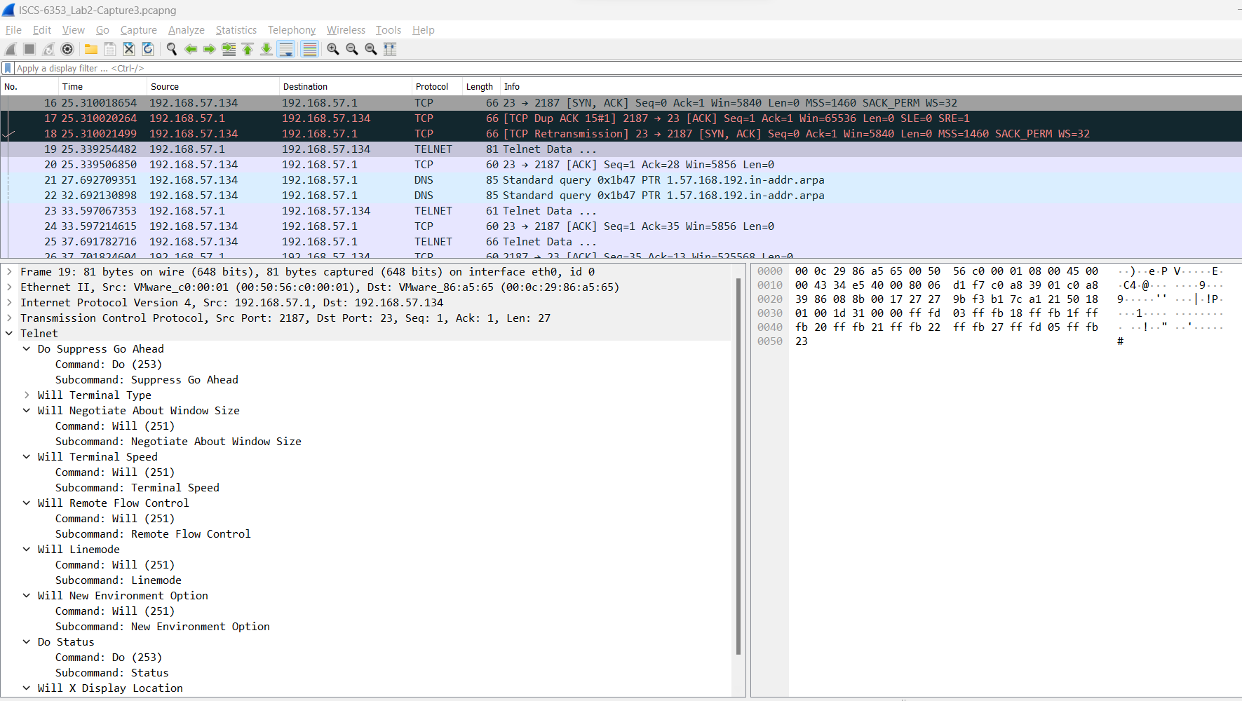
Figure A2. Plaintext Telnet session observed in Capture 3, showing unencrypted remote access traffic.
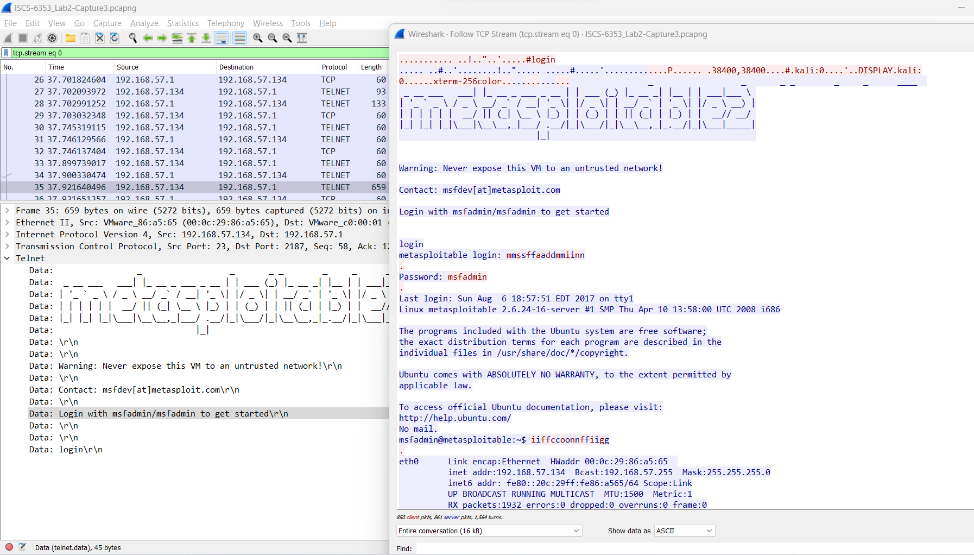
Figure A3. Telnet login to the Metasploitable host using visible plaintext credentials in Capture 3.
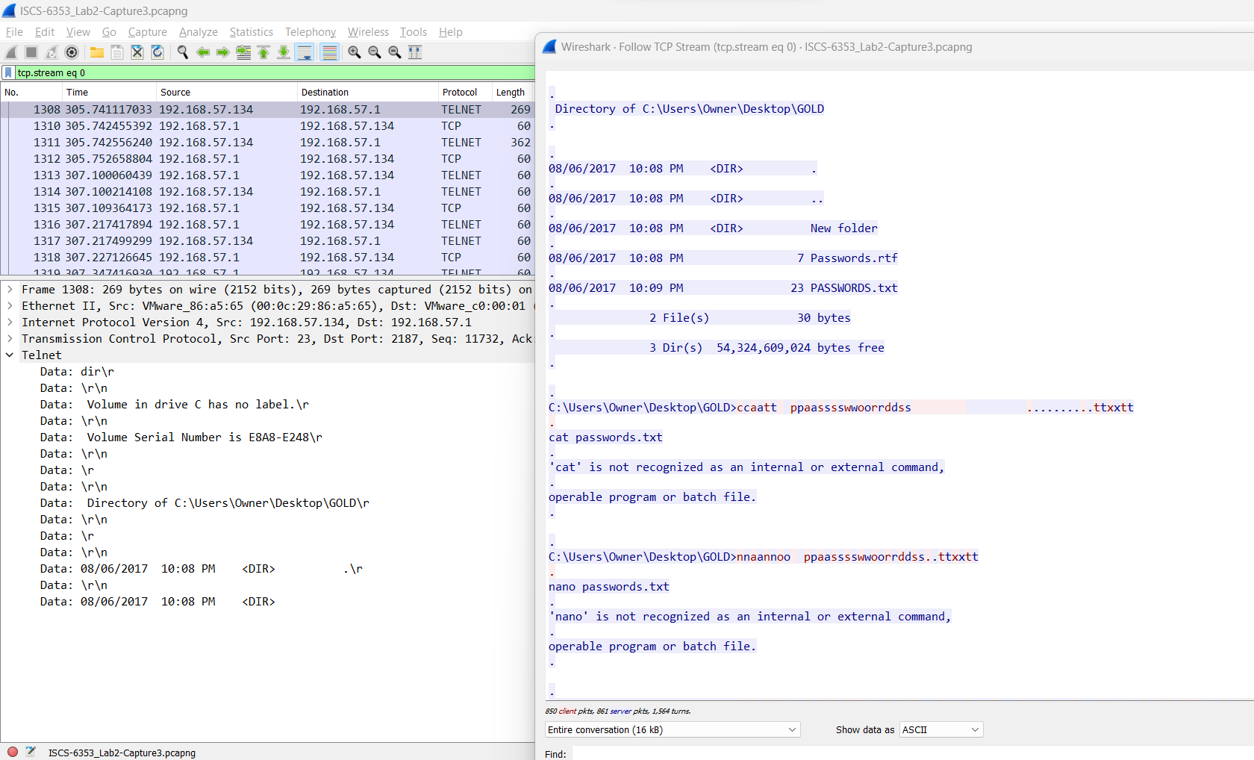
Figure A4. Subsequent host interaction following the Telnet session, showing communication with another internal system.
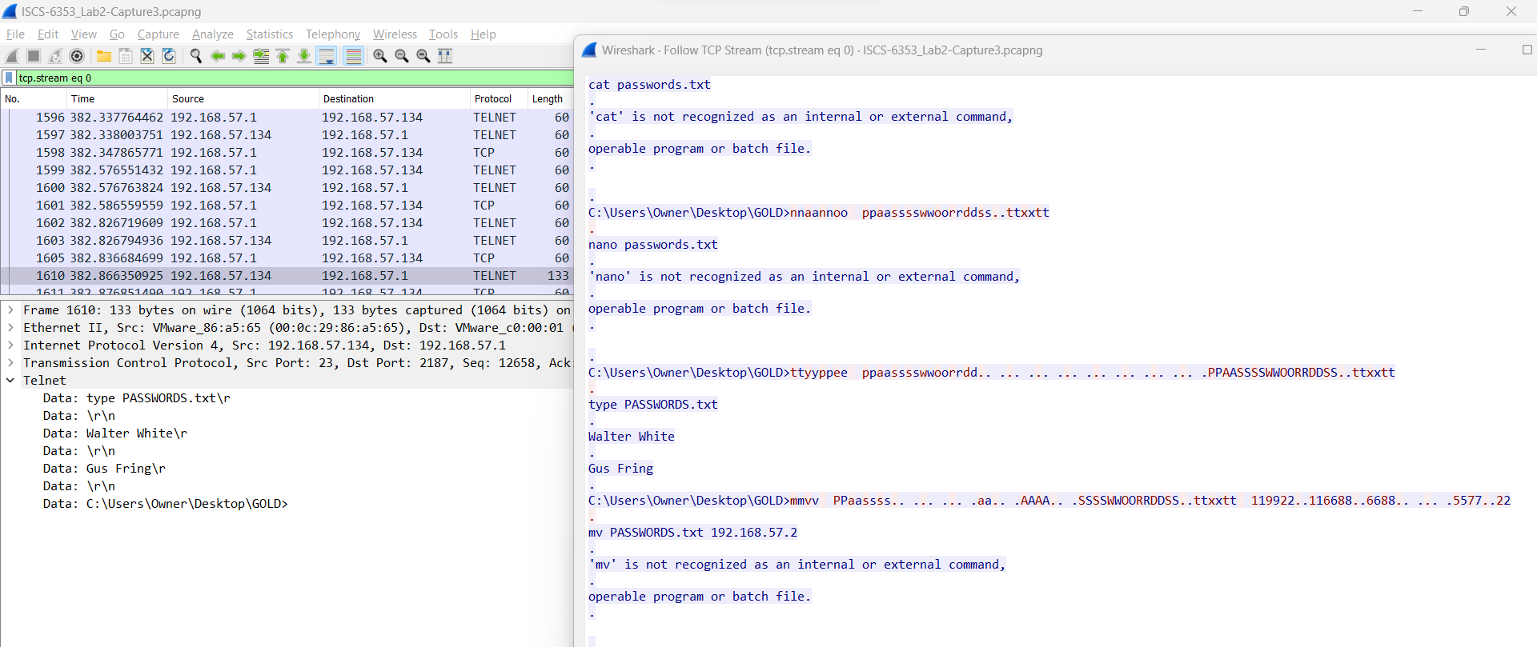
Figure A5. Retrieval of a password file from an internal Windows host during the Capture 3 activity sequence.
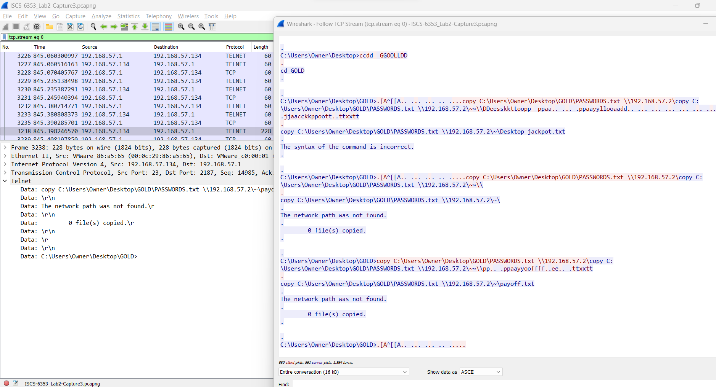
Figure A6. Contents of the retrieved password file showing exposed credential data.

Appendix B: Snort Alert Evidence
These figures capture the alert-review workflow across the four sessions, combining Snort output with packet-level views used to validate the underlying network activity.
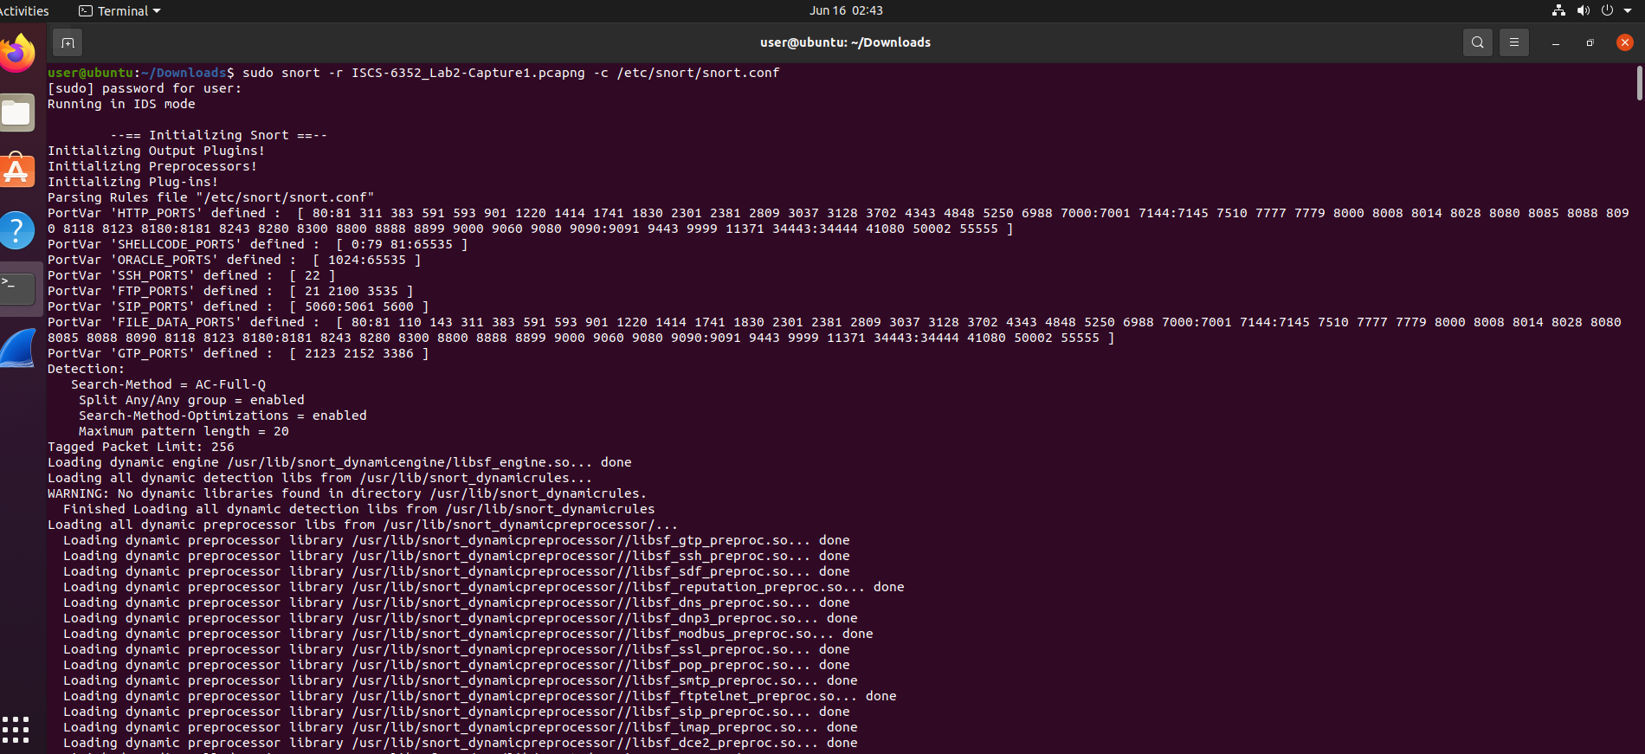
Figure B1. Snort alert output associated with Capture 1, including discovery-related detections.
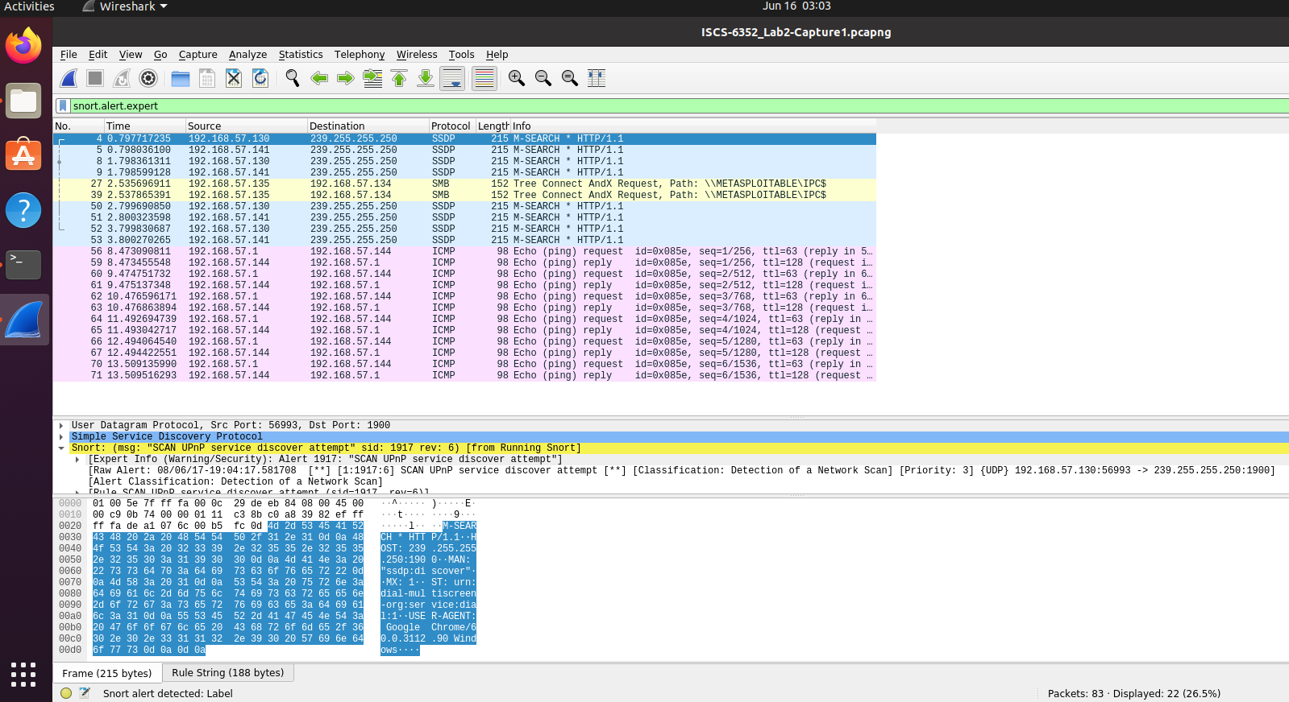
Figure B2. Packet view correlated with Capture 1 during alert review in Wireshark.
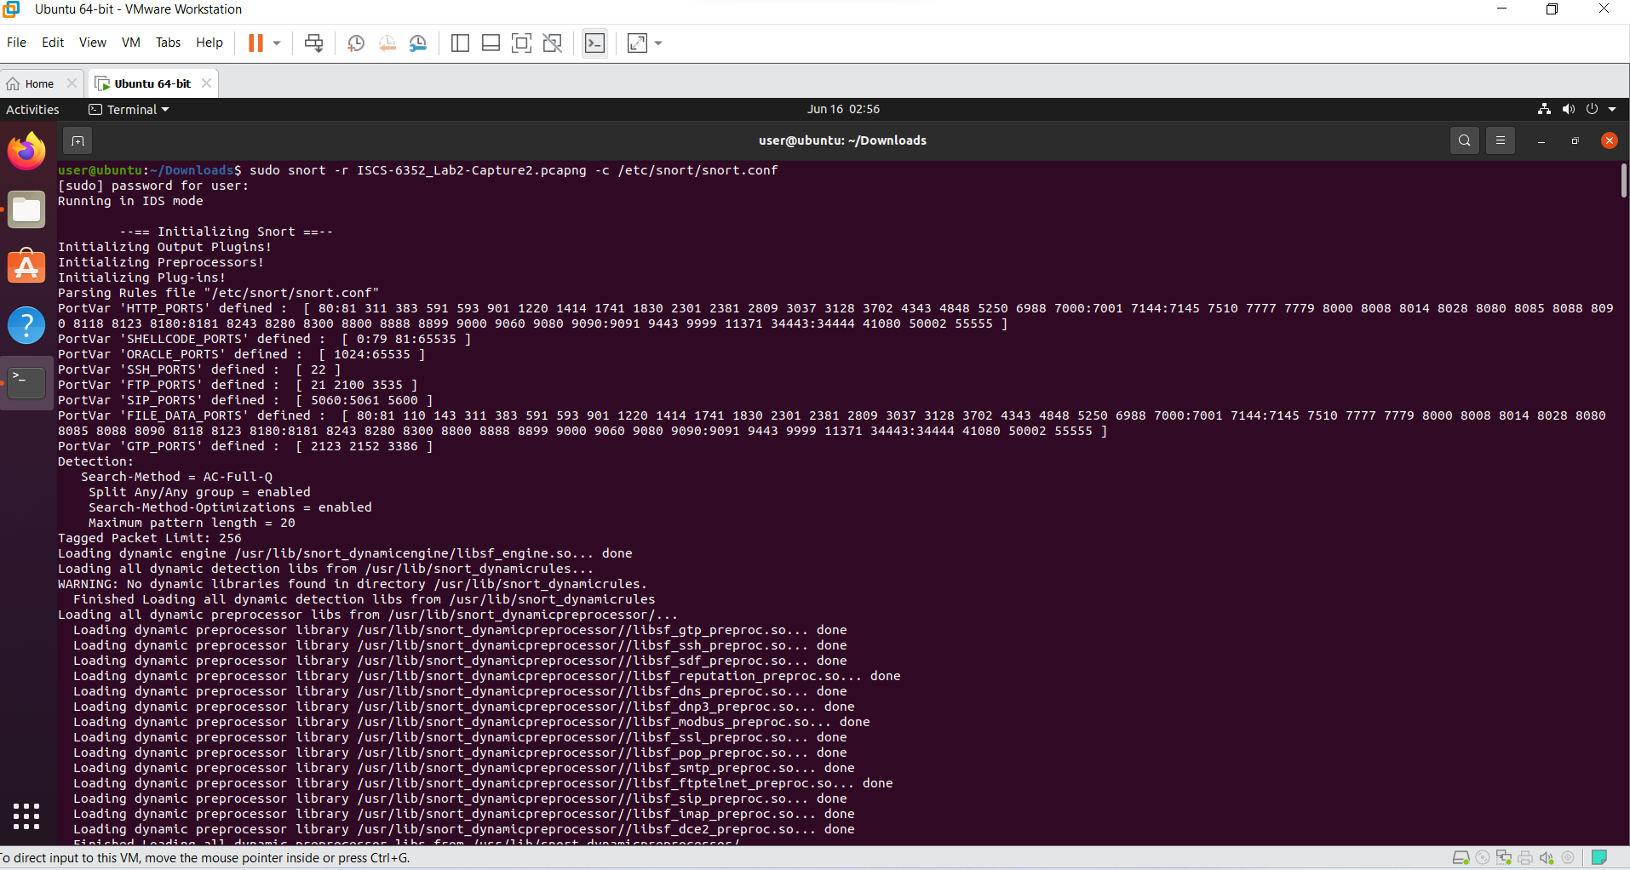
Figure B3. Snort alert output associated with Capture 2, including network discovery and ICMP-related detections.
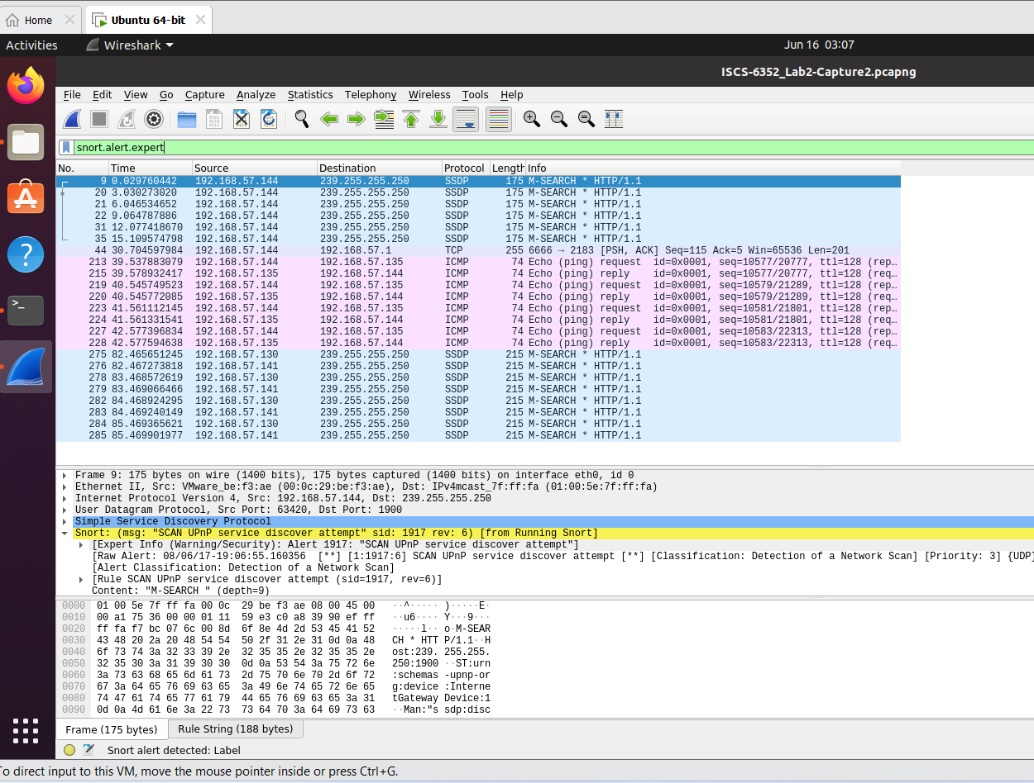
Figure B4. Packet view correlated with Capture 2 during alert validation in Wireshark.
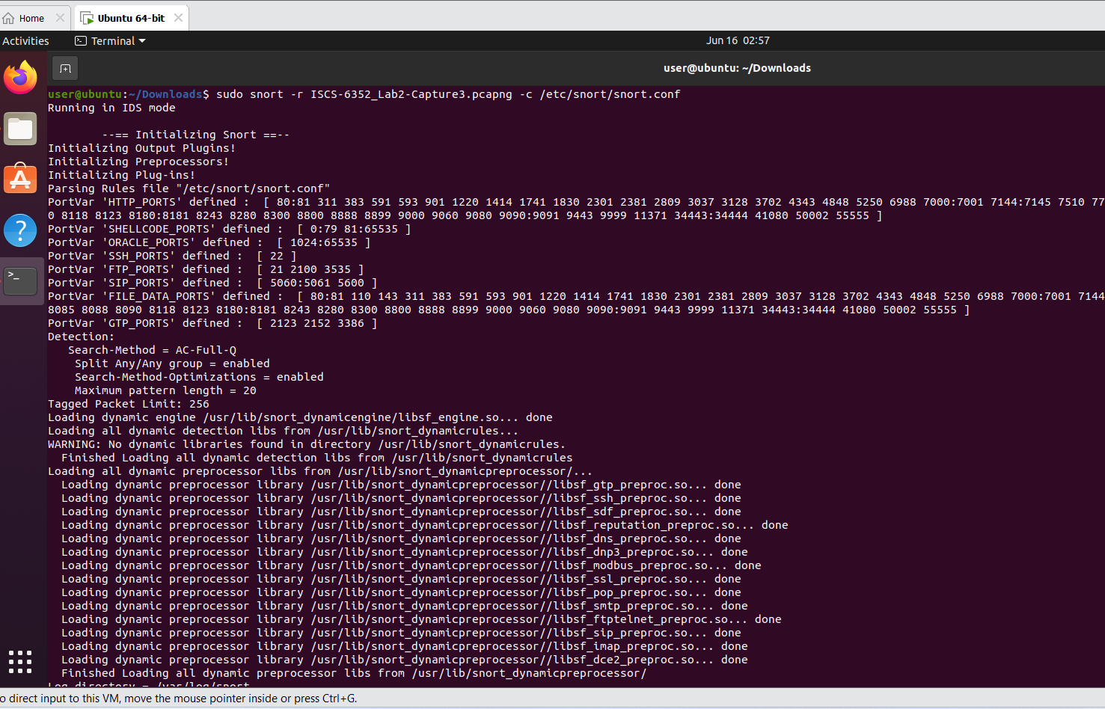
Figure B5. Snort alert output associated with Capture 3, showing directory-listing and scan-related detections.
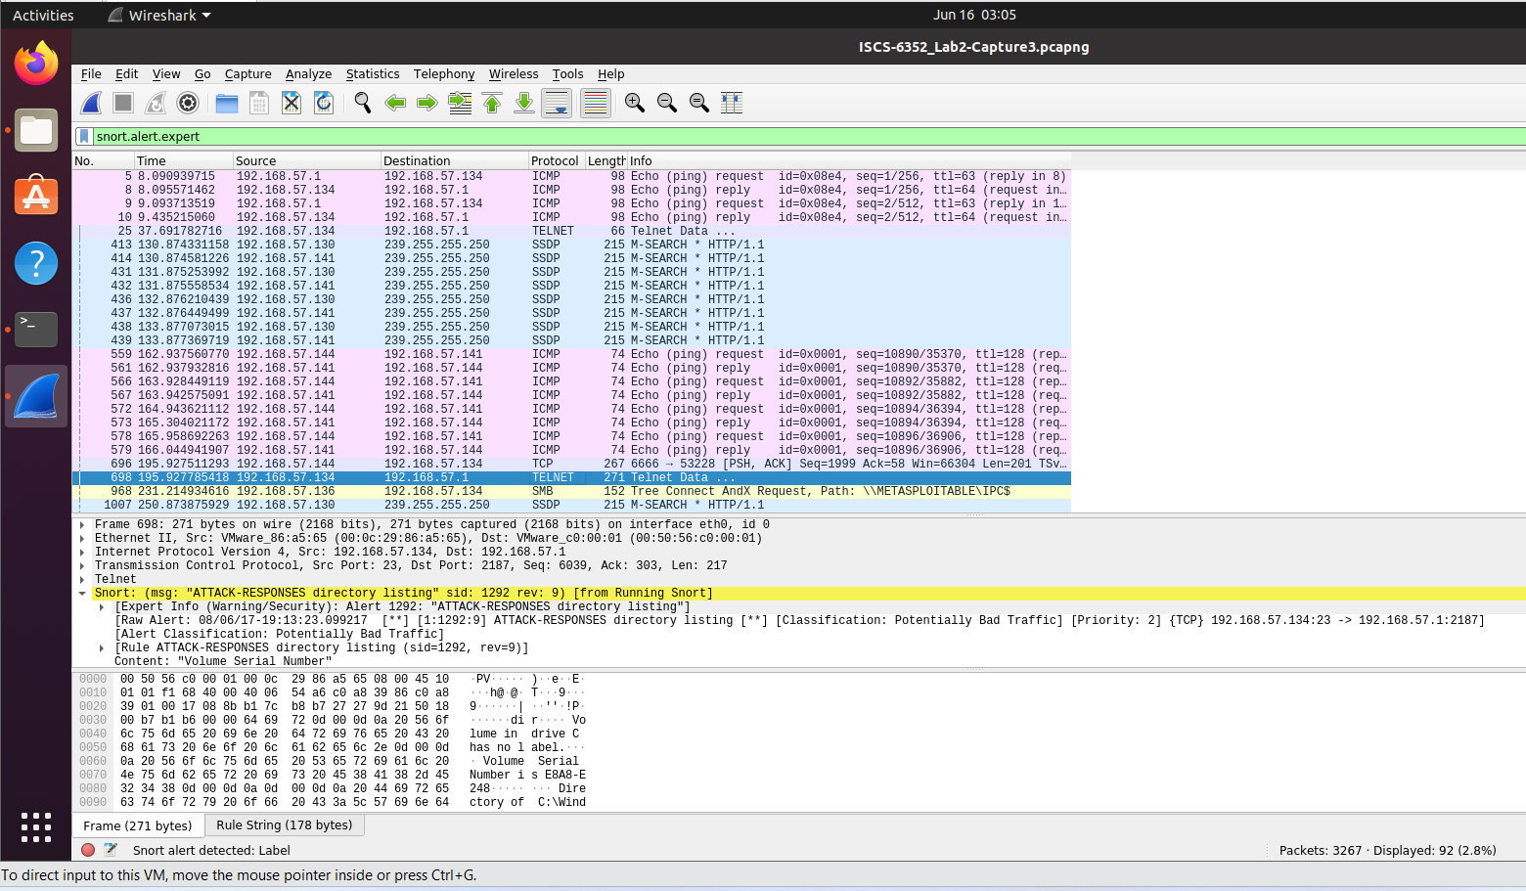
Figure B6. Packet view correlated with Capture 3 during alert validation in Wireshark.
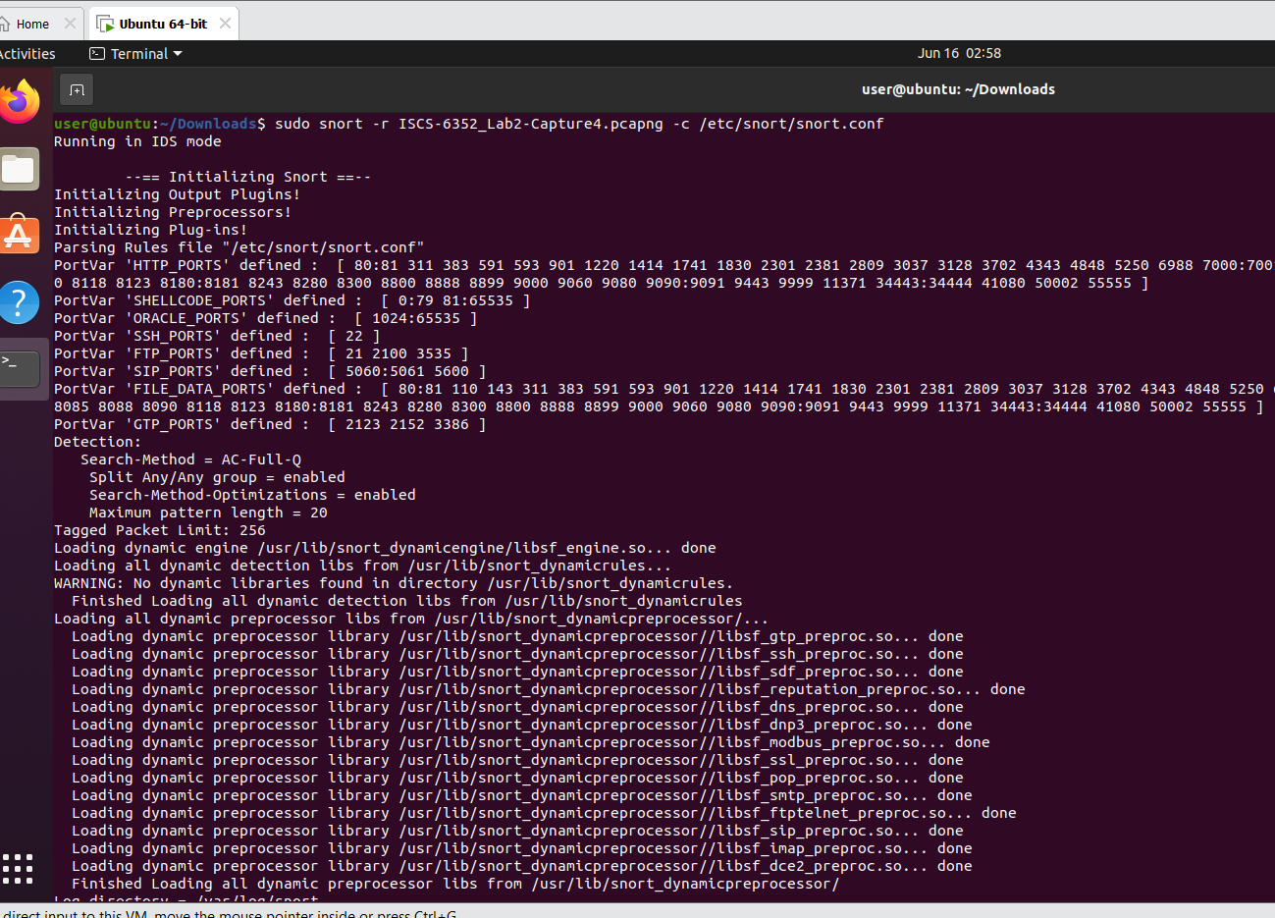
Figure B7. Snort alert output associated with Capture 4 and later scan-related alert review.
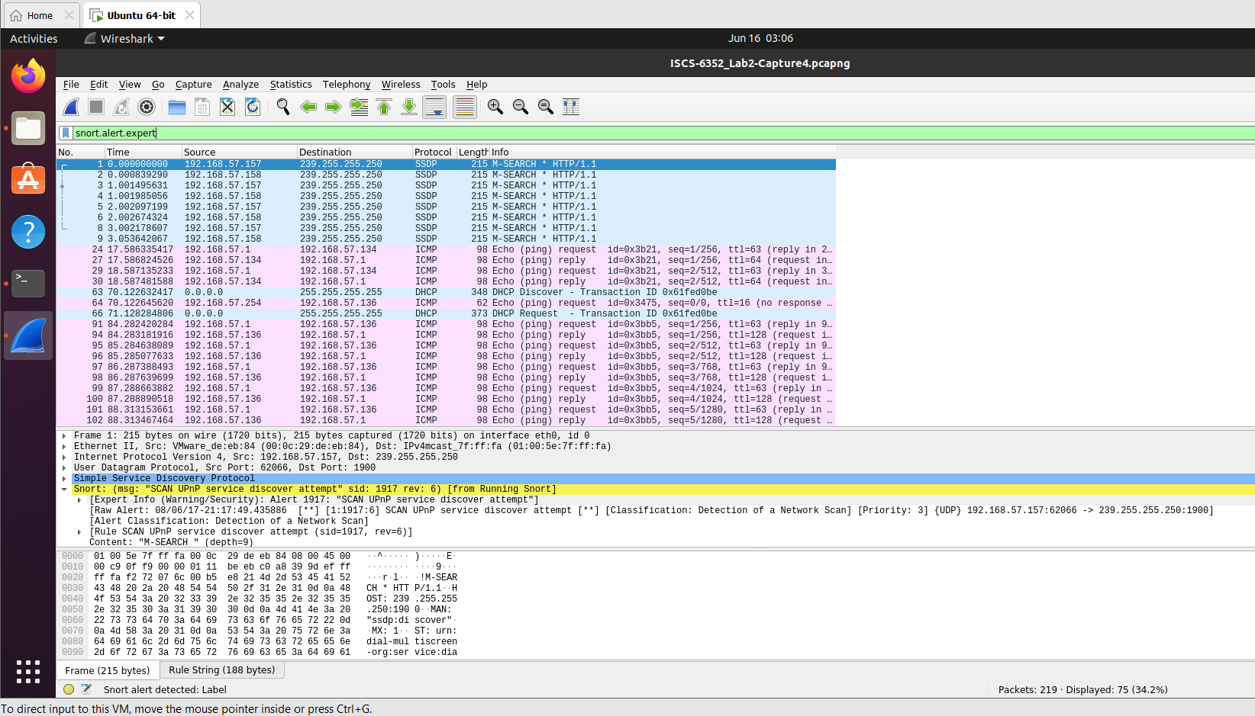
Figure B8. Packet view correlated with Capture 4 during alert validation in Wireshark.

