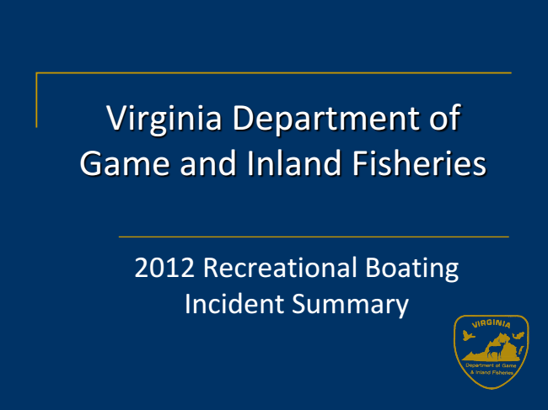

Virginia Department of Game and Inland Fisheries

2012 Recreational Boating Incident Summary

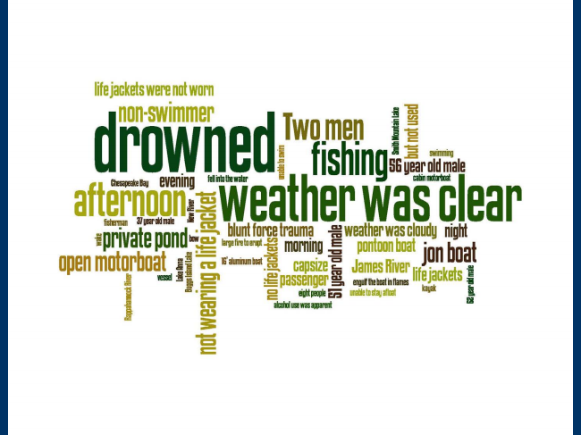

2

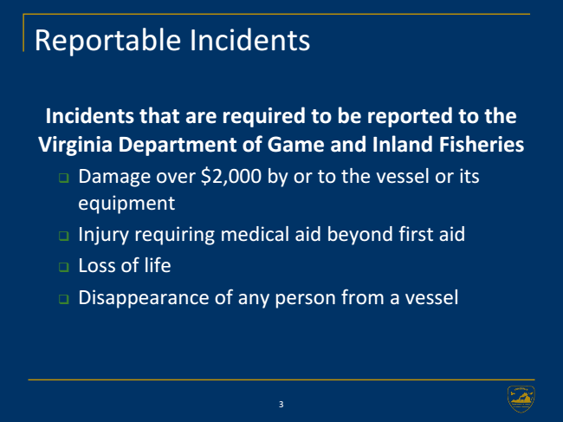

Reportable Incidents

**Incidents that are required to be reported to the Virginia Department of Game and Inland Fisheries**

❑

Damage over $2,000 by or to the vessel or its equipment

❑

Injury requiring medical aid beyond first aid

❑

Loss of life

❑

Disappearance of any person from a vessel

3

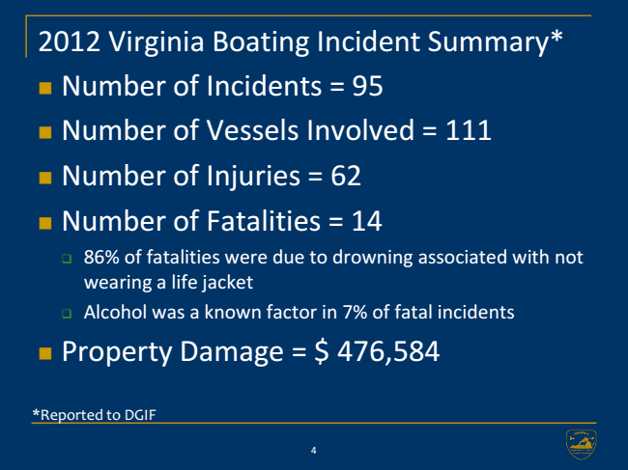

2012 Virginia Boating Incident Summary*

∎

Number of Incidents = 95

∎

Number of Vessels Involved = 111

∎

Number of Injuries = 62

∎

Number of Fatalities = 14

❑

86% of fatalities were due to drowning associated with not wearing a life jacket

❑

Alcohol was a known factor in 7% of fatal incidents

∎

Property Damage = $ 476,584

*Reported to DGIF

4

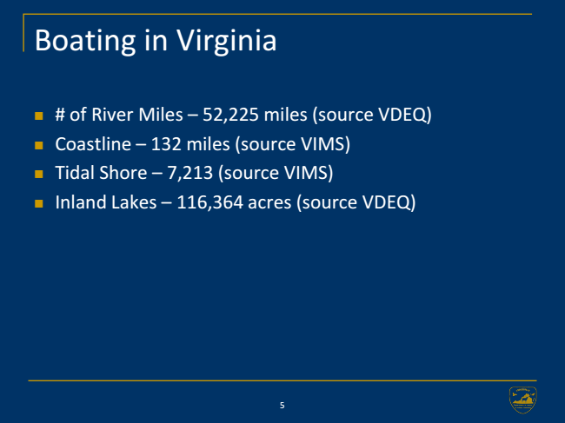

Boating in Virginia

∎

# of River Miles – 52,225 miles (source VDEQ)

∎

Coastline – 132 miles (source VIMS)

∎

Tidal Shore – 7,213 (source VIMS)

∎

Inland Lakes – 116,364 acres (source VDEQ)

5

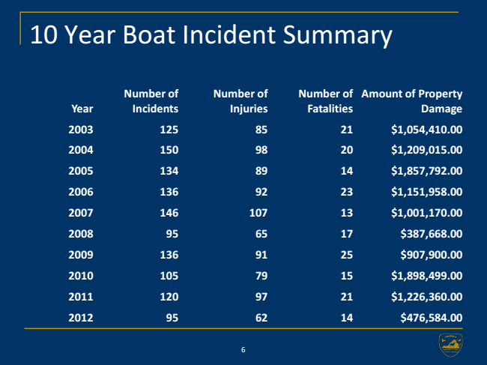

10 Year Boat Incident Summary

**Number of Incidents**

**6 Number of Injuries**

**Number of Fatalities**

**Amount of Property Year**

**Damage**

**2003 125 85 21 $1,054,410.00**

**2004 150 98 20 $1,209,015.00**

**2005 134 89 14 $1,857,792.00**

**2006 136 92 23 $1,151,958.00**

**2007 146 107 13 $1,001,170.00**

**2008 95 65 17 $387,668.00**

**2009 136 91 25 $907,900.00**

**2010 105 79 15 $1,898,499.00**

**2011 120 97 21 $1,226,360.00**

**2012 95 62 14 $476,584.00**

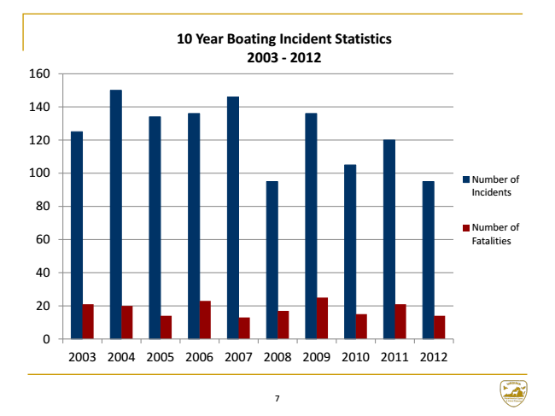

**10 Year Boating Incident Statistics 2003 - 2012 160**

140

120

100

Number of Incidents 80

60

Number of Fatalities

40

20

0

2003 2004 2005 2006 2007 2008 2009 2010 2011 2012

7

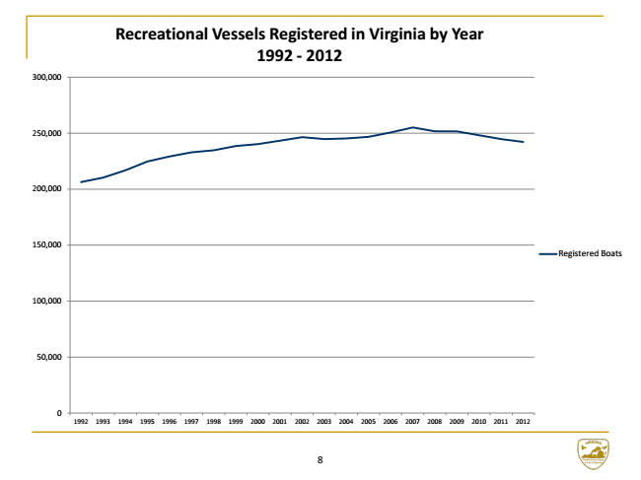

**Recreational Vessels Registered in Virginia by Year 1992 - 2012**

300,000

250,000

200,000

150,000

Registered Boats

100,000

50,000

0

1992 1993 1994 1995 1996 1997 1998 1999 2000 2001 2002 2003 2004 2005 2006 2007 2008 2009 2010 2011 2012

8

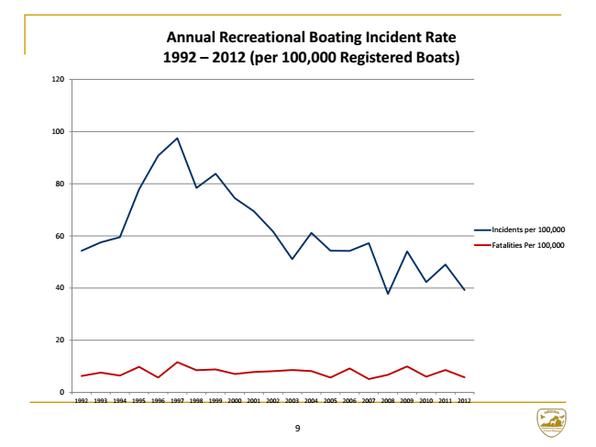

**Annual Recreational Boating Incident Rate 1992 – 2012 (per 100,000 Registered Boats)**

120

100

80

60

Incidents per 100,000

Fatalities Per 100,000

40

20

0

1992 1993 1994 1995 1996 1997 1998 1999 2000 2001 2002 2003 2004 2005 2006 2007 2008 2009 2010 2011 2012

9

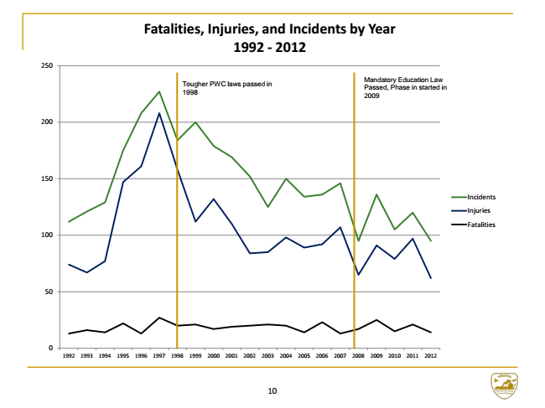

**Fatalities, Injuries, and Incidents by Year 1992 - 2012**

250

Tougher PWC laws passed in 1998

Mandatory Education Law Passed, Phase in started in 2009

200

150

Incidents

Injuries

Fatalities 100

50

0

1992 1993 1994 1995 1996 1997 1998 1999 2000 2001 2002 2003 2004 2005 2006 2007 2008 2009 2010 2011 2012

10