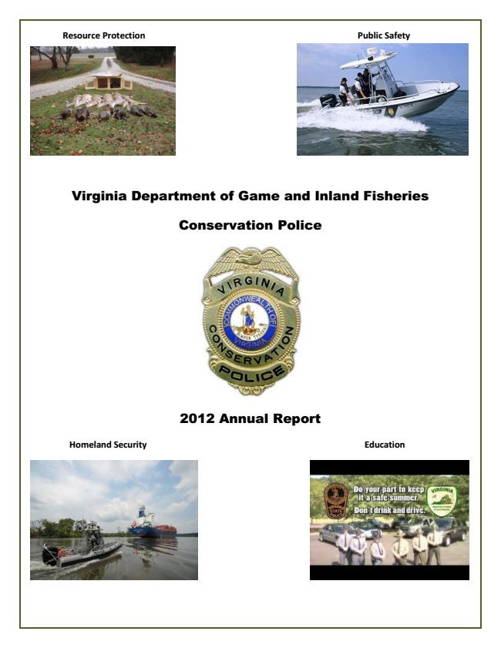

**Resource Protection Public Safety**

Virginia Department of Game and Inland Fisheries

Conservation Police

2012 Annual Report

**Homeland Security Education**

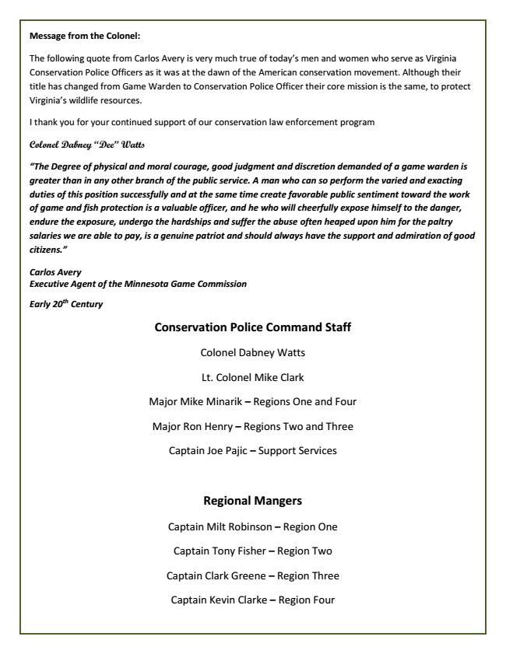

**Message from the Colonel:**

The following quote from Carlos Avery is very much true of today’s men and women who serve as Virginia Conservation Police Officers as it was at the dawn of the American conservation movement. Although their title has changed from Game Warden to Conservation Police Officer their core mission is the same, to protect Virginia’s wildlife resources.

I thank you for your continued support of our conservation law enforcement program

**Colonel Dabney “Dee” Watts**

***“The Degree of physical and moral courage, good judgment and discretion demanded of a game warden is greater than in any other branch of the public service. A man who can so perform the varied and exacting duties of this position successfully and at the same time create favorable public sentiment toward the work of game and fish protection is a valuable officer, and he who will cheerfully expose himself to the danger, endure the exposure, undergo the hardships and suffer the abuse often heaped upon him for the paltry salaries we are able to pay, is a genuine patriot and should always have the support and admiration of good citizens.”***

***Carlos Avery Executive Agent of the Minnesota Game Commission***

***Early 20***

***th***

***Century***

**Conservation Police Command Staff**

Colonel Dabney Watts

Lt. Colonel Mike Clark

Major Mike Minarik – Regions One and Four

Major Ron Henry – Regions Two and Three

Captain Joe Pajic – Support Services

**Regional Mangers**

Captain Milt Robinson – Region One

Captain Tony Fisher – Region Two

Captain Clark Greene – Region Three

Captain Kevin Clarke – Region Four

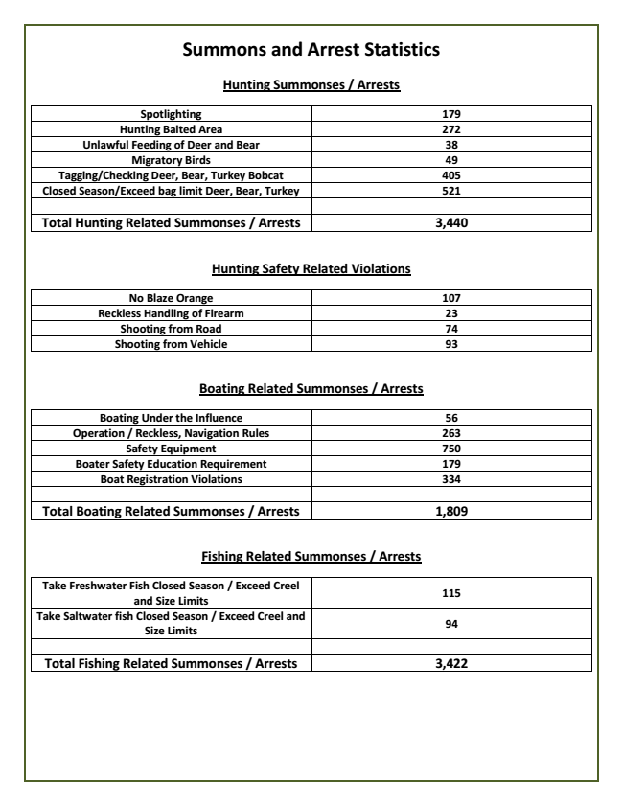

**Summons and Arrest Statistics**

**Hunting Summonses / Arrests**

**Spotlighting 179 Hunting Baited Area 272 Unlawful Feeding of Deer and Bear 38 Migratory Birds 49 Tagging/Checking Deer, Bear, Turkey Bobcat 405 Closed Season/Exceed bag limit Deer, Bear, Turkey 521**

**Total Hunting Related Summonses / Arrests 3,440**

**Hunting Safety Related Violations**

**No Blaze Orange 107 Reckless Handling of Firearm 23 Shooting from Road 74 Shooting from Vehicle 93**

**Boating Related Summonses / Arrests**

**Boating Under the Influence 56 Operation / Reckless, Navigation Rules 263 Safety Equipment 750 Boater Safety Education Requirement 179 Boat Registration Violations 334**

**Total Boating Related Summonses / Arrests 1,809**

**Fishing Related Summonses / Arrests**

**Take Freshwater Fish Closed Season / Exceed Creel and Size Limits**

**115**

**Take Saltwater fish Closed Season / Exceed Creel and Size Limits**

**94**

**Total Fishing Related Summonses / Arrests 3,422**

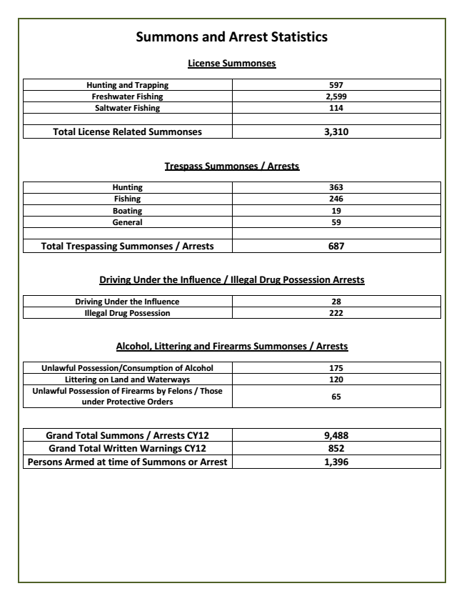

**Summons and Arrest Statistics**

**License Summonses**

**Hunting and Trapping 597**

**Freshwater Fishing 2,599 Saltwater Fishing 114**

**Total License Related Summonses 3,310**

**Trespass Summonses / Arrests**

**Hunting 363 Fishing 246 Boating 19 General 59**

**Total Trespassing Summonses / Arrests 687**

**Driving Under the Influence / Illegal Drug Possession Arrests**

**Driving Under the Influence 28**

**Illegal Drug Possession 222**

**Alcohol, Littering and Firearms Summonses / Arrests**

**Unlawful Possession/Consumption of Alcohol 175 Littering on Land and Waterways 120 Unlawful Possession of Firearms by Felons / Those under Protective Orders**

**65**

**Grand Total Summons / Arrests CY12 9,488 Grand Total Written Warnings CY12 852 Persons Armed at time of Summons or Arrest 1,396**

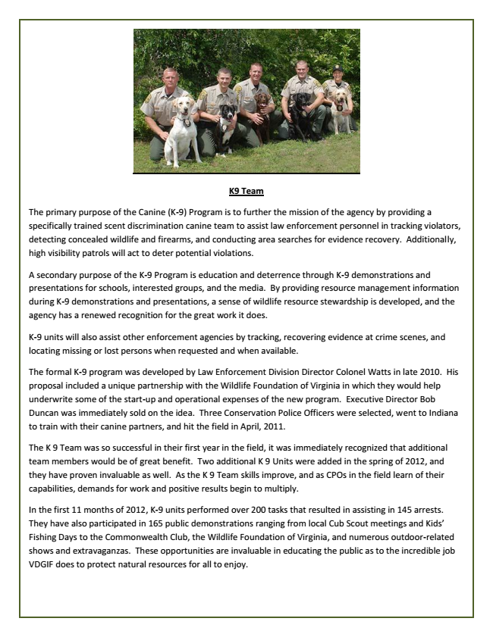

**K9 Team**

The primary purpose of the Canine (K-9) Program is to further the mission of the agency by providing a specifically trained scent discrimination canine team to assist law enforcement personnel in tracking violators, detecting concealed wildlife and firearms, and conducting area searches for evidence recovery. Additionally, high visibility patrols will act to deter potential violations.

A secondary purpose of the K-9 Program is education and deterrence through K-9 demonstrations and presentations for schools, interested groups, and the media. By providing resource management information during K-9 demonstrations and presentations, a sense of wildlife resource stewardship is developed, and the agency has a renewed recognition for the great work it does.

K-9 units will also assist other enforcement agencies by tracking, recovering evidence at crime scenes, and locating missing or lost persons when requested and when available.

The formal K-9 program was developed by Law Enforcement Division Director Colonel Watts in late 2010. His proposal included a unique partnership with the Wildlife Foundation of Virginia in which they would help underwrite some of the start-up and operational expenses of the new program. Executive Director Bob Duncan was immediately sold on the idea. Three Conservation Police Officers were selected, went to Indiana to train with their canine partners, and hit the field in April, 2011.

The K 9 Team was so successful in their first year in the field, it was immediately recognized that additional team members would be of great benefit. Two additional K 9 Units were added in the spring of 2012, and they have proven invaluable as well. As the K 9 Team skills improve, and as CPOs in the field learn of their capabilities, demands for work and positive results begin to multiply.

In the first 11 months of 2012, K-9 units performed over 200 tasks that resulted in assisting in 145 arrests. They have also participated in 165 public demonstrations ranging from local Cub Scout meetings and Kids’ Fishing Days to the Commonwealth Club, the Wildlife Foundation of Virginia, and numerous outdoor-related shows and extravaganzas. These opportunities are invaluable in educating the public as to the incredible job VDGIF does to protect natural resources for all to enjoy.

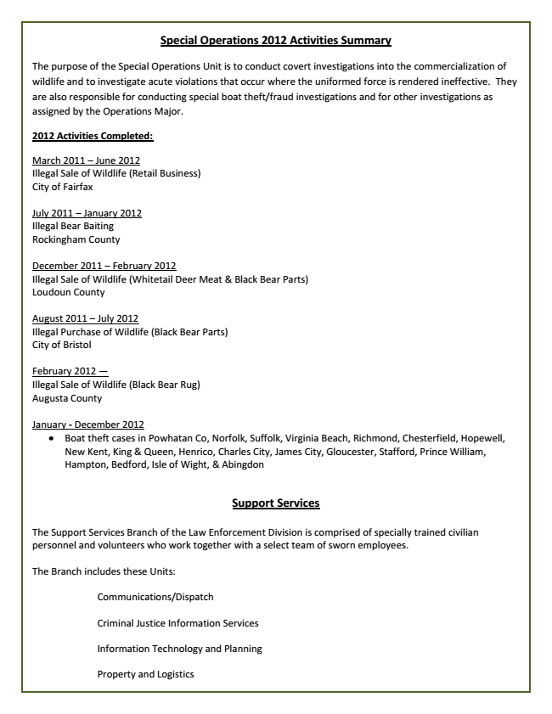

**Special Operations 2012 Activities Summary**

The purpose of the Special Operations Unit is to conduct covert investigations into the commercialization of wildlife and to investigate acute violations that occur where the uniformed force is rendered ineffective. They are also responsible for conducting special boat theft/fraud investigations and for other investigations as assigned by the Operations Major.

**2012 Activities Completed:**

March 2011 – June 2012 Illegal Sale of Wildlife (Retail Business) City of Fairfax

July 2011 – January 2012 Illegal Bear Baiting Rockingham County

December 2011 – February 2012 Illegal Sale of Wildlife (Whitetail Deer Meat & Black Bear Parts) Loudoun County

August 2011 – July 2012 Illegal Purchase of Wildlife (Black Bear Parts) City of Bristol

February 2012 — Illegal Sale of Wildlife (Black Bear Rug) Augusta County

January - December 2012

Boat theft cases in Powhatan Co, Norfolk, Suffolk, Virginia Beach, Richmond, Chesterfield, Hopewell, New Kent, King & Queen, Henrico, Charles City, James City, Gloucester, Stafford, Prince William, Hampton, Bedford, Isle of Wight, & Abingdon

**Support Services**

The Support Services Branch of the Law Enforcement Division is comprised of specially trained civilian personnel and volunteers who work together with a select team of sworn employees.

The Branch includes these Units:

Communications/Dispatch

Criminal Justice Information Services

Information Technology and Planning

Property and Logistics

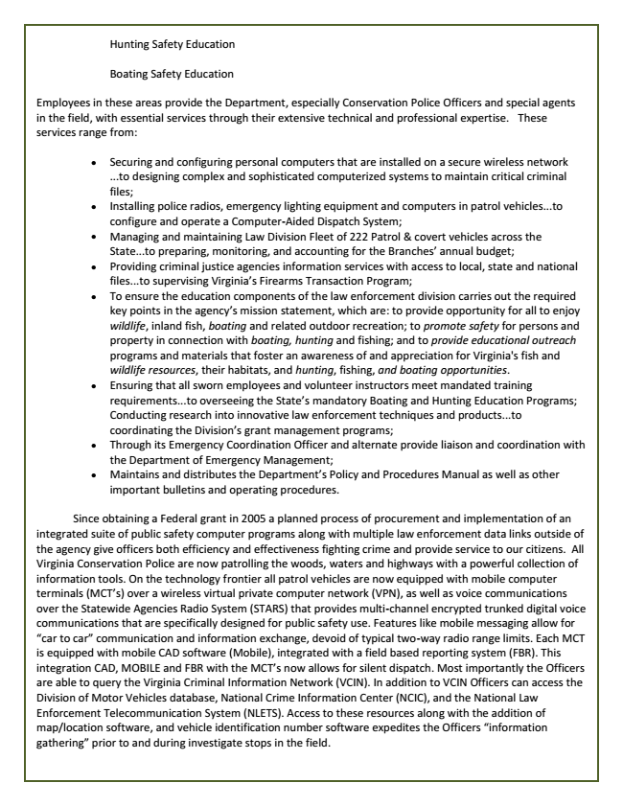

Hunting Safety Education

Boating Safety Education

Employees in these areas provide the Department, especially Conservation Police Officers and special agents in the field, with essential services through their extensive technical and professional expertise. These services range from:

Maintains and distributes the Department’s Policy and Procedures Manual as well as other important bulletins and operating procedures.

Since obtaining a Federal grant in 2005 a planned process of procurement and implementation of an integrated suite of public safety computer programs along with multiple law enforcement data links outside of the agency give officers both efficiency and effectiveness fighting crime and provide service to our citizens. All Virginia Conservation Police are now patrolling the woods, waters and highways with a powerful collection of information tools. On the technology frontier all patrol vehicles are now equipped with mobile computer terminals (MCT’s) over a wireless virtual private computer network (VPN), as well as voice communications over the Statewide Agencies Radio System (STARS) that provides multi-channel encrypted trunked digital voice communications that are specifically designed for public safety use. Features like mobile messaging allow for “car to car” communication and information exchange, devoid of typical two-way radio range limits. Each MCT is equipped with mobile CAD software (Mobile), integrated with a field based reporting system (FBR). This integration CAD, MOBILE and FBR with the MCT’s now allows for silent dispatch. Most importantly the Officers are able to query the Virginia Criminal Information Network (VCIN). In addition to VCIN Officers can access the Division of Motor Vehicles database, National Crime Information Center (NCIC), and the National Law Enforcement Telecommunication System (NLETS). Access to these resources along with the addition of map/location software, and vehicle identification number software expedites the Officers “information gathering” prior to and during investigate stops in the field.

Securing and configuring personal computers that are installed on a secure wireless network ...to designing complex and sophisticated computerized systems to maintain critical criminal files;

Installing police radios, emergency lighting equipment and computers in patrol vehicles...to configure and operate a Computer-Aided Dispatch System;

Managing and maintaining Law Division Fleet of 222 Patrol & covert vehicles across the State...to preparing, monitoring, and accounting for the Branches’ annual budget;

Providing criminal justice agencies information services with access to local, state and national files...to supervising Virginia’s Firearms Transaction Program;

To ensure the education components of the law enforcement division carries out the required key points in the agency’s mission statement, which are: to provide opportunity for all to enjoy wildlife, inland fish, boating and related outdoor recreation; to promote safety for persons and property in connection with boating, hunting and fishing; and to provide educational outreach programs and materials that foster an awareness of and appreciation for Virginia's fish and wildlife resources, their habitats, and hunting, fishing, and boating opportunities.

Ensuring that all sworn employees and volunteer instructors meet mandated training requirements...to overseeing the State’s mandatory Boating and Hunting Education Programs; Conducting research into innovative law enforcement techniques and products...to coordinating the Division’s grant management programs;

Through its Emergency Coordination Officer and alternate provide liaison and coordination with the Department of Emergency Management;

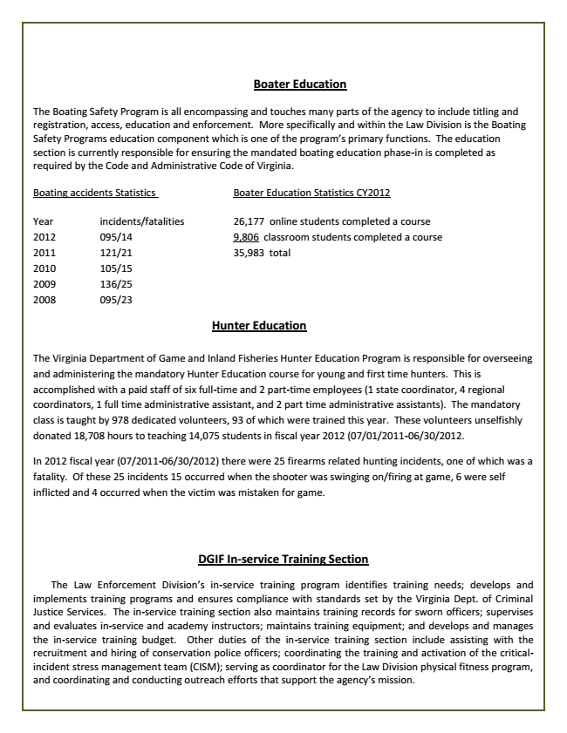

**Boater Education**

The Boating Safety Program is all encompassing and touches many parts of the agency to include titling and registration, access, education and enforcement. More specifically and within the Law Division is the Boating Safety Programs education component which is one of the program’s primary functions. The education section is currently responsible for ensuring the mandated boating education phase-in is completed as required by the Code and Administrative Code of Virginia.

Boating accidents Statistics Boater Education Statistics CY2012

Year incidents/fatalities 26,177 online students completed a course 2012 095/14 9,806 classroom students completed a course 2011 121/21 35,983 total 2010 105/15 2009 136/25 2008 095/23

**Hunter Education**

The Virginia Department of Game and Inland Fisheries Hunter Education Program is responsible for overseeing and administering the mandatory Hunter Education course for young and first time hunters. This is accomplished with a paid staff of six full-time and 2 part-time employees (1 state coordinator, 4 regional coordinators, 1 full time administrative assistant, and 2 part time administrative assistants). The mandatory class is taught by 978 dedicated volunteers, 93 of which were trained this year. These volunteers unselfishly donated 18,708 hours to teaching 14,075 students in fiscal year 2012 (07/01/2011-06/30/2012.

In 2012 fiscal year (07/2011-06/30/2012) there were 25 firearms related hunting incidents, one of which was a fatality. Of these 25 incidents 15 occurred when the shooter was swinging on/firing at game, 6 were self inflicted and 4 occurred when the victim was mistaken for game.

**DGIF In-service Training Section**

The Law Enforcement Division’s in-service training program identifies training needs; develops and implements training programs and ensures compliance with standards set by the Virginia Dept. of Criminal Justice Services. The in-service training section also maintains training records for sworn officers; supervises and evaluates in-service and academy instructors; maintains training equipment; and develops and manages the in-service training budget. Other duties of the in-service training section include assisting with the recruitment and hiring of conservation police officers; coordinating the training and activation of the critical- incident stress management team (CISM); serving as coordinator for the Law Division physical fitness program, and coordinating and conducting outreach efforts that support the agency’s mission.

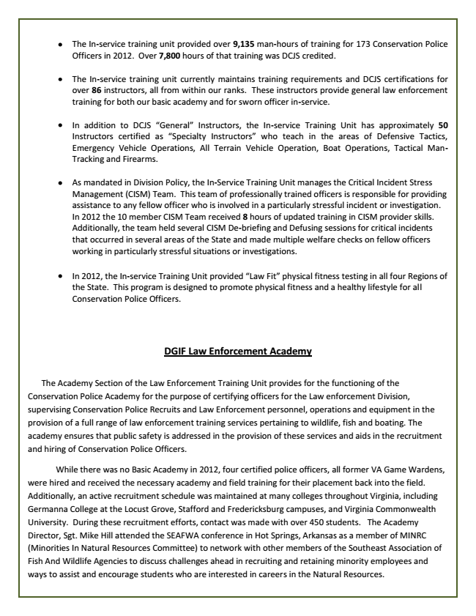

In 2012, the In-service Training Unit provided “Law Fit” physical fitness testing in all four Regions of the State. This program is designed to promote physical fitness and a healthy lifestyle for all Conservation Police Officers.

**DGIF Law Enforcement Academy**

The Academy Section of the Law Enforcement Training Unit provides for the functioning of the Conservation Police Academy for the purpose of certifying officers for the Law enforcement Division, supervising Conservation Police Recruits and Law Enforcement personnel, operations and equipment in the provision of a full range of law enforcement training services pertaining to wildlife, fish and boating. The academy ensures that public safety is addressed in the provision of these services and aids in the recruitment and hiring of Conservation Police Officers.

While there was no Basic Academy in 2012, four certified police officers, all former VA Game Wardens, were hired and received the necessary academy and field training for their placement back into the field. Additionally, an active recruitment schedule was maintained at many colleges throughout Virginia, including Germanna College at the Locust Grove, Stafford and Fredericksburg campuses, and Virginia Commonwealth University. During these recruitment efforts, contact was made with over 450 students. The Academy Director, Sgt. Mike Hill attended the SEAFWA conference in Hot Springs, Arkansas as a member of MINRC (Minorities In Natural Resources Committee) to network with other members of the Southeast Association of Fish And Wildlife Agencies to discuss challenges ahead in recruiting and retaining minority employees and ways to assist and encourage students who are interested in careers in the Natural Resources.

The In-service training unit provided over 9,135 man-hours of training for 173 Conservation Police Officers in 2012. Over 7,800 hours of that training was DCJS credited.

The In-service training unit currently maintains training requirements and DCJS certifications for over 86 instructors, all from within our ranks. These instructors provide general law enforcement training for both our basic academy and for sworn officer in-service.

In addition to DCJS “General” Instructors, the In-service Training Unit has approximately 50 Instructors certified as “Specialty Instructors” who teach in the areas of Defensive Tactics, Emergency Vehicle Operations, All Terrain Vehicle Operation, Boat Operations, Tactical Man- Tracking and Firearms.

As mandated in Division Policy, the In-Service Training Unit manages the Critical Incident Stress Management (CISM) Team. This team of professionally trained officers is responsible for providing assistance to any fellow officer who is involved in a particularly stressful incident or investigation. In 2012 the 10 member CISM Team received 8 hours of updated training in CISM provider skills. Additionally, the team held several CISM De-briefing and Defusing sessions for critical incidents that occurred in several areas of the State and made multiple welfare checks on fellow officers working in particularly stressful situations or investigations.