

**Data Summary**

**January 2010**

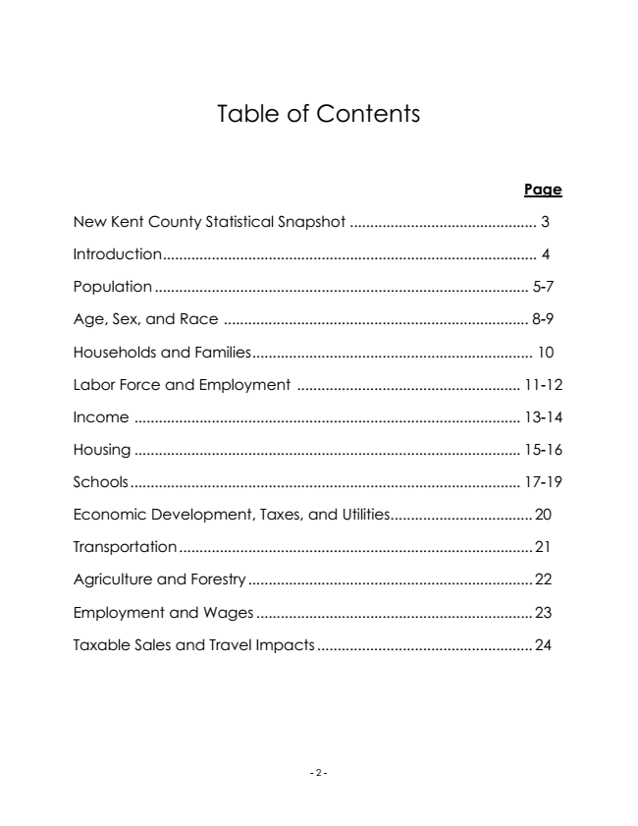

Table of Contents

**Page**

New Kent County Statistical Snapshot .............................................. 3

Introduction............................................................................................ 4

Population ............................................................................................ 5-7

Age, Sex, and Race ........................................................................... 8-9

Households and Families..................................................................... 10

Labor Force and Employment ....................................................... 11-12

Income ............................................................................................... 13-14

Housing ............................................................................................... 15-16

Schools ................................................................................................ 17-19

Economic Development, Taxes, and Utilities................................... 20

Transportation.......................................................................................21

Agriculture and Forestry ...................................................................... 22

Employment and Wages .................................................................... 23

Taxable Sales and Travel Impacts ..................................................... 24

- 2 -

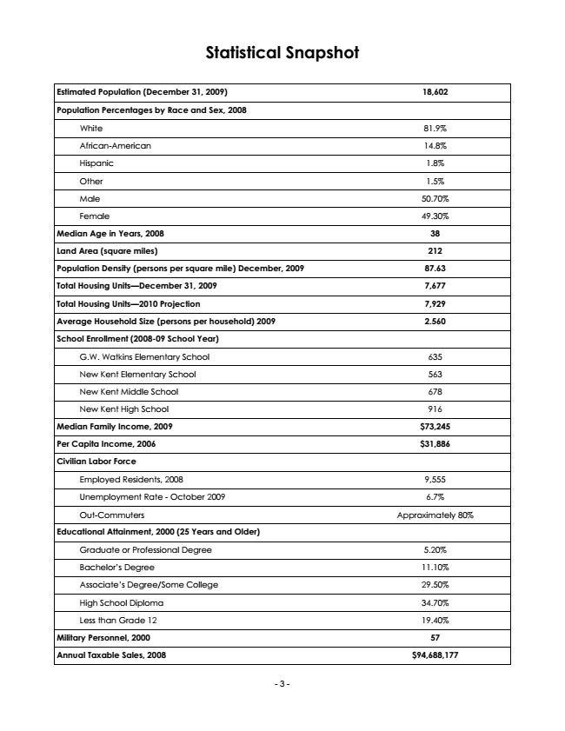

**Statistical Snapshot**

**Estimated Population (December 31, 2009) 18,602**

**Population Percentages by Race and Sex, 2008**

White 81.9%

African-American 14.8%

Hispanic 1.8%

Other 1.5%

Male 50.70%

Female 49.30%

**Median Age in Years, 2008 38**

**Land Area (square miles) 212**

**Population Density (persons per square mile) December, 2009 87.63**

**Total Housing Units—December 31, 2009 7,677**

**Total Housing Units—2010 Projection 7,929**

**Average Household Size (persons per household) 2009 2.560**

**School Enrollment (2008-09 School Year)**

G.W. Watkins Elementary School 635

New Kent Elementary School 563

New Kent Middle School 678

New Kent High School 916

**Median Family Income, 2009 $73,245**

**Per Capita Income, 2006 $31,886**

**Civilian Labor Force**

Employed Residents, 2008 9,555

Unemployment Rate - October 2009 6.7%

Out-Commuters Approximately 80%

**Educational Attainment, 2000 (25 Years and Older)**

Graduate or Professional Degree 5.20%

Bachelor’s Degree 11.10%

Associate’s Degree/Some College 29.50%

High School Diploma 34.70%

Less than Grade 12 19.40%

**Military Personnel, 2000 57**

**Annual Taxable Sales, 2008 $94,688,177**

- 3 -

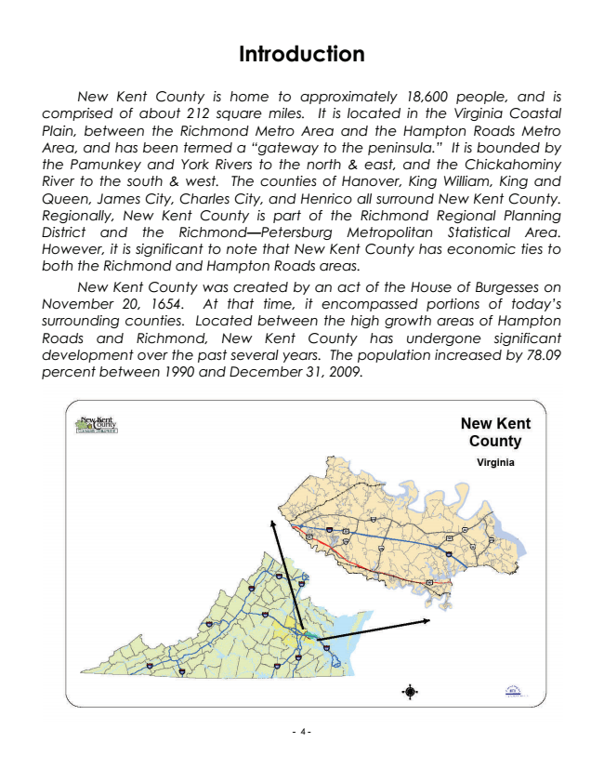

**Introduction**

*New Kent County is home to approximately 18,600 people, and is comprised of about 212 square miles. It is located in the Virginia Coastal Plain, between the Richmond Metro Area and the Hampton Roads Metro Area, and has been termed a “gateway to the peninsula.” It is bounded by the Pamunkey and York Rivers to the north & east, and the Chickahominy River to the south & west. The counties of Hanover, King William, King and Queen, James City, Charles City, and Henrico all surround New Kent County. Regionally, New Kent County is part of the Richmond Regional Planning District and the Richmond—Petersburg Metropolitan Statistical Area. However, it is significant to note that New Kent County has economic ties to both the Richmond and Hampton Roads areas.*

*New Kent County was created by an act of the House of Burgesses on November 20, 1654. At that time, it encompassed portions of today’s surrounding counties. Located between the high growth areas of Hampton Roads and Richmond, New Kent County has undergone significant development over the past several years. The population increased by 78.09 percent between 1990 and December 31, 2009.*

- 4 -

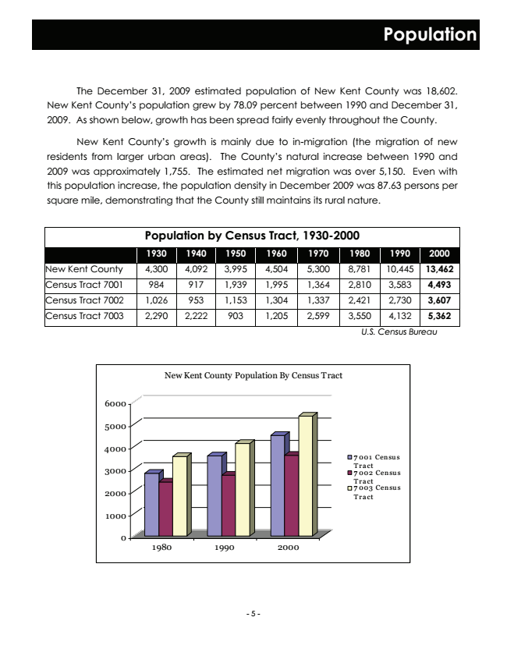

**Population**

The December 31, 2009 estimated population of New Kent County was 18,602. New Kent County’s population grew by 78.09 percent between 1990 and December 31, 2009. As shown below, growth has been spread fairly evenly throughout the County.

New Kent County’s growth is mainly due to in-migration (the migration of new residents from larger urban areas). The County’s natural increase between 1990 and 2009 was approximately 1,755. The estimated net migration was over 5,150. Even with this population increase, the population density in December 2009 was 87.63 persons per square mile, demonstrating that the County still maintains its rural nature.

**Population by Census Tract, 1930-2000**

**1930 1940 1950 1960 1970 1980 1990 2000**

New Kent County 4,300 4,092 3,995 4,504 5,300 8,781 10,445 13,462

Census Tract 7001 984 917 1,939 1,995 1,364 2,810 3,583 4,493

Census Tract 7002 1,026 953 1,153 1,304 1,337 2,421 2,730 3,607

Census Tract 7003 2,290 2,222 903 1,205 2,599 3,550 4,132 5,362

0

*U.S. Census Bureau*

New Kent County Population By Census Tract

6000

5000

4000

7001 Census

3000

Tract 7002 Census Tract 2000

7003 Census Tract

1000

1980 1990 2000

- 5 -

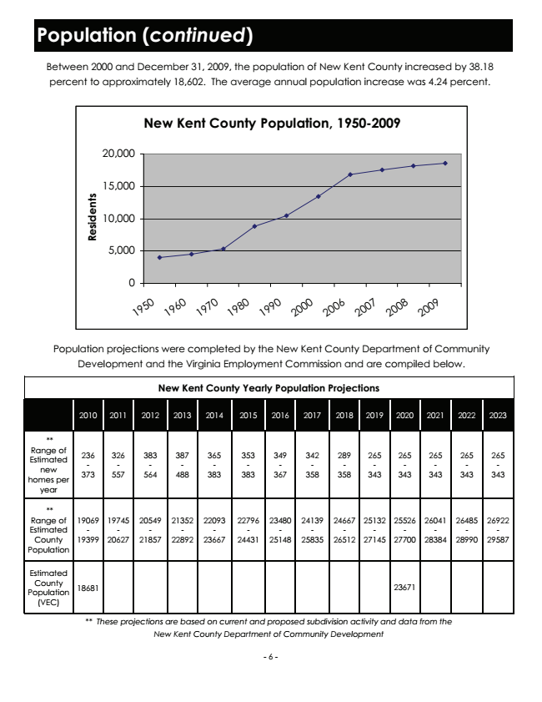

**Population (continued)**

Between 2000 and December 31, 2009, the population of New Kent County increased by 38.18 percent to approximately 18,602. The average annual population increase was 4.24 percent.

**New Kent County Population, 1950-2009**

20,000

15,000

10,000

5,000

0

1

9

5

0

1

9

6

0

1

9

7

0

1

9

8

0

1

9

9

0

2

0

0

0

2

0

0

6

2

0

0

7

2

0

0

8

2

0

0

9

Population projections were completed by the New Kent County Department of Community Development and the Virginia Employment Commission and are compiled below.

**New Kent County Yearly Population Projections**

2010 2011 2012 2013 2014 2015 2016 2017 2018 2019 2020 2021 2022 2023

** Range of Estimated new homes per year

- 6 - 236 - 373

326 - 557

383 - 564

387 - 488

365 - 383

353 - 383

349 - 367

342 - 358

289 - 358

265 - 343

265 - 343

265 - 343

265 - 343

265 - 343

** Range of Estimated County Population

19069 - 19399

19745 - 20627

20549 - 21857

21352 - 22892

22093 - 23667

22796 - 24431

23480 - 25148

24139 - 25835

24667 - 26512

25132 - 27145

25526 - 27700

26041 - 28384

26485 - 28990

26922 - 29587

Estimated County Population (VEC)

18681 23671

*\*\* These projections are based on current and proposed subdivision activity and data from the New Kent County Department of Community Development*

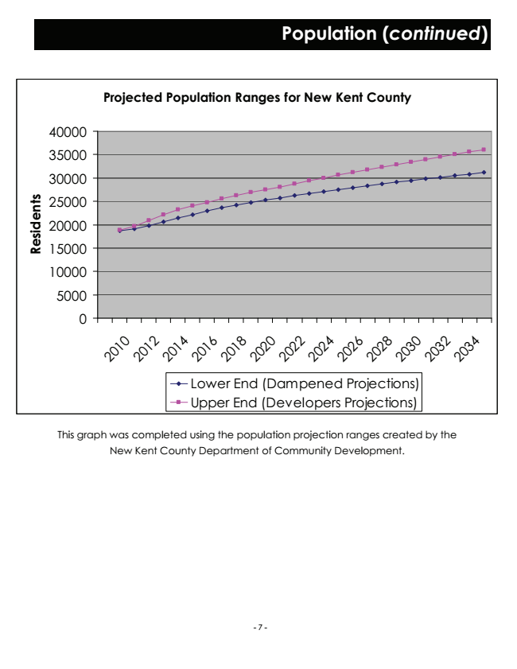

**Projected Population Ranges for New Kent County**

40000

35000

30000

25000

20000

15000

10000

5000

0

2

This graph was completed using the population projection ranges created by the New Kent County Department of Community Development.

1 0

0

2

1 0

2

2

1 0

**Population (continued)**

4

2

0

1

6

2

0

1

8

2

0

2

0

2

0

2

2

2

0

2

4

2

0

2

6

2

0

2

8

2

0

3

0

2

0

3

2

2

0

3

4

Lower End (Dampened Projections) Upper End (Developers Projections)

- 7 -

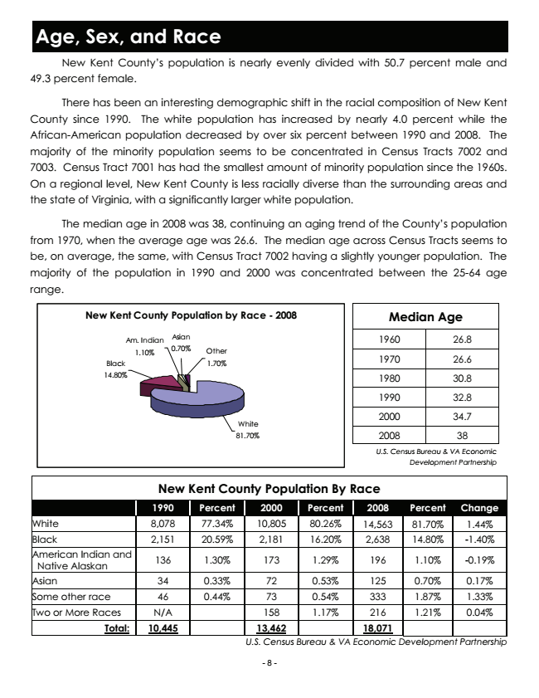

**Age, Sex, and Race**

New Kent County’s population is nearly evenly divided with 50.7 percent male and 49.3 percent female.

There has been an interesting demographic shift in the racial composition of New Kent County since 1990. The white population has increased by nearly 4.0 percent while the African-American population decreased by over six percent between 1990 and 2008. The majority of the minority population seems to be concentrated in Census Tracts 7002 and 7003. Census Tract 7001 has had the smallest amount of minority population since the 1960s. On a regional level, New Kent County is less racially diverse than the surrounding areas and the state of Virginia, with a significantly larger white population.

The median age in 2008 was 38, continuing an aging trend of the County’s population from 1970, when the average age was 26.6. The median age across Census Tracts seems to be, on average, the same, with Census Tract 7002 having a slightly younger population. The majority of the population in 1990 and 2000 was concentrated between the 25-64 age range.

**New Kent County Population by Race - 2008**

**Median Age**

Am. Indian

Asian

1960 26.8 1.10%

0.70%

Other Black

1.70%

1970 26.6

14.80%

1980 30.8

1990 32.8

White

2000 34.7

81.70%

2008 38

*U.S. Census Bureau & VA Economic Development Partnership*

**New Kent County Population By Race**

1990 Percent 2000 Percent Change White 8,078 77.34% 10,805 80.26% 1.44% Black 2,151 20.59% 2,181 16.20% -1.40% American Indian and

Native Alaskan

**2008**

**Percent**

14,563

81.70% 2,638

14.80%

136 1.30% 173 1.29% 196

1.10%

-0.19%

Asian 34 0.33% 72 0.53% 125

0.70%

0.17% Some other race 46 0.44% 73 0.54% 333

1.87%

1.33% Two or More Races N/A 158 1.17% 216

1.21%

**0.04% Total: 10,445 13,462**

*18,071 U.S. Census Bureau & VA Economic Development Partnership*

- 8 -

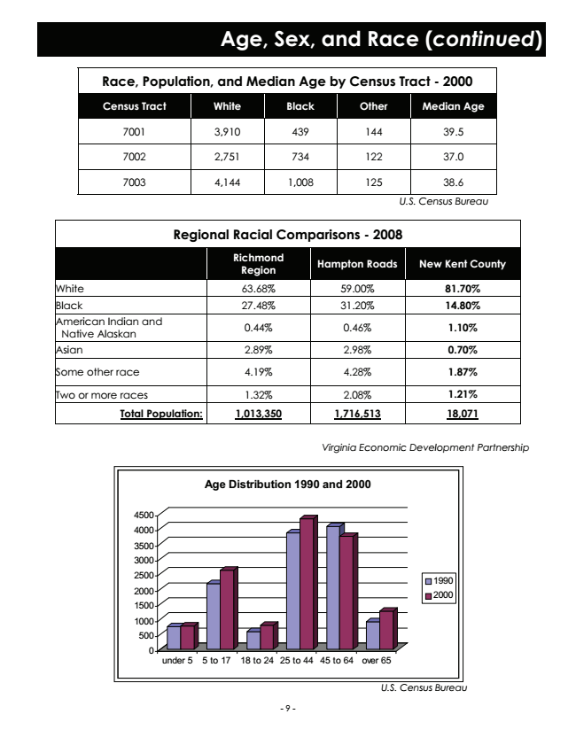

**Age, Sex, and Race (continued)**

**Race, Population, and Median Age by Census Tract - 2000**

**Census Tract White Black Other Median Age**

7001 3,910 439 144 39.5

7002 2,751 734 122 37.0

7003 4,144 1,008 125 38.6

*U.S. Census Bureau*

**Regional Racial Comparisons - 2008**

**Richmond Region**

**Hampton Roads New Kent County**

White 63.68% 59.00% 81.70%

Black 27.48% 31.20% 14.80% American Indian and

Native Alaskan

0.44% 0.46% 1.10%

Asian 2.89% 2.98% 0.70%

Some other race 4.19% 4.28% 1.87%

Two or more races 1.32% 2.08% 1.21%

**Total Population: 1,013,350 1,716,513 18,071**

*Virginia Economic Development Partnership*

**Age Distribution 1990 and 2000**

4500 4000

3500 3000 2500

1990 2000

2000 1500

1000 500 0

under 5 5 to 17 18 to 24 25 to 44 45 to 64 over 65

*U.S. Census Bureau*

- 9 -

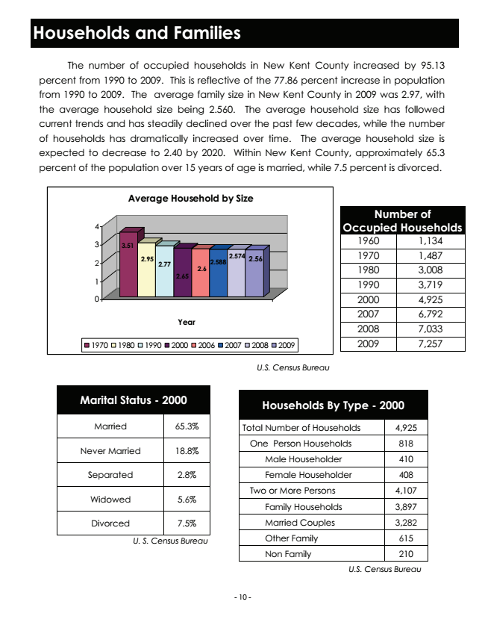

**Households and Families**

The number of occupied households in New Kent County increased by 95.13 percent from 1990 to 2009. This is reflective of the 77.86 percent increase in population from 1990 to 2009. The average family size in New Kent County in 2009 was 2.97, with the average household size being 2.560. The average household size has followed current trends and has steadily declined over the past few decades, while the number of households has dramatically increased over time. The average household size is expected to decrease to 2.40 by 2020. Within New Kent County, approximately 65.3 percent of the population over 15 years of age is married, while 7.5 percent is divorced.

**Average Household by Size**

**Number of 4**

**Occupied Households**

3

**3.51**

1960 1,134

2

**2.95**

**2.77**

**2.588**

**2.574**

**2.56**

**2.65**

1970 1,487 1980 3,008 1990 3,719

0

1970

**Year**

**2.6**

1

2000 4,925 2007 6,792 2008 7,033

1970 1980 1990 2000 2006 2007 2008 2009

2009 7,257

*U.S. Census Bureau*

**Marital Status - 2000**

**Households By Type - 2000**

Married 65.3%

Total Number of Households

4,925

Never Married 18.8%

One Person Households 818

Male Householder 410

Separated 2.8%

Female Householder 408

Widowed 5.6%

Two or More Persons Family Households 4,107 3,897

Divorced 7.5%

Married Couples 3,282

*U. S. Census Bureau*

Other Family 615

Non Family 210

- 10 -

*U.S. Census Bureau*