数据挖掘技术
实验指导书

上海第二工业大学
工学部

实验三 朴素贝叶斯分类算法的实现及其应用

【实验目的】
- 掌握朴素贝叶斯分类算法的原理，理解算法的步骤。
- 加深对贝叶斯分类算法的理解，逐步培养解决实际问题的能力。

【实验性质】
设计型实验

【实验内容】

使用贝叶斯算法来实现决策树分类

【实验环境】
Python 2

【实验要求】
将实验报告文件保存在命名为“学号+姓名+实验3”的文件中并上传到指定的服务器（192.168.101.1 上指定的目录）。

【实验结果】
- 完整代码：bayes.py
from numpy import *

def loadDataSet():
postingList=[['my', 'dog', 'has', 'flea', 'problems', 'help', 'please'],
['maybe', 'not', 'take', 'him', 'to', 'dog', 'park', 'stupid'],
['my', 'dalmation', 'is', 'so', 'cute', 'I', 'love', 'him'],
['stop', 'posting', 'stupid', 'worthless', 'garbage'],
['mr', 'licks', 'ate', 'my', 'steak', 'how', 'to', 'stop', 'him'],
['quit', 'buying', 'worthless', 'dog', 'food', 'stupid']]
classVec = [0,1,0,1,0,1] #1 is abusive, 0 not
return postingList,classVec

def createVocabList(dataSet):
vocabSet = set([]) #create empty set
for document in dataSet:
vocabSet = vocabSet | set(document) #union of the two sets
return list(vocabSet)

def setOfWords2Vec(vocabList, inputSet):
returnVec = [0]*len(vocabList)
for word in inputSet:
if word in vocabList:
returnVec[vocabList.index(word)] = 1
else: print "the word: %s is not in my Vocabulary!" % word
return returnVec

def trainNB0(trainMatrix,trainCategory):
numTrainDocs = len(trainMatrix)
numWords = len(trainMatrix[0])
pAbusive = sum(trainCategory)/float(numTrainDocs)
p0Num = ones(numWords); p1Num = ones(numWords) #change to ones()
p0Denom = 2.0; p1Denom = 2.0 #change to 2.0
for i in range(numTrainDocs):
if trainCategory[i] == 1:
p1Num += trainMatrix[i]
p1Denom += sum(trainMatrix[i])
else:
p0Num += trainMatrix[i]
p0Denom += sum(trainMatrix[i])
p1Vect = log(p1Num/p1Denom) #change to log()
p0Vect = log(p0Num/p0Denom) #change to log()
return p0Vect,p1Vect,pAbusive

def classifyNB(vec2Classify, p0Vec, p1Vec, pClass1):
p1 = sum(vec2Classify * p1Vec) + log(pClass1) #element-wise mult
p0 = sum(vec2Classify * p0Vec) + log(1.0 - pClass1)
if p1 > p0:
return 1
else:
return 0

def testingNB():
listOPosts,listClasses = loadDataSet()
myVocabList = createVocabList(listOPosts)
trainMat=[]
for postinDoc in listOPosts:
trainMat.append(setOfWords2Vec(myVocabList, postinDoc))
p0V,p1V,pAb = trainNB0(array(trainMat),array(listClasses))
testEntry = ['love', 'my', 'dalmation']
thisDoc = array(setOfWords2Vec(myVocabList, testEntry))
print testEntry,'classified as: ',classifyNB(thisDoc,p0V,p1V,pAb)
testEntry = ['stupid', 'garbage']
thisDoc = array(setOfWords2Vec(myVocabList, testEntry))
print testEntry,'classified as: ',classifyNB(thisDoc,p0V,p1V,pAb)
- 测试代码：test.py
import bayes
listOPosts,lisClasses = bayes.loadDataSet()
myVocabList = bayes.createVocabList(listOPosts)
print myVocabList
a=bayes.setOfWords2Vec(myVocabList,listOPosts[0])
print a
b=bayes.setOfWords2Vec(myVocabList,listOPosts[3])
print b

from numpy import *
reload(bayes)
listOPosts,listClasses = bayes.loadDataSet()
myVocabList = bayes.createVocabList(listOPosts)
myVocabList = bayes.createVocabList(listOPosts)
trainMat=[]
for postinDoc in listOPosts:
trainMat.append(bayes.setOfWords2Vec(myVocabList,postinDoc))
p0V,p1V,pAb=bayes.trainNB0(trainMat,listClasses)
print pAb
print p0V
print p1V

reload(bayes)
c=bayes.testingNB()
print c
- 最后结果：
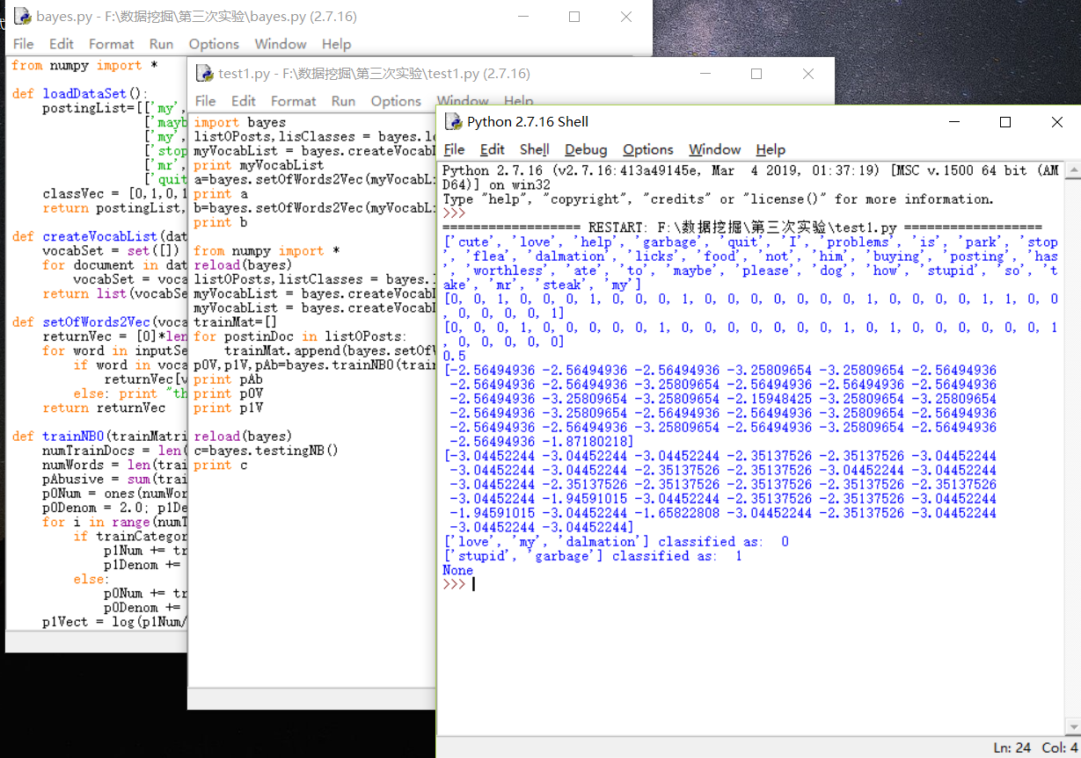

【实验步骤】
程序清单4-1 词表到向量的转换函数
- 代码：
def loadDataSet():
postingList=[['my', 'dog', 'has', 'flea', 'problems', 'help', 'please'],
['maybe', 'not', 'take', 'him', 'to', 'dog', 'park', 'stupid'],
['my', 'dalmation', 'is', 'so', 'cute', 'I', 'love', 'him'],
['stop', 'posting', 'stupid', 'worthless', 'garbage'],
['mr', 'licks', 'ate', 'my', 'steak', 'how', 'to', 'stop', 'him'],
['quit', 'buying', 'worthless', 'dog', 'food', 'stupid']]
classVec = [0,1,0,1,0,1] #1 is abusive, 0 not
return postingList,classVec

def createVocabList(dataSet):
vocabSet = set([]) #create empty set
for document in dataSet:
vocabSet = vocabSet | set(document) #union of the two sets
return list(vocabSet)

def setOfWords2Vec(vocabList, inputSet):
returnVec = [0]*len(vocabList)
for word in inputSet:
if word in vocabList:
returnVec[vocabList.index(word)] = 1
else: print "the word: %s is not in my Vocabulary!" % word
return returnVec
- 结果：
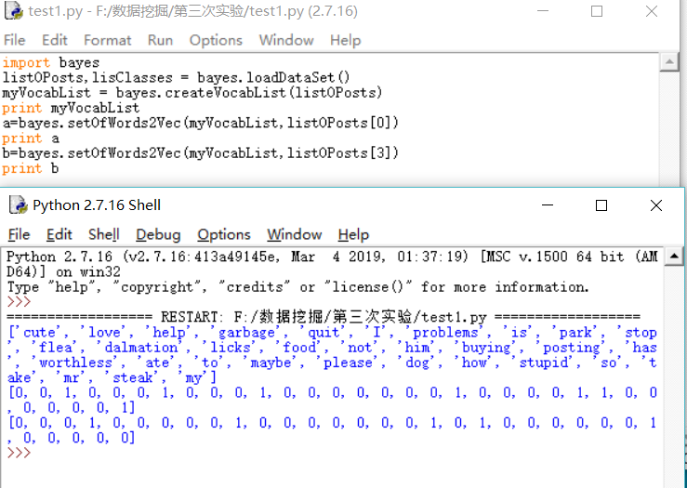

程序清单4-2 朴素贝叶斯分类器训练函数
- 代码：
def trainNB0(trainMatrix,trainCategory):
numTrainDocs = len(trainMatrix)
numWords = len(trainMatrix[0])
pAbusive = sum(trainCategory)/float(numTrainDocs)
p0Num = ones(numWords); p1Num = ones(numWords) #change to ones()
p0Denom = 2.0; p1Denom = 2.0 #change to 2.0
for i in range(numTrainDocs):
if trainCategory[i] == 1:
p1Num += trainMatrix[i]
p1Denom += sum(trainMatrix[i])
else:
p0Num += trainMatrix[i]
p0Denom += sum(trainMatrix[i])
p1Vect = log(p1Num/p1Denom) #change to log()
p0Vect = log(p0Num/p0Denom) #change to log()
return p0Vect,p1Vect,pAbusive
- 结果：
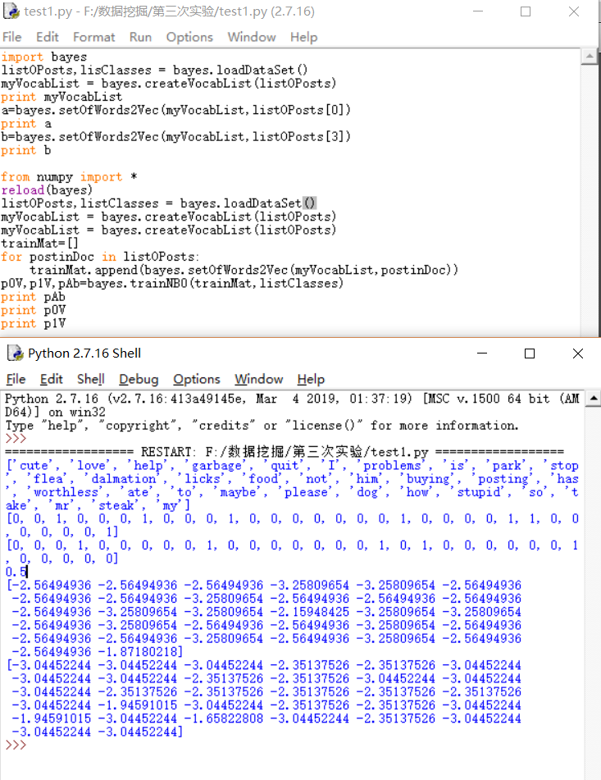

程序清单4-3 朴素贝叶斯分类函数
- 代码：
def classifyNB(vec2Classify, p0Vec, p1Vec, pClass1):
p1 = sum(vec2Classify * p1Vec) + log(pClass1) #element-wise mult
p0 = sum(vec2Classify * p0Vec) + log(1.0 - pClass1)
if p1 > p0:
return 1
else:
return 0

def testingNB():
listOPosts,listClasses = loadDataSet()
myVocabList = createVocabList(listOPosts)
trainMat=[]
for postinDoc in listOPosts:
trainMat.append(setOfWords2Vec(myVocabList, postinDoc))
p0V,p1V,pAb = trainNB0(array(trainMat),array(listClasses))
testEntry = ['love', 'my', 'dalmation']
thisDoc = array(setOfWords2Vec(myVocabList, testEntry))
print testEntry,'classified as: ',classifyNB(thisDoc,p0V,p1V,pAb)
testEntry = ['stupid', 'garbage']
thisDoc = array(setOfWords2Vec(myVocabList, testEntry))
print testEntry,'classified as: ',classifyNB(thisDoc,p0V,p1V,pAb)

- 结果：
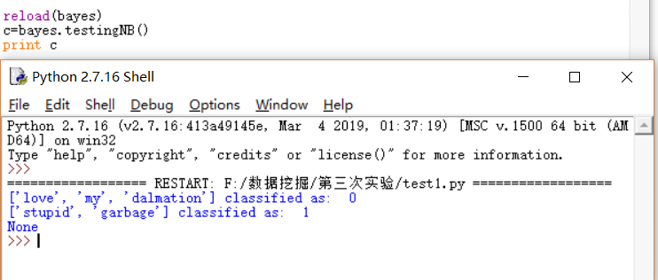

【实验总结】
通过这次实验我掌握了掌握朴素贝叶斯分类算法的概念，理解了算法的步骤，加深了对贝叶斯分类算法的理解，培养了我解决实际问题的能力。让我对数据挖掘产生了极大的兴趣，了解了关于python库函数的应用。在解决问题的过程中遇到困难积极询问同学和老师解答，同时增进了我和师生的关系，养成了交流讨论问题的习惯，最后感谢老师的精心指导和同学们的热心帮助。

