数据挖掘技术
实验指导书

上海第二工业大学
工学部

实验二 决策树分类算法的实现及其应用

【实验目的】
- 掌握决策树分类算法ID3的概念，理解算法的步骤。
- 加深对ID3算法的理解，逐步培养解决实际问题的能力。

【实验性质】
设计型实验

【实验内容】

使用ID3算法来实现决策树分类

【实验环境】
Python 2

【实验要求】
将实验报告文件保存在命名为“学号+姓名+实验2”的文件中并上传到指定的服务器（192.168.101.1 上指定的目录）。
【实验结果】
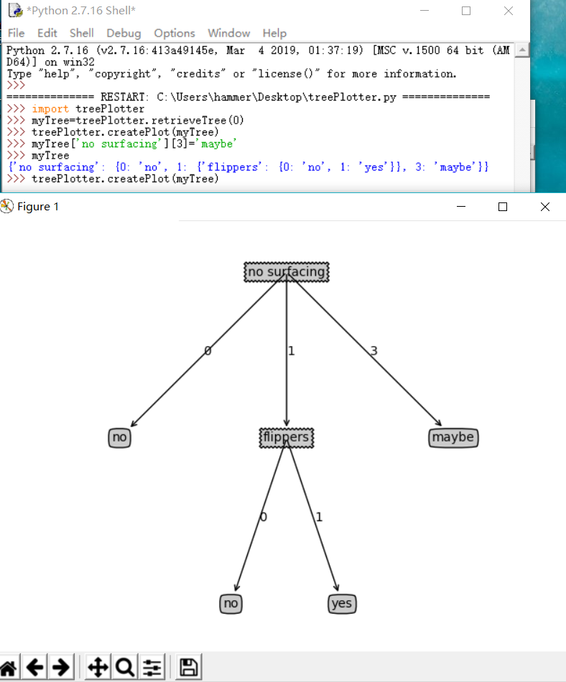
【实验步骤】
程序清单3-1 计算给定数据集的香农熵
程序代码：
import operator
from math import log
def calcShannonEnt(dataSet):
numEntries=len(dataSet)
labelCounts={}
for featVec in dataSet:
currentLabel=featVec[-1]
if currentLabel not in labelCounts.keys():
labelCounts[currentLabel]=0
labelCounts[currentLabel]+=1
shannonEnt=0.0
for key in labelCounts:
prob=float(labelCounts[key]) / numEntries
shannonEnt -= prob*log(prob,2)
return shannonEnt
def createDataSet():
dataSet=[[1,1,'yes'],[1,1,'yes'],[1,0,'no'],[0,1,'no'],[0,1,'no']]
labels =['no surfacing','flippers']
return dataSet,labels

运行结果;
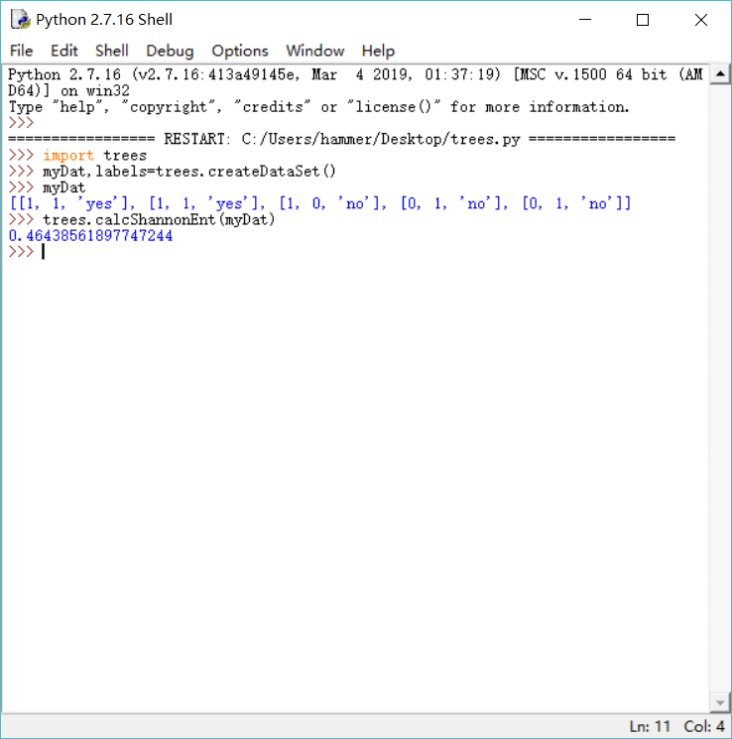

程序清单3-2 按照给定特征划分数据集
程序代码：

def splitDataSet(dataSet,axis,value):
retDataSet=[]
for featVec in dataSet:
if featVec[axis] == value:
reducedFeatVec=featVec[:axis]
reducedFeatVec.extend(featVec[axis+1:])
retDataSet.append(reducedFeatVec)
return retDataSet

运行结果：
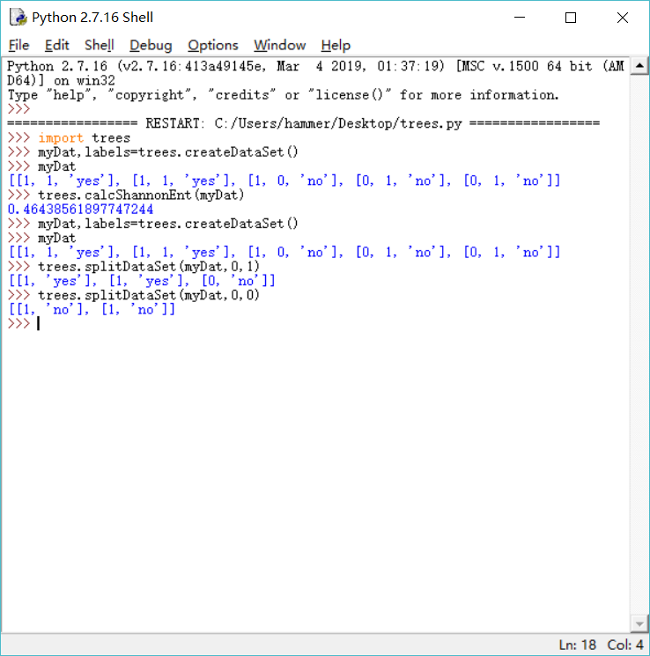

程序清单3-3 选择最好的数据集划分方式
程序代码：
def chooseBestFeatureToSplit(dataSet):
numFeatures = len(dataSet[0])-1
baseEntropy = calcShannonEnt(dataSet)
bestInfoGain = 0.0;bestFeature = -1
for i in range(numFeatures):
featList = [example[i] for example in dataSet]
uniqueVals = set(featList)
newEntropy = 0.0
for value in uniqueVals:
subDataSet = splitDataSet(dataSet,i,value)
prob = len(subDataSet)/float(len(dataSet))
newEntropy += prob * calcShannonEnt(subDataSet)
infoGain = baseEntropy - newEntropy
if (infoGain > bestInfoGain):
bestinfoGain = infoGain
bestFeature = i
return bestFeature

运行结果：
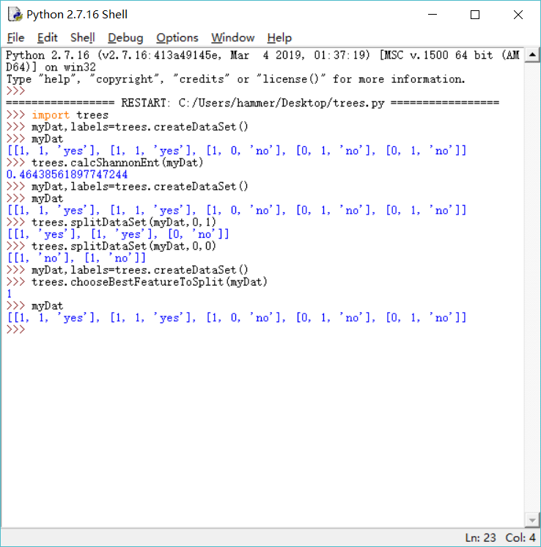

3.1.3递归构建决策树
程序代码：
def majortyCnt(classList):
classCount = {}
for vote in classList:
if vote not in classCount.keys():
classCount[vote] = 0
classCount[vote] += 1
sortedClassCount = sorted(classCount.items(),
key = operator.itemgetter(1),reverse = True)
return sortedClassCount[0][0]

程序清单3-4 创建树的函数代码
程序代码：

def createTree(dataSet,labels):
classList = [example[-1] for example in dataSet]
if classList.count(classList[0]) == len(classList):
return classList[0]
if len(dataSet[0]) == 1:
return majorityCnt(classList)
bestFeat = chooseBestFeatureToSplit(dataSet)
bestFeatLable = labels[bestFeat]
myTree = {bestFeatLable:{}}
del(labels[bestFeat])
featValues = [example[bestFeat] for example in dataSet]
uniqueVals = set(featValues)
for value in uniqueVals:
subLabels = labels[:]
myTree[bestFeatLable][value] = createTree(splitDataSet\
(dataSet,bestFeat,value),subLabels)
return myTree

运行结果:
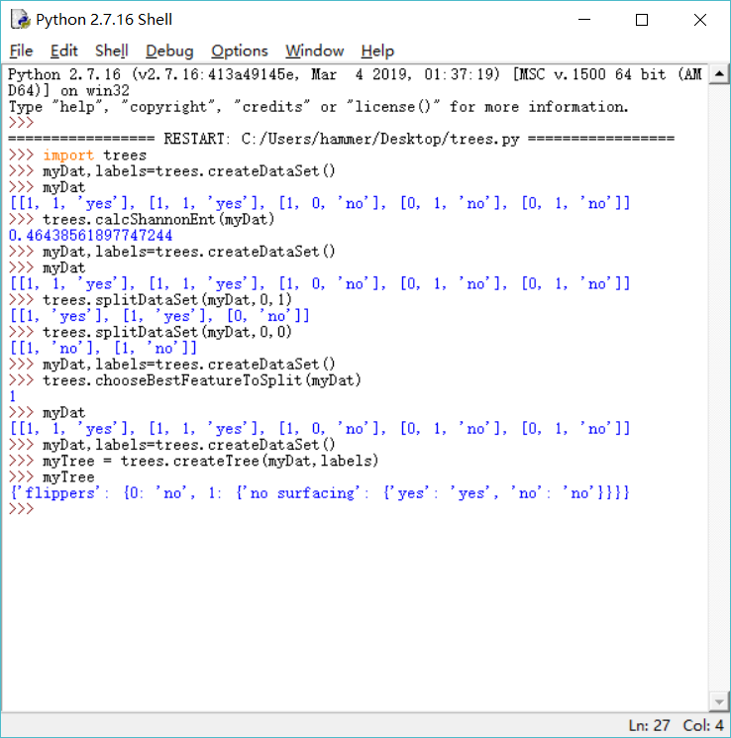

3.2 在python中使用Matplotlib注解绘制树形图
3.2.1Matplotlib注解
程序清单3-5 使用文本注解绘制树节点
程序代码;
import matplotlib.pyplot as plt

decisionNode = dict(boxstyle = "sawtooth",fc = "0.8")
leafNode = dict(boxstyle = "round4",fc = "0.8")
arrow_args = dict(arrowstyle = "<-")
def plotNode (nodeTxt,centerPt,parentPt,nodeType):
createPlot.ax1.annotate(nodeTxt,xy = parentPt,xycoords = 'axes fraction',
xytext = centerPt,textcoords = 'axes fraction',
va = "center",ha = "center",bbox = nodeType,
arrowprops = arrow_args)
def createPlot():
fig = plt.figure(1,facecolor = 'white')
fig.clf()
createPlot.ax1 = plt.subplot(111,frameon = False)
plotNode('a decision node',(0.5,0.1),(0.1,0.5),decisionNode)
plotNode('a leaf node',(0.8,0.1),(0.3,0.8),leafNode)
plt.show()

运行结果：
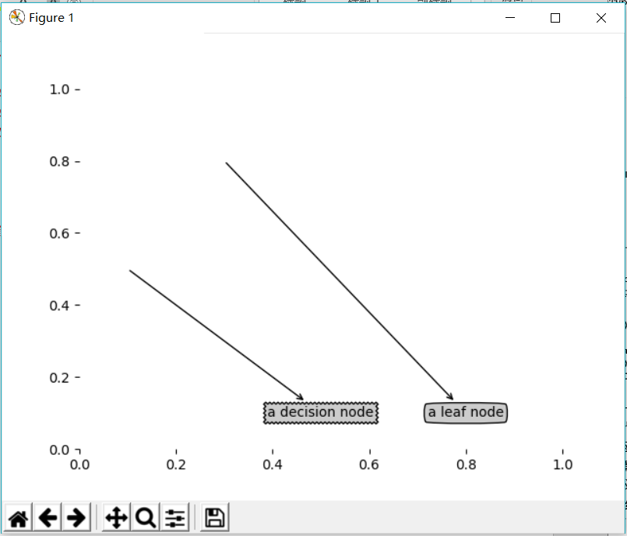

程序清单3-6 获取叶节点的数目和树的层次
程序代码：

def getNumLeafs(myTree):
numLeafs = 0
firstStr = myTree.keys()[0]
secondDict = myTree[firstStr]
for key in secondDict.keys():
if type(secondDict[key]).__name__=='dict':
numLeafs += getNumLeafs(secondDict[key])
else:
numLeafs += 1
return numLeafs
def getTreeDepth(myTree):
maxDepth = 0
firstStr = myTree.keys()[0]
secondDict = myTree[firstStr]
for key in secondDict.keys():
if type(secondDict[key]).__name__=='dict':
thisDepth = 1 + getTreeDepth(secondDict[key])
else:
thisDepth = 1
if thisDepth > maxDepth:
maxDepth = thisDepth
return maxDepth
def retrieveTree(i):
listOfTree = [{'no surfacing':{0:'no',1:{'flippers':\
{0:'no',1:'yes'}}}},
{'no surfacing':{0:'no',1:{'flippers':\
{0:{'head':{0:'no',1:'yes'}},1:'no'}}}}]
return listOfTree[i]
运行结果：
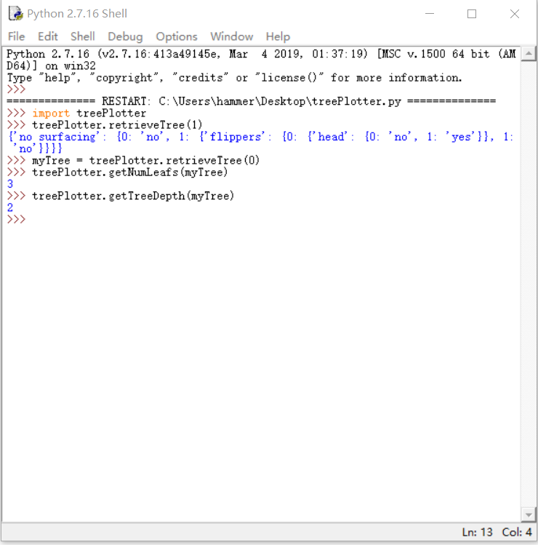

程序清单3-7 plotTree函数
程序代码：
def plotMidText(cntrPt,parentPt,txtString):
xMid=(parentPt[0]-cntrPt[0])/2.0+cntrPt[0]
yMid=(parentPt[1]-cntrPt[1])/2.0+cntrPt[1]
createPlot.ax1.text(xMid,yMid,txtString)
def plotTree(myTree,parentPt,nodeTxt):
numLeafs=getNumLeafs(myTree)
depth=getTreeDepth(myTree)
firstStr=myTree.keys()[0]
cntrPt=(plotTree.xOff + (1.0 + float(numLeafs))/2.0/plotTree.totalW,\
plotTree.yOff)
plotMidText(cntrPt,parentPt,nodeTxt)
plotNode(firstStr,cntrPt,parentPt,decisionNode)
secondDict=myTree[firstStr]
plotTree.yOff=plotTree.yOff - 1.0/plotTree.totalD
for key in secondDict.keys():
if type(secondDict[key]).__name__=='dict':
plotTree(secondDict[key],cntrPt,str(key))
else:
plotTree.xOff=plotTree.xOff + 1.0/plotTree.totalW
plotNode(secondDict[key],(plotTree.xOff,plotTree.yOff),
cntrPt,leafNode)
plotMidText((plotTree.xOff,plotTree.yOff),cntrPt,str(key))
plotTree.yOff=plotTree.yOff+1.0/plotTree.totalD
def createPlot(inTree):
fig=plt.figure(1,facecolor='white')
fig.clf()
axprops=dict(xticks=[],yticks=[])
createPlot.ax1=plt.subplot(111,frameon=False,**axprops)
plotTree.totalW=float(getNumLeafs(inTree))
plotTree.totalD=float(getTreeDepth(inTree))
plotTree.xOff=-0.5/plotTree.totalW;plotTree.yOff=1.0;
plotTree(inTree,(0.5,1.0),'')
plt.show()
运行结果：
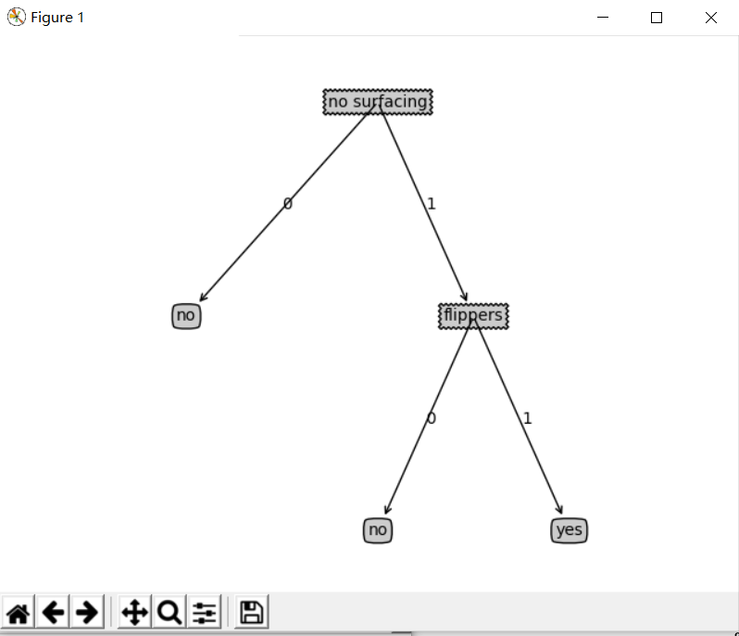

最终结果：

【实验总结】
通过这次实验我掌握了掌握决策树分类算法ID3的概念，理解了算法的步骤，加深了对ID3算法的理解，培养了我解决实际问题的能力。让我对数据挖掘产生了极大的兴趣，了解了关于python库函数的应用。在解决问题的过程中遇到困难积极询问同学和老师解答，同时增进了我和师生的关系，养成了交流讨论问题的习惯，最后感谢老师的精心指导和同学们的热心帮助。

