数据挖掘技术
实验指导书

上海第二工业大学
工学部

实验五 利用逻辑回归算法进行分类

【实验目的】
- 掌握逻辑回归算法的原理，理解算法的步骤。
- 掌握不同梯度方法下的逻辑回归算法，加深对逻辑回归算法的理解。

【实验性质】
设计型实验

【实验内容】

使用Logistic算法实现分类，完成实验内容5.1-5.2节

【实验环境】
Python 2

【实验要求】
将实验报告文件保存在命名为“学号+姓名+实验5”的文件中并上传到指定的服务器（192.168.101.1 上指定的目录）。

【实验结果】
完整代码：
from numpy import *

def loadDataSet():
dataMat = []; labelMat = []
fr = open('testSet.txt')
for line in fr.readlines():
lineArr = line.strip().split()
dataMat.append([1.0, float(lineArr[0]), float(lineArr[1])])
labelMat.append(int(lineArr[2]))
return dataMat,labelMat

def sigmoid(inX):
return 1.0/(1+exp(-inX))

def gradAscent(dataMatIn, classLabels):
dataMatrix = mat(dataMatIn)
labelMat = mat(classLabels).transpose() #convert to NumPy matrix
m,n = shape(dataMatrix)
alpha = 0.001
maxCycles = 500
weights = ones((n,1))
for k in range(maxCycles):
h = sigmoid(dataMatrix*weights)
error = (labelMat - h)
weights = weights + alpha * dataMatrix.transpose()* error #matrix mult
return weights

def plotBestFit(weights):
import matplotlib.pyplot as plt
dataMat,labelMat=loadDataSet()
dataArr = array(dataMat)
n = shape(dataArr)[0]
xcord1 = []; ycord1 = []
xcord2 = []; ycord2 = []
for i in range(n):
if int(labelMat[i])== 1:
xcord1.append(dataArr[i,1]); ycord1.append(dataArr[i,2])
else:
xcord2.append(dataArr[i,1]); ycord2.append(dataArr[i,2])
fig = plt.figure()
ax = fig.add_subplot(111)
ax.scatter(xcord1, ycord1, s=30, c='red', marker='s')
ax.scatter(xcord2, ycord2, s=30, c='green')
x = arange(-3.0, 3.0, 0.1)
y = (-weights[0]-weights[1]*x)/weights[2]
ax.plot(x, y)
plt.xlabel('X1'); plt.ylabel('X2');
plt.show()

def stocGradAscent0(dataMatrix, classLabels):
m,n = shape(dataMatrix)
alpha = 0.01
weights = ones(n) #initialize to all ones
for i in range(m):
h = sigmoid(sum(dataMatrix[i]*weights))
error = classLabels[i] - h
weights = weights + alpha * error * dataMatrix[i]
return weights

def stocGradAscent1(dataMatrix, classLabels, numIter=150):
m,n = shape(dataMatrix)
weights = ones(n) #initialize to all ones
for j in range(numIter):
dataIndex = range(m)
for i in range(m):
alpha = 4/(1.0+j+i)+0.0001 #apha decreases with iteration, does not
randIndex = int(random.uniform(0,len(dataIndex)))#go to 0 because of the constant
h = sigmoid(sum(dataMatrix[randIndex]*weights))
error = classLabels[randIndex] - h
weights = weights + alpha * error * dataMatrix[randIndex]
del(dataIndex[randIndex])
return weights

测试代码：
import logRegres
dataArr,labelMat=logRegres.loadDataSet()
a = logRegres.gradAscent(dataArr,labelMat)
print a

from numpy import *
reload(logRegres)
print logRegres.plotBestFit(a.getA())

'''
weights = logRegres.stocGradAscent0 (array(dataArr),labelMat)
print logRegres.plotBestFit(weights)
'''

weights = logRegres.stocGradAscent1 (array(dataArr),labelMat)
print logRegres.plotBestFit(weights)

【实验步骤】

程序清单5-1 Logistic回归梯度上升优化算法
from numpy import *

def loadDataSet():
dataMat = []; labelMat = []
fr = open('testSet.txt')
for line in fr.readlines():
lineArr = line.strip().split()
dataMat.append([1.0, float(lineArr[0]), float(lineArr[1])])
labelMat.append(int(lineArr[2]))
return dataMat,labelMat

def sigmoid(inX):
return 1.0/(1+exp(-inX))

def gradAscent(dataMatIn, classLabels):
dataMatrix = mat(dataMatIn) #convert to NumPy matrix
labelMat = mat(classLabels).transpose() #convert to NumPy matrix
m,n = shape(dataMatrix)
alpha = 0.001
maxCycles = 500
weights = ones((n,1))
for k in range(maxCycles): #heavy on matrix operations
h = sigmoid(dataMatrix*weights) #matrix mult
error = (labelMat - h) #vector subtraction
weights = weights + alpha * dataMatrix.transpose()* error #matrix mult
return weights

测试结果：
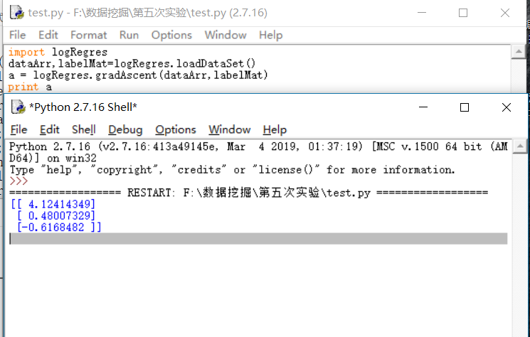

程序清单5-2 画出数据集和Logistic回归最佳拟合直线的函数

def plotBestFit(weights):
import matplotlib.pyplot as plt
dataMat,labelMat=loadDataSet()
dataArr = array(dataMat)
n = shape(dataArr)[0]
xcord1 = []; ycord1 = []
xcord2 = []; ycord2 = []
for i in range(n):
if int(labelMat[i])== 1:
xcord1.append(dataArr[i,1]); ycord1.append(dataArr[i,2])
else:
xcord2.append(dataArr[i,1]); ycord2.append(dataArr[i,2])
fig = plt.figure()
ax = fig.add_subplot(111)
ax.scatter(xcord1, ycord1, s=30, c='red', marker='s')
ax.scatter(xcord2, ycord2, s=30, c='green')
x = arange(-3.0, 3.0, 0.1)
y = (-weights[0]-weights[1]*x)/weights[2]
ax.plot(x, y)
plt.xlabel('X1'); plt.ylabel('X2');
plt.show()

测试结果：
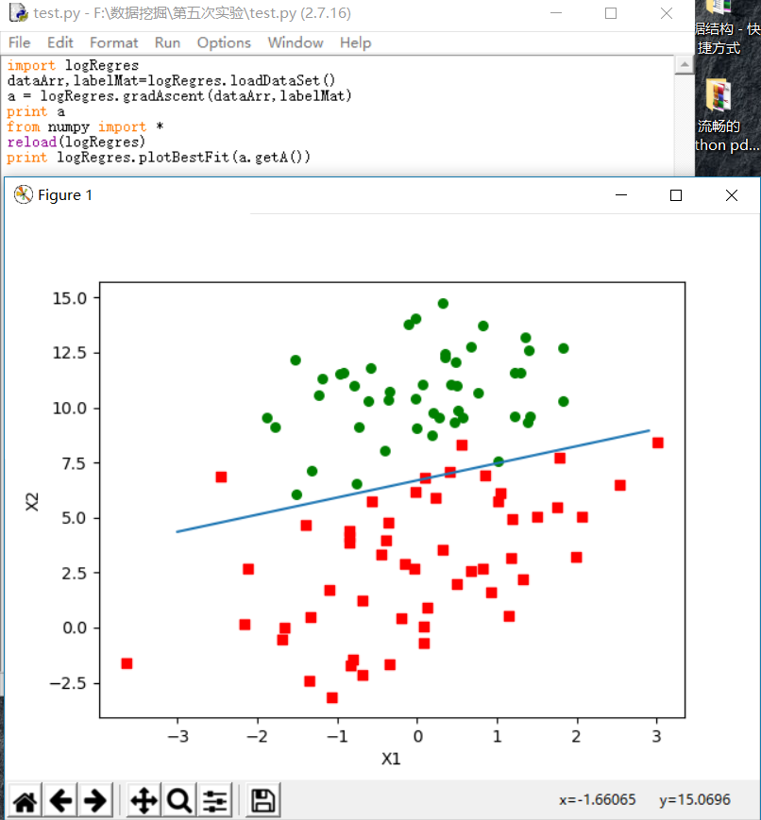

程序清单5-3 随机梯度上升算法
def stocGradAscent0(dataMatrix, classLabels):
m,n = shape(dataMatrix)
alpha = 0.01
weights = ones(n) #initialize to all ones
for i in range(m):
h = sigmoid(sum(dataMatrix[i]*weights))
error = classLabels[i] - h
weights = weights + alpha * error * dataMatrix[i]
return weights
测试结果：

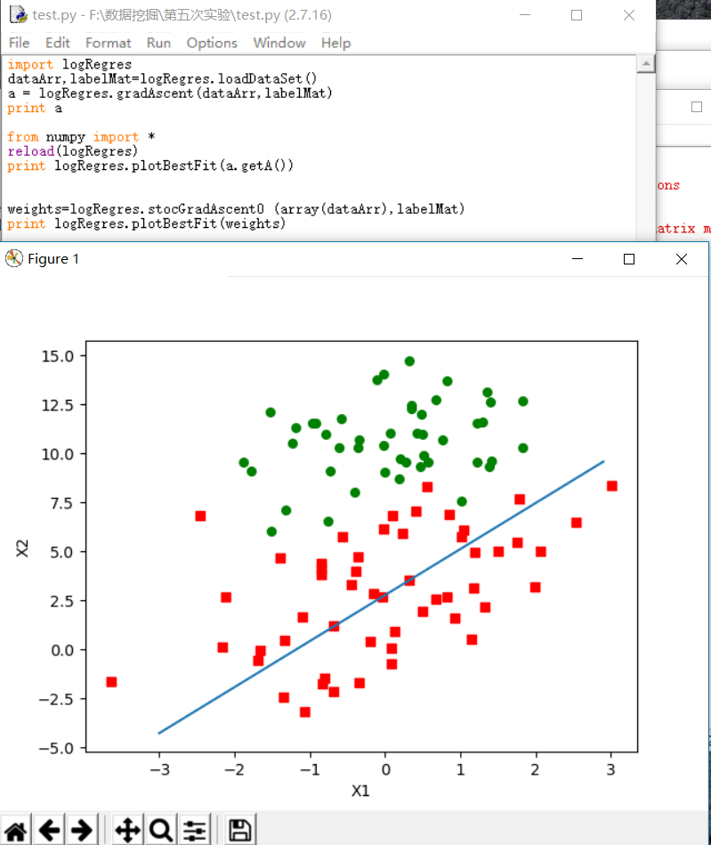

程序清单5-4 改进的随机梯度上升算法
def stocGradAscent1(dataMatrix, classLabels, numIter=150):
m,n = shape(dataMatrix)
weights = ones(n) #initialize to all ones
for j in range(numIter):
dataIndex = range(m)
for i in range(m):
alpha = 4/(1.0+j+i)+0.0001 #apha decreases with iteration, does not
randIndex = int(random.uniform(0,len(dataIndex)))#go to 0 because of the constant
h = sigmoid(sum(dataMatrix[randIndex]*weights))
error = classLabels[randIndex] - h
weights = weights + alpha * error * dataMatrix[randIndex]
del(dataIndex[randIndex])
return weights

测试结果：
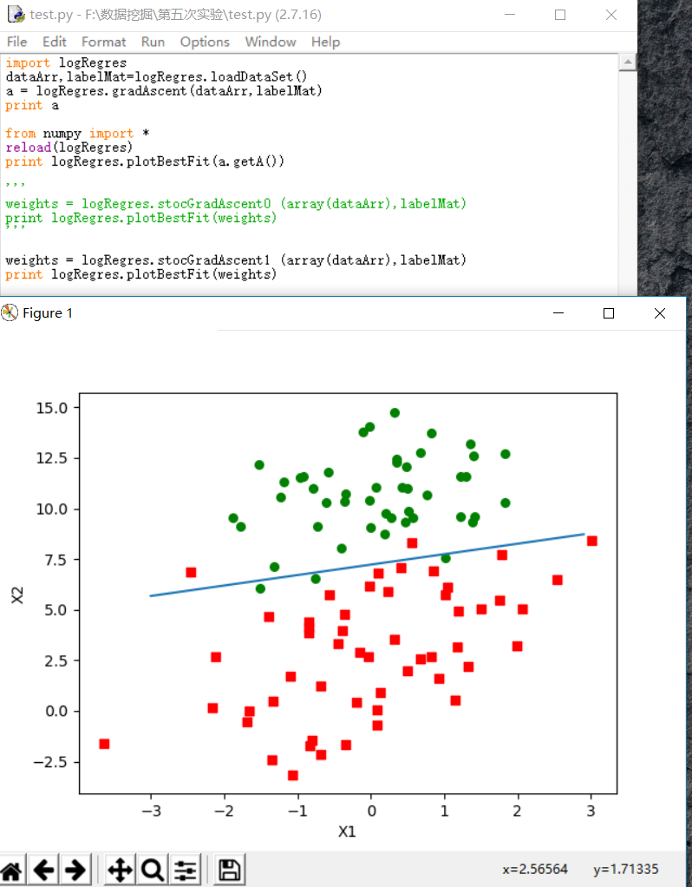

【实验总结】
通过这次实验我掌握了逻辑回归算法的原理，理解了算法的步骤。掌握不同梯度方法下的逻辑回归算法，加深对逻辑回归算法的理解。培养了我解决实际问题的能力。让我对数据挖掘产生了极大的兴趣，了解了关于python库函数的应用。在解决问题的过程中遇到困难积极询问同学和老师解答，同时增进了我和师生的关系，养成了交流讨论问题的习惯，最后感谢老师的精心指导和同学们的热心帮助。

