数据挖掘技术
实验指导书

上海第二工业大学
工学部

实验四 K-means聚类算法的实现及其应用

【实验目的】
- 掌握K-means聚类算法的原理，理解算法的步骤。
- 加深对K-means聚类算法的理解，掌握改进的K-means算法。

【实验性质】
设计型实验

【实验内容】

使用K-means实现聚类，完成实验内容10.1-10.3节

【实验环境】
Python 2

【实验要求】
将实验报告文件保存在命名为“学号+姓名+实验4”的文件中并上传到指定的服务器（192.168.101.1 上指定的目录）。

【实验结果】
部分测试数据截图：
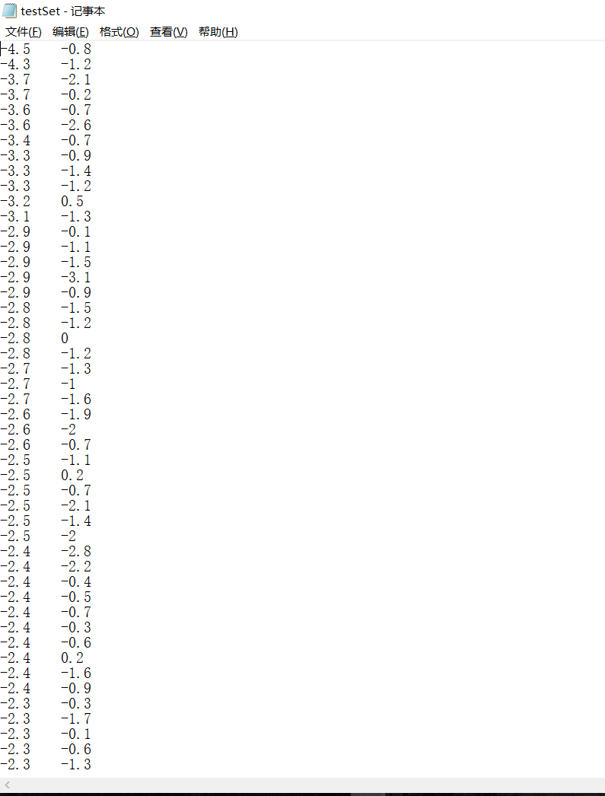
全部代码:
from numpy import *

def loadDataSet(fileName):
dataMat = []
fr = open(fileName)
for line in fr.readlines():
curLine = line.strip().split('\t')
fltLine = map(float,curLine)
dataMat.append(fltLine)
return dataMat

def distEclud(vecA, vecB):
return sqrt(sum(power(vecA - vecB, 2)))

def randCent(dataSet, k):
n = shape(dataSet)[1]
centroids = mat(zeros((k,n)))
for j in range(n):
minJ = min(dataSet[:,j])
rangeJ = float(max(dataSet[:,j]) - minJ)
centroids[:,j] = mat(minJ + rangeJ * random.rand(k,1))
return centroids

def kMeans(dataSet, k, distMeas=distEclud, createCent=randCent):
m = shape(dataSet)[0]
clusterAssment = mat(zeros((m,2)))#create mat to assign data points
#to a centroid, also holds SE of each point
centroids = createCent(dataSet, k)
clusterChanged = True
while clusterChanged:
clusterChanged = False
for i in range(m):#for each data point assign it to the closest centroid
minDist = inf; minIndex = -1
for j in range(k):
distJI = distMeas(centroids[j,:],dataSet[i,:])
if distJI < minDist:
minDist = distJI; minIndex = j
if clusterAssment[i,0] != minIndex: clusterChanged = True
clusterAssment[i,:] = minIndex,minDist**2
print centroids
for cent in range(k):#recalculate centroids
ptsInClust = dataSet[nonzero(clusterAssment[:,0].A==cent)[0]]#get all the point in this cluster
centroids[cent,:] = mean(ptsInClust, axis=0) #assign centroid to mean
return centroids, clusterAssment

def biKmeans(dataSet, k, distMeas=distEclud):
m = shape(dataSet)[0]
clusterAssment = mat(zeros((m,2)))
centroid0 = mean(dataSet, axis=0).tolist()[0]
centList =[centroid0] #create a list with one centroid
for j in range(m):#calc initial Error
clusterAssment[j,1] = distMeas(mat(centroid0), dataSet[j,:])**2
while (len(centList) < k):
lowestSSE = inf
for i in range(len(centList)):
ptsInCurrCluster = dataSet[nonzero(clusterAssment[:,0].A==i)[0],:]#get the data points currently in cluster i
centroidMat, splitClustAss = kMeans(ptsInCurrCluster, 2, distMeas)
sseSplit = sum(splitClustAss[:,1])#compare the SSE to the currrent minimum
sseNotSplit = sum(clusterAssment[nonzero(clusterAssment[:,0].A!=i)[0],1])
print "sseSplit, and notSplit: ",sseSplit,sseNotSplit
if (sseSplit + sseNotSplit) < lowestSSE:
bestCentToSplit = i
bestNewCents = centroidMat
bestClustAss = splitClustAss.copy()
lowestSSE = sseSplit + sseNotSplit
bestClustAss[nonzero(bestClustAss[:,0].A == 1)[0],0] = len(centList) #change 1 to 3,4, or whatever
bestClustAss[nonzero(bestClustAss[:,0].A == 0)[0],0] = bestCentToSplit
print 'the bestCentToSplit is: ',bestCentToSplit
print 'the len of bestClustAss is: ', len(bestClustAss)
centList[bestCentToSplit] = bestNewCents[0,:].tolist()[0]#replace a centroid with two best centroids
centList.append(bestNewCents[1,:].tolist()[0])
clusterAssment[nonzero(clusterAssment[:,0].A == bestCentToSplit)[0],:]= bestClustAss#reassign new clusters, and SSE
return mat(centList), clusterAssment

测试代码:
import kMeans
from numpy import *
datMat=mat(kMeans.loadDataSet('testSet.txt'))
print min(datMat[:,0])
print min(datMat[:,1])
print max(datMat[:,1])
print max(datMat[:,0])
print kMeans.randCent(datMat,2)
print kMeans.distEclud(datMat[0],datMat[1])

reload(kMeans)
datMat=mat(kMeans.loadDataSet('testSet.txt'))
myCentroids,clustAssing=kMeans.kMeans(datMat,4)
print myCentroids

print '二分k-均值聚类测试结果：'
reload(kMeans)
datMat3=mat(kMeans.loadDataSet('testSet.txt'))
print datMat3
centList,myNewAssment=kMeans.biKmeans(datMat3,3)
print myNewAssment
print centList

最终结果：
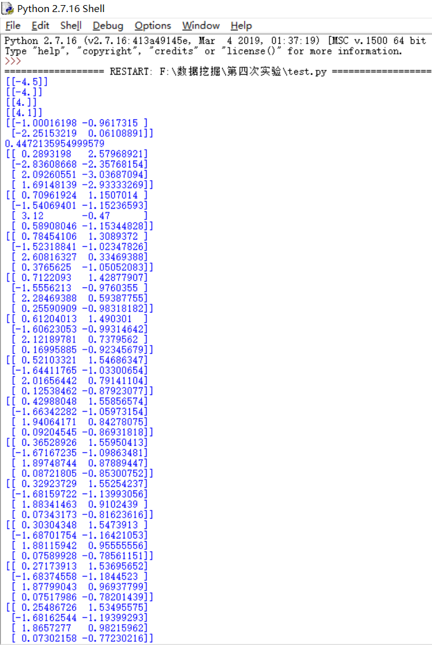
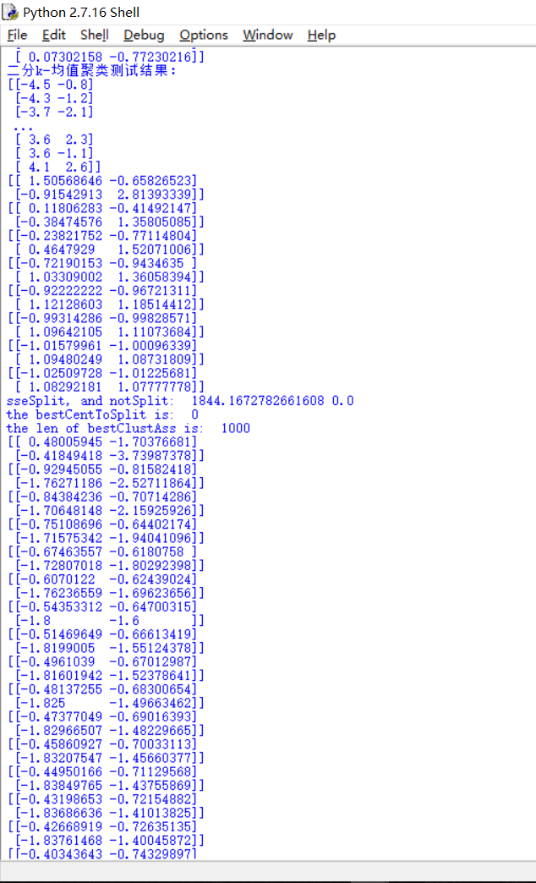
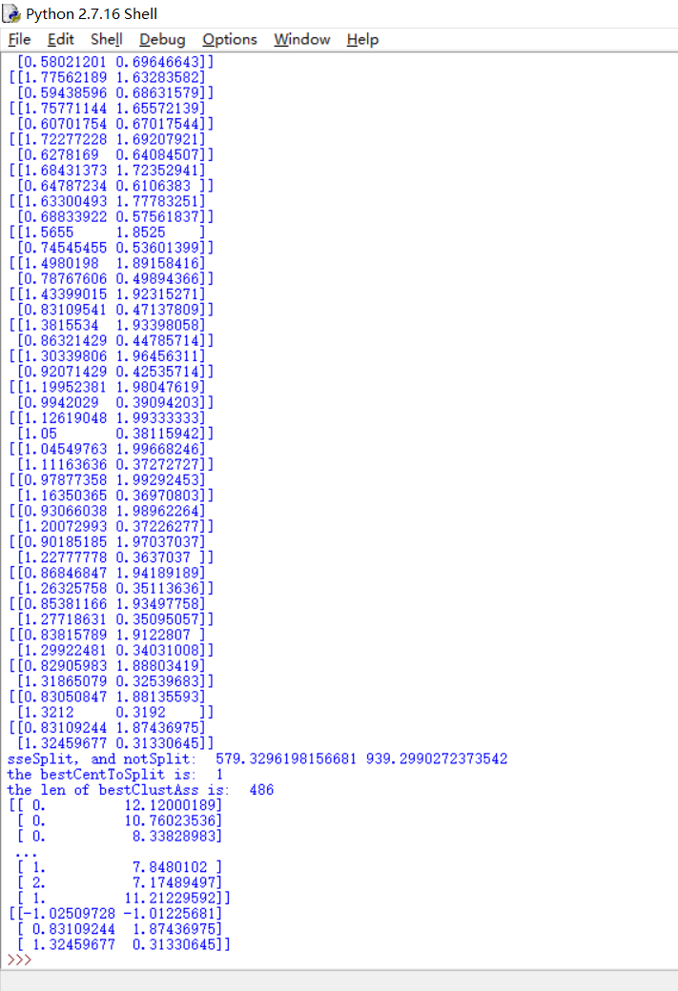

【实验步骤】
程序清单10.1 k-均值聚类支持函数
from numpy import *

def loadDataSet(fileName):
dataMat = []
fr = open(fileName)
for line in fr.readlines():
curLine = line.strip().split('\t')
fltLine = map(float,curLine)
dataMat.append(fltLine)
return dataMat

def distEclud(vecA, vecB):
return sqrt(sum(power(vecA - vecB, 2)))

def randCent(dataSet, k):
n = shape(dataSet)[1]
centroids = mat(zeros((k,n)))
for j in range(n):
minJ = min(dataSet[:,j])
rangeJ = float(max(dataSet[:,j]) - minJ)
centroids[:,j] = mat(minJ + rangeJ * random.rand(k,1))
return centroids

测试结果：
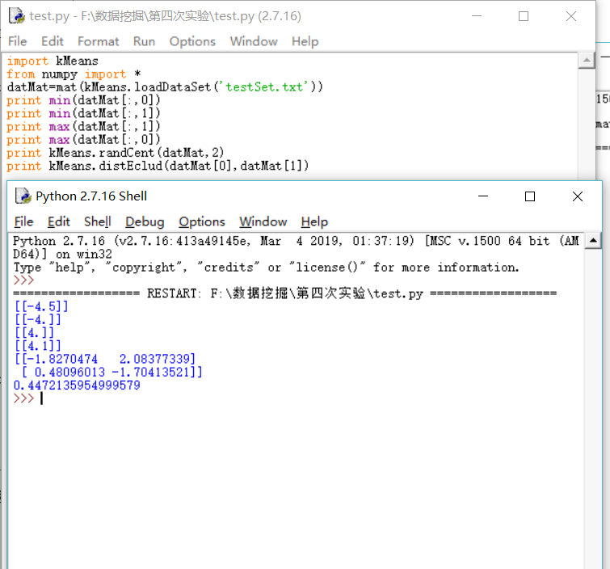
程序清单10.2 k-均值聚类算法

def kMeans(dataSet, k, distMeas=distEclud, createCent=randCent):
m = shape(dataSet)[0]
clusterAssment = mat(zeros((m,2)))#create mat to assign data points
#to a centroid, also holds SE of each point
centroids = createCent(dataSet, k)
clusterChanged = True
while clusterChanged:
clusterChanged = False
for i in range(m):#for each data point assign it to the closest centroid
minDist = inf; minIndex = -1
for j in range(k):
distJI = distMeas(centroids[j,:],dataSet[i,:])
if distJI < minDist:
minDist = distJI; minIndex = j
if clusterAssment[i,0] != minIndex: clusterChanged = True
clusterAssment[i,:] = minIndex,minDist**2
print centroids
for cent in range(k):#recalculate centroids
ptsInClust = dataSet[nonzero(clusterAssment[:,0].A==cent)[0]]#get all the point in this cluster
centroids[cent,:] = mean(ptsInClust, axis=0) #assign centroid to mean
return centroids, clusterAssment

运行结果：
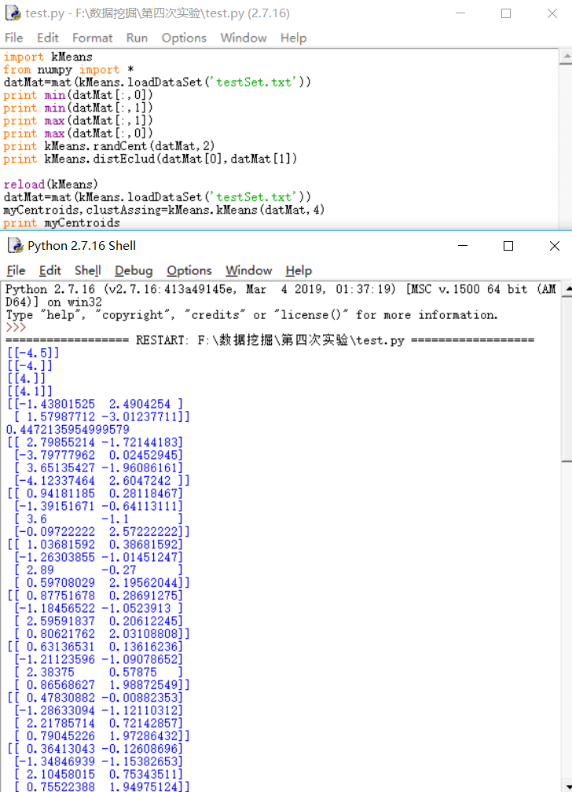

程序清单10.3 二分K-均值聚类算法
def biKmeans(dataSet, k, distMeas=distEclud):
m = shape(dataSet)[0]
clusterAssment = mat(zeros((m,2)))
centroid0 = mean(dataSet, axis=0).tolist()[0]
centList =[centroid0] #create a list with one centroid
for j in range(m):#calc initial Error
clusterAssment[j,1] = distMeas(mat(centroid0), dataSet[j,:])**2
while (len(centList) < k):
lowestSSE = inf
for i in range(len(centList)):
ptsInCurrCluster = dataSet[nonzero(clusterAssment[:,0].A==i)[0],:]#get the data points currently in cluster i
centroidMat, splitClustAss = kMeans(ptsInCurrCluster, 2, distMeas)
sseSplit = sum(splitClustAss[:,1])#compare the SSE to the currrent minimum
sseNotSplit = sum(clusterAssment[nonzero(clusterAssment[:,0].A!=i)[0],1])
print "sseSplit, and notSplit: ",sseSplit,sseNotSplit
if (sseSplit + sseNotSplit) < lowestSSE:
bestCentToSplit = i
bestNewCents = centroidMat
bestClustAss = splitClustAss.copy()
lowestSSE = sseSplit + sseNotSplit
bestClustAss[nonzero(bestClustAss[:,0].A == 1)[0],0] = len(centList) #change 1 to 3,4, or whatever
bestClustAss[nonzero(bestClustAss[:,0].A == 0)[0],0] = bestCentToSplit
print 'the bestCentToSplit is: ',bestCentToSplit
print 'the len of bestClustAss is: ', len(bestClustAss)
centList[bestCentToSplit] = bestNewCents[0,:].tolist()[0]#replace a centroid with two best centroids
centList.append(bestNewCents[1,:].tolist()[0])
clusterAssment[nonzero(clusterAssment[:,0].A == bestCentToSplit)[0],:]= bestClustAss#reassign new clusters, and SSE
return mat(centList), clusterAssment

运行结果：
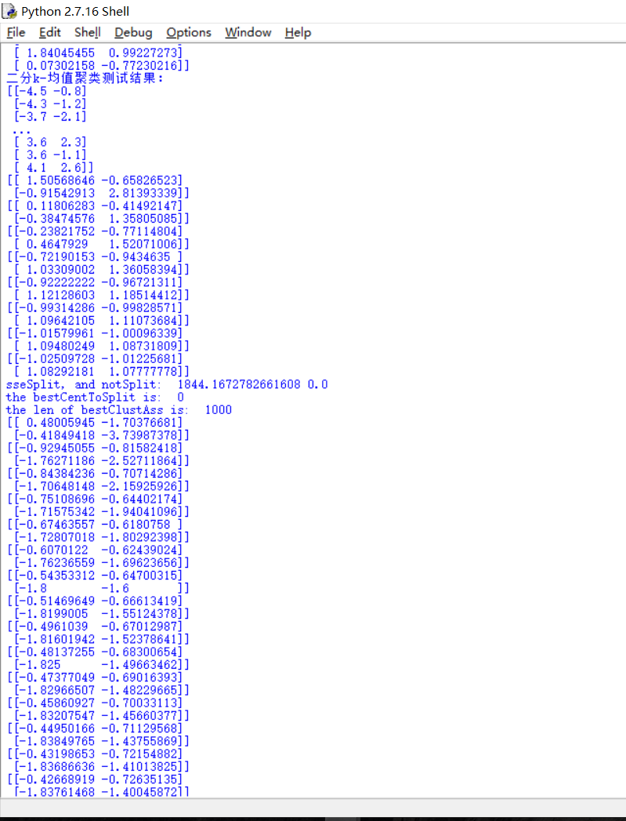
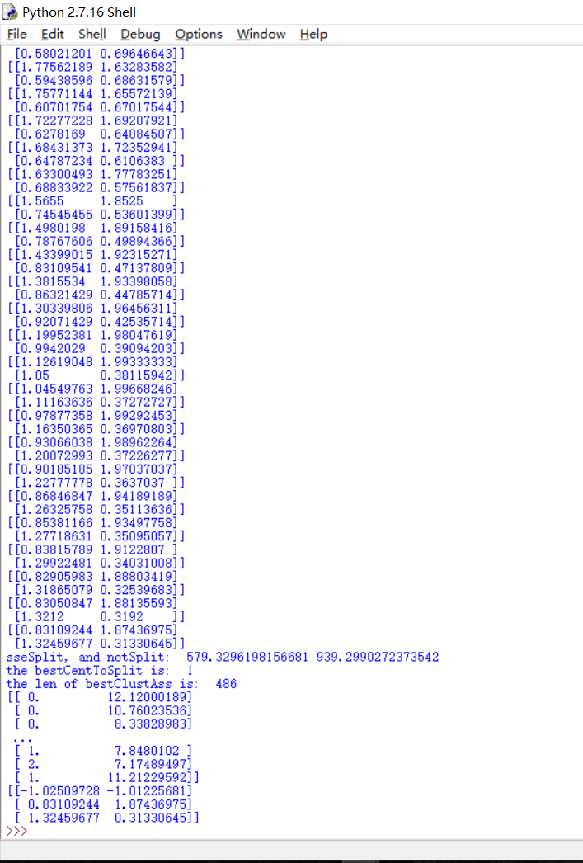

【实验总结】
要点：k-means聚类前要采集数据
通过这次实验我掌握了K-means均值聚类算法的概念，理解了算法的步骤，加深了对K-means算法的理解，掌握了改进的K-means算法，培养了我解决实际问题的能力。让我对数据挖掘产生了极大的兴趣，了解了关于python库函数的应用。在解决问题的过程中遇到困难积极询问同学和老师解答，同时增进了我和师生的关系，养成了交流讨论问题的习惯，最后感谢老师的精心指导和同学们的热心帮助。

