A beach litter survey on the shores of Lake Geneva
Bhavish Patel^{*a}, Roger Erismann^{b}, Christian Ludwig^{a,c}

ª Bioenergy and Catalysis Laboratory (LBK), Energy and Environment Research Division (ENE), Paul Scherrer Institut (PSI), 5232 Villigen PSI, Switzerland
^{b} Hammerdirt, Clos d’Aubonne 14, La Tour de Peilz, Switzerland
^{c} Environmental Engineering Institute (IIE),GR-LUD, School of Architecture, Civil and Environmental Engineering (ENAC), École Polytechnique Fédérale de Lausanne (EPFL), CH 1015 Lausanne, Switzerland

Abstract

Acronyms:
AL = Anthropogenic Litter
API = Application Programming Interface
EPFL = École Polytechnique Fédérale de Lausanne
FOEN = Swiss Federal Office of the Environment
JRC = Joint Research Centre
MCBP = Montreux Clean Beach Project
MLW = Marine Litter Watch
MSFD = Marine Strategy Framework Directive
OSPAR = Oslo Paris Commission
pcs/m = Pieces of trash per meter of shoreline or riverbank
SLR = Swiss Litter Report
SLS = Shoreline Litter Surveillance
UNEP = United Nations Environment Programme
WWF = World Wildlife Fund
1.0 Introduction
The impact of human activity on the environment has led to several irreversible and undesirable changes (ref). This trend is not expected to change in the near-term given the political, economic and technological bottlenecks, but also due to the discovery of new sources of pollutants and its effect on overall natural cycles and eco-systems (ref). Recently, marine litter has garnered global attention based on the promotion of the Pacific waste gyre. In fact, the garbage patch has existed since the late 80s, but only minimal, if any, action was taken to prevent its growth or target the influent waste streams until now (ref). It should be noted that island like formation from debris can now be found in almost all oceans around the world, as well as beaches and shorelines (ref). Consequently, there is substantial deterioration in marine water quality, health of marine life and depletion of aquatic diversity leading to an imminent urgency to address and resolve the problem (ref).
Most of the attention, as well as focus on this topic is towards marine aquatic sources, but an even more critical and crucial resource is freshwater. Used for both farming and human consumption, freshwater is essential for humans, and needs to be preserved from experiencing the same fate given its importance and limited availability. Many important rivers and lakes around the world are already beyond acceptable safety pollutant limits, with many considered dangerous to human health(ref), especially in populous developing countries. Not only do these contain chemical waste, but also a plethora of industrial, municipal and organic pollutants resulting from accidental/ancillary disposal and the more likely and usual scenario of intentional disposal(ref). The debris eventually end up in the oceans and contribute to the ever-growing environmental catastrophe. Therefore, assessing the current situation and acting to prevent and reduce introduction of pollutants upstream to limit and stop further damage should be a priority. As such, freshwater systems are considered to be the principal routes of transmission of anthropogenic litter (AL) to the oceans. However, in relation to the ocean, accumulation and transport of AL is rarely studied in freshwater systems {3}. Current studies are not comparable because protocols for freshwater systems have yet to be standardized {4}.
In this study, we attempt to address and present a methodology to contribute towards quantifying the AL problem in fresh water sources using Lake Geneva in Switzerland as an example. Although public education and outreach are key components of the Swiss litter prevention program (ref), there is no publicly funded systematic surveillance of AL on Swiss waterways. Thus, it is envisaged that the research presented herein will aid towards policy development and address underlying sources for the abatement and prevention of solid waste entering the waterways. Considered an oasis of natural and environmental beauty, Switzerland is a leader in the environmental performance indexes (ref). Lake Geneva supplies drinking water for at least 800’000 people. The mean altitude of the lake is 372 metres, and is maintained by the Canton of Geneva in accordance with the “Acte intercantonal concernant la correction et la régularisation de l’écoulement des eaux du Léman”.{1} With a surface area of 580 km² and over 200 km of coastline, Lake Geneva is western Europe’s largest perialpine lake and largest freshwater reserve, receiving 75% of its inflow from the Rhone river.{2}
The project on Lake Geneva, herein referred to as Montreux clean beach project (MCBP) was designed to fill that knowledge gap by providing data using an established protocol that was recognized by European member states: marine litter watch (MLW) or OSPAR. Both systems are designed to be implemented at the local level, require minimal financial resources and put the “citizen” at the centre of data collection {5}{6}{7}. In this regard, the methodology implemented by Hammerdirt, a non-government organisation initiating and spearheading this endeavour differs and provides an alternative means for AL quantification. The key difference between the Hammerdirt project and the MLW or OSPAR protocol is the frequency of samples. On Lake Geneva samples were taken at random intervals and locations. This has led to an elevated number of samples for the lake when compared to traditional OSPAR (four samples per year) monitoring. The goal is not so much to determine the exact quantity of debris but rather determine the probability distribution of “pieces of trash per meter” for a region or sub-region. With the intention of quantifying the material to determine the probability, on a year over year basis if an individual will encounter more or less trash per metre of shoreline. The effort to develop this database via litter collection started around 2015 and has continued to grow and evolve ever since. However, in this instance, for the first time, this research presents the overall results obtained by Hammerdirt for litter surveys carried out across Lake Geneva between the time period of November 2015 to November 2018. Furthermore, as an example, detailed findings of two shorelines is presented yielding both quantitative and qualitative insights, as well as to demonstrate the practicalities and method of the litter collection activity.
2.0 Methodology
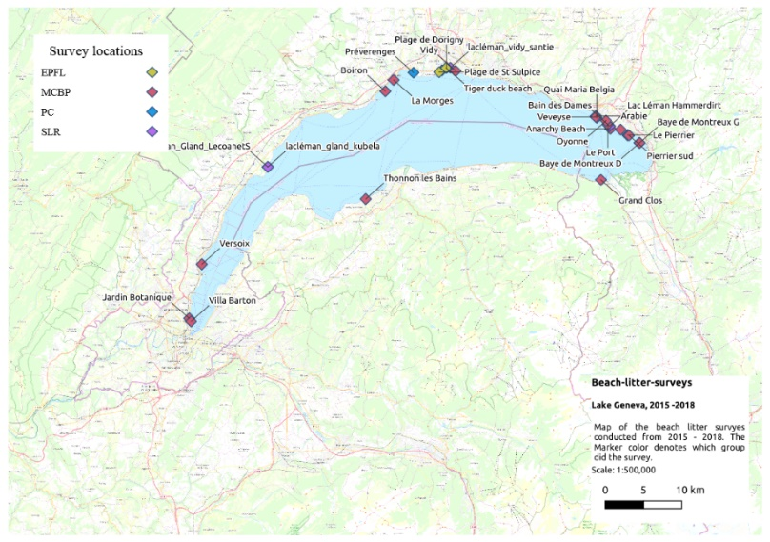
Surveillance of AL on Lake Geneva is based on the principle that shoreline litter is a proxy for AL in the water system {8}. This implies that participants restrict debris collection to a fixed length of shoreline and maintain a search perimeter within the strandline. Although the level of Lake Geneva is maintained at a relatively constant rate, the location of the strandline varies throughout the year. Participants must use their judgment when determining the “width” of the collection area. Fig. 1 below, shows the surveyed beaches by Hammerdirt around Lake Geneva in its entirety. 29 different beach locations were sampled, representing 148 separate operations and over 51’000 objects categorized according to the MLW system. Of those 148 samples, 6 are attributed to this work which proves to exemplify the procedure for the sampling, data collection, data processing as well as conclusions based on findings.
Figure 1 -Tagged map of surveyed locations around Lake Geneva. The inlet to the lake is via river Rhône, located between points 28-29.
For methodical and precise quantification of the AL, the below mentioned steps serve as a guideline.
Sampling: Participants select a length of beach and identify the strandline:
- The limits of the sampling area are identified and marked
- All anthropogenic debris is collected and deposited on a flat surface
- Objects are sorted and counted according to one of the MLW categories
- Results are recorded either on paper or directly into the application with a connected device (Whether the data is entered online or on paper is dependent on the participant and the training level)
- Beach location: latitude, longitude (the start point of the sample area)
- Beach name: As defined by user
- Sample length: meters to nearest integer value
- Sample results per identified object
It should be noted that the above-mentioned procedure is universal and if followed properly there is no bias regardless of the technical ability of the volunteer. Independent sampling is for individuals or groups that wish to conduct sampling for a sustained period of time. Essentially, prior to the sampling there are two training methods for individuals or groups interested in participating in the litter surveillance program. Both methods are primarily concerned with identifying the strandline and identifying the objects collected.
2.1 Method One – Accompanied sampling
This method is designed for groups that do not intend to conduct repeated sampling but wish to participate in the surveillance program. In a classroom setting the participants receive the following:
- A brief overview of the project, including current results
- A brief explanation of the scientific base and application to the global problem
- Examples of commonly misidentified items
Once the classroom portion is complete, the participants are accompanied to the site and Hammerdirt staff assist with site selection, identifying the limits of the sample area, identifying objects and ensuring items are accounted for appropriately. Data entry is performed by Hammerdirt staff. The SWE group whose data is presented in detail later were part of this accompanied sampling methodology.
2.2 Method Two – Independent sampling
Independent sampling is for individuals or groups that wish to conduct sampling for a sustained period of time. The biggest difference is there is no classroom activity. Candidates are invited to accompany Hammerdirt staff on routine sampling operations. At each operation candidates learn how to identify the strandline, identify objects and record results. Although there is no set number of operations that determine a candidate’s proficiency, historically, we have found that three or four operations are sufficient to cover all the topics including data entry and interpreting results. This is a more hand-on approach.
In the particular case of beach litter data collection by non-academic researchers, it has proved to be as effective if not as efficient as academic researchers {9}. Thus, the methodology ensures uniformity and accessibility to all individuals via the concept of citizen science. The collection method determines the analysis techniques. In the Hammerdirt project samples are taken at varying frequencies and at random locations since there is a geographical bias related to the participants place of residence. Participants tend to sample in close proximity to their domicile, thus creating geographical clusters of samples. Those clusters contain samples that vary in frequency and location {11}. This sampling method limits the application of the Mann-Kendall methods traditionally used to detect monotonic trends in series of environmental data {10}{12}. For the reasons mentioned above data analysis of survey results is done on a year over year basis by comparing the probability density function (PDF) of all results from one year to the next.
Thus, in this work we present the results of the beach litter survey conducted on the shores of Lake Geneva using a mixture of the above two methodologies. The subsequent data acquired is statistically treated and analysed to gain deeper insights, as well as qualitatively assess selected sites. The work presented herein represents the power of combining an easy to use dashboard type data acquisition procedure to enable the general public to take part in citizen science type projects and aid local authorities make better informed decisions in the realm of water pollutants. To our knowledge this is a first study of its kind that uses this methodology for freshwater shore assessment in Switzerland.
3.0 Results & Discussion
The results of the beach litter survey conducted using the beforementioned methodologies is presented in the subsequent sections. The statistical and methodology aspects are discussed first, followed by a general evaluation of the litter type, quantity and potential source.
3.1 Number of surveys and sites
The shorelines along Lake Geneva where the litter survey was performed is shown in Fig. 1. A total of 148 surveys segmented as 83, 41, and 24 beaches were conducted in year 1, 2 and 3, respectively. It should be noted that in the context of this article, a year is defined as starting in the first week of November. Thus, the study presented is based on a three year period between Nov 2015 to Nov 2018. During the development of the litter survey database, the samples varied both in frequency and location. This is not by design, but it is a by-product of any long-term project that is unfunded and reliant on volunteer resources and thus the variation is understood to be a factor of citizen science type projects. As a result, not all locations were sampled throughout the three-year period and consequently the number of samples per location ranges from 1 to 18. The data set that results is a collection of geographical clusters that are themselves composed of a series of samples that vary both in location and frequency.
To highlight the above, an excellent example is the distribution of beaches surveyed and the number of surveys per beach for year 1, 2 and 3 as shown in Fig.2. During the course of the project, volunteers and the Hammerdirt staff changed locations and as a result, the number of surveys and the survey locations changed between year 1 and 2, leading to a broader geographical coverage, but lesser number of surveys. Year 2 (2016 - 2017) also saw the addition of new beaches on Lake Geneva using the MLW protocol taking part in a year-long national survey organized by STOPPP Switzerland and volunteers from the (WWF). In year 3 the drop continued both in the number of surveys and locations surveyed. As a dynamic study, the database continues to evolve over time as new locations, collaborators become involved and contribute towards its growth. The resulting variety of locations and changing frequency limits the application of the Mann-Kendall methods traditionally used to detect monotonic trends in time series of environmental data {10}{12}. However, the same protocol as defined in the methodology section was consistently used by all participants throughout the three-year period and furthermore training was also provided by the organizers (Hammerdirt). For instance, the WWF organized two training days and provided a written guide in French and German. Given these conditions we compared the year over year probability distribution of results.
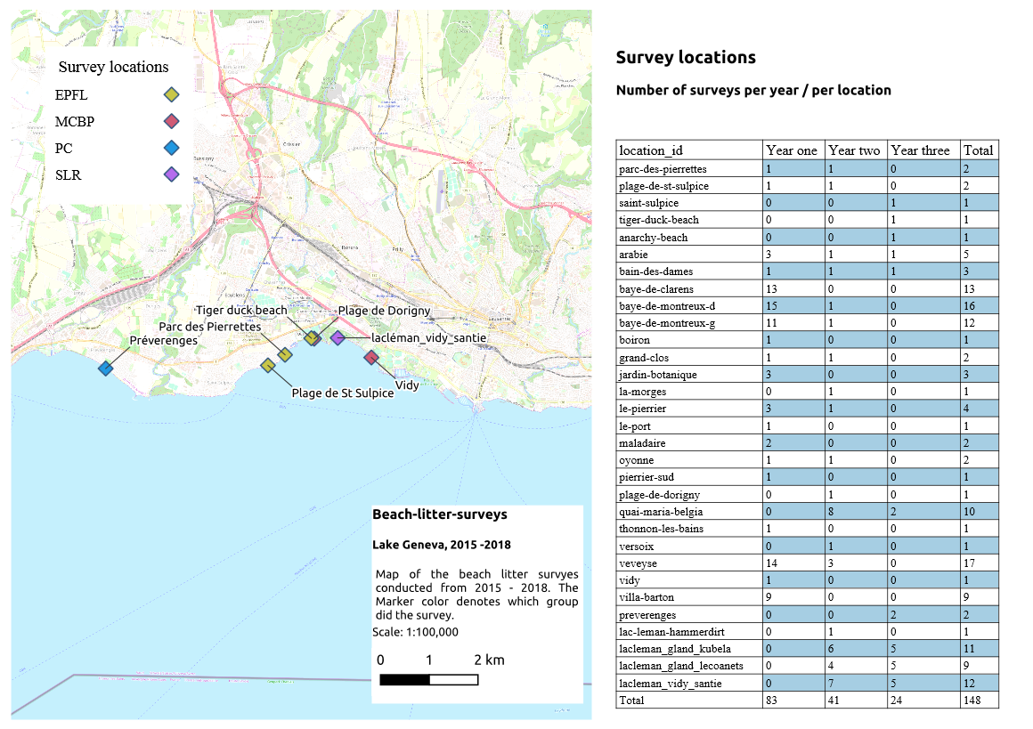
Figure 2 – Breakdown of surveyed beach locations in Year 1 (a), Year 2 (b) and Year 3 (c).

Next, the data set was divided into three twelve-month periods, where the 1st year is defined as beginning in Nov 2015. This was the first recorded sample using the MLW protocol in the Hammerdirt database. Units were expressed as pieces of trash per metre of shoreline (pcs/m) and the surveys were stored and analysed as reported by the participants. It should be noted that the word trash and AL have the same definition and is used synonymously. In total, there were 148 surveys reported by five different groups. Only two groups have consistently reported results for the entire three-year period, solid waste engineering (SWE) and MCBP. Of the thirty different locations surveyed, 29 locations are in Switzerland (147 surveys) and one location in France (1 survey). Of the 147 surveys in Switzerland 88 are located between the cities of Montreux and Vevey (positions 16-28 on the map). 65 of the 88 samples between Vevey and Montreux were taken in the first year. The first year was designated as the base year not only because of the temporal aspect but also because of the geographic consistency and the stability of the staff that collected the samples as 81 of 83 samples were collected by Hammerdirt staff. All of the above data is provided in its entirely in Fig. 3 which depicts the pcs/m of trash collected by each of the groups over the 3 years.
3.2 Variation in trash over time
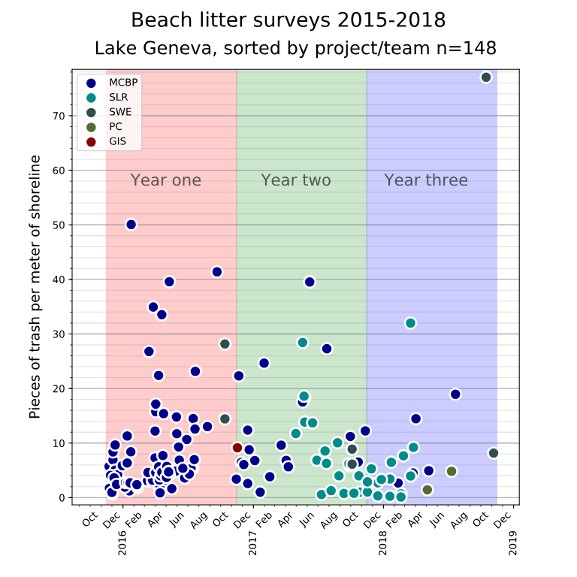
In terms of variety of observations, the second year has the largest variety of surveys. In year two, no group is responsible for more than 50% of the surveys. Year two provides both geographic and demographic variety of the observations. The similarities with the distribution of values to the first year should not be overlooked. On the other hand, in the third year there are only 24 surveys, 15 of which come from the same group: SLR. Lastly, in the first year MCBP was responsible for 81 out of the83 surveys and the remaining two were conducted by SWE. The descriptive statistics in Table 1 (Appendix 1) confirms that although the number of surveys conducted over the 3 years is in decline, there is no particular difference in the mean amount of trash found per metre with values of 8.7, 10.15 and 9.01 pcs/m in each of the years. However, the standard deviation (SDEV) of the surveys from year 3 has a broader spread, which is due to the most recent litter survey in Lausanne, which had the highest quantity of trash.
Figure 3 – Breakdown of pieces of trash per metre of shoreline quantified by surveying group over the 3 years.

Based on the SDEV as well as the maximum quantity of pcs/m, we can deduce that the quantity of AL can be very high at certain locations, but it does not necessarily imply that the mean will be affected. For instance, year 3 has a higher maximum pcs/m than year 2, by almost 50%, but the difference in the mean is negligible. Thus, the aggregated results for all surveys in units of pcs/m are skewed right with a long tail, as shown in Fig. 4. There were no surveys with a reported value of zero. The log transformation tends to skew left with a shortened tail. Thus, our assumption is that with enough samples the results tend to a log-normal distribution.
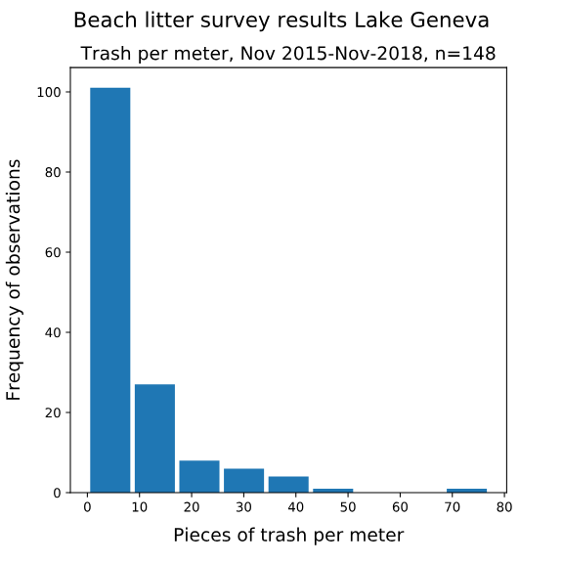
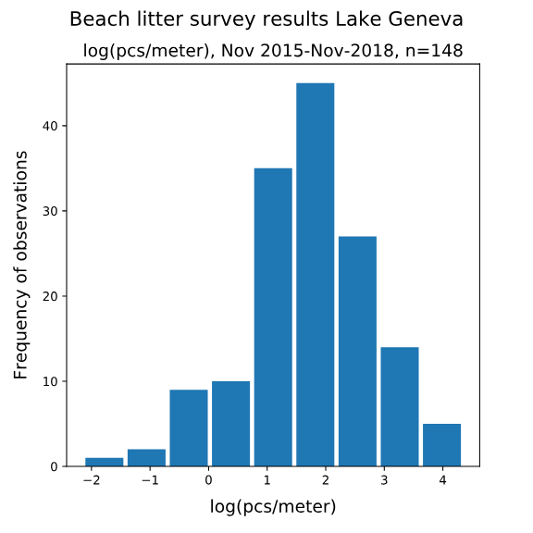

Figure 4 – Breakdown of pieces of trash per metre of shoreline quantified by the surveying group over the 3 years showing aggregated frequency

Taking the mean and standard deviation of the year over year results and performing a lognormal transformation on the daily pcs/m results in the distribution shown in Fig. 4, yields the graph shown in in Fig. 5. Statistically, observing the model poses an interesting question whether there is any bias between groups. From the breakdown of the surveys (Table 1) it is evident that MCBP has the greatest amount of surveys over the three-year period followed by SLR. Thus, since these were the means that the aggregated results are influenced by the observations of Hammerdirt staff. This effect may be moderated in years two and three because the ratio of surveys completed by Hammerdirt staff to other groups diminishes with each year.

Table 1 – Breakdown of surveys conducted by participating groups over the three years (Nov 2015 –Nov 2018)

Group | Number of samples
MCBP | 106
SLR | 33
SWE | 6
PC | 2
GIS | 1

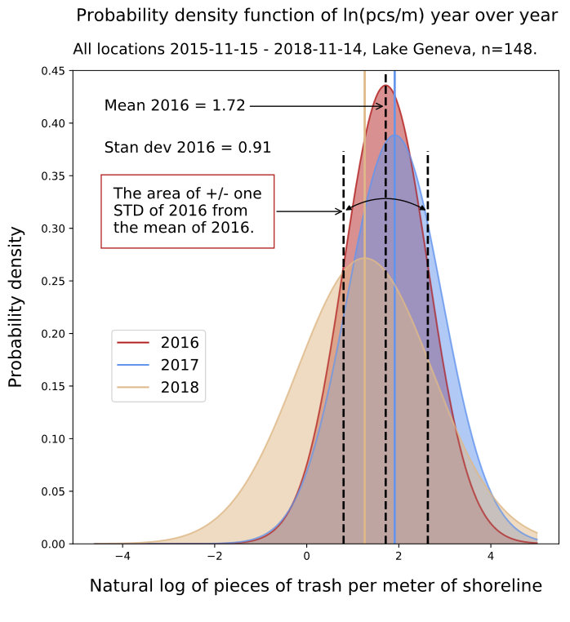
Figure 5 – Year on year log normal distribution of pcs/m showing the change in SDEV over the three years
3.3 Comparison between the survey groups
To illustrate the potential differences arising from the surveying techniques of different groups, the descriptive statistics in Table 2 (Appendix) and the accompanying PDF in Figure 6 of the two biggest groups, which accounts for 94% of the survey is used as an example. In the first instance, it can be seen that the probability density of the SLR is lower than that of the MCBP, and the same applies to the mean.

MCBP and SWE are the only groups that have surveys throughout the period. If the combined observations of MCBP and SLR are an accurate representation of the type and number of objects that a person is likely to find on the shoreline, then we expect most of the samples from the smaller groups to fall within one or two standard deviations of the combined distributions.
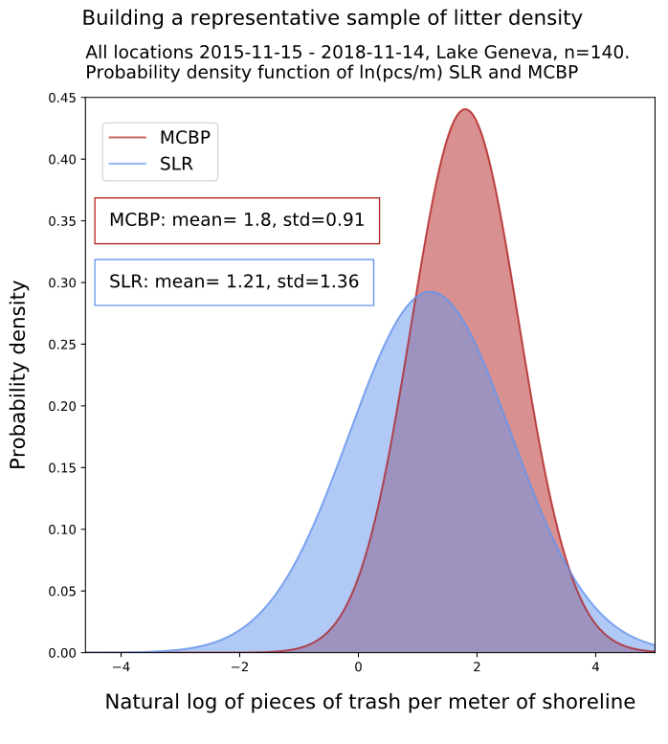
Figure 6 – Log normal distribution of pcs/m between the two largest sampling units, SLR and MCBP encompassing total surveys over the three-year period

It would be expected that results from a similar geographical coordinates would yield a much lower litter count, but this is not entirely true. As such, the cumulative probability plot in Fig. 7 is used to depict the possibility of finding certain amounts of trash per metres. Based on the MCBP and SLR survey groups, which accounts for a total of 130 surveys, it becomes apparent that the actual data approximately follows a similar path to the normalised curve, where an asymptote is reached around 30 pcs/metres. Furthermore, the steepness of the slope also illustrates height of the relative frequency plot.

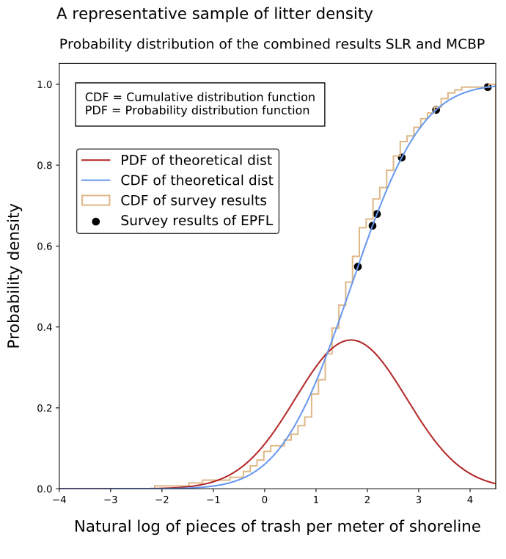
Figure 7 – Cumulative distribution and subsequent normalised curve of the SLR and MCBP surveys encompassing total surveys over the three-year period

3.4 Site Specific Results
To deep dive into the data from the surveys, the litter collection exercise from two sites is used as an example. In particular, the data from the SWE group is used. Upon collection and sorting, the quantity of each material type was input into the database based on the MLW code classification. Fig. 8 and 9 shows the segmented data for the litter collected at Plage de St Sulpice (PS) and Parc des Pierrettes (PP) beaches. From the onset, it is clear that both these locations contain higher than average amounts of waste on the shoreline compared to the Swiss national average of 5.8 pcs/metre (ref). Scrutinizing the data further, it can be seen that the majority of the litter is composed of plastics which accounts for approximately 60 and 75% for both PS and PP, respectively.
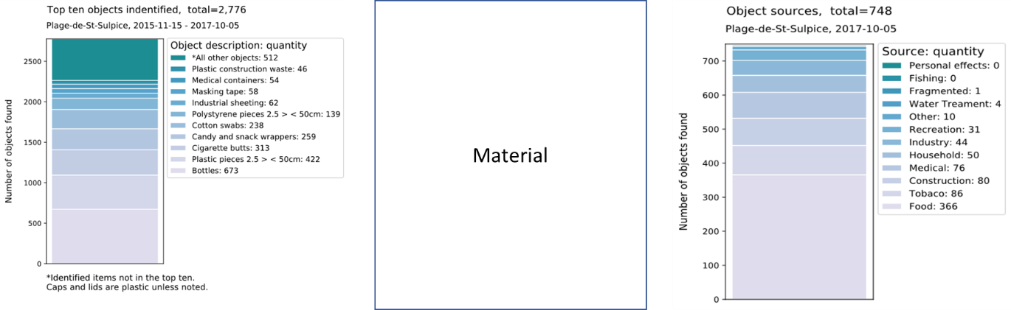
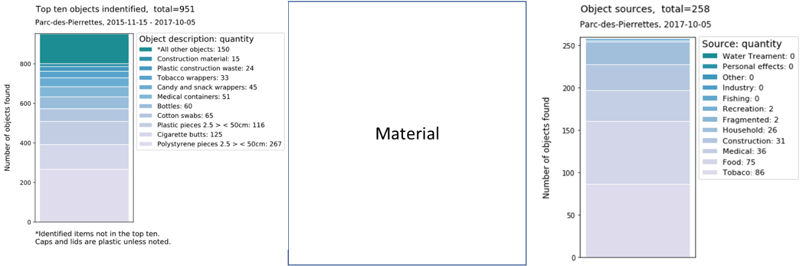
Figure 8 – Breakdown of AL collected by SWE group at Plage de St Sulpice showing the type (left), material (centre), and source (right)
Figure 9 – Breakdown of AL collected by SWE group at Parc des Pierrettes showing the type (left), material (centre), and source (right)

Taking the top 10 litter items from PP and PS, and organising them along with the total surveyed quantities, a comparison of the interquartile range and the outliers is made (Fig. 10). Surprisingly, the items collected, although similar (predominantly artificial polymeric material), are not from the same source. Litter G100, G200, G30, G87 and G95, are all outliers and represent an ‘above average’ accumulation on the shore of PS. On the other hand, at the PP beach, most of the litter type is within the surveyed range and in much lower quantities (pcs/metre). In fact, this difference is clearly visible in the probability density function (Fig. 11) where the mean of PS is higher than the total surveyed sites, whereas PP is much closer to the median. Via categorising the AL in accordance to the MLW, and comparing the total surveyed data, it is shown that even with the appearance of the same physical material, in this case predominantly composed of polymeric material, the source it originates from is different along with the quantity. Most probably the, reason for the difference could be the flow in the lake. It takes approximately 10 years for the volume of water to pass through the lake (residence time), and at the same time seasonal fluctuation and the direction of the beach can affect where and by how much the waste accumulates. For instance, the PS beach is somewhat sheltered from the directly flow of water, and thus there is a higher potential of debris accumulating there over time. PP is mostly parallel to the flow and thus, it attracts a different type of waste. Thus, a quantitative assessment as such helps gain insight as to how ‘healthy’ the shoreline is when used for recreational activities based on the location relative to the flow.
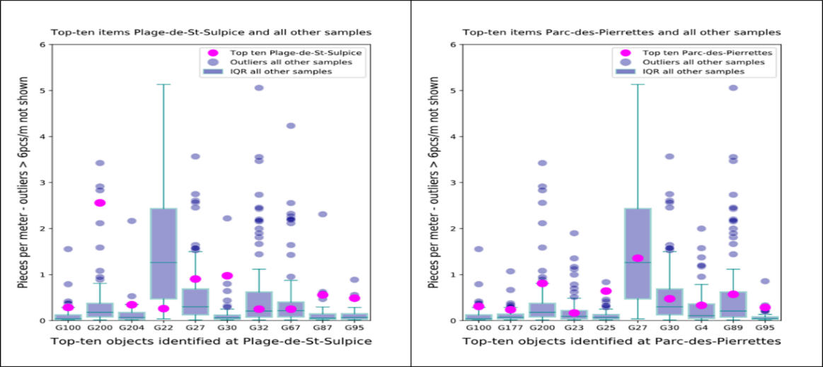

Figure 10 – A comparison of the top 10 AL (by quantity) found at PS (a) and PP (b) with the total surveyed sites showing the interquartile range, median and outliers
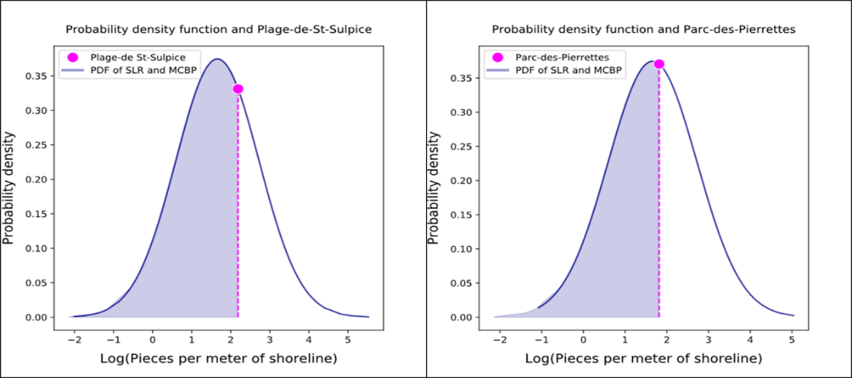

Figure 11 – Probability density function of the total surveyed sites (SLR and MCBP) with PS (a) and PP (b)
From the collection study, it was consistently observed that plastic waste always contained above average quantity of G87, or plastic cotton buds (Q-tips) in addition to pelletized granules and plastic bag remains. Although the partially degraded plastic waste can be explained via direct littering in the lake, or runoff from natural inlet streams, the presence of the Q-tips is surprising as it is very unlikely to have been disposed at any of the locations directly (including at natural inlets), and thus points towards a secondary source. One such explanation could be, typically an ill-informed consumer will wrongly dispose Q-tips into the toilet leading to its eventual journey to a wastewater treatment plant (WWTP). Depending on the type of technology utilised at the facility, the Q-tips can potentially pass through the filtering system and enter the environment during treated water disposal. In this case, depositing at the shoreline or remaining in the water of the lake. Also, during heavy rain, it is sometimes necessary to direct untreated or partially treated sewage directly into waterways to prevent overflow. Both these scenarios are likely, but also undesired. Even though the cotton at the tips can degrade within six months, the Polypropylene tube has a low biodegradability and can thus linger in the environment for a long time.
3.5 Public Awareness
It is interesting to also notice, that on average, more Q-tips are found around lake Geneva than other surveyed parts of Switzerland (Fig. 12)The existence of Q-tips at the shore is an important example that highlights the importance of effective and successful outreach for waste management. For instance, there has been a huge effort to educate consumers and the public about recycling of aluminium cans around the world. As such, recycling rates of up to 91% (ref.) has been achieved resulting in 95% energy savings from aluminium production. This equates to 9 kg CO₂ per kg-recycled aluminium (ref), with the added advantage of negligible detriment in the product quality (ref).

Figure 12 – Quantity of Q-tips and aluminium cans found around the surveyed shores of Swiss lakes
It could be argued that aluminium has a higher monetary value compared to Q-tips waste, but to the consumer this makes no difference as they do not directly benefit monetarily and thus the issue is even more fundamental. Fig. 13 highlights the key differences towards the approach of public awareness and treatment of the two waste sources. Given that Q-tip pollution is largely unknown and not yet considered a major issue, the recycling drive for it does not yet exist; neither does a public awareness campaign. Typically, aluminium cans are source separated and its convenient disposal means is readily available, but in the case of Q-tips, only packaging information is available. Thus, the general consumer it appears is not well informed about the problems that accumulate in the environment, where their innocuous action of disposal into the sewer can cause problems downstream post WWTP. It must be stressed that the recycling of Q-tips with infrastructure synonymous to aluminium cans might be tricky, and therefore its value as a useful resource remains in energy recovery/generation during the incineration/combustion process since the heat capacity of Polypropylene is 46 MJ/kg, which is almost thrice that of paper (ref).

Figure 13 – The difference in dealing with a low economic and higher economic value consumer waste

In terms of AL quantification, lakes and rivers have a completely different litter density and distribution as expected due to the hydrological effect of flowing fluids. Consequently, it would be expected that trash accumulation at the shores of Swiss rivers is less than that of lakes, In fact, Fig. 14. shows the distribution of litter density and frequency of occurrence using data gathered from 238 and 277 Swiss lakes and rivers, respectively. While the mean litter quantity is 1 piece/metre for rivers, the lakes generally have a higher figure of almost 5 pcs/metre.
Figure 14 – Distribution and frequency of AL in Swiss rivers and lakes

4.0 Conclusion
The collection of AL and its subsequent quantification for statistical processing to document its change year on year, as well the development of a probability predicting model using statistical methods was conducted. From the study, we find that even with a ‘clean’ appearance, the shores of Lake Geneva has an AL density of 8.7, 10.15 and 9.01 pieces/metres as quantified in year 1, 2 and 3 of this study, respectively. Categorising the collected trash according to the MLW system showed the majority of waste originated from food packaging, including plastics and glass. Some construction waste and personal hygiene litter was also found. To demonstrate the usefulness of such citizen science type project, the locations of PP and PS beaches was used to obtain quantitative information and yield qualitative appraisal. It is envisaged that this study proves to show that implementing a program to gather data from the Swiss lakes/rivers shoreline can help keep track of policy improvements, technology advancements as well as define future changes needed to reduce the accumulation of AL on shorelines.

