**Sprint Two Plan - Slug Stock - Team Slug Stock**

**Sprint Two Completion Date:** January 28, 2016

**Revision Number:** #1

**Revision Date:** January 31, 2016

**Sprint Two Goal:** Set up stock notifications for users along with history graphs.

**User Story 1:** I as a user want to get emergency email notifications when a stock hits a specified price.

Tasks:

* Automatically update stock information in the database (Time Estimate: 4 hrs)
* Set up separate thread to automatically email users when stocks reach the user set limit (Time Estimate: 3 hrs)
* Create format for messages sent to users. (Time Estimate: 1.5 hrs)
* Total time: 8.5 hrs

**User Story 2:** I as a user want to get daily email updates.

Tasks:

* Set up email system for our website and define email format. (Time Estimate: 1.5 hrs)
* Create schedule for emails to be sent out at end of a stock trading day (Time Estimate: 1 hr)
* Create separate process for daily emailing (Time Estimate 1 hr)
* Total time: 3.5 hrs

**User Story 3:** I as a user want to see history of the stock in a simple chart day, week, month, year, all.

Tasks:

* Create system to store stock history (Time Estimate: 1.5 hrs)
* Write code to display chart/graph (Time Estimate: 3 hrs)
* Create chart visuals for user stocks (Time Estimate: 1 hrs)
* Total time: 5.5 hrs

**Team Roles:**

**Dustin Bryan (Product Owner):**

Creating charts

**James Brower**

Emergency email system managing

**Aramis Marden:**

Daily email set-up

**Peter Greer (Scrum Master):**

Emergency email thread creation

**Trevor Barnes:**

Emergency email creation

**Initial Task Assignment:**

**Dustin Bryan (Product Owner):**

User Story 3, task 1,2,3

**James Brower (Scrum Master):**

User Story 1, task 1

**Peter Greer:**

User Story 1, task 2

**Aramis Marden:**

User Story 2, task 1,2

**Trevor Barnes:**

User Story 1, task 3

**Initial Burn Up Chart:**

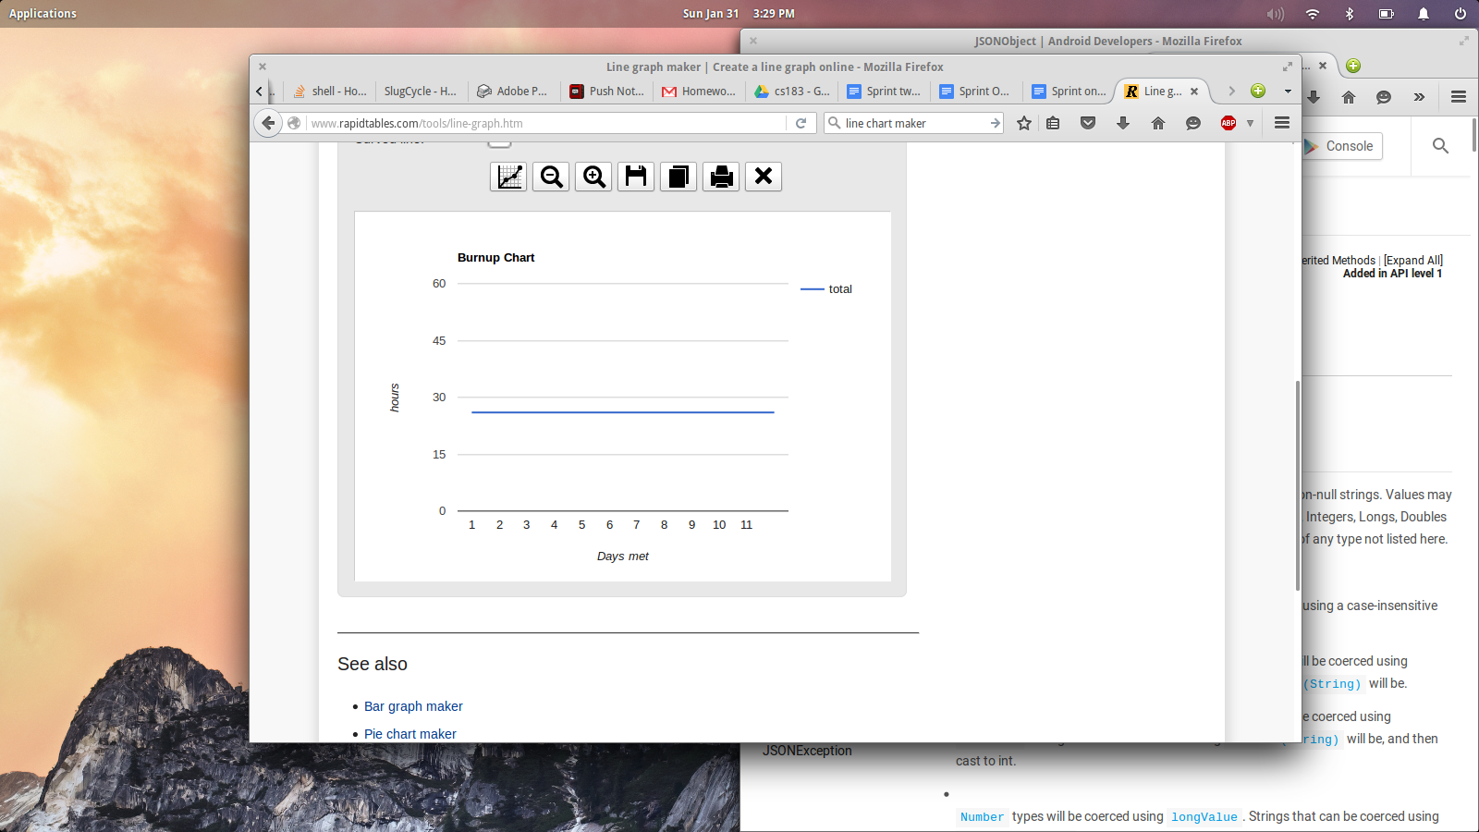

**Scrum Board:**

**Scrum Times:**

Tuesday: 4:00 PM

Thursday: 4:00 PM

Sunday: 2:00 PM

Monday: 3:30 PM (meeting with TA)