 Guidelines for Intravenous Prolastin-C Infusion

PURPOSE:
To provide specific guidelines for the intravenous administration of Prolastin-C® (Alpha₁-Proteinase Inhibitor Human).

INDICATION:
Intended to treat the unopposed protease activity, which causes pulmonary emphysema and necrotizing panniculitis in individuals with severe Alpha-1 Antitrypsin Deficiency. Not indicated for the treatment of liver disease due to Alpha-1 Antitrypsin Deficiency.

SELECTION CRITERIA:
Medical Criteria:

- Patient should be under the care of a licensed physician familiar with the use of Prolastin-C, including indications, dosing, method of administration, and potential adverse reactions;
- Consideration should be given to administering initial infusion in a medically supervised setting, however there is no requirement for this stated in the packet insert from Talecris Biotherapeutics, epinephrine injection/EpiPen and emergency equipment available.
- Establish home care services with a licensed home health agency/home infusion company with qualified IV nurses trained in the procedure if insurance benefits allow

Additional considerations for home infusion:
- Patients who are motivated and physically able may be taught to self-administer Prolastin-C. Others may be infused by a significant other who has been properly trained in the procedure.
- The patient should be capable and feel comfortable with performing self-care safely after sufficient training and education. If not, the primary care giver must meet those requirements.
- It is important to have second responsible individual in the home during infusions.
- The home must be clean and have a working telephone.
- A contingency plan should be in place for untoward events occurring before, during, and after the infusion.

HOW SUPPLIED:
- Trade name “Prolastin-C” manufactured by Talecris Biotherapeutics.
- Supplied in single use vials with the functional activity in milligrams stated on the label of each vial. Vial size is supplied in 1000 mg approximate activity. Milligrams per vial vary from lot to lot produced. Carefully read the prescription label and the milligrams contained in each vial since a given prescribed dose may require the reconstitution of varying numbers of vials per lot, depending on the milligrams per vial. It is usual practice, if a partial vial is calculated to complete the dose, to use the entire vial. Please contact the pharmacist if you have any questions or concerns regarding dosing or calculations.
- The approximate 1000 mg vials are reconstituted with 20 ml of sterile water.

DOSE, ROUTE, and ADMINISTRATION:
- The recommended dose is 60 mg/kg body weight IV once weekly.
- Given by intermittent intravenous infusion.
- Recommended administration rate is 0.08 ml/kg/min but this should be adjusted according to patient’s clinical condition and tolerance. Do not exceed rate of 0.08ml/kg.min
- All connections for IV tubing’s etc. for home infusion shall be leur lock
- Infusion can be administered via gravity infusion or IV pump. If the patient or caregiver administers without a nurse present, they will be taught to accurately regulate the IV rate.
- If the patient’s prescription is for infusion other than weekly, it is recommended that weekly amounts are prepared and pooled, utilizing one set up of equipment per bag. This means that multiple bags may be administered.

DOCTOR’S ORDERS:
Will include:
- Dosage calculated according to patient’s weight
- Route of administration
- Frequency of infusions
- Any premedications
- Laboratory monitoring parameters and schedule if indicated
- Standing order for use of epinephrine injection/EpiPen 0.3 mg IM prn anaphylaxis

CONTRAINDICATIONS
Do not use in patients with known selective IgA deficiency with antibody to IgA, due to the increased risk of severe hypersensitivity reactions, including anaphylaxis.

SIDE EFFECTS/POTENTIAL COMPLICATIONS
Side effects are reported to be mild and generally rare; they include:
- Chills
- Malaise
- Headache
- Rash
- Hot Flash
- Prurtis
- Anaphylaxis (rare) is a risk with any plasma product

NURSING IMPLICATIONS
- Assess needs of patient and/or primary caregiver: physical, psychosocial, & cognitive.
- Assess the patient’s understanding of Prolastin-C therapy, potential side effects and risks of blood borne pathogen transmission.
- Educate the patient/caregiver against smoking, and second hand smoke as smoke inactivates the drug and serves to further promote lung destruction.
- Administer within 3 hours after reconstitution. DO NOT refrigerate reconstituted Prolastin-C as a precipitation may occur. The reconstituted Prolastin-C should be kept at room temperature until administered.
- Instruct patient and/or caregiver on proper storage of drug and supplies, therapy requirements, and procedures: Universal Precautions, aseptic technique, catheter care, connect, disconnect, medication preparation/handling and disposal of used supplies.
- Instruct patient in self-monitoring: including but not limited to: temperature, reporting of side effects, weight changes, over all status, including any changes in activity or exercise tolerance.
- Instruct patient to report significant changes to healthcare provider.
- If patient self-administers, plan home care follow-up with appropriate medical care team members at regular intervals. Establish a known and reliable contingency plan.
- Provide follow-up communication (verbal or written) including lab results, changes in condition to the physician, pharmacist, and other health care team members.
- Document all assessments, instruction sessions, home visits and follow-up plan.
- For home patient visits with RN performing the administration, documentation in the nursing notes should include:
- Total Prolastin-C given milligrams and milliliters, Lot Numbers, concentration in vial, Exp. date
- Route of infusion
- Length of infusion
- Baseline cardiopulmonary assessment (including breath sounds)
- Baseline vital signs
- Weight
- Changes in condition, activity or exercise tolerance, sputum production, cough
- Any patient complaints
- Patient tolerance of infusion
- Any adverse reaction and intervention

- Vital signs are assessed at baseline and at the end of infusion, as well as prn for any patient complaint during the infusion. Temperature is checked at baseline and end of infusion, or prn with patient complaint.
- Document and report any unusual or severe side effects to Talecris Biotherapeutics at:
1-800-520-2807.

PHARMACY IMPLICATIONS:
- Discuss procedure for obtaining prescriptions, renewals, and changes in therapy with the physician. Talecris Direct must have accurate and signed prescription on file.
- Determine prescription appropriateness against the defined treatment goals and patient diagnosis.
- Document in the clinical record all communication with the physician, laboratories, home health nurse, and others involved in the patient’s care.
- Discuss follow-up communication requirements (verbal or written) for the physician or other health care team members.
- Prolastin-C may be stored in the refrigerator or stored at room temperature not exceed 77° F. Allow vials to warm to room temperature if refrigerated prior to reconstitution.
- The manufacturer recommends administering the solution within 3 hours of reconstitution as the product contains no preservative.
- DO NOT refrigerate reconstituted Prolastin-C as a precipitate may occur. The reconstituted Prolastin-C should be kept at room temperature until administered.

MISCELLANEOUS:
- Empty vials of diluent should be disposed of in household trash, or recycled if applicable in the patient’s local area.
- Empty vials of reconstituted Prolastin-C are to be disposed of in household trash. The only exception to this information is if your IV tubing has visible blood back up, at any time during the infusion then it should be considered biohazardous and discarded in the biohazard container. You should dispose of needles and other hazardous materials in the biohazard container.

References:
Physician’s Desk Reference, MED, Medical Economics, 4th Edition, 1994
Nursing IV Drug Handbook, 5th Edition, Springhouse Corp., 1995
Home Therapy Standards, Policies & Procedures, Aspen Publishers, 1995
Talecris Biotherapeutics, Prolastin-C, Drug Package Insert

Guidelines For
Prolastin-C® Home Mixing
Syringe Method

Prolastin-C per patient prescription 18 gauge Needle(s)
Alcohol wipes IV catheter/insertion supplies
Non-sterile gloves IV administration tubing with luer lock
Empty IV bag(s) Tape
Needle Free valve(s) Biowaste container
30cc Syringe(s) luer lock tip

Prolastin-C may be stored at room temperature not to exceed 77° F, or refrigerated, prior to reconstitution. If refrigerated, remove Prolastin-C from the refrigerator prior to infusion and allow it to warm to room temperature. Check lot numbers, mg of functional activity per vial and expiration dates and remove the correct number of boxes to prepare the prescribed dose.

Maintain strict asepsis while performing all preparation activities!

Reconstitution

Step 1. Identify and clean a designated work area. Gather supplies needed.

Step 2. Wash your hands.

Step 3. Remove the vials of unreconstituted Prolastin-C and diluent from their boxes. In each box is a transfer needle, in the pink cover, and filter needle, in the clear cover. Set the filter needles aside for use later in the procedure.

It is important to note that the filter needle is intended for use in one direction only. That means, it should be used either to draw up solution or to dispense solution, not both.

Step 4. Remove the protective lids from the diluent and Prolastin-C vials, and aseptically wipe each rubber seal with an alcohol pad, using one pad for each vial, and allow to dry.

Step 5. Don non-sterile gloves. Using the pink-covered transfer needle, remove the shorter plastic cover, and penetrate the middle of the rubber seal of the diluent (sterile water) vial with the exposed short needle.

Step 6. Remove the remaining portion of the pink plastic cover. Stabilize the exposed long needle at its hub with your index finger. Invert the diluent vial while firmly anchoring the Prolastin-C powder vial on the table with your other hand, and insert the needle into the middle of the rubber seal of the Prolastin-C vial at a 45 degree angle. This will direct the stream of diluent against the wall of the product vial and minimize foaming. Some foaming will occur, but does not affect the quality of the product. The Prolastin-C vial has a vacuum and will draw the diluent into the vial. Failure to anchor the vial to the table may result in loss of vacuum.

Step 7. After the diluent has been transferred into the Prolastin-C vial, remove the empty vial and needle, by grasping the needle at its hub and withdrawing the needle and vial as
one unit. Dispose of the needle directly into the biowaste container. The empty glass vial of diluent should be disposed of in the household trash or recycling receptacle.

Step 8. Repeat this process until all vials of diluent are transferred into each vial of Prolastin-C powder.

Step 9. To assist with getting the powder into solution, swirl vigorously for 10-15 seconds to thoroughly breakup cake and then swirl continuously until the powder is completely dissolved.

Step 10. Inspect the solution for particles or clumps, and continue to swirl the vial until all the powder is completely mixed and in solution. If, after approximately 15 minutes of mixing, the solution remains cloudy, discolored, has particulates or otherwise looks suspicious, set it aside and do not use it. Notify the pharmacy, as they may want to retrieve that vial. After reconstitution, Prolastin-C is clear to pale yellow in color with more viscosity than water.

Getting the Prolastin-C into solution can take some time and is more difficult when the Prolastin and diluent are cold.

Pooling

Once the drug is reconstituted, the contents of the vials will need to be pooled into an empty sterile IV bag, in preparation for infusion.

If the patient’s prescription for infusion is other than weekly, it is recommended that batches of the weekly dose of 60mg/kg be reconstituted and pooled. While infusing the first batch, subsequent batches can be reconstituted, pooled and then infused sequentially until the entire dose is given.

Step 1. Aseptically wipe each rubber seal on the reconstituted vials of Prolastin-C with an alcohol wipe, using one wipe for each vial.

Step 2. Take the needle free valve and attach the 18 gauge needle to the male or distal end.

Step 3. Wipe the rubber injection port on the empty IV bag with an alcohol pad and insert the 18-gauge needle with attached needle free valve and secure the connection with tape.

Step 4. Wipe end of valve with an alcohol pad and allow it to dry. (Remove any protective caps if applicable-before wiping with alcohol)

Step 5. Attach a filter needle to the 30 cc syringe. The filter needle is in the clear plastic cartridge.

Step 6. Remove the protective cap from the filter needle and draw in 10-15 cc of air. While holding a vial of reconstituted Prolastin firmly on the table, insert the needle into the rubber seal of the vial. Slowly inject all of the air. While maintaining a firm and positive pressure on the plunger, invert the vial then withdraw the contents into the syringe.

It is essential to maintain aseptic technique. Remember to only handle the flanges of the syringe, as the syringe will be used repeatedly, proper handling of the syringe to avoid contamination of the plunger is imperative.

Step 7. Once the contents have been drawn into the syringe, withdraw the needle and syringe from the empty vial. Now carefully remove the filter needle and attach the syringe directly to the needle free valve at the injection port of the IV bag. Slowly inject the Prolastin-C into the IV bag to prevent foaming.

Step 8. Repeat steps 6 and 7 using a new filter needle each time until all vials are pooled.

*Remember to wipe the needle free valve with alcohol and allow it to dry, each time before injecting into the bag.

Step 9. After all of the vials are pooled into the IV bag, remove the needle free valve and needle from the injection port and dispose of it in the biowaste receptacle.

Step 10. Discard all empty Prolastin-C vials into the household trash. Used needles must be discarded into the in the biowaste receptacle.

Prolastin is now ready for infusion. Attach IV administration tubing and prime.

NOTE: At the end of the infusion, all IV bags and administration tubing can be disposed of into the household trash unless contaminated with visible blood at any time during the infusion. If blood has been observed, the IV bags, syringes and IV administration tubing must be disposed of into the biohazardous waste container.

Needle Free Valve

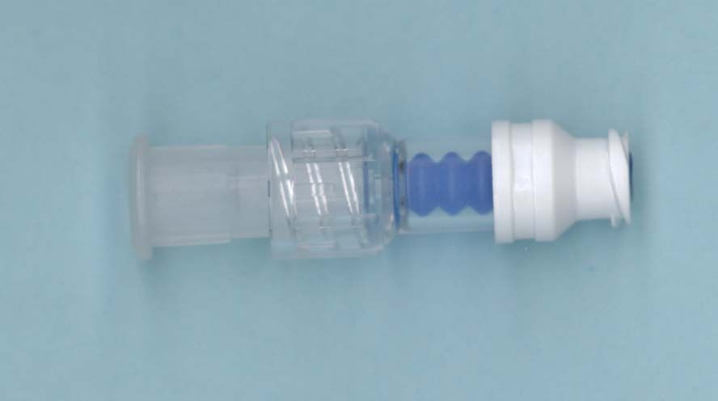
Similar item available from various manufacturers

IV Bag with Needle Free Valve
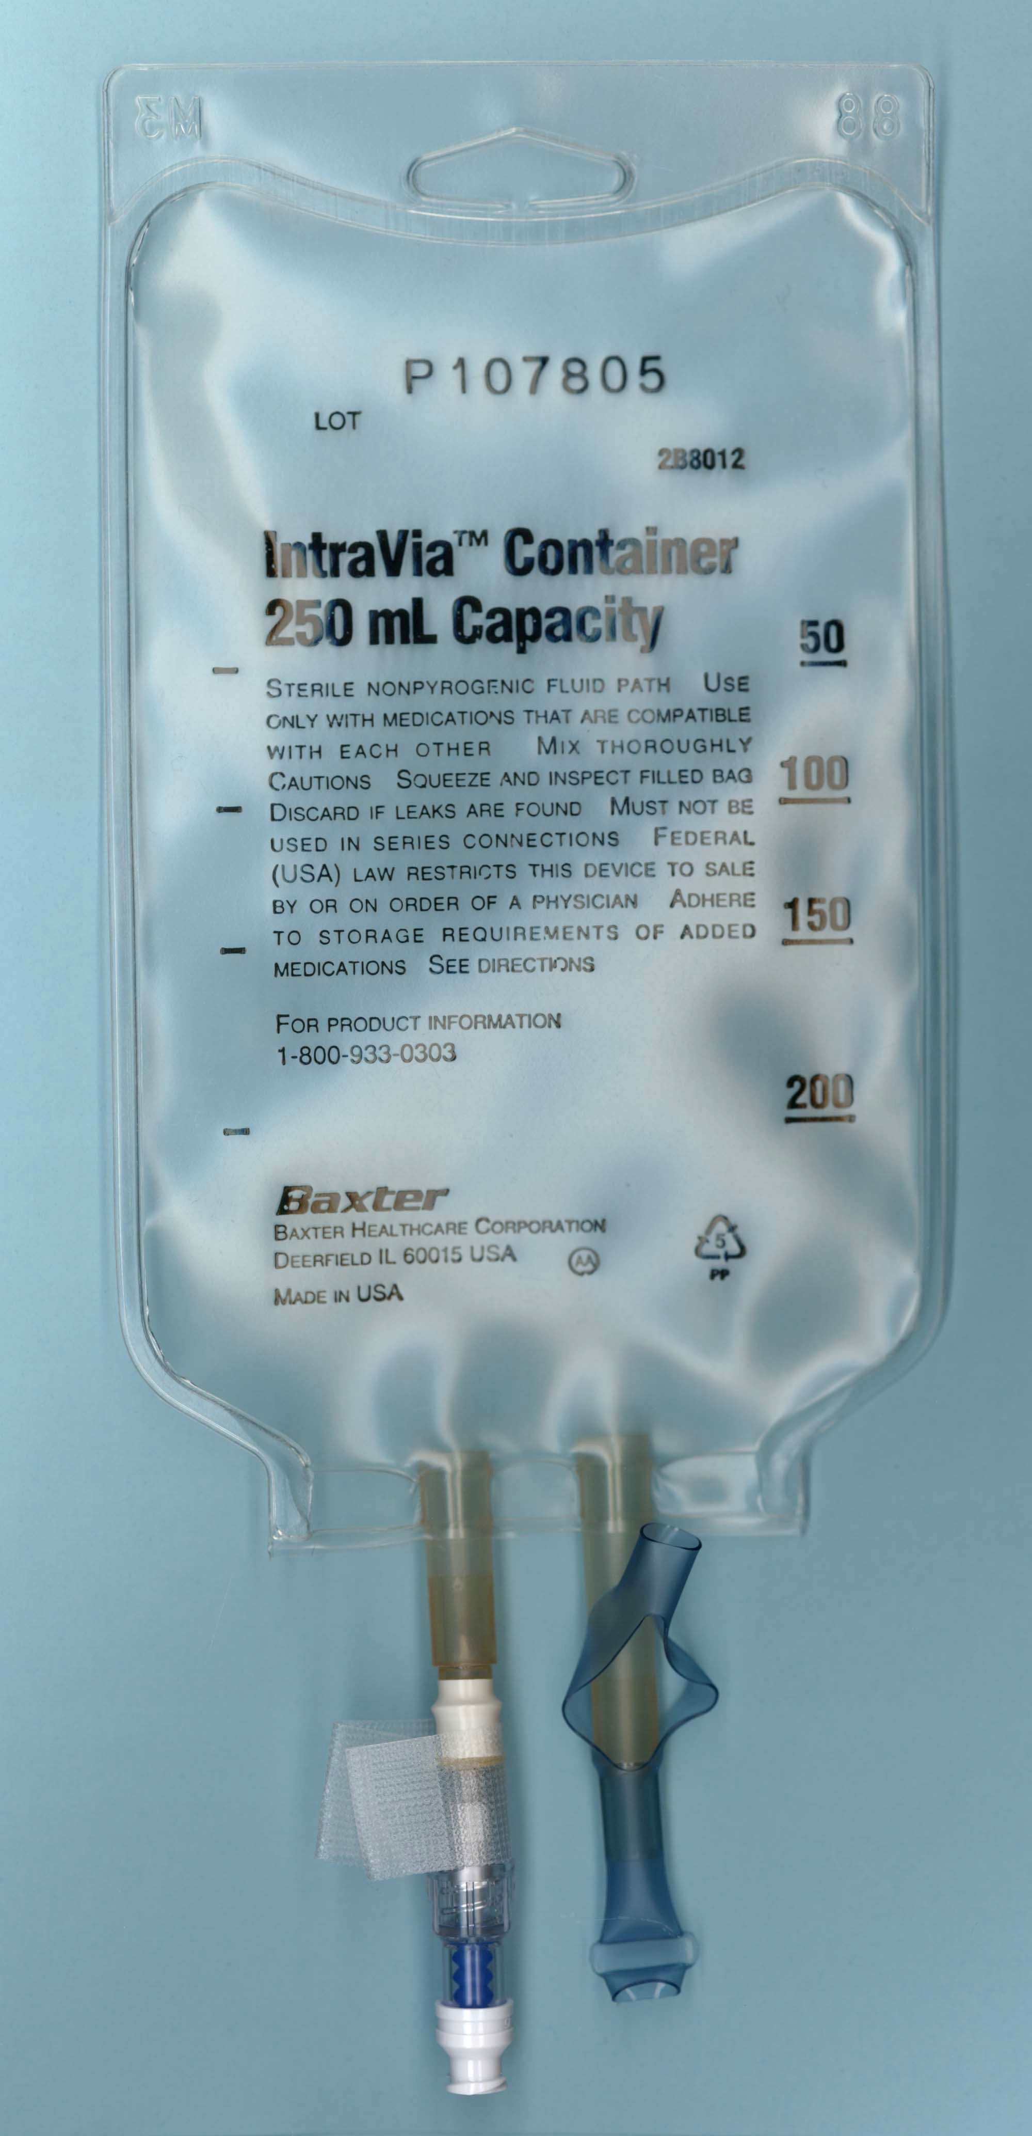

Guidelines For
Prolastin-C® Home Mixing
Transfer Tubing Method

Prolastin-C per patient prescription IV catheter/insertion supplies
Alcohol wipes IV administration tubing with luer lock
Non-sterile gloves Tape
Empty IV bag(s) Biowaste container
Vented vial access spike (s)
30” macro bore transfer tubing(s) male luer connection both ends

Prolastin-C may be stored at room temperature not to exceed 77° F, or refrigerated, prior to reconstitution. If refrigerated, remove Prolastin-C from the refrigerator prior to infusion and allow it to warm to room temperature. Check lot numbers, mg of functional activity per vial and expiration dates and remove the correct number of boxes to prepare the prescribed dose.

Maintain strict asepsis while performing all preparation activities!

Reconstitution

Step 1. Identify and clean a designated work area. Gather supplies needed.

Step 2. Wash your hands.

Step 3. Remove the vials of unreconstituted Prolastin-C and diluent from their boxes.
In each box is a transfer needle in the pink cover, and a filter needle in the clear cover. Set the filter needles aside for use later in the procedure.

It is important to note that the filter needle is intended for use in one direction only. That means, it should be used either to draw up solution or to dispense solution, not both.

Step 4. Remove the protective lids from the diluent and Prolastin-C vials, and aseptically wipe each rubber seal with an alcohol pad, using one pad for each vial, and allow to dry.

Step 5. Don non-sterile gloves. Using the pink-covered transfer needle, remove the shorter plastic cover, and penetrate the middle of the rubber seal of the diluent (sterile water) vial with the exposed short needle.

Step 6. Remove the remaining portion of the pink plastic cover. Stabilize the exposed long needle at its hub with your index finger. Invert the diluent vial while firmly anchoring the Prolastin-C powder vial on the table with your other hand, and insert the needle into the middle of the rubber seal of the Prolastin-C vial. The Prolastin-C vial has a vacuum and will draw the diluent into the vial. Failure to secure the vial to the table may result in loss of vacuum.
Needle Free valve

Step 7. After the diluent has been transferred into the Prolastin-C vial, remove the empty vial and needle, by grasping the needle at its hub and withdrawing the needle and vial as
one unit. Dispose of the needle directly into the biowaste container. The empty glass
vial of diluent should be disposed of in the household trash or recycling receptacle.

Step 8. Repeat this process until all vials of diluent are transferred into each vial of Prolastin powder.

Step 9. To assist with getting the powder into solution, swirl vigorously for 10-15 seconds to thoroughly breakup cake and then swirl continuously until the powder is completely dissolved.

Step 10. Inspect the solution for particles or clumps, and continue to swirl the vial until all the powder is completely mixed and in solution. If, after approximately 15 minutes of mixing, the solution remains cloudy, discolored, has particulates or otherwise looks suspicious, set it aside and do not use it. Notify the pharmacy, as they may want to retrieve that vial. After reconstitution, Prolastin-C is clear to pale yellow in color with more viscosity than water.

Getting the Prolastin-C into solution can take some time and is more difficult when the Prolastin-C and diluent are cold.

Pooling

Once the drug is reconstituted, the contents of the vials will need to be pooled into an empty sterile IV bag, in preparation for infusion.

If the patient’s prescription for infusion is other than weekly, it is recommended that batches of the weekly dose of 60mg/kg be reconstituted and pooled. While infusing the first batch, subsequent batches can be reconstituted, pooled and then infused sequentially until the entire dose is given.

Step 1. Aseptically wipe each rubber seal on the reconstituted vials of Prolastin-C with an alcohol wipe, using one wipe for each vial.

Step 2. Remove the transfer tubing from its package and aseptically attach a filter needle to one end. This is now identified as the “distal end”.

Step 3. Attach a vented vial access spike to the other end. This end is now identified as the “proximal end”.

Step 4. Wipe the rubber injection port of the empty IV bag with an alcohol pad and allow it to dry.

Step 5. Remove the clear protective cap from the filter needle on place it on the distal end of the transfer tubing. Insert the needle into the rubber injection port of the IV bag. Secure in place with tape.

Step 6. Remove the protective cap of the vented vial access spike. While holding the vial of reconstituted Prolastin-C firmly on the table, insert the spike into the center of the rubber seal.

Step 7. Invert the vial, holding it approximately 10-12” above the IV bag, while allowing the IV bag to lie flat on the table. The flow should begin automatically as gravity pulls fluid into the bag.

If the flow does not start readily, try squeezing and crimping the transfer tubing to force a small amount of air back into the vial to initiate the flow. You can also try to pull the walls of the empty IV bag apart to create a mild suction that will initiate the flow.

Step 8. Allow the vial to empty and engage the clamp on the tubing or crimp the tubing as soon as the vial is empty.

Do not allow the transfer tubing to empty completely between vials.

Step 9. Remove the spike and insert it into the next vial using the same technique, while maintaining aseptic technique. Uncrimp the tubing or disengage the clamp to allow the flow to resume.

Step 10. Repeat these steps until all vials are pooled into the IV bag.

Step 11. With the last vial, the transfer tubing can be allowed to empty completely.

Step 12. Engage the clamp on the tubing again, which will prevent leaking, and remove the transfer tubing and filter needle along with the last empty vial of Prolastin-C. Dispose of the transfer tubing in the household trash and the filter needle in the biowaste container.

Step 13. Discard all empty Prolastin-C vials in the household trash.

Prolastin-C is now ready for infusion. Attach the IV administration tubing and prime.

NOTE:
At the end of the infusion, all IV bags and administration tubing can be disposed of into the household trash unless contaminated with visible blood at any time during the infusion. If blood has been observed, the IV bags, syringes and IV administration tubing must be disposed of into the biohazardous waste container.

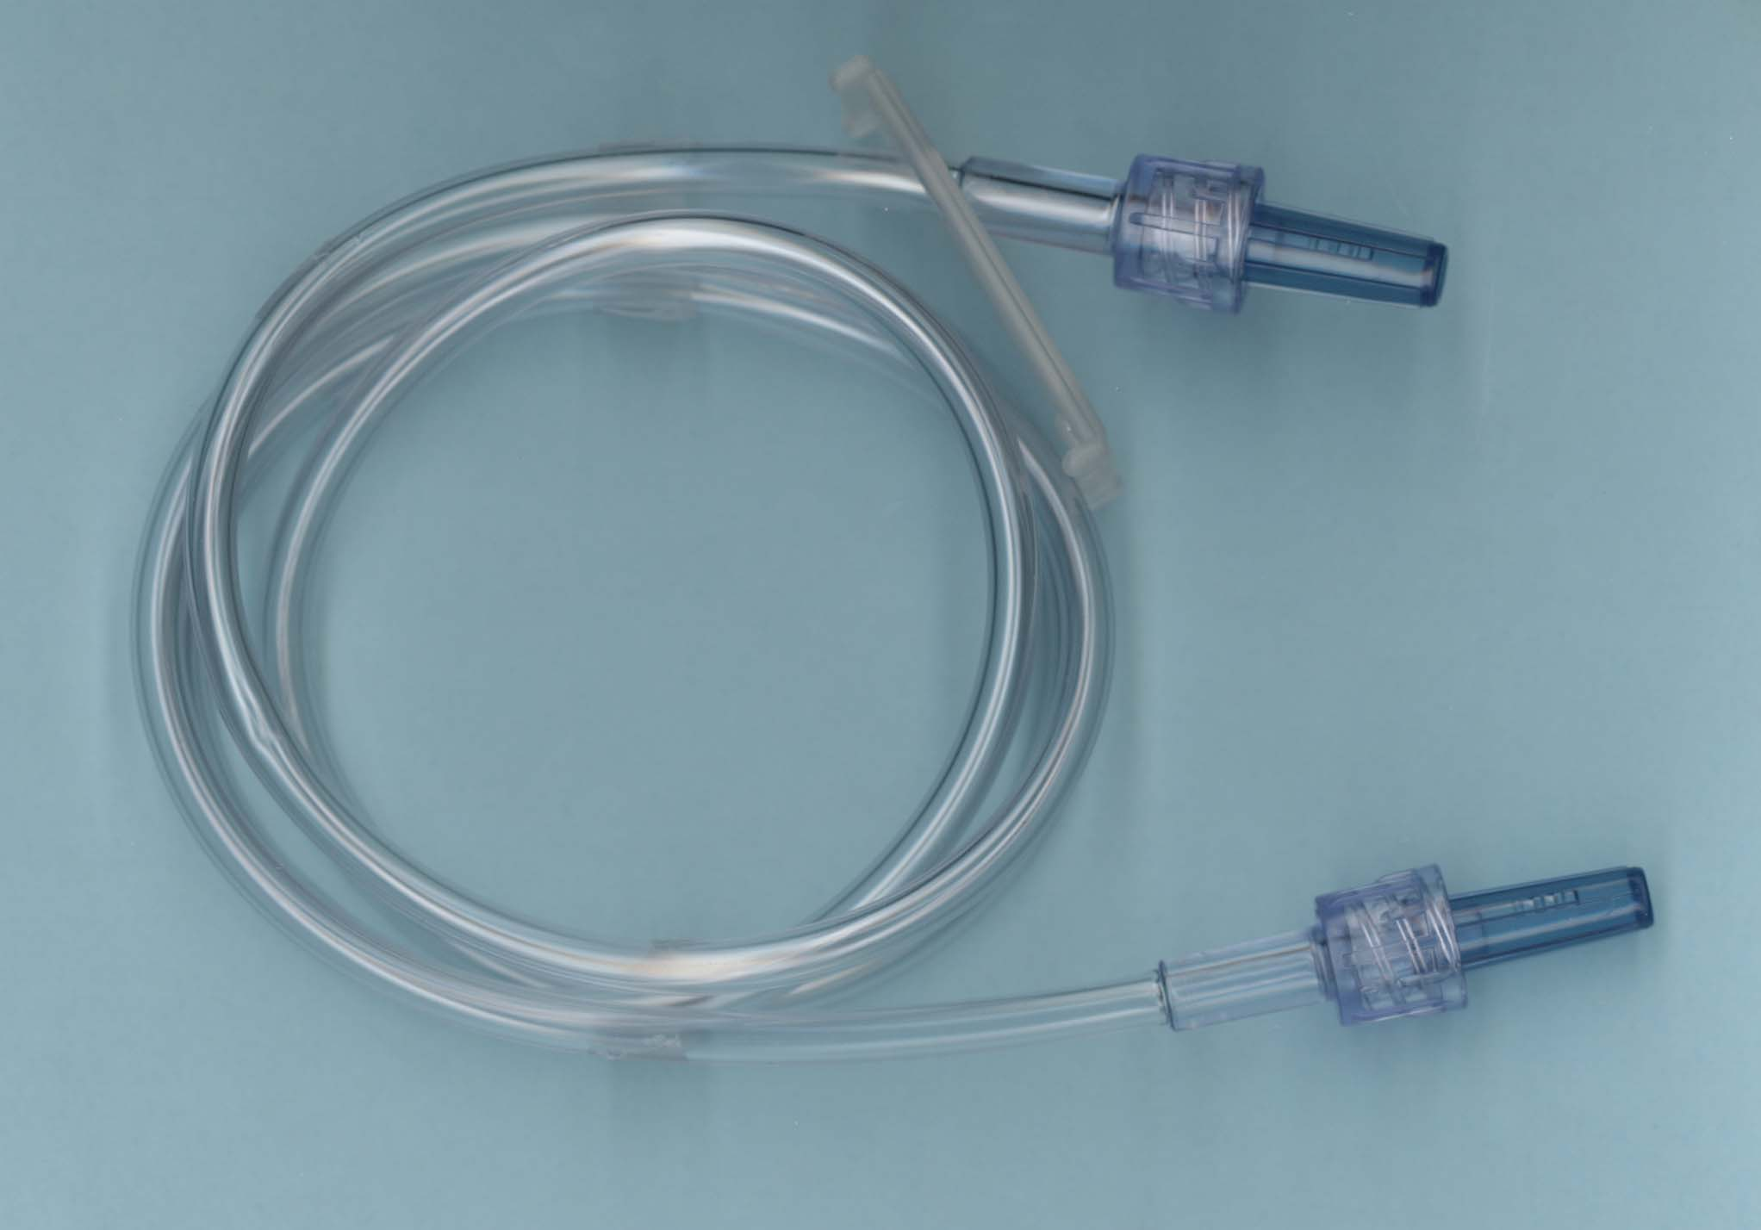

Transfer Tubing

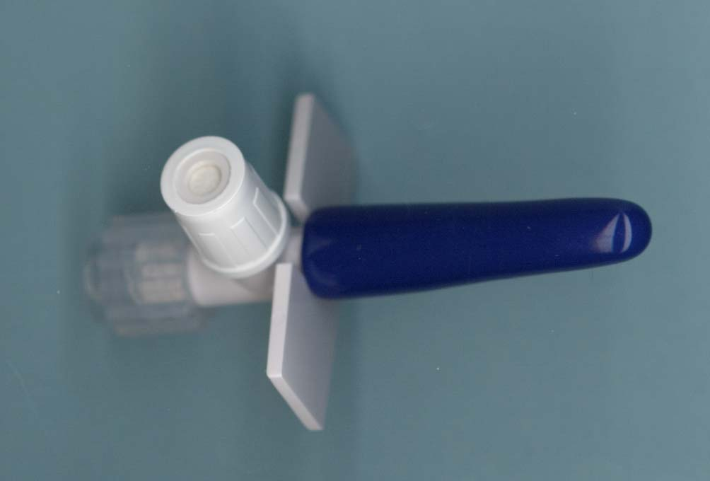

Vented Vial Access Spike
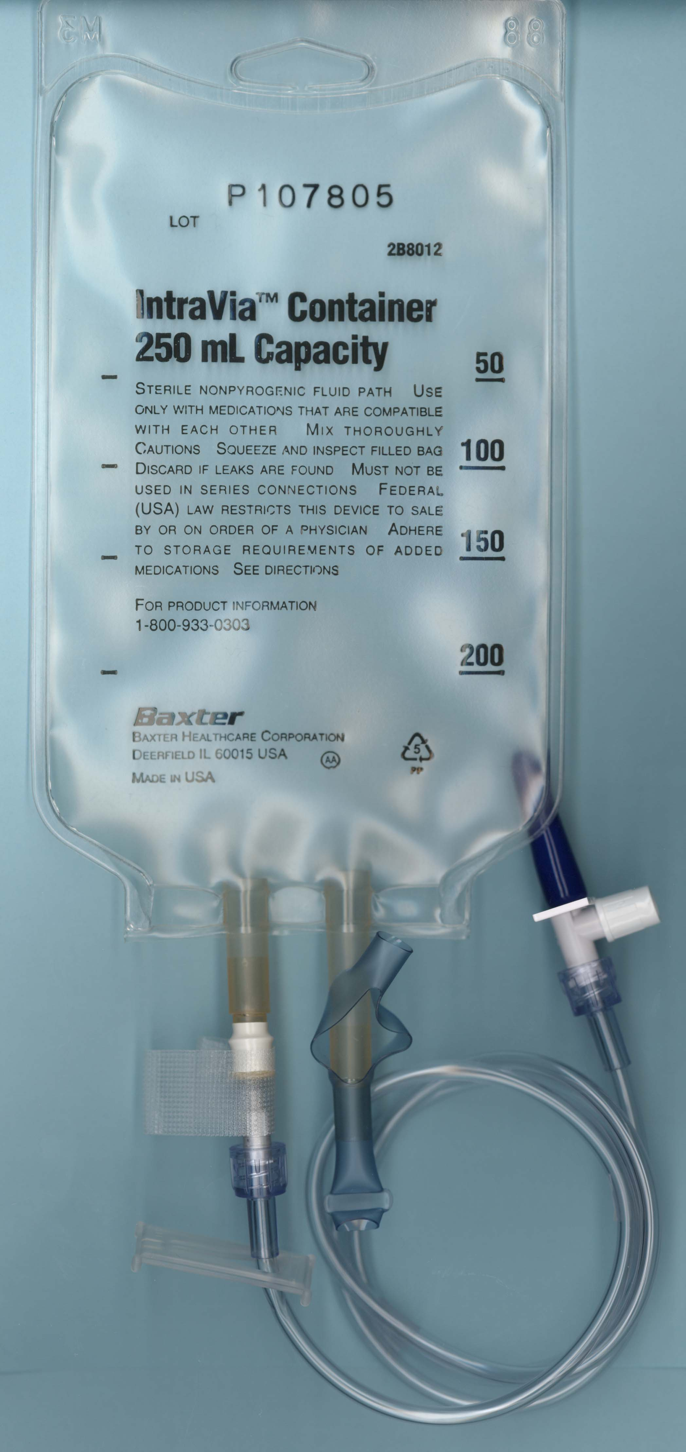

Transfer tubing
Vented Vial Access Spike
Filter needle

Infusion Calculations

RECOMMENDED DOSE: 60 mg/kg IV weekly

***Prolastin-C is available in approximate 1000mg vials with 20 ml of sterile water as diluent.

***Milligrams contained in each vial vary from lot to lot produced***

Carefully read the prescription label and the mg amounts contained in each vial. Doses given are equal to or slightly greater than the calculated dose due to the varying assays. No drug is withdrawn or wasted. The number of vials reconstituted to achieve the patient’s dose will vary from lot to lot. One can not safely assume that the same number of vials is reconstituted for each infusion prepared from subsequent lots.

Please contact the pharmacist if you have any questions or concerns regarding dosing or calculations.

DOSE CALCULATION:

Example: Individual weighing 155 lbs.

Step 1:

Convert lbs to kg by dividing by 2.2

155 ÷ 2.2 = 70 kg

Multiply 60 mg (prescribed weekly dose) x 70 kg= 4200 mg

Dose is 4200 mg IV weekly

Step 2:

Determine how many vials of Prolastin-C will be needed to formulate the required dose.
For our example we will use 1078 mg per vial.

Divide the calculated dose of 4200 mg by the number of milligrams in a vial.

4200mg ÷ 1078mg = 3.9 vials

Remember that no drug is wasted: therefore total vials to be infused will be 4. Total mgs is 4312 mg and total fluid volume: 80 ml (4 x 20 ml)

RECOMMENDED INFUSION RATE: 0.08 ml/kg/min

RATE CALCULATION:

Using the same example of a 70kg individual:

To calculate the patient’s infusion rate using the recommended rate of 0.08 ml/kg/min you would do the following steps

Step 1. Multiply 0.08 ml x 70 kg = 5.6 ml/min

Step 2. Convert ml/min to ml/hr by multiplying by 60 (60 min/hour)
5.6 ml x 60 min = 336 ml/hr

Step 3. Calculate the drop rate using the formula as shown

Drops (gtt) of IV set x total hourly volume = gtts/minute
60 (min in hour)

In this example, the calculation would look like this:

10 gtts** x 336 = 56 drops/min
60 min/hr

** Remember to check the drop factor of your specific IV tubing as
Drop factor rates vary

Step 4. Divide 56 by 4 as there are four 15-second periods in a minute

56 ÷ 4 = 14 drops

Step 5: Count 14 drops/15 seconds to regulate the rate

