Alpha-1 Nurse Certification of Completion

Has Successfully Completed

Alpha-1 Antitrypsin Deficiency and Augmentation Therapy

Prolastin-C Liquid
Date:
Expiration Date of this course is: 2/12/2021
For: 3.0 Contact Hours

Presented By: AlphaNet, Inc.
3300 Ponce de Leon Boulevard
Coral Gables, Florida 33134
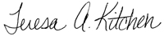
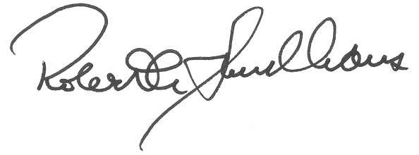
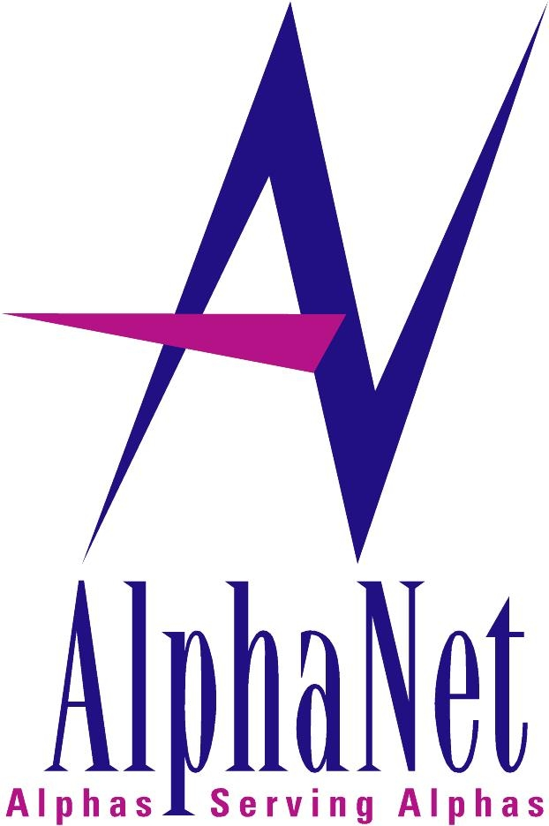
_______________________________ ____________________________
Robert Sandhaus MD, PH.D Teresa Kitchen RN, BSN
Medical Director Educational Program Coordinator

This continuing nursing education activity was approved by the Colorado Nurses Association, an accredited approver by the American Nurses Credentialing Center’s Commission on Accreditation.

