PJ22045.0.1 1R8T Aurora Relay — Design Document
Project | Folder ~/Desktop/PJ22045.0.1. Three Vivado 2025.2 projects: vu13p/vu13p.xpr (relay / broadcaster, BD aurora_gty_vu13p_rst), 47dr1/47dr1.xpr (z1, ADC transmitter, BD design_1), 47dr2/47dr2.xpr (z2, 8-DAC receiver, BD design_1). Built from ~/Desktop/PJ22045_EV1/13P_integrated_2 and 47DR_integrated_3 (D1); per-project notes in <project>/DESIGN_NOTES.md
Target | One Virtex UltraScale+ `xcvu13p-fhgb2104-2-i` linked by Aurora 64B66B to two Zynq UltraScale+ RFSoC `xczu47dr-ffvg1517-2-i` (z1, z2) (D2). GT pinout from the read-only IBERT golden projects in ~/Desktop/board_test_item/ (R2)
Top modules | aurora_gty_vu13p_rst_wrapper (VU13P), design_1_wrapper (z1, z2). Link containers (BD containers): aurora_gty_vu13pto47dr (VU13P, 8 quads), aurora_gty_47drto13p (z1 and z2, identical, 4 quads), aurora_gty_vu13ptovu13p (VU13P 13P↔13P link, unchanged in function)
Current revision | 0.12 (see §14 Revision history)
Status | Rev 0.12: VU13P core-1 link-reset fix (D19), VU13P rebuilt — WNS +0.011 ns, WHS +0.010 ns, GT/refclk placement unchanged (= golden); z1 / z2 unchanged from build #5. Companion documents SIGNAL_TRANSMISSION.md and TIMING_SYNC.md (with figures). Rev 0.11: all three bitstreams built and timing met (build #5, 2026-10-14: VU13P WNS +0.025 ns, z1 +0.008 ns, z2 +0.023 ns, WHS +0.010 ns on all; GT and refclk placement = golden; §12.6). Debug ILAs on every link (§17); MTS clock-crossing constraint (D16); unused sources removed (D18). Not yet run on hardware. Rev 0.10: doc only — full description of the system time base and timers (§6). Rev 0.9: FIFO budget verified by simulation (no loss in normal operation and with a 1 µs TX stall, §9.3); this document and the slide deck. Rev 0.8: ADC stream confirmed on Aurora core 1 (VU13P broadcaster ← M_AXIS_X1Y8_C1), z2 axi_delay at 0xA008_0000, full naming pass (§8). All three block designs validate clean. VU13P bitstream exists from build #3 (rev 0.6: WNS +0.026 ns, WHS +0.010 ns, GT/refclk placement = golden) but predates rev 0.7–0.8, so a rebuild of all three projects is pending. 47dr1/47dr2 have no bitstream yet (build #3 stopped on a build-script bug, fixed). Not yet run on hardware

History policy: this document is append-only with respect to decisions. When the design changes, the body text is updated to describe the current design, a new row is added to §14 Revision history, and the decision is recorded in §13 Decision log. Superseded decisions are marked SUPERSEDED by Dxx and never deleted. Each project's DESIGN_NOTES.md keeps the detailed per-project history.

Contents

1. Requirements
2. Overview
3. Serial link allocation
4. Clocking
5. Data path and format
5.1 Sample format
5.2 Timestamp and packet
5.3 160 → 128 → 160
5.4 Header overhead
6. Time base and timers (whole system)
6.1 Timer hardware (identical on z1 and z2)
6.2 Starting both timers together
6.3 Stamping on z1
6.4 Carrying the time (z1 → VU13P → z2)
6.5 Rebuilding the time on z2
6.6 Scheduling and release on z2 (per Aurora core)
6.7 End-to-end latency
6.8 Wrap-around
6.9 What breaks the time base, and recovery
7. Board designs
7.1 z1 — 47dr1 (transmitter)
7.2 VU13P (relay)
7.3 z2 — 47dr2 (receiver, 8 DACs)
8. Naming (rev 0.8)
9. Flow control, CDC and reset
9.1 Flow control
9.2 CDC inventory
9.3 FIFO budget (rev 0.9)
9.4 Reset
10. Error handling and recovery
11. Performance
12. Verification, limitations and future work
12.1 End-to-end simulation (scripts/sim_chain/run.sh <delay> [wrap] [lost_packets] [packet_length])
12.2 FIFO budget (scripts/sim_chain/run_fifo.sh) — rev 0.9, see §9.3.
12.3 Block-design checks
12.4 Not yet done
12.5 Known limitations / possible fixes
12.6 Implementation results (VU13P build #6 rev 0.12; z1 / z2 build #5 rev 0.11; Vivado 2025.2)
13. Decision log (append-only)
14. Revision history (append-only)
15. Bring-up procedure (three boards)
16. Scripts
17. Debug ILAs (rev 0.11)
18. Release package (rev 0.12)

(Right-click the table of contents and choose Update Field if page numbers are missing.)

1. Requirements
ID | Requirement | Source
R1 | Three projects (VU13P, 47DR z1, 47DR z2) built from the PJ22045_EV1 integrated designs; the sources stay untouched. | user
R2 | GT pinout per the four IBERT golden projects; the golden projects are never modified. | user
R3 | Vivado 2025.2; part xczu47dr-ffvg1517-2-i for both 47DRs. | user
R4 | z1 sends one 160-bit ADC stream (ADC tile 0 ch 0) over one 2-lane Aurora to the VU13P. | user
R5 | The VU13P broadcasts 1 → 8 over eight 2-lane Auroras to z2; each z2 Aurora feeds one RFSoC DAC (1R8T). | user
R6 | z1 keeps eight 2-lane Auroras on X0Y1–X0Y4; the VU13P mirrors them. | user
R7 | Remove PARAM_RECORDER and phase_calibration from z1 and z2. | user
R8 | All other z1 ADC channels loop back to the same-index z1 DAC. | user
R9 | All links identical (same FIFO and register slice as X1Y4) on VU13P and z2. | user
R10 | Each link carries 160-bit samples on 128-bit Aurora: 160 → 128 with a header, 128 → 160 on receive, timestamp in tuser (40 bit, other bits 0). | user
R11 | A timing aligner on z2 outputs every sample at the correct time; z1 and z2 share a 40-bit time base. | user
R12 | No data loss in any FIFO along the link. | user (rev 0.9)
R13 | Consistent naming of modules, hierarchies, pins, ports and wires. | user (rev 0.8)
R14 | Every project has its own design notes with a dated history; no synthesis unless asked. | user

2. Overview
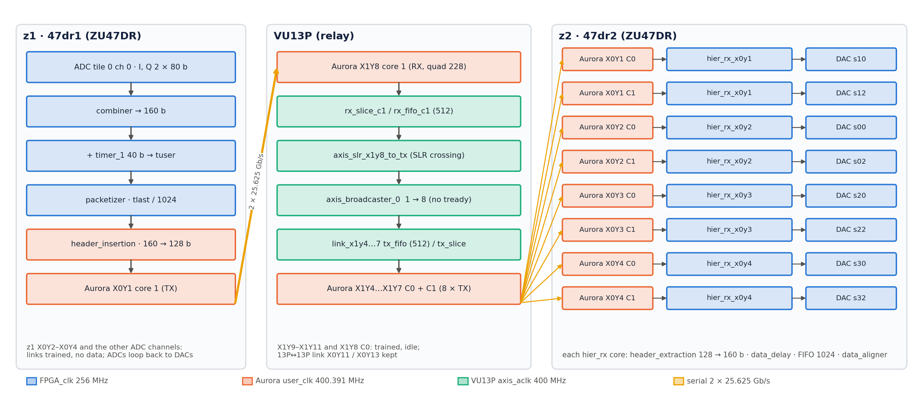
Figure 1: System overview: z1 ADC stream → VU13P X1Y8 C1 → broadcaster → eight links → eight z2 DACs
- One source, eight sinks. z1 sends ADC tile 0 channel 0 on Aurora X0Y1 core 1. The VU13P receives it on X1Y8 core 1, crosses SLRs and duplicates it to all eight Aurora cores of quads 224–227, each linked to one z2 core.
- Timestamped samples. Each 160-bit sample (5 I/Q pairs at 256 MHz = 1.28 GSPS complex) is tagged with the z1 40-bit timer. The timestamp travels in-band as a 64-bit header once per 1024-sample packet, and z2 rebuilds it per beat.
- Scheduled playback. z2 adds a programmable delay (axi_delay) and releases every sample when its own timer reaches that time, so all eight DACs play the stream with a fixed, known latency.
- Independent links. The broadcaster has no back-pressure; a stalled or down z2 link loses data on that link only.
- z1 Aurora RX and the z1↔VU13P links on X0Y2–X0Y4 are built and trained but carry no data.
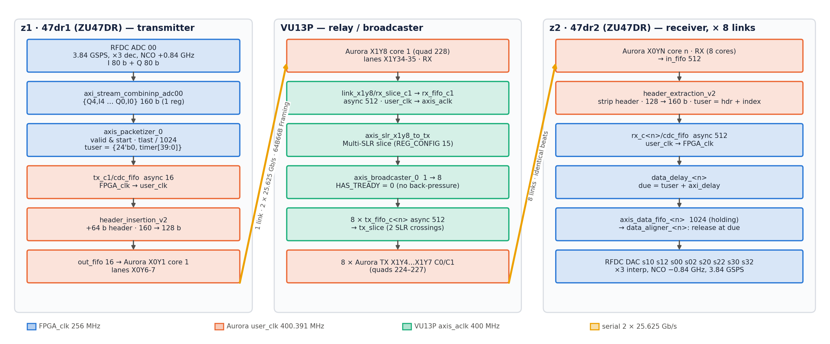
Figure 2: Every block on the path from the z1 ADC to a z2 DAC, coloured by clock domain

3. Serial link allocation
Aurora 64B66B v13.0, Framing mode, 2 lanes, 25.625 Gb/s per lane, no flow control, no CRC, 156.25 MHz reference clock on MGTREFCLK0 of the own quad. Two cores per quad: core 0 owns the QPLL and user clock, core 1 shares them.
z1 quad (bank) | z1 lanes C0 / C1 | VU13P quad (bank) | VU13P lanes C0 / C1 | z2 quad (bank) | Use
X0Y1 (128) | X0Y4-5 / X0Y6-7 | X1Y8 (228) | X1Y32-33 / X1Y34-35 | — | ADC stream (C1)
X0Y2 (129) | X0Y8-9 / X0Y10-11 | X1Y9 (229) | X1Y36-37 / X1Y38-39 | — | link only
X0Y3 (130) | X0Y12-13 / X0Y14-15 | X1Y10 (230) | X1Y40-41 / X1Y42-43 | — | link only
X0Y4 (131) | X0Y16-17 / X0Y18-19 | X1Y11 (231) | X1Y44-45 / X1Y46-47 | — | link only
— | — | X1Y4 (224) | X1Y16-17 / X1Y18-19 | X0Y1 (128) | broadcaster M00 / M01
— | — | X1Y5 (225) | X1Y20-21 / X1Y22-23 | X0Y2 (129) | M02 / M03
— | — | X1Y6 (226) | X1Y24-25 / X1Y26-27 | X0Y3 (130) | M04 / M05
— | — | X1Y7 (227) | X1Y28-29 / X1Y30-31 | X0Y4 (131) | M06 / M07

Reference clock pins (P / N, from the golden IBERT):
Board | Quad → pins
VU13P | X1Y4 AW9/AW8 · X1Y5 AT11/AT10 · X1Y6 AM11/AM10 · X1Y7 AH11/AH10 · X1Y8 AD11/AD10 · X1Y9 Y11/Y10 · X1Y10 T11/T10 · X1Y11 M11/M10 · (13P↔13P: X0Y11 R36/R37, X0Y13 L36/L37)
ZU47DR (z1, z2) | X0Y1 AA33/AA34 · X0Y2 W33/W34 · X0Y3 U33/U34 · X0Y4 P31/P32

GT serial pins are placed by the Aurora IP location (no PACKAGE_PIN). Lane pairing C0 ↔ C0 and C1 ↔ C1 is assumed straight; the golden IBERT confirms the quad pairing only (§12.4).
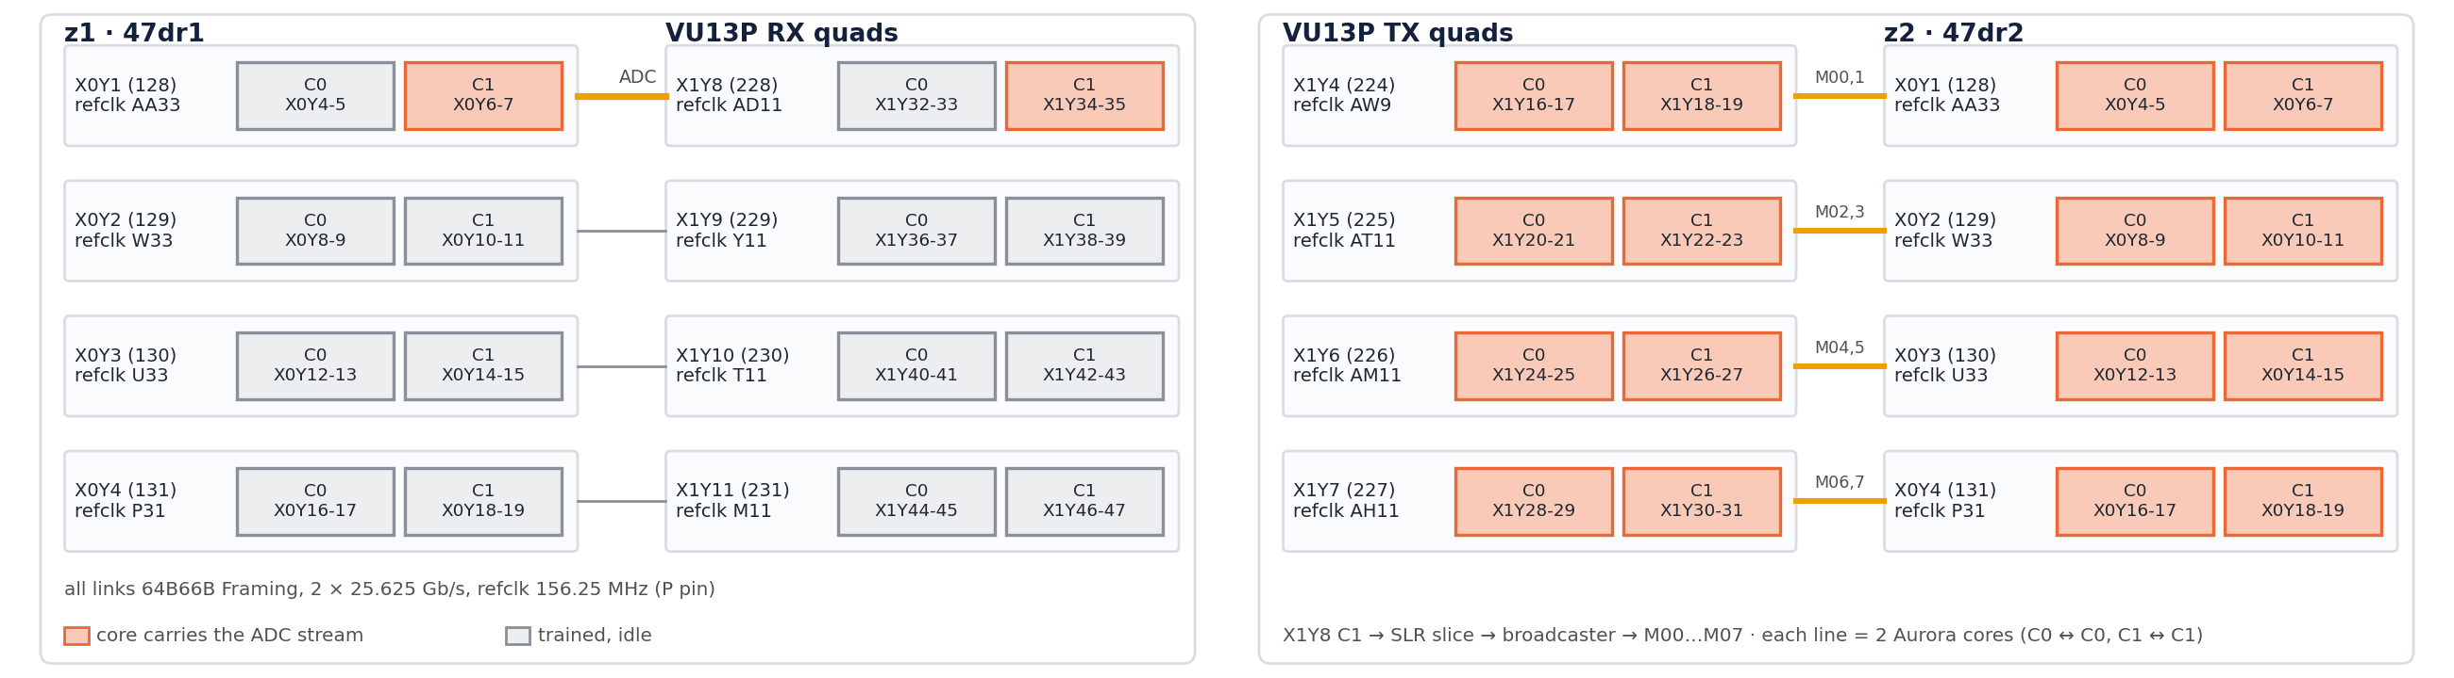
Figure 3: Link and lane allocation: z1 ↔ VU13P receive quads, VU13P transmit quads ↔ z2, refclk pins

4. Clocking
Clock | Frequency | Source | Users
FPGA_clk (z1, z2) | 256 MHz | board pin FPGA_clk_p_0 → util_ds_buf_0 | RFDC AXIS, combiners, packetizer, timer_1, container s_axis_aclk, hier_rx, data_delay, data_aligner
init_clk (z1, z2) | 100 MHz | fpga_clk_100mhz (AN10) → util_ds_buf_2 | Aurora init_clk, reset logic
pl_clk0 (z1, z2) | 100 MHz | Zynq PS | AXI-Lite (smartconnect_0, GPIOs, RFDC s_axi, DMA_Ctrl)
PL_SYSREF (z1, z2) | — | board pin → util_ds_buf_3 | pl_sysref_int, sync_pulse_to_level_1 (timer start)
sys_clk (VU13P) | 100 MHz | BA15, DIFF_HSTL_I_18 | Aurora init_clk, clk_wiz_0 input
axis_aclk (VU13P) | 400 MHz | clk_wiz_0/clk_out1 | link FIFOs (fabric side), axis_slr_x1y8_to_tx, broadcaster
Aurora user_clk | ≈ 390 MHz (line rate / 66 per 64-bit lane word) | each quad's core 0 | Aurora user interface, header_insertion / header_extraction, link slices
GT refclk | 156.25 MHz | MGTREFCLK0 of each quad | QPLL

- Time base. z1 and z2 must take FPGA_clk from a common reference, so their timers count at exactly the same rate (§6). The VU13P only relays; its clocks need no relation to z1/z2 because every link has headroom (§11).
- All crossings between FPGA_clk / axis_aclk and user_clk are AXIS data FIFOs with independent clocks (§9.2).
- pma_rst: z1/z2 drive PMA_RST (LVDS, util_ds_buf_1 OBUFDS) from axi_gpio_pma_rst; the VU13P receives it on AU16/AV16 and uses it for the Aurora pma_init of all cores.
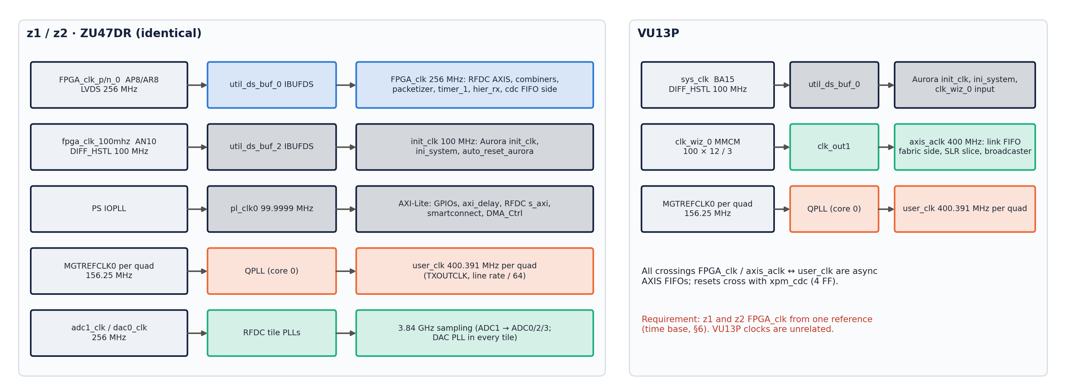
Figure 4: Clock tree of the 47DR boards and the VU13P

5. Data path and format

5.1 Sample format
- ADC: RFDC tile 0 ch 0, 3.84 GSPS, ×3 decimation, NCO +0.84 GHz, I/Q mode: m00_axis (I) and m01_axis (Q), 80 bits = 5 samples each per 256 MHz clock.
- axi_stream_combininp_adc00 interleaves them into 160 bits: {Q4,I4,Q3,I3,Q2,I2,Q1,I1,Q0,I0} (16 bit each). This is the format the RFDC DAC expects in I/Q mode, so the same word drives a DAC directly (z1 loopbacks, z2 outputs).
- DAC: 3.84 GSPS, ×3 interpolation, NCO −0.84 GHz, 160-bit IQ input per channel.
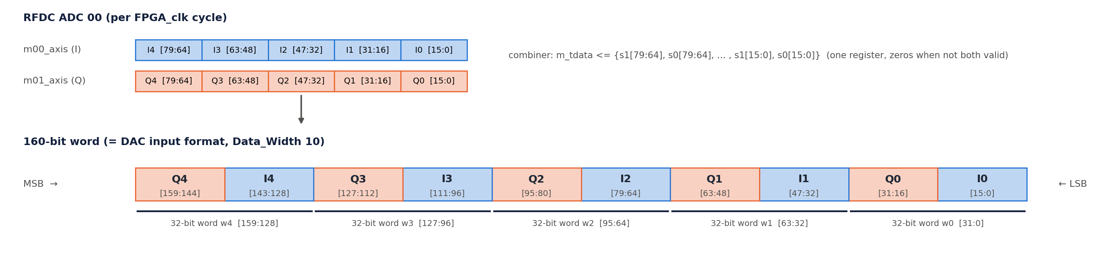
Figure 5: Combiner: RFDC I and Q streams interleaved into the 160-bit DAC word

5.2 Timestamp and packet
- timer_1 (40 bit) counts FPGA_clk cycles from the start event (§6). tuser = {24'b0, timer[39:0]} (ilconcat_1 + xlconstant_0).
- axis_packetizer_0: valid only after start, tlast every 1024 samples (PACKET_LENGTH).

5.3 160 → 128 → 160
- header_insertion_v2 (z1 container, hier_tx_x0y1/tx_c1, user_clk): at the first beat of a packet it inserts the 64-bit header {ip[15:0], type[7:0], time[39:0]} = the packet's first tuser, then packs the 160-bit samples into 128-bit beats (32-bit word shift register). A packet is 64 + 1024 × 160 = 163 904 bits = 1280.5 beats. The half beat is carried into the next packet, so packets alternate between 1281 and 1280 beats and the 64-bit word alignment depends on the previous packet (§10).
- Aurora Framing carries tlast across both hops (z1 → VU13P → z2).
- header_extraction_v2 (z2 container, hier_rx_x0yN/rx_c<n>): takes the header from the top 64 bits of the first beat after tlast, unpacks to 160 bits and outputs `tuser` = header + beat index (upper 24 bits 0). err output (XOR check of the data words) goes to the container ILA.
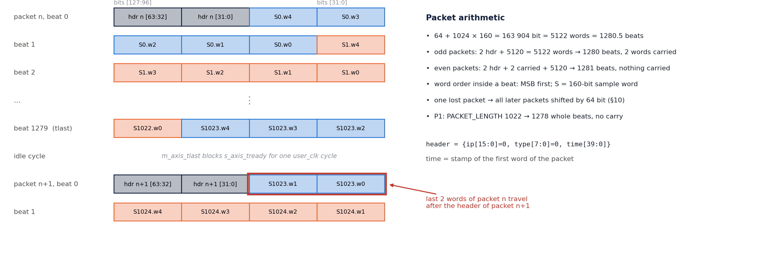
Figure 6: header_insertion_v2 beat layout: header, word order and the 2 words carried into the next packet

5.4 Header overhead
64 bits per 1024 samples = 0.04 %. With the frame separator and the one-cycle stall per packet in header_insertion, a packet occupies ≈ 1282.5 user_clk cycles (§11).

6. Time base and timers (whole system)
The system has one time base, kept by two identical counters: timer_1 on z1 and timer_1 on z2. Both count 256 MHz FPGA_clk cycles from the same SYSREF pulse, so at any instant they hold the same value. z1 writes its timer value into every sample; z2 compares that value (plus a programmable delay) with its own timer and plays the sample when they meet. The VU13P has no timer: it forwards the time inside the packet header untouched.
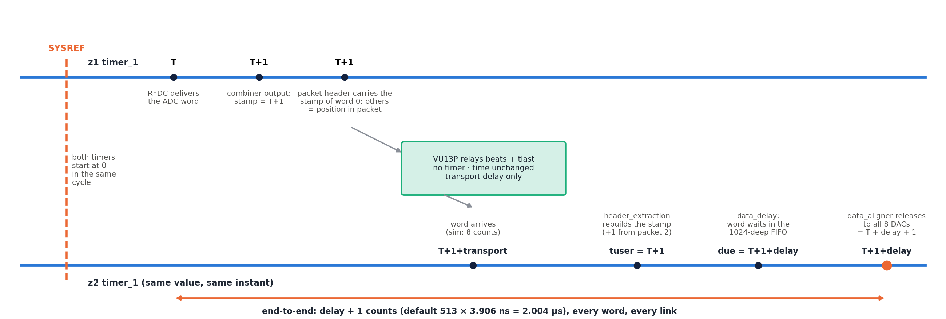
Figure 7: Life of a time value: SYSREF starts both timers; z1 stamps, the header carries, z2 rebuilds, delays and releases

6.1 Timer hardware (identical on z1 and z2)
Block | RTL | Function
timer_1 | timer.v (TIME_WIDTH = 40) | timestamp <= timestamp + 1 every FPGA_clk cycle while start = 1; cleared by aresetn = 0; holds while start = 0
sync_pulse_to_level_1 | sync_pulse_to_level.v | level_ref (= start) goes 1 on the first pulse_ref (PL SYSREF) after rst_n is released and stays 1 until the next reset
xpm_cdc_gen_1 | XPM sync reset | axi_gpio_arstn (PS, pl_clk0) → irstn on FPGA_clk; resets timer, sync_pulse_to_level, packetizer (z1), hier_rx and axi_delay (z2)
util_ds_buf_3 | IBUFDS | board PL_SYSREF pin → pulse_ref (also to pl_sysref_int for RFDC multi-tile sync)

- Clock: FPGA_clk 256 MHz (util_ds_buf_0); one count = 3.906 ns; 40 bits wrap after 2⁴⁰ cycles = 71.6 min.
- On z1 the same start level also enables axis_packetizer_0, so the first transmitted sample carries time ≈ 0.
- On z2 the timer value goes to all four hier_rx_x0yN/timestamp inputs (all eight aligners use one time).
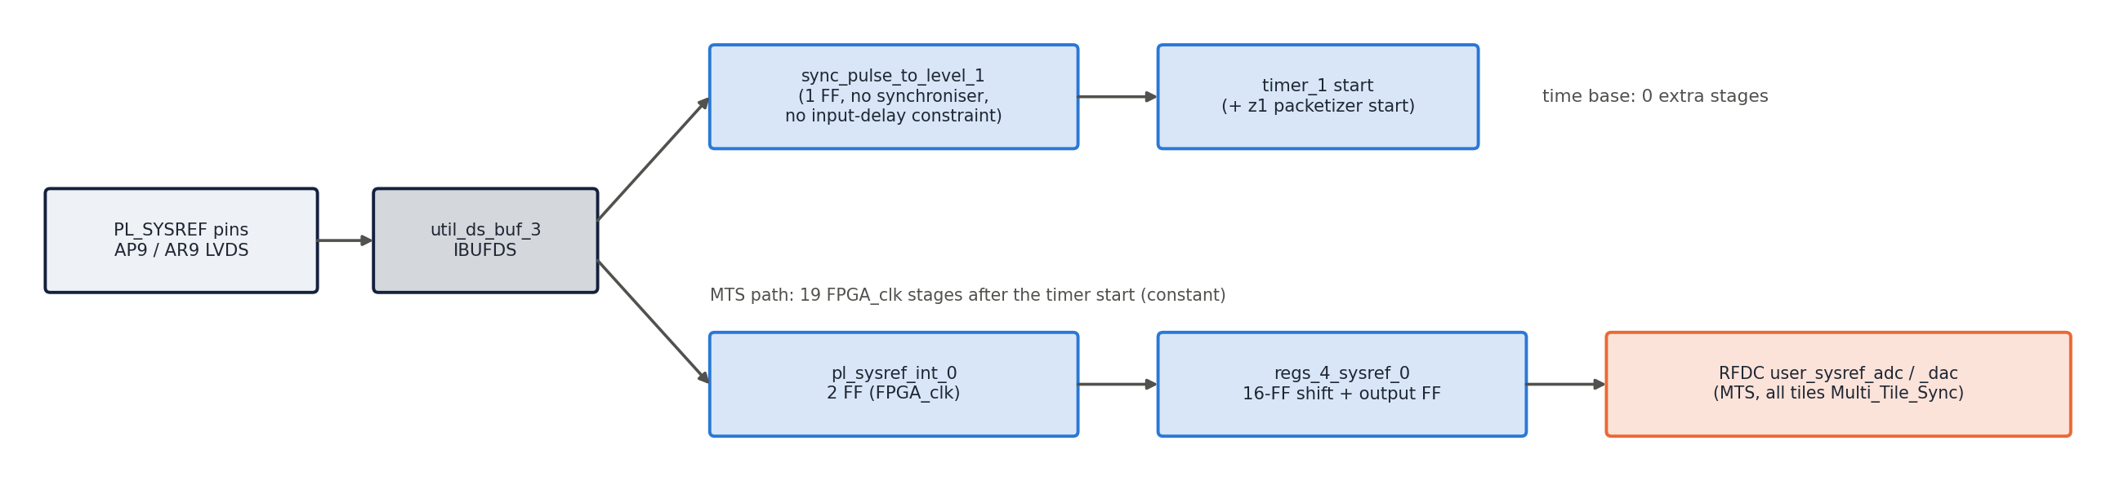
Figure 8: PL SYSREF inside each 47DR: time-base start path and RFDC multi-tile-sync path

6.2 Starting both timers together
- Hold arstn = 0 on both boards (axi_gpio_arstn @ 0xA001_0000 = 0): timers at 0, start = 0.
- Release arstn on z2, then z1 (z2 must be ready before z1 sends).
- Issue one PL SYSREF pulse to both boards. On the next FPGA_clk edge both start levels go 1 and both timers count from 0 in the same cycle.
Requirements for the two counters to stay equal:
- Same frequency: z1 and z2 FPGA_clk must come from one reference. An offset of x ppm makes the timers drift by x × 256 counts per second (100 ppm = 25 600 counts/s); z2 would play samples progressively early or late and its holding FIFO overflows in < 50 ms.
- Same start edge: SYSREF must reach both boards with a fixed phase to FPGA_clk and must be sampled after both arstn are released. If SYSREF is periodic and one board is released one period later, its timer lags by one SYSREF period for the whole run.
- There is no further time correction: the timers are free-running after the start, so any start offset Δ (z2 ahead by Δ counts) shortens the effective latency to delay − Δ.
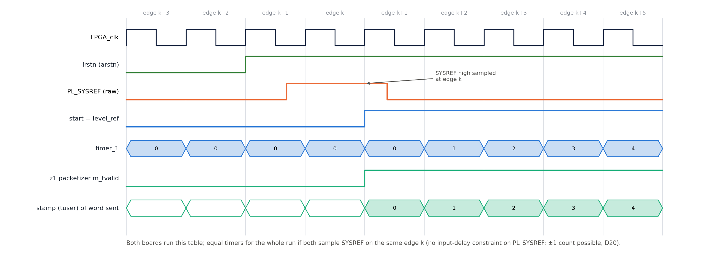
Figure 9: Start of the time base, cycle by cycle (same on z1 and z2)

6.3 Stamping on z1
- tuser = {24'b0, timer[39:0]} (ilconcat_1: In0 = timer_1/timestamp, In1 = xlconstant_0 = 0) is applied to axis_packetizer_0 in the same cycle as the sample. The combiner registers the RFDC data once, so the time is taken one cycle after the ADC word left the RFDC — a constant offset that cancels in the end-to-end latency (§6.7).
- The packetizer passes tuser with every sample and asserts tlast every 1024 samples.

6.4 Carrying the time (z1 → VU13P → z2)
- header_insertion_v2 sends only the time of the first sample of each packet, in the 64-bit header {ip 16, type 8, time 40} (ip and type are 0). The other 1023 times are implied by their position.
- The VU13P relays 128-bit beats and tlast only (rx_fifo → SLR slice → broadcaster → tx_fifo); it never reads or changes the time, and its clocks need no relation to the z1/z2 time base.
- Transport delay (Aurora hops, FIFOs, clock crossings) does not change the time value; it only uses up part of the delay budget (§6.7).

6.5 Rebuilding the time on z2
- header_extraction_v2 loads m_axis_tuser from the header and adds 1 for every output sample: tuser = header time + sample index, i.e. every sample gets back the z1 time at which it was stamped. (Simulation detail: from the second packet on, the rebuilt tuser is one count higher than in the first packet, because the last beat of a packet is output after the next header is loaded; the measured DAC latency is still constant for every sample, §6.7.)
- tuser crosses into FPGA_clk with the sample in rx_c<n>/cdc_fifo (512 deep, 64-bit tuser).

6.6 Scheduling and release on z2 (per Aurora core)
data_delay — computes the due time:
- due = time + delay (40-bit arithmetic, wraps with the timer). delay (32 bit) is axi_delay (0xA008_0000, default 0x200 = 512 counts = 2.0 µs), shared by all eight cores.
- Guard: if the incoming time jumps forward by more than 1024 counts relative to the previous due time, the previous due time is kept (protects against a corrupted header; see §10 for its side effect after packet loss).
- Never back-pressures (s_axis_tready = 1); output goes into axis_data_fifo (1024 deep), which holds the samples until they are due.
data_aligner — releases at the due time:
- end_time = z2 timer + 2 (two-cycle pipeline compensation). sys_time and data_time are 41-bit: the extra MSB toggles each time the 40-bit value wraps, so comparisons stay correct across the 71.6-min wrap.
- out_valid = sys_time ≥ data_time (equal, or later within the same epoch, or the epoch bit differs and the low bits are smaller). While out_valid = 0 the FIFO is not read and the DAC receives zeros; when 1 the sample is read and sent. A late sample (due time already passed) is sent immediately, without waiting.
- ILA probes in each hier_rx_x0yN: timestamp (z2 timer), sys_time, data_time, end_time.
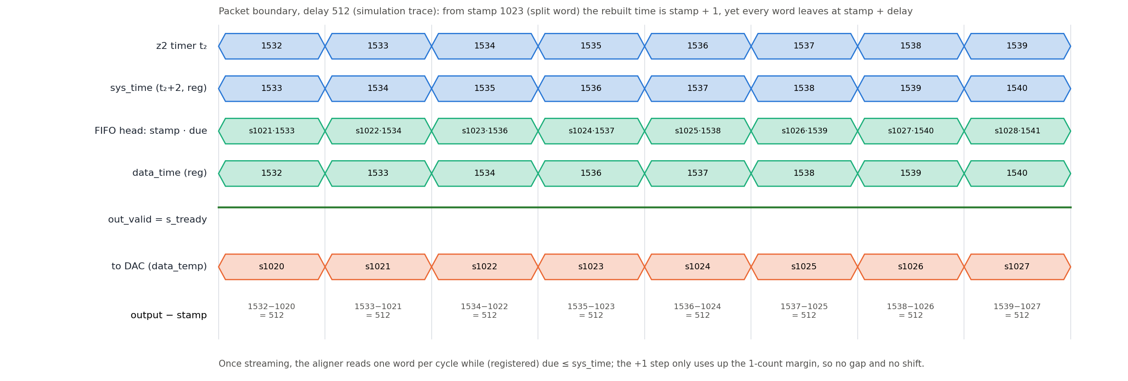
Figure 10: data_aligner release at the first packet boundary (simulation trace, delay 512)

6.7 End-to-end latency
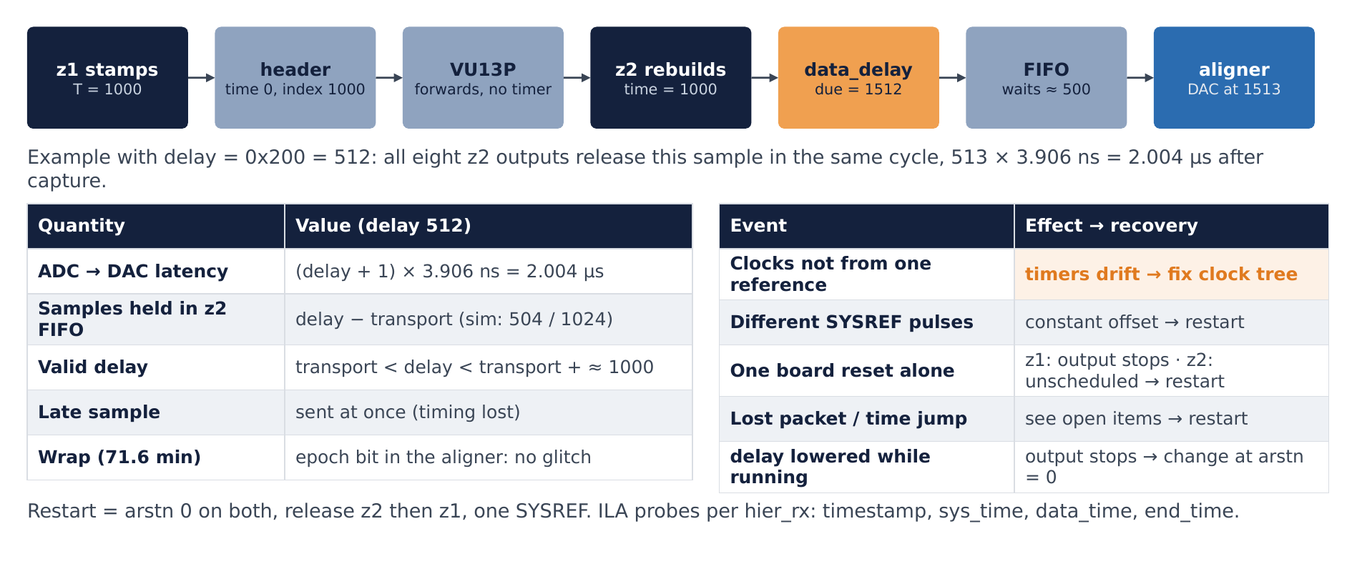
Figure 11: Latency: a sample stamped T on z1 leaves every z2 output at T + delay + 1
A sample captured when the z1 timer reads T leaves the z2 aligner when the z2 timer reads T + delay + 1 (simulation, every sample, every link, delays 200 and 512). The +1 is the net of the combiner register, the aligner +2 compensation and the aligner output register.
Quantity | Value (default delay 512)
Fixed ADC → DAC latency | (delay + 1) × 3.906 ns = 513 × 3.906 ns = 2.004 µs
Transport latency (z1 packetizer → z2 FIFO) | < delay; measured in simulation well below 512 counts
Samples waiting in the z2 holding FIFO | delay − transport latency (simulation: 504 of 1024)
Valid delay range | transport latency < delay < transport latency + ≈ 1000

Worked example (delay = 0x200 = 512): SYSREF at t = 0 → both timers 0. A sample stamped T = 1000 on z1 is sent in the packet that started at T = 0 (header time 0, index 1000). It reaches z2 a few hundred counts later; z2 rebuilds time 1000, computes due = 1512 and keeps it in the FIFO. When the z2 timer reaches 1512 (sys_time = end_time = 1513 ≥ data_time) the aligner reads it and the DAC receives it at z2 time 1513 = 1000 + 512 + 1. All eight z2 outputs release this sample in the same cycle.
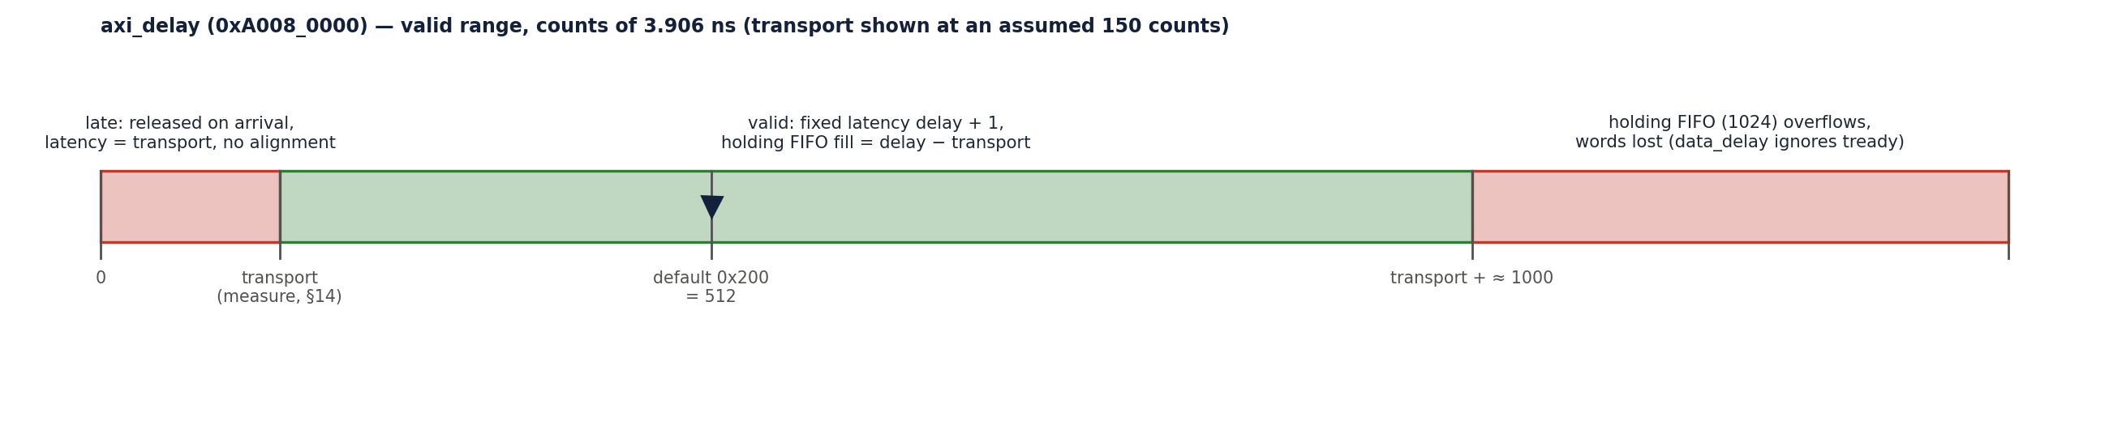
Figure 12: Valid range of axi_delay

6.8 Wrap-around
- Both timers wrap from 0xFF_FFFF_FFFF to 0 in the same cycle (71.6 min after start). data_delay wraps due the same way, and the aligner's epoch bit keeps the ordering. Simulated across the wrap: latency constant, no gaps.

6.9 What breaks the time base, and recovery
Event | Effect | Recovery
z1 and z2 clocks not from one reference | timers drift; outputs early/late, z2 FIFO overflow | fix the clock tree, restart (§6.2)
Boards started on different SYSREF pulses | constant offset of N SYSREF periods | restart with one SYSREF after both arstn releases
z1 reset / reprogrammed | z1 time restarts low → due times decrease → data_aligner epoch bit toggles → z2 outputs zeros, holding FIFO overflows (RTL analysis, rev 0.12) | hold arstn on both, restart (§6.2)
z2 reset alone | data_delay guard freezes the due time at 0 → samples pass through unscheduled (RTL analysis, rev 0.12) | restart both (§6.2)
Lost packet / large time jump | see §10 (alignment, data_delay guard) | reset both, restart
delay changed while running | smaller delay: due time decreases → epoch toggles → output stops; larger delay: zeros for the difference, FIFO fill grows (RTL analysis, rev 0.12) | change delay only while arstn = 0

7. Board designs

7.1 z1 — 47dr1 (transmitter)
ADC ch (I/Q) | Combiner | Destination
00 (m00/m01) | axi_stream_combininp_adc00 | axis_packetizer_0 → S_AXIS_X0Y1_C1 → VU13P
02 | axi_stream_combininp_adc02 | DAC s02
10 | axi_stream_combininp_adc10 | DAC s10
12 | axi_stream_combininp_adc12 | DAC s12
20 | axi_stream_combininp_adc20 | DAC s20
22 | axi_stream_combininp_adc22 | DAC s22
30 | axi_stream_combininp_adc30 | DAC s30
32 | axi_stream_combininp_adc32 | DAC s32

DAC s00 and the z1 Aurora RX outputs are unused. Removed (R7): PARAM_RECORDER (with its GPIOs, CDC and broadcaster; PS HP0/HP1 disabled), phase_calibration, pulse generator, debug VIOs (resets now from AXI GPIO).

7.2 VU13P (relay)
- Container aurora_gty_vu13pto47dr: for each quad X1Y4…X1Y11 a hier_x1yN (2 Aurora cores, status VIOs, reset helpers) and an identical link_x1yN (R9): TX S_AXIS_TX_C<n> → tx_fifo_c<n> (512, axis_aclk → user_clk) → tx_slice_c<n> (Multi-SLR crossing) → core; RX core → rx_slice_c<n> → rx_fifo_c<n> (512, user_clk → axis_aclk) → M_AXIS_RX_C<n>.
- Top: M_AXIS_X1Y8_C1 → axis_slr_x1y8_to_tx (Multi-SLR crossing; quad 228 and quads 224–227 are in different SLRs, D11) → axis_broadcaster_0 (8 × 128 b, no tready, D12) → S_AXIS_X1Y4_C0 … S_AXIS_X1Y7_C1.
- system_ila_0 in the container monitors X1Y4 (core 0 RX, core 0/1 TX).
- Core-1 link reset (hier_x1yN/aurora_rstn_1) follows aurora_x1yN_1/channel_up since rev 0.12 (D19; it followed core 0 lane_up before, inherited from EV1 hier_x1y4).
- 13P↔13P container (aurora_gty_vu13ptovu13p, X0Y11/X0Y13) kept; not part of the 1R8T path.
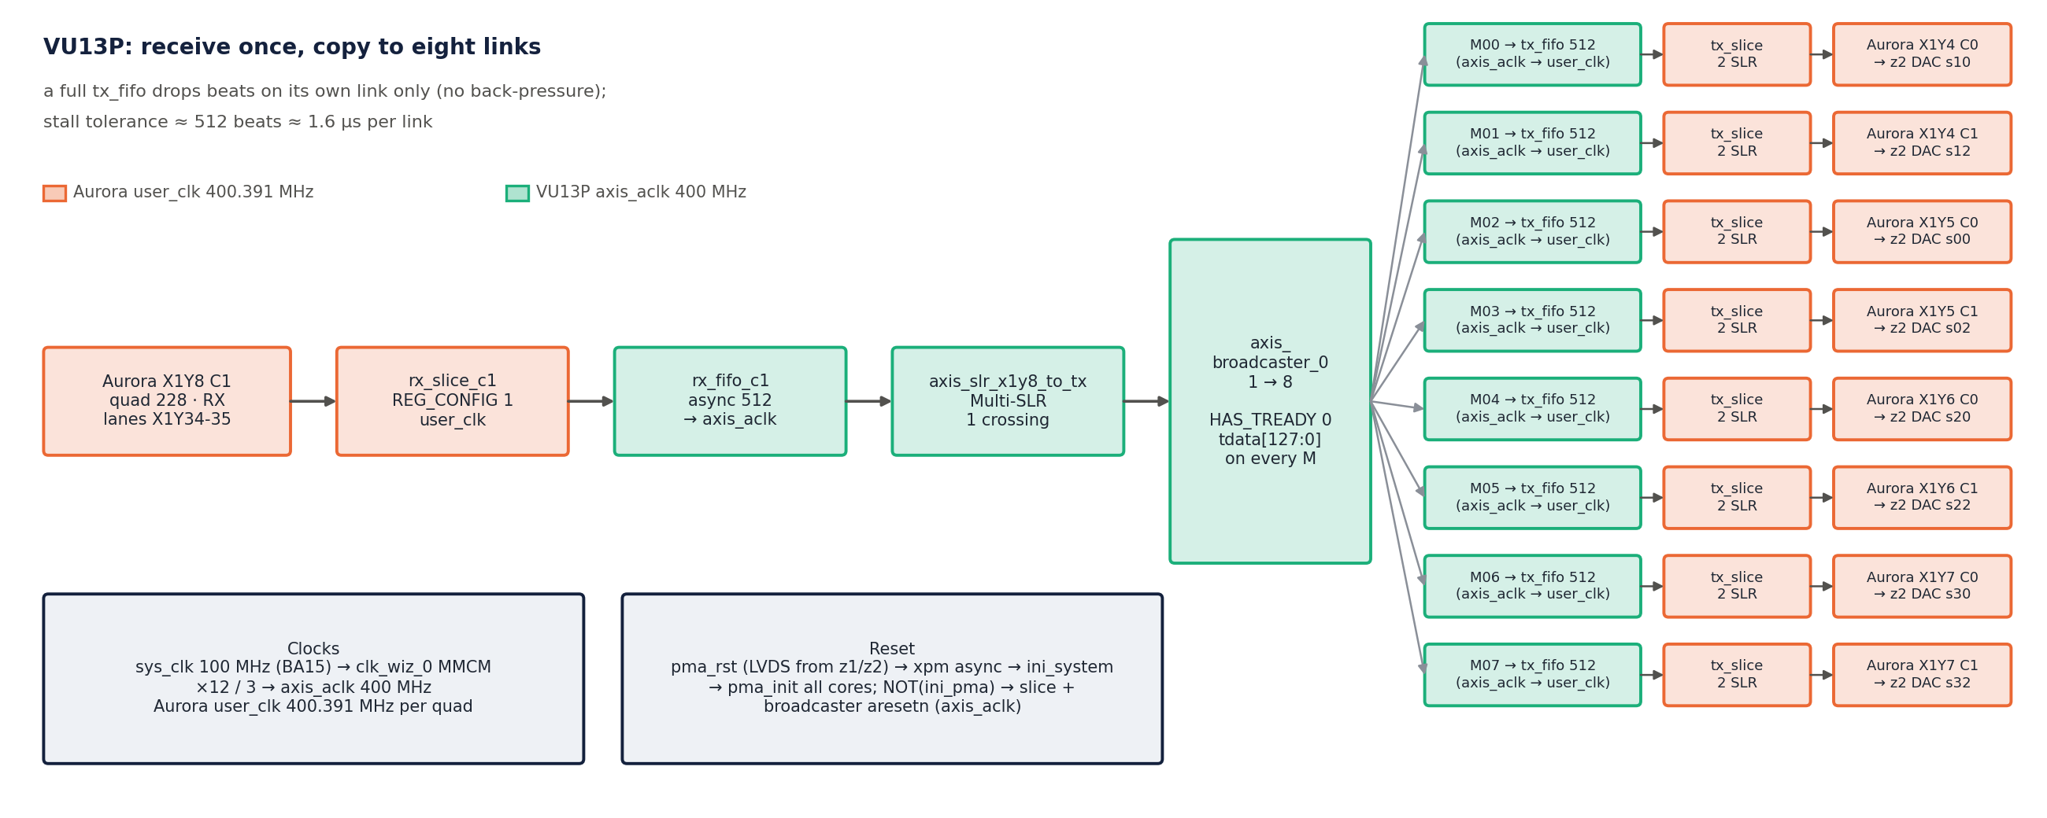
Figure 13: VU13P relay: X1Y8 core 1 → SLR slice → broadcaster → eight TX FIFOs, slices and cores

7.3 z2 — 47dr2 (receiver, 8 DACs)
Container port | hier_rx | DAC
M_AXIS_X0Y1_C0 / _C1 | hier_rx_x0y1 | s10 / s12
M_AXIS_X0Y2_C0 / _C1 | hier_rx_x0y2 | s00 / s02
M_AXIS_X0Y3_C0 / _C1 | hier_rx_x0y3 | s20 / s22
M_AXIS_X0Y4_C0 / _C1 | hier_rx_x0y4 | s30 / s32

- hier_rx_x0yN: per core data_delay_<n> → axis_data_fifo_<n> (1024) → data_aligner_<n>, ILAs on the delay/aligner times. DAC tile 3 is configured like tile 2.
- AXI map (/zynq_ultra_ps_e_0/Data): DMA_Ctrl 0xA000_0000, axi_gpio_arstn 0xA001_0000, axi_gpio_pma_rst 0xA002_0000, axi_intc_0 0xA003_0000, RFDC 0xA004_0000 (256 K), `axi_delay` 0xA008_0000.
- Removed (R7 and user edits 2026-10-14): PARAM_RECORDER, phase_calibration, unused ADC combiners, top-level TX generators, pulse generator, phase-cal and debug VIOs.

8. Naming (rev 0.8)
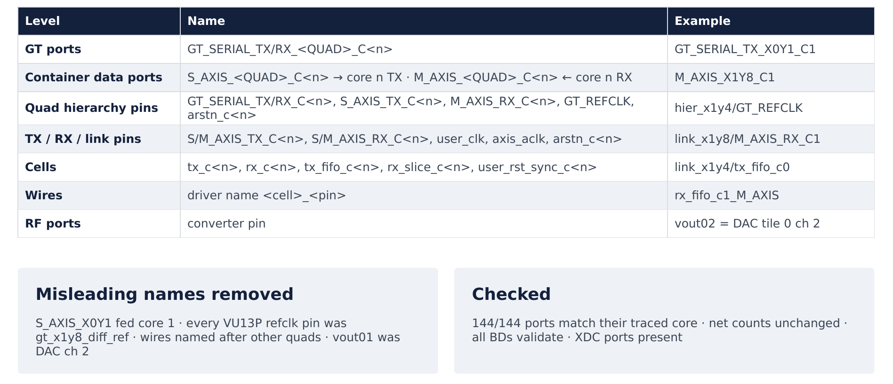
Figure 14: Naming convention: every name follows the quad, core and direction it connects to
Every name is derived from what it connects to (quad, Aurora core, direction). Generated and checked by scripts/naming/gen_container.py and gen_top.py, applied by apply_container.tcl / apply_top.tcl (lib.tcl).
Level | Name | Example
GT ports | GT_SERIAL_TX_<QUAD>_C<n>, GT_SERIAL_RX_<QUAD>_C<n> (n = Aurora core) | GT_SERIAL_TX_X0Y1_C1
Container data ports | S_AXIS_<QUAD>_C<n> → TX of core n; M_AXIS_<QUAD>_C<n> ← RX of core n | M_AXIS_X1Y8_C1
hier_<quad> pins | GT_SERIAL_TX/RX_C<n>, S_AXIS_TX_C<n>, M_AXIS_RX_C<n>, GT_REFCLK, arstn_c<n>, pma_init, user_clk_out | hier_x1y4/GT_REFCLK
TX / RX / link pins | S/M_AXIS_TX_C<n>, S/M_AXIS_RX_C<n>, user_clk (Aurora), axis_aclk (fabric), arstn_c<n> | link_x1y8/M_AXIS_RX_C1
Per-core cells | tx_c<n>, rx_c<n>, tx_fifo_c<n>, tx_slice_c<n>, rx_slice_c<n>, rx_fifo_c<n>, user_rst_sync_c<n>, axis_rst_sync_c<n>, cdc_fifo, in_fifo, out_fifo | link_x1y4/tx_fifo_c0
Wires | driver name: <cell>_<pin>, or the input port / hierarchy pin that drives it | rx_fifo_c1_M_AXIS
RF ports | converter pin | vout02 = DAC tile 0 ch 2
Unchanged | refclk / board ports (XDC), Aurora core cells aurora_<quad>_<n>, hier_<quad>, container instances, AXI peripherals (address map)

Errors removed by the pass: S_AXIS_X0Y1 fed core 1 (_1 fed core 0) in every quad and on the 13P↔13P link; GT_SERIAL_TX_3 was core 0; every VU13P refclk pin was gt_x1y8_diff_ref; every link_x1yN pin said x1y4; wires named after other quads (aurora_x0y4_* inside hier_x0y1, hier_x0y13_*, rxq3_*); s_axis_axlk; z2 port vout01 was DAC ch 2. Checks: 144/144 container ports equal their traced quad/core; net and endpoint counts identical before/after; all BDs validate; all XDC ports present in the wrappers.

9. Flow control, CDC and reset

9.1 Flow control
Back-pressure exists only between header_insertion and the z1 Aurora TX, inside the VU13P TX path (tx_fifo → Aurora TX) and between header_extraction and its FIFOs. Four points ignore `tready`, so their FIFO must never fill:
Point | Ignores tready | Protected by
z1 RFDC / combiner → packetizer | yes | z1 tx_c1/cdc_fifo (16) + link headroom
Aurora RX (VU13P, z2) | yes (Aurora has no RX back-pressure) | rx_fifo (512) / in_fifo (512)
VU13P broadcaster | yes (D12) | tx_fifo_c<n> (512) per link
z2 data_delay | yes (s_axis_tready = 1) | hier_rx FIFO (1024) and the delay constraint (§6.7)

9.2 CDC inventory
Signal | From → To | Method
z1 samples + tuser | FPGA_clk → user_clk | tx_c<n>/cdc_fifo (axis_data_fifo, independent clocks, 16)
VU13P RX stream | user_clk (228) → axis_aclk | rx_fifo_c<n> (512)
VU13P TX stream | axis_aclk → user_clk (224–227) | tx_fifo_c<n> (512)
z2 samples + tuser | user_clk → FPGA_clk | rx_c<n>/cdc_fifo (512)
Aurora channel-up reset | user_clk ↔ axis_aclk / FPGA_clk | xpm_cdc_gen async reset (user_rst_sync_c<n>, axis_rst_sync_c<n>)
arstn, pma_rst GPIO | pl_clk0 → FPGA_clk / init_clk | xpm_cdc_gen sync reset (xpm_cdc_gen_0/1)
Aurora TX out clocks | async to sys_clk / board clocks | set_clock_groups -asynchronous in the XDC

9.3 FIFO budget (rev 0.9)
FIFO | Depth | Peak fill, normal | Peak fill, 1 µs VU13P TX stall | Peak fill, 3 µs stall
z1 tx_c1/cdc_fifo | 16 | 1 | 1 | 1
z1 tx_c1/out_fifo | 16 | 4 | 4 | 4
VU13P rx_fifo_c1 | 512 | 1 | 1 | 1
VU13P tx_fifo_c<n> | 512 | 4 | 321 | 512 (overflow, 450 beats lost)
z2 rx_c<n>/in_fifo | 512 | 1 | 1 | 1
z2 rx_c<n>/cdc_fifo | 512 | 6 | 259 | 411
z2 hier_rx FIFO | 1024 | 504 (= delay) | 504 | 1024 (overflow)

scripts/sim_chain/run_fifo.sh <stall_ns> [txdepth]: real RTL (axis_packetizer, header_insertion_v2, header_extraction_v2, data_delay, data_aligner, timer), real FIFO depths, Aurora TX model with the 64b/66b gearbox pause (1 in 33), clock compensation (3 cycles in 5000) and one separator cycle per frame, three independent user clocks and the 400 MHz VU13P fabric clock. Result: no data loss and constant latency in normal operation and with a 1 µs stall of a VU13P TX link. VU13P TX stall tolerance ≈ 512 beats ≈ 1.6 µs. The z1 TX FIFOs (16) peak at 4 because the link has 17 % headroom; 64-deep z1 FIFOs change nothing.
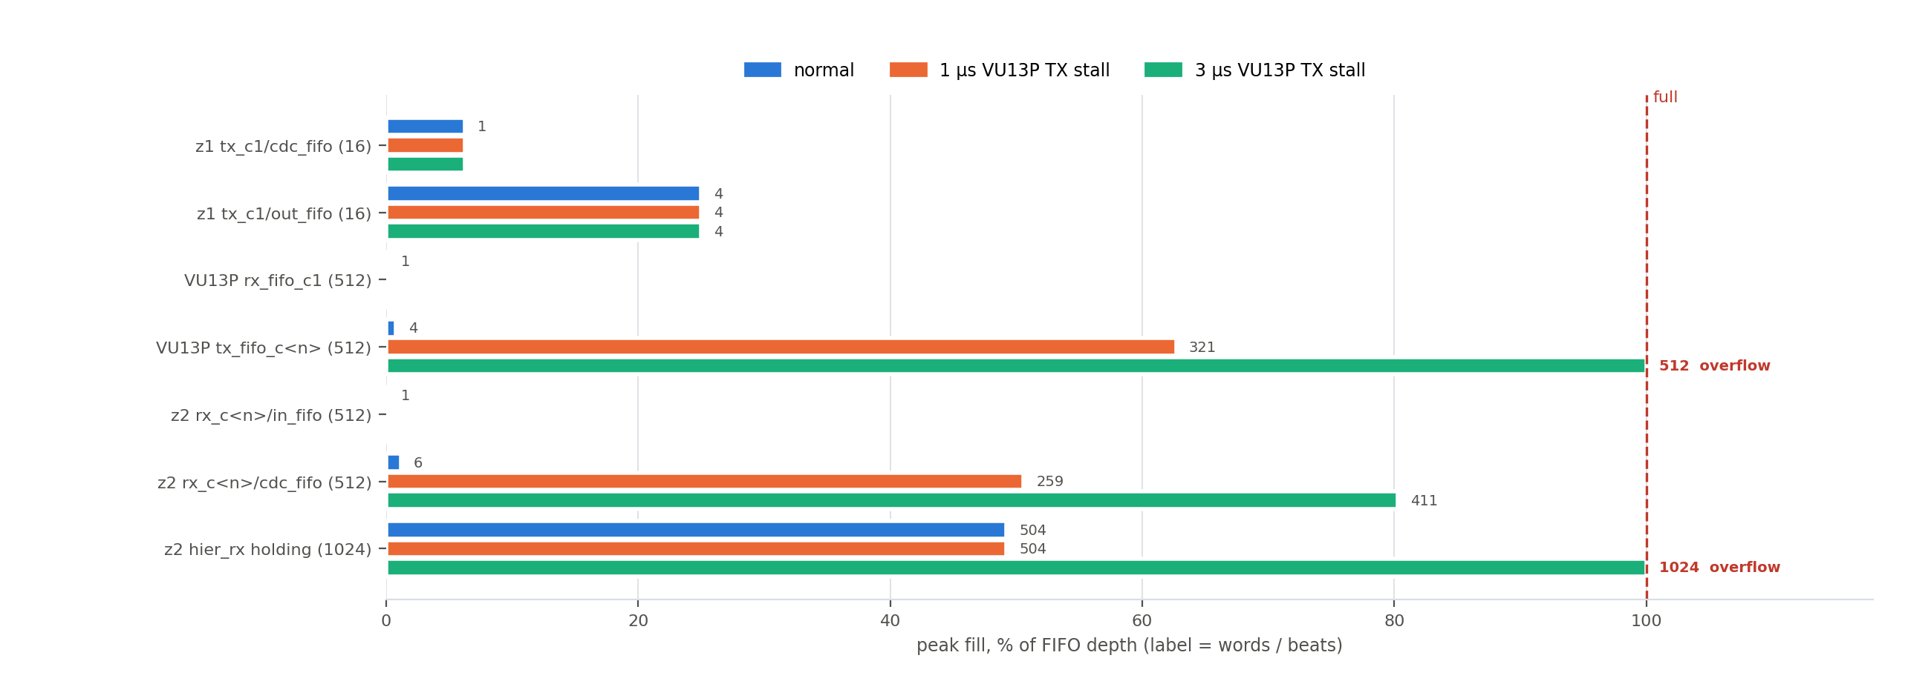
Figure 15: FIFO budget: peak fill of every FIFO, normal and with 1 µs / 3 µs VU13P TX stalls

9.4 Reset
- arstn (AXI GPIO → xpm_cdc_gen_1) resets the timer, sync_pulse_to_level, packetizer (z1) and hier_rx / axi_delay (z2). pma_rst (AXI GPIO → xpm_cdc_gen_0) drives ini_system → pma_init of all Aurora cores and the PMA_RST LVDS output.
- Each Aurora core's aurora_rstn derives a link reset from channel_up; it is synchronised into user_clk and axis_aclk / FPGA_clk and resets that core's FIFOs and slices. A link that is down drops its data.
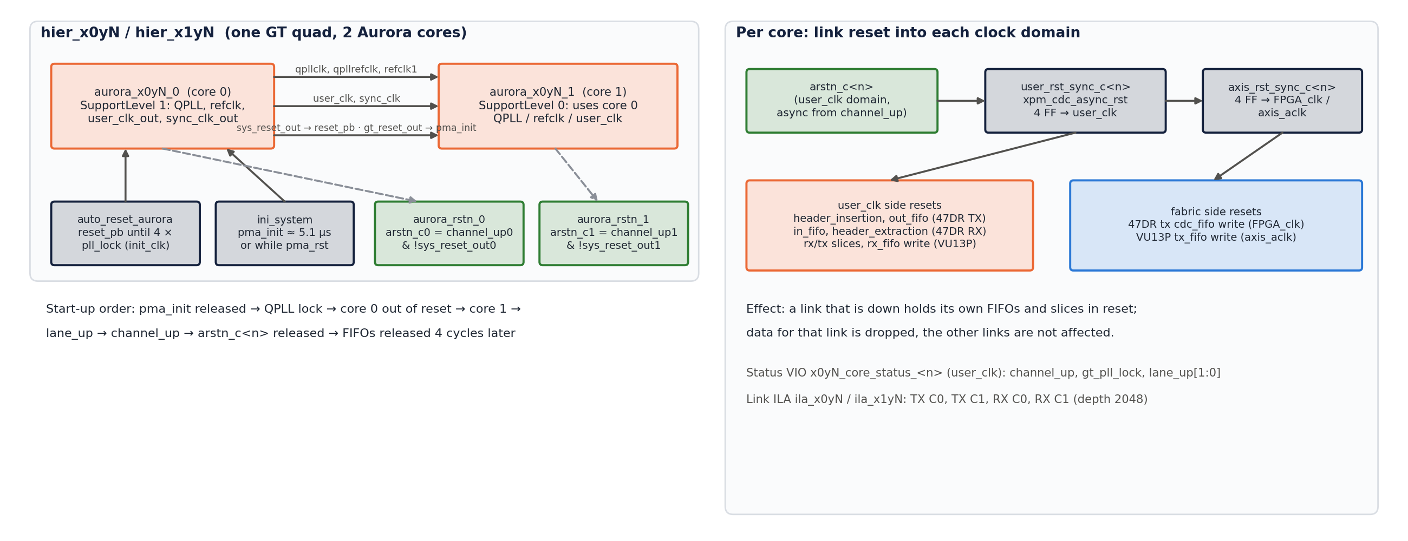
Figure 16: Per-quad reset chain and link reset into each clock domain

10. Error handling and recovery
- There is no retransmission. Aurora Framing without CRC delivers frames as received.
- Lost packet: because of the carried half beat (§5.3) one lost packet shifts the 64-bit word alignment of every later packet → wrong data on that z2 output until reset. Simulation: PACKET_LENGTH = 1022 (64 + 1022 × 160 bits = 1278 whole beats) makes packets independent; a lost packet then only zeroes its own samples (Open item P1).
- Timestamp jump > delay + 1024 (≥ 2 lost packets): data_delay keeps the previous time and the output stops until reset (P2).
- Link down / late link-up: the VU13P drops that link's data; when the link comes up mid-stream, z2 must be reset (or P1 applied) to resynchronise to a packet start.
- Clock / SYSREF error: see §6.2 and §6.9; recovery = reset both boards and restart on a common SYSREF.

11. Performance
Step | Value
ADC payload | 160 b × 256 MHz = 40.96 Gb/s (1.28 GSPS complex, 16-bit I/Q)
Header | 64 b / 1024 samples = +0.04 %
Link beats per packet | 1280.5 + 1 separator + 1 header stall ≈ 1282.5 per 4.0 µs
Link payload capacity | 2 × 25.625 Gb/s × 64/66 = 49.7 Gb/s ≈ 1553 beats per 4.0 µs; clock compensation ≈ 0.06 %
Link utilisation | ≈ 82.6 % (17 % headroom)
VU13P fabric | 128 b × 400 MHz = 51.2 Gb/s (above the link, RX FIFO never fills)
End-to-end latency | delay + 1 cycles of 256 MHz (default 513 cycles = 2.0 µs)

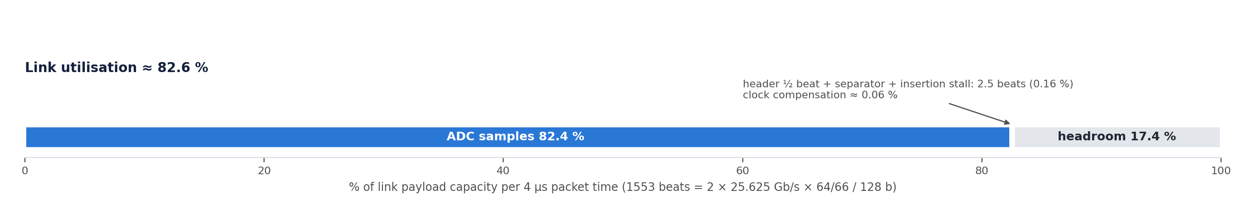
Figure 17: Link utilisation per 4 µs packet time

12. Verification, limitations and future work

12.1 End-to-end simulation (scripts/sim_chain/run.sh <delay> [wrap] [lost_packets] [packet_length])
Real RTL of the whole chain, two Aurora hops with back-pressure gaps, three independent user clocks.
Test | Result (rev 0.7)
delay 512 | PASS — every sample at the DAC exactly delay + 1 cycles after its z1 timestamp, no gaps, no drops
delay 200 | PASS — same
delay 1400 | FAIL as expected — 1024-deep holding FIFO overflows (constraint §6.7)
40-bit wrap | PASS — latency constant through 0xFF_FFFF_FFFF → 0
1 lost packet | FAIL — word misalignment until reset (§10); PASS with PACKET_LENGTH = 1022 (1 packet of zeros)
2 lost packets | FAIL — data_delay guard freezes the time (§10)

12.2 FIFO budget (scripts/sim_chain/run_fifo.sh) — rev 0.9, see §9.3.

12.3 Block-design checks
- validate_bd_design clean on all BDs (rev 0.8).
- RFDC: z1 ADC and z2 DAC configurations match (3.84 GSPS, ×3, 1.28 GSPS complex, NCO ±0.84 GHz).
- All Aurora cores: Framing, 25.625 Gb/s, 2 lanes, start lanes as in §3.

12.4 Not yet done
- Hardware bring-up (§15).
- Lane-level pairing C0/C1 between boards is assumed straight; verify with the IBERT or the core status VIOs.

12.5 Known limitations / possible fixes
- P1 PACKET_LENGTH = 1022 (packet = whole beats).
- P2 data_delay guard: resynchronise on a large timestamp jump instead of freezing.
- data_delay.v line 66 keeps s_axis_tuser[24] instead of [63:40] (harmless: upper bits are 0).
- VU13P methodology TIMING-4/27 on clk_wiz_0/clk_in1 (inherited).

12.6 Implementation results (VU13P build #6 rev 0.12; z1 / z2 build #5 rev 0.11; Vivado 2025.2)
 | VU13P · relay | z1 · 47dr1 | z2 · 47dr2
Setup slack (WNS) | +0.011 ns (rev 0.11: +0.025) | +0.008 ns | +0.023 ns
Hold slack (WHS) | +0.010 ns | +0.010 ns | +0.010 ns
Failing endpoints | 0 | 0 | 0
GT channels | 40 (X1Y16–X1Y47 + X0Y44–47, X0Y52–55) | 16 (X0Y4–X0Y19) | 16 (X0Y4–X0Y19)
Refclk pins | = golden (AW9 AT11 AM11 AH11 AD11 Y11 T11 M11, R36 L36) | = golden (AA33 W33 U33 P31) | = golden
LUT / FF / BRAM | 3.3 % / 4.7 % / 18.4 % | 14.7 % / 10.1 % / 20.8 % | 21.3 % / 16.1 % / 46.9 %
DRC | warnings only (PDCN-1569, RTSTAT-10) | same | same
Methodology critical | TIMING-4/27 on clk_wiz_0/clk_in1 (inherited) | none | none
Bitstream + probes | vu13p.runs/impl_1/aurora_gty_vu13p_rst_wrapper.bit + .ltx | 47dr1.runs/impl_1/design_1_wrapper.bit + .ltx | 47dr2.runs/impl_1/design_1_wrapper.bit + .ltx
XSA (with bitstream) | — (no PS) | 47dr1/z1_47dr1.xsa | 47dr2/z2_47dr2.xsa

Reports: <project>/reports/ (timing_summary, utilization, drc, methodology, clock_interaction, cdc, gt_placement). BRAM rose with the 2048-deep link ILAs (§17). Build #4 (no ILAs) had z1/z2 failing only the two MTS crossings (−1.414 / −2.049 ns), the same as the original 47DR_integrated_3 project → D16.

13. Decision log (append-only)
ID | Rev | Decision | Rationale | Status
D1 | 0.1 | Full copy of the EV1 integrated projects into three new projects. | User choice; originals stay untouched. | Active
D2 | 0.1 | 47DR part xczu47dr-ffvg1517-2-i (was -2-e), IP upgraded. | Matches the golden IBERT boards. | Active
D3 | 0.1 | Vivado 2025.2. | User tool. | Active
D4 | 0.1 | 1R8T: z1 one 2-lane Aurora → VU13P → broadcast to eight 2-lane Auroras → z2, one DAC per core. | User architecture (R4, R5). | Active
D5 | 0.2 | z1 keeps 8 cores on X0Y1–X0Y4; VU13P mirrors them with 8 RX cores on quads 228–231. | User (R6); every z1 lane pair has a partner. | Active
D6 | 0.3 | Remove PARAM_RECORDER and phase_calibration in z1 and z2; DACs fed directly. | User (R7). | Active
D7 | 0.4 | ADC stream on z1 X0Y1 core 1; VU13P broadcaster from X1Y8 core 1. | User option (b), confirmed again in rev 0.8 after a GUI edit had moved it to core 0. | Active
D8 | 0.5 | Remaining z1 ADC channels loop back to the same-index DAC. | User (R8). | Active
D9 | 0.5 | All links identical: VU13P link_x1yN = copy of the X1Y4 plumbing; 47DR quads with identical TX/RX wiring. | User (R9). | Active
D10 | 0.6 | Build with XILINX_LOCAL_USER_DATA=no; delete only phase_calibration_inst_* / PARAM_RECORDER_inst_* stale filesets. | Parallel runs crashed with SIGBUS; a broader cleanup deleted a live container fileset and crashed Vivado. | Active
D11 | 0.6 | Multi-SLR register slice axis_slr_x1y8_to_tx before the broadcaster. | −0.116 ns on 400 MHz inter-SLR paths (quad 228 vs 224–227). | Active
D12 | 0.1 | Broadcaster without tready. | A stalled or down z2 link must not stop the others. | Active (FIFO budget §9.3)
D13 | 0.7 | axi_delay AXI GPIO (32 bit, default 0x200) replaces vio_data_delay; address 0xA008_0000. | User edit; software-controlled latency. | Active
D14 | 0.8 | Connectivity-derived naming at every level (§8), tool-generated and checked. | User (R13); old names were misleading (core swaps, wrong quads). | Active
D15 | 0.9 | Keep FIFO depths (z1 16/16, VU13P 512/512, z2 512/512/1024). | Simulation: no loss with 17 % link headroom; VU13P TX tolerates 1.6 µs stalls. | Active

D16 | 0.11 | False path hier_mts/sysref_trig_det_*/waitsysref → sync_out_latch_*/waitforsysref_d1 + ASYNC_REG on d1/d2 (47DR XDC). | FPGA_clk → RFDC ADC0/DAC0 clocks are unrelated; the 4-flop synchroniser is the real CDC; Vivado timed it with a 0.03 ns requirement (failed in the original project too). | Active
D17 | 0.11 | Debug ILAs on every link: ila_x0yN (47DR container), ila_x1yN + ila_bcast (VU13P), ADC slot on z1 system_ila_1; resets left open. | User request: monitor the data traffic for debug on every hop. | Active
D18 | 0.11 | Remove all sources not used by the tops (old BDs aurora.bd, aurora_gty_rst_47dr.bd, PARAM_RECORDER, phase_calibration, standalone IPs, ~40 RTL files per 47DR project). | User request; stale entries had crashed / broken three builds. Backup backup/pre_cleanup_20261014.tgz. | Active
D19 | 0.12 | VU13P hier_x1yN/aurora_rstn_1/channel_up driven by core 1 channel_up (was core 0 lane_up) in all eight quads. | Inherited from EV1 hier_x1y4, copied to all quads by D9; core-1 FIFOs must follow their own link. Backup backup/pre_rstn_fix_20261014.tgz. | Active
D20 | 0.12 | PL_SYSREF input-delay constraint not added (TIMING_SYNC T1). | User decision. | Active

Proposed (not yet decided): P1 PACKET_LENGTH = 1022; P2 resynchronising data_delay guard; P3 fixed bring-up sequence (§15).

14. Revision history (append-only)
Rev | Date | Author | Changes
0.1 | 2026-10-13 | Claude Code (for johnny@jxense.com) | Projects created from the EV1 integrated designs (D1–D3); part change, IP upgrade, local IP repo; first 1R8T pass (D4).
0.2 | 2026-10-13 | Claude Code (for johnny@jxense.com) | z1 keeps 8 Aurora cores on X0Y1–X0Y4; VU13P hier_x1y8 rebuilt with 2 cores, hier_x1y9–x1y11 added, refclks 229–231 (D5).
0.3 | 2026-10-13 | Claude Code (for johnny@jxense.com) | PARAM_RECORDER and phase_calibration removed (D6); DAC s10/s12 fed from hier_rx_x0y1.
0.4 | 2026-10-13 | Claude Code (for johnny@jxense.com) | 47DR container: X0Y3/X0Y4 hier_tx/hier_rx visible like X0Y1/X0Y2; broadcaster source X1Y8 core 1 (D7).
0.5 | 2026-10-13 | Claude Code (for johnny@jxense.com) | z1 ADC loopbacks (D8); all links uniform on VU13P and 47DR (D9); z2 hier_rx_x0y2..4 copies, DAC tile 3.
0.6 | 2026-10-14 | Claude Code (for johnny@jxense.com) | Builds #1–#3: SIGBUS fix, stale filesets (D10), X1Y5–7 refclks restored, SLR-crossing slice (D11). VU13P bitstream: WNS +0.026 / WHS +0.010 ns, GT/refclk = golden. 47DR runs stopped on a build-script bug (fixed).
0.7 | 2026-10-14 | Claude Code (for johnny@jxense.com) | User GUI edits reviewed (z2 cleanup, axi_delay, 32-bit data_delay input). End-to-end RTL simulation added (scripts/sim_chain/run.sh): timing exact, 40-bit wrap clean; limits found (packet loss, delay range).
0.8 | 2026-10-14 | Claude Code (for johnny@jxense.com) | Broadcaster back on X1Y8 core 1 (D7); axi_delay address (D13); full naming pass on all BDs (D14), backup backup/pre_naming_20261014.tgz.
0.9 | 2026-10-14 | Claude Code (for johnny@jxense.com) | FIFO depths read from Vivado; FIFO budget simulation with real depths and Aurora pause model (run_fifo.sh), D15. This document, docs/DESIGN.docx and docs/pj22045_1r8t_design.pptx.
0.10 | 2026-10-14 | Claude Code (for johnny@jxense.com) | Doc only, per user: §6 rewritten as Time base and timers (whole system) — timer hardware, start procedure and requirements, stamping on z1, transport, rebuild on z2, data_delay / data_aligner scheduling, end-to-end latency with a worked example, wrap-around, failure modes. Deck: two new time-base slides (8, 9).
0.11 | 2026-10-14 | Claude Code (for johnny@jxense.com) | Build #4/#5. Fixes on the way: stale phase_calibration BlockSrcs fileset (deleting it crashed Vivado; removed from .xpr and the generated design_1.bxml), missing container IP runs (build.tcl now runs generate_target + create_ip_run), MTS CDC false path (D16). Debug ILAs on every link (D17, §17). All three bitstreams: timing met, GT/refclk = golden (§12.6). Unused sources removed (D18).
0.12 | 2026-10-14 | Claude Code (for johnny@jxense.com) | Docs SIGNAL_TRANSMISSION.md/.docx and TIMING_SYNC.md/.docx (every module and IP configuration, time base); ASCII diagrams replaced by generated figures (scripts/docs/make_figs.py, docs/fig/) in all three documents. D19: VU13P core-1 link reset on its own channel_up (scripts/mod13_vu13p_rstn.tcl), VU13P rebuilt (WNS +0.011 / WHS +0.010 ns, GT placement unchanged). D20: no PL_SYSREF input-delay constraint (user). §6.9 failure rows corrected from RTL analysis; §15 err note corrected.

15. Bring-up procedure (three boards)
- Build all three projects (scripts/run_build.sh vu13p|47dr1|47dr2), program the VU13P, then z1 and z2, each with its own .bit + .ltx.
- Hold arstn low on z1 and z2 (axi_gpio_arstn = 0). Pulse axi_gpio_pma_rst if a link does not come up.
- Check channel_up / lane_up on the core-status VIOs (x0yN_core_status_<n>, x1yN_core_status_<n>): VU13P X1Y8 C1 and X1Y4–X1Y7 C0/C1, z2 X0Y1–X0Y4 C0/C1.
- Write axi_delay on z2 (0xA008_0000, default 0x200). It must exceed the path latency and stay below ≈ 1000 + latency.
- Release arstn on z2 first, then z1, then issue one SYSREF seen by both boards; both timers start together and z1 starts sending.
- ILAs (§17): z1 ila_x0y1, VU13P ila_x1y8 / ila_bcast, z2 ila_x0yN follow the stream link by link. On z2, the hier_rx ILAs show data_time and sys_time: once running, every output sample should leave exactly when sys_time = data_time. (header_extraction err is a test-pattern check and is not meaningful for ADC data — SIGNAL_TRANSMISSION.md §4.4.)
- Re-sync rule: after any link drop or board reset, hold arstn on both boards and repeat steps 5–6.
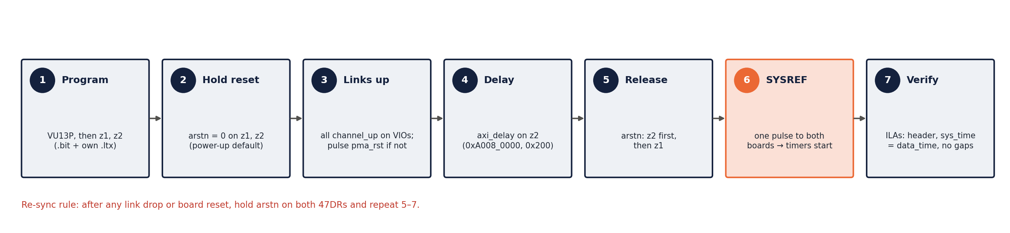
Figure 18: Bring-up sequence

16. Scripts
Script | Purpose
scripts/run_build.sh <proj> [jobs] → build.tcl | clear container caches, synth → impl → bitstream, reports in <proj>/reports/
scripts/sim_chain/run.sh, run_fifo.sh | end-to-end and FIFO-budget simulations (xsim)
scripts/naming/* | naming generator / apply / checks (§8)
scripts/check/fifo_report.tcl | read-only list of every FIFO / slice / Aurora configuration
scripts/mod*.tcl, fix*.tcl, fin*.tcl | historical BD edit passes (rev 0.1–0.8), see DESIGN_NOTES.md
scripts/docs/make_ppt.py | builds docs/pj22045_1r8t_design.pptx (template: the reference deck in ~/Downloads/serdes_selecio_axis/docs)
scripts/mod12_add_ila.tcl | debug ILAs on every link (§17)
scripts/export_xsa.tcl | XSA export (§18)
scripts/release/make_release.sh | release package (§18)
scripts/check/unused_sources.tcl, scripts/cleanup/* | list / remove sources not used by the tops (D18)
scripts/docs/make_docx.py [NAME] | builds docs/<NAME>.docx (DESIGN, SIGNAL_TRANSMISSION, TIMING_SYNC) from the markdown; embeds ![…](fig/…) figures and two deck slides
scripts/docs/make_figs.py | draws all figures into docs/fig/ (needs matplotlib)
scripts/mod13_vu13p_rstn.tcl | rev 0.12 core-1 link-reset fix (D19)

17. Debug ILAs (rev 0.11)
Every link has an ILA on its Aurora user interface, so the traffic can be followed from the z1 ADC to every z2 DAC. All are system_ila in INTERFACE (AXIS monitor) mode; resets are left open so they keep capturing while a link is down. Added by scripts/mod12_add_ila.tcl.
Board | ILA | Clock | Slots (AXIS) | Depth | Shows
z1 | system_ila_1 (top) | FPGA_clk 256 MHz | 0: axis_packetizer_0/m_axis (160 b + tuser + tlast); 1: axi_stream_combininp_adc00/m (ADC 160 b) | 1024 | ADC samples and their timestamps before the link
z1, z2 | ila_x0y1 … ila_x0y4 (container) | quad user_clk_out | 0/1: TX C0/C1 into the core (hier_tx_x0yN/M_AXIS_TX_C0/C1); 2/3: RX C0/C1 out of the core (hier_x0yN/M_AXIS_RX_C0/C1) | 2048 | 128-bit link traffic incl. header beats and tlast; z1 ADC stream = ila_x0y1 slot 1
z1, z2 | hier_rx_x0y1/rx_c0/system_ila_0 (container, kept) | quad 1 user_clk | Aurora RX → in_fifo → header_extraction (in/out) + header, err | 1024 | header decode on quad 1 core 0
z2 | hier_rx_x0yN/system_ila_0/1 (kept) | FPGA_clk | per core: data_delay in/out, FIFO out, aligner out + timestamp, sys_time, data_time, end_time | 1024 | scheduling and release of every DAC sample (§6)
z2 | system_ila_0 (top, kept) | FPGA_clk | DAC s00_axis | 1024 | one DAC input
VU13P | ila_x1y4 … ila_x1y11 (container) | quad user_clk_out | 0/1: TX C0/C1 into the core (link_x1yN/M_AXIS_TX_C0/C1); 2/3: RX C0/C1 (hier_x1yN/M_AXIS_RX_C0/C1) | 2048 | ADC stream received on ila_x1y8 slot 3; the eight outputs on ila_x1y4..7 slots 0/1
VU13P | ila_bcast (top) | axis_aclk 400 MHz | 0: broadcaster input (axis_slr_x1y8_to_tx/M_AXIS); 1–8: axis_broadcaster_0/M00..M07_AXIS | 1024 | the 1 → 8 copy; tready = 0 on an output means that link's TX FIFO is full (data lost)

The previous VU13P container ILA (system_ila_0, X1Y4 only) is replaced by ila_x1y4.
Typical checks
- z1 ila_x0y1 slot 1: first beat after tlast carries the header {ip 0, type 0, time} in bits [127:64].
- VU13P ila_x1y8 slot 3 shows the same beats; ila_bcast: all M0x tvalid follow the input, tready stays 1.
- z2 ila_x0yN slots 2/3 show the same beats again on every quad; hier_rx ILAs: sys_time = data_time when a sample leaves (§6.6).
- Trigger on tlast to align a capture to a packet start (one packet = 1280.5 beats, fits in 2048).

18. Release package (rev 0.12)
PJ22045_1R8T_release_rev0.12_20261014.tar.gz in the project root (52 MB, 1843 files, SHA256-checked), made by scripts/release/make_release.sh 0.12: VU13P bitstream from build #6 (D19), z1 / z2 from build #5, all three documents with docs/fig/. The rev 0.11 package (…rev0.11_20261014.tar.gz) is kept for reference.
Folder | Content
bitstreams/ | vu13p.bit/.ltx, z1_47dr1.bit/.ltx, z2_47dr2.bit/.ltx (load each .bit with its own .ltx)
xsa/ | z1_47dr1.xsa, z2_47dr2.xsa (write_hw_platform -fixed -include_bit)
docs/ | DESIGN, SIGNAL_TRANSMISSION, TIMING_SYNC (.md + .docx), fig/, pj22045_1r8t_design.pptx, DESIGN_NOTES_<project>.md
reports/<project>/ | timing summary, utilization, DRC, methodology, clock interaction, CDC, GT placement
source/ | <project>.xpr + <project>.srcs (+ ip_repo for the 47DR projects), scripts/ — open the .xpr and run scripts/run_build.sh <project> to rebuild
README.md, SHA256SUMS | contents, versions, results, checksums

Before packaging, the working tree was cleaned of old logs, crash dumps, superseded reports, Vivado temp folders and simulation build products; backup/ (pre-naming / pre-ILA / pre-cleanup snapshots) stays in the working tree only.

