PJ22045.0.1 1R8T — Signal Transmission and Synchronisation
Project | Folder ~/Desktop/PJ22045.0.1: 47dr1 (z1, ADC transmitter), vu13p (relay / 1 → 8 broadcaster), 47dr2 (z2, 8-DAC receiver). System document: docs/DESIGN.md (rev 0.11)
Scope | How one ADC stream travels from the z1 RFSoC to eight z2 DACs: every module on the path, its RTL behaviour, its IP configuration, the serial links, flow control, clock crossings, link start-up and recovery. The time base and the scheduled playback are described in the companion document docs/TIMING_SYNC.md
Data source | IP settings were read from the three Vivado 2025.2 block designs (read-only dump of every cell CONFIG.* and every net, 2026-10-14, all values below are copied from that dump); RTL from <project>.srcs/sources_1/imports/new and sources_1/new; Aurora user-clock frequency from 47dr2/reports/timing_summary.rpt
Revision | 1.1 (2026-10-14), matches design rev 0.12
Status | Design built and timing met on all three boards; not yet run on hardware. Rev 1.1: VU13P core-1 link-reset defect (§5.4) fixed in design rev 0.12 (D19), VU13P rebuilt

History policy: this document describes the current design. When the design changes, the text is updated and a row is added to §13 Revision history. Decisions stay in docs/DESIGN.md §13 (D-numbers are quoted here).

Contents

1. Reading guide
2. End-to-end path
3. z1 — signal source (47dr1, BD design_1)
3.1 RF Data Converter — ADC side (usp_rf_data_converter_1, v2.6)
3.2 axi_stream_combininput (module reference, sources_1/new/axi_stream_combininput.v)
3.3 axis_packetizer (module reference, imports/new/axis_packetizer.v)
3.4 Other z1 blocks on the path
4. 47DR link container (aurora_gty_47drto13p, identical on z1 and z2)
4.1 Structure
4.2 TX chain per core (hier_tx_x0yN/tx_c<n>)
4.3 header_insertion_v2 — design (160 → 128 bit with header)
4.4 RX chain per core (hier_rx_x0yN/rx_c<n>) and header_extraction_v2
4.5 Aurora 64B66B cores (aurora_64b66b 13.0) — identical on all three boards
4.6 Core 0 / core 1 sharing and reset chain inside hier_x0yN
5. VU13P relay (BD aurora_gty_vu13p_rst)
5.1 Top level
5.2 Container aurora_gty_vu13pto47dr (8 quads X1Y4 … X1Y11)
5.3 13P↔13P container (aurora_gty_vu13ptovu13p)
5.4 Fixed defect (rev 0.12, D19): core-1 link reset on the VU13P quads X1Y4 … X1Y11
6. z2 — receiver (47dr2, BD design_1)
6.1 Path per Aurora core
6.2 Link-to-DAC map
6.3 RF Data Converter — DAC side (z2, same IP configuration on z1)
6.4 Control registers (PS M_AXI_HPM0_FPD, 64 bit, pl_clk0 100 MHz via smartconnect_0)
7. Serial links
7.1 Lane map
7.2 What the link carries
8. Flow control, clock crossings, FIFO budget, throughput
8.1 Where back-pressure exists
8.2 Clock-domain crossings on the path
8.3 FIFO budget
8.4 Throughput
9. Link start-up, reset and synchronisation
9.1 Power-up sequence of one quad
9.2 Packet synchronisation
9.3 Re-synchronisation rule
10. Error behaviour
11. Debug on hardware
12. Verification
13. Revision history

(Right-click the table of contents and choose Update Field if page numbers are missing.)

1. Reading guide
- §2 gives the whole path in one table. §3–§6 follow a sample through the hardware: z1 source (§3), the 47DR link container that both 47DR boards share (§4), the VU13P relay (§5), the z2 receiver (§6).
- §7 describes the Aurora serial links, §8 flow control / clock crossings / FIFO budget / throughput, §9 link start-up, reset and synchronisation, §10 what happens when something goes wrong, §11 debug, §12 verification.
- Notation: C0 / C1 = Aurora core 0 / 1 of a quad; beat = one 128-bit Aurora word; sample word = one 160-bit RFSoC word = 5 complex samples. FPGA_clk = 256 MHz, user_clk = Aurora user clock 400.391 MHz, axis_aclk = VU13P fabric clock 400 MHz.

2. End-to-end path
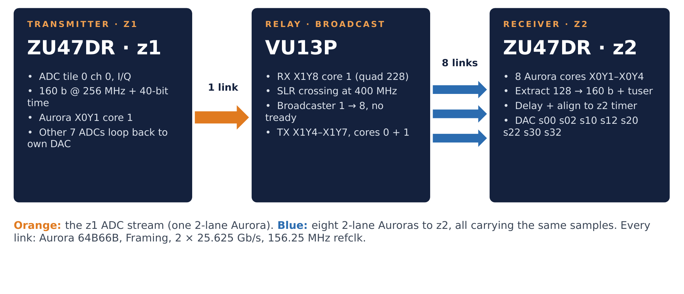
Figure 1: System overview: z1 sends one ADC stream to the VU13P, which broadcasts it on eight links to z2
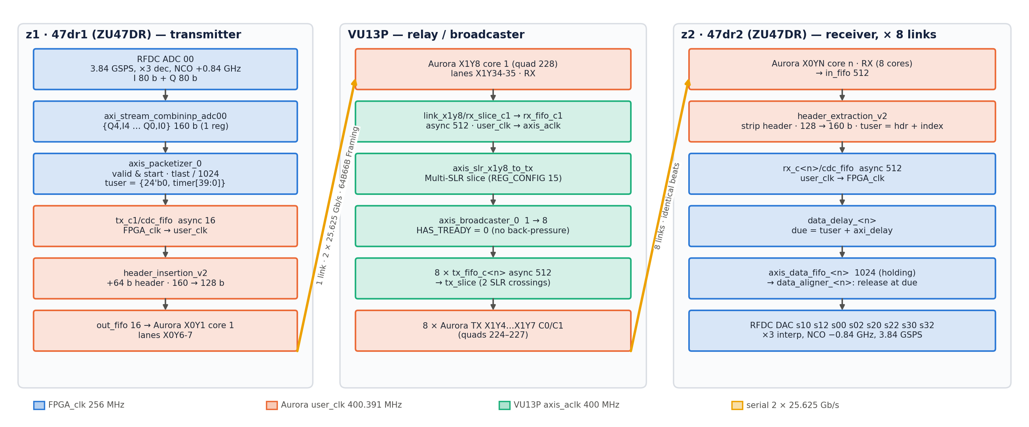
Figure 2: Every block on the path from the z1 ADC to a z2 DAC, coloured by clock domain
# | Board | Block (BD path) | Clock | Width in → out | Function
1 | z1 | usp_rf_data_converter_1 ADC tile 0 ch 0 | FPGA_clk | RF → 2 × 80 b | 3.84 GSPS, ×3 decimation, fine mixer +0.84 GHz, I and Q streams
2 | z1 | axi_stream_combininp_adc00 | FPGA_clk | 2 × 80 → 160 b | interleaves I/Q into the DAC word format
3 | z1 | axis_packetizer_0 (+ ilconcat_1 time) | FPGA_clk | 160 b + 64 b tuser | gates the stream with start, tlast every 1024 words, carries the timestamp
4 | z1 | aurora_gty_47drto13p_0/hier_tx_x0y1/tx_c1/cdc_fifo | FPGA_clk → user_clk | 160 + 64 | async FIFO, 16 deep
5 | z1 | …/tx_c1/header_insertion_v2_0 | user_clk | 160 → 128 b | inserts 64-bit header, repacks 5 words → 4 words
6 | z1 | …/tx_c1/out_fifo → hier_x0y1/aurora_x0y1_1 | user_clk | 128 b | 16-deep FIFO, Aurora TX core 1 of quad X0Y1
7 | link | GTY lanes X0Y6-7 → VU13P X1Y34-35 | — | 2 × 25.625 Gb/s | 64B66B, Framing
8 | VU13P | hier_x1y8/aurora_x1y8_1 → link_x1y8/rx_slice_c1 → rx_fifo_c1 | user_clk(228) → axis_aclk | 128 b | RX core, register slice, async FIFO 512
9 | VU13P | axis_slr_x1y8_to_tx → axis_broadcaster_0 | axis_aclk | 128 b → 8 × 128 b | SLR crossing, 1 → 8 copy, no back-pressure
10 | VU13P | link_x1yN/tx_fifo_c<n> → tx_slice_c<n> → hier_x1yN/aurora_x1yN_<n> | axis_aclk → user_clk(224–227) | 128 b | async FIFO 512, Multi-SLR slice, 8 TX cores
11 | link | VU13P X1Y16…X1Y31 → z2 X0Y4…X0Y19 | — | 8 × 2 × 25.625 Gb/s | 64B66B, Framing
12 | z2 | hier_x0yN/aurora_x0yN_<n> → hier_rx_x0yN/rx_c<n>/in_fifo | user_clk | 128 b | RX core, 512-deep FIFO
13 | z2 | …/rx_c<n>/header_extraction_v2_0 → cdc_fifo | user_clk → FPGA_clk | 128 → 160 b + 64 b tuser | strips header, repacks 4 → 5 words, rebuilds per-word time, async FIFO 512
14 | z2 | hier_rx_x0yN/data_delay_<n> → axis_data_fifo_<n> → data_aligner_<n> | FPGA_clk | 160 b | due time, 1024-deep holding FIFO, release at due time (TIMING_SYNC.md)
15 | z2 | usp_rf_data_converter_1 DAC slice | FPGA_clk | 160 b → RF | ×3 interpolation, fine mixer −0.84 GHz, 3.84 GSPS

3. z1 — signal source (47dr1, BD design_1)
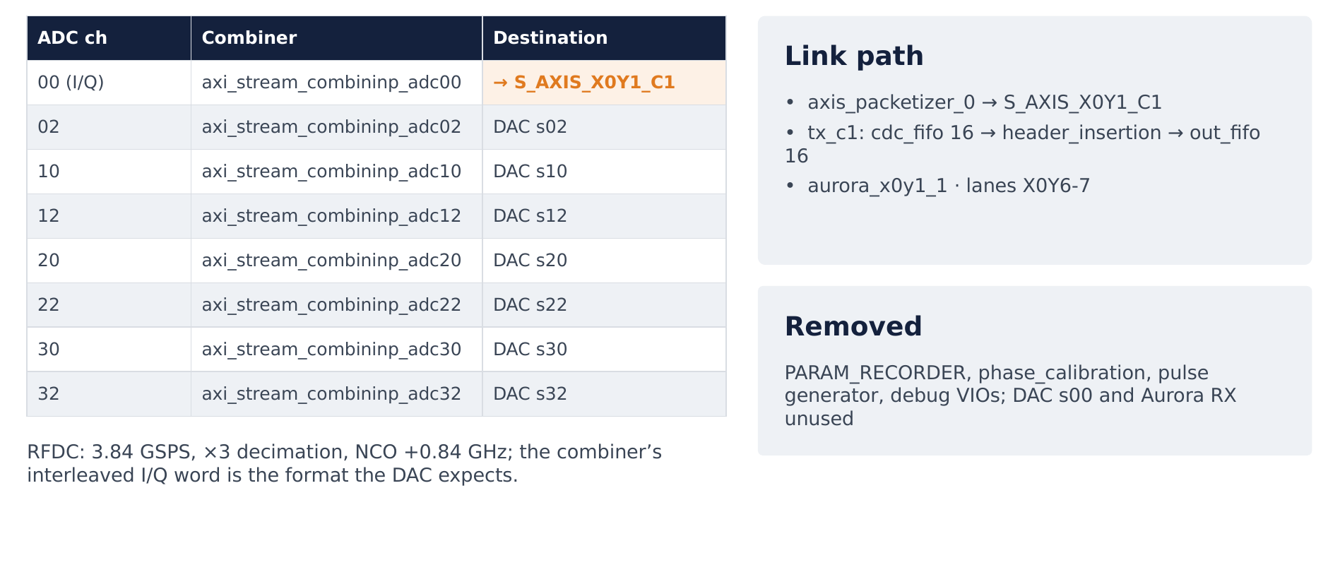
Figure 3: z1: ADC 00 goes to the link, the seven other ADC channels loop back to their DACs

3.1 RF Data Converter — ADC side (usp_rf_data_converter_1, v2.6)
All four ADC tiles and all 16 ADC slices are enabled with identical slice settings; only tile 0 slice 0/1 (m00_axis = I, m01_axis = Q of ADC 00) feeds the link. The same IP configuration is used on z2 (where the ADCs are unused).
Setting (per slice, all 16 identical) | Value | Meaning
ADC_Data_Type | 1 | I/Q output (two AXIS streams per converter: mx0 = I, mx1 = Q)
ADC_Decimation_Mode | 3 | ×3 decimation: 3.84 GSPS → 1.28 GSPS complex
ADC_Mixer_Type / ADC_NCO_Freq | 2 (fine) / +0.84 GHz | NCO down-conversion
ADC_Data_Width | 5 | 5 samples of 16 bit = 80 bit per stream per fabric clock
ADC_Nyquist | 1 | first Nyquist zone
ADC_CalOpt_Mode / ADC_Dither | 1 / false | calibration mode 1, no dither

Tile setting | ADC0 | ADC1 | ADC2 | ADC3
Sampling_Rate | 3.84 GSPS | 3.84 | 3.84 | 3.84
PLL_Enable / Refclk_Freq | off / 3840 MHz | on / 256 MHz | off / 3840 | off / 3840
Clock_Source / Clock_Dist | 1 / 0 | 1 / 2 | 1 / 0 | 1 / 0
Fabric_Freq / Outclk_Freq | 256 / 30 MHz | 256 / 30 | 256 / 30 | 256 / 30
Multi_Tile_Sync | true | true | true | true

- Tile ADC1 (adc1_clk board port) runs its PLL from a 256 MHz reference and distributes the 3.84 GHz sampling clock (Clock_Dist = 2); tiles 0, 2, 3 run without PLL on the distributed 3.84 GHz clock.
- All AXIS ports (m0..m3_axis_aclk, s0..s3_axis_aclk) are clocked by FPGA_clk (util_ds_buf_0) and reset by dac_rst1/peripheral_aresetn (PS reset synchronised to FPGA_clk). AXI-Lite at 0xA004_0000 on pl_clk0.
- Sysref_Source = 1, user_sysref_adc/dac from regs_4_sysref_0 — multi-tile sync, see TIMING_SYNC.md §4.4.

3.2 axi_stream_combininput (module reference, sources_1/new/axi_stream_combininput.v)
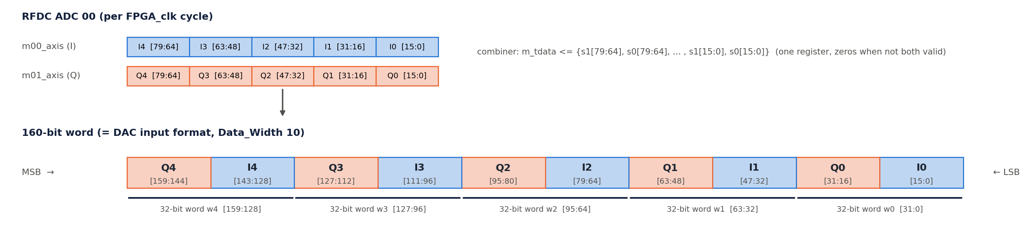
Figure 4: Combiner: RFDC I and Q streams interleaved into the 160-bit DAC word; 32-bit words as used by header_insertion
Eight instances (axi_stream_combininp_adc00 … adc32), one per ADC converter. adc00 feeds the packetizer, the other seven loop back to the same-index z1 DAC (s02_axis … s32_axis, requirement R8).
Port | Width | Connection (adc00)
s0 | 80 b | RFDC m00_axis (I0…I4)
s1 | 80 b | RFDC m01_axis (Q0…Q4)
m | 160 b | axis_packetizer_0/s_axis (+ system_ila_1 slot 1)
clk | — | FPGA_clk

Behaviour (one register stage, no reset):
- When s0_tvalid and s1_tvalid: m_tdata <= {Q4,I4,Q3,I3,Q2,I2,Q1,I1,Q0,I0} (bits [16k+15:16k]: even k = I, odd k = Q, sample 0 in the LSBs), m_tvalid <= 1. Otherwise m_tdata <= 0, m_tvalid <= 0.
- s0_tready = s1_tready = m_tready (pass-through). The RFDC ADC AXIS has no back-pressure, so the combiner never stalls; it is exactly one FPGA_clk cycle of latency.
- The 160-bit word is the RFDC DAC I/Q input format (DAC Data_Width = 10 × 16 bit, §6.4), so the same word drives a DAC unchanged on z1 (loopback) and on z2 (after the link).

3.3 axis_packetizer (module reference, imports/new/axis_packetizer.v)
Parameter | Value
DATA_WIDTH | 160
USER_WIDTH | 64
PACKET_LENGTH | 1024

Port | Connection
s_axis | combiner adc00/m; s_axis_tuser = ilconcat_1/dout = {24'b0, timer_1/timestamp[39:0]}
m_axis | container S_AXIS_X0Y1_C1 (+ system_ila_1 slot 0)
start | sync_pulse_to_level_1/level_ref (time-base start, TIMING_SYNC.md §4)
aclk / aresetn | FPGA_clk / xpm_cdc_gen_1/dest_rst_out (= axi_gpio_arstn)

Behaviour:
- Data and tuser pass straight through (combinational). m_axis_tvalid = s_axis_tvalid & start: nothing is sent before the time base starts, so the first transmitted word carries time ≈ 0.
- A 10-bit counter cnt advances on every accepted word (s_tvalid & m_tready & start) and wraps at 1023; m_axis_tlast = (cnt == 1023). One packet = 1024 sample words = 4 µs.
- s_axis_tready = m_axis_tready, but the combiner ignores tready: if the z1 TX FIFO were full, words would be lost (counted in simulation as drop_tx; never happens, §8.3).

3.4 Other z1 blocks on the path
Cell | IP / config | Role
ilconcat_1 | inline concat, NUM_PORTS 2, IN0_WIDTH 40, IN1_WIDTH 24, dout 64 | tuser = {xlconstant_0 (24'b0), timer_1/timestamp}
xlconstant_0 | CONST_VAL 0, CONST_WIDTH 24 | upper tuser bits
system_ila_1 | 2 AXIS monitor slots, depth 1024, FPGA_clk, reset irstn | slot 0 packetizer out, slot 1 combiner out
vio_data_delay | 1 output probe, 40 bit, unconnected | left-over from the EV1 design (D13 replaced it on z2); no function on z1

4. 47DR link container (aurora_gty_47drto13p, identical on z1 and z2)

4.1 Structure
One BD container, instantiated as aurora_gty_47drto13p_0 in both 47DR design_1s. Per quad X0YN (N = 1…4):
Hierarchy | Contents
hier_x0yN | aurora_x0yN_0 (core 0, owns QPLL), aurora_x0yN_1 (core 1), auto_reset_aurora, aurora_rstn_0/1, x0yN_core_status_0/1 (VIO)
hier_tx_x0yN | tx_c0, tx_c1 (cdc_fifo → header_insertion_v2_0 → out_fifo), axis_rst_sync_c0/c1
hier_rx_x0yN | rx_c0, rx_c1 (in_fifo → header_extraction_v2_0 → cdc_fifo); quad 1 core 0 also has a header ILA
ila_x0yN | system ILA, 4 AXIS slots (TX C0, TX C1, RX C0, RX C1), depth 2048, quad user_clk

Plus one ini_system_0 (pma_init generator for all quads). Container ports: S_AXIS_X0YN_C<n> (TX in), M_AXIS_X0YN_C<n> (RX out), GT_SERIAL_TX/RX_X0YN_C<n>, gt_x0yN_diff_ref, s_axis_aclk (= FPGA_clk), init_clk (100 MHz, util_ds_buf_2), ini_pma_rst (xpm_cdc_gen_0 = axi_gpio_pma_rst).
Used ports: z1 uses only S_AXIS_X0Y1_C1 (TX of the ADC stream); its RX outputs are unused. z2 uses all eight M_AXIS_X0YN_C<n>; its TX inputs are unused. All 8 links per board are built and train (R6).

4.2 TX chain per core (hier_tx_x0yN/tx_c<n>)
Cell | IP | Configuration
cdc_fifo | axis_data_fifo 2.0 | depth 16, IS_ACLK_ASYNC 1, 20 bytes tdata, TUSER_WIDTH 64, tlast yes, tkeep no, sync stages 3, memory auto, packet mode off
header_insertion_v2_0 | module ref | WORD_WIDTH 32, DIN_WORDS 5, DOUT_WORDS 4, IP_WIDTH 16, TYPE_WIDTH 8, TIME_WIDTH 40, USER_WIDTH 64, BUFF_DEPTH 4
out_fifo | axis_data_fifo 2.0 | depth 16, synchronous (user_clk), 16 bytes, tlast + tkeep, no tuser

Clocks / resets: cdc_fifo write side FPGA_clk with axis_rst_sync_c<n> (xpm_cdc_async_rst, 4 stages, link reset into FPGA_clk); read side, header_insertion and out_fifo on the quad user_clk with arstn_c<n> (link reset).

4.3 header_insertion_v2 — design (160 → 128 bit with header)
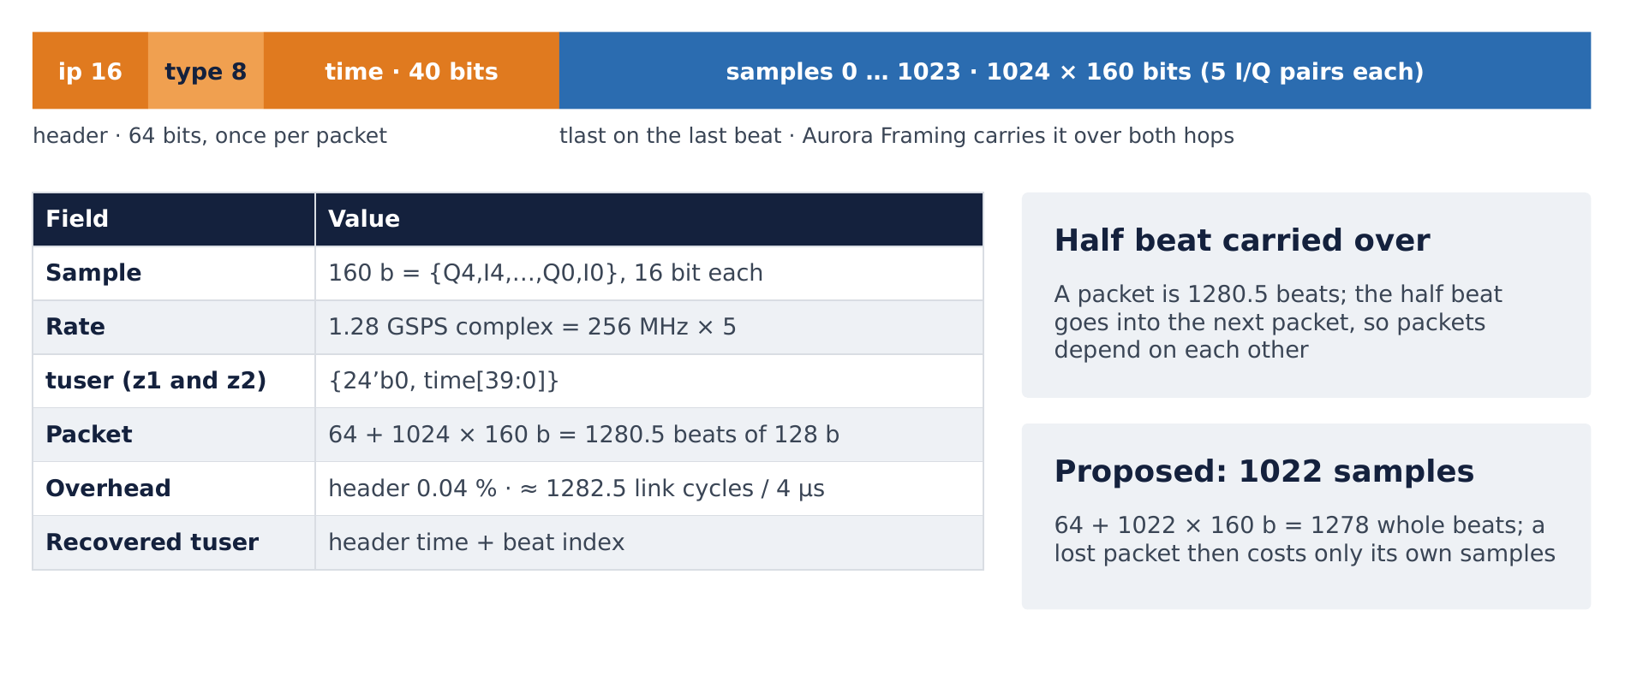
Figure 5: Packet format: 64-bit header with the 40-bit time, then 1024 samples of 160 bits on 128-bit beats
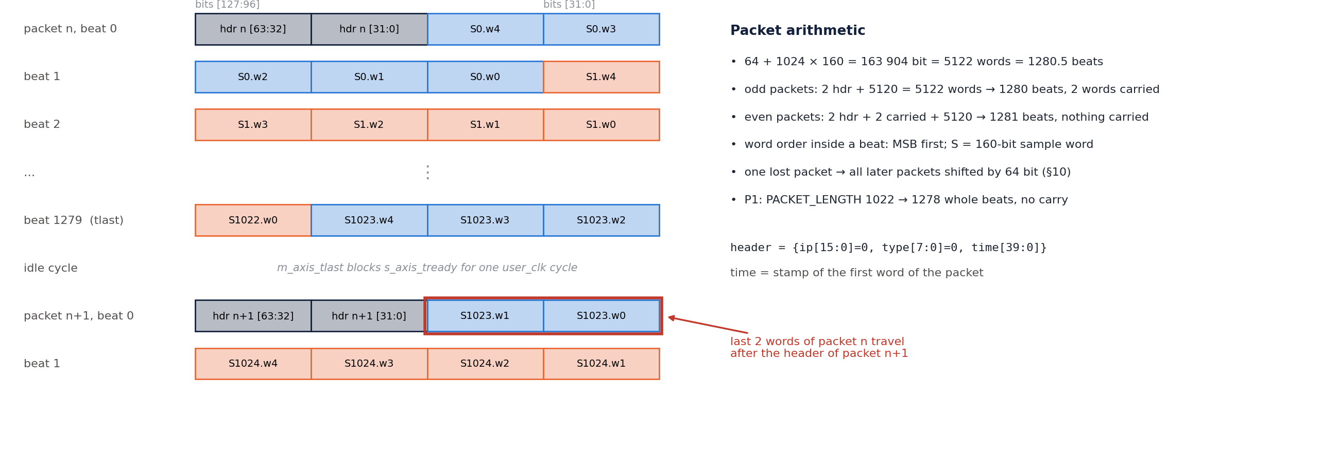
Figure 6: header_insertion_v2 beat layout: header, word order and the 2 words carried into the next packet
The module is a 32-bit-word shift register of BUFF_DEPTH × DIN_WORDS = 20 words (640 bits) with a fill counter data_rem (0…20). Words enter at the top (MSB) side and leave as 4-word beats from the top.
Signal | Rule
s_axis_tready | data_rem ≤ 15 and not m_axis_tlast (one-cycle stall after each packet end)
in_words | 5 per accepted sample word; 7 for the first word of a packet (sof): 2 header words + 5 data words
out_words | 4 if data_rem + in_words ≥ 4 and not m_axis_tlast, else 0
header | {ip[15:0], type[7:0], time[39:0]} = the packet's first s_axis_tuser (ip = type = 0 here); placed in the top 64 bits of the register, ahead of all remaining data
m_axis_tdata | top 128 bits of the register (word order MSB-first: header, then sample words, each sample word [159:128] first)
m_axis_tvalid | registered: 1 when a beat is formed, held while !m_axis_tready
m_axis_tlast | registered copy of the accepted input tlast; held until the beat is accepted
m_axis_tkeep | ~(0xFFFF >> (out_words × 4)) = 0xFFFF for every full beat
sof | 1 after reset and after each accepted tlast; cleared by the next accepted word

Packet arithmetic: 64 + 1024 × 160 = 163 904 bits = 5122 words = 1280.5 beats. When the last sample word of a packet is accepted, 2 words (half a beat) stay in the register. At the next sof the register is shifted down by 64 bits and the new header is written on top, so the next packet's first beat is {header(n+1) [127:64], last 2 words of packet n [63:0]}. Consequences:
- Packets alternate between 1280 beats (2 words carried) and 1281 beats (no carry): odd packets 2 + 5120 = 5122 words, even packets 2 + 2 + 5120 = 5124 words.
- The stream of sample words is continuous across packets — the carried words are delivered in order — but the 64-bit alignment of every packet depends on the previous one (lost-packet effect, §10).
- After every packet the module inserts one idle cycle (m_axis_tlast blocks tready), so a packet occupies ≈ 1281.5–1282.5 user_clk cycles (§8.4).

4.4 RX chain per core (hier_rx_x0yN/rx_c<n>) and header_extraction_v2
Cell | IP | Configuration
in_fifo | axis_data_fifo 2.0 | depth 512, synchronous (user_clk), 16 bytes, tlast + tkeep, no tuser
header_extraction_v2_0 | module ref | WORD_WIDTH 32, DIN_WORDS 4, DOUT_WORDS 5, USER_WIDTH 64, TIME_WIDTH 40, BUFF_DEPTH 3
cdc_fifo | axis_data_fifo 2.0 | depth 512, IS_ACLK_ASYNC 1, 20 bytes, TUSER_WIDTH 64, tlast + tkeep, sync stages 3
system_ila_0 (hier_rx_x0y1/rx_c0 only) | system ILA | 3 AXIS slots (RX in, in_fifo out, extraction out) + probes header[63:0], err, depth 1024

header_extraction_v2 is the inverse of §4.3 with a 12-word register:
- sof = first beat after an accepted tlast (and after reset). On that beat the top 64 bits are the header: header_valid = 1, header = s_axis_tdata[127:64], and only the lower 2 words (in_words = 2) enter the register. Other beats add 4 words.
- A 160-bit word is output whenever ≥ 5 words are buffered. s_axis_tready = (data_rem ≤ 8) & !tlast_r (one idle cycle after each packet end).
- Timestamp rebuild: m_axis_tuser is loaded with the header on the sof beat and incremented on every output handshake → every sample word gets back the z1 time it was stamped with (details and the one-count step after the first packet: TIMING_SYNC.md §7).
- m_axis_tlast = registered input tlast (marks the word output in the cycle the last beat arrived).
- err = (w0 != w0 ^ w1 ^ w2 ^ w3 ^ w4[22:0]) on the output word, i.e. err = 1 whenever w1^w2^w3^w4[22:0] ≠ 0. This is a test-pattern check from the original design; for ADC data it is almost always 1 and carries no meaning. (It also only uses 23 bits of word 4: m_axis_tdata[150:128].)
- cdc_fifo (512) carries data + 64-bit tuser + tlast from user_clk to FPGA_clk. Its read side (z2 hier_rx) never back-pressures (data_delay.s_axis_tready = 1).

4.5 Aurora 64B66B cores (aurora_64b66b 13.0) — identical on all three boards
All 72 core instances in the three projects (16 on z1, 16 on z2, 40 on the VU13P incl. the 13P↔13P link) were compared: every setting below is the same; only the start lane / quad / refclk source differ.
Setting | Value
C_LINE_RATE | 25.625 Gb/s per lane
C_AURORA_LANES | 2
interface_mode | Framing (AXIS with tlast / tkeep)
flow_mode | None (no native / user flow control)
dataflow_config | Duplex
crc_mode | false (no CRC)
C_REFCLK_FREQUENCY / source | 156.25 MHz / MGTREFCLK0_of_Quad_<quad>
C_PLL_TYPE (GT_SETTINGS TX/RX_PLL_TYPE) | LCPLL (QPLL)
C_INIT_CLK / DRP_FREQ | 100 MHz / 100 MHz
SupportLevel | 1 on core 0 (shared logic in core: QPLL, clocking, user_clk_out); 0 on core 1 (uses core 0's)
RX equalisation | RX_EQ_MODE AUTO, INS_LOSS_NYQ 20 dB, RX_COUPLING AC, RX_TERMINATION PROGRAMMABLE 800 mV, RX_PPM_OFFSET 0, RX_SSC_PPM 0
C_USE_BYTESWAP, C_USER_K, C_DOCCPORT_ENABLE, TransceiverControl, drp_mode | false / false / false / false / Disabled
C_INT_DEBUG | true
SINGLEEND_INITCLK | true (init_clk from a fabric buffer)

User clock: TXOUTCLK-derived 400.391 MHz (= 25.625 Gb/s / 64, timing report). The 128-bit user interface (2 lanes × 64 bit) pauses 1 cycle in 33 for the 64b/66b gearbox, so the payload rate is 400.391 × 32/33 × 128 = 49.69 Gb/s per link before clock compensation.

4.6 Core 0 / core 1 sharing and reset chain inside hier_x0yN
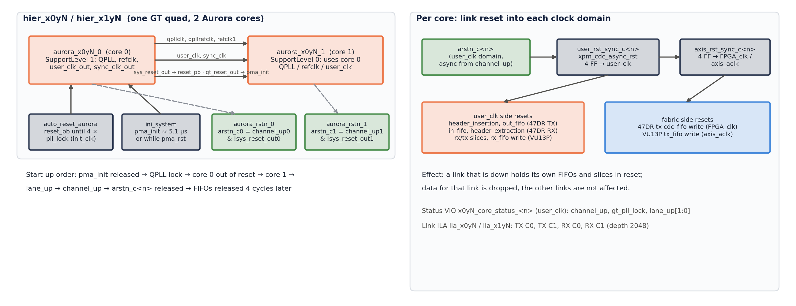
Figure 7: Inside one quad: core 0 / core 1 sharing, reset helpers and the per-core link reset into each clock domain
Core 1 pin | Driven by | Purpose
gt_qpllclk_quad1_in, gt_qpllrefclk_quad1_in, refclk1_in | core 0 gt_qpll*_out, gt_refclk1_out | shared QPLL and refclk
user_clk, sync_clk | core 0 user_clk_out, sync_clk_out | same user clock for both cores (one user_clk per quad)
reset_pb | core 0 sys_reset_out | core 1 leaves reset after core 0
pma_init | core 0 gt_reset_out | —

Core 0 pin | Driven by
reset_pb | auto_reset_aurora (held 1 until gt_pll_lock is high for 4 init_clk cycles)
pma_init | container ini_system_0/ini_pma
init_clk | 100 MHz init_clk

Reset helper RTL (identical on the three boards):
Module | Behaviour
auto_reset_aurora | 4-flop shift of pll_lock on init_clk; reset_pb = 0 only when all 4 are 1 (initial value 1)
ini_system | 9-bit saturating counter on init_clk from configuration; ini_pma = 1 while i_pma_rst = 1 or cnt[7:0] ≠ 0xFF. Result: pma_init high for the first 255 cycles (2.55 µs), one cycle low at cnt = 255, high again until cnt = 511, then low (released) for good. The one-cycle release at 255 is harmless (the GT ignores sub-µs pma_init pulses) but is a quirk of the original RTL
aurora_rstn | arstn = !system_rst & channel_up (combinational): a core's link reset is released only while its channel is up
xpm_cdc_gen (axis_rst_sync_c<n>, user_rst_sync_c<n>) | xpm_cdc_async_rst, DEST_SYNC_FF 4, active-low: brings arstn_c<n> into FPGA_clk / axis_aclk (assert async, release sync)

Status VIOs x0yN_core_status_0/1 (3 inputs each, on the quad user_clk): channel_up, gt_pll_lock, lane_up[1:0].

5. VU13P relay (BD aurora_gty_vu13p_rst)
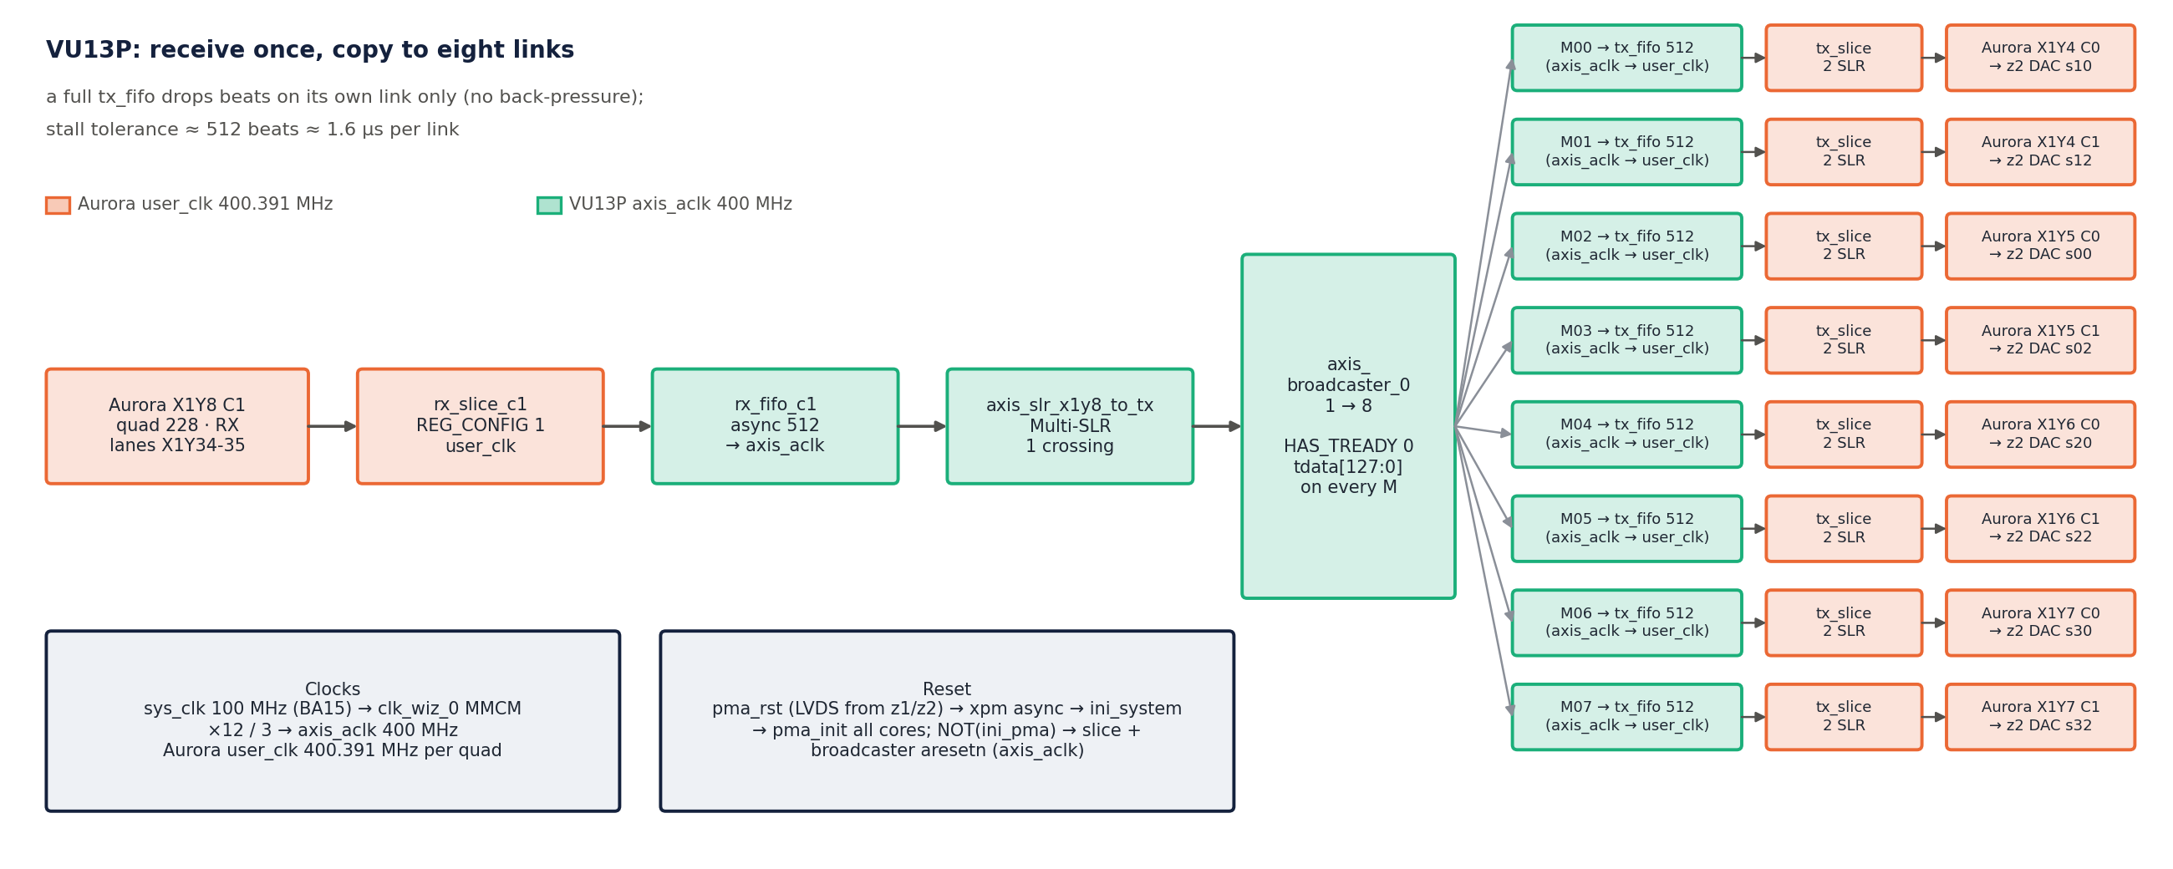
Figure 8: VU13P relay: X1Y8 core 1 → SLR slice → broadcaster → eight TX FIFOs, slices and cores

5.1 Top level
Cell | IP / config | Connections
util_ds_buf_0 | IBUFDS | sys_clk 100 MHz (BA15) → init_clk of both containers, clk_wiz_0, hier_rst
clk_wiz_0 | clk_wiz 6.0, MMCM, in 100 MHz, CLKFBOUT_MULT_F 12, CLKOUT0_DIVIDE_F 3 → `clk_out1` 400 MHz (jitter 90 ps), no reset / locked pins | s_axis_aclk = axis_aclk of both containers, slice, broadcaster, ila_bcast
util_ds_buf_1 | IBUFDS | board pma_rst LVDS input (AU16/AV16, driven by z1/z2 PMA_RST)
xpm_cdc_gen_1 | xpm_cdc_async_rst, 4 stages, dest sys_clk | pma_rst → hier_rst/i_pma_rst
hier_rst/ini_system_0 | ini_system (§4.6) | ini_pma → ini_pma_rst of both containers
xpm_cdc_gen_0 + util_vector_logic_0 (NOT) | async reset sync into axis_aclk, then inverted | aresetn of axis_slr_x1y8_to_tx and axis_broadcaster_0 = !ini_pma
axis_slr_x1y8_to_tx | axis_register_slice 1.1, REG_CONFIG 15 (Multi-SLR crossing), NUM_SLR_CROSSINGS 1, pipelines master 1 / slave 1 / middle 0, 16 bytes, tlast + tkeep | container M_AXIS_X1Y8_C1 → broadcaster S_AXIS (D11: quad 228 and quads 224–227 are in different SLRs)
axis_broadcaster_0 | axis_broadcaster 1.1, NUM_MI 8, `HAS_TREADY 0`, tlast + tkeep, M0x_TDATA_REMAP tdata[127:0], M0x_TUSER_REMAP 1'b0 | M00…M07_AXIS → container S_AXIS_X1Y4_C0, X1Y4_C1, X1Y5_C0 … X1Y7_C1
ila_bcast | system ILA, 9 AXIS slots, depth 1024, axis_aclk | slot 0 broadcaster input, slots 1–8 outputs

Broadcaster without tready (D12): every output gets every beat in the same cycle; a full TX FIFO on one link drops that link's beats only, the other seven continue.

5.2 Container aurora_gty_vu13pto47dr (8 quads X1Y4 … X1Y11)
Per quad: hier_x1yN (2 Aurora cores, auto_reset_aurora, aurora_rstn_0/1, status VIOs — same as §4.6), link_x1yN (identical plumbing for all eight quads, D9) and ila_x1yN (4 slots, depth 2048, quad user_clk).
Cell in link_x1yN (per core n) | IP | Configuration
rx_slice_c<n> | axis_register_slice 1.1 | REG_CONFIG 1, no SLR crossing, 16 bytes, tlast + tkeep, user_clk
rx_fifo_c<n> | axis_data_fifo 2.0 | depth 512, async (user_clk → axis_aclk), 16 bytes, tlast + tkeep, no tuser
tx_fifo_c<n> | axis_data_fifo 2.0 | depth 512, async (axis_aclk → user_clk), 16 bytes, tlast, no tkeep, tuser 64 (unused)
tx_slice_c<n> | axis_register_slice 1.1 | REG_CONFIG 15 Multi-SLR crossing, NUM_SLR_CROSSINGS 2, pipelines 1/1/1, 16 bytes, tlast, user_clk
user_rst_sync_c<n> | xpm_cdc_async_rst, 4 stages | arstn_c<n> → user_clk (slices, rx_fifo write side)
axis_rst_sync_c<n> | xpm_cdc_async_rst, 4 stages | user_rst_sync output → axis_aclk (tx_fifo write side)

Used: M_AXIS_X1Y8_C1 (ADC stream in) and S_AXIS_X1Y4_C0 … S_AXIS_X1Y7_C1 (eight outputs). The quads X1Y9–X1Y11 and X1Y8 C0 are trained links with no data (they pair with z1 X0Y2–X0Y4 and X0Y1 C0).

5.3 13P↔13P container (aurora_gty_vu13ptovu13p)
Quads X0Y11 and X0Y13 (2 cores each, same Aurora settings, link FIFOs 512, register slices), kept unchanged from the EV1 design. Not part of the 1R8T path.

5.4 Fixed defect (rev 0.12, D19): core-1 link reset on the VU13P quads X1Y4 … X1Y11
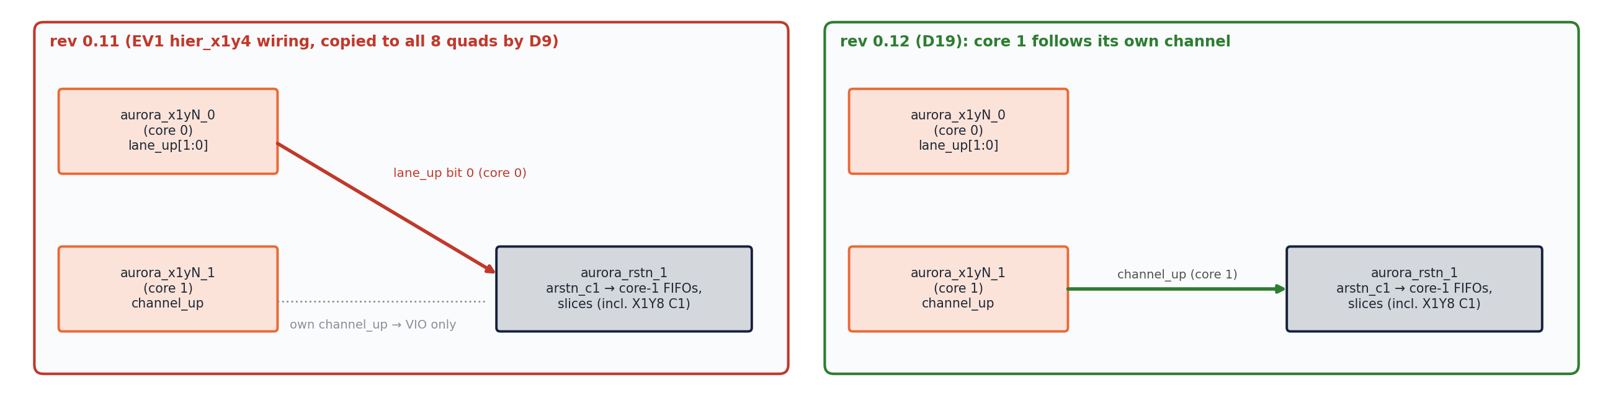
Figure 9: Core-1 link reset on the VU13P quads before (rev 0.11) and after (rev 0.12) the fix
Up to rev 0.11, in every hier_x1yN of aurora_gty_vu13pto47dr, aurora_rstn_1/channel_up was driven by the net `aurora_x1yN_0_lane_up` (core 0's 2-bit lane_up, bit 0 used) instead of aurora_x1yN_1_channel_up. system_rst is correct (aurora_x1yN_1_sys_reset_out). The 4 cores of the 13P↔13P container and all 16 cores of the 47DR containers are wired correctly (checked: 28 of 36 aurora_rstn correct, these 8 wrong).
- Origin: the EV1 source design had this wiring on hier_x1y4 only (X1Y8 was correct). Rev 0.5 copied the X1Y4 plumbing to all quads (D9), so it now also affects X1Y8 core 1, the ADC-stream receiver, and the four broadcaster outputs on core 1 (M01, M03, M05, M07 → z2 DACs s12, s02, s22, s32).
- Effect: the core-1 FIFOs and slices of a quad are released when core 0 lane 0 is up, not when core 1's channel is up. In normal operation both cores train together and nothing is visible. If core 1 drops while core 0 stays up, its FIFOs are not flushed (stale or partial packets continue into the broadcaster); if core 0 is down, the ADC stream on core 1 is held in reset although core 1 is up.
- Fix (rev 0.12, `scripts/mod13_vu13p_rstn.tcl`): aurora_rstn_1/channel_up now on net aurora_x1yN_1_channel_up (with aurora_x1yN_1/channel_up and the status VIO) in all eight hier_x1yN; BD validated; VU13P rebuilt. Backup of the old BDs: backup/pre_rstn_fix_20261014.tgz. All 36 aurora_rstn in the three projects now follow their own core.

6. z2 — receiver (47dr2, BD design_1)
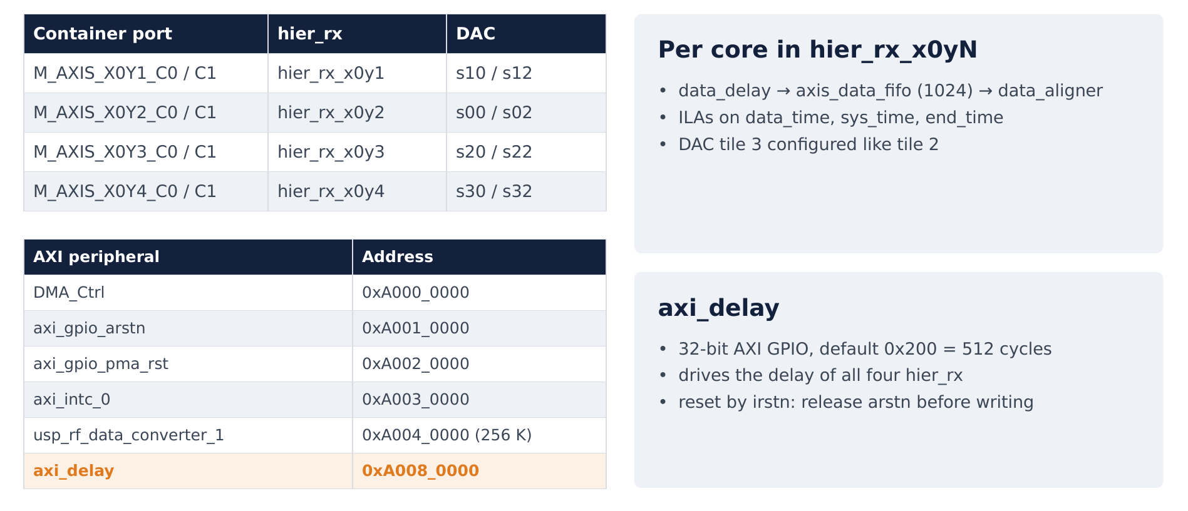
Figure 10: z2: eight links, eight hier_rx paths, eight DACs

6.1 Path per Aurora core
Container M_AXIS_X0YN_C<n> (§4.4: in_fifo 512 → header_extraction_v2 → cdc_fifo 512) → hier_rx_x0yN:
Cell (per core n) | IP | Configuration
data_delay_<n> | module ref data_delay.v | DATA_WIDTH 160, USER_DATA_WIDTH 64, TIME_WIDTH 40; delay = axi_delay (32 bit)
axis_data_fifo_<n> | axis_data_fifo 2.0 | depth 1024, synchronous FPGA_clk, 20 bytes, TUSER_WIDTH 64, no tlast, no tkeep, memory auto
data_aligner_<n> | module ref data_aligner.v | DATA_WIDTH 160, USER_DATA_WIDTH 64, TIME_WIDTH 40; timestamp = z2 timer_1
system_ila_<n> | system ILA | 4 AXIS slots (delay in, delay out, FIFO out, aligner out) + probes timestamp[39:0], sys_time[40:0], data_time[40:0], end_time[39:0]; depth 1024, FPGA_clk

Clock FPGA_clk, reset xpm_cdc_gen_1/dest_rst_out (= axi_gpio_arstn). The design of data_delay and data_aligner is in TIMING_SYNC.md §8. data_aligner ignores m_axis_tready (the RFDC DAC is always ready) and outputs zeros while no sample is due.

6.2 Link-to-DAC map
Container port | hier_rx | RFDC input | DAC (tile, ch) | Board port
M_AXIS_X0Y1_C0 / _C1 | hier_rx_x0y1 | s10_axis / s12_axis | 1.0 / 1.2 | vout10 / vout12
M_AXIS_X0Y2_C0 / _C1 | hier_rx_x0y2 | s00_axis / s02_axis | 0.0 / 0.2 | vout00 / vout02
M_AXIS_X0Y3_C0 / _C1 | hier_rx_x0y3 | s20_axis / s22_axis | 2.0 / 2.2 | vout20 / vout22
M_AXIS_X0Y4_C0 / _C1 | hier_rx_x0y4 | s30_axis / s32_axis | 3.0 / 3.2 | vout30 / vout32

system_ila_0 (top) monitors s00_axis (DAC 0.0).

6.3 RF Data Converter — DAC side (z2, same IP configuration on z1)
Setting (per enabled slice: 00, 02, 10, 12, 20, 22, 30, 32) | Value
DAC_Data_Type | 0
DAC_Interpolation_Mode | 3 (×3: 1.28 GSPS complex → 3.84 GSPS)
DAC_Data_Width | 10 (10 × 16 bit = 160-bit word, I/Q interleaved = the combiner format)
DAC_Mixer_Type / DAC_NCO_Freq | 2 (fine) / −0.84 GHz
DAC_Nyquist / DAC_Invsinc_Ctrl / DAC_Decoder_Mode | 1 / true (inverse-sinc on) / 0

Tile setting | DAC0 | DAC1 | DAC2 | DAC3
Sampling_Rate | 3.84 GSPS | 3.84 | 3.84 | 3.84
PLL_Enable / Refclk_Freq | on / 256 MHz | on / 256 | on / 256 | on / 256
Clock_Source / Clock_Dist | 4 / 1 | 4 / 0 | 4 / 0 | 4 / 0
Fabric_Freq / Outclk_Freq | 256 / 240 MHz | 256 / 240 | 256 / 240 | 256 / 240
VOP (output current) | 32 mA | 32 | 32 | 32
Multi_Tile_Sync | true | true | true | true

DAC tile 0 takes the 256 MHz reference from the dac0_clk board port and distributes it (Clock_Dist = 1); each tile runs its own PLL to 3.84 GHz.

6.4 Control registers (PS M_AXI_HPM0_FPD, 64 bit, pl_clk0 100 MHz via smartconnect_0)
Peripheral | Address | Configuration | Function
axi_gpio_arstn | 0xA001_0000 | 1 bit, all outputs, default 0 | arstn → xpm_cdc_gen_1 (xpm_cdc_sync_rst, 4 stages) → FPGA_clk reset of timer, packetizer (z1), hier_rx (z2)
axi_gpio_pma_rst | 0xA002_0000 | 1 bit, all outputs, default 0 | → xpm_cdc_gen_0 (sync to init_clk) → container ini_pma_rst and util_ds_buf_1 OBUFDS PMA_RST (to the VU13P)
axi_delay (z2 only) | 0xA008_0000 | 32 bit, all outputs, default 0x0000_0200 | delay of all eight data_delay
RFDC | 0xA004_0000 (256 K) | — | converter control, MTS
axi_intc_0 | 0xA003_0000 | 1 level interrupt (RFDC irq) | —
DMA_Ctrl | 0xA000_0000 | axi_lite_interface + status_reg | EV1 MTS / capture control (hier_mts), not on the data path

7. Serial links

7.1 Lane map
z1 quad · lanes (C0 / C1) | VU13P quad · lanes (C0 / C1) | z2 quad · lanes (C0 / C1) | Data
X0Y1 · X0Y4-5 / X0Y6-7 | X1Y8 (228) · X1Y32-33 / X1Y34-35 | — | ADC stream on C1
X0Y2 · X0Y8-9 / X0Y10-11 | X1Y9 (229) · X1Y36-37 / X1Y38-39 | — | none
X0Y3 · X0Y12-13 / X0Y14-15 | X1Y10 (230) · X1Y40-41 / X1Y42-43 | — | none
X0Y4 · X0Y16-17 / X0Y18-19 | X1Y11 (231) · X1Y44-45 / X1Y46-47 | — | none
— | X1Y4 (224) · X1Y16-17 / X1Y18-19 | X0Y1 · X0Y4-5 / X0Y6-7 | broadcaster M00 / M01
— | X1Y5 (225) · X1Y20-21 / X1Y22-23 | X0Y2 · X0Y8-9 / X0Y10-11 | M02 / M03
— | X1Y6 (226) · X1Y24-25 / X1Y26-27 | X0Y3 · X0Y12-13 / X0Y14-15 | M04 / M05
— | X1Y7 (227) · X1Y28-29 / X1Y30-31 | X0Y4 · X0Y16-17 / X0Y18-19 | M06 / M07

Reference clocks 156.25 MHz on MGTREFCLK0 of each quad (pins in DESIGN.md §3). GT serial pins are placed by the Aurora IP location constraint. Lane pairing C0 ↔ C0 / C1 ↔ C1 across boards is assumed straight; the IBERT golden projects confirm the quad pairing only.

7.2 What the link carries
- Aurora Framing: each AXIS frame (tlast) becomes one Aurora frame. With 2 lanes the 128-bit beat is striped over the two lanes; frames are separated by control blocks (one separator per frame), clock compensation is inserted by the core (3 cycles in 5000 assumed in the FIFO model).
- There is no CRC and no retransmission: a corrupted block is delivered as received; a frame lost to a lane error is simply missing at the receiver (§10).
- Only the ADC stream link (z1 X0Y1 C1 → VU13P X1Y8 C1) and the eight VU13P → z2 links carry data. All other cores train and stay idle (their status is visible on the VIOs).

8. Flow control, clock crossings, FIFO budget, throughput

8.1 Where back-pressure exists
Point | tready honoured? | Protection
RFDC ADC → combiner → packetizer | no (RFDC has no ready) | z1 tx_c1/cdc_fifo (16) drains at user_clk with 17 % link headroom
header_insertion ↔ out_fifo ↔ Aurora TX (z1) | yes | Aurora TX pauses (gearbox, CC, separator) back-pressure into out_fifo (16)
Aurora RX (VU13P, z2) | no (Aurora has no RX ready) | VU13P rx_fifo (512); z2 in_fifo (512)
VU13P broadcaster | no (HAS_TREADY 0, D12) | tx_fifo_c<n> (512) per link
VU13P tx_fifo → slice → Aurora TX | yes | —
z2 header_extraction | yes (to in_fifo / cdc_fifo) | —
z2 data_delay | no (s_axis_tready = 1) | holding FIFO (1024) + the delay range (TIMING_SYNC.md §9)
z2 aligner → DAC | no (m_axis_tready ignored) | DAC is always ready

8.2 Clock-domain crossings on the path
Crossing | Method
z1 FPGA_clk → z1 user_clk (X0Y1) | tx_c1/cdc_fifo, async axis_data_fifo 16, 3 sync stages
VU13P user_clk (228) → axis_aclk | link_x1y8/rx_fifo_c1, async 512
VU13P axis_aclk → user_clk (224–227) | link_x1yN/tx_fifo_c<n>, async 512
z2 user_clk (X0Y1…X0Y4) → FPGA_clk | rx_c<n>/cdc_fifo, async 512
link reset (channel_up) → FIFO / slice domains | xpm_cdc_async_rst, 4 stages
arstn, pma_rst GPIO (pl_clk0) → FPGA_clk / init_clk | xpm_cdc_sync_rst, 4 stages
Aurora TX out clocks vs board clocks | set_clock_groups -asynchronous (XDC)

The VU13P clocks (sys_clk, 400 MHz axis_aclk) have no relation to z1/z2: every crossing is a FIFO with headroom.

8.3 FIFO budget
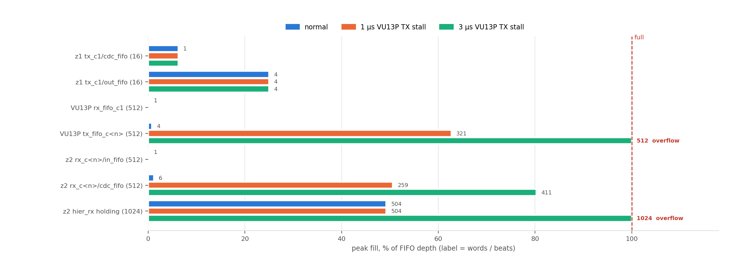
Figure 11: FIFO budget: peak fill of every FIFO, normal and with 1 µs / 3 µs VU13P TX stalls (simulation)
Simulated with the real RTL, the real FIFO depths, an Aurora TX model (gearbox pause 1 in 33, clock compensation 3 in 5000, one separator per frame), three independent user clocks and the 400 MHz VU13P clock (scripts/sim_chain/run_fifo.sh, Vivado simset sim_fifo in 47dr2.xpr):
FIFO | Depth | Peak fill, normal | 1 µs VU13P TX stall | 3 µs stall
z1 tx_c1/cdc_fifo | 16 | 1 | 1 | 1
z1 tx_c1/out_fifo | 16 | 4 | 4 | 4
VU13P rx_fifo_c1 | 512 | 1 | 1 | 1
VU13P tx_fifo_c<n> | 512 | 4 | 321 | 512 — overflow, 450 beats lost
z2 rx_c<n>/in_fifo | 512 | 1 | 1 | 1
z2 rx_c<n>/cdc_fifo | 512 | 6 | 259 | 411
z2 hier_rx holding FIFO | 1024 | 504 (= delay − transport) | 504 | 1024 (overflow)

No loss in normal operation and with a 1 µs stall of one VU13P TX link; stall tolerance ≈ 512 beats ≈ 1.6 µs.

8.4 Throughput
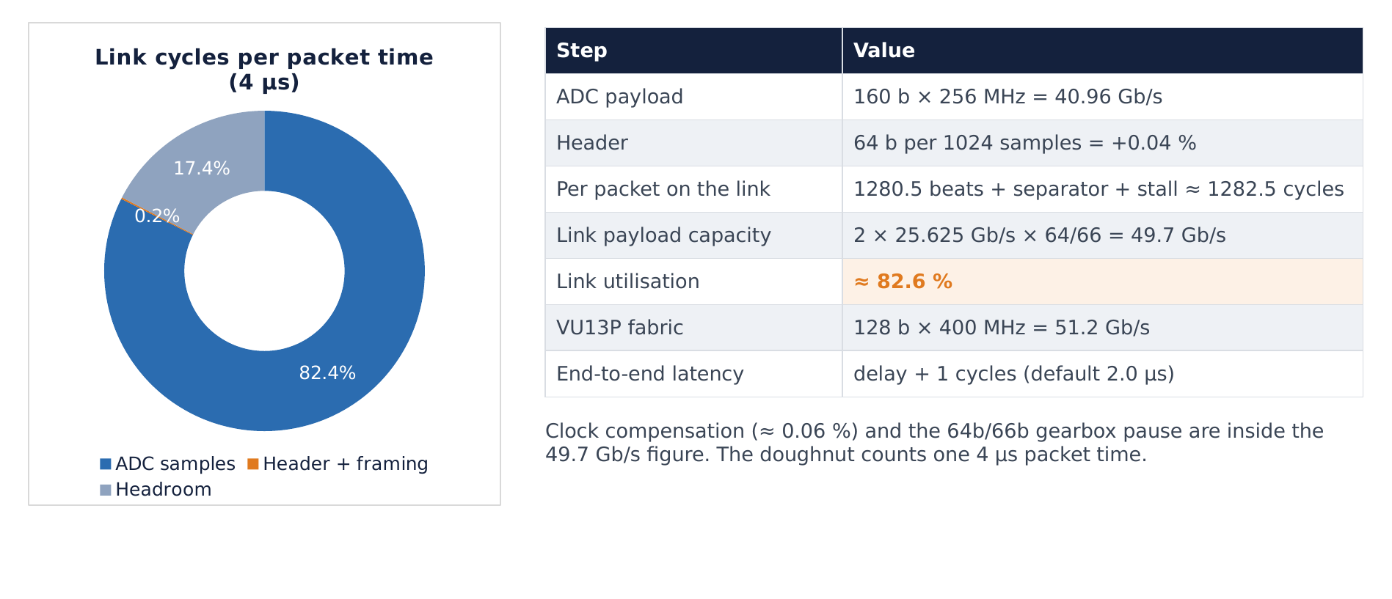
Figure 12: Link load per 4 µs packet time: 82.6 % samples, 0.2 % header and framing, 17 % headroom
Quantity | Value
ADC payload | 160 b × 256 MHz = 40.96 Gb/s (1.28 GSPS complex, 16-bit I/Q)
Header | 64 b per 1024 words = +0.04 %
Link beats per 4 µs packet | 1280.5 data + 1 separator + 1 insertion stall ≈ 1282.5
Link capacity per 4 µs | 400.391 MHz × 32/33 × 4 µs ≈ 1553 beats (49.69 Gb/s), minus ≈ 0.06 % clock compensation
Link utilisation | ≈ 82.6 % (17 % headroom)
VU13P fabric | 128 b × 400 MHz = 51.2 Gb/s (> link rate, rx_fifo never fills)

9. Link start-up, reset and synchronisation

9.1 Power-up sequence of one quad
- ini_system holds pma_init of core 0 high for ≈ 5.1 µs after configuration (511 init_clk cycles), or as long as pma_rst / axi_gpio_pma_rst is 1.
- Core 0 brings up the QPLL; auto_reset_aurora releases core 0 reset_pb 4 init_clk cycles after gt_pll_lock.
- Core 1 follows: its reset_pb is core 0 sys_reset_out, its pma_init is core 0 gt_reset_out.
- Each core trains lane alignment and channel bonding with its partner on the other board; lane_up[1:0] then channel_up go high (VIOs).
- aurora_rstn releases the core's link reset arstn_c<n> = channel_up & !sys_reset_out (VU13P core 1 since rev 0.12, §5.4); the xpm_cdc_async_rst stages release the FIFOs and slices in the fabric clock domain 4 cycles later.
The VU13P additionally holds the slice and broadcaster in reset while its own ini_pma is 1.

9.2 Packet synchronisation
There is no training pattern or sequence number on the data path. Synchronisation to the packet structure comes from:
- tlast carried by Aurora Framing end-to-end (z1 → VU13P → z2 unchanged);
- sof in header_extraction_v2 = 1 after reset and after every tlast → the first beat after reset (or after a tlast) is taken as a header.
So the receiver is synchronised only if its first received beat after reset is the first beat of a packet. The normal start order guarantees that: z2 and the VU13P links are up and idle before z1 starts sending (z1 sends nothing until the time base starts, §3.3; the start procedure is in TIMING_SYNC.md §5).

9.3 Re-synchronisation rule
After any link drop, link reset or board reset while data is flowing: hold arstn low on z1 and z2, wait for all channel_up, then restart the time base (TIMING_SYNC.md §5). A link that comes up in the middle of a packet interprets a data beat as a header and stays misaligned (§10).

10. Error behaviour
Event | What happens on the data path | Recovery
One packet lost on a link (lane error, link drop) | the 2 words carried across packets (§4.3) are missing → every later packet on that link is shifted by 64 bits → wrong samples and wrong times on that output until reset | restart (§9.3). Proposal P1: PACKET_LENGTH = 1022 (64 + 1022 × 160 = 1278 whole beats, no carry) — simulated: a lost packet then only blanks its own 4 µs
≥ 2 packets lost | time jump > delay + 1024 → data_delay guard freezes the due time (TIMING_SYNC.md §8.1) | restart
z2 link comes up mid-stream | first beat taken as header → misaligned output | restart
VU13P TX link stalls > 1.6 µs | that tx_fifo overflows, beats dropped (broadcaster has no ready) → as a lost packet, on that link only | restart
z2 holding FIFO overflow (delay too large) | data_delay ignores tready → samples lost | keep delay − transport < ≈ 1000
Corrupted bits (no CRC) | delivered as received; a corrupted header gives a wrong time for one packet | none needed for data; time: see TIMING_SYNC.md §11
VU13P core 1 drops (any core) | that core's FIFOs and slices are reset while its channel is down, data lost on that link | restart (§9.3)

11. Debug on hardware
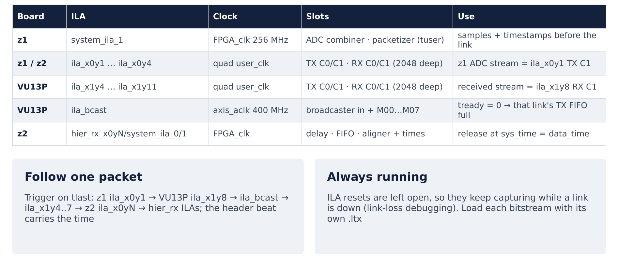
Figure 13: Debug ILAs on every hop of the stream
Board | ILA | Clock | What to look at
z1 | system_ila_1 | FPGA_clk | slot 1 combiner out, slot 0 packetizer out (tuser time, tlast every 1024)
z1 | ila_x0y1 slot 1 | quad user_clk | 128-bit TX beats; first beat after tlast: header in [127:64] = {0, 0, time}
VU13P | ila_x1y8 slot 3 | quad 228 user_clk | same beats received on X1Y8 C1
VU13P | ila_bcast | axis_aclk | slot 0 input, slots 1–8 outputs; outputs must follow the input
VU13P | ila_x1y4 … x1y7 slots 0/1 | quad user_clk | beats entering the eight TX cores
z2 | ila_x0yN slots 2/3 | quad user_clk | beats received on every quad
z2 | hier_rx_x0y1/rx_c0/system_ila_0 | quad 1 user_clk | header[63:0] per packet (err is not meaningful, §4.4)
z2 | hier_rx_x0yN/system_ila_<n> | FPGA_clk | delay in/out, FIFO out, aligner out, timestamp, sys_time, data_time, end_time
all | x0yN_core_status_<n>, x1yN_core_status_<n> VIOs | quad user_clk | channel_up, gt_pll_lock, lane_up[1:0]

Trigger on tlast to align a capture to a packet start (one packet ≈ 1281 beats fits in the 2048-deep link ILAs).

12. Verification
Test | Tool | Result
End-to-end chain, delay 512 / 200 | scripts/sim_chain/run.sh = Vivado simset sim_1 in 47dr2.xpr (real RTL, 2 Aurora hops with random gaps, 3 user clocks) | every sample at the DAC exactly delay + 1 cycles after its z1 ADC time; no drops; 50 498 samples checked
Delay 1400 | same | holding FIFO overflow (expected)
1 / 2 lost packets | same, LOSS generic | misalignment until reset / time freeze (§10); PACKET_LENGTH 1022 limits loss to one packet
FIFO budget, stalls 0 / 1 / 3 µs | run_fifo.sh = simset sim_fifo | §8.3
Aurora settings | BD dump, 72 cores | all identical (§4.5)
Reset wiring | BD dump, 36 aurora_rstn | rev 0.11: 8 wrong on the VU13P; fixed in rev 0.12 (§5.4)

Testbench note: the align_err and tuser_mismatch counters of tb.v / tb_fifo.v count almost every word. They compare against the first output word (a start-up zero) and against data_ts + 1 while the model stamps tuser = data_ts + 1 and the rebuild adds one more count after the first packet. The latency histogram (exact delay + 1 for every sample) is the valid check; the two counters should be fixed before they are used.

13. Revision history
Rev | Date | Author | Changes
1.0 | 2026-10-14 | Claude Code (for johnny@jxense.com) | First issue: per-module design and IP configuration of the whole signal path, read from the rev 0.11 block designs; VU13P core-1 reset defect (§5.4), ini_system one-cycle release and header_extraction err meaning documented.
1.1 | 2026-10-14 | Claude Code (for johnny@jxense.com) | §5.4 defect fixed (design rev 0.12, D19), VU13P rebuilt; §9.1, §10, §12 updated.

