PJ22045.0.1 1R8T — Timing Synchronisation
Project | Folder ~/Desktop/PJ22045.0.1: 47dr1 (z1, ADC transmitter), vu13p (relay), 47dr2 (z2, 8-DAC receiver). System document: docs/DESIGN.md (rev 0.11); signal path: docs/SIGNAL_TRANSMISSION.md
Scope | The system time base and the scheduled playback: clocks and SYSREF, the two timers, how they are started together, how every sample is stamped on z1, carried, rebuilt on z2, delayed and released to the DACs; latency, alignment of the eight outputs, wrap-around, failure modes, bring-up measurements
Data source | RTL of timer.v, sync_pulse_to_level.v, axis_packetizer.v, header_insertion_v2.v, header_extraction_v2.v, data_delay.v, data_aligner.v, pl_sysref_int.v, regs_4_sysref.vhd; IP settings from a read-only dump of the rev 0.11 block designs (2026-10-14); cycle traces from scripts/sim_chain/tb.v (xsim, 2026-10-14)
Revision | 1.1 (2026-10-14), matches design rev 0.12
Status | Simulated (latency exact for every sample, 40-bit wrap clean); not yet run on hardware. Statements marked (RTL) are derived from reading the RTL and were not simulated

History policy: this document describes the current design. When the design changes, the text is updated and a row is added to §16 Revision history. Decisions stay in docs/DESIGN.md §13.

Contents

1. Reading guide
2. Principle
3. Clocks and references the time base depends on
4. Time-base hardware (identical on z1 and z2)
4.1 timer_1 (module reference timer.v, TIME_WIDTH = 40)
4.2 sync_pulse_to_level_1 (module reference sync_pulse_to_level.v)
4.3 Reset of the time base
4.4 SYSREF inside each 47DR
4.5 Start, cycle by cycle (RTL; confirmed in simulation)
4.6 SYSREF capture margin — accepted as is (D20)
5. Start procedure
6. Stamping on z1
7. Carrying and rebuilding the time
7.1 Header (z1, header_insertion_v2)
7.2 Rebuild (z2, header_extraction_v2)
8. Scheduling and release on z2 (per Aurora core, 8 ×)
8.1 data_delay — computes the due time
8.2 Holding FIFO (axis_data_fifo_<n>)
8.3 data_aligner — releases at the due time
8.4 Release timing in practice (simulation trace, delay 512)
9. End-to-end latency
9.1 Formula
9.2 Transport latency and the delay budget
9.3 Worked example (delay = 0x200 = 512)
10. Alignment of the eight DAC outputs
11. Wrap-around
12. Verification
13. Failure modes and recovery
14. Hardware bring-up and measurements
15. Open issues and proposals
16. Revision history

(Right-click the table of contents and choose Update Field if page numbers are missing.)

1. Reading guide
§2 states the principle. §3 lists the clocks and references the time base depends on, §4 the time-base hardware down to the cycle, §5 the start procedure. §6–§8 follow one sample: stamping (z1), carrying and rebuilding the time, scheduling and release (z2). §9 derives the latency, §10 the alignment of the eight DAC outputs, §11 wrap-around. §12 is verification, §13 failure modes, §14 hardware bring-up and measurements, §15 open issues.
Units: one count = one FPGA_clk cycle = 1 / 256 MHz = 3.906 ns. T = z1 timer value, t₂ = z2 timer value.

2. Principle
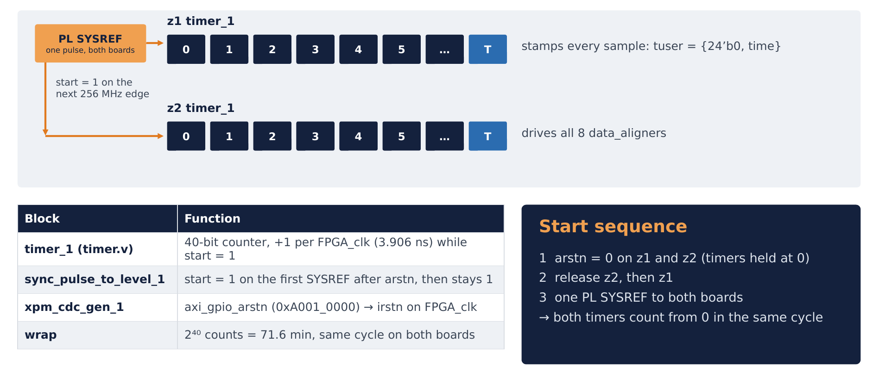
Figure 1: One time base: z1 and z2 timer_1 start from 0 on the same SYSREF and count 256 MHz cycles
The system has one time base kept by two identical counters: timer_1 on z1 and timer_1 on z2. Both count 256 MHz FPGA_clk cycles from the same SYSREF pulse, so at every instant they hold the same value (if the requirements of §3 and §5 hold). z1 writes its timer value into every sample; z2 adds a programmable delay and plays the sample when its own timer reaches that value. The VU13P has no timer; it forwards the time inside the packet header untouched, and its clocks need no relation to z1/z2.
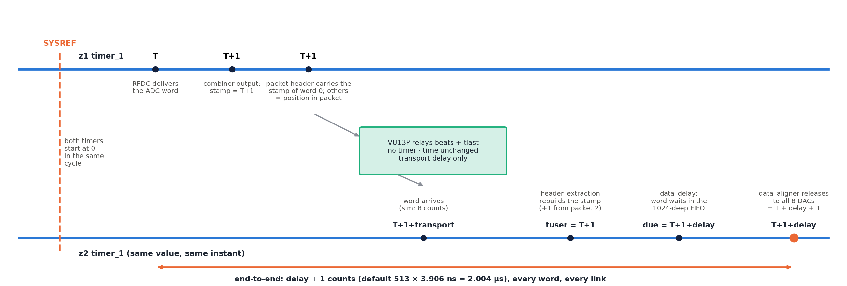
Figure 2: Life of a time value: SYSREF starts both timers; z1 stamps, the header carries, z2 rebuilds, delays and releases
Result: every sample leaves every z2 DAC input at z2 time = stamp + delay (stamp = z1 time the word left the combiner), i.e. delay + 1 counts after the RFDC ADC delivered it (§9).

3. Clocks and references the time base depends on
Clock / signal | Board | Source | Used by | Requirement
FPGA_clk 256 MHz | z1, z2 | board pins FPGA_clk_p/n_0 (AP8/AR8, LVDS) → util_ds_buf_0 IBUFDS; XDC create_clock -period 3.90625 | timer_1, sync_pulse_to_level_1, combiners, packetizer (z1), hier_rx (z2), RFDC AXIS | z1 and z2 from one frequency reference (same clock tree / same reference)
PL_SYSREF | z1, z2 | board pins PL_SYSREF_clk_p/n[0] (AP9/AR9, LVDS) → util_ds_buf_3 IBUFDS | sync_pulse_to_level_1 (timer start), pl_sysref_int_0 (RFDC MTS) | one pulse reaching both boards in the same FPGA_clk cycle (§4.6)
adc1_clk 256 MHz | z1, z2 | RFDC ADC tile 1 refclk port | ADC PLL → 3.84 GHz, distributed to ADC tiles 0/2/3 | —
dac0_clk 256 MHz | z1, z2 | RFDC DAC tile 0 refclk port | DAC PLLs → 3.84 GHz (all four tiles) | —
sysref_in | z1, z2 | RFDC analog SYSREF port | RFDC multi-tile sync (Sysref_Source = 1) | per RFDC MTS rules
pl_clk0 100 MHz | z1, z2 | PS IOPLL (99.9999 MHz) | AXI GPIOs (arstn, pma_rst, axi_delay) | none (crossed by xpm_cdc_sync_rst)
VU13P sys_clk, axis_aclk, Aurora user_clk | VU13P, links | independent | relay only | none — the time travels as data

Frequency match. If z1 and z2 FPGA_clk differ by x ppm, the timers drift by x × 256 counts per second (100 ppm = 25 600 counts/s). z2 then plays samples progressively early or late; with the default delay its holding FIFO (1024) overflows or runs empty in < 50 ms. There is no correction loop in the design: the frequency match must come from the clock distribution.

4. Time-base hardware (identical on z1 and z2)

4.1 timer_1 (module reference timer.v, TIME_WIDTH = 40)
always @(posedge aclk) // aclk = FPGA_clk
if (!aresetn) timestamp <= 0; // aresetn = xpm_cdc_gen_1/dest_rst_out
else if (start) timestamp <= timestamp + 1;// start = sync_pulse_to_level_1/level_ref

- Counts while start = 1, holds while start = 0, cleared by reset. 40 bits wrap after 2⁴⁰ counts = 71.6 min.
- z1: timestamp → ilconcat_1/In0 (stamp). z2: timestamp → all four hier_rx_x0yN/timestamp (one time for all eight aligners).

4.2 sync_pulse_to_level_1 (module reference sync_pulse_to_level.v)
always @(posedge clk) // clk = FPGA_clk
if (!rst_n) level_ref <= 0; // rst_n = xpm_cdc_gen_1/dest_rst_out
else if (pulse_ref) level_ref <= 1; // pulse_ref = util_ds_buf_3/IBUF_OUT (raw PL_SYSREF)

level_ref (= start) goes to 1 on the first SYSREF high level sampled after reset release and stays 1 until the next reset. Later SYSREF pulses have no effect. On z1 the same start also gates axis_packetizer_0.

4.3 Reset of the time base
Cell | Configuration | Function
axi_gpio_arstn | AXI GPIO, 1 bit, all outputs, C_DOUT_DEFAULT 0 (reset asserted after configuration), 0xA001_0000 | software reset of the time base
xpm_cdc_gen_1 | xpm_cdc_sync_rst, DEST_SYNC_FF 4, INIT 1, active-low | GPIO (pl_clk0) → irstn on FPGA_clk
reset loads | timer, sync_pulse_to_level, packetizer + system_ila_1 (z1); hier_rx_x0y1…4 = data_delay, holding FIFO, data_aligner, ILAs (z2) | —

Because the GPIO powers up as 0, both boards come out of configuration with the time base held in reset.

4.4 SYSREF inside each 47DR
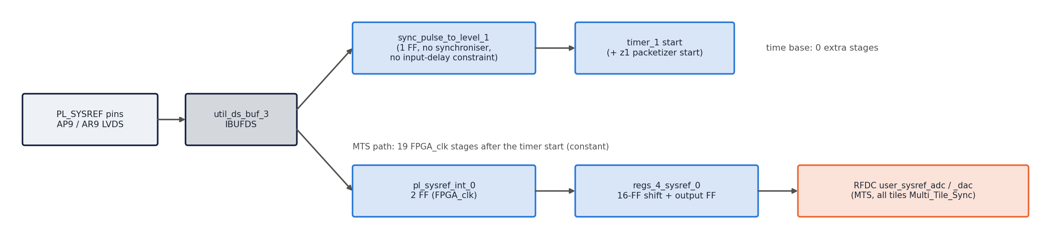
Figure 3: PL SYSREF inside each 47DR: time-base start path and RFDC multi-tile-sync path
util_ds_buf_3 output drives two independent paths:
Path | Stages (FPGA_clk) | Destination
time base | 0 extra: raw IBUFDS output sampled directly by sync_pulse_to_level_1 | start of timer (and packetizer on z1)
RFDC multi-tile sync | pl_sysref_int_0 (2 flops: pl_clk_buf then pl_clk_adc / pl_clk_dac, all = FPGA_clk) → regs_4_sysref_0 (16-flop shift + output flop) | RFDC user_sysref_adc / user_sysref_dac (MTS, all ADC/DAC tiles Multi_Tile_Sync = true)

hier_mts (sysref_trig_det, sync_out_latch, sig1_gen, daq_timing_ctrl, adc_dma_ctrl) is the EV1 MTS debug logic (D16 constrains its clock crossing); it does not touch the time base.

4.5 Start, cycle by cycle (RTL; confirmed in simulation)
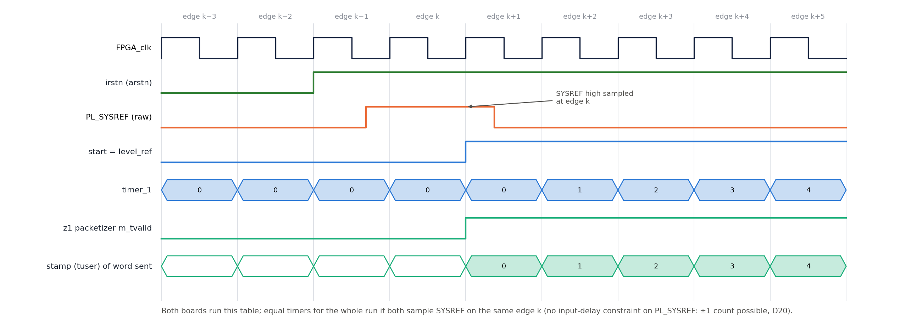
Figure 4: Start of the time base, cycle by cycle (same on z1 and z2)
FPGA_clk edge | SYSREF sampled | start after edge | timer after edge | z1 packetizer
k − 1 | 0 | 0 | 0 | m_tvalid = 0
k | 1 | 1 | 0 | m_tvalid = s_tvalid from now on
k + 1 | — | 1 | 1 | first word accepted, stamped tuser = 0
k + 2 | — | 1 | 2 | second word, stamp 1

Both boards execute the same table. If they sample SYSREF on the same edge k, their timers are equal for the whole run.

4.6 SYSREF capture margin — accepted as is (D20)
PL_SYSREF has no `set_input_delay` in the 47DR XDC files and goes to sync_pulse_to_level without a synchroniser, so the capture edge is not timed by Vivado. If the SYSREF edge arrives close to an FPGA_clk edge, a board may capture it one cycle early or late. The result is a constant offset of one count (3.9 ns) between the z1 and z2 timers for that run: the end-to-end latency changes by one count; the eight z2 outputs stay aligned to each other (they share the z2 timer). Remedy, if the board clocking does not guarantee the phase: add set_input_delay on PL_SYSREF_clk_p[0] relative to FPGA_clk (from the clock-chip data sheet), or capture SYSREF in an IOB / IDELAY-tuned flop. User decision (D20, rev 0.12): no constraint is added; the capture is checked on hardware with §14 step 6.

5. Start procedure
- Hold arstn = 0 on both boards (axi_gpio_arstn @ 0xA001_0000 = 0; this is also the power-up state). Timers 0, start = 0, z1 sends nothing.
- Bring the links up and check all channel_up (SIGNAL_TRANSMISSION.md §9.1).
- Write the delay on z2: axi_delay @ 0xA008_0000 (default 0x200 = 512 counts = 2.0 µs). Only change it while arstn = 0 (§13).
- Release arstn = 1 on z2 first, then z1 (z2 must be ready to take the first header).
- Issue one PL SYSREF pulse to both boards (a periodic SYSREF works too: the first pulse after the later of the two releases starts both timers — both releases must happen before the same pulse, see below).
- Both timers count from 0 in the same cycle; z1 starts sending; z2 releases the first sample at t₂ = delay.
Requirements:
- Same frequency on both FPGA_clk (§3).
- Same start edge: the SYSREF pulse must be seen by both boards in the same FPGA_clk cycle (§4.6), and both arstn must be released before that pulse. With a periodic SYSREF, a board released one period later starts one SYSREF period later and its timer lags by that period for the whole run.
- The timers are free-running afterwards; any start offset Δ (z2 ahead by Δ counts) changes the effective latency to delay − Δ. There is no further correction.

6. Stamping on z1
Step | Block | Detail
1 | RFDC ADC 00 | delivers I (m00_axis) and Q (m01_axis), 80 bit each, every FPGA_clk cycle; call the timer value at that moment T
2 | axi_stream_combininp_adc00 | registers the interleaved 160-bit word: the word appears at the combiner output in cycle T + 1
3 | ilconcat_1 + xlconstant_0 | tuser = {24'b0, timer_1/timestamp} — the current timer value, i.e. T + 1, combinational
4 | axis_packetizer_0 | passes word and tuser together; asserts tlast every 1024 words

So the stamp of a word is T + 1 (one register after the ADC). This constant offset is part of the +1 in the end-to-end latency (§9).

7. Carrying and rebuilding the time

7.1 Header (z1, header_insertion_v2)
Only the stamp of the first word of each packet is transmitted, in the 64-bit header {ip[15:0], type[7:0], time[39:0]} (ip = type = 0; the upper 24 tuser bits are 0). It occupies bits [127:64] of the first beat of each packet. The other 1023 stamps are implied by position. The VU13P copies beats and tlast only; transport delay (Aurora hops, FIFOs, SLR slices, clock crossings) does not change any time value — it only uses part of the delay budget (§9).

7.2 Rebuild (z2, header_extraction_v2)
if (header_valid) m_axis_tuser <= header; // sof beat: load packet time
else if (m_axis_tvalid && m_axis_tready) m_axis_tuser <= m_axis_tuser + 1; // +1 per output word

- First packet after reset: every word gets back exactly its stamp.
- From the second packet on, the rebuilt time is stamp + 1. Reason: the last word of packet n is split across packets (2 of its 5 words follow the header of packet n+1, SIGNAL_TRANSMISSION.md §4.3). It is output after the header of n+1 has been loaded, so it receives header(n+1) = its own stamp + 1, and the count continues from there. Simulation trace (tb stamps tuser = word time + 1): word 500 → rebuilt 501 (exact); words 1022…1025 → 1024…1027 (one higher).
- The step is +1 once, at the first packet boundary; afterwards the offset stays constant. §8.4 shows why it does not change the output timing.
- tuser (64 bit) crosses to FPGA_clk with its word in rx_c<n>/cdc_fifo (512).

8. Scheduling and release on z2 (per Aurora core, 8 ×)
hier_rx_x0yN: data_delay_<n> → axis_data_fifo_<n> (1024, FPGA_clk, 20-byte data + 64-bit tuser, no tlast) → data_aligner_<n> → RFDC DAC s<t><c>_axis. Clock FPGA_clk, reset irstn.

8.1 data_delay — computes the due time
assign delayed_time = (s_tuser[39:0] > m_tuser[39:0] + 1024) ? m_tuser[39:0] // guard: keep previous due
: s_tuser[39:0] + delay;
assign s_axis_tready = 1; // never back-pressures
always @(posedge aclk) if (s_tvalid) begin
m_tdata <= s_tdata;
m_tuser <= {s_tuser[24], delayed_time}; // see note on bit 24
end
always @(posedge aclk) m_tvalid <= s_tvalid; // ignores m_tready

Item | Detail
delay | 32 bit from axi_delay (0xA008_0000, default 0x200), shared by all eight cores; added to the 40-bit time (wraps with it)
due | m_tuser[39:0] = rebuilt time + delay
guard | if the incoming time is more than 1024 counts later than the previous due, the previous due is kept. Intended to reject a corrupted header. Threshold relative to the previous time = delay + 1024
latency | one register (FPGA_clk)
flow | s_axis_tready = 1, output valid every cycle a word arrives; the holding FIFO must never fill (§9.3)
bit 24 quirk | m_tuser[63:40] gets s_tuser[24] (a single bit, zero-extended) instead of [63:40]. Harmless: those bits are 0

Guard side effects (RTL):
- Wrap: when due wraps past 0xFF_FFFF_FFFF before the time does, the next incoming times (≈ 2⁴⁰ − delay) are "more than 1024 above" the small wrapped due, so the guard holds the due constant for ≈ delay words until the time wraps too. In the gap-free stream this has no visible effect (simulation: latency exact through the wrap), because the aligner streams one word per cycle once running (§8.4). A gap in the stream exactly at the wrap would release those words early.
- Time jump forward by > delay + 1024 (≥ 2 lost packets, z1 restarted with a larger time): the due time freezes at the old value; because every later time is also "too far ahead", it stays frozen until reset → the aligner sees past-due words and releases them as they arrive (no scheduling).
- z2 reset alone while z1 runs: after reset m_tuser = 0, the first incoming time is > 1024 → due frozen at 0 → same as above: words pass through unscheduled.

8.2 Holding FIFO (axis_data_fifo_<n>)
Depth 1024, synchronous. Holds the words between arrival and release. Steady-state fill = delay − transport latency (simulation, delay 512: 502–504 words). Overflow loses words silently (data_delay ignores tready).

8.3 data_aligner — releases at the due time
assign end_time = timestamp + 2; // z2 timer + 2 (pipeline compensation)
always @(posedge aclk) sys_time <= {epoch_s ^ (end_time < sys_time[39:0]), end_time};
always @(posedge aclk) data_time <= {epoch_d ^ (s_tuser[39:0] < data_time[39:0]), s_tuser[39:0]};
assign out_valid = (sys_time == data_time)
| (sys_time[39:0] < data_time[39:0] && sys_time[40] != data_time[40])
| (sys_time[39:0] > data_time[39:0] && sys_time[40] == data_time[40]);
assign s_axis_tready = out_valid; // read the FIFO when due
assign m_axis_tdata = out_valid ? data_temp : 0; // zeros while nothing is due
assign m_axis_tvalid = out_valid && s_axis_tvalid; // m_axis_tready ignored
always @(posedge aclk) if (s_axis_tvalid && s_axis_tready) data_temp <= s_axis_tdata;

Item | Detail
sys_time (41 bit) | registered z2 timer + 2; bit 40 = epoch, toggles each time the 40-bit value wraps
data_time (41 bit) | registered due time of the FIFO head word; bit 40 toggles each time the due time decreases
out_valid | sys_time ≥ data_time in 41-bit modular sense: equal, or later in the same epoch, or the epoch differs and the low bits are smaller
release | while out_valid = 1 the FIFO is read one word per cycle; the word read is output from data_temp in the following cycle
not due | out_valid = 0: the FIFO is not read, the DAC gets zeros (m_axis_tdata = 0)
late word | due time already passed → released immediately, no waiting
ports to ILA | sys_time, data_time, end_time (and timestamp) on hier_rx_x0yN/system_ila_<n>

Epoch rule consequence (RTL): any decrease of the due time that is not a wrap (z1 restarted with a smaller time, delay reduced while running) toggles the data epoch, so the aligner treats the word as one 71.6-minute epoch in the future and stops releasing: the DAC outputs zeros and the holding FIFO overflows. Recovery = restart (§5).

8.4 Release timing in practice (simulation trace, delay 512)
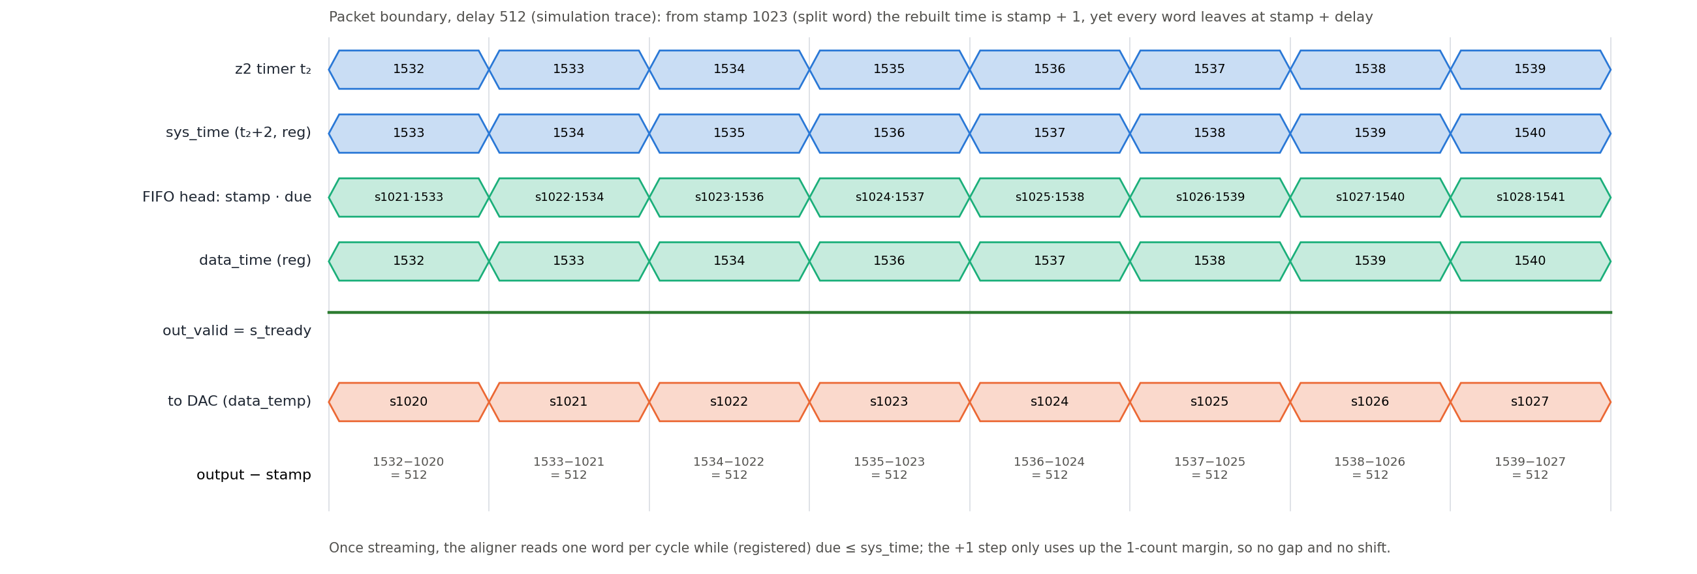
Figure 5: data_aligner release at the first packet boundary (simulation trace, delay 512)
Word (tb time) | stamp | rebuilt tuser | due | read from FIFO at t₂ | sys_time / data_time at read | output at t₂ | output − stamp
500 (packet 1) | 501 | 501 | 1013 | 1012 | 1013 / 1012 | 1013 | 512
1022 (packet 1, last, split) | 1023 | 1024 | 1536 | 1534 | 1535 / 1534 | 1535 | 512
1023 (packet 2) | 1024 | 1025 | 1537 | 1535 | 1536 / 1536 | 1536 | 512
1025 | 1026 | 1027 | 1539 | 1537 | 1538 / 1538 | 1538 | 512
3000 | 3001 | 3002 | 3514 | 3512 | 3513 / 3513 | 3513 | 512

How it works: the comparison is made against data_time, the registered due of the FIFO head, i.e. the previous word's due while streaming. The first word sets the phase: it is released when its due is reached. From then on the FIFO is read one word per cycle and out_valid stays 1 as long as each new due is ≤ sys_time (= t₂ + 1 after the register). The +1 step of the rebuilt time at the first packet boundary (§7.2) reduces this margin from 1 to 0 and does not stall the stream, so every word leaves at stamp + delay. A due-time step of ≥ 2 counts upward would stall one cycle per extra count (gap on the DAC); a step downward triggers the epoch rule (§8.3).

9. End-to-end latency
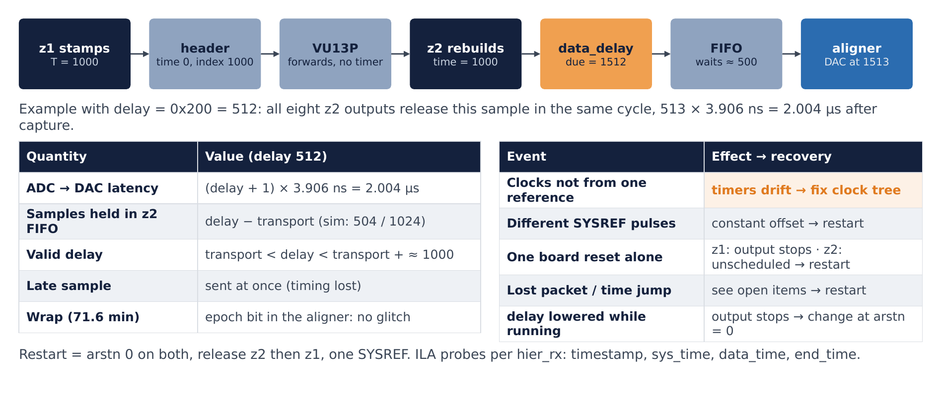
Figure 6: Latency: a sample stamped T on z1 leaves every z2 output at T + delay + 1

9.1 Formula
From | To | Latency
z1 RFDC delivers word (z1 time T) | combiner output, stamp | 1 count (stamp = T + 1)
stamp | z2 aligner output (z2 time) | delay (§8.4)
z1 RFDC ADC AXIS | z2 RFDC DAC AXIS | delay + 1 counts (default 513 × 3.906 ns = 2.004 µs)
RF in → ADC AXIS, DAC AXIS → RF out | analog | fixed RFDC pipeline latency (decimation / interpolation filters, mixers); constant for the configuration, aligned across tiles by MTS; not part of this budget

Valid for every sample, every link, every packet (simulation: 50 498 words, delays 200 and 512).

9.2 Transport latency and the delay budget
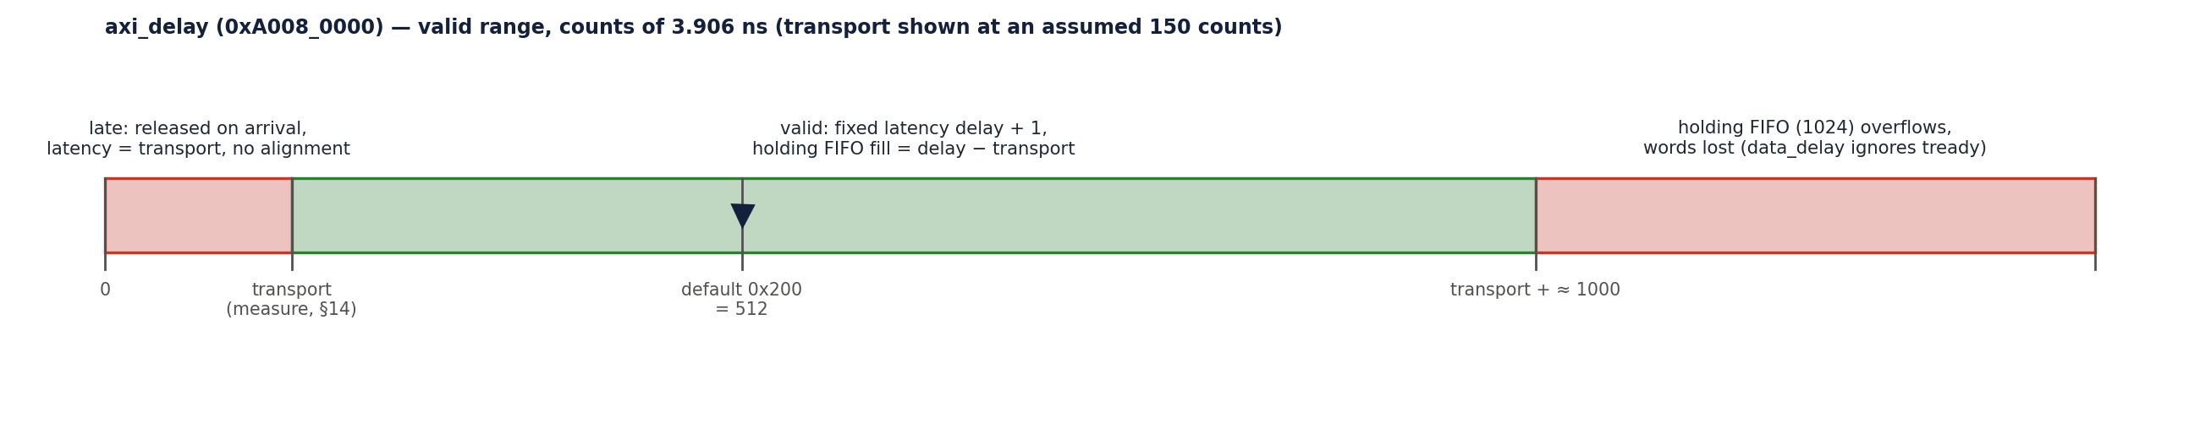
Figure 7: Valid range of axi_delay: late below the transport latency, FIFO overflow above transport + ≈ 1000
Transport = time from stamp to the word's arrival at data_delay on z2. It consumes part of the delay:
Quantity | Value
Transport in simulation | 8 counts (word 500: stamp 501, arrives at t₂ = 509). The model has no GT / SERDES latency and zero-latency FIFO models, so this is a lower bound
Transport on hardware | to be measured (§14 step 7): two Aurora hops (TX + RX PCS/PMA, gearbox, elastic buffers), six async FIFOs, two Multi-SLR slices; expected a few hundred ns
Words in the holding FIFO | delay − transport (simulation: 504 at delay 512)
Valid delay range | transport < delay < transport + ≈ 1000 (FIFO 1024 with a margin for the rebuild step and jitter)

If delay ≤ transport, words arrive after their due time and are released on arrival: the latency is no longer fixed (it follows the transport latency) and the eight outputs are only as aligned as their links. If delay − transport ≥ 1024, the holding FIFO overflows.

9.3 Worked example (delay = 0x200 = 512)
SYSREF at edge k → both timers count from 0. The ADC delivers a word at z1 time T = 1000; it leaves the combiner at 1001 with stamp 1001, travels in the packet that started at stamp 0 (header time 0, position 1001), arrives on z2 a few hundred counts later, is rebuilt to 1001 (first packet), due = 1513, waits in the FIFO, is read at t₂ = 1512 and reaches all eight DAC AXIS inputs at t₂ = 1513 = T + delay + 1.

10. Alignment of the eight DAC outputs
- In the PL: all eight aligners use the same z2 timer, the same delay and the same rebuilt times (the broadcaster sends identical beats). With all links started before z1 sends (normal start), every output releases word i in the same FPGA_clk cycle. Simulation checked one link; the eight links are identical hardware.
- Late-joining link (RTL): a link whose receiver starts with a later packet (after a per-link reset) rebuilds stamp + 1 from its first word on; its first word then sets the phase one count later → that output is one count (3.9 ns) later than the others. The documented restart (§5) avoids this.
- Across DAC tiles (analog): the AXIS words enter four DAC tiles in the same cycle; the analog outputs are aligned only if RFDC multi-tile sync has been run (all tiles Multi_Tile_Sync = true, SYSREF via pl_sysref_int → regs_4_sysref → user_sysref_dac, analog sysref_in). MTS operation and the analog alignment are not covered by the simulation and must be verified on hardware.
- Between boards: z1 ADC and z2 DAC analog alignment adds the RFDC pipelines of both boards (constant) and the SYSREF capture uncertainty of §4.6.

11. Wrap-around
- Both timers wrap from 0xFF_FFFF_FFFF to 0 in the same cycle, 71.6 min after the start. data_delay wraps the due time the same way; data_aligner keeps the order with the epoch bits.
- Simulation (run.sh 512 1: both timers moved to 2⁴⁰ − 30 000 at 20 µs): the word stamped 0xFF_FFFF_FFFF − 1 left at t₂ = 0x1FF, words 0, 1, 2 at 0x201…0x203 — latency exactly delay + 1 through the wrap, no gap.
- The data_delay guard holds the due time for ≈ delay words around the wrap (§8.1); invisible in a gap-free stream.

12. Verification
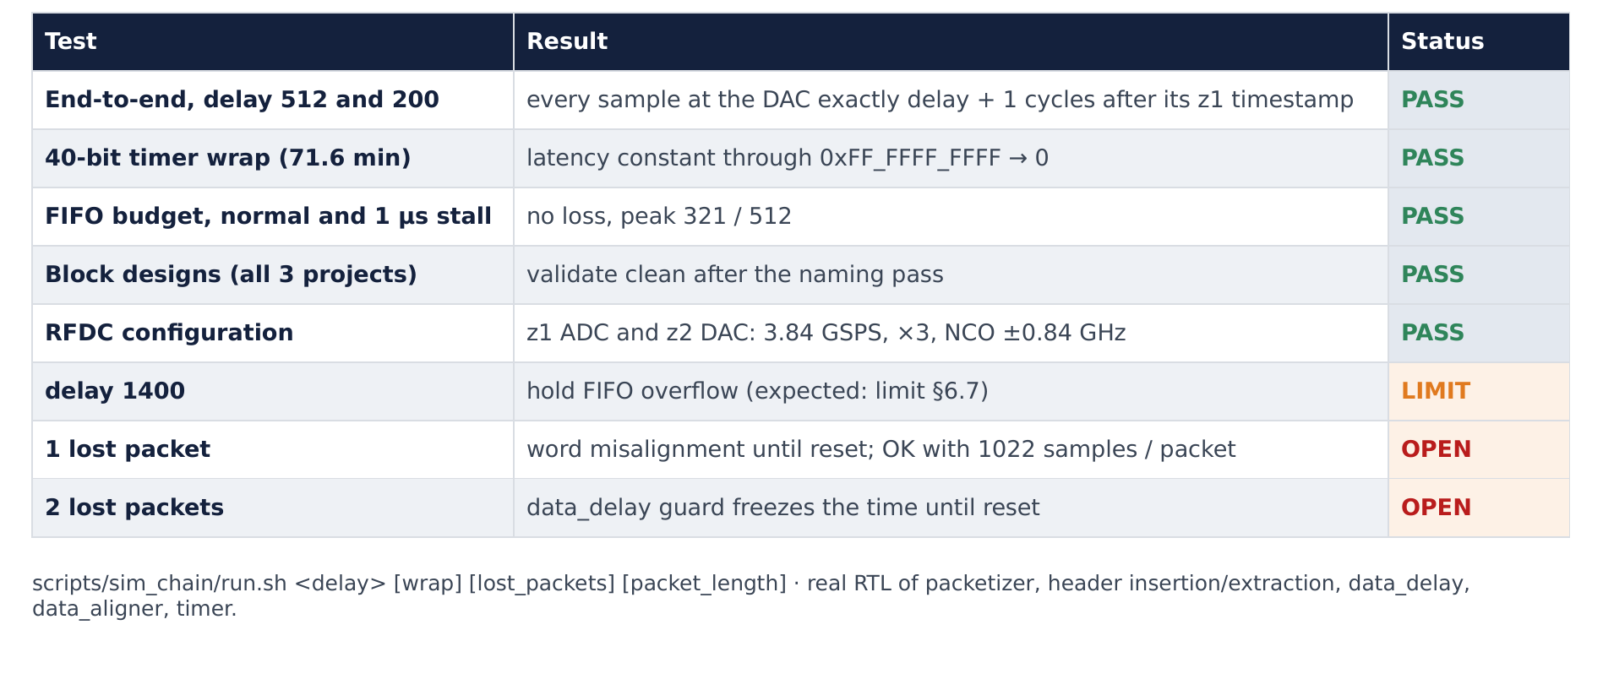
Figure 8: Simulation confirms exact timing
Test | Command / Vivado simset | Result
Latency, delay 512 | scripts/sim_chain/run.sh 512 / sim_1 (47dr2.xpr) | 50 498 words, all delay + 1 after the ADC time
Latency, delay 200 | run.sh 200 | same
40-bit wrap | run.sh 512 1 | 42 921 words checked after the jump, all delay + 1; no gap at the wrap
Cycle trace | tb.v + trace probes (2026-10-14) | §8.4 table
Delay too large (1400) | run.sh 1400 | holding FIFO overflow (expected)
1 / 2 lost packets | run.sh 512 0 1 / 0 2 | misalignment / time freeze (§13)
FIFO budget, stalls | run_fifo.sh / sim_fifo | latency unchanged with a 1 µs stall; SIGNAL_TRANSMISSION.md §8.3
Not simulated | — | SYSREF capture margin, ppm drift, RFDC MTS, reset of one board while the other runs, delay change while running

Testbench note: in tb.v the "ADC" word carries the timer value of the previous cycle while tuser carries the current one (models the combiner register). The tuser_mismatch counter expects tuser = data + 1 and therefore counts every word after the first packet (the +1 rebuild step), and align_err compares against the first output word, which is a start-up zero. Both counters are testbench artefacts; the latency histogram is the valid check.

13. Failure modes and recovery
Event | Effect on timing | Recovery
z1 and z2 FPGA_clk not from one reference | timers drift (x ppm → x × 256 counts/s); outputs move early/late; holding FIFO overflows or empties | fix the clock tree, restart (§5)
SYSREF captured on different edges | constant 1-count offset z1 ↔ z2 (§4.6) | constrain / retime SYSREF
Boards started on different SYSREF pulses | constant offset of N SYSREF periods → latency delay − N·P; outside the valid range → overflow or unscheduled | release both arstn before the same pulse
z1 reset or reprogrammed while z2 runs (RTL) | z1 time restarts low → due times decrease → aligner epoch toggles → z2 outputs zeros, FIFO overflows; the interrupted packet also misaligns the receiver | hold arstn on both, restart (§5)
z2 reset alone while z1 runs (RTL) | data_delay guard freezes due at 0 → words pass through unscheduled (latency = transport); a mid-packet start also misaligns the data | restart both
One packet lost | data misaligned by 64 bits until reset (SIGNAL_TRANSMISSION.md §10); times shifted with it | restart; P1 (PACKET_LENGTH 1022)
≥ 2 packets lost (time jump > delay + 1024) | guard freezes the due time → unscheduled output | restart; P2 (resynchronising guard)
delay reduced while running (RTL) | due decreases → epoch toggles → output stops, FIFO overflows | change delay only while arstn = 0
delay increased by d while running (RTL) | d counts of zeros on the DAC, FIFO fill + d; if d > 1024 the guard freezes the due time | change only while arstn = 0
Corrupted header (no CRC) | one packet with a wrong time: if far ahead → guard keeps previous due; if earlier → epoch toggle (output stops) | restart if outputs stop

DESIGN.md §6.9 was corrected to these rows in design rev 0.12.

14. Hardware bring-up and measurements
- Program VU13P, z1, z2 (each .bit with its own .ltx). arstn = 0 on both 47DRs (power-up default).
- Check every channel_up / lane_up on the core-status VIOs (VU13P X1Y8 C1 and X1Y4–X1Y7 C0/C1, z2 X0Y1–X0Y4 C0/C1).
- Confirm FPGA_clk on z1 and z2 comes from one reference (clock-chip configuration).
- Write axi_delay on z2 (start with 0x200).
- Release arstn z2, then z1; issue one SYSREF.
- Start check: trigger system_ila_1 (z1) and a z2 hier_rx ILA on the first valid word: z1 packetizer tuser of the first word = 0; z2 timestamp must equal z1 time — read both timers through ILAs triggered from a common event (e.g. the next SYSREF edge on both boards): the difference must be 0 (± 1 → §4.6).
- Transport latency: on a z2 hier_rx_x0yN/system_ila_<n>, slot 0 (data_delay input), the difference timestamp − tuser[39:0] of an incoming word = transport latency in counts. Choose delay > transport + margin and < transport + ≈ 1000.
- Release check: on the same ILA, slot 3 (aligner output) is continuous (no zero gaps) and sys_time − data_time stays 0 or 1 while streaming; end_time = timestamp + 2.
- Eight-output check: capture two hier_rx ILAs (different quads) on a common trigger: the same word appears on both outputs in the same cycle.
- Analog check: run RFDC MTS (DAC tiles 0–3), feed a pulse or a step into ADC 00 on z1 and measure the eight z2 DAC outputs on a scope against the input: skew between outputs and total delay (expected PL part = (delay + 1) × 3.906 ns plus the fixed RFDC pipelines).
- Re-sync rule: after any link drop or board reset, hold arstn on both boards and repeat steps 5–9.

15. Open issues and proposals
ID | Item | Proposal
T1 | SYSREF capture not timed (§4.6) | not done — user decision (D20); verify the start offset on hardware with §14 step 6
T2 | No drift detection | optional: send z1 time periodically and compare on z2 (ILA or register) to detect a ppm error
P1 | Packet carry (one lost packet breaks alignment) | PACKET_LENGTH = 1022 (whole beats); also removes the +1 rebuild step
P2 | data_delay guard freezes forever | resynchronise: accept the new time after N consecutive "too far" words
T3 | Epoch toggle on any decreasing due time | treat a decrease larger than a threshold as an error (resync) instead of a new epoch
T4 | data_delay bit-24 quirk | m_tuser <= {s_tuser[63:40], delayed_time}
T5 | Transport latency unknown on hardware | measure (§14 step 7), then fix the default delay

16. Revision history
Rev | Date | Author | Changes
1.0 | 2026-10-14 | Claude Code (for johnny@jxense.com) | First issue: time-base hardware, start cycle table, stamping, header carry and rebuild (+1 step explained), data_delay / data_aligner design with guard and epoch analysis, simulation trace of the release, latency budget, eight-output alignment, wrap, failure modes (z1/z2 reset and delay-change rows corrected from DESIGN.md §6.9), bring-up measurements, SYSREF capture open point.
1.1 | 2026-10-14 | Claude Code (for johnny@jxense.com) | T1 (SYSREF constraint) closed as not done by user decision (D20); DESIGN.md §6.9 now matches §13.

