



Volunteers in Service Program

Volunteer Work Deployment Report



Campaign Name:

Regular Placement Cohort#06_2025: ALZHEIMERS PAKISTAN

Address:



167_B,PCSIR2,LAHORE

Volunteer’s Name:
Hammad Hafeez

Registration#
L1F21BSCS0624

Contact#
03126603012

Campaign Duration (Date):
13 NOV 2025 to 27 NOV 2025

Also send softcopy of this report to
REPORT.VIS@UCP.EDU.PK

Table of Contents
Table of Contents i
1. Introduction of the individual 1
1.1 Product (Problem Statement) 1
1.2 Background 1
1.3 Scope 1
1.4 Objective(s)/Aim(s)/Target(s) 1
1.5 Challenges 1
1.6 Learning Outcomes 1
1.7 Nature of End Product 1
1.8 Completeness Criteria 1
1.9 Business Goals 1
1.10 Related Work/ Literature Survey/ Literature Review 2
1.11 Document Conventions 2
2. Organization Profile 3
2.1 Product Features 3
2.2 User Classes and Characteristics 3
2.3 Operating Environment 3
2.4 Design and Implementation Constraints 3
2.5 Assumptions and Dependencies 3
3. Day & Date Wise Activities 4
3.1 Name of Use-Case 1 4
3.2 Name of Use-Case 2 (and so on) 4
3.3 Requirements Analysis and Modeling 4
4. What Social Issues Organization is Working on, how 5
4.1 Performance Requirements 5
4.2 Safety Requirements 5
4.3 Security Requirements 5
4.4 Additional Software Quality Attributes 5
5. How do you plan on Working on the Issue Development 5
6. Working Profile 5
7. Annexwures 6
Appendix A: Glossary 7
Appendix B: IV & V Report 8

Account of All Activities
(Incase you have performed more than 1 activity, Please Elaborate Each Activity Separately, also mention the Purpose of Each Activity)
Full Page should be filled in keeping the font size not more than 12.

- Firstly I had to register myself from the facebook page of UCP VIS.


- In its registration it asked me to fulfill the blanked spaces which included name, registration number, email and contact number.
- After registration I received an email after 2 or 3 days that my registration has been accepted and that I am part of campaign #10 tree plantation drive.
- The email also contained the time,date and venue of our orientation for this campaign.
- In the orientation we were told why VIS is important,why plantation is important for our climate change and what we are going to do further
- After that we were to reach alkhidmat office the next day to submit RS-8000 for our plants.
- We had to reach the next day at TOWN SHIP PARK, at 3pm.
- On that day firstly we were asked to get alkhidmat jackets and caps to perform this activity which were to be returned after the activity to the alkhidmat.
- Then we had to wait as some guests were to arrive which included a member of JAMAAT-E-ISLAMI and alkhidmat officials and PHA officials .
- Then the activity began and we were asked to go and plant the trees which PHA had provided us .
- We were also asked to take photos during the plantation and after we had planted our tree
We also had to take photos with different booths
- All these photos were posted at our social media account
- At the end we were advised to mark our attendance ,return jacket and cap back to alkhidmat and leave.
- Then we received an email to write a report and submit it in soft copy through email and hardcopy to VIS office in UCP.

Key Learning’s


(What did you learn from the aforementioned activities? Write in bullets.)

- Firstly I learned the importance of plantation in climate change
- I learned the real meaning of sabr by waiting in a very warm weather which would not be much warm if all of us new the real meaning of plantation.
- I also learned how to plant a tree.
- I learned that our gardeners and farmers are very less paid according to the amount of effort they really put in.
- I learned that this should not only stop here ,but also I should carry on with this campaign on my own for the betterment of environment.

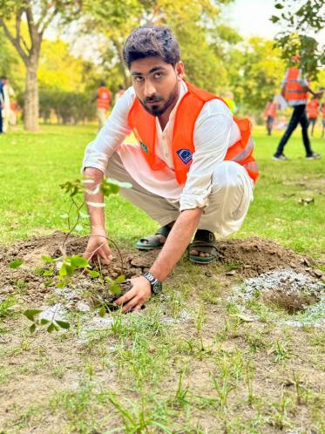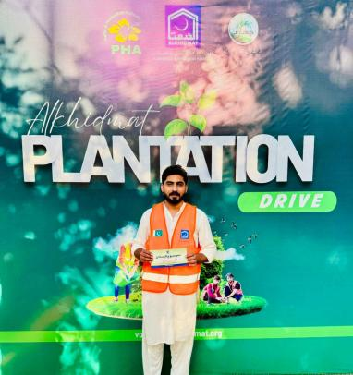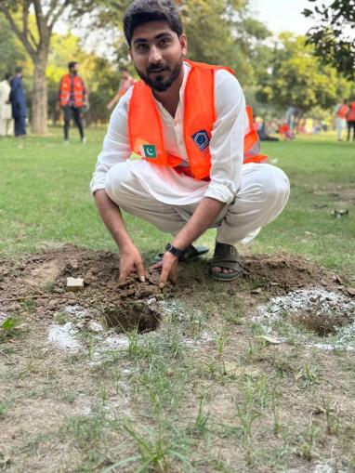
Volunteers Working Pictures

Social Media Link and Picture

Link: https://www.facebook.com/1000127670/posts/pfbid02JJVnT D8ky2q83UAQsLYqti6ErEsN4qZsXza9JzC58csPwiS3nGWRXo DTfJsfl/?app=fbl

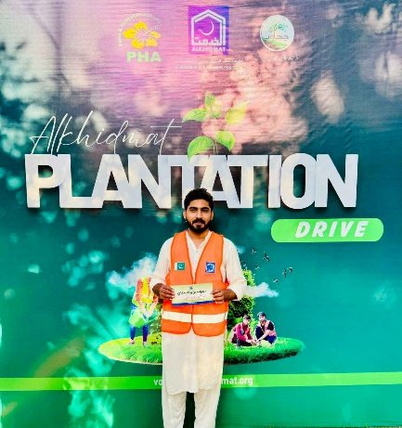

Payment Slip
