Manawa Ora software

Overview and user guide

The Manawa-Ora codebase comprises two parts:

- The User Interface software that allows the user to read and control the ventilator using a web browser. The browser can be on a tablet or central PC
- The code on the mini-computer inside the ventilator is written using python. The software starts automatically and the normal user does not have to do any setup.

The user interface is shown below:

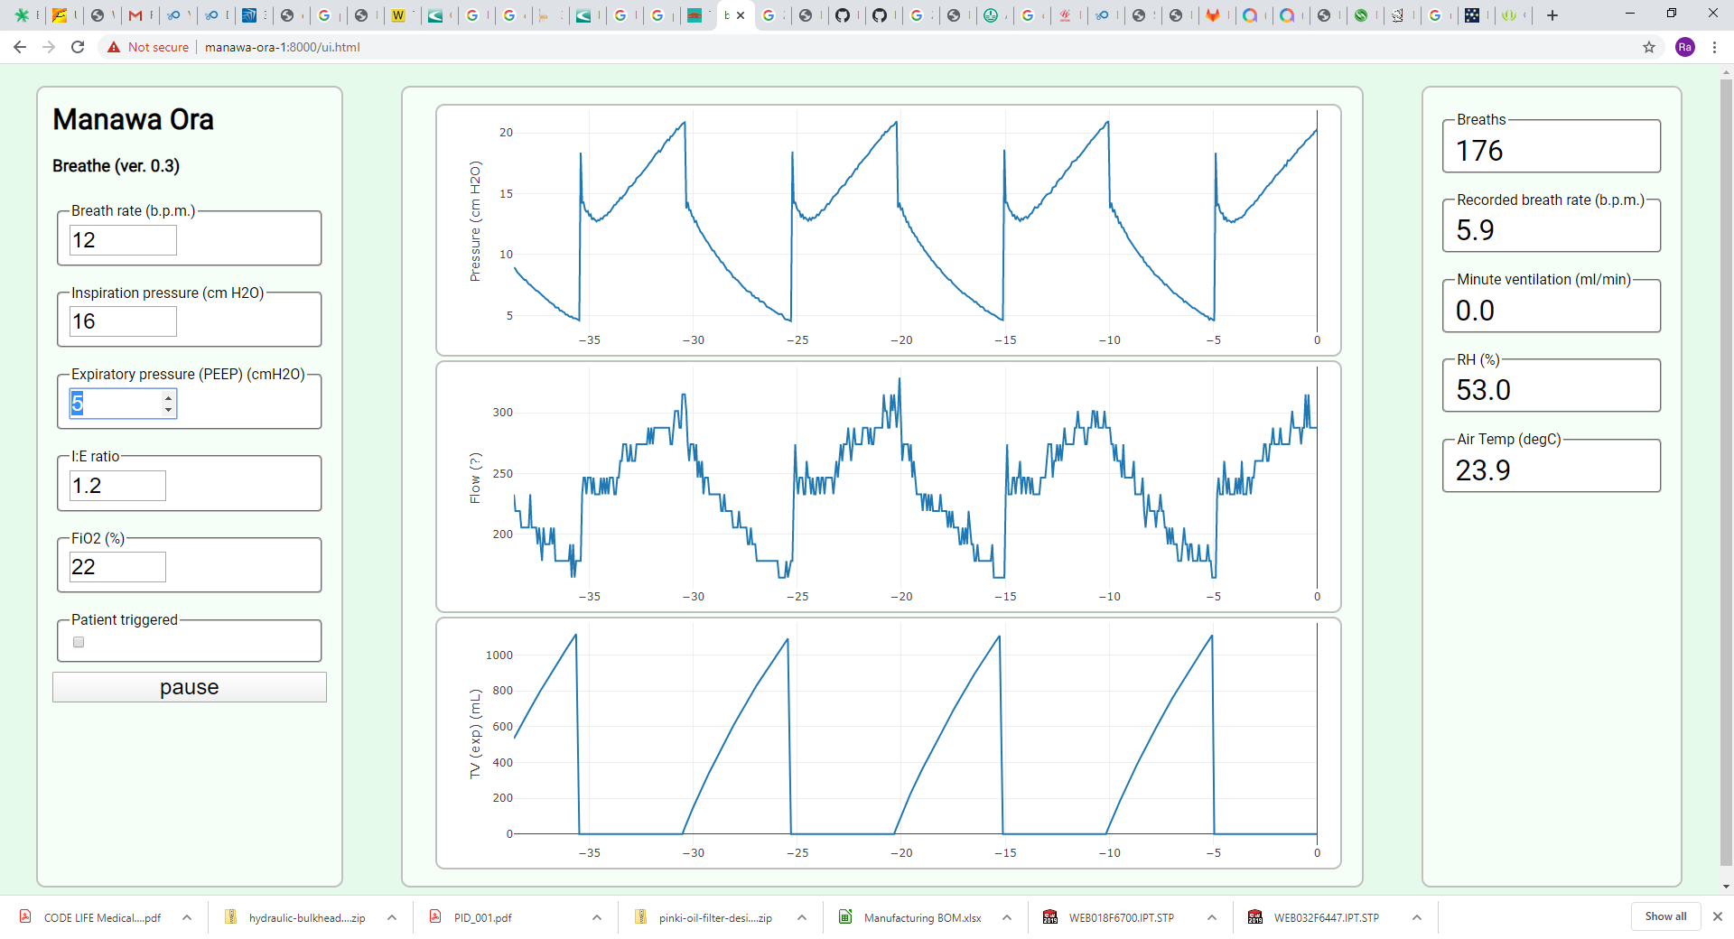

The operator can modify settings using the menu in the left panel. Resulting ventilation graphs and readings are shown in the centre and right hand panels.

Installation
To install the ventilator for the first time the cabinet must be opened and an ethernet cable attached to the controller and a facility IT professional must assign the computer a static IP address: a ventilator ID should (preferably) be given as the machine hostname.

To install the User Interface software:

- The device browser, on a tablet or PC, needs to point to the IP address or hostname.

