# LS.1.5: Log End Imagery

## Remarks

### Yard Images

Log end images were collected in the KPP yard using a handheld digital camera. The images were taken after both ends had been trimmed using a chainsaw (i.e. they are not the same surface as seen by the inline (A&E) cameras).

Bot ends of all logs were imaged. There is no missing yard end imagery.

The positioning and orientation of the camera relative to the log end, the lighting, the focus, etc were all variable. This includes variation in which way is up in each image.

A framing square was included in each image to serve as a reference scale. However, the positioning and oriention of the square also varied from image to image.

A reference length (on the framing square), the pith, a 'heart' zone and boundary and the underbark (or outside) boundary were manually digitized for each image with the help of a special purpose computer program (''log_end_digitize.pyw'').

The heart zone was distinguished from the rest of the log end by virtue of its:

1. colour (the heart being lighter and drier looking than the rest)
2. texture (rougher with more fibre tear out near the pith)

For the most part (and as a coincidental consequence of the silvicultural regime) in this dataset the heart zone contains the wider growth rings.

The digitized points were transformed from image (pixels, origin in frame corner) to world coordinates (mm, origin at pith). All digitization data was stored in the LS15 database.

TODO: include sample image (include original, colour tweaked and as digitized)

In teh yard end imagery other features (e.g. compression wood) are visible that might have a bearing on log quality prediction. To date, no attempt has been made to use such information.

### Inline Images

SWI commissioned A&E to install a pair of log-end imaging cameras on the KPP chain. One camera images the large end of the log as it approaches (the leading end), the other images the small end as it moves away (the trailing end).

Unfortunately on the days the trial logs were collected, lighting and triggering issues meant that:

* images from only 153 of the 200 log ends were captured,
* only 65 of the 100 logs with both ends imaged,
* all of the leading end images (i.e. images of the LE) are very poorly illuminated
* the majority of the leading end images are of as-delivered (rather than fresh sawn) surfaces with the wood obscured by dirt and paint marks

The inline imagery has been digitized in a similar fashion to the yard imagery, except that the transformation from image to world coordinates is undertaken using a perspective transform based on a single pair of calibration images. The calibration images are of a 500x500mm plywood target displaying a 100x100mm grid. The target was imaged in the nominal triggering plane.

The inline imagery also exhibits a distinctive zone surrounding the pith. While this zone is referred to below as the heart zone, this shouldn't be taken as constituting a claim that this zone is indentially heartwood.

TODO: include sample image

### Summary Measures

#### Log Ends

*Areas* Total area and heartwood area computed from digitized polygon

*Heart Area Fraction*

*Eccentricities* Vectorial differences between pith and/or geometric centres of heart and total zones scaled by the effective radius

#### Log

*Heart Volume Fraction* Average of area fractions at both ends

*Average Pith Eccentricity* Average of absolute pith eccentricty at both ends

*Average Heart Eccentricity* Average of absolute heart zone eccentricty at both ends

library(RODBC)  
library(lattice)  
library(reshape2)  
library(randomForest)

## randomForest 4.6-7 Type rfNews() to see new features/changes/bug fixes.

## Shapes

Start by taking a look at the as-digitized data.

ch = odbcConnect("LS15")  
P = sqlQuery(ch, "select * from LogEndDigitizations as d, LogEndDigitizationEdges as e, LogEndDigitizationPoints as p where d.id=e.digitizationID and e.id=p.edgeID and type<>'pith'")  
myxyplot = function(x, y, ...) {  
 panel.abline(h = 0, col = "grey70")  
 panel.abline(v = 0, col = "grey70")  
 panel.xyplot(x, y, ...)  
}

Raw digitized underbark shapes in image coordinates.

xyplot(iy ~ ix | as.factor(ScionLogNumber), group = paste(logEnd), P, auto.key = list(lines = TRUE,   
 points = FALSE), type = "l", subset = type == "underbark" & imageType ==   
 "yard", layout = c(10, 10, 1), aspect = "iso", main = "Yard Images: Digitized Boundaries: Image Coordinates")

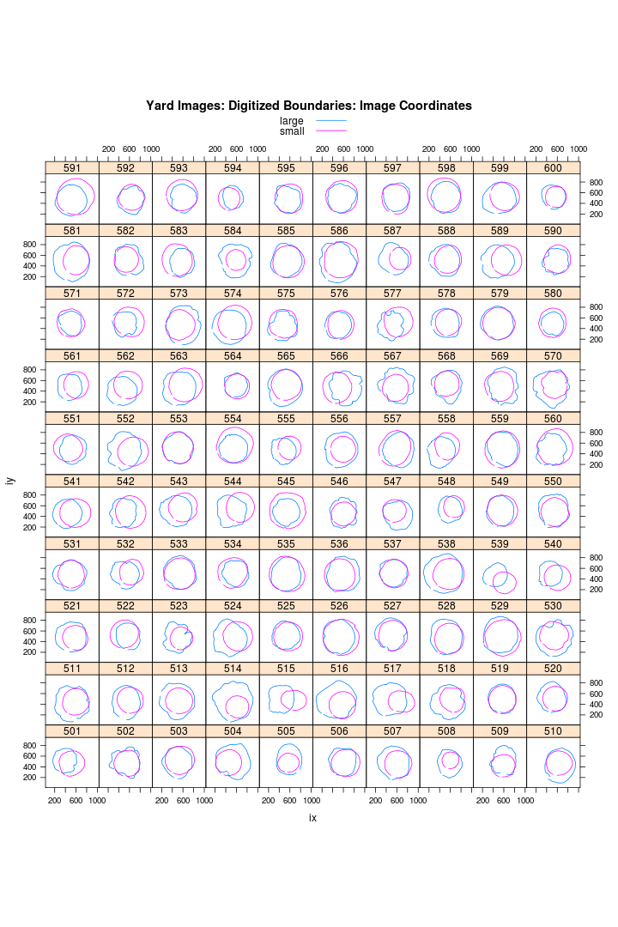

plot of chunk unnamed-chunk-3

Now look at the underbark shapes after transforming to world coordinates (using mm as units). The pith is at (0,0).

xyplot(y_mm ~ x_mm | as.factor(ScionLogNumber), group = paste(logEnd), P, auto.key = list(lines = TRUE,   
 points = FALSE), type = "l", subset = type == "underbark" & imageType ==   
 "yard", layout = c(10, 10, 1), aspect = "iso", panel = myxyplot, main = "Yard Images: Digitized Boundaries: World Coordinates")

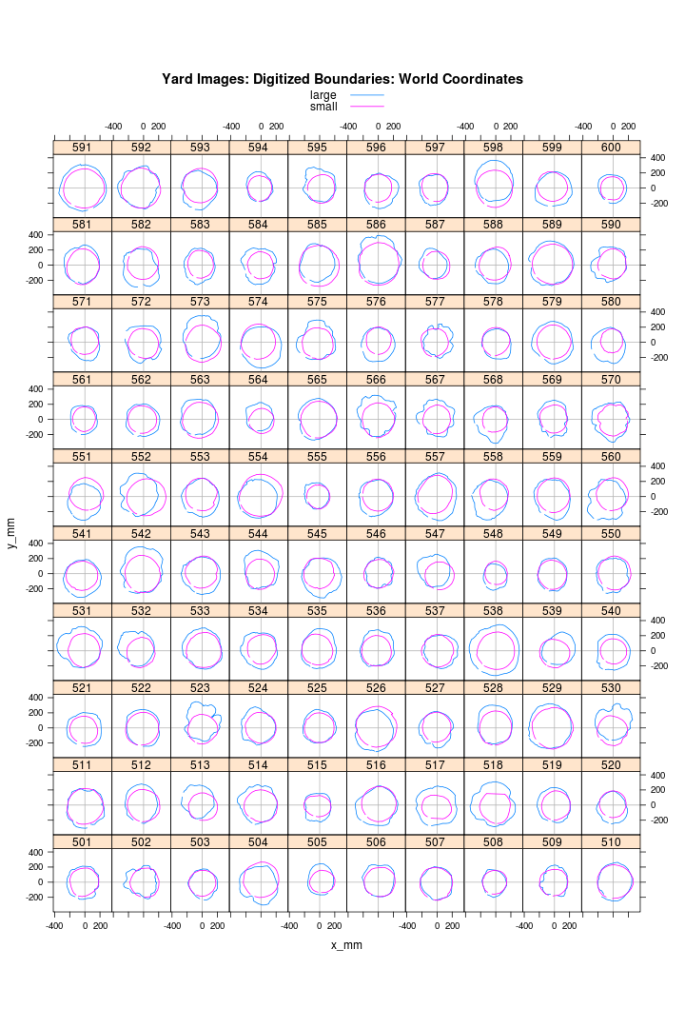

plot of chunk unnamed-chunk-4

Definite signs of foreshortening due to camera optical axis not being perpindicular to the log end. This shouldn't affect the area fractions but will influence pith eccentricty calculations. It also renders any sort of circularity measure useless. Perhaps a 3 point calibration procedure should be used? But the framer square is not guaranteed to lie in the log end plane, so hopeless???

At this stage the digitized points from the yard imagery are not rotationally aligned from one end to the other, which means that at a log level we can only consider average total pith eccentricity.

TODO: account for image orientation

Lets compare the results from the yard and A&E cameras:

xyplot(y_mm ~ x_mm | as.factor(ScionLogNumber), group = paste(imageType, type),   
 P, auto.key = list(lines = TRUE, points = FALSE), type = "l", subset = logEnd ==   
 "small", layout = c(10, 10, 1), aspect = "iso", panel = myxyplot, main = "A&E vs Yard Images : Small End")

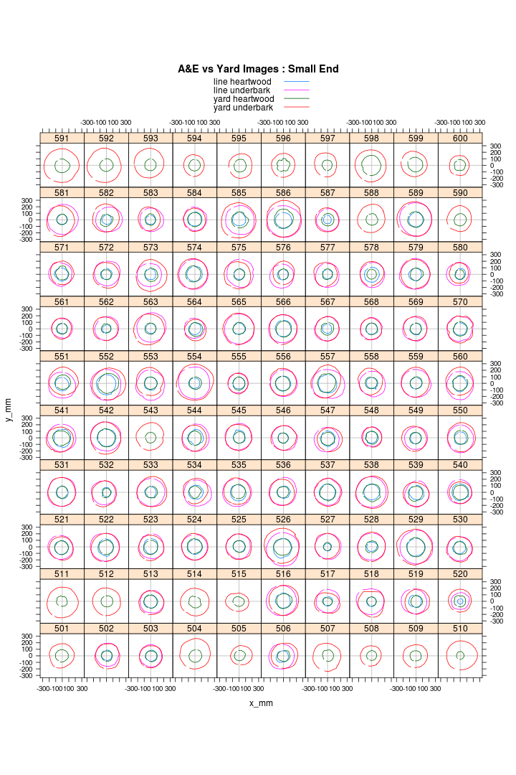

plot of chunk unnamed-chunk-5

xyplot(y_mm ~ x_mm | as.factor(ScionLogNumber), group = paste(imageType, type),   
 P, auto.key = list(lines = TRUE, points = FALSE), type = "l", subset = logEnd ==   
 "large", layout = c(10, 10, 1), aspect = "iso", panel = myxyplot, main = "A&E vs Yard Images : Large End")

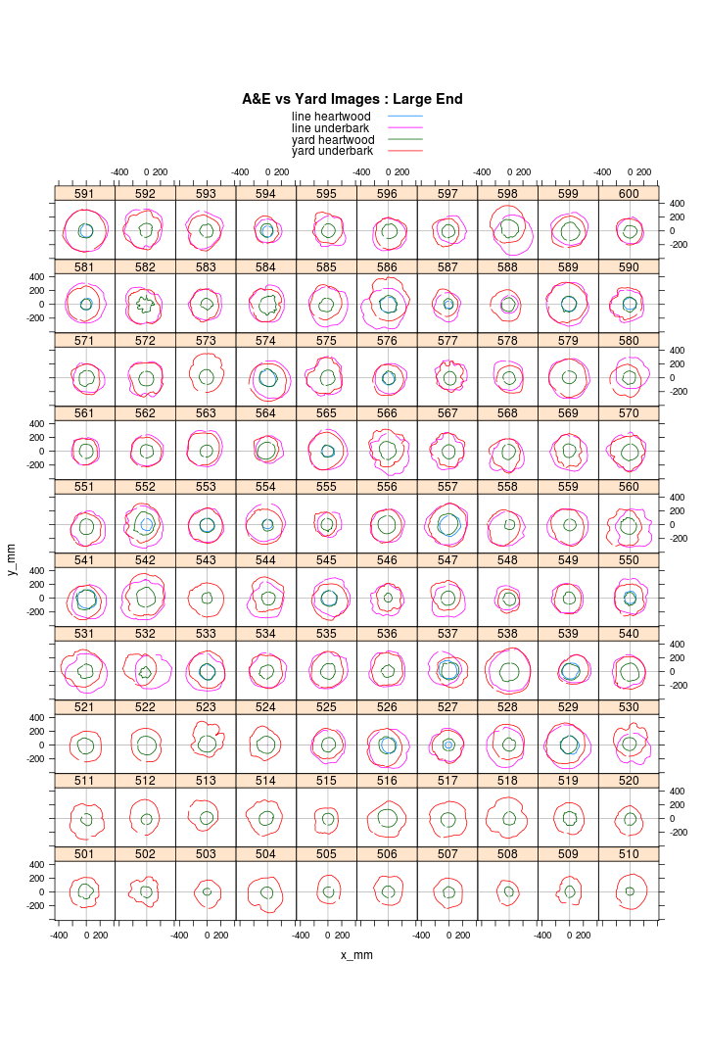

plot of chunk unnamed-chunk-5

Most of the small differences that exist can be attributed to log rotation. On the other hand, there are some curiosities:

* at the small end: 578, 520
* at the large end: 552, 527

## Summary Measures: Log Ends

ch = odbcConnect("LS15")  
X = sqlQuery(ch, "select * from LogEndDigitizations where mm_per_pixel is not null")  
str(X)

## 'data.frame': 200 obs. of 19 variables:  
## $ id : int 1 2 3 4 5 6 7 8 9 10 ...  
## $ ScionLogNumber : int 501 501 502 502 503 503 504 505 506 507 ...  
## $ digitizationTime: POSIXct, format: "2013-12-09 21:59:01" "2013-12-09 22:01:06" ...  
## $ operator : Factor w/ 2 levels "harringj","hodgkisp": 1 1 1 1 1 1 1 2 2 2 ...  
## $ flipbookNumber : int 1 1 2 2 3 3 4 5 6 7 ...  
## $ upInImage : Factor w/ 2 levels "left","top": 1 2 1 2 1 2 1 1 1 1 ...  
## $ logEnd : Factor w/ 2 levels "large","small": 1 2 1 2 1 2 1 1 1 1 ...  
## $ filename : Factor w/ 200 levels "IMGP1111.JPG",..: 1 2 3 4 5 6 7 8 9 10 ...  
## $ refLength : num 600 600 600 600 400 600 600 400 500 500 ...  
## $ imageType : Factor w/ 1 level "yard": 1 1 1 1 1 1 1 1 1 1 ...  
## $ mm_per_pixel : num 1.05 1.26 1.33 1.27 1.47 ...  
## $ A_mm2 : num 147954 111521 130011 117170 115750 ...  
## $ Aheart_mm2 : num 33724 28779 21072 20836 9011 ...  
## $ pithEccX : num 0.1188 0.0568 0.1233 -0.0904 -0.0713 ...  
## $ pithEccY : num 0.0277 -0.0127 -0.0365 0.0367 0.1378 ...  
## $ pithEccXheart : num 0.12477 0.06128 0.08948 -0.09176 0.00359 ...  
## $ pithEccYheart : num -0.09747 -0.0093 -0.00784 0.04384 -0.05492 ...  
## $ heartEccX : num 0.0592 0.0256 0.0873 -0.0517 -0.0723 ...  
## $ heartEccY : num 0.07419 -0.00793 -0.0333 0.01825 0.15317 ...

X$e = sqrt(X$pithEccX^2 + X$pithEccY^2)  
X$eh = sqrt(X$pithEccXheart^2 + X$pithEccYheart^2)  
X$E = sqrt(X$heartEccX^2 + X$heartEccY^2)  
X$ah = X$Aheart_mm2/X$A_mm2

Compare the two sets of images:

pch = c(1, 1, 19, 19)  
col = c("blue", "red", "blue", "red")  
# xyplot(A_mm2 ~ Aheart_mm2 | as.factor(ScionLogNumber),  
# group=paste(imageType, logEnd), X, pch=pch, col=col,  
# key=list(text=list(unique(paste(X$imageType, X$logEnd))),  
# points=list(pch=pch, col=col)))  
trellis.par.set(superpose.symbol = list(pch = pch, col = col))  
xyplot(A_mm2 ~ Aheart_mm2 | as.factor(ScionLogNumber), group = paste(imageType,   
 logEnd), X, auto.key = TRUE)

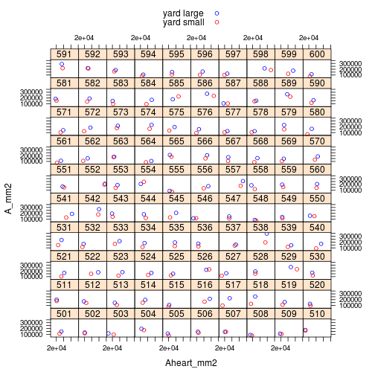

plot of chunk unnamed-chunk-7

The good news is that all three sources (yard camera, leading edge camera and trailing edge camera) yield areas that are in the same ballpark (so calibration stuff is probably ok). However:

* not all logs are represented by 4 points (ie. missing images/digitizations)
* at a given log end, yard and A&E cameras don't necessarily match
* large ends are oocasionally smaller than small ends!!! (
* 585: due to bad scaling of smalle end image
* 554: bad scaling at small end
* 516: damage at large end (reflength wrongly recorded at small end as 500 rather than 400). FIXED

xyplot(e ~ eh | imageType, group = logEnd, X, pch = 19, auto.key = TRUE) #, xlim=c(0,0.25))

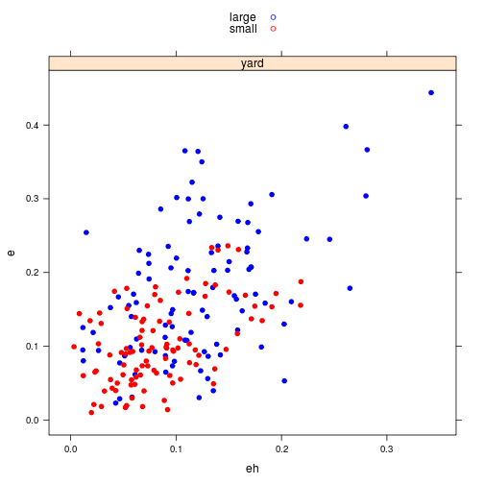

plot of chunk unnamed-chunk-8

Compare LE and SE characteristics.

xyplot(small ~ large, dcast(X[X$imageType == "yard", ], ScionLogNumber ~ logEnd,   
 value.var = "ah"), main = "Heart Area Fraction at LE and SE", aspect = "iso")

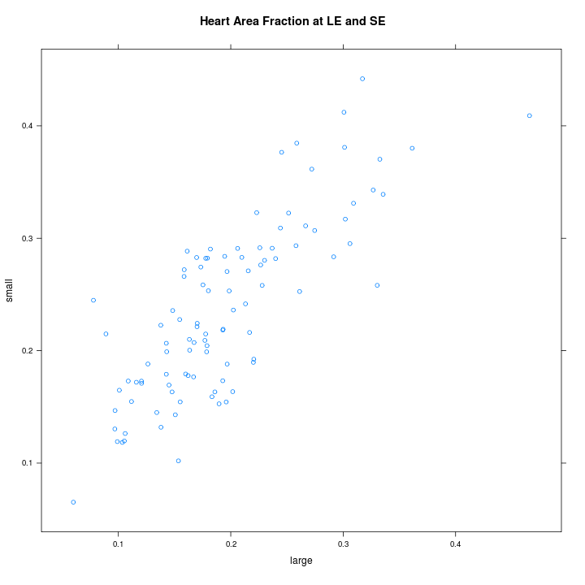

plot of chunk unnamed-chunk-9

xyplot(small ~ large, dcast(X[X$imageType == "yard", ], ScionLogNumber ~ logEnd,   
 value.var = "e"), main = "Pith Eccentricty at LE and SE", aspect = "iso")

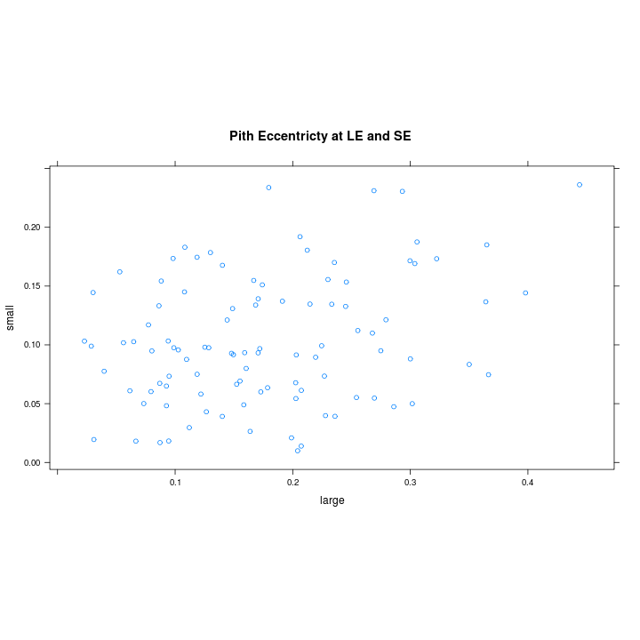

plot of chunk unnamed-chunk-9

# xyplot(apply(cbind(small,large),1,max)~ (small+large)/2,  
# dcast(X[X$imageType=='yard',], ScionLogNumber ~ logEnd, value.var='e'),  
# main='Pith Eccentricty at LE and SE',  
# aspect='iso',xlab='Average',ylab='Max') # repeated below!!!  
xyplot(small ~ large, dcast(X[X$imageType == "yard", ], ScionLogNumber ~ logEnd,   
 value.var = "eh"), main = "Pith Eccentricity in heart zone at LE and SE",   
 aspect = "iso")

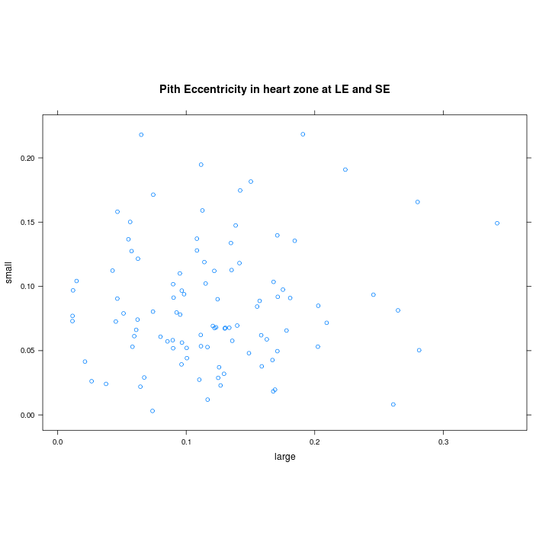

plot of chunk unnamed-chunk-9

xyplot(small ~ large, dcast(X[X$imageType == "yard", ], ScionLogNumber ~ logEnd,   
 value.var = "E"), main = "Heart Eccentricty at LE and SE", aspect = "iso")

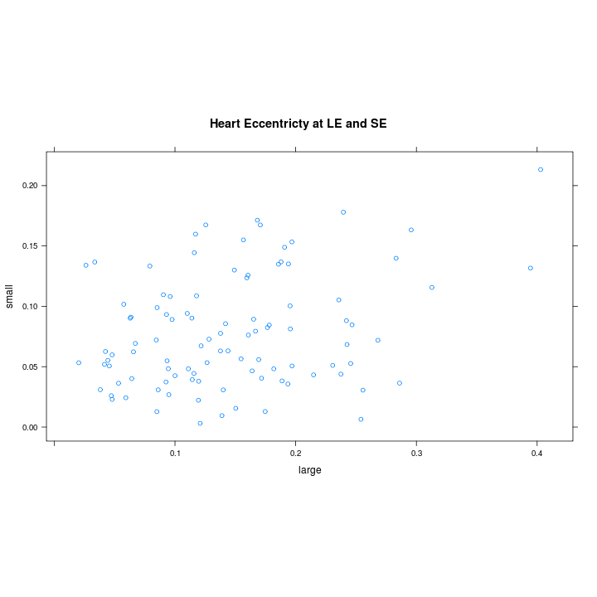

plot of chunk unnamed-chunk-9

Unsurprisingly, the heart area fraction is reasonably consistent from end-to-end whereas the pith eccentricities are not.

## Summary Measures: Logs

ch = odbcConnect("LS15")  
L = sqlQuery(ch, "select * from logs")

*Pith Eccentricity*

xyplot(maxPithEcc ~ avgPithEcc, L, panel = function(x, y, ...) {  
 panel.abline(c(0, 1), col = "grey70")  
 panel.xyplot(x, y, ...)  
})

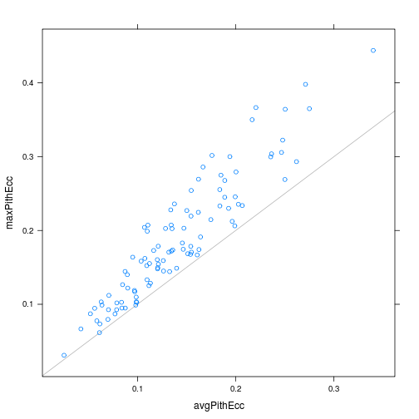

plot of chunk unnamed-chunk-11

Despite the poor correlation between pith eccentricity at the LE and SE noted above, the maximum pith eccentricity and the average pith eccentricity rank logs similarly, certainly at the extremes (e.g the worst and best logs for avgPithEcc are the same as those for maxPithEcc). Probably not worth carrying the average value further.

*Log SWV, Board SWV and MoE*

pairs(L[, c("heartVolFrac", "avgPithEcc", "avgHeartEcc", "velocity", "avgBoardSWV",   
 "avgBoardMoE")], lower.panel = function(x, y, digits = 2, prefix = "", cex.cor,   
 ...) {  
 usr <- par("usr")  
 on.exit(par(usr))  
 par(usr = c(0, 1, 0, 1))  
 r <- abs(cor(x, y))  
 txt <- format(c(r, 0.123456789), digits = digits)[1]  
 txt <- paste0(prefix, txt)  
 if (missing(cex.cor))   
 cex.cor <- 0.8/strwidth(txt)  
 text(0.5, 0.5, txt, cex = cex.cor * r)  
})

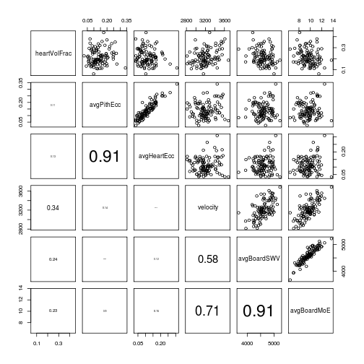

plot of chunk unnamed-chunk-12

The high degree of correlation between pith and heart eccentricity implies that eccentricity, at least in the bottom log, developed later in life for the trees from which these logs were taken. To make life simpler, lets not consider ''avgHeartEcc'' in further exploration.

This level of positive correlation observed between log SWV (''velocity'') and heartwood volume fraction (''heartVolFrac'') is about what would be expected if the log average stiffness were independent of heart volume fraction but the log average green density was linearly related to it.

The observed correlation is not consistent with a model having log average stiffness negatively correlated with heart/core volume fraction.

Do any of the log end image derived metrics improved board recovery prediction?

summary(lm(avgBoardMoE ~ velocity + heartVolFrac + avgPithEcc + avgHeartEcc,   
 L))

##   
## Call:  
## lm(formula = avgBoardMoE ~ velocity + heartVolFrac + avgPithEcc +   
## avgHeartEcc, data = L)  
##   
## Residuals:  
## Min 1Q Median 3Q Max   
## -2.2607 -0.2938 0.0677 0.4625 1.2410   
##   
## Coefficients:  
## Estimate Std. Error t value Pr(>|t|)   
## (Intercept) -7.80e+00 1.15e+00 -6.81 8.7e-10 ***  
## velocity 6.14e-03 3.76e-04 16.32 < 2e-16 ***  
## heartVolFrac -1.08e+01 1.21e+00 -8.96 2.8e-14 ***  
## avgPithEcc 4.84e+00 3.19e+00 1.52 0.13   
## avgHeartEcc -4.88e+00 3.77e+00 -1.29 0.20   
## ---  
## Signif. codes: 0 '***' 0.001 '**' 0.01 '*' 0.05 '.' 0.1 ' ' 1  
##   
## Residual standard error: 0.662 on 95 degrees of freedom  
## Multiple R-squared: 0.756, Adjusted R-squared: 0.746   
## F-statistic: 73.5 on 4 and 95 DF, p-value: <2e-16

summary(lm(avgBoardMoE ~ velocity + heartVolFrac, L))

##   
## Call:  
## lm(formula = avgBoardMoE ~ velocity + heartVolFrac, data = L)  
##   
## Residuals:  
## Min 1Q Median 3Q Max   
## -2.2215 -0.2747 0.0493 0.4910 1.3365   
##   
## Coefficients:  
## Estimate Std. Error t value Pr(>|t|)   
## (Intercept) -7.866603 1.145976 -6.86 6.3e-10 ***  
## velocity 0.006135 0.000374 16.42 < 2e-16 ***  
## heartVolFrac -9.879304 1.005230 -9.83 3.2e-16 ***  
## ---  
## Signif. codes: 0 '***' 0.001 '**' 0.01 '*' 0.05 '.' 0.1 ' ' 1  
##   
## Residual standard error: 0.664 on 97 degrees of freedom  
## Multiple R-squared: 0.75, Adjusted R-squared: 0.744   
## F-statistic: 145 on 2 and 97 DF, p-value: <2e-16

summary(lm(avgBoardMoE ~ velocity, L))

##   
## Call:  
## lm(formula = avgBoardMoE ~ velocity, data = L)  
##   
## Residuals:  
## Min 1Q Median 3Q Max   
## -2.920 -0.512 0.110 0.668 2.058   
##   
## Coefficients:  
## Estimate Std. Error t value Pr(>|t|)   
## (Intercept) -6.027537 1.589032 -3.79 0.00026 ***  
## velocity 0.004896 0.000494 9.90 < 2e-16 ***  
## ---  
## Signif. codes: 0 '***' 0.001 '**' 0.01 '*' 0.05 '.' 0.1 ' ' 1  
##   
## Residual standard error: 0.933 on 98 degrees of freedom  
## Multiple R-squared: 0.5, Adjusted R-squared: 0.495   
## F-statistic: 98.1 on 1 and 98 DF, p-value: <2e-16

Yes, ''heartVolFrac'' improves from 0.50 to 0.74. Neither of the eccentricity measures are useful.

The next pair of plots illustrate the improvement in prediction of average board MoE if heartwood volume fraction is included:

par(mfcol = c(1, 2))  
m.2 = lm(avgBoardMoE ~ velocity + heartVolFrac, L)  
m.1 = lm(avgBoardMoE ~ velocity, L)  
plot(L$avgBoardMoE ~ predict(m.1), ylab = "measured", xlab = "predicted", main = "Log SWV alone")  
plot(L$avgBoardMoE ~ predict(m.2), ylab = "measured", xlab = "predicted", main = "Log SWV + heartwood\n volume fraction")

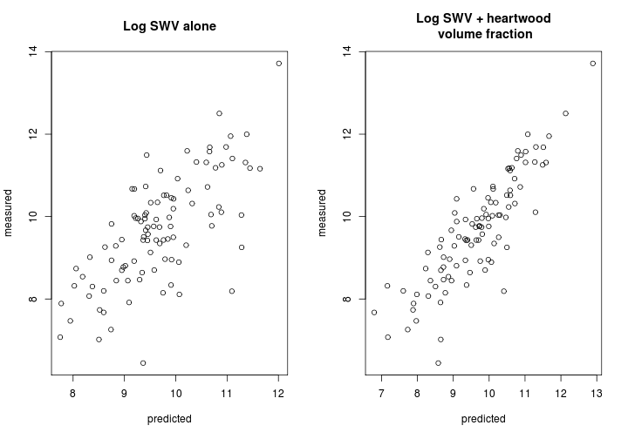

plot of chunk unnamed-chunk-14

*Bow and Crook*

par(mfcol = c(1, 2))  
plot(avgBoardABC ~ heartVolFrac, L)  
plot(avgBoardABC ~ avgPithEcc, L)

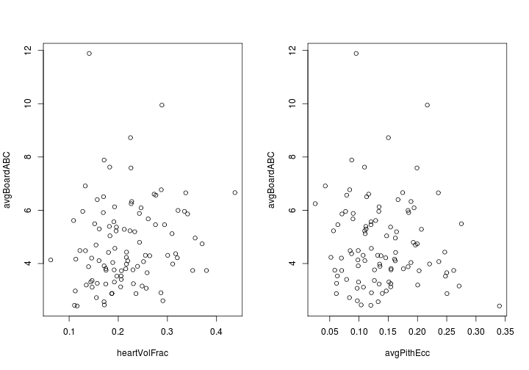

plot of chunk unnamed-chunk-15

summary(lm(avgBoardABC ~ velocity + heartVolFrac + avgPithEcc + avgHeartEcc,   
 L))

##   
## Call:  
## lm(formula = avgBoardABC ~ velocity + heartVolFrac + avgPithEcc +   
## avgHeartEcc, data = L)  
##   
## Residuals:  
## Min 1Q Median 3Q Max   
## -2.478 -0.902 -0.441 0.736 5.938   
##   
## Coefficients:  
## Estimate Std. Error t value Pr(>|t|)   
## (Intercept) 1.64e+01 2.42e+00 6.79 9.5e-10 ***  
## velocity -4.37e-03 7.94e-04 -5.51 3.1e-07 ***  
## heartVolFrac 1.16e+01 2.55e+00 4.54 1.7e-05 ***  
## avgPithEcc -1.89e+01 6.73e+00 -2.81 0.0060 **   
## avgHeartEcc 2.21e+01 7.96e+00 2.78 0.0066 **   
## ---  
## Signif. codes: 0 '***' 0.001 '**' 0.01 '*' 0.05 '.' 0.1 ' ' 1  
##   
## Residual standard error: 1.4 on 95 degrees of freedom  
## Multiple R-squared: 0.301, Adjusted R-squared: 0.271   
## F-statistic: 10.2 on 4 and 95 DF, p-value: 6.47e-07

randomForest(avgBoardABC ~ velocity + heartVolFrac + avgPithEcc + avgHeartEcc,   
 L, mtry = 1, ntree = 500)

##   
## Call:  
## randomForest(formula = avgBoardABC ~ velocity + heartVolFrac + avgPithEcc + avgHeartEcc, data = L, mtry = 1, ntree = 500)   
## Type of random forest: regression  
## Number of trees: 500  
## No. of variables tried at each split: 1  
##   
## Mean of squared residuals: 2.251  
## % Var explained: 15.31

Nothing to see here. Move on.

*Twist*

par(mfcol = c(1, 2))  
plot(avgBoardTwist ~ heartVolFrac, L)  
plot(avgBoardTwist ~ avgPithEcc, L)

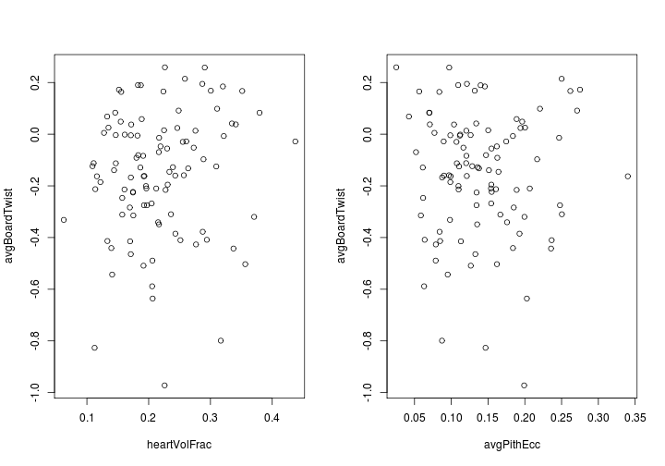

plot of chunk unnamed-chunk-17

summary(lm(avgBoardTwist ~ velocity + heartVolFrac + avgPithEcc + avgHeartEcc,   
 L))

##   
## Call:  
## lm(formula = avgBoardTwist ~ velocity + heartVolFrac + avgPithEcc +   
## avgHeartEcc, data = L)  
##   
## Residuals:  
## Min 1Q Median 3Q Max   
## -0.8215 -0.1310 0.0222 0.1642 0.4051   
##   
## Coefficients:  
## Estimate Std. Error t value Pr(>|t|)  
## (Intercept) -0.624801 0.422546 -1.48 0.14  
## velocity 0.000128 0.000139 0.93 0.36  
## heartVolFrac 0.373253 0.445329 0.84 0.40  
## avgPithEcc -0.429748 1.175455 -0.37 0.72  
## avgHeartEcc 0.330082 1.389318 0.24 0.81  
##   
## Residual standard error: 0.244 on 95 degrees of freedom  
## Multiple R-squared: 0.0254, Adjusted R-squared: -0.0156   
## F-statistic: 0.62 on 4 and 95 DF, p-value: 0.65

randomForest(avgBoardTwist ~ velocity + heartVolFrac + avgPithEcc + avgHeartEcc,   
 L, mtry = 1, ntree = 500)

##   
## Call:  
## randomForest(formula = avgBoardTwist ~ velocity + heartVolFrac + avgPithEcc + avgHeartEcc, data = L, mtry = 1, ntree = 500)   
## Type of random forest: regression  
## Number of trees: 500  
## No. of variables tried at each split: 1  
##   
## Mean of squared residuals: 0.06305  
## % Var explained: -8.37

If ABC was disappointing, twist is a heart breaker.

## TODO

* compare log end areas based on imagery with yard SED/LED, KPP SED/LED, USNR cross-sections
* add ring count (heart and total) at both ends to list of potential predictors