# LS.1.5: Board Conditioning: Update 29-Jul-2014

Post processing of scans done using:

$ mysql -u root joe90 < updatedb1.sql  
$ python3.3 Joescan3/updatedb.py

## Environment

The boards are stored in a shed, completely enclosed in a black plastic membrane.

Two probes, each measuring temperature and relative humidity at 15 min intervals, were inserted into the middle of the stack 30 June 2014. The subset boards of boards being monitored are within the same plastic envelope, but a metre or so above where the probes are.

Apparently, at some time in July, radiant heaters in the shed were turned on, but not the heater directly above the board stack.

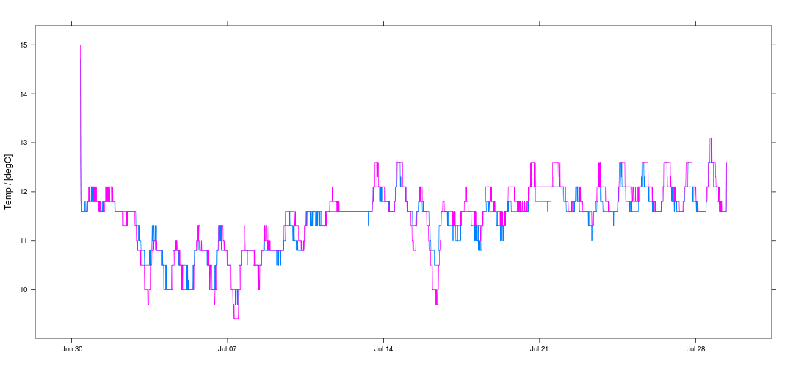 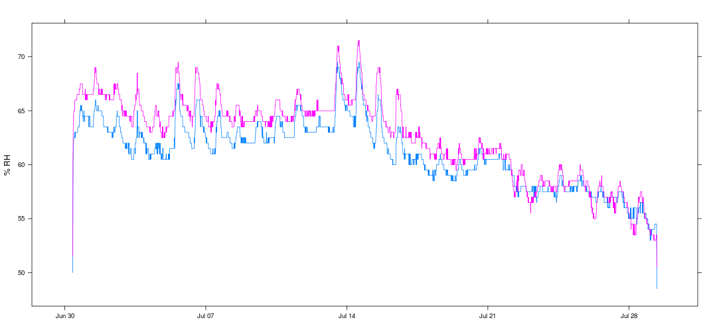 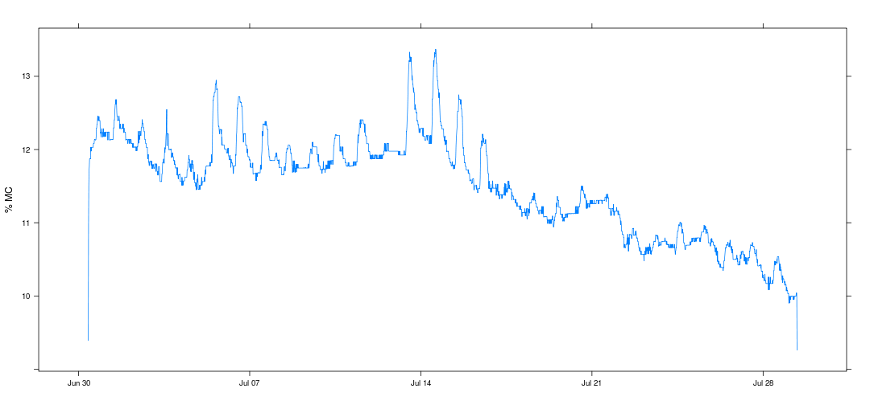 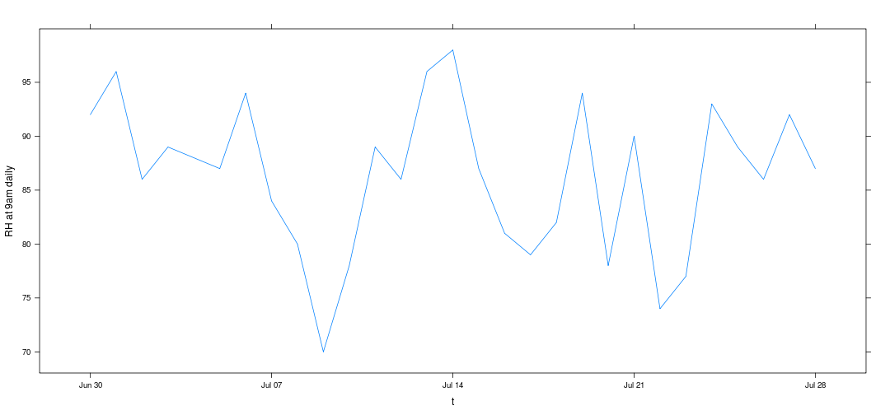 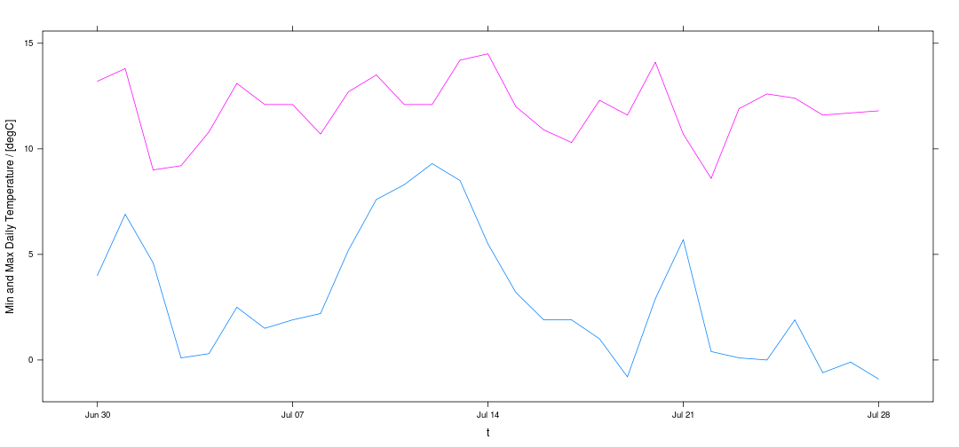

Temperature in the stack is relatively stable, with a diurnal variation of ~ 1degC and a long term variation (i.e. the slight rise over the month) that reflects the introduction of heating. Bothe probes essentially measure the same temperature.

Humidity on the other hand is a bit weird. Diurnal variation exists, but is presumably driven by changes in relative humidity with temperature for a fixed absolute humidity. Certainly the diurnal variation is much less than atmospheric. The long term trend though is quite unlike the exterior atmosphere with a significant reduction particularly over the last half of July.

The reduction in relative humidity corresponds to ~ a 2% change in equilibrium moisture content (using the 1999 FPL sorption isotherm), which equates, **at equilibrium**, to a 170 g reduction in the weight of a typical board. However, there's not much sign of a decrese in board mass, and certainly nothing close to the equilibrium value.

It is also odd that two identical probes, at the same location measure humidities that can differ by as much as 5%. Perhaps they're just not that accurate, or perhaps the lack of airflow in the stack is preventing the probes from operating correctly.

## Mass

Based on repeated weights of the white aluminium reference beam, an estimate of the standard error for the weight measurement is 0.07 kg. In the plot below the red dotted lines indicate the 95% limits (assuming weight errors normally distributed).

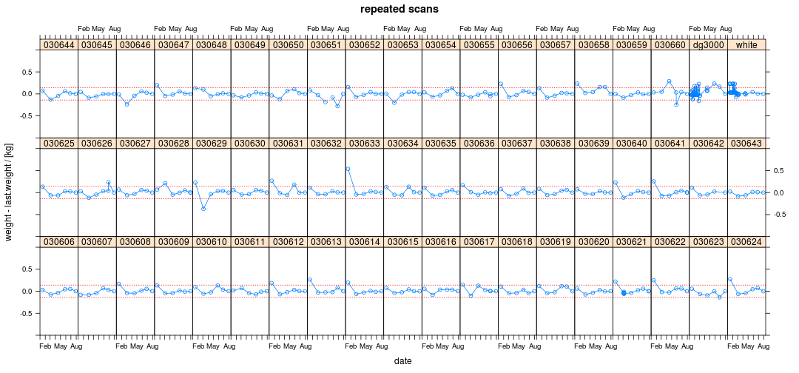

On the whole, the board masses have changed very little, with what changes there have been being equally distributed bewteen gains and losses.

It is clear from this remeasurement that the immediately preceding measurement of 030660 was almost certainly an extreme error.

030651 remains an oddity.

The current remeasurement of 030626 exhibits poor repeatability (whereas 030655 exhibits good repeatability).

## Resonance

Based on repeated weights of the wooden calibration beam (dg3000), an estimate of the standard error for the weight measurement is 2 Hz. In the plot below the red dotted lines indicate the 95% limits (assuming weight errors normally distributed). 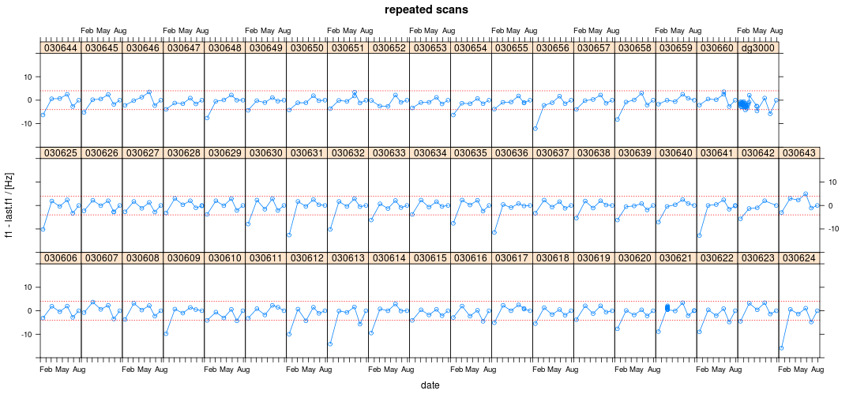

Without exception, all the resonances have dropped since last time, but by varying amounts and within the measurement error limits.

Grant Emms suggest this is due to changes in board temperature.

[grant76](http://www.dpi.nsw.gov.au/__data/assets/pdf_file/0010/389917/The-Effect-of-Change-of-Temperature-On-the-Apparent-Modulus-of-Elesticity-of-Radiata-Pine-Scantling-with-Particular-Reference-to-Mechanical-Stress-Grading.pdf) measured an average change in modulus for dry radiata pine (12%mc) in bending of 4.9% over the range 3-22 degC. Since

then for %/degC, GPa, m, g/cc, and degC, then Hz, or for Hz (the mean value in this study), Hz. which is in the right ballpark.

## Crook

Crook is probably the warp measure least affected by how the boards are stacked between measurements. Repeated measurements suggest the mid-point crook estimate has a standard error of around 1 mm.

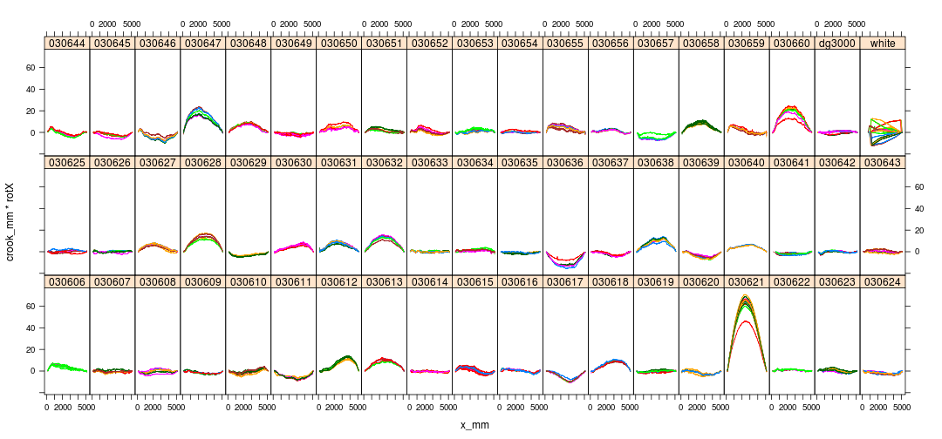

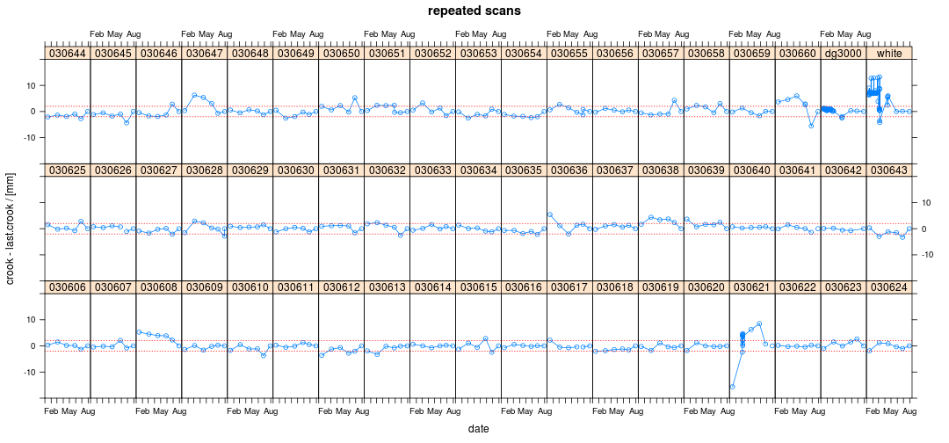

With a couple of notable exceptions (030660, 030621) the crook values appear to have stabilised.

## Bow

Mid-point bow appears to have a similar repeatability as mid-point crook, i.e. 1 mm.

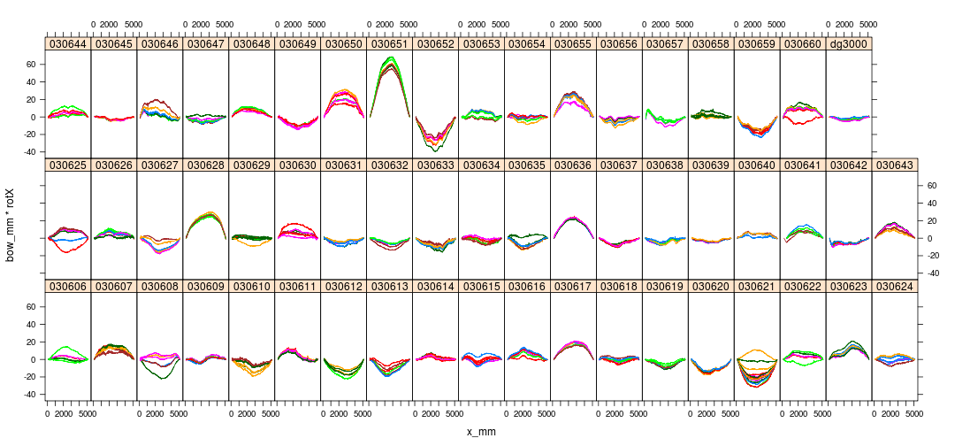

The latest measurement of 030621 is comletely unlike any previous and the change cannot be explained away as an orientation issue since the crook is about right. Perhaps it was mounted round the wrong way length wise? (But the maxima is still closer to x=0!)

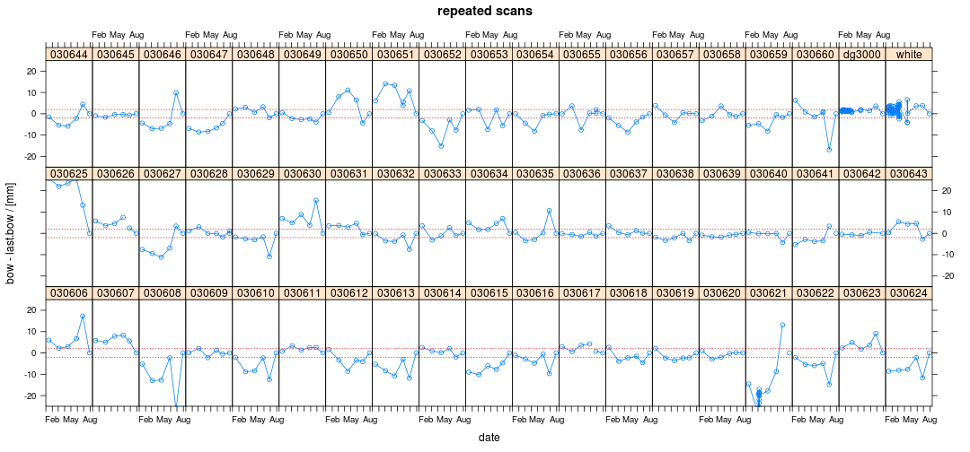

While more variable than crook, the bow values also appear to have settled back down, particularly when compared with the large changes that were seen in last months data. Once again 030660 and 030621 are behaving in an extreme fashion.

## Twist

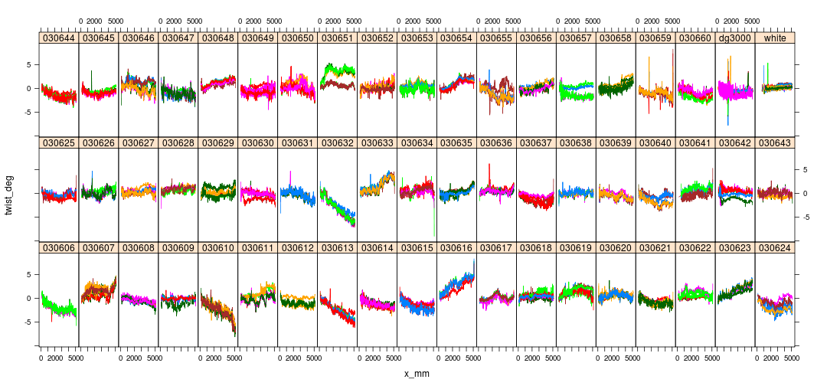

Total twist repeatability looks to be around 0.5 deg (~1mm for 100mm width).

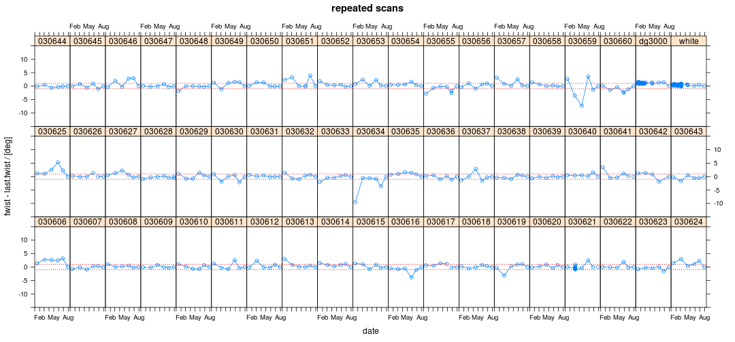

For the most part twist appears to have reached a stable value. Some exceptions, probably artefacts of processing (616, 634, 659).

## Individual Boards

Lets take a detailed look at the warp evolution for some of the problem boards:

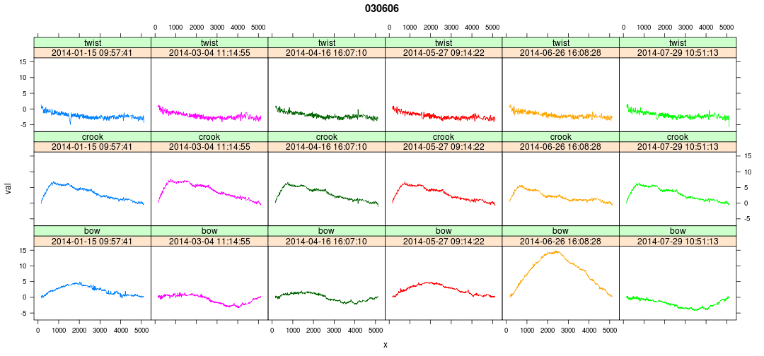 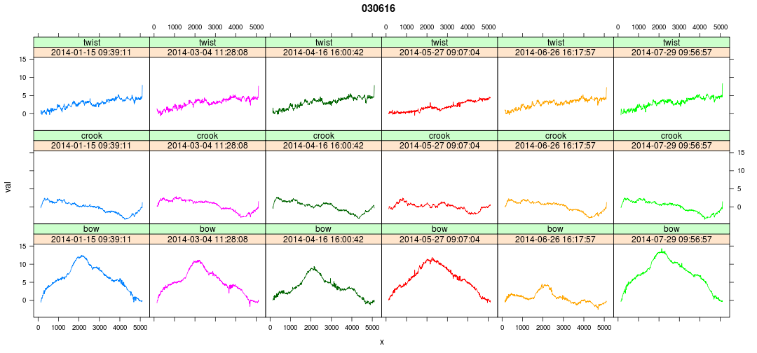 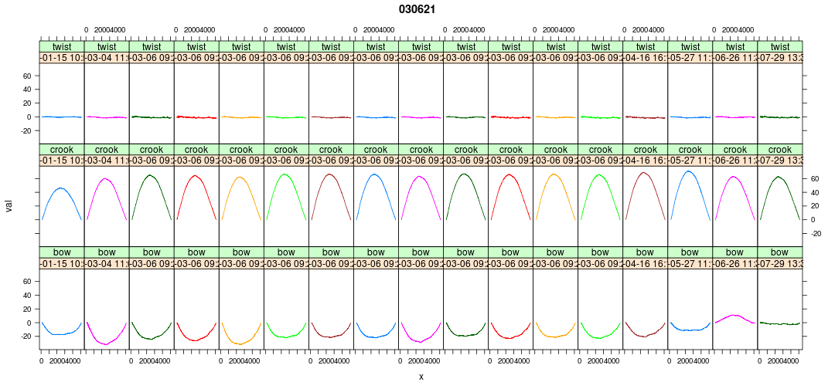 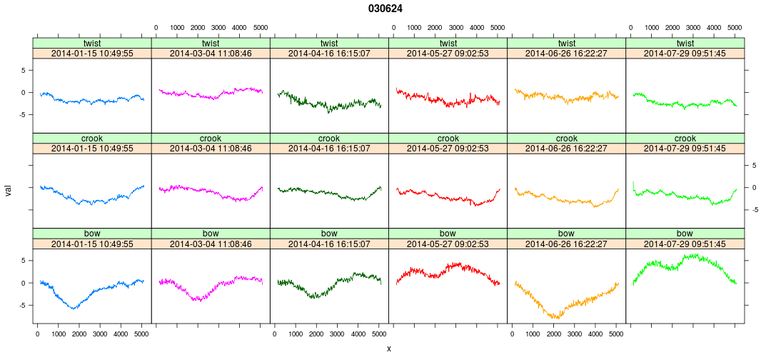 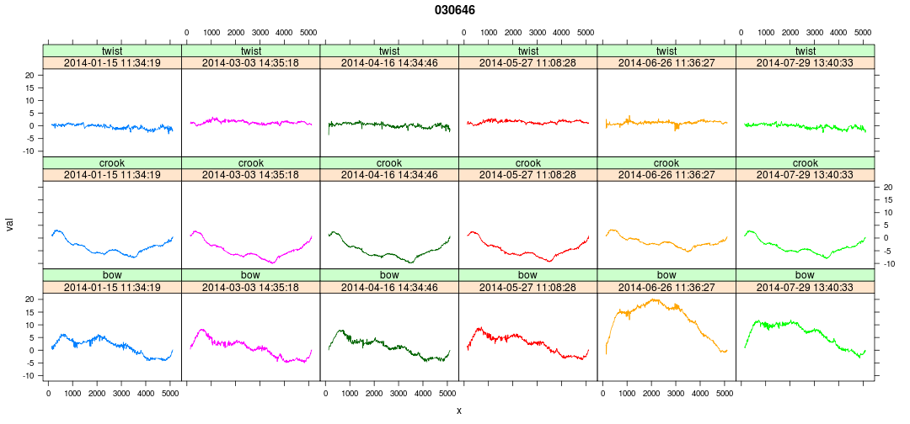 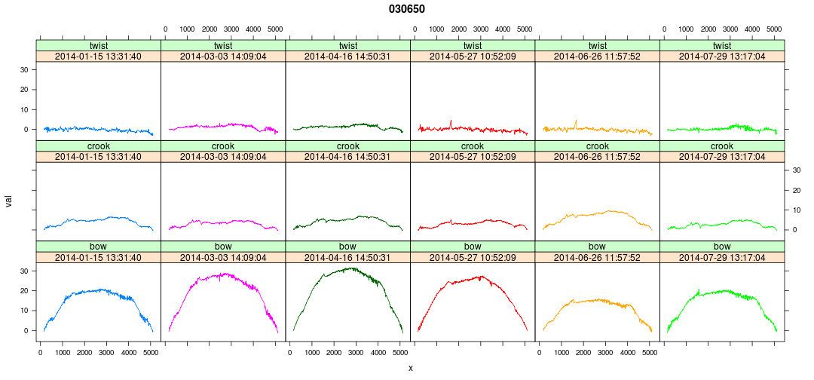 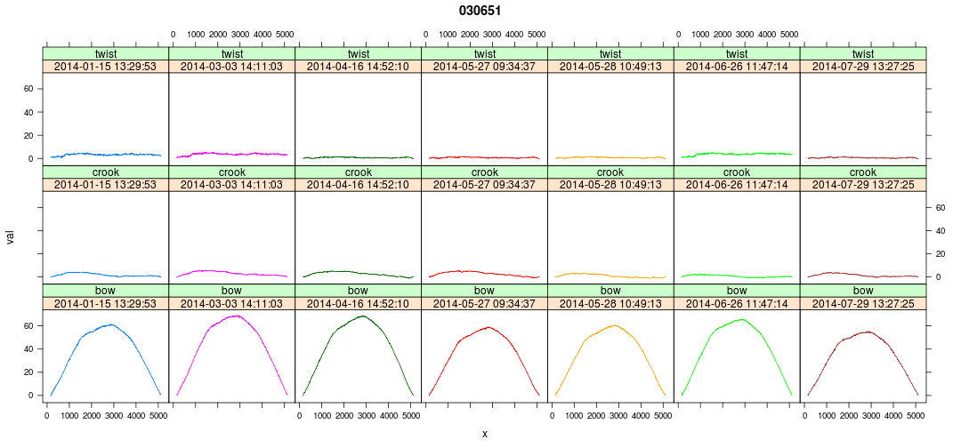 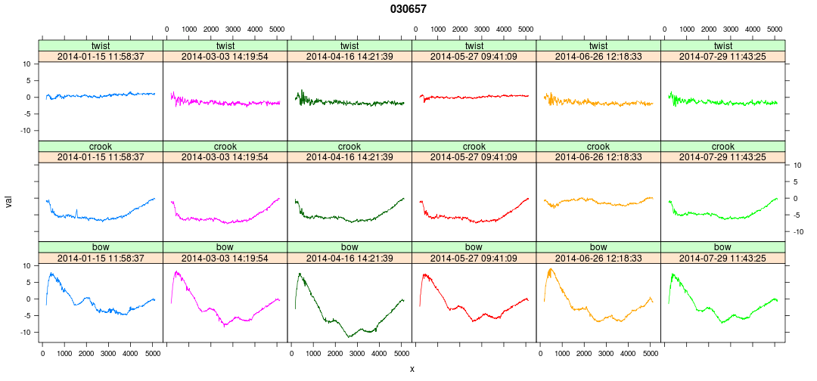 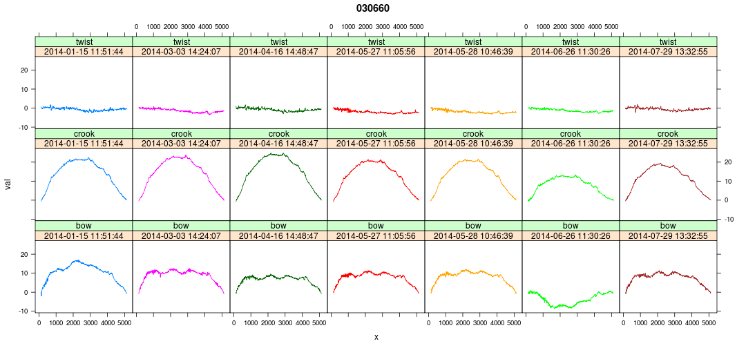

While some of these evolutions are quite weird, there's nothing that looks obviously wrong.

## Conclusions

1. The stack condition measurements seem peculiar and probably don't represent the average environment within the wrapped stack.
2. For the majority of boards, crook and bow are probably as stable as they're ever going to get.
3. There's a small fraction of boards that appear to be very sensitive to environmetal perturbation. It would be interesting to know why this is.

## Recommendations and Further Work

1. Hold the boards wrapped as they are till SWI decides the LS15 project is completed. If funding and manpower permits, continue to measure the subset boards at monthly intervals.
2. Continue to monitor the stack conditions, but check that the equipment being used operates properly in the absence of airflow.
3. Establish better repeatability estimates, particularly for the warp measures. A workplan for doing this exists, and is awaiting approval.
4. Assuming the last 3 months represent typical 'post-drying' warp values, revisit the question of whether or not the first measurement differs significantly (and hence how accurate a picture of log level stability based on the first scan of all boards might be)

Nice-to-do:

1. Improve the twist extraction algorithm to eliminate artefacts arising at the board ends. This is probably a tuning rather than re-engineering exercise.
2. Investigate if change in moisture content between time of first scanning and equilibrium can be used to predict the final warp. If so, then perhaps we only need to reweigh (rather than rescan) all the boards. This is a long shot (since the first measurement was made on boards with mc gradients) but needs doing before rescanning everything.
3. Board weights exhibit a surprisingly large number of extreme errors (e.g. 030651 discussed above). Perhaps there is something in the setup that causes this? Perhaps multiple measurements should be made?
4. Once again, a small number of boards (two probably) have been mounted on the scanner inconsistently. This problem could be solved by marking the boards to reflect the scan orientation on first measurement and from then on orienting similarly.
5. Assuming our experience with this set of boards is typical, it is not going to be practical to condition boards from the Hyne or JNL trial till they reach equilibrium. Thus it is important that we extract from this exercise some guidance as to how critical conditioning is in terms of log level performance.