# LS.1.5: Board Conditioning: Update 27-Jun-2014

Post processing of scans done using:

$ mysql -u root joe90 < updatedb1.sql  
$ python3.3 Joescan3/updatedb.py

## Mass

Based on repeated weights of the white aluminium reference beam, an estimate of the standard error for the weight measurement is 0.07 kg. In the plot below the red dotted lines indicate the 95% limits (assuming weight errors normally distributed).

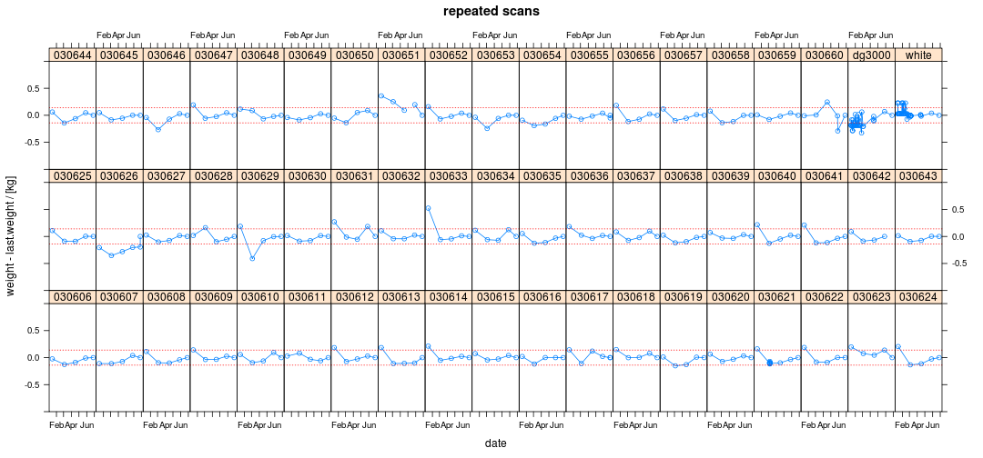

On the whole, the board masses have changed very little, with what changes there have been being equally distributed bewteen gains and losses.

It is clear from this remeasurement that the immediately preceding measurement of 030660 was almost certainly an extreme error.

030651 remains an oddity.

The current remeasurement of 030626 exhibits poor repeatability (whereas 030655 exhibits good repeatability).

## Resonance

Based on repeated weights of the wooden calibration beam (dg3000), an estimate of the standard error for the weight measurement is 2 Hz. In the plot below the red dotted lines indicate the 95% limits (assuming weight errors normally distributed). 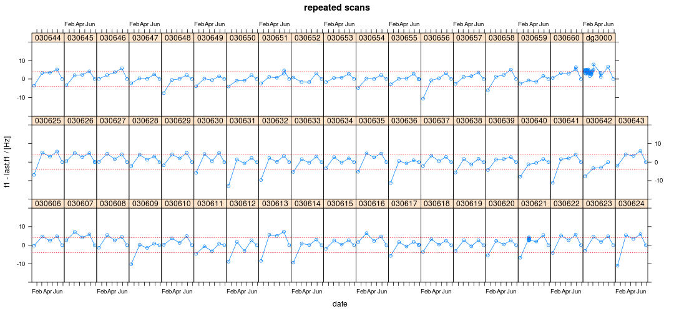

Without exception, all the resonances have dropped since last time, but by varying amounts and within the measurement error limits.

Grant, could this be a calibration artefact? Ambient temperature?

## Crook

Crook is probably the warp measure least affected by how the boards are stacked between measurements. Repeated measurements suggest the mid-point crook estimate has a standard error of around 1 mm.

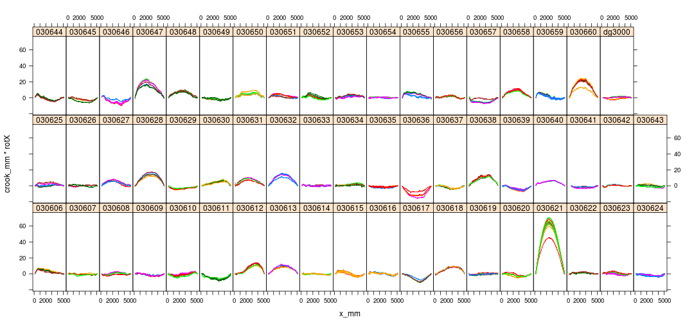

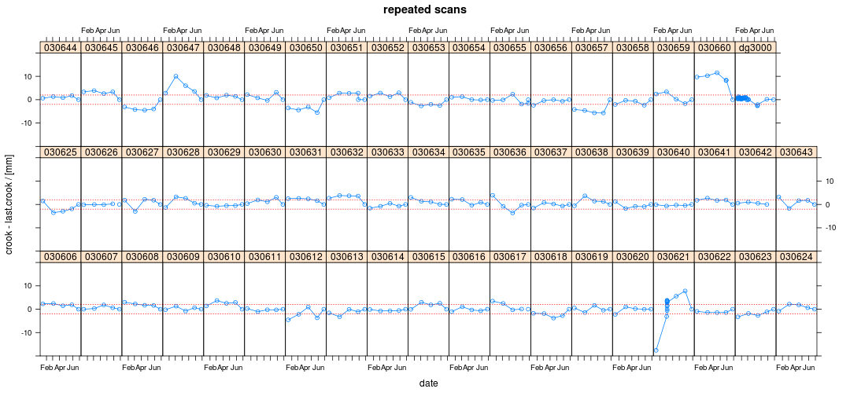

Around 26% (15/57) of the boards appear to have changed significantly since the previous measurement. Dramatic changes apparent for four (7%) of these boards (621, 650, 657, 660).

## Bow

Mid-point bow appears to have a similar repeatability as mid-point crook, i.e. 1 mm.

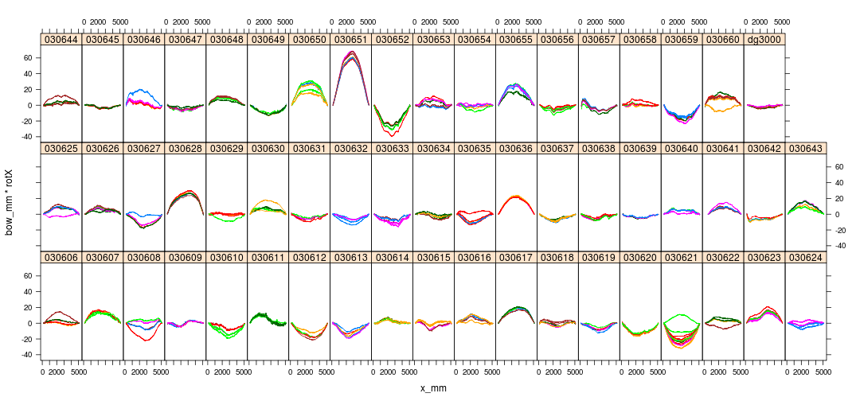

The latest measurement of 030621 is comletely unlike any previous and the change cannot be explained away as an orientation issue since the crook is about right. Perhaps it was mounted round the wrong way length wise? (But the maxima is still closer to x=0!)

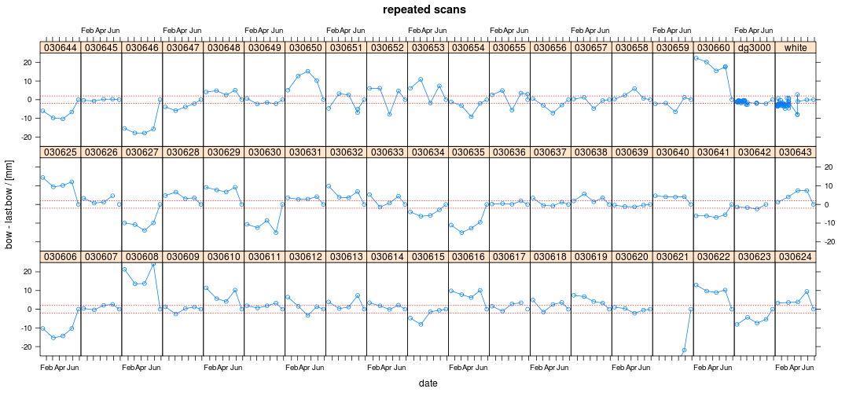

Around 30% (37/57) of the boards appear to have significantly different bow compared to previous measurement. Dramatic changes for 19 (33%) boards (606, 608, 610, 613, 616, 621, 622, 624, 625, 627, 629, 630, 632, 635, 643, 644, 646, 650, 660).

## Twist

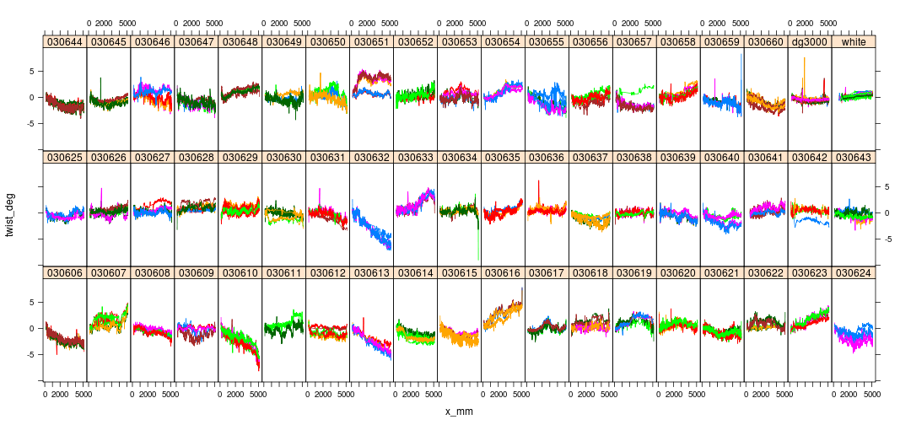

Total twist repeatability looks to be around 0.5 deg (~1mm for 100mm width).

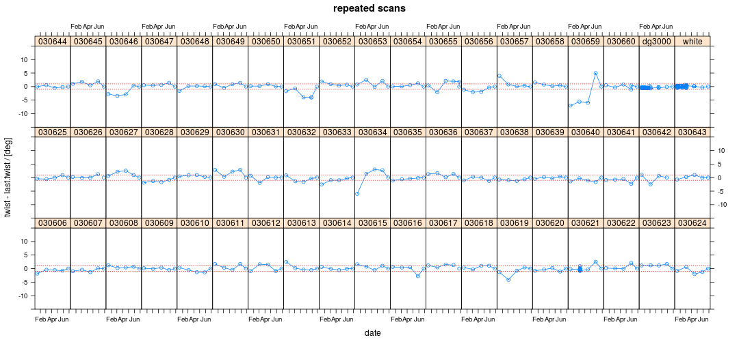

For the most part twist appears to have reached a stable value. Some exceptions, probably artefacts of processing (616, 634, 659).

## Individual Boards

Lets take a detailed look at the warp evolution for some of the problem boards:

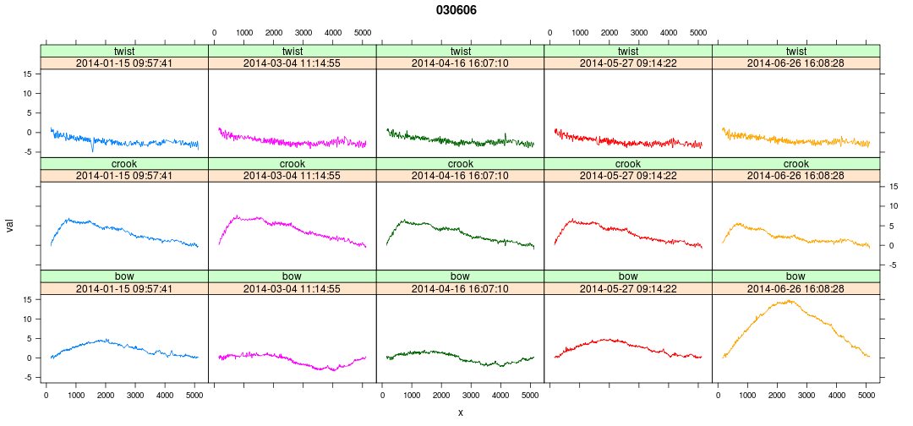 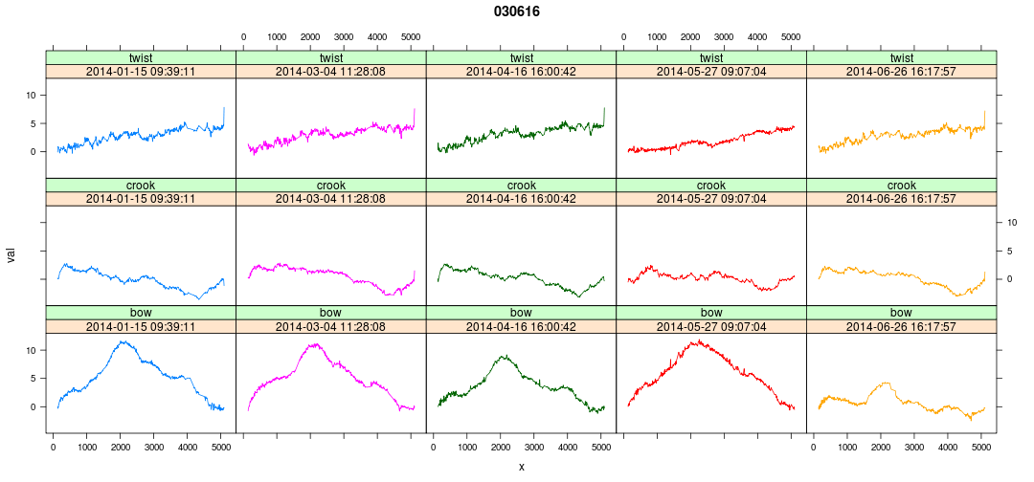 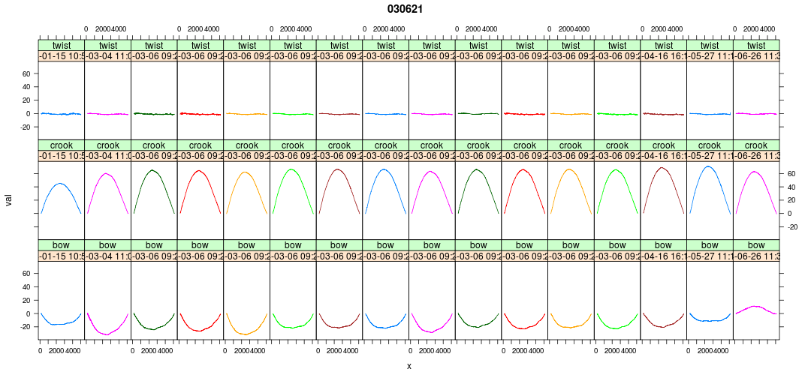 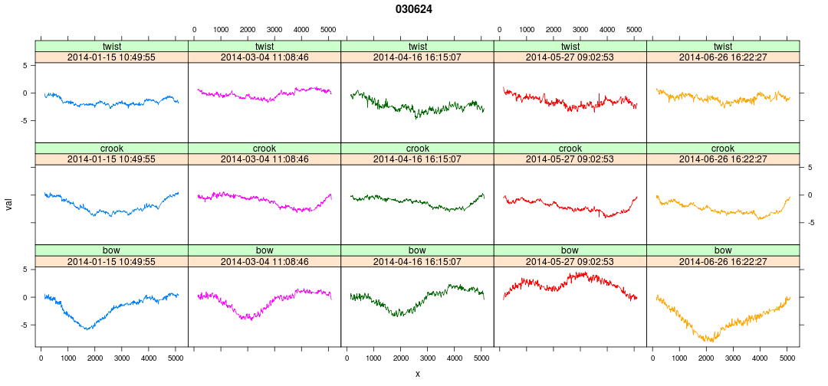 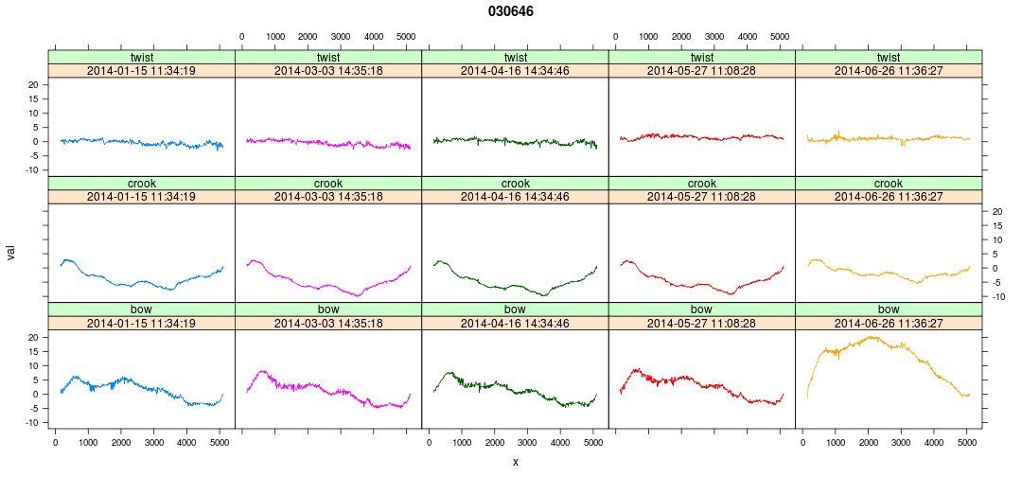 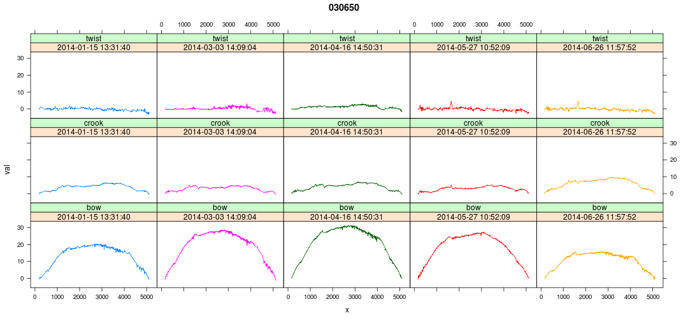 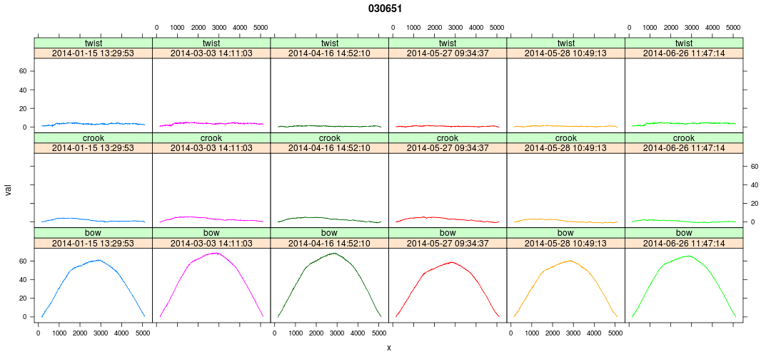 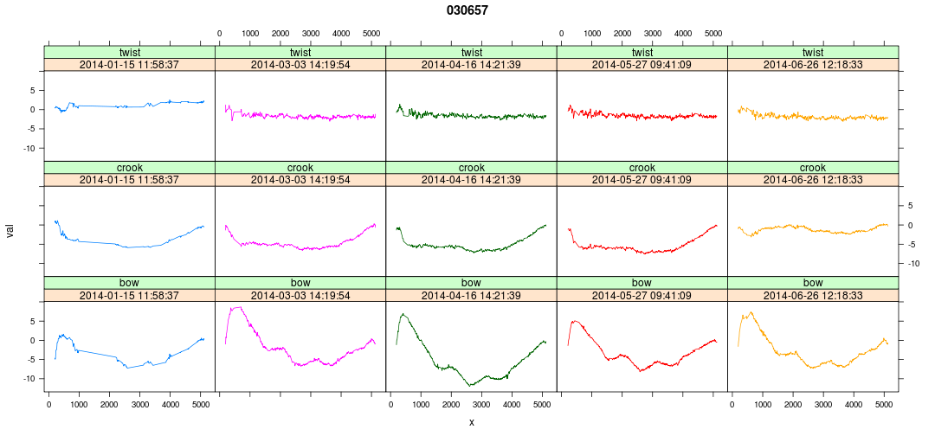 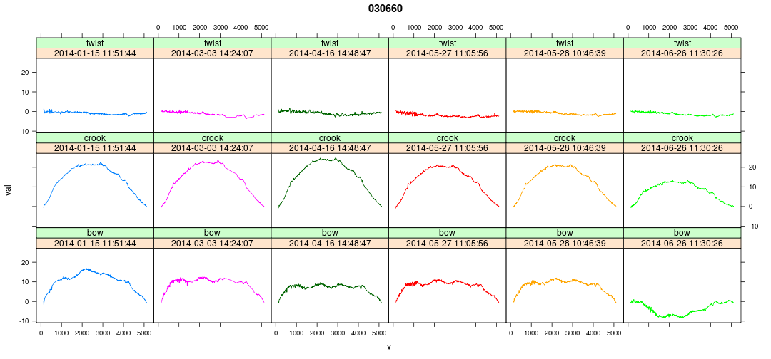

While some of these evolutions are quite weird, there's nothing that looks obviously wrong.

## Conclusions

1. The crook and bow of a subset of boards continue to change significantly. There are a number of potential explanations for this:
2. Driven by changing environment (seems unlikely, but can easily be checked)
3. Changes in shape caused by physical mechanisms other than change in moisture content (e.g. creep under self-weight and/or applied loads).
4. Changes are artefacts of measurement method (incl. post-processing). However, this has been investigated to some extent and both the raw and processed results appear good. Better estimates of repeatability would help here though.
5. Perhaps rather than a single approach to equilibrioum from green, what we're looking at is the response to post-drying perturbations (move from donnelly's to scion, seasonal changes). But why are different boards affected to different degrees (even accounting for different warp 'potentials') and in different directions (some becoming more curved others less)?
6. Assuming our experience with this set of boards is typical, it is not going to be practical to condition boards from the Hyne or JNL trial till they reach equilibrium. Thus it is important that we extract from this exercise some guidance as to how critical conditioning is in terms of log level performance.

## Recommendations and Further Work

Essential:

1. Hold the boards and remeasure again in 4 weeks time.
2. Monitor the stack conditions to determine if the changes we continue to see are being driven by changes in the environment. JL tells me Temp/RH monitoring installed 9:30a, 30 Jun 2014.
3. Establish better repeatability estimates, particularly for the warp measures.

Nice-to-do:

1. Improve the twist extraction algorithm to eliminate artefacts arising at the board ends. This is probably a tuning rather than re-engineering exercise.
2. Investigate if change in moisture content between time of first scanning and equilibrium can be used to predict the final warp. If so, then perhaps we only need to reweigh (rather than rescan) all the boards. This is a long shot (since the first measurement was made on boards with mc gradients) but needs doing before rescanning everything.
3. Board weights exhibit a surprisingly large number of extreme errors (e.g. 030651 discussed above). Perhaps there is something in the setup that causes this? Perhaps multiple measurements should be made?
4. Once again, a small number of boards (two probably) have been mounted on the scanner inconsistently. This problem could be solved by marking the boards to reflect the scan orientation on first measurement and from then on orienting similarly.