# LS.1.5: Board Conditioning: Update 27-May-2014

## Mass

Based on repeated weights of the white aluminium reference beam, an estimate of the standard error for the weight measurement is 0.07 kg. In the plot below the red dotted lines indicate the 95% limits (assuming weight errors normally distributed).

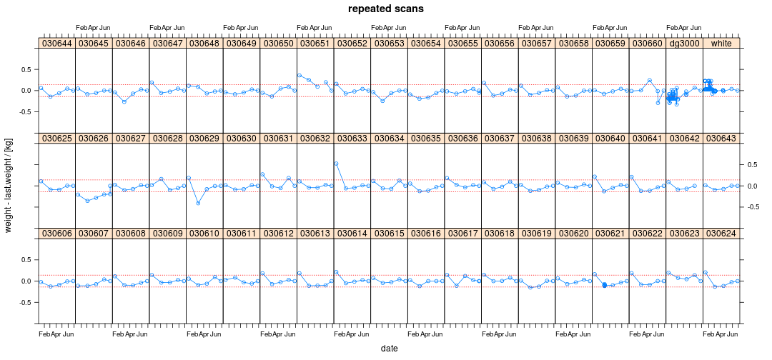

Initially 030651 (and maybe 030660) appeared to have changed in weight considerably. After rescanning it became apparent that the first weight measurment for 030651 was grossly in error (~0.7kg lower) and this measurement was deleted from the database.

## Resonance

Based on repeated weights of the wooden calibration beam (dg3000), an estimate of the standard error for the weight measurement is 2 Hz. In the plot below the red dotted lines indicate the 95% limits (assuming weight errors normally distributed). 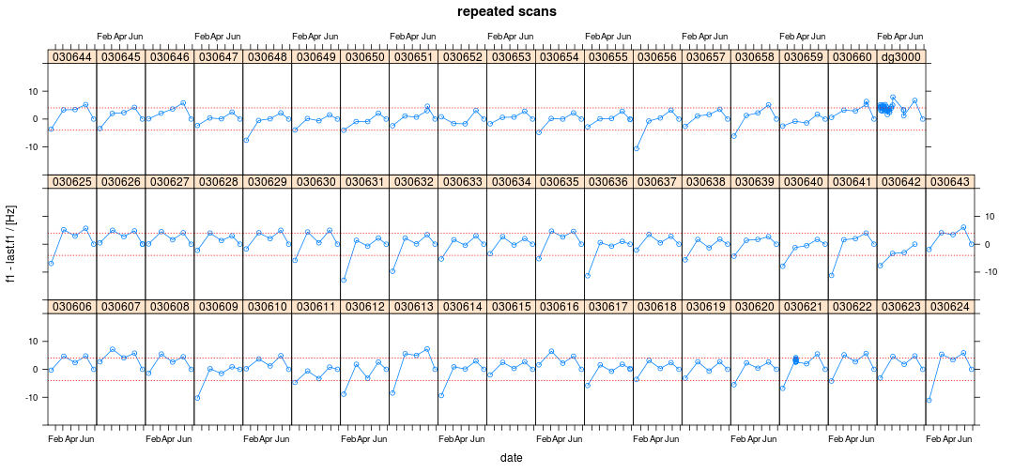

Based on resonance measurments, all boards appear to have reached equilibrium.

## Crook

Crook is probably the warp measure least affected by how the boards are stacked between measurments.

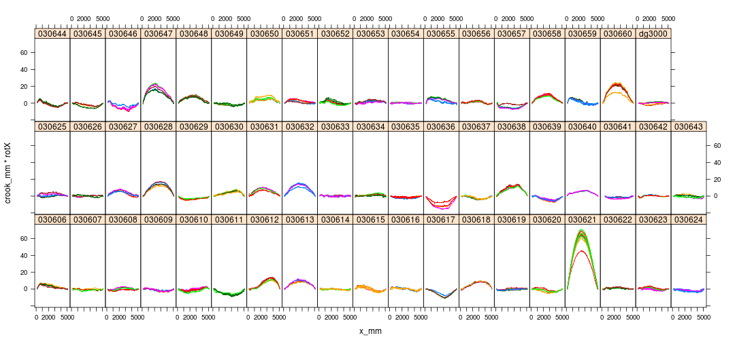

Despite the boards being marked, some warp scans have the boards oriented differently. To fix this introduce a ''rotX'' field into the database and manually estimate it based on the warp profile data. Having done that, the warp data can be corrected:

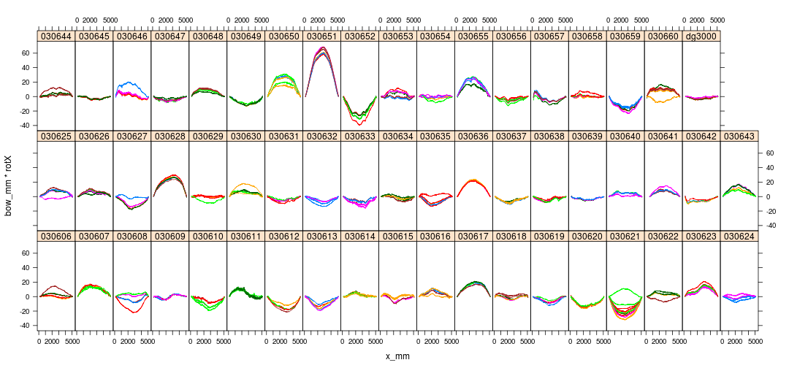

Repeated measurements suggest the mid-point crook estimate has a standard error of around 1 mm.

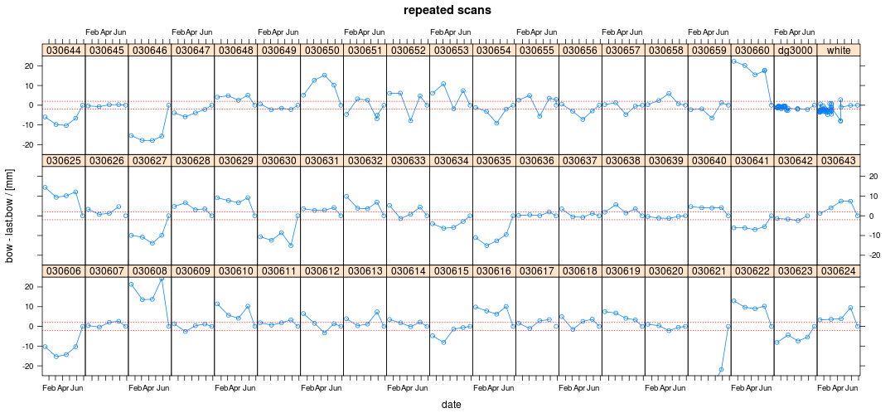

Around 15% (8/57) of the boards appear **not** to have reached a stable crook.

## Bow

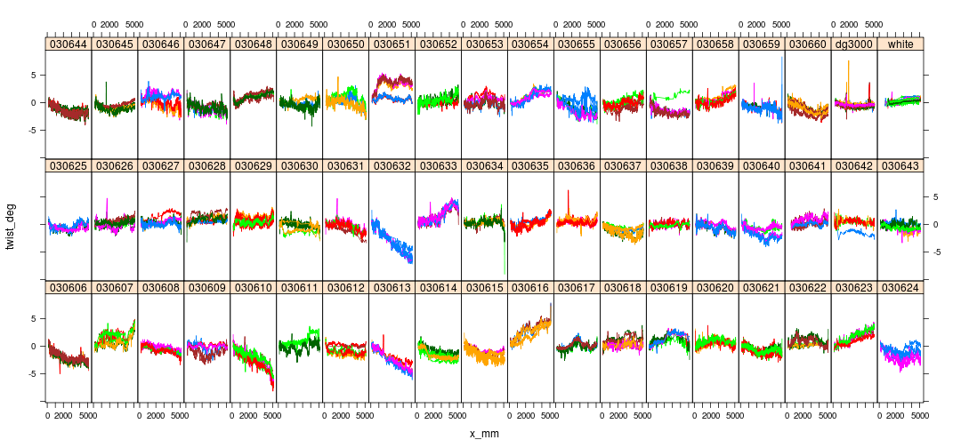

Mid-point bow appears to have a similar repeatability as mid-point crook, i.e. 1 mm.

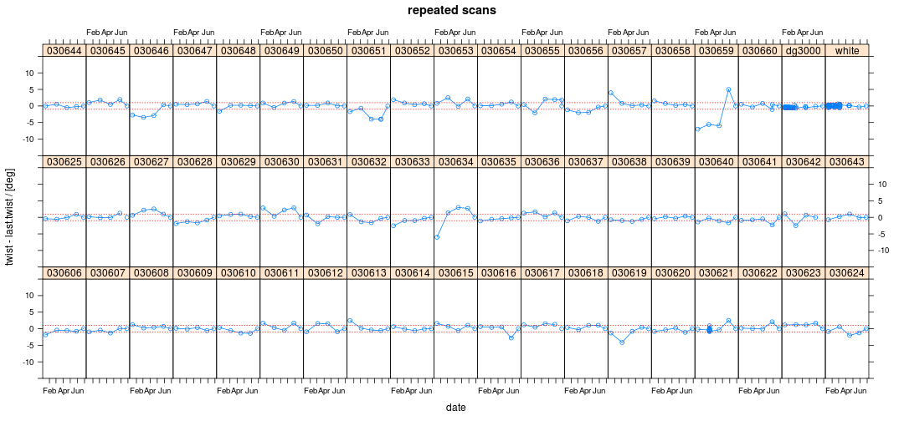

Around 30% (17/57) of the boards do **not** appear to have reached a stable bow.

## Twist



Total twist repeatability looks to be around 0.5 deg (~1mm for 100mm width).



For the most part twist appears to have reached a stable value. The two notable exceptions (030659, 030616) are artefacts of the twist extraction algorithm, as can be seen in the twist profiles (see plot above).

## Conclusions

1. The plots above very clearly show that, for all the measures considered (weight, resonance, bow, crook, twist), the first measurement (i.e. the measurement made when the full set of boards were scanned) differs significantly from the equilibrium value. This is particularly true for bow and crook.
2. Hold the boards and remeasure again in 4 weeks time.
3. Establish better repeatability estimates, particularly for the warp measures.
4. Improve the twist extraction algorithm to eliminate artefacts arising at the board ends. This is probably a tuning rather than re-engineering exercise.
5. Investigate if change in moisture content between time of first scanning and equilibrium can be used to predict the final warp. If so, then perhaps we only need to reweigh (rather than rescan) all the boards. This is a long shot (since the first measurement was made on boards with mc gradients) but needs doing before rescanning everything.
6. Board weights exhibit a surprisingly large number of extreme errors (e.g. 030651 discussed above). Perhaps there is something in the setup that causes this? Perhaps multiple measurements should be made?
7. Review scanning protocol to see if there is any way to make sure boards get scanned in the correct orientation.