Hyne Trial : Green Board Data

Jonathan Harrington

Tuesday, Septemeber 8, 2014

# Hyne: Green Board Data

## Todo

* grab a lot more example data for comparison
* why is MOE=6.50 over-represented? DONE
* check that ecoustic MOE is based on rather than some empirical correlation.
* classify boards as cant or side

## Background

### Trimmer

Green board shape could not be collected. USNR software crashed whenever writing shape data to disk enabled.

Data collected USNR database on TRIMMER2.

### SICK Camera

Power was lost briefly around 11:40a (someone tripped over the power cord?). drive

(see sick.Rmd)

### Ecoustic

Ecoustic data collected as csv file copied from Ecoustic2 PC by ML.

Loaded into HYNE database using ecoustic-create.sql and ecoustic2db.py.

## Ecoustic Dataset

library(lattice)  
library(RODBC)  
ch = odbcConnect("HYNE", "sa", "password12")  
E = sqlQuery(ch, "select Timestamp, ScheduledDimensions, Width, Thickness, Length, Weight, Density, MOE from ecoustic")  
E$swv = sqrt(E$MOE/E$Density * 1e+09)  
E$f1 = E$swv/2/E$Length  
# pairs(E[,3:10])  
pairs(E[, 7:9])

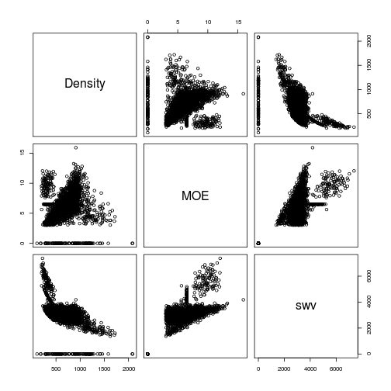

plot of chunk unnamed-chunk-1

Board properties:

xyplot(Thickness ~ Timestamp, E)

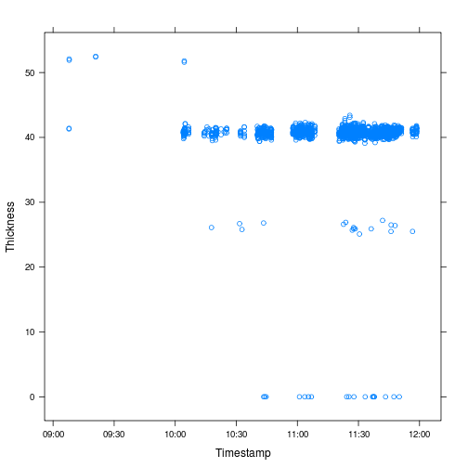

plot of chunk unnamed-chunk-2

xyplot(Width ~ Timestamp, E)

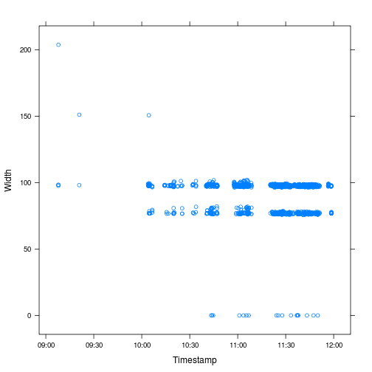

plot of chunk unnamed-chunk-2

xyplot(Length ~ Timestamp, E)

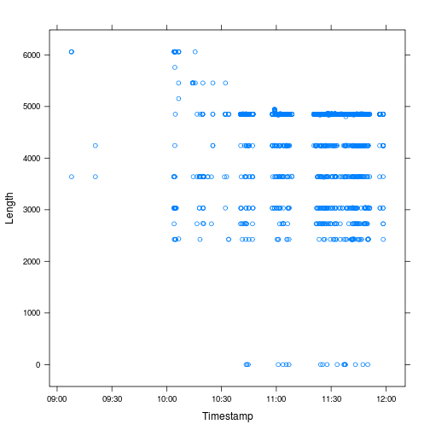

plot of chunk unnamed-chunk-2

xyplot(Density ~ Timestamp, E)

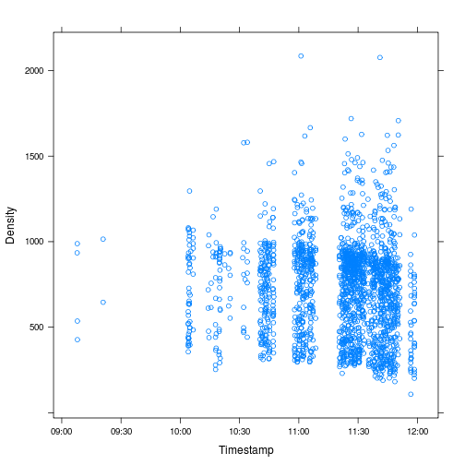

plot of chunk unnamed-chunk-2

xyplot(MOE ~ Timestamp, E)

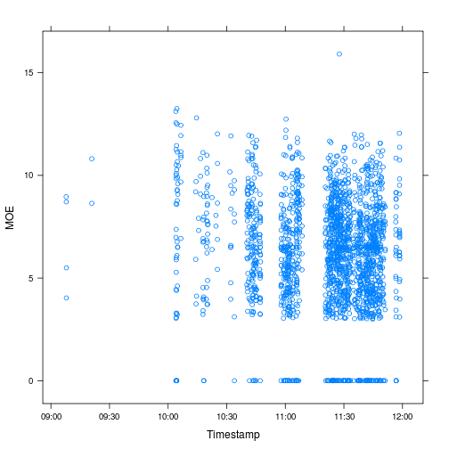

plot of chunk unnamed-chunk-2

# summary(lm(MOE ~ ScaledMOE, E)) # MOE = ScaledMOE

What does Length=Thickness=Width=0 denote? All have Grade='Not graded'.

Where does the board dimension data come from? The Trimmer2 scanner? Yes, via PLC (not db).

sum(E$Length == 0) # 18 length=width=thickness=0

## [1] 18

sum(E$Density <= 0) # 0

## [1] NA

sum(E$Weight <= 0) # 0

## [1] 0

sum(E$MOE == 0) # 122

## [1] 122

E$MOE[E$Length == 0] # always 0

## [1] 0 0 0 0 0 0 0 0 0 0 0 0 0 0 0 0 0 0

E$MOE[E$Width == 0] # always 0

## [1] 0 0 0 0 0 0 0 0 0 0 0 0 0 0 0 0 0 0

E[E$MOE == 6.5, ] # nothing unusual

## Timestamp ScheduledDimensions Width Thickness Length Weight  
## 45 2014-08-31 10:04:50 100x38x7000 98.1 41.3 2425 5.23  
## 47 2014-08-31 10:04:56 75x38x7000 76.8 42.1 2425 3.89  
## 119 2014-08-31 10:32:03 100x38x7000 98.7 40.8 4850 9.34  
## 120 2014-08-31 10:32:04 100x38x7000 98.6 41.0 4850 9.19  
## 152 2014-08-31 10:40:48 100x38x7000 97.8 40.7 3637 4.66  
## 181 2014-08-31 10:41:54 100x38x7000 98.5 40.7 4850 6.05  
## 265 2014-08-31 10:44:50 100x38x7000 98.5 40.7 4850 6.12  
## 305 2014-08-31 10:47:09 100x38x7000 98.3 41.2 4850 10.34  
## 307 2014-08-31 10:47:11 100x38x7000 97.6 40.7 4850 8.86  
## 320 2014-08-31 10:57:46 100x38x7000 97.1 40.7 4243 17.19  
## 325 2014-08-31 10:57:50 100x38x7000 98.1 41.4 4850 11.86  
## 365 2014-08-31 10:59:15 100x38x7000 98.7 40.7 4921 6.32  
## 390 2014-08-31 11:00:13 100x38x7000 97.7 41.0 4850 8.32  
## 405 2014-08-31 11:00:23 100x38x7000 98.3 40.7 4850 8.12  
## 531 2014-08-31 11:04:00 100x38x7000 101.1 41.3 4243 12.56  
## 547 2014-08-31 11:05:32 100x38x7000 98.3 40.8 4850 6.14  
## 579 2014-08-31 11:06:04 100x38x7000 99.3 40.8 4850 7.00  
## 622 2014-08-31 11:07:03 100x38x7000 98.5 40.7 4850 7.25  
## 695 2014-08-31 11:22:01 75x38x7000 77.6 41.8 4850 4.75  
## 716 2014-08-31 11:22:31 100x38x7000 97.3 41.0 3027 8.34  
## 734 2014-08-31 11:22:52 100x38x7000 98.3 40.4 4850 7.75  
## 909 2014-08-31 11:26:05 100x38x7000 98.5 40.7 4850 8.18  
## 921 2014-08-31 11:26:13 100x38x7000 97.5 40.7 4850 7.69  
## 927 2014-08-31 11:26:17 100x38x7000 97.4 40.5 4850 5.74  
## 977 2014-08-31 11:26:53 100x38x7000 98.4 40.7 4850 9.60  
## 985 2014-08-31 11:27:00 100x38x7000 98.2 40.3 4850 6.01  
## 993 2014-08-31 11:27:11 100x38x7000 98.0 40.4 4850 6.68  
## 1012 2014-08-31 11:27:28 100x38x7000 97.4 40.8 4850 7.18  
## 1017 2014-08-31 11:27:34 100x38x7000 97.4 40.4 4850 7.23  
## 1019 2014-08-31 11:27:36 100x38x7000 97.6 41.2 4850 6.74  
## 1020 2014-08-31 11:27:36 100x38x7000 97.9 40.8 4850 6.95  
## 1047 2014-08-31 11:28:00 75x38x7000 77.2 40.8 4850 5.21  
## 1070 2014-08-31 11:28:14 100x38x7000 98.5 40.7 4850 6.18  
## 1136 2014-08-31 11:29:44 100x38x7000 97.8 42.1 4850 13.01  
## 1154 2014-08-31 11:30:16 100x38x7000 97.7 40.6 4850 5.76  
## 1158 2014-08-31 11:30:19 100x38x7000 98.5 40.7 4860 7.23  
## 1199 2014-08-31 11:30:46 100x38x7000 98.3 40.7 4850 7.01  
## 1203 2014-08-31 11:30:49 100x38x7000 98.9 40.7 4850 7.04  
## 1218 2014-08-31 11:31:35 75x38x7000 76.1 41.6 4850 5.92  
## 1346 2014-08-31 11:35:48 100x38x7000 98.3 40.7 4850 6.04  
## 1391 2014-08-31 11:37:44 100x38x7000 98.3 40.7 4850 5.29  
## 1439 2014-08-31 11:38:30 100x38x7000 98.3 40.8 4850 5.32  
## 1446 2014-08-31 11:38:34 100x38x7000 98.8 40.8 4850 5.29  
## 1462 2014-08-31 11:38:58 100x38x7000 98.0 40.8 4850 4.69  
## 1475 2014-08-31 11:39:09 100x38x7000 98.1 40.7 4850 5.36  
## 1537 2014-08-31 11:41:27 100x38x7000 98.3 40.8 4850 5.33  
## 1568 2014-08-31 11:41:48 100x38x7000 98.3 40.8 4850 6.83  
## 1609 2014-08-31 11:42:17 75x38x7000 76.3 40.5 2435 11.10  
## 1612 2014-08-31 11:42:21 100x38x7000 97.2 41.1 4834 7.36  
## 1624 2014-08-31 11:42:34 100x38x7000 98.3 40.6 4850 5.15  
## 1626 2014-08-31 11:42:35 100x38x7000 97.9 40.3 4850 7.28  
## 1627 2014-08-31 11:42:39 100x38x7000 98.4 40.8 4850 5.66  
## 1657 2014-08-31 11:43:28 100x38x7000 98.3 40.7 4850 6.06  
## 1708 2014-08-31 11:44:31 100x38x7000 98.4 40.8 4850 5.57  
## 1720 2014-08-31 11:44:45 100x38x7000 97.2 41.6 4850 7.75  
## 1721 2014-08-31 11:44:46 75x38x7000 77.1 41.5 4850 4.64  
## 1771 2014-08-31 11:45:47 100x38x7000 98.4 40.7 4850 5.89  
## 1797 2014-08-31 11:46:13 100x38x7000 98.4 40.8 4850 5.17  
## 1824 2014-08-31 11:46:53 100x38x7000 98.6 40.8 4850 5.68  
## 1872 2014-08-31 11:48:13 100x38x7000 98.5 40.6 4850 5.11  
## 1901 2014-08-31 11:48:43 100x38x7000 98.1 40.6 4850 10.74  
## 1903 2014-08-31 11:48:44 100x38x7000 98.4 40.8 4850 4.92  
## 1985 2014-08-31 11:56:50 100x38x7000 98.4 40.8 4850 6.68  
## Density MOE swv f1  
## 45 532.1 6.5 3495 0.7206  
## 47 496.6 6.5 3618 0.7460  
## 119 478.0 6.5 3688 0.3802  
## 120 468.9 6.5 3723 0.3838  
## 152 321.8 6.5 4494 0.6179  
## 181 311.1 6.5 4571 0.4712  
## 265 315.0 6.5 4543 0.4683  
## 305 526.3 6.5 3514 0.3623  
## 307 459.9 6.5 3760 0.3876  
## 320 1025.1 6.5 2518 0.2967  
## 325 602.0 6.5 3286 0.3388  
## 365 319.6 6.5 4509 0.4582  
## 390 428.2 6.5 3896 0.4016  
## 405 418.5 6.5 3941 0.4063  
## 531 708.9 6.5 3028 0.3568  
## 547 315.9 6.5 4536 0.4677  
## 579 356.0 6.5 4273 0.4405  
## 622 373.0 6.5 4174 0.4303  
## 695 301.7 6.5 4642 0.4785  
## 716 690.7 6.5 3068 0.5067  
## 734 402.2 6.5 4020 0.4144  
## 909 421.0 6.5 3929 0.4051  
## 921 399.3 6.5 4035 0.4160  
## 927 300.1 6.5 4654 0.4798  
## 977 494.4 6.5 3626 0.3738  
## 985 313.4 6.5 4554 0.4695  
## 993 348.0 6.5 4322 0.4455  
## 1012 372.7 6.5 4176 0.4305  
## 1017 378.9 6.5 4142 0.4270  
## 1019 345.6 6.5 4337 0.4471  
## 1020 358.8 6.5 4256 0.4388  
## 1047 341.2 6.5 4365 0.4500  
## 1070 317.9 6.5 4522 0.4662  
## 1136 651.7 6.5 3158 0.3256  
## 1154 299.6 6.5 4658 0.4802  
## 1158 371.1 6.5 4185 0.4306  
## 1199 361.5 6.5 4241 0.4372  
## 1203 360.4 6.5 4247 0.4378  
## 1218 385.5 6.5 4106 0.4233  
## 1346 311.2 6.5 4570 0.4711  
## 1391 272.6 6.5 4883 0.5034  
## 1439 273.6 6.5 4874 0.5025  
## 1446 270.4 6.5 4903 0.5054  
## 1462 241.6 6.5 5186 0.5347  
## 1475 276.8 6.5 4846 0.4995  
## 1537 274.1 6.5 4870 0.5020  
## 1568 351.0 6.5 4303 0.4436  
## 1609 1475.5 6.5 2099 0.4310  
## 1612 381.0 6.5 4131 0.4272  
## 1624 266.1 6.5 4942 0.5095  
## 1626 380.4 6.5 4134 0.4262  
## 1627 290.5 6.5 4730 0.4877  
## 1657 312.2 6.5 4563 0.4704  
## 1708 286.1 6.5 4767 0.4914  
## 1720 395.3 6.5 4055 0.4180  
## 1721 299.2 6.5 4661 0.4805  
## 1771 303.4 6.5 4628 0.4772  
## 1797 265.4 6.5 4948 0.5102  
## 1824 291.3 6.5 4723 0.4870  
## 1872 263.6 6.5 4965 0.5119  
## 1901 555.8 6.5 3420 0.3526  
## 1903 252.8 6.5 5071 0.5228  
## 1985 343.0 6.5 4353 0.4488

histogram(~Thickness | ScheduledDimensions, E, nint = 1000, type = "count")

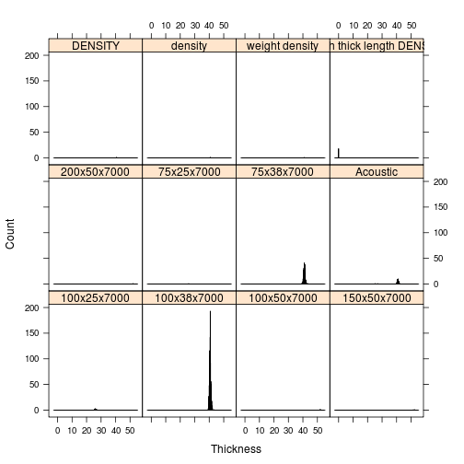

plot of chunk unnamed-chunk-4

histogram(~Width | ScheduledDimensions, E, nint = 1000, type = "count")

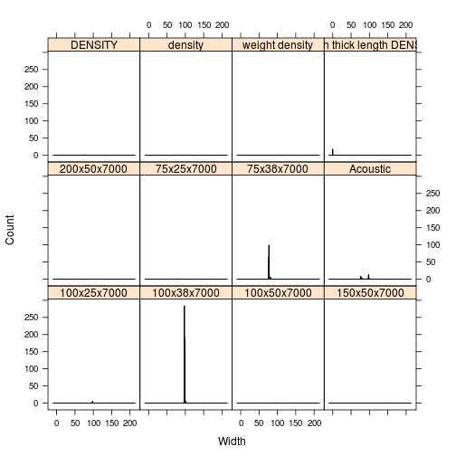

plot of chunk unnamed-chunk-4

histogram(~Length | ScheduledDimensions, E, nint = 1000, type = "count")

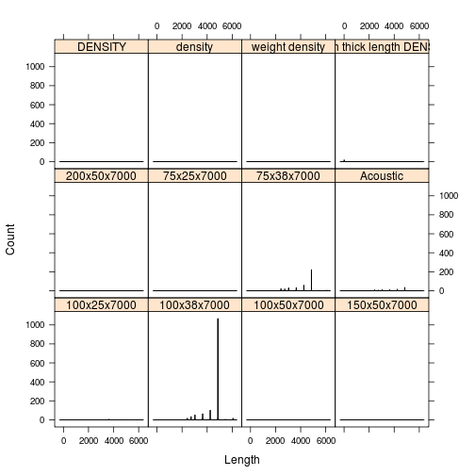

plot of chunk unnamed-chunk-4

histogram(~Weight | ScheduledDimensions, E, nint = 100)

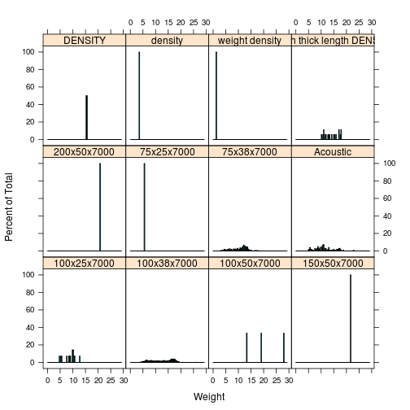

plot of chunk unnamed-chunk-4

histogram(~Density | ScheduledDimensions, E, nint = 100)

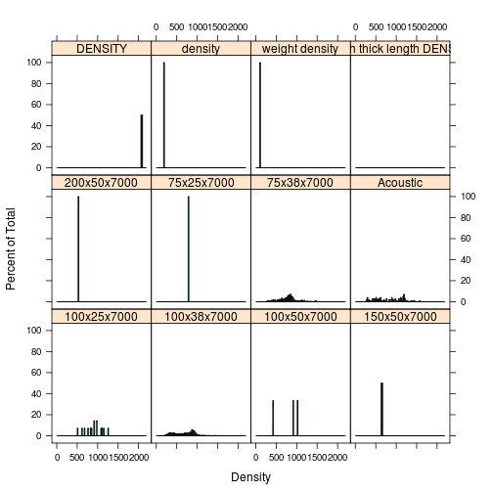

plot of chunk unnamed-chunk-4

histogram(~MOE | ScheduledDimensions, E, nint = 10001)

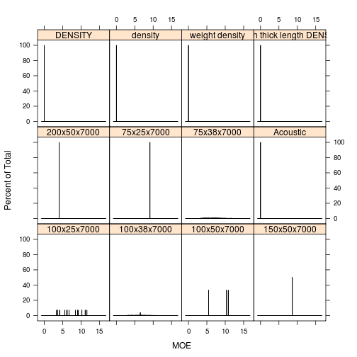

plot of chunk unnamed-chunk-4

~6% of boards have densities>1100 kg/m^3, these are considered unreasonable (a fully saturated board of basic density 500 kg/m^3 has a green density of 1166 kg/m^3).

Why does MOE=6.50 occur way more often than it should?

On the question below there are some cases where 6.5 MoE is assumed. It happens when the confidence in the velocity is low (~50%) but the mill wanted a conservative approach (don’t throw potentially good boards out) so 6.5 is assigned. The real MoE could be above or below that. One reason the confidence could be low on trimmer line 2 is that there can be some bouncing of the test boards away from the hammer when the next large board hits the fence after the trimmer. There is no record in the file of which boards had low confidence.

## Total Recovery

Total flitches seen in trial period (based on TRIMMER2_FlitchDetail table): 1959 (10:29:39--11:56:15 T2.DateTime)

Non trial flitches imaged: 5 (SICK_images.id in 28,33,43,64,102).

Total trial flitches: 1954+1=1955 (extra is due to flitchId=1281565 containing two boards!)

Note that SICK_images.id=43 is FlitchID=1281070 and has no corresponding board!! As do a total of 68 in trial flitches.

Total images containing boards in the SICK_images table: 1886

Total number of boards imaged with SICK camera: 1887. One image contains two boards (sid=1187, 20140831_110531667_GOOD_READ, flitchId=1281565)

Flitches not seen by SICK due to power outage: 73 (11:39:16--11:40:26 T2.DateTime, 11:39--11:40:11 SICK_images.Timestamp)

Total readable images in SICK_barcodes table: 1793 (92% of trial flitches)

Total boards in ecoustic: 1790

Byproduct boards (no ecoustic): 101

Trial boards with no labels: 8

Trial boards with unreadable labels:

library(RODBC)  
ch = odbcConnect("HYNE", "sa", "password12")  
L = sqlQuery(ch, "\nselect logs.*, t.*, (L.h + S.h)/2. as heartVolFrac from\nlogs\nleft join (select t.SWILogNumber, power(heartwoodDiameter_mm,2)/POWER(LED,2) as h from logends as e left join yardTrimmed as t on t.SWILogNumber=e.SWILogNumber where logEnd='L') as L\non L.SWILogNumber=logs.SWILogNumber\nleft join (select t.SWILogNumber, power(heartwoodDiameter_mm,2)/POWER(SED,2) as h from logends as e left join yardTrimmed as t on t.SWILogNumber=e.SWILogNumber where logEnd='S') as S\non S.SWILogNumber=logs.SWILogNumber\nleft join yardTrimmed as t\non t.SWILogNumber=logs.SWILogNumber\nwhere logs.SWILogNumber is not null and logs.DateAndTime>'2014-08-31 09:00:00'\norder by logs.DateAndTime \n")  
B.all = sqlQuery(ch, "\nselect \nf.flitchId, f.DateTime as [t.trimmer2], f.SWILogNumber,\n f.Width as Wf, f.Thickness as Tf, f.Length as Lf,\nb.boardId, b.isByproduct, \n b.Width as Wb, b.Thickness as Tb, b.Length as Lb,\ns.id as sickImageId, s.Timestamp as [t.SICK], s.nboards, s.filename, \n s.boardWidth_pxl*0.137 as Ws, s.boardThickness_pxl*0.137 as Ts,\n s.boardOrientation_rad as theta_s,\ne.id as ecousticId, e.Timestamp as [t.ecoustic], e.Width, f.Thickness, f.Length,\n e.Width as We, e.Thickness as Te, e.Length as Le, e.Weight, e.Density, e.MOE\nfrom TRIMMER2_FlitchDetail as f full join TRIMMER2_BoardDetail as b \non b.flitchId=f.flitchid \nleft join SICK_images as s\non s.flitchId=f.flitchId\nfull join ecoustic as e\non e.flitchId2=f.flitchId\nwhere inTrial in (0,1)\norder by f.DateTime")  
B.all$W = B.all$Wf  
B.all$T = B.all$Tf  
B.all$L = B.all$Lf  
# is100x450 = B.all$Wb>95 & B.all$Tb>36  
is100x40 = B.all$Wf > 95 & B.all$Tf > 35 # 1443 boards  
ii = !is100x40 & !is.na(B.all$Le) & B.all$isByproduct != 1 # use ecoustic length except when isByproduct=1  
B.all$L[ii] = B.all$Le[ii]  
ii = !is100x40 & !is.na(B.all$Lb) & B.all$isByproduct == 1 # in which case use Lb  
B.all$L[ii] = B.all$Lb[ii]  
B.all$V = B.all$W * B.all$T * B.all$L/1e+09  
B.all$swv = sqrt(B.all$MOE/B.all$Density * 1e+09)  
  
# total volume recovered as boards  
sum(B.all$V)/sum(L$volume) # 67%

## [1] 0.6721

# number of boards with known LogNumber  
B.knownlog = B.all[!is.na(B.all$SWILogNumber), ]  
nrow(B.knownlog) # 1754 (90%)

## [1] 1954

# number of boards with known LogNumber and reasonable MOE and Density  
# (remember MOE=6.50 is a default value)  
B = B.all[!is.na(B.all$SWILogNumber) & !is.na(B.all$MOE) & B.all$MOE > 0 & B.all$MOE !=   
 6.5 & !is.na(B.all$Density) & B.all$Density < 1100 & B.all$swv < 4000, ]  
B$SWILogNumber = factor(substr(B$SWILogNumber, 1, 3), ordered = TRUE)  
nrow(B) # 1486 (76%)

## [1] 1486

# number of 100x40's  
sum(is100x40) # 1443 (74%)

## [1] 1443

Finished board dimensions are f.Width, f.Thickness and if 100x40 f.Length, otherwise b.Length (unless b missing...)

## Board Dimensions

Let's compare the dimension data in the trimmer (f=FlitchDetail, b=BoardDetail), SICK (s=skimage.regionprops), ecoustic (e)YY

pairs(B[, c("Wf", "Wb", "We", "Ws")])

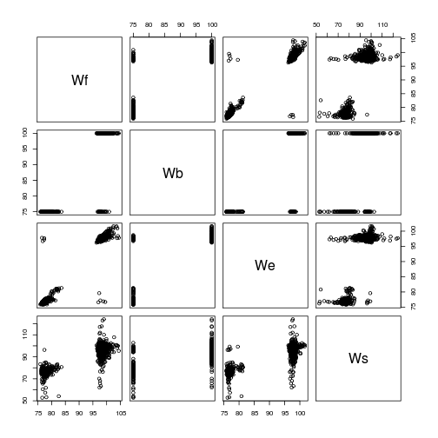

plot of chunk unnamed-chunk-6

pairs(B[, c("Tf", "Tb", "Te", "Ts")])

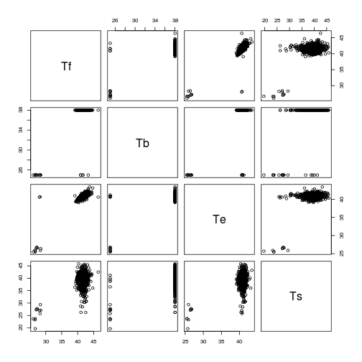

plot of chunk unnamed-chunk-6

pairs(B[, c("Lf", "Lb", "Le")])

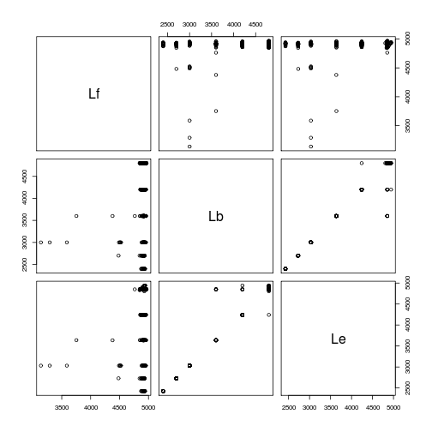

plot of chunk unnamed-chunk-6

imismatch = abs(B$Wf - B$We) > 10 | abs(B$Tf - B$Te) > 10 | abs(B$Lb - B$Le) >   
 200  
B[imismatch, c("flitchId", "isByproduct", "Wf", "Wb", "Ws", "We", "Tf", "Tb",   
 "Ts", "Te", "Lf", "Lb", "Le")]

## flitchId isByproduct Wf Wb Ws We Tf Tb Ts Te Lf Lb  
## 248 1281309 1 97.5 75 85.22 98.4 41.3 38 38.04 40.7 4925 4200  
## 358 1281419 1 99.9 75 97.13 97.6 41.3 38 37.41 41.4 4947 4200  
## 365 1281426 1 97.3 75 98.31 97.1 28.0 25 27.00 40.6 4763 3600  
## 500 1281561 1 97.0 75 97.04 76.6 42.7 38 39.17 40.6 4906 4800  
## 516 1281577 1 97.3 75 99.20 79.6 40.7 38 38.09 40.4 4914 4800  
## 675 1281736 1 97.3 75 98.53 97.0 42.4 38 43.28 41.1 4910 3600  
## 692 1281753 1 98.0 75 94.38 97.8 41.6 38 38.11 41.0 4924 3600  
## 736 1281797 1 97.2 75 100.23 97.2 41.2 38 44.60 41.2 4931 4200  
## 823 1281884 1 99.5 75 96.10 76.7 41.3 38 40.44 41.3 4872 4800  
## 867 1281928 1 98.1 75 94.56 97.2 41.8 38 41.80 40.7 4914 4200  
## 1074 1282135 1 98.0 75 94.37 97.6 41.3 38 37.84 40.5 4911 4200  
## 1112 1282173 1 98.0 75 94.16 98.4 42.0 38 36.56 40.9 4920 3600  
## 1194 1282255 1 77.3 75 72.18 97.2 40.9 25 36.52 40.8 4928 4800  
## 1389 1282450 1 77.3 75 72.59 97.7 43.3 25 40.04 40.9 4905 4800  
## 1438 1282499 1 76.8 75 76.18 96.7 41.6 25 38.70 40.7 4905 3600  
## 1487 1282548 1 76.5 75 75.67 97.8 41.6 25 39.33 40.7 4935 4800  
## 1703 1282764 1 97.6 75 76.68 97.0 42.3 38 37.17 41.3 4916 4200  
## 1782 1282843 1 97.7 75 97.37 98.4 28.2 25 25.74 40.7 4933 4800  
## 1827 1282888 1 97.7 75 97.16 77.2 41.5 38 41.26 40.9 4891 3600  
## 1952 1283013 1 98.8 75 99.26 76.9 42.6 38 39.66 41.4 4948 4800  
## Le  
## 248 4942  
## 358 4850  
## 365 4850  
## 500 4850  
## 516 4850  
## 675 4850  
## 692 4850  
## 736 4850  
## 823 4850  
## 867 4850  
## 1074 4850  
## 1112 4850  
## 1194 4850  
## 1389 4850  
## 1438 4850  
## 1487 4850  
## 1703 4850  
## 1782 4850  
## 1827 4850  
## 1952 4242

The 19 boards (5 of them 100x40s) with significantly different dimensions in the FlitchDetail and Ecoustic tables are all byproducts that normally would have been tippled out and resawn. Instead they were passed through the trim saw and on to the ecoustic which, since it is triggered locally with a PE, tapped them. If the PLC dosn't know about these boards then the ecoustic acquires the dimensions of the previous board from the PLC. In these cases, the FlitchDetail estimates of dimensions are more likely best, and Density and MOE should be recalculated (but using the BoardDetail length!). In fact, Density and MOE could be recalculated for all isByproduct=1 boards. To do this requires estimating volume from FlitchDetail nominal dimensions (rather than the 3D cloud that the USNR software would have used) and extracting resonant frequency from ecoustic MOE.

AAAARGGGH. Some 100x40's that the optimiser thought should be re-edged were also trimmed (probably because the do-not-trim logic was based on optimised rather than actual board dimensions) e.g. FlitchId 1282173.

hist(B$L[is100x40], 100)

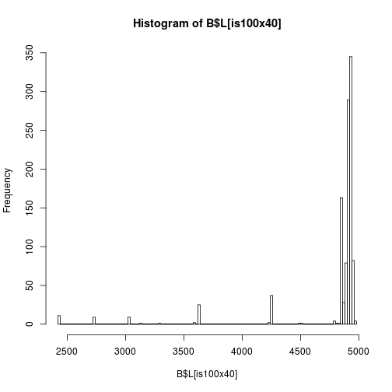

plot of chunk unnamed-chunk-7

Is log length distinct enough to help identify boards that no good barcode read was extracted from?

bwplot(as.factor(SWILogNumber) ~ Le, B, subset = is100x40)

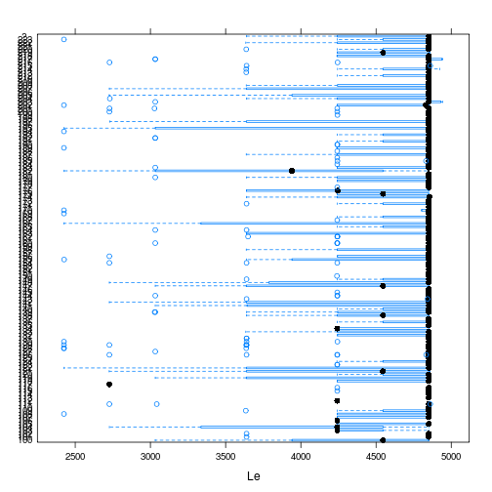

plot of chunk unnamed-chunk-8

## Board Orientation in SICK Images

ii = !is.na(B$theta_s)  
t = B$theta_s[ii]  
t[t < 0] = pi + t[t < 0]  
histogram(t/pi * 180, breaks = seq(60, 120))

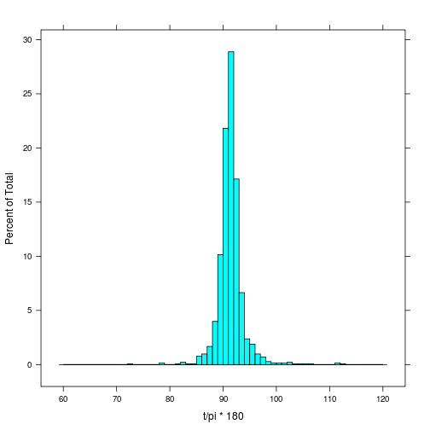

plot of chunk unnamed-chunk-9

summary(t * 180/pi)

## Min. 1st Qu. Median Mean 3rd Qu. Max.   
## 72.1 90.4 91.3 91.4 92.2 112.0

Assign SWILogNumber to unidentified boards -----------------------------------------'

Based on:

1. sequence
2. untrimmed (FlitchDetail) length
3. time (but apart from limited cases where whole chain flushed no more info than sequence and a lot harder to work with)
4. Saw pattern (see below) but this is pretty tricky

Not much than can be done about the boards 73 boards that passed through while the SICK camera was off (from logs: 161, 110, 159, 101, 184, 178, 120, 122, 116, 118, 106, 102, 175, 121, 183, 129)

plot(1:nrow(B.all), B.all$Lf, cex=0.1)#, xlim=c(0,30))  
text(c(1:nrow(B.all)), B.all$Lf+40, B.all$SWILogNumber, cex=0.7)



plot of chunk unnamed-chunk-10

# Do this using plot.ly (so zoom-pan-identify works easily):  
library(plotly)

## Loading required package: RCurl Loading required package: bitops Loading  
## required package: RJSONIO Loading required package: ggplot2

py <- plotly()  
trace0 <- list(  
 #x = B.all$t.trimmer2,  
 x = 1:nrow(B.all),  
 y = B.all$Lf,  
 mode = "markers+text",  
 text = B.all$SWILogNumber,  
 textposition = "top",  
 type = "scatter"  
 )  
layout <- list(  
 #xaxis = list(range = c(1, 15)),   
 xaxis = list(range = c(1480, 1580)),   
 #yaxis = list(range = c(4600, 5000))  
 yaxis = list(range = c(4850, 4980))  
)  
response <- py$plotly(trace0, kwargs=list(layout=layout, filename="hyne-untrimmed-board-length", fileopt="overwrite"))  
response$url

## [1] "https://plot.ly/~letme1n/1"

## Board Density, MOE and SWV

library(hexbin)

## Loading required package: grid

splom(B[, c("Density", "MOE", "swv")], lower.panel = function(x, y, ...) {  
 panel.hexbinplot(x, y)  
})

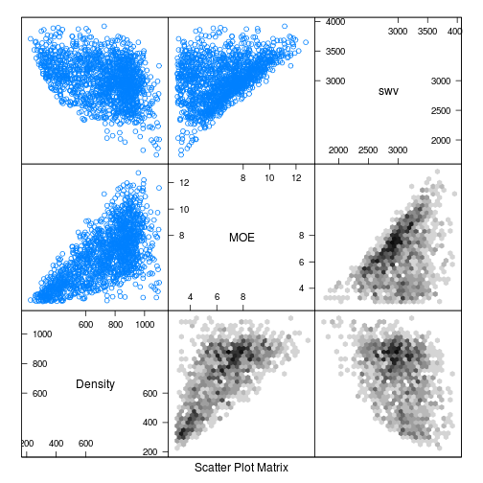

plot of chunk unnamed-chunk-11

Hmmm. What green board data have we got to compare this with?

library(plyr)  
library(lattice)  
L = merge(L, ddply(B, .(SWILogNumber), summarize, nboards = length(SWILogNumber),   
 boardVolume = sum(V), boardArea = sum(W * T), avgBoardMOE = sum(MOE * W *   
 T)/boardArea, avgBoardDEN = sum(Density * W * T)/boardArea, avgBoardSWV = sum(swv *   
 W * T)/boardArea))  
L$recFrac = L$boardVolume/L$volume  
L$den = L$weight/L$volume  
L$MOE = L$SWV^2 * L$den/1e+09  
xyplot(volume ~ nboards, L)

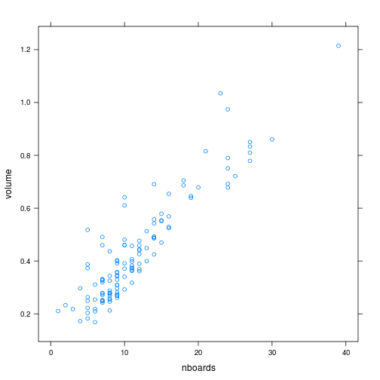

plot of chunk unnamed-chunk-12

suspect.lognumbers = c(161, 110, 159, 101, 184, 178, 120, 122, 116, 118, 106,   
 102, 175, 121, 183, 129) # logs likely to have boards the SIC camera missed during outage  
clr = rep("black", nrow(L))  
clr[L$SWILogNumber %in% suspect.lognumbers] = "red"  
plot(boardVolume/volume * 100 ~ volume, L, ylab = "% Recovered Boards with Readable Labels",   
 col = clr)  
text(L$volume, L$boardVolume/L$volume * 100 + 1.2, L$SWILogNumber, cex = 0.6)

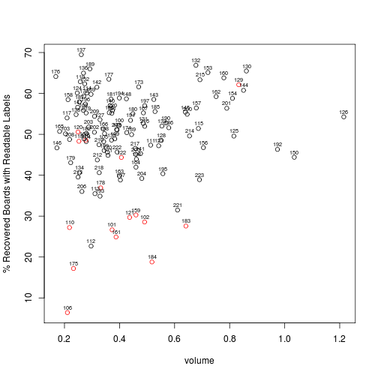

plot of chunk unnamed-chunk-13

Why is log 137 the best recovered? All boards from 137 are actual reads from the SICK camera rather than maual assignations.

## Average Board Density

plot(avgBoardDEN ~ den, L, xlab = "Log Density / [kg/m^3]", ylab = "Average Green Board Density / [kg/m^3]")  
abline(c(0, 1), col = "grey70")

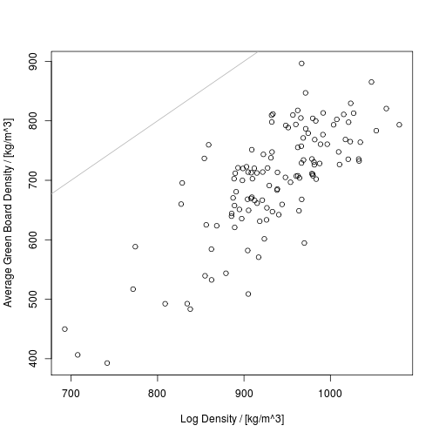

plot of chunk unnamed-chunk-14

summary(m <- lm(avgBoardDEN ~ den + heartVolFrac, L))

##   
## Call:  
## lm(formula = avgBoardDEN ~ den + heartVolFrac, data = L)  
##   
## Residuals:  
## Min 1Q Median 3Q Max   
## -160.37 -37.78 -4.74 40.98 159.98   
##   
## Coefficients:  
## Estimate Std. Error t value Pr(>|t|)   
## (Intercept) -201.413 163.547 -1.23 0.22   
## den 0.982 0.152 6.45 2.5e-09 ***  
## heartVolFrac -68.804 107.128 -0.64 0.52   
## ---  
## Signif. codes: 0 '***' 0.001 '**' 0.01 '*' 0.05 '.' 0.1 ' ' 1  
##   
## Residual standard error: 60.1 on 120 degrees of freedom  
## Multiple R-squared: 0.596, Adjusted R-squared: 0.589   
## F-statistic: 88.4 on 2 and 120 DF, p-value: <2e-16

Why is log density so much higher than average board density? Just due to over representation of inner material?

## Average Board SWV

Only look at hitman SWV due to issues with calibre SWV (see hyne-log.Rmd).

plot(avgBoardSWV ~ SWV, L, xlab = "Log Sonic Velocity / [m/s]", ylab = "Average Green Board SWV / [m/s]")  
abline(c(0, 1), col = "grey70")

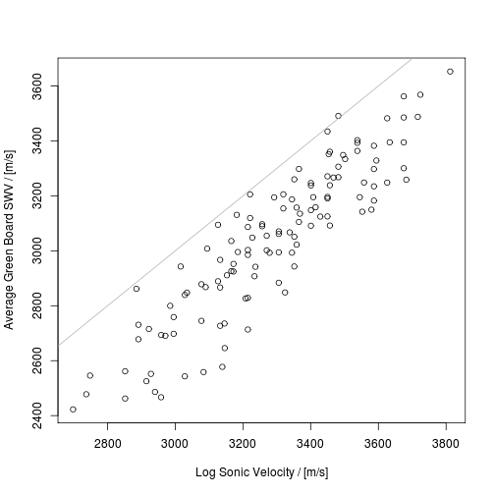

plot of chunk unnamed-chunk-15

summary(m <- lm(avgBoardSWV ~ SWV, L))

##   
## Call:  
## lm(formula = avgBoardSWV ~ SWV, data = L)  
##   
## Residuals:  
## Min 1Q Median 3Q Max   
## -306.6 -74.1 13.0 75.6 249.3   
##   
## Coefficients:  
## Estimate Std. Error t value Pr(>|t|)   
## (Intercept) -392.2604 148.6353 -2.64 0.0094 **   
## SWV 1.0438 0.0451 23.15 <2e-16 ***  
## ---  
## Signif. codes: 0 '***' 0.001 '**' 0.01 '*' 0.05 '.' 0.1 ' ' 1  
##   
## Residual standard error: 120 on 120 degrees of freedom  
## (1 observation deleted due to missingness)  
## Multiple R-squared: 0.817, Adjusted R-squared: 0.816   
## F-statistic: 536 on 1 and 120 DF, p-value: <2e-16

summary(m <- lm(avgBoardSWV ~ SWV + heartVolFrac, L))

##   
## Call:  
## lm(formula = avgBoardSWV ~ SWV + heartVolFrac, data = L)  
##   
## Residuals:  
## Min 1Q Median 3Q Max   
## -304.7 -72.9 13.7 76.0 248.9   
##   
## Coefficients:  
## Estimate Std. Error t value Pr(>|t|)   
## (Intercept) -388.1794 151.8441 -2.56 0.012 *   
## SWV 1.0413 0.0483 21.57 <2e-16 ***  
## heartVolFrac 17.5469 120.2745 0.15 0.884   
## ---  
## Signif. codes: 0 '***' 0.001 '**' 0.01 '*' 0.05 '.' 0.1 ' ' 1  
##   
## Residual standard error: 120 on 119 degrees of freedom  
## (1 observation deleted due to missingness)  
## Multiple R-squared: 0.817, Adjusted R-squared: 0.814   
## F-statistic: 266 on 2 and 119 DF, p-value: <2e-16

summary(m <- lm(avgBoardSWV ~ SWV + heartVolFrac + den, L))

##   
## Call:  
## lm(formula = avgBoardSWV ~ SWV + heartVolFrac + den, data = L)  
##   
## Residuals:  
## Min 1Q Median 3Q Max   
## -274.0 -73.0 14.5 70.7 242.6   
##   
## Coefficients:  
## Estimate Std. Error t value Pr(>|t|)   
## (Intercept) 387.8216 345.0696 1.12 0.263   
## SWV 1.0488 0.0474 22.15 <2e-16 ***  
## heartVolFrac -435.7066 216.6704 -2.01 0.047 *   
## den -0.7465 0.2996 -2.49 0.014 *   
## ---  
## Signif. codes: 0 '***' 0.001 '**' 0.01 '*' 0.05 '.' 0.1 ' ' 1  
##   
## Residual standard error: 118 on 118 degrees of freedom  
## (1 observation deleted due to missingness)  
## Multiple R-squared: 0.826, Adjusted R-squared: 0.822   
## F-statistic: 187 on 3 and 118 DF, p-value: <2e-16

summary(m <- lm(avgBoardSWV ~ SWV + heartVolFrac + avgBoardDEN, L))

##   
## Call:  
## lm(formula = avgBoardSWV ~ SWV + heartVolFrac + avgBoardDEN,   
## data = L)  
##   
## Residuals:  
## Min 1Q Median 3Q Max   
## -308.9 -71.5 12.0 77.9 216.5   
##   
## Coefficients:  
## Estimate Std. Error t value Pr(>|t|)   
## (Intercept) 350.2997 225.3872 1.55 0.123   
## SWV 0.9817 0.0474 20.73 < 2e-16 ***  
## heartVolFrac -359.0692 143.6403 -2.50 0.014 *   
## avgBoardDEN -0.6519 0.1544 -4.22 4.8e-05 ***  
## ---  
## Signif. codes: 0 '***' 0.001 '**' 0.01 '*' 0.05 '.' 0.1 ' ' 1  
##   
## Residual standard error: 112 on 118 degrees of freedom  
## (1 observation deleted due to missingness)  
## Multiple R-squared: 0.841, Adjusted R-squared: 0.837   
## F-statistic: 208 on 3 and 118 DF, p-value: <2e-16

## Average Board MOE

xyplot(avgBoardMOE ~ SWV, L, xlab = "Log Sonic Velocity / [m/s]", ylab = "Average Green Board MOE / [GPa]")

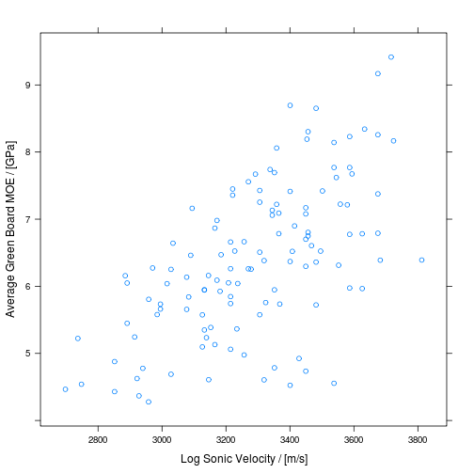

plot of chunk unnamed-chunk-16

xyplot(avgBoardMOE ~ MOE, L, xlab = "Log MOE / [GPa]", ylab = "Average Green Board MOE / [GPa]")

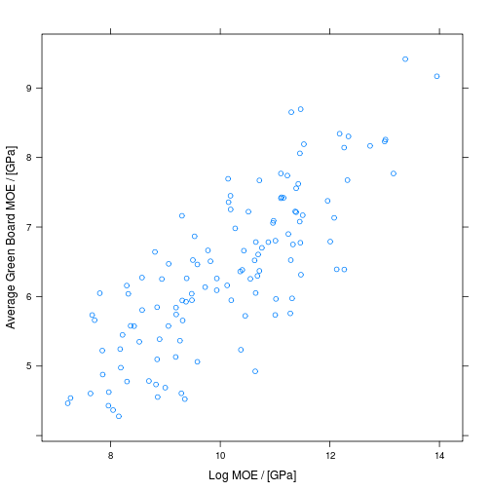

plot of chunk unnamed-chunk-16

summary(m <- lm(avgBoardMOE ~ MOE, L))

##   
## Call:  
## lm(formula = avgBoardMOE ~ MOE, data = L)  
##   
## Residuals:  
## Min 1Q Median 3Q Max   
## -1.7695 -0.4290 -0.0208 0.4440 1.5546   
##   
## Coefficients:  
## Estimate Std. Error t value Pr(>|t|)   
## (Intercept) 0.1728 0.4293 0.4 0.69   
## MOE 0.6130 0.0419 14.6 <2e-16 ***  
## ---  
## Signif. codes: 0 '***' 0.001 '**' 0.01 '*' 0.05 '.' 0.1 ' ' 1  
##   
## Residual standard error: 0.684 on 120 degrees of freedom  
## (1 observation deleted due to missingness)  
## Multiple R-squared: 0.64, Adjusted R-squared: 0.637   
## F-statistic: 214 on 1 and 120 DF, p-value: <2e-16

summary(m <- lm(avgBoardMOE ~ SWV, L))

##   
## Call:  
## lm(formula = avgBoardMOE ~ SWV, data = L)  
##   
## Residuals:  
## Min 1Q Median 3Q Max   
## -2.5406 -0.6021 0.0266 0.6075 1.9924   
##   
## Coefficients:  
## Estimate Std. Error t value Pr(>|t|)   
## (Intercept) -3.018852 1.125760 -2.68 0.0084 **   
## SWV 0.002859 0.000341 8.37 1.2e-13 ***  
## ---  
## Signif. codes: 0 '***' 0.001 '**' 0.01 '*' 0.05 '.' 0.1 ' ' 1  
##   
## Residual standard error: 0.906 on 120 degrees of freedom  
## (1 observation deleted due to missingness)  
## Multiple R-squared: 0.369, Adjusted R-squared: 0.364   
## F-statistic: 70.1 on 1 and 120 DF, p-value: 1.21e-13

summary(m <- lm(avgBoardMOE ~ MOE + den, L))

##   
## Call:  
## lm(formula = avgBoardMOE ~ MOE + den, data = L)  
##   
## Residuals:  
## Min 1Q Median 3Q Max   
## -1.6751 -0.3836 0.0199 0.3998 1.5973   
##   
## Coefficients:  
## Estimate Std. Error t value Pr(>|t|)   
## (Intercept) -2.020827 0.855673 -2.36 0.020 *   
## MOE 0.582068 0.042009 13.86 <2e-16 ***  
## den 0.002683 0.000914 2.93 0.004 **   
## ---  
## Signif. codes: 0 '***' 0.001 '**' 0.01 '*' 0.05 '.' 0.1 ' ' 1  
##   
## Residual standard error: 0.663 on 119 degrees of freedom  
## (1 observation deleted due to missingness)  
## Multiple R-squared: 0.665, Adjusted R-squared: 0.659   
## F-statistic: 118 on 2 and 119 DF, p-value: <2e-16

summary(m <- lm(avgBoardMOE ~ SWV + den, L))

##   
## Call:  
## lm(formula = avgBoardMOE ~ SWV + den, data = L)  
##   
## Residuals:  
## Min 1Q Median 3Q Max   
## -1.7102 -0.4269 0.0263 0.4409 1.6067   
##   
## Coefficients:  
## Estimate Std. Error t value Pr(>|t|)   
## (Intercept) -1.39e+01 1.39e+00 -10.00 <2e-16 ***  
## SWV 3.55e-03 2.64e-04 13.43 <2e-16 ***  
## den 9.20e-03 9.36e-04 9.83 <2e-16 ***  
## ---  
## Signif. codes: 0 '***' 0.001 '**' 0.01 '*' 0.05 '.' 0.1 ' ' 1  
##   
## Residual standard error: 0.676 on 119 degrees of freedom  
## (1 observation deleted due to missingness)  
## Multiple R-squared: 0.652, Adjusted R-squared: 0.646   
## F-statistic: 111 on 2 and 119 DF, p-value: <2e-16

summary(m <- lm(avgBoardMOE ~ MOE + heartVolFrac, L))

##   
## Call:  
## lm(formula = avgBoardMOE ~ MOE + heartVolFrac, data = L)  
##   
## Residuals:  
## Min 1Q Median 3Q Max   
## -1.6921 -0.4323 -0.0388 0.4639 1.5095   
##   
## Coefficients:  
## Estimate Std. Error t value Pr(>|t|)   
## (Intercept) 0.6901 0.4538 1.52 0.1310   
## MOE 0.6024 0.0409 14.73 <2e-16 ***  
## heartVolFrac -1.8024 0.6258 -2.88 0.0047 **   
## ---  
## Signif. codes: 0 '***' 0.001 '**' 0.01 '*' 0.05 '.' 0.1 ' ' 1  
##   
## Residual standard error: 0.664 on 119 degrees of freedom  
## (1 observation deleted due to missingness)  
## Multiple R-squared: 0.664, Adjusted R-squared: 0.658   
## F-statistic: 117 on 2 and 119 DF, p-value: <2e-16

summary(m <- lm(avgBoardMOE ~ SWV + heartVolFrac, L))

##   
## Call:  
## lm(formula = avgBoardMOE ~ SWV + heartVolFrac, data = L)  
##   
## Residuals:  
## Min 1Q Median 3Q Max   
## -1.7395 -0.4653 -0.0909 0.6157 1.5627   
##   
## Coefficients:  
## Estimate Std. Error t value Pr(>|t|)   
## (Intercept) -4.372616 0.932252 -4.69 7.3e-06 ***  
## SWV 0.003673 0.000296 12.39 < 2e-16 ***  
## heartVolFrac -5.820696 0.738429 -7.88 1.7e-12 ***  
## ---  
## Signif. codes: 0 '***' 0.001 '**' 0.01 '*' 0.05 '.' 0.1 ' ' 1  
##   
## Residual standard error: 0.737 on 119 degrees of freedom  
## (1 observation deleted due to missingness)  
## Multiple R-squared: 0.585, Adjusted R-squared: 0.578   
## F-statistic: 84 on 2 and 119 DF, p-value: <2e-16

summary(m <- lm(avgBoardMOE ~ MOE + heartVolFrac + den, L))

##   
## Call:  
## lm(formula = avgBoardMOE ~ MOE + heartVolFrac + den, data = L)  
##   
## Residuals:  
## Min 1Q Median 3Q Max   
## -1.6762 -0.3990 0.0018 0.4549 1.5583   
##   
## Coefficients:  
## Estimate Std. Error t value Pr(>|t|)   
## (Intercept) -0.88260 1.82486 -0.48 0.63   
## MOE 0.58951 0.04339 13.58 <2e-16 ***  
## heartVolFrac -0.86562 1.22505 -0.71 0.48   
## den 0.00159 0.00179 0.89 0.38   
## ---  
## Signif. codes: 0 '***' 0.001 '**' 0.01 '*' 0.05 '.' 0.1 ' ' 1  
##   
## Residual standard error: 0.665 on 118 degrees of freedom  
## (1 observation deleted due to missingness)  
## Multiple R-squared: 0.666, Adjusted R-squared: 0.658   
## F-statistic: 78.4 on 3 and 118 DF, p-value: <2e-16

summary(m <- lm(avgBoardMOE ~ SWV + heartVolFrac + den, L))

##   
## Call:  
## lm(formula = avgBoardMOE ~ SWV + heartVolFrac + den, data = L)  
##   
## Residuals:  
## Min 1Q Median 3Q Max   
## -1.6978 -0.4246 0.0138 0.4886 1.5708   
##   
## Coefficients:  
## Estimate Std. Error t value Pr(>|t|)   
## (Intercept) -1.30e+01 1.99e+00 -6.52 1.8e-09 ***  
## SWV 3.59e-03 2.73e-04 13.15 < 2e-16 ***  
## heartVolFrac -7.98e-01 1.25e+00 -0.64 0.52   
## den 8.27e-03 1.73e-03 4.79 4.9e-06 ***  
## ---  
## Signif. codes: 0 '***' 0.001 '**' 0.01 '*' 0.05 '.' 0.1 ' ' 1  
##   
## Residual standard error: 0.678 on 118 degrees of freedom  
## (1 observation deleted due to missingness)  
## Multiple R-squared: 0.653, Adjusted R-squared: 0.644   
## F-statistic: 74 on 3 and 118 DF, p-value: <2e-16

summary(m <- lm(avgBoardMOE ~ SWV + heartVolFrac + den + avgBoardDEN, L))

##   
## Call:  
## lm(formula = avgBoardMOE ~ SWV + heartVolFrac + den + avgBoardDEN,   
## data = L)  
##   
## Residuals:  
## Min 1Q Median 3Q Max   
## -1.3371 -0.3600 0.0469 0.4124 1.0955   
##   
## Coefficients:  
## Estimate Std. Error t value Pr(>|t|)   
## (Intercept) -1.35e+01 1.57e+00 -8.60 4.3e-14 ***  
## SWV 4.35e-03 2.33e-04 18.63 < 2e-16 ***  
## heartVolFrac -1.11e+00 9.87e-01 -1.12 0.27   
## den 6.60e-04 1.63e-03 0.40 0.69   
## avgBoardDEN 7.47e-03 8.80e-04 8.49 7.7e-14 ***  
## ---  
## Signif. codes: 0 '***' 0.001 '**' 0.01 '*' 0.05 '.' 0.1 ' ' 1  
##   
## Residual standard error: 0.535 on 117 degrees of freedom  
## (1 observation deleted due to missingness)  
## Multiple R-squared: 0.785, Adjusted R-squared: 0.778   
## F-statistic: 107 on 4 and 117 DF, p-value: <2e-16

Estimates of heartwood volume fraction and log green density add significantly to prediction of average green board stiffness from log SWV.

## Saw Patterns

Plot board centroids:

library(RODBC)  
ch = odbcConnect("HYNE", "sa", "password12")  
C = sqlQuery(ch, "select *, \n (i1-42)*0.7071*20.0 - (i2-42)*0.2588*20.0 as x,\n(i1-42)*0.7071*20.0 + (i2-42)*0.9659*20.0 as y\n from SICK_barcodes") # where boardCentroidX_mm is not null')  
C$xc = C$boardCentroidX_mm  
C$yc = C$boardCentroidY_mm  
  
# xyplot(y ~ x | as.factor(SWILogNumber), C, group=imageId, aspect='iso',  
# pch=19, subset=imageId==721) xyplot(yc ~ xc | as.factor(SWILogNumber), C,  
# group=imageId, aspect='iso', pch=19, subset=imageId==721)  
  
# xyplot(y ~ x | as.factor(SWILogNumber), C, group=imageId, aspect='iso',  
# pch=19, type='b')#, subset=SWILogNumber==150)  
xyplot(yc ~ xc | as.factor(SWILogNumber), C, group = imageId, aspect = "iso",   
 pch = 19, type = "b") #, subset=SWILogNumber==150)

## Warning: closing unused RODBC handle 2

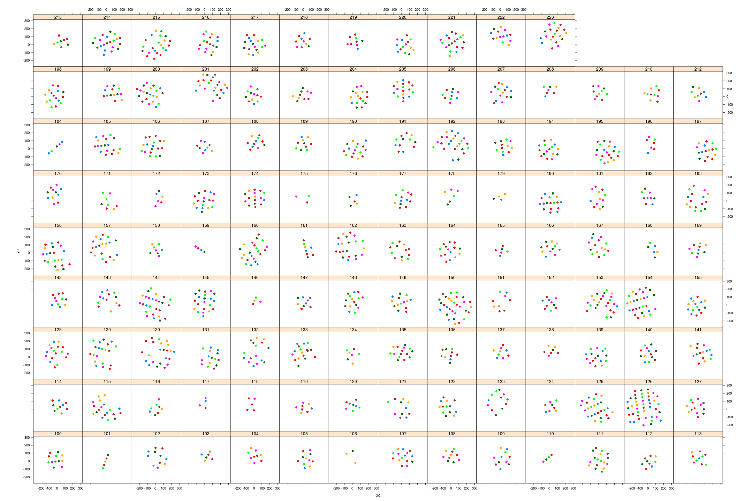

plot of chunk unnamed-chunk-17

SICK camera scale factor

histogram(~pxl2mm, nint = 30, C)

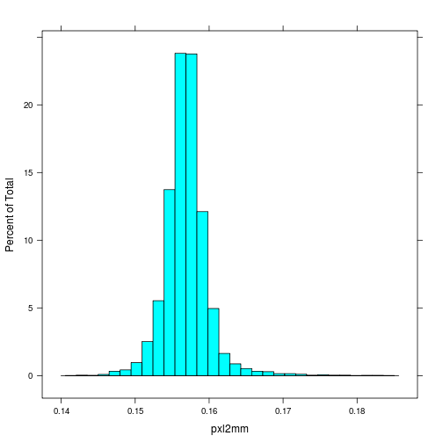

plot of chunk unnamed-chunk-18

summary(C$pxl2mm)

## Min. 1st Qu. Median Mean 3rd Qu. Max. NA's   
## 0.1 0.2 0.2 0.2 0.2 0.2 520

Does SICK scale factor vary through time?

library(RODBC)  
ch = odbcConnect("HYNE", "sa", "password12")  
F = sqlQuery(ch, "select b.pxl2mm, i.Timestamp from SICK_images as i left join SICK_barcodes as b on b.imageId=i.id where nboards>0")  
xyplot(pxl2mm ~ Timestamp, F)

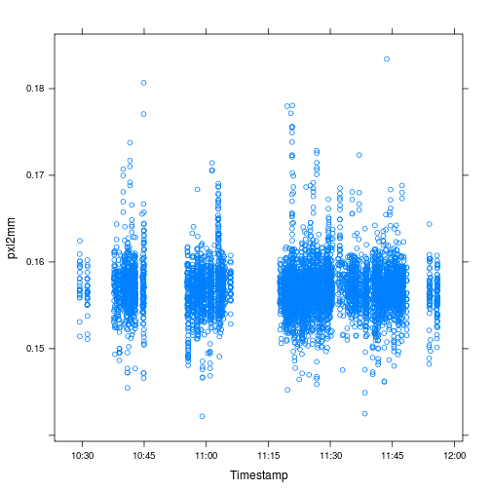

plot of chunk unnamed-chunk-19

library(changepoint)

## Loading required package: zoo  
##   
## Attaching package: 'zoo'  
##   
## The following objects are masked from 'package:base':  
##   
## as.Date, as.Date.numeric  
##   
## Successfully loaded changepoint package version 1.1.5 Created on  
## 2014-06-25 Substantial changes to the structure of the package have  
## occured from version 1.0. Please see the package NEWS for details.

summary(m <- cpt.mean(F$pxl2mm[is.finite(F$pxl2mm)], method = "PELT"))

## Changepoint type : Change in mean   
## Method of analysis : PELT   
## Test Statistic : Normal   
## Type of penalty : SIC with value, 8.761   
## Maximum no. of cpts : Inf   
## Changepoint Locations :

plot(m) # no evidence for a shift in mean

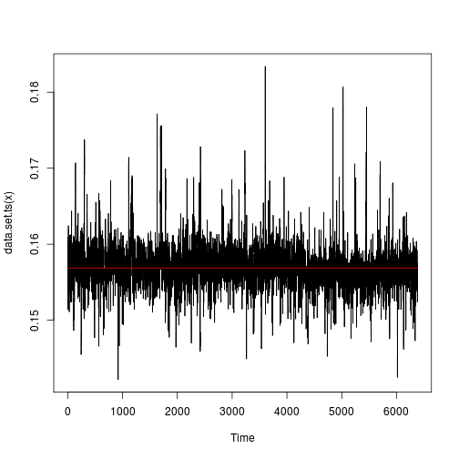

plot of chunk unnamed-chunk-19

Not so much.

The major outlier is image 1187, the image with two boards in one lug. The boards are from two different logs (160, 153) consequently the relative positions are meaningless.

The next worst is 1626. Based on two barcodes. Manual calcs agree, as do calcs based on individual barcodes.

Board orientation w.r.t log csys. Ideally 4 peaks separated by 90 deg. Expect the cant direction (two of the peaks separated by 180 deg) to be more popular.

histogram(~theta * 180/pi | as.factor(SWILogNumber), nint = 100, C)

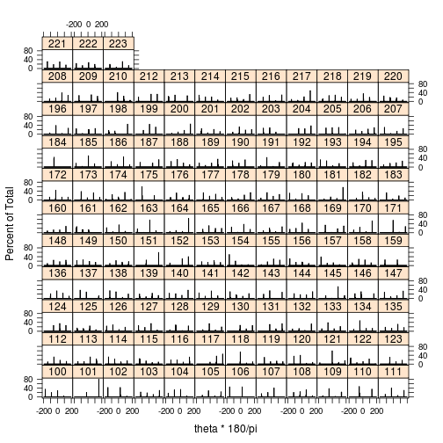

plot of chunk unnamed-chunk-20

## Recommendations

To make merge different board data streams easier:

* include lug id explicitly (is this even possible? if so, who needs to action?)
* leave tipples running and pass byproduct boards back through (though without trimming labelled end) or disable the byproduct option in the optimiser (so PLC knows about all boards)

Assigning log numbers to boards with lost/unreadable labels would be much easier if

* either the chain were flushed between logs
* or logs were trimmed, as squarely as possible, to random but distinctly different lengths (this still dosn't help with short, waney outer boards though)

If the green and dry board data is to be merged, then to avoid extra effort need to make sure that as many barcodes as possible are read from each dry board SICK image.