# Joe90 Measurement Uncertainty

## Todo

* add width and thickness to the list of measures for repeatability assessment?
* modify the Joescan3 algorithm to eliminate spikes at ends in twist profiles

## Background - Joe90

The Joe90 system has been in use at Scion since 2007, with a number of refinements being implemented on top of the original system designed by Joescan for Weyerhaeuser:

* replacement of the original point cloud post-processing algorithm,
* modification of the board mounting system,
* inclusion of weight and resonance measurement equipment,
* addition of a motor drive,
* replacement of the original user interface software and data storage mechanism.

To date, no comprehensive experiment has been conducted to determine the quality of measurements coming from the system, although a variety of ad-hoc tests have been conducted, including:

* the repeated scanning of a number of individual boards,
* scanning of reference boards (white beam and DG3000) at the start of each batch of scans (typically at the start of each day).

Currently the joe90 system is being used to assess the approach to equilibrium of a set of boards for a commercial client (SWI, LS.1.5). In order to do this efficiently, good quality estimates of the uncertainty associated with measures of warp (particularly crook and bow) are required.

As well as , other reasons for performing a repeatability and reproducibility experiment include:

* incorporation in the Joe90 publication currently in preparation
* serving as a basis for QC/QA in the future
* the dataset collected can be used to guide refinement/tuning of the post-processing algorithm
* serve as test set for a fully numerical approach to algorithm uncertainty (3D board model - simulated noisy point cloud - recovered board shape)

## Background - Repeatability and Reproducibility

Measurement systems analysis is a large and complex topic (see references). In the context of measurement systems analysis, repeatability and reproducibility are defined as:

Repeatability : is the measurement variability exhibited when the same item is measured repeatedly with the same equipment by the same operator and within a period of time short enough to exclude the unwanted influence of factors that cannot be guaranteed constant, e.g. environment. Recalibration, unless an essential part of every single measurement, should not occur during repeatability testing.

Reproducibility : is the additional measurement variability found when the same item is measured repeatedly under conditions other than those used for repeatability testing, for example over lengthy periods of time, after recalibration, with different operators, in different laboratories or with different equipment.

Here we are interested in both repeatability, and a limited version of reproducibility.

A wide range of factors potentially contribute to Joe90 measurement uncertainty:

* board length, size, shape including
* presence and degree of wane
* dimensional variation induce by sawing
* cross-sectional departures from rectangular (wane, cup, sawing)
* positioning of the board relative to the supports, including
* orientation of the board relative to gravity
* the distance from acoustic hammer to board end
* motion of the board relative to supports during scan
* changes in straightness of the transport rail (if not corrected for)
* changes in position of supports (relative to one another and relative to start position)
* board surface finish and surface moisture content (affects where laser light reflects from)
* Joescan camera calibration (accounts for relative positions and orientations of the cameras)
* load cell calibration
* post-processing algorithm
* the algorithm itself
* tuning parameters
* the summary measure being considered (e.g max(bow) sensitive to small changes in S shaped boards)
* temperature and humidity changes (over short periods of time)

Quantifying the contribution of these factors to overall measurement uncertainty is compounded by the changes in the boards being measured due to changes in temperature, moisture content and inelastic deformation (e.g. creep under self-weight).

## Proposed Approach

There are essentially two approaches to measurement system analysis.

The first takes a bottom-up perspective, involves a so-called uncertainty budget and derives overall uncertainty from a mathematical model of the measurement process and nominal uncertainties of constituent data (e.g. the stated uncertainty of point positions coming from the JS-20 scan heads is ±0.75 mm). The complexity of the Joe90 measurement equipment and procedure effectively rules this approach out.

The second approach, and the approach adopted here, makes use of a statistical model to interpret results from a designed experiment.

Trueness of the Joe90 system has been proved previously[1]. While trueness is again examined (albeit with only 6 boards), this study focusses on determining measurement uncertainty, particularly the uncertainty of the various warp measures.

### Board Selection

A set of 6 boards were selected from the LS15 subset (the boards that have been being monitored at monthly intervals). This allows for longer term reproduceability issues to be addressed.

Selection was made to span a range of warp characteristics (see table). No attempt was made to control other board characteristics (e.g. surface finish, knottiness).

To keep the number of scans to a minimum, only a single board size (100x40's) and length (4.9m) have been considered.

|  |  |
| --- | --- |
| board | character |
| 030621 | severely warped and unstable through time (poor environmental reproduceability?) |
| 030609 | straight |
| 030647 | bad but stable crook |
| 030628 | bad but stable bow (and crook) |
| 030610 | bad but stable twist |
| 030613 | worst combined bow/crook/twist |

None of the selected boards have wane (no waney boards in the LS15 subset). 10 and 47 are knotty.

### Board Scanning

Scanning took place over 3 consecutive days (Tue 9/9/2014- Thu 11/9/2014).

Two operators (JL, RP) scanned all boards on each day, with JL scanning in the morning (typ. 9-10a) and RP in the afternoon (typ. 4-5p)

Within each scanning session repeatability conditions held (i.e. same operator, minimal elapsed time, no recalibration). Each board was mounted in a joist orientation on the joe90 device and scanned twice (2 repeats) and then removed. Each board was mounted a total of four times (i.e. 4 placements) with the latter 2 of these placements being in an upside-down orientation.

At the start of each scan session:

* the JSdiag app was used to check and if necessary calibrate the cameras.
* the load cells were calibrated using the normal procedure.
* the white beam and dg3000 board were scanned prior to scanning anything else, and scanned again at the end of the session.

Between session boards were stored in a block stack wrapped in plastic. When outside of the board stack, and when not being scanned, boards were kept in polythene socks to prevent moisture movement.

Ambient temperature and RH should be recorded for each batch.

Between scan sessions no adjustment to equipment was made other than specified above.

Board weight, moisture content (electrical resistance probe, three locations) and resonance (hitman) of each board were measured as part of the morning scan session. After scanning was completed, traditional methods (string and edge) were used to measure warp (bow, crook and twist).

### Post-Processing

The scan data has been post-processed using Joescan3 algorithm (rev.107).

Board orientation has been accounted for by rotating post processed results (rather than the point cloud). No attempt has been made to correct for gravity.

## Results

library(lattice)  
library(lme4)

## Loading required package: Matrix Loading required package: Rcpp

library(RODBC)  
library(pander)

## Attaching package: 'pander'  
##   
## The following object is masked from 'package:knitr':  
##   
## pandoc

ch = odbcConnect('joe90')  
X = sqlQuery(ch, "  
select   
 scans.scantime,  
 scans.id as scanId,  
 scans.operator,  
 scans.barcode,  
 scans.weight_kg*1000 as weight,  
 scans.resonance_Hz as resonance,  
 scans.length_fromData_mm as length,  
 scans.volume_cm3 as volume,  
 scans.rotX,  
 bow.value*scans.rotX as bow,  
 crook.value*scans.rotX as crook,  
 twist.value as twist  
from   
 scans,  
 (select scanId, value from warp where measure='bow.xref_mm' and postMethod='Joescan3_rev.107') as bow,  
 (select scanId, value from warp where measure='crook.xref_mm' and postMethod='Joescan3_rev.107') as crook,  
 (select scanId, value from warp where measure='twist.xref_deg' and postMethod='Joescan3_rev.107') as twist  
where  
 scans.id=bow.scanId  
 and scans.id=crook.scanId  
 and scans.id=twist.scanId  
 and `ignore`=0  
 and project='R&R'  
 and barcode not in ('white','dg3000')  
")  
X$day = factor(as.Date(X$scantime, tz="NZ"))  
X = merge(X,read.csv('id_rep_placement_orientation.csv')[,c('id','rep','placement','orientation')],by.x='scanId',by.y='id')  
X$orientation = factor(X$orientation) # orientation has been written back to the db as rotX  
X$rep = factor(X$rep)  
X$placement = factor(X$placement)  
X$board = factor(X$barcode-30600)  
measures = c('weight','resonance','length','volume','bow','crook','twist')  
effects = c('day','board','operator','placement','orientation')

### Dataset v Workplan

Should be 8 scans (2 repeats x 2 placements x 2 orientations) per board per day per operator.

table(X$barcode, X$day, X$operator)

## , , = JL  
##   
##   
## 2014-09-09 2014-09-10 2014-09-11  
## 30609 8 8 8  
## 30610 8 8 8  
## 30612 8 8 8  
## 30613 7 8 8  
## 30628 7 8 8  
## 30647 8 7 8  
##   
## , , = RP  
##   
##   
## 2014-09-09 2014-09-10 2014-09-11  
## 30609 8 12 8  
## 30610 8 12 8  
## 30612 8 12 8  
## 30613 8 10 8  
## 30628 9 10 9  
## 30647 9 11 8

Dataset is nearly complete, but missing values would make balanced anova difficult. Occasionally a repeat scan (i.e. one scan of a per placement pair) is missing.

### Environment

O = read.csv("other_results.csv")  
O$day = as.POSIXct(as.character(O$day))  
O$board = factor(O$board)  
str(O)

## 'data.frame': 126 obs. of 5 variables:  
## $ board : Factor w/ 6 levels "30609","30610",..: NA NA NA NA NA NA NA NA NA NA ...  
## $ day : POSIXct, format: "2014-09-10 09:00:00" "2014-09-10 10:00:00" ...  
## $ operator: Factor w/ 2 levels "JL","RP": 1 1 2 2 1 1 2 2 1 1 ...  
## $ measure : Factor w/ 8 levels "bow","crook",..: 6 6 6 6 5 5 5 5 6 6 ...  
## $ value : num 14.2 12.9 15.2 14.9 0.33 0.39 0.43 0.43 10.9 12.2 ...

xyplot(value ~ day | measure, O, subset = measure %in% c("temp", "rh"), type = "b",   
 scales = list(y = list(relation = "free"))) # , ylab='Air Temperature / [degC]'

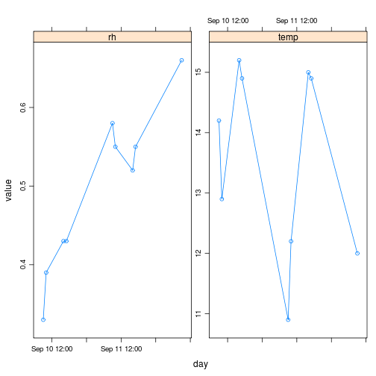

plot of chunk unnamed-chunk-3

# xyplot(100*value ~ day | measure, O, subset=measure%in%c('rh'), ylab='%  
# Relative Humidity', type='b')

Temperature relatively stable (10-15 degC). Relative humidity quite variable, with consistent increasing trend over the scanning period.

Envionmental conditions not recorded for first day (2014-09-09).

### Board Moisture Content

# xyplot(value ~ day | board, O, subset=measure=='mc', ylab='% Moisture  
# Content')  
counts = list(`30610` = 0, `30609` = 0, `30612` = 0, `30613` = 0, `30628` = 0,   
 `30647` = 0)  
O$rep = 0  
for (i in 1:nrow(O)) {  
 if (O$measure[i] == "mc") {  
 counts[[O$board[i]]] = counts[[O$board[i]]] + 1  
 O$rep[i] = counts[[O$board[i]]]  
 }  
}  
xyplot(value ~ rep | board, O, subset = measure == "mc", ylab = "% Moisture Content")

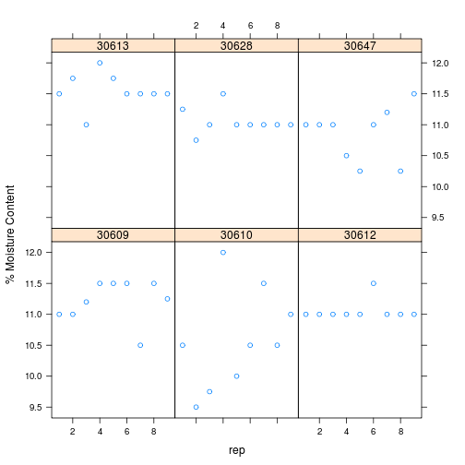

plot of chunk unnamed-chunk-4

# bwplot(value ~ board, O, subset=measure=='mc') (m = lmer(value ~ 1 +  
# (1|board), O, subset=measure=='mc')) summary(lm(value ~ 1, O,  
# subset=measure=='mc')) coef(m)$board qqnorm(residuals(m))  
# xyplot(residuals(m) ~ rep | board, O[O$measure=='mc',])

Boards have a moisture content of 11±0.5%. 030610 appears to have a more variable MC than other boards.

### Weight

board.mean = function(m) {  
 model = lmer(value ~ (1 | board), O[O$measure == m, ])  
 d = coef(model)$board  
 colnames(d) = m  
 d  
}  
xyplot(value ~ day | board, O, subset = measure == "weight")

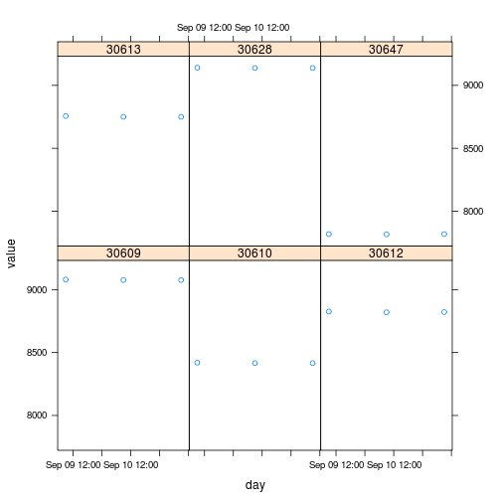

plot of chunk unnamed-chunk-5

# dotplot(jitter(value, amount=0.01) ~ board, O, subset=measure=='weight')  
M = board.mean("weight")

### Hitman

Were the hitman results based on a nominal 4.9m length? If not, what was the length used?

xyplot(value ~ day | board, O, subset = measure == "hitman")

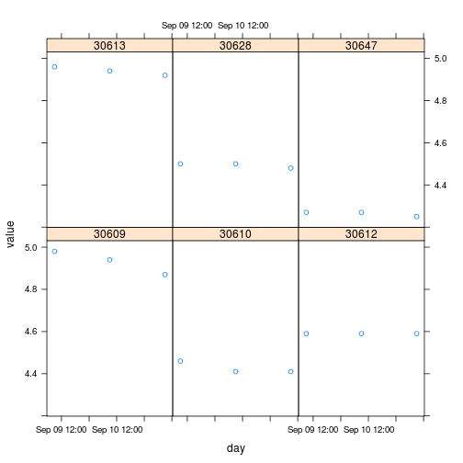

plot of chunk unnamed-chunk-6

# dotplot(jitter(value, amount=0.01) ~ board, O, subset=measure=='hitman')  
M = cbind(M, board.mean("hitman"))  
M = data.frame(M)  
M$resonance = M$hitman * 1000/4.9/2

The decreasing trend for only 030609 is curious.

### String Warp

Are bow and crook midpoint or maximum measures? Twist is total twist in mm?

Repeat manual measurements including sign?

M$board = as.numeric(rownames(M))  
for (m in c("bow", "crook", "twist")) {  
 for (i in 1:nrow(M)) {  
 b = M[i, "board"]  
 M[i, m] = O$value[O$measure == m & O$board == b]  
 }  
}

### White Beam

library(RODBC)  
ch = odbcConnect("joe90")  
sql = "select \n * \nfrom \n warpProfiles, scans \nwhere \n scanId=scans.id \n and postMethod='Joescan3_rev.107' \n and `ignore`=0 \n and project='R&R'\n and barcode in ('white')"  
P = sqlQuery(ch, sql)  
for (m in c("bow_mm", "crook_mm", "twist_deg")) {  
 print(xyplot(P[, m] ~ x_mm | scantime, P, main = paste("WHITE", m), ylab = m,   
 type = "l", layout = c(1, length(unique(P$scantime)))))  
}

## Warning: closing unused RODBC handle 1

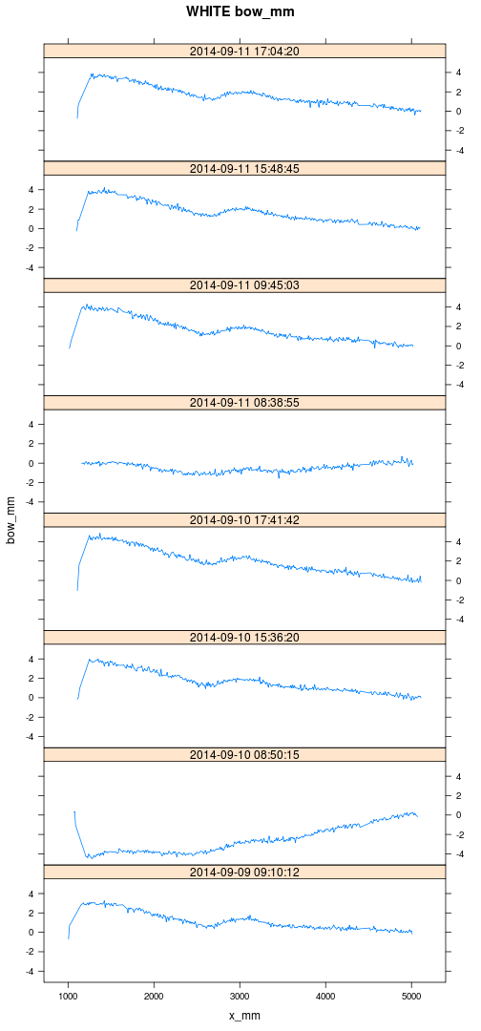 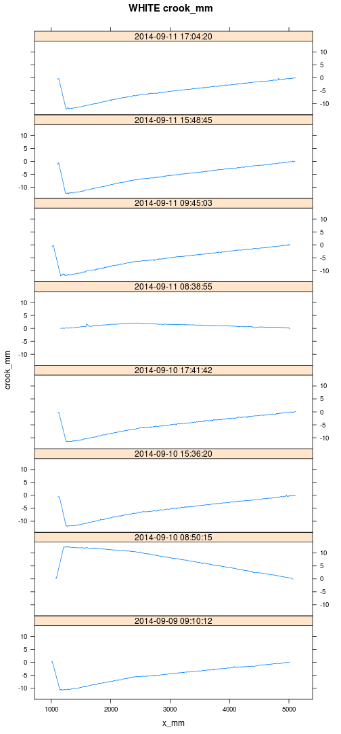 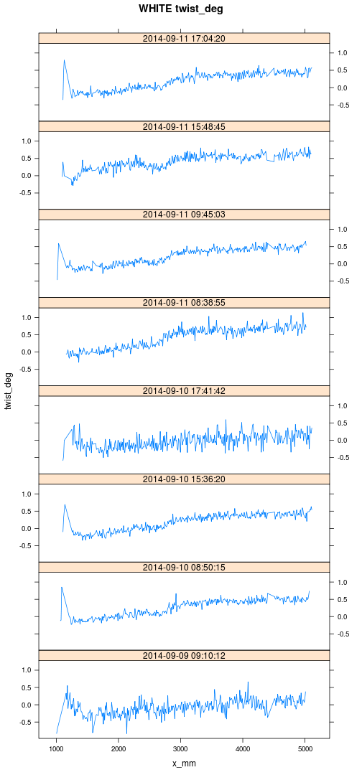

Expected 2x2x3=12 white scans. Got 8.

In bow/crook plots, the warp extraction algorithm stuggling to accurately locate the board centre. Due to the stub sticking out the end? Why is the LH end at 1000 mm not 0?

Shape of reference beam similar from start of trial to finish. A good thing.

### DG3000

library(RODBC)  
ch = odbcConnect("joe90")  
sql = "select \n * \nfrom \n warpProfiles, scans \nwhere \n scanId=scans.id \n and postMethod='Joescan3_rev.107' \n and `ignore`=0 \n and project='R&R'\n and barcode in ('dg3000')"  
P = sqlQuery(ch, sql)

## Warning: closing unused RODBC handle 2

for (m in c("bow_mm", "crook_mm", "twist_deg")) {  
 print(xyplot(P[, m] ~ x_mm | scantime, P, main = paste("DG3000", m), ylab = m,   
 type = "l", layout = c(1, length(unique(P$scantime)))))  
}

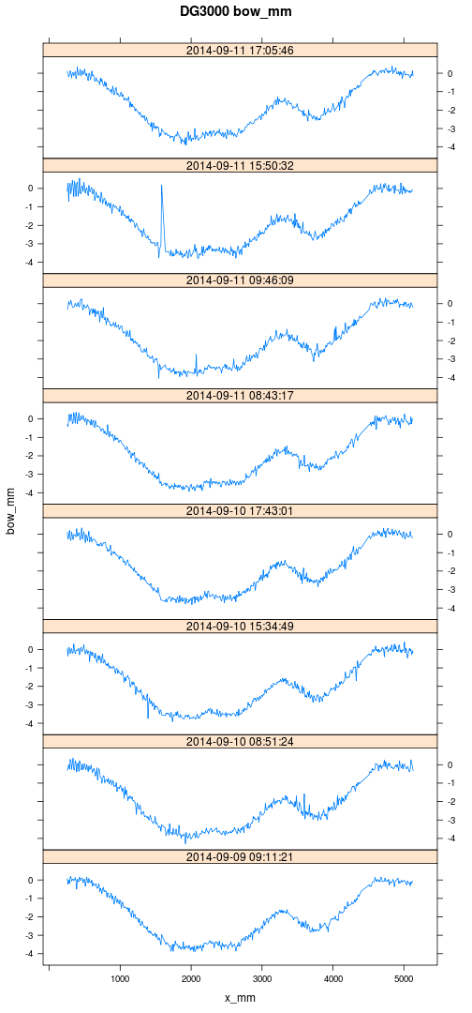 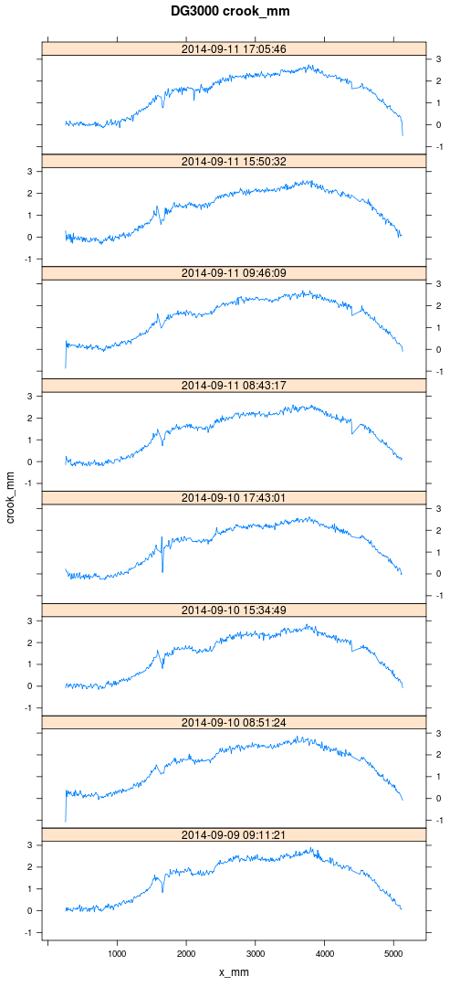 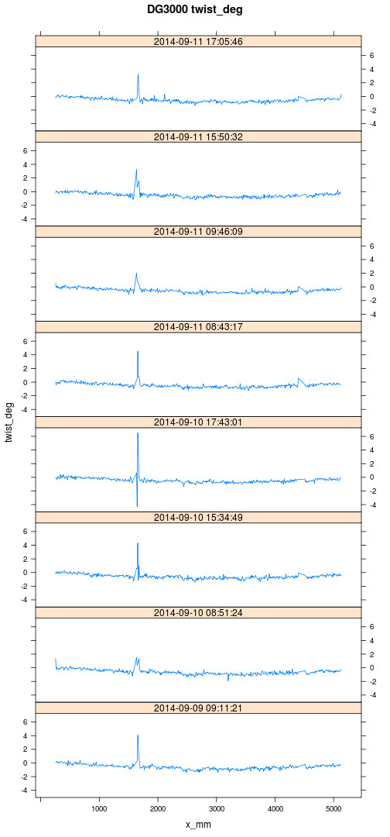

Like white beam, the dg3000 board shape consistent from start to finish.

### Fixed Effects?

par(mfrow = c(length(measures), length(effects)))  
for (m in measures) {  
 for (e in effects) {  
 boxplot(X[, m] ~ X[, e], main = paste(m, e))  
 }  
}

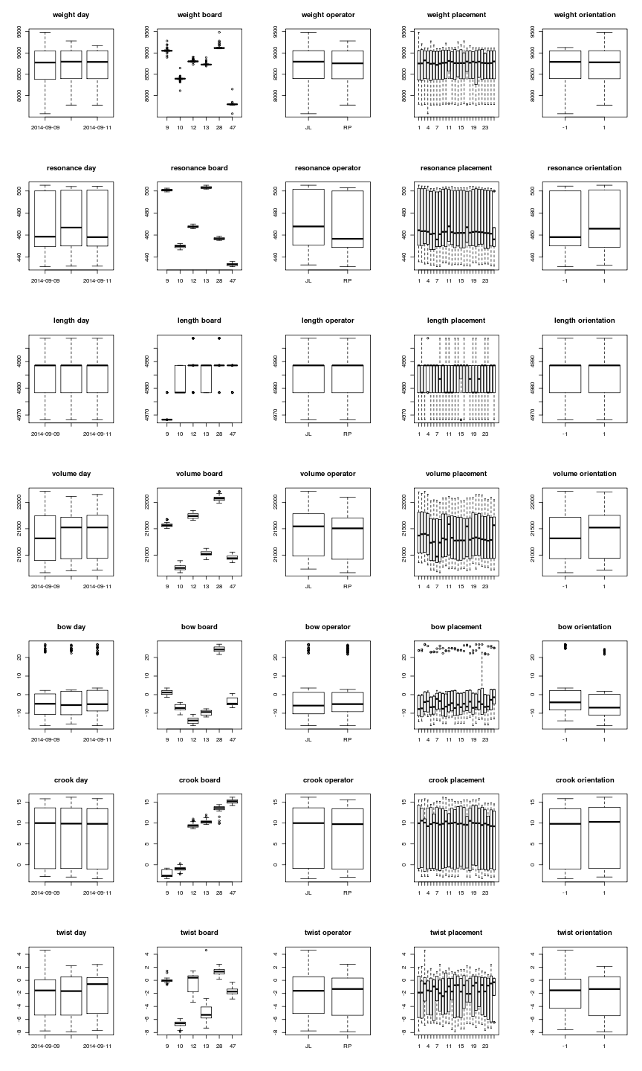

plot of chunk unnamed-chunk-10

### Mean Measures and Residuals

board.mean = function(m) {  
 model = lmer(X[, m] ~ (1 | board), X)  
 # print(xyplot(X[,m] ~ rep | board, X, layout=c(1,6), pch=19,  
 # group=paste(day,operator)))  
 print(xyplot(residuals(model) ~ rep | board, X, layout = c(1, 6), pch = 19,   
 group = paste(day, operator), main = m))  
 d = coef(model)$board  
 colnames(d) = m  
 d  
}  
D = board.mean(measures[1])

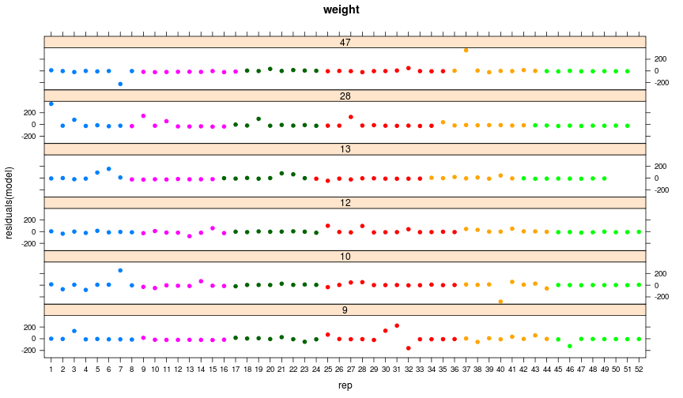

plot of chunk unnamed-chunk-11

for (m in measures[2:length(measures)]) {  
 D = cbind(D, board.mean(m))  
}

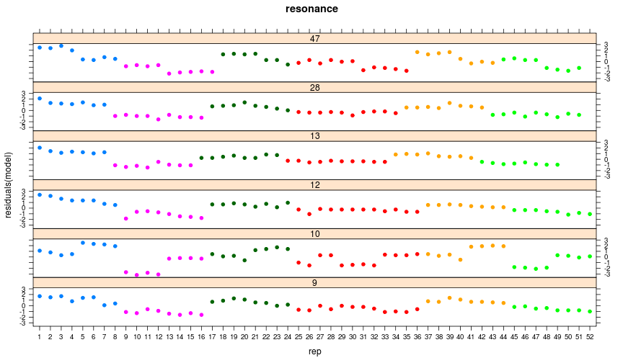 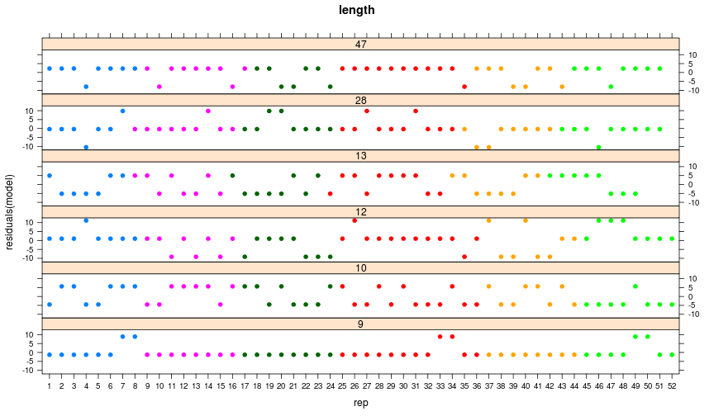 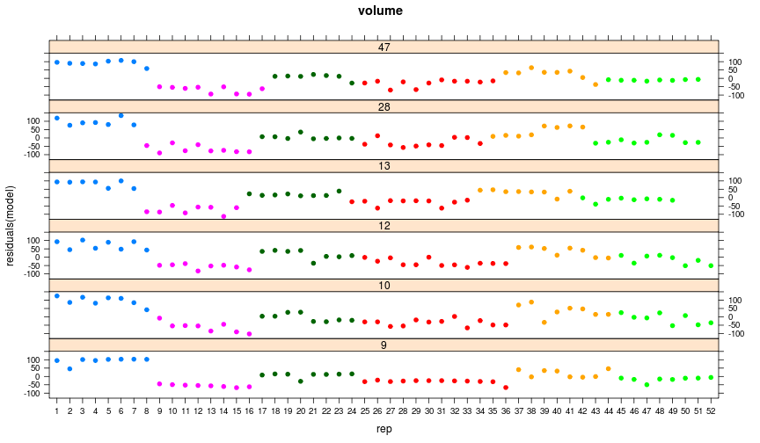 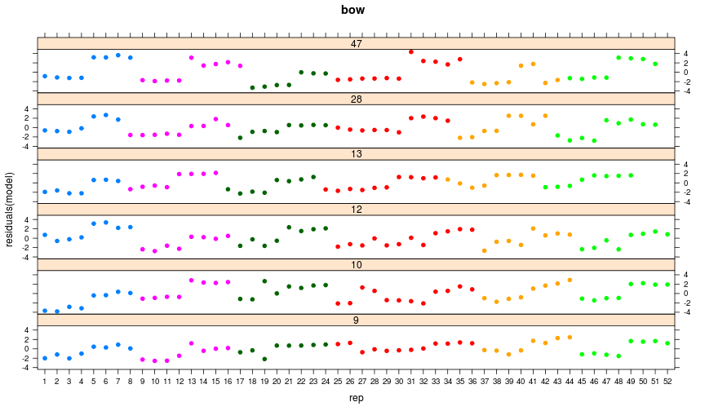 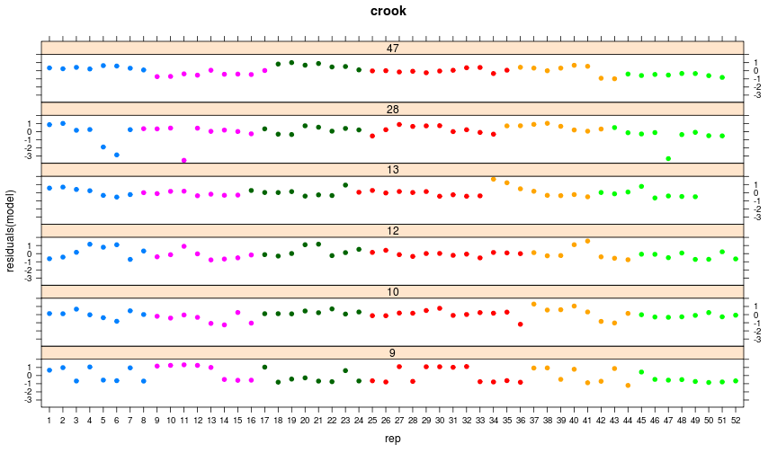 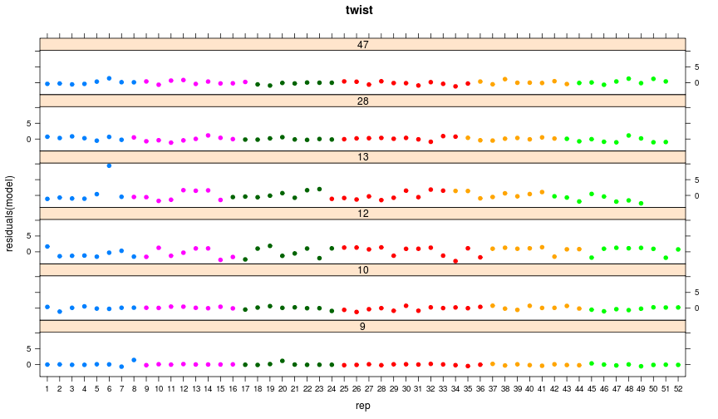

D = data.frame(D)  
D$board = 30600 + as.numeric(rownames(D))  
rownames(D) = sprintf("%06i", 30600 + as.numeric(rownames(D)))

pandoc.table(D[, 1:(ncol(D) - 1)], style = "rmarkdown", digits = 2, keep.trailing.zeros = TRUE,   
 justify = "right", split.tables = Inf)

|  |  |  |  |  |  |  |  |
| --- | --- | --- | --- | --- | --- | --- | --- |
|  | weight | resonance | length | volume | bow | crook | twist |
| **030609** | 9058 | 501 | 4970 | 21574 | 1.1 | -2.12 | -0.015 |
| **030610** | 8395 | 450 | 4983 | 20769 | -7.0 | -0.98 | -6.672 |
| **030612** | 8808 | 468 | 4988 | 21743 | -14.0 | 9.43 | -0.416 |
| **030613** | 8738 | 503 | 4984 | 21028 | -9.7 | 10.32 | -4.800 |
| **030628** | 9134 | 457 | 4989 | 22077 | 24.5 | 13.38 | 1.305 |
| **030647** | 7800 | 433 | 4986 | 20950 | -3.7 | 15.18 | -1.679 |

### Compare Joe90 with Alternate Methods

Are bow and crook midpoint or maximum measures? Twist is total twist in mm?

Repeat manual measurements including sign?

Measure board lengths? Cross-sectional dimensions?

# manual measurmements  
MD = merge(M, D, by = "board", suffixes = c(".m", ".j"))  
myplot = function(x, y, ...) {  
 plot(x, y, xlab = "joe90", ylab = "alternate", ...)  
 abline(c(0, 1), col = "grey50")  
}  
par(mfrow = c(1, 6))  
myplot(MD$weight.j, MD$weight.m, main = "Weight / [kg]")  
myplot(MD$resonance.j, MD$resonance.m, main = "Resonance / [Hz]")  
myplot(abs(MD$bow.j), MD$bow.m, main = "Bow / [mm]")  
myplot(abs(MD$crook.j), MD$crook.m, main = "Crook / [mm]")  
myplot(abs(sin(MD$twist.j/180 * pi) * 100), MD$twist.m, main = "Twist / [mm]")

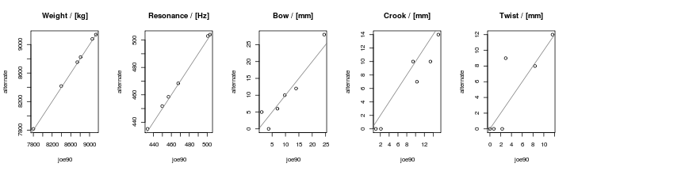

plot of chunk unnamed-chunk-12

Weight and resonance within 0.5%. Warp not so good. But only 6 samples!

### Uncertainty Budget

Treat everything as a random effect.

myfun = function(m) {  
 mdl = lmer(X[, m] ~ (1 | board) + (1 | day) + (1 | operator) + (1 | orientation) +   
 (1 | board:day) + (1 | board:orientation) + (1 | board:placement) +   
 (1 | board:operator), X)  
 print(xyplot(residuals(mdl) ~ rep | board, group = paste(day, operator),   
 X, layout = c(1, 6), pch = 19, main = m))  
 mdl  
}  
models = list()  
par(mfcol = c(3, 3))  
for (m in measures) {  
 models[[m]] = myfun(m)  
}

## Warning: Model failed to converge with max|grad| = 0.00301092 (tol =  
## 0.002, component 5)

V = data.frame(Group = c(as.data.frame(VarCorr(models[[1]]))$grp, "TOTAL", "TYP.VALUE",   
 "%TYP"))  
for (m in measures) {  
 qqnorm(residuals(models[[m]]), main = paste(m, "Normal Q-Q Plot"))  
 df = as.data.frame(VarCorr(models[[m]]))  
 typ = abs(median(D[, m]))  
 tot = sqrt(sum(df$sdcor[df$grp != "board"]^2))  
 V[, m] = c(df$sdcor, tot, typ, tot/typ * 100)  
}  
# V  
rownames(V) = V$Group

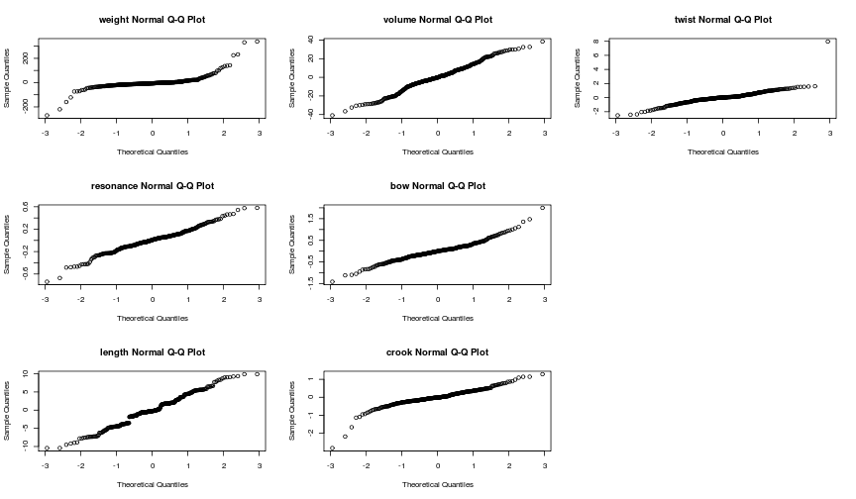

plot of chunk unnamed-chunk-14

# set.alignment(c('left',rep('right',length(measures))))  
pandoc.table(V[c(6, 8, 7, 2, 3, 4, 1, 9, 10, 11, 12), c(2:ncol(V))], justify = "right",   
 style = "rmarkdown", digits = 2, round = 2, split.table = Inf, keep.trailing.zeros = TRUE)

|  |  |  |  |  |  |  |  |
| --- | --- | --- | --- | --- | --- | --- | --- |
|  | weight | resonance | length | volume | bow | crook | twist |
| **day** | 0.00 | 0.03 | 0.00 | 8.4 | 0.00 | 0.05 | 0.00 |
| **operator** | 7.39 | 1.16 | 0.31 | 53.8 | 0.00 | 0.22 | 0.10 |
| **orientation** | 0.00 | 0.00 | 0.00 | 4.7 | 1.90 | 0.29 | 0.00 |
| **board:day** | 3.64 | 0.00 | 0.42 | 0.0 | 0.38 | 0.12 | 0.15 |
| **board:operator** | 0.00 | 0.10 | 0.00 | 0.0 | 0.39 | 0.07 | 0.14 |
| **board:orientation** | 15.50 | 0.70 | 1.27 | 3.1 | 0.27 | 0.20 | 0.37 |
| **board:placement** | 0.00 | 0.37 | 1.53 | 27.7 | 0.67 | 0.33 | 0.28 |
| **Residual** | 50.21 | 0.26 | 4.45 | 19.0 | 0.54 | 0.50 | 0.91 |
| **TOTAL** | 53.19 | 1.43 | 4.91 | 64.2 | 2.17 | 0.74 | 1.05 |
| **TYP.VALUE** | 8772.64 | 462.22 | 4984.98 | 21301.0 | 5.36 | 9.87 | 1.05 |
| **%TYP** | 0.61 | 0.31 | 0.10 | 0.3 | 40.56 | 7.54 | 99.96 |

### Board Profiles

library(RODBC)  
ch = odbcConnect("joe90")  
sql = "select \n barcode,\n crook_mm*rotX as crook_mm, \n bow_mm*rotX as bow_mm, \n twist_deg,\n x_mm,\n scanId\nfrom \n warpProfiles, scans \nwhere \n scanId=scans.id \n and postMethod='Joescan3_rev.107' \n and `ignore`=0 \n and project='R&R'\n and barcode not in ('dg3000','white')"  
P = sqlQuery(ch, sql)

## Warning: closing unused RODBC handle 3

for (m in c("crook_mm", "bow_mm", "twist_deg")) {  
 print(xyplot(P[, m] ~ x_mm | as.factor(barcode), group = scanId, P, type = "l",   
 layout = c(1, 6)), ylab = m, main = m)  
}

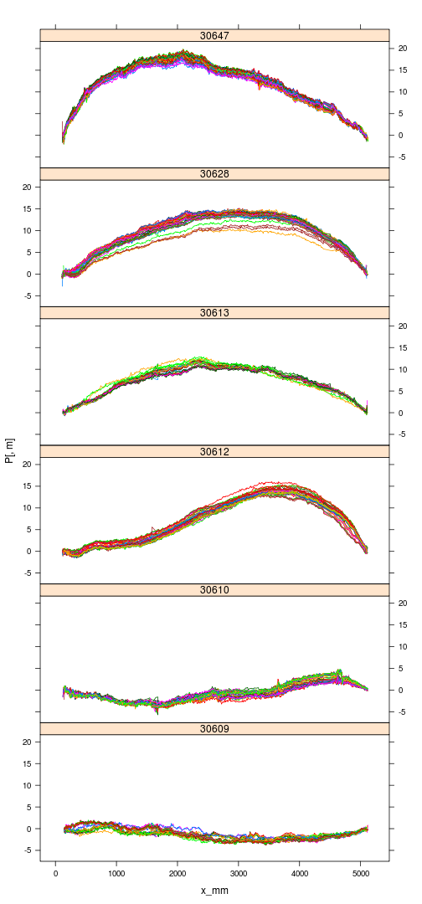 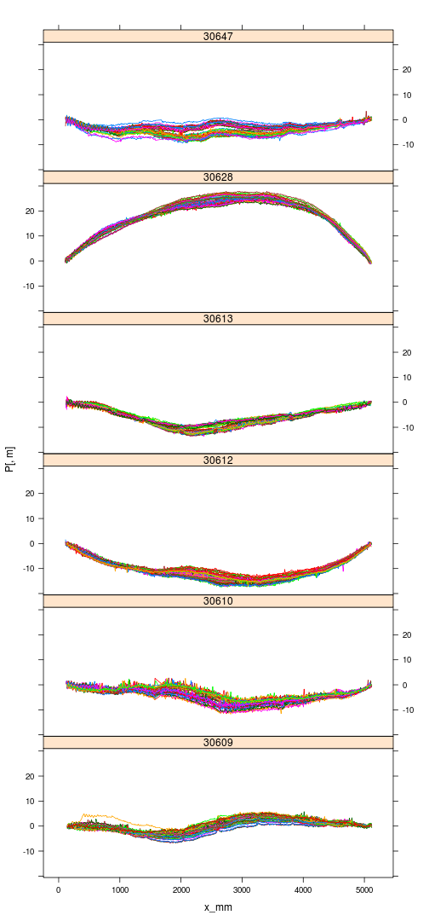 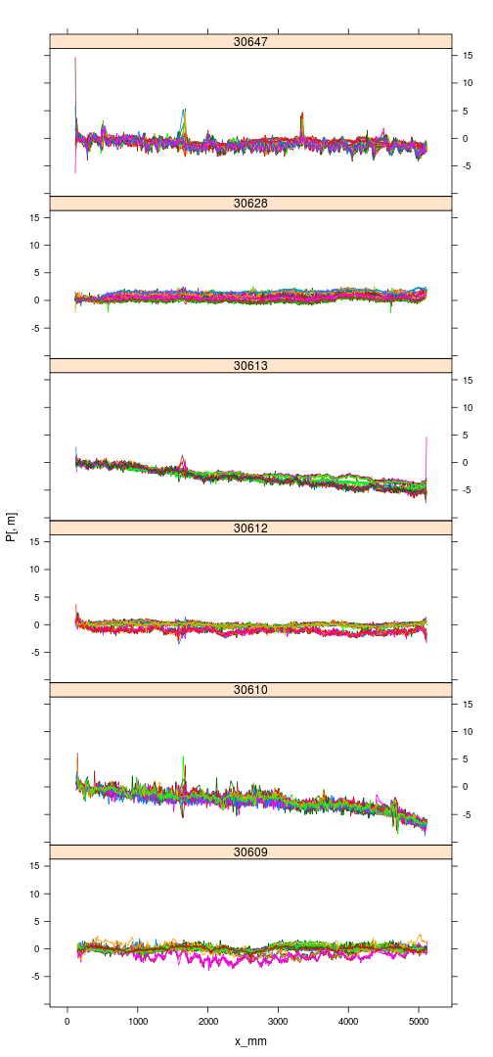

## Discussion

030612 selected instead of 030621.

Operator and time-of-day confounded due to same operator performing scans at same time-of-day.

No waney samples included (no wane in 50 LS15 board subset).

Do the ranges in density, stiffness, warp tested here span the range seen in practice? Lower stiffness boards can be expected to be more influenced by orientation. SHould orientation be a fixed effect?

Weight measurement uncertainties far from normal, with many more large deviations than a normal distribution would produce. What causes the extreme results?

## Conclusions

Absolute measurement uncertainty does not appear to be depend significantly on the value of the measurand (???).

None of the selected boards have wane. Wane will affect results via physical and computational mechanisms. If this is believed important, at least one waney board should be added to the dataset.

Only one size/length combination examined. The combination represents the bulk of the material scanned to date. It is quite possible that board length (and maybe even dimension) affect repeatability in complex ways. Should other sizes become important in the future, this R&R exercise should be repeated.

## References

* [JCGM 100:2008 Evaluation of measurement data — Guide to the expression of uncertainty in measurement](http://www.iso.org/sites/JCGM/GUM-introduction.htm)
* [Guidelines for Evaluating and Expressing the Uncertainty of NIST Measurement Results](http://www.nist.gov/pml/pubs/tn1297/index.cfm)
* http://en.wikipedia.org/wiki/Measurement_systems_analysis
* [ISO 5725 Accuracy of Measurement Methods and Results](https://www.iso.org/obp/ui/#iso:std:iso:5725:-1:ed-1:v1:en)
* ASTM E2782 Standard Guide for measurement systems analysis

1. As part of the FFR PQPV study, traditional methods were used to independently assess warp, density and stiffness of a set of boards for comparison with joe90. In all cases the results were found to be in agreement.