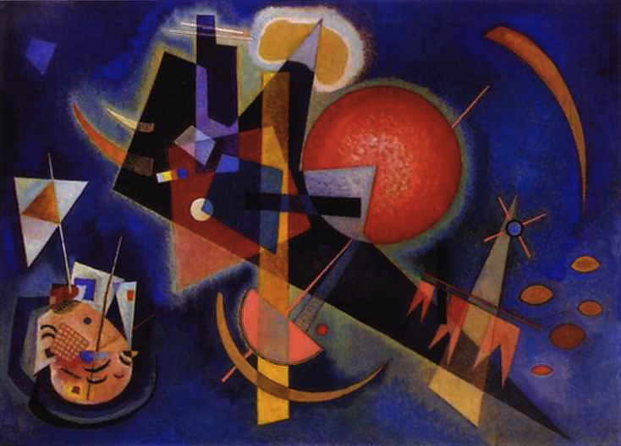

Wassily Kandinsky – *In Blue*

Saint Blue:  
a world premiere

*“a cosmic beauty…   
of acutely crafted music”****John von Rhein, Chicago Tribune***

**For immediate release**

**World premiere of American composer Geoffrey Gordon’s *Saint Blue* at the Elgar Concert Hall with Simon Desbruslais, Clare Hammond and the English Symphony Orchestra.**

On **13 May 2015**, acclaimed trumpet and piano duo, Simon Desbruslais and Clare Hammond, will give the **world premiere** of American composer Geoffrey Gordon’s ***Saint Blue***, a double concerto for trumpet, piano and strings, inspired by the works of Russian artist and visionary **Wassily Kandinsky**. The programme also includes a concerto for trumpet and piano and a chamber symphony by Shostakovich, alongside Tchaikovsky’s well-loved Serenade for strings, performed by the **English Symphony Orchestra** under conductor **Kenneth Woods**.

“Steel-lipped” trumpeter, Simon Desbruslais, and virtuoso pianist, Clare Hammond, are rapidly making a name for themselves as the leading trumpet and piano duo of our time. Their strong commitment to new music has already seen them commission over six new works for trumpet and piano duo, from composers including John McCabe and Edwin Roxburgh. This concert heralds the first of their concerto commissions with a dazzling new work from American composer Geoffrey Gordon, described by *Le Monde* as “a rising star in contemporary music”.

Two of Kandinsky’s paintings, *All Saints 1* and *In Blue*, provide the inspiration for Geoffrey Gordon’s *Saint Blue*, an explosion of riotous colour and vivid characterisation. The central section of the work comprises an extended jazz-infused cadenza where the orchestra’s principal double bass is drawn into a trio with the trumpet and piano soloists. Both *Saint Blue* and Shostakovich’s Concerto for Piano, Trumpet and Strings, also included in this concert programme, are scheduled to be recorded with the ESO in 2015-16.

For further information, press CDs, downloads, photos and interview opportunities please contact

Simon Desbruslais, E: simon.desbruslais@gmail.com, T: 07984 801158

Related downloads, including high-resolution photos, at **http://www.clarehammond.com/eso.html**

**Notes to Editors**

Concert at 7.30pm at the Elgar Concert Hall, Birmingham University, B15 2TT.

Tickets £20 / £15 for the over 60s / £5 for students on 0121 345 0600 or online on http://eso.co.uk/?p=2088.

The full concert programme is as follows:

Shostakovich (arr. Barshai) – Chamber Symphony Op. 110a (String Quartet No. 8)  
Shostakovich – Concerto for Piano, Trumpet and Strings

Interval

Geoffrey Gordon – *Saint Blue* for Piano, Trumpet and Strings (World Premiere)  
Tchaikovsky – Serenade for Strings

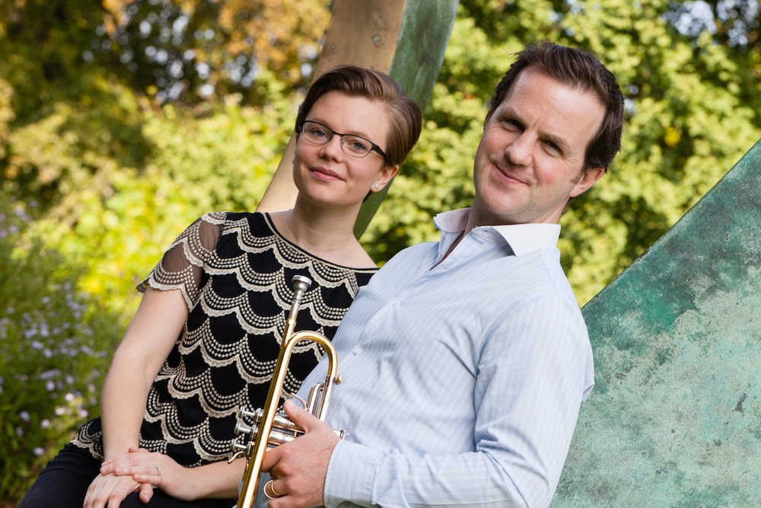

Simon Desbruslais and Clare Hammond. Photo © Michael Desbruslais

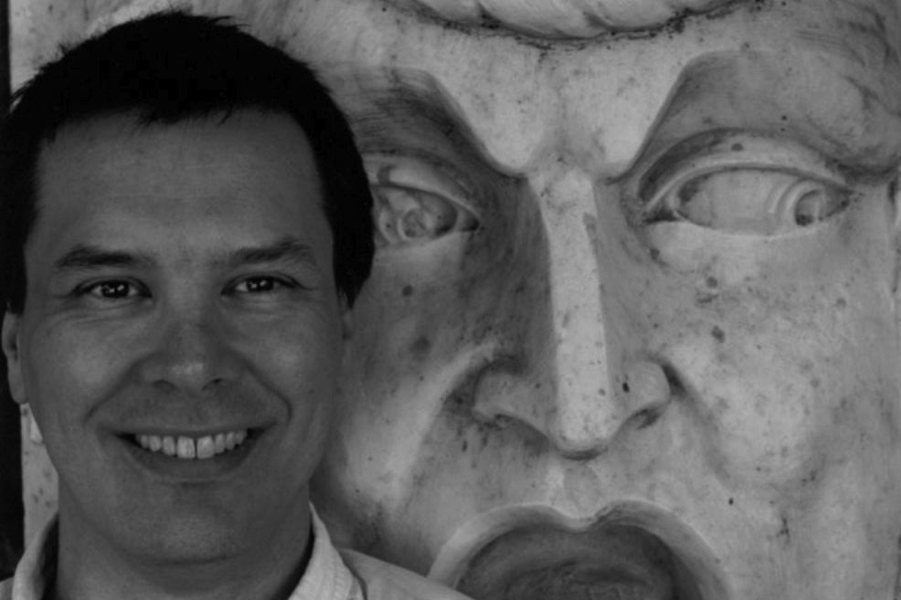

Geoffrey Gordon

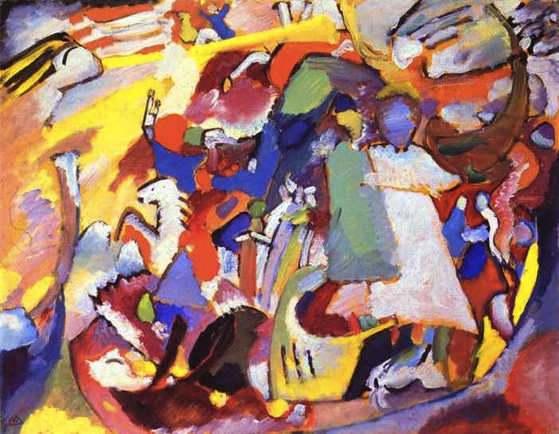

Kandinsky – *All Saints* *I*(from the Stadtische Galerie’s permanent collection in Munich)**BIOGRAPHIES**

**Geoffrey Gordon**

A winner of the Aaron Copland Award, Geoffrey Gordon has been described as “a rising star in contemporary music” (Le Monde). His list of works includes orchestral and chamber music—vocal and instrumental—as well as scores for theater, dance and film. His music has been called “brilliant” (Boston Globe), “stunning” (Milwaukee Journal), “wonderfully idiomatic” (Salt Lake Tribune), “haunting” (Strings Magazine) and “remarkable” (Fanfare). Chicago Tribune music critic John von Rhein called Mr. Gordon’s *lux solis aeterna*, “a cosmic beauty … of acutely crafted music.” He has worked with (or soon will work with) some of the best ensembles in the world, including the Copenhagen Philharmonic, Britten Sinfonia, the Cleveland Orchestra, the Dallas Symphony, the Milwaukee Symphony, JACK Quartet, Zeitfluss, AKOM Ensemble, Le Train Bleu, Third Angle Ensemble, the Buffalo Philharmonic, Boston Modern Orchestra Project and the San Francisco Contemporary Music Players. In 2015, he will serve as composer-in-residence at the International Centre for Composers in Visby, Sweden.

**http://geoffreygordoncomposer.com/**

**Simon Desbruslais and Clare Hammond**

Simon Desbruslais and Clare Hammond are quickly establishing themselves as an adventurous and distinctive duo with a strong commitment to new music. Individually, they have received international acclaim for their ever-growing discography and riveting performances, and in 2011 they decided to form a musical partnership in order to promote and expand repertoire for trumpet and piano.

To date, Desbruslais and Hammond have commissioned over six new works for trumpet and piano, from composers including John McCabe and Edwin Roxburgh, as well as three new double concertos. In May 2015, they will give the world premiere of Geoffrey Gordon’s ‘Saint Blue’ for Piano, Trumpet and Strings and perform Shostakovich’s Concerto for Piano, Trumpet and Strings with the English String Orchestra. Both works are scheduled to be recorded with the ESO in 2015-16.

**http://www.abmcproductions.com/?page_id=247**

**English Symphony Orchestra**

The Worcestershire-based ESO was founded by  conductor William Boughton as the English String Orchestra in 1978. It soon earned an international reputation for performances of English music, made over fifty recordings and began touring regularly in Europe. Over time, the orchestra’s repertoire expanded to include the full breadth of orchestral music, the ESO grew to become the English Symphony Orchestra. Ever since then, “ESO” has served as an acronym with a dual meaning.

Conductor Vernon “Tod” Handley succeeded William Boughton in 2007, and led the orchestra until his death in 2008. Over the years, the ESO has worked with a distinguished list of instrumentalists, composers and conductors, including Stephen Isserlis, Daniel Hope, Michael Tippett, Nicholas Maw and Yehudi Menuhin, who was appointed the ESO’s Principal Guest Conductor in 1991, and led the orchestra on a number of international tours.

Central to the mission of the modern ESO is a commitment to share the power of live music with as wide a population as possible. The orchestra is dedicated to bringing performances of international standard to new audiences not only in the concert hall, but in schools, care homes, hospices and other under-served venues. These concerts often provide the only opportunity locally to hear live music by a professional orchestra. That includes people who by reason of age (young or old) or infirmity would otherwise be unable to access it. ESO raises funds, therefore, to send its Wind and String Quartets to play in local care homes and Hospices.

**http://eso.co.uk/**

**http://eso.co.uk/?p=2088** **[http://www.clarehammond.com/eso.html](http://www.kingsplace.co.uk/panufnik)**