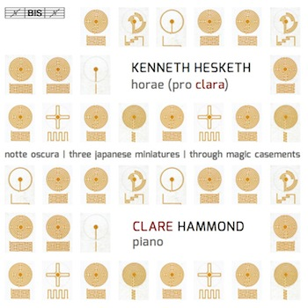

CLARE HAMMOND

piano

***"… unfaltering bravura and conviction"***   
Gramophone Magazine UK

*“****… this array of wizardry is not for the faint hearted”***BBC Music Magazine

***“… one of the most enjoyable recordings to come my way this year”***American Record Guide

**PRESS RELEASE: IMMEDIATE**

**Pianist Clare Hammond releases a disc of solo piano music by   
British composer Kenneth Hesketh**

*“Hammond displayed the scintillating passagework and poetic calm [of Horae (pro clara)] with great flair.”* The Guardian

On **6 June 2016**, Clare Hammond will release her third disc with BIS Records, of solo piano music by British composer **Kenneth Hesketh**. Featuring Kenneth’s masterpiece, ***Horae (pro clara)***, a series of twelve miniatures written for Clare in 2011/12, this disc features a further three works which illustrate his kaleidoscopic approach to colour and the incisiveness of his imagination: *Notte Oscura*, *Three Japanese Miniatures* and *Through Magic Casements*.

Clare and Kenneth first met after her debut recital at the Southbank Centre in 2010 and have since developed a close artistic collaboration. *Horae (pro clara)* was written for Clare over a period of two years and premiered at the Cheltenham Festival in 2013, while this season she tours a new work by Kenneth for piano and silent film, *Hände*. Clare says of his music that “it can seem overwhelming at times, yet if one engages with its textural intricacy, the scope of his extra-musical allusions, and volatile virtuosity, rich rewards lie in store”.

Hesketh was born in Liverpool and sang as a chorister in the Anglican Cathedral as a boy, before undertaking compositional studies in London and at Tanglewood in the US, as a student of Henri Dutilleux. He has developed a long-standing relationship with the Royal Liverpool Philharmonic Orchestra and has also collaborated with the Seattle Symphony Orchestra, BBC Philharmonic Orchestra and Göttinger Symphonie Orchester, among others. While his compositional style has changed significantly over time, a preoccupation with colour, vibrancy and harmonic pungency remains constant.

Over the past few years, Clare has built a reputation as an authority on contemporary music and is developing a “reputation for brilliantly imaginative concert programmes” (*BBC Music Magazine*, ‘Rising Star’). In 2015 the Guardian described her as a “dazzling athlete” following her Barbican Hall debut and she was specially invited to perform as part of the ‘In Tune’ Christmas special, her fifth appearance on BBC Radio 3 that year. Over the past year she has recorded discs for Sony, BIS Records and Signum and, in 2014, gave debut performances at 7 festivals across Europe, including the ‘Chopin and his Europe Festival’ in Warsaw. She says of this next disc that “it is rare to find a composer whose style has so much affinity with my own way of playing. It has been a real joy to explore Kenneth’s music in such depth and to get to grips with the vitality and vivid drama of his writing for piano.

**Notes to Editors**

A dedicated press site for the disc with a pdf of the press release, press photos, and audio demos can be found at **http://www.clarehammond.com/hesketh_disc.html**.

The disc will be launched at the Cheltenham Music Festival at 5pm on Sunday 10 July at Clare’s recital in the Parabola Arts Centre, Bayshill Road, Cheltenham, GL50. If you would like to attend, please email Jo Carpenter on jo@jocarpenter.com to reserve a ticket.

The disc has been supported by the RVW Trust and the Fidelio Charitable Trust. Clare and Kenneth are also grateful for the support of the Cardiff University Music Department.

For further information, press CDs, downloads, photos and interview opportunities, please contact:  
Jo Carpenter Music PR Consultancy E: jo@jocarpenter.com, T: 07771 538868

**BIS Records, BIS 2193**

Release date: 6 June 2016  
Total playing time: tbc

**Kenneth Hesketh**

*Through Magic Casements* (2008)

*Horae (pro clara)* (2011/12)

i. Trasparente (diaphanous)  
ii. Velocissima assai (as fleet as the tiniest humming bird)  
iii. Semplice  
iv. Agilmente (maniaco ed instabile – with never-ceasing energy)  
v. Diretto, ancora fluido (like the splash and suspension of water droplets)  
vi. Nervoso, ma dolce (flessibile)

vii. Capriccioso  
viii. Ritmico (giusto) (like intertwining chime clocks) / Flessibile  
ix. Capriccioso (impishly sardonic)  
x. Scorrevole (ma meccanico) (like an ‘evening full of the linnet’s wings’)  
xi. Indolente (… lapping, with low sounds)  
xii. Molto misterioso, desolate (‘for now we see through a glass, darkly’)

*Notte Oscura*(2002)

*Three Japanese Miniatures* (2002)  
i. Temple Music  
ii. The Cradle Rocks…  
iii. Little Bumbuku

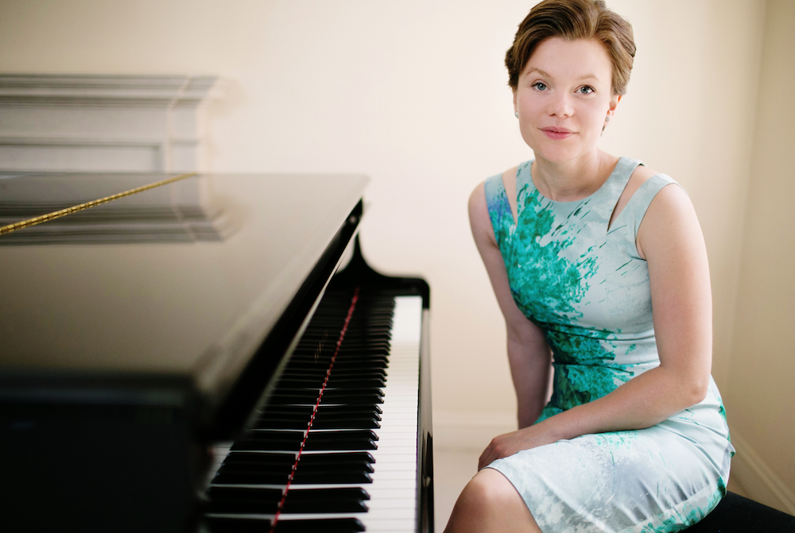

Photo © Julie Kim

**Clare Hammond - biography**

Acclaimed as a pianist of “amazing power and panache”(*The Telegraph*), Clare Hammond is recognised for the virtuosity and authority of her performances and is developing a “reputation for brilliantly imaginative concert programmes” (*BBC Music Magazine*, ‘Rising Star’). In 2015 the Guardian described her as a “dazzling athlete” following her sold-out Barbican Hall debut and she was specially invited to perform as part of the ‘In Tune’ Christmas special, her fifth appearance on BBC Radio 3 that year. Over the past year she has recorded discs for Sony, BIS Records and Signum and, in 2014, gave debut performances at 7 festivals across Europe, including the ‘Chopin and his Europe Festival’ in Warsaw.

Highlights in 2016 include her Royal Festival Hall debut with the Philharmonia, and a concerto tour of Poland, to include a newly discovered work by Josef Myslivecek, a mentor of Mozart. In June, Hammond releases her third disc for BIS Records, *Horae (pro clara)*, with solo piano music by Ken Hesketh, and returns to the Cheltenham and Presteigne Festivals later in the summer. Her most recent disc release, ‘Etude’ has received unanimous critical praise for its “unfaltering bravura and conviction” (*Gramophone*) while the BBC Music Magazine stated that “this array of wizardry is not for the faint hearted”. ‘Etude’, and Hammond’s previous disc of music by Andrzej and Roxanna Panufnik, ‘Reflections’, have been featured on BBC Radio 3’s ‘In Tune’ and ‘CD Review’, and on radio in Switzerland, Sweden, the Netherlands, the US and Canada.

In 2014, Hammond gave a Panufnik Centenary tour of Poland with a series of recital and concerto performances, under the auspices of the British Council’s ‘Artists’ International Development Fund’. Her debut recital at the ‘Chopin and his Europe Festival’ in Warsaw was recorded for broadcast on Polish Radio. Hammond also co-curated and managed the festival ‘Panufnik 100: a family celebration’ with the Brodsky Quartet at Kings Place in London which was hailed as the “culmination of this year’s Andrzej Panufnik centenary” (*The* *Telegraph*).

Contemporary music forms an important part of Hammond’s work. She has given 24 world premieres including those of major works by composers Robert Saxton, Edwin Roxburgh, John McCabe and Arlene Sierra. In 2015, she premiered and recorded concertos for trumpet and piano by Geoffrey Gordon and Toby Young with Simon Desbruslais and the English Symphony Orchestra, to be released on Signum Records.

An active chamber musician, Hammond is a member of the Odysseus Piano Trio alongside violinist Sara Trickey and cellist Gregor Riddell. She has also worked with the Brodsky, Endellion, Badke, Dante and Piatti Quartets and in duos with Henning Kraggerud, Andrew Kennedy, Jennifer Pike, Philippe Graffin and Lawrence Power. In November 2015, she made her film debut as the younger version of Maggie Smith’s character, ‘Miss Shepherd’, in the Alan Bennett film adaptation, *The Lady in the Van*, directed by Nick Hytner.

Hammond completed a BA at Cambridge University, where she obtained a double first in music, and undertook postgraduate study with Ronan O’Hora at the Guildhall School of Music & Drama and with Professor Rhian Samuel at City University London. She completed a doctorate on twentieth-century left-hand piano concertos in 2012 and is in demand as a speaker, regularly giving presentations for research series at universities across the UK. In 2014 she was paired with French pianist Anne Queffélec on the Philip Langridge Mentoring Scheme run by the Royal Philharmonic Society.

Hammond is grateful for the support of the Fidelio Charitable Trust, Help Musicians UK, Stradivari Trust, Ambache Charitable Trust, British Korean Society, Chandos Memorial Trust, Vernon Ellis Foundation, Polish Cultural Institute, RVW Trust, British Council, Arts Council England, John S Cohen Foundation, Britten-Pears Foundation and the Hinrichsen Foundation.

[**http://www.clarehammond.com**](http://www.clarehammond.com) [**http://www.bis.se**](http://www.bis.se)

**https://www.facebook.com/clarehammondpiano**