

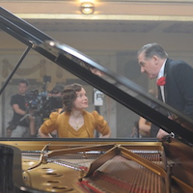

**For release on November 13 2015**

**Pianist Clare Hammond appears in a new Alan Bennett film adaptation, *The Lady in the Van*, as the younger Miss Shepherd**

Pianist **Clare Hammond** will appear in the forthcoming film adaptation of **Alan Bennett**’s play, *The Lady in the Van*, as the younger version of **Dame Maggie Smith**’s character, Miss Shepherd. Downton Abbey’s” Dame Maggie Smith, a two-time Oscar® winner, recreates one of her most celebrated roles – the singular Miss Shepherd – in TriStar’s The Lady in the Van, Alan Bennett’s big-screen comedic adaptation of his own iconic memoir and honored stage play.  Bennett’s story is based on the true story of Miss Shepherd, a woman of uncertain origins who “temporarily” parked her van in Bennett’s London driveway and proceeded to live there for 15 years.  What begins as a begrudged favor becomes a relationship that will change both their lives. Filmed on the street and in the house where Bennett and Miss Shepherd lived all those years, acclaimed director Nicholas Hytner reunites with Bennett (The Madness of King George, The History Boys) to bring this touching, poignant, and life-affirming story to the screen. Due for release on **November 13 2015**.

For images from the film and further information please contact

Clare Cornick at Sony Pictures Releasing on

**clare_cornick@spe.sony.com**

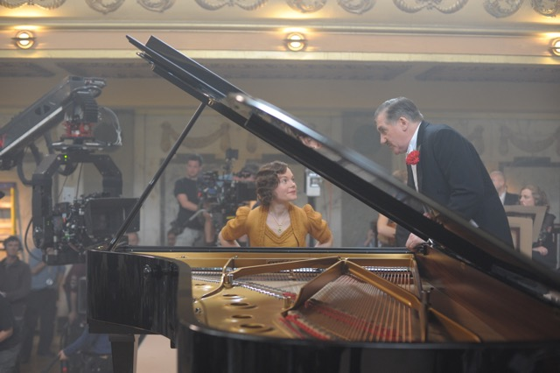

Clare Hammond on set with composer George Fenton. Photo © Nicola Dove

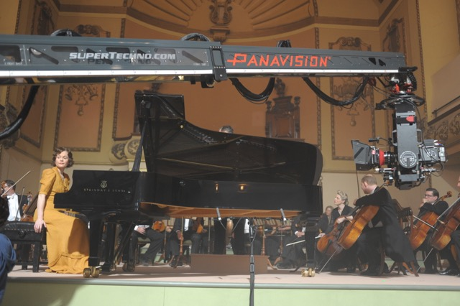

Clare Hammond on set with the BBC Concert Orchestra. Photo © Nicola Dove

**SHORT BIOGRAPHY**

Acclaimed as a pianist of “amazing power and panache”(*The Telegraph*), Clare Hammond is recognised for the virtuosity and authority of her performances and is developing a “reputation for brilliantly imaginative concert programmes” (*BBC Music Magazine*, ‘Rising Star’). In 2014 she gave debut performances at 7 festivals across Europe, including the ‘Chopin and his Europe Festival’ in Warsaw, world premieres of works by 10 composers, and three broadcasts for BBC Radio. Her performance at the Barbican Hall in April 2015 led the *Guardian* to describe her as a “dazzling athlete”.

Hammond’s latest disc release, ‘Etude’, has received unanimous critical praise for its “unfaltering bravura and conviction” (*Gramophone*), was selected as Critic’s Choice by Classical Music Magazine, and the BBC Music Magazine stated that “this array of wizardry is not for the faint hearted”. Both ‘Etude’, and Hammond’s previous disc of music by Andrzej and Roxanna Panufnik, ‘Reflections’, were featured on BBC Radio 3’s ‘In Tune’ and ‘CD Review’. In 2014 Hammond recorded music by Sibelius and Rangström as part of a BBC Symphony Orchestra studio concert for ‘Afternoon on 3’ while in 2012 her live recital broadcast of Ravel’s *Le Tombeau de Couperin* from the Wigmore Hall was chosen as one of Radio 3’s highlights of the month.

Last year Hammond gave a Panufnik Centenary tour of Poland with a series of recital and concerto performances, under the auspices of the British Council’s ‘Artists’ International Development Fund’. Her debut recital at the ‘Chopin and his Europe Festival’ in Warsaw was recorded for broadcast on Polish Radio. Hammond also co-curated and managed the festival ‘Panufnik 100: a family celebration’ with the Brodsky Quartet at Kings Place in London which was hailed as the “culmination of this year’s Andrzej Panufnik centenary” (*The* *Telegraph*).

Hammond completed a BA at Cambridge University, where she obtained a double first in music, and undertook doctoral study with Ronan O’Hora at the Guildhall School of Music & Drama and with Professor Rhian Samuel at City University London.

**http://www.clarehammond.com**