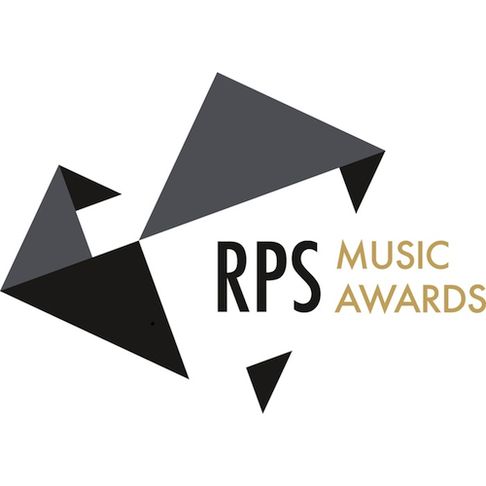

CLARE HAMMOND

piano

***"… unfaltering bravura and conviction"***   
Gramophone Magazine UK

*“****… this array of wizardry is not for the faint hearted”***BBC Music Magazine

***“… the young British rising star Clare Hammond was a dazzling athlete”***Guardian

**PRESS RELEASE: embargoed until 1 April 2016**

**Pianist Clare Hammond shortlisted for the RPS Music Awards 2016**

Pianist **Clare Hammond** has been shortlisted for the **Young Artist** category of the **Royal Philharmonic Society’s Music Awards** for 2016. The awards celebrate outstanding achievement in 2015 and were launched as part of **BBC Radio 3’s ‘In Tune’** on the 31 March. Winners will be announced at the Awards Ceremony on the **10 May 2016**.

The annual RPS Music Awards, presented in association with BBC Radio 3, are the highest recognition for live classical music in the UK. Awards, in thirteen categories, are decided by independent panels consisting of some of the music industry's most distinguished practitioners. The awards honour musicians, composers, writers, broadcasters and inspirational arts organisations. The list of previous winners reads like a *Who's Who* of classical music.

In recent years, Clare Hammond has built a reputation both as an advocate of unusual repertoire and “for brilliantly imaginative concert programmes” (*BBC Music Magazine*, ‘Rising Star’). In 2015 the Guardian described her as a “dazzling athlete” following her performance at the Barbican Hall, and she gave five performances on BBC Radio 3. Forthcoming highlights include performances of new works for piano and film at Kings Place in London on the 9 April and at the Cheltenham Festival on the 10 July. She releases her third disc for BIS Records, of solo piano music by Ken Hesketh, on the 27 May, and performs with the Philharmonia at the Royal Festival Hall in December.

**Notes to Editors**

The ‘Young Artist’ Award is sponsored by the Bowerman Charitable Trust.

More information on the Awards can be found at[**http://www.rpsmusicawards.com**](http://www.rpsmusicawards.com).

For high-resolution press photos, visit [**http://www.clarehammond.com/download.html**](http://www.clarehammond.com/download.html).

For further information on the RPS Music Awards please contact:  
Sophie Cohen, Music PR Consultancy   
E: sophiecohen@blueyonder.co.uk T: 020 7428 9850 M: 07711 551 787

**Clare Hammond - biography**

Acclaimed as a pianist of “amazing power and panache”(*The Telegraph*), Clare Hammond is recognised for the virtuosity and authority of her performances and is developing a “reputation for brilliantly imaginative concert programmes” (*BBC Music Magazine*, ‘Rising Star’). She is currently shortlisted for the ‘Young Artist’ category of the Royal Philharmonic Society’s Music Awards, which recognise outstanding achievement in 2015. Over the past year, Clare made 5 broadcasts on BBC Radio 3 and recorded discs for Sony, BIS Records and Signum. In 2014, she gave debut performances at 7 festivals across Europe, including the ‘Chopin and his Europe Festival’ in Warsaw.

Highlights in 2016 include her Royal Festival Hall debut with the Philharmonia, and a concerto tour of Poland, to include a newly discovered work by Josef Myslivecek, a mentor of Mozart. In May, Hammond releases her third disc for BIS Records, *Horae (pro clara)*, with solo piano music by Ken Hesketh, and returns to the Cheltenham and Presteigne Festivals later in the summer. Her most recent disc release, ‘Etude’ has received unanimous critical praise for its “unfaltering bravura and conviction” (*Gramophone*) while the BBC Music Magazine stated that “this array of wizardry is not for the faint hearted”. ‘Etude’, and Hammond’s previous disc of music by Andrzej and Roxanna Panufnik, ‘Reflections’, have been featured on BBC Radio 3’s ‘In Tune’ and ‘CD Review’, and on radio in Switzerland, Sweden, the Netherlands, the US and Canada.

In 2014, Hammond gave a Panufnik Centenary tour of Poland with a series of recital and concerto performances, under the auspices of the British Council’s ‘Artists’ International Development Fund’. Her debut recital at the ‘Chopin and his Europe Festival’ in Warsaw was recorded for broadcast on Polish Radio. Hammond also co-curated and managed the festival ‘Panufnik 100: a family celebration’ with the Brodsky Quartet at Kings Place in London which was hailed as the “culmination of this year’s Andrzej Panufnik centenary” (*The* *Telegraph*).

Contemporary music forms an important part of Hammond’s work. She has given 24 world premieres including those of major works by composers Robert Saxton, Edwin Roxburgh, John McCabe and Arlene Sierra. In 2015, she premiered and recorded concertos for trumpet and piano by Geoffrey Gordon and Toby Young with Simon Desbruslais and the English Symphony Orchestra, to be released on Signum Records.

An active chamber musician, Hammond is a member of the Odysseus Piano Trio alongside violinist Sara Trickey and cellist Gregor Riddell. She has also worked with the Brodsky, Endellion, Badke, Dante and Piatti Quartets and in duos with Henning Kraggerud, Andrew Kennedy, Jennifer Pike, Philippe Graffin and Lawrence Power. In November 2015, she made her film debut as the younger version of Maggie Smith’s character, ‘Miss Shepherd’, in the Alan Bennett film adaptation, *The Lady in the Van*, directed by Nick Hytner.

Hammond completed a BA at Cambridge University, where she obtained a double first in music, and undertook postgraduate study with Ronan O’Hora at the Guildhall School of Music & Drama and with Professor Rhian Samuel at City University London. She completed a doctorate on twentieth-century left-hand piano concertos in 2012 and is in demand as a speaker, regularly giving presentations for research series at universities across the UK. In 2014 she was paired with French pianist Anne Queffélec on the Philip Langridge Mentoring Scheme run by the Royal Philharmonic Society.

Hammond is grateful for the support of the Fidelio Charitable Trust, Help Musicians UK, Stradivari Trust, Ambache Charitable Trust, British Korean Society, Chandos Memorial Trust, Vernon Ellis Foundation, Polish Cultural Institute, RVW Trust, British Council, Arts Council England, John S Cohen Foundation, Britten-Pears Foundation and the Hinrichsen Foundation.

[**http://www.clarehammond.com**](http://www.clarehammond.com)

[**https://www.facebook.com/clarehammondpiano**](https://www.facebook.com/clarehammondpiano)