**Info for Modflow course 2017**

**Instructor - Hamish Robertson: hr0392@bristol.ac.uk**

This course will use the Python programming language in conjunction with a module called ‘FloPy’. Python is relatively similar to Matlab.

I have four small requests. In total I’d imagine it taking <45 mins and doable whilst eating dinner!

1. In order to speed everything up could everyone please download and install Anaconda – Python 3.6 version <https://www.anaconda.com/download/>

* Do not think you can do this 10 minutes before the practical in G4. It’s ~600MB AND takes 30 minutes to install. Also if everyone did this that’s something like 25GB of bandwidth being delivered to G4 and it will take ~30 minutes to download alone!
* DO NOT INSTALL 2.7 !!!!
* Remember to select the appropriate operating system e.g. Windows, Mac or Linux!
* Click the big green download button.

1. If everyone can watch this video on GitHub <https://www.youtube.com/watch?v=SWYqp7iY_Tc>
2. Please make an account on GitHub <https://github.com/join>
3. Download and install Git

MacOS

The ‘terminal window’ is the terminal program. Everyone has it. You can find it in your applications folder or doing a search. It looks something like this…

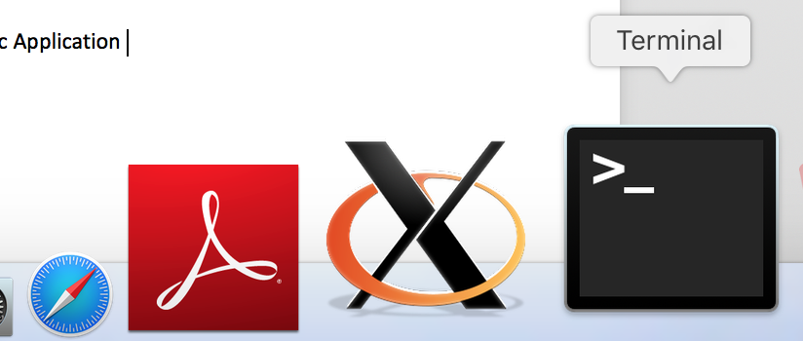

1. Paste the following command into terminal and press enter. Follow the instructions (just say yes basically to everything)

/usr/bin/ruby -e "$(curl -fsSL https://raw.githubusercontent.com/Homebrew/install/master/install)"

1A => At the end you may need to run the command;

brew doctor

1. Once completed paste the following command

brew install git

It should now be completed!! Homebrew installs everything Apple doesn’t bother to install. Its super useful and lets you install and update tons of stuff super easily.

Windows

I’m not really a Windows person though this looks a promising route (looks like git for windows has several different ways to go, I’d personally start here)

Watch <https://www.youtube.com/watch?v=J_Clau1bYco>

Linux

If (and I doubt anyone here is) you’re a running Linux then you probably already have everything or can work out how to get everything installed. If I’m being presumptuous and you struggle with the above steps by all means drop me an email.

Uninstall

You can uninstall everything after the course if you never want to see any of this stuff again;

<https://stackoverflow.com/questions/42182706/how-to-uninstall-anaconda-completely>

Homebrew you probably don’t need to uninstall. The xcode developer tools can take up quite abit of space (like 4GB). From memory these are fairly straightforward to ditch and reinstall if you need them again.