

TECHWIZ 7 PROJECT DOCUMENTATION
APTECH COMPUTER EDUCATION
HYDERABAD-1 PAKISTAN
FANDOM UNIVERSE
BY
CYBER SQUAD
TEAM LEADER:
ABUZAR KHANZADA
TEAM MEMBERS:
MUBASHIR ALI
HAMNA ARSHAD
SUKAINA
MUHAMMAD AHMED
ABDULLAH
MENTOR: SYEDA SUHAIRA
SUBMITTED ON: 26-09-2026
Live website: https://fandomverse-by-cybersquad.netlify.app/
PROJECT TRACK: FRONTEND
CATEGORY: (WEB INNOVATION UNLEASHED)
CPISM: 7144
SEMESTER: 1ST & 2ND
CENTRE ACADEMIC HEAD: SYEDA IMAMA ALI
CENTRE MANAGER: SHOAIB AHMED

ACKNOWLEDGEMENTS
The successful completion and documentation of this project are the result of collective effort, guidance, and support throughout every phase of development. I extend my sincere gratitude to my mentor, Ms. Syeda Suhaira, whose technical expertise, continuous guidance, and constructive feedback were instrumental in shaping the project’s direction and resolving key challenges.
I am equally grateful to my team members—Abuzar Khanzada (Team Leader), Mubashir Ali, Hamna Arshad, Sukaina, Muhammad Ahmed, and Abdullah—for their tireless collaboration, creative problem-solving, and shared commitment to delivering high-quality work throughout this initiative.
I would also like to express my sincere appreciation to our Center Academic Head, Ms. Syeda Imama, for her valuable guidance, encouragement, and academic support. My heartfelt thanks also go to our Center Manager, Mr. Shoaib Ahmed, for his continuous support and for providing a positive environment that contributed to the successful completion of this project.
Finally, I extend my deep appreciation to Aptech Latifabad for providing the supportive learning environment, facilities, and resources that made this project possible.

CERTIFICATION
This is to certify that,
Abuzar Khanzada, Mubashir Ali, Hamna Arshad, Sukaina, Muhammad Ahmed, and Abdullah
have successfully designed:
FANDOM UNIVERSE

Student1727712
Student1727710
Student1731099
Student1731095
Student1731485
Student1731102
Abuzar Khanzada
Mubashir Ali
Hamna Arshad
Sukaina
Muhammad Ahmed
Abdullah

Date of Issue: 23-09-2026
Date of Submission: 26-09-2026

TABLE OF CONTENTS
TECHWIZ 7 PROJECT DOCUMENTATION 1
ACKNOWLEDGEMENTS 2
CERTIFICATION 3
TABLE OF CONTENTS 4
PROJECT REPORT 5
PROBLEM DEFINITION 6
DESIGN SPECIFICATION 7
DATA FLOW DIAGRAMS 8
1. Level 0 DFD 8
2. Level 1 DFD 9
DATA TEST USED IN THE PROJECTS 10
1. Fandom Categories 10
2. Fandom Content Data 10
3. Character Data 10
4. Event Data 10
5. Product Data 10
6. Cart Test Data 10
7. Trailer Data 10
8. Gallery Data 10
9. Search and Filter Test Data 10
10. Purpose of the Test Data 11

PROJECT REPORT

Contest Category:
Project Title:
Team Name:
Team Leader:
Team Members:

Issue Date:
Submission Date:
Center Name:
Course & Curriculum:
Semester:
Mentor:
Center Academic Head:
Center Manager:
WEB INNOVATION UNLEASHED
FANDOM UNIVERSE
CYBER SQUAD
ABUZAR KHANZADA
MUBASHIR ALI, HAMNA ARSHAD, SUKAINA, MUHAMMAD AHMED, AND ABDULLAH
23 SEPTEMBER 2026
26 SEPTEMBER 2026
ACE Hyderabad-1, Pakistan
CPISM (7144)
1
Syeda Suhaira
Syeda Imama
Shoaib Ahmed

PROBLEM DEFINITION
Background
Fandom communities are highly active across Anime, Gaming, Movies, TV Shows, K-Pop, Comics, and Manga. However, useful information such as articles, character details, media, events, trailers, and merchandise is usually spread across different websites. Users therefore have to switch between multiple platforms to explore their interests.
Main Problems
- 1. Scattered Information: Fandom content is distributed across separate websites, making discovery slow and inconvenient.
- 2. Inconsistent User Experience: Different platforms use different layouts and interfaces, which can make browsing less simple, especially on smaller screens.
- 3. Limited Quick-Access Features: Many basic fandom websites do not provide search, filtering, bookmarks, a temporary cart, media previews, and interactive assistance in one place.
Proposed Solution
Fandom Universe addresses these problems by providing a single responsive frontend platform where users can explore seven fandom categories, search and filter content, view characters and media, explore events and trailers, bookmark content, and manage temporary merchandise selections. The project uses client-side JavaScript, JSON/data files, and browser storage without a backend database.
- Browse across 7 main fandom categories (Anime, Gaming, Movies, TV, K-Pop, Comics, and Manga) from one dashboard.
- Search and filter content instantly without waiting for whole pages to reload.
- Save favourite posts directly in their browser (local Storage) so they don't lose them.
- Watch video previews in pop-up windows and test out a basic merchandise checkout process.

DESIGN SPECIFICATION
1. Project Purpose
Fandom Universe is a responsive frontend web platform that brings fandom content, characters, media, events, trailers, and merchandise into one organized interface.
2. Concept Selection
The concept was selected to solve the problem of scattered fandom information while providing an engaging platform for exploring multiple fictional universes.
3. Frontend Technologies
The project is implemented as a frontend application using HTML5, CSS3, JavaScript, Bootstrap, and JSON/data files. HTML structures the interface, CSS controls visual styling and responsiveness, while JavaScript manages dynamic and interactive behavior.
4. Interface & Theme
The interface uses a modern fandom-inspired visual style with responsive navigation, cards, buttons, sections, animations, hover effects, and organized content areas. Flexbox/CSS Grid and responsive Bootstrap layouts support desktop and mobile viewing.
5. Dynamic Content
Fandom data is separated from the page structure and loaded through JavaScript/data files. This allows category content, characters, events, products, trailers, and gallery items to be displayed dynamically and updated more easily.
6. Search, Filter & Sorting
Users can search content and narrow results by category or content type. Sorting supports organized browsing such as alphabetical or popularity-based display.
7. Browser Storage
localStorage is used for browser-based features such as bookmarks and temporary cart selections. This provides useful interaction without requiring a server-side database.
8. Interactive Features
JavaScript-powered modals, media previews, chatbot responses, visitor counter, clock, hover effects, breadcrumbs, and UI-only login/signup controls improve interaction while keeping the application frontend-focused.
9. Overall Design Approach
The design combines responsive UI, dynamic data, client-side interaction, and organized fandom content to create a single-page experience that is easy to explore and maintain.

The documentation uses the project’s available system-flow visuals below as supporting reference for how the frontend, data.js, localStorage, and interactive features work together.
WEBSITE REFERENCE & VISUAL INSTRUCTIONS

DATA FLOW DIAGRAMS
Data Flow Diagrams show how information moves between the user and different parts of the Fandom Universe website. The diagrams represent the main flow of content, user actions, cart and bookmark data, and the Fandom Bot.

1. Level 0 DFD
The Level 0 Data Flow Diagram gives an overall view of the Fandom Universe website. It shows how the user interacts with the website and how the website communicates with data.js for fandom content and localStorage for cart and bookmark data.
Figure 1: Level 0 DFD of Fandom Universe

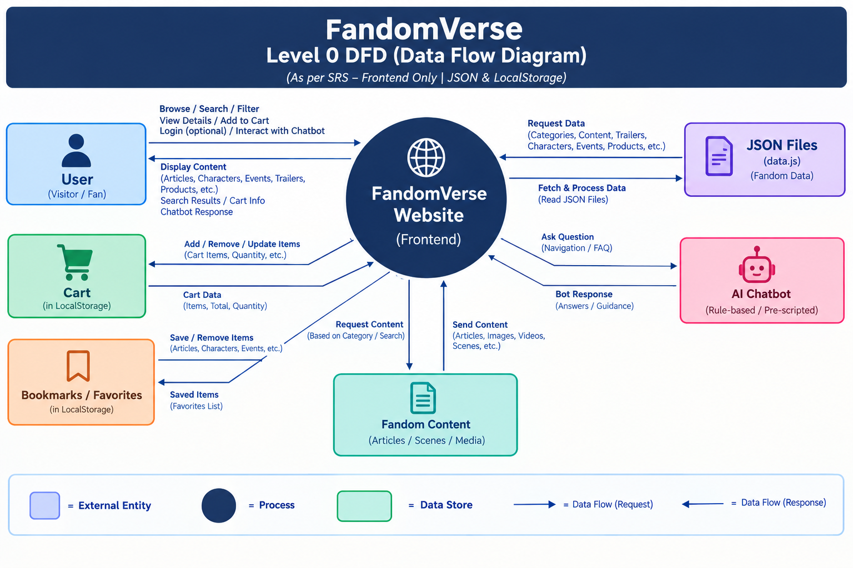

2. Level 1 DFD
The Level 1 Data Flow Diagram provides a more detailed view of the system. It breaks the website into different processes such as browsing and searching content, viewing details, managing the cart, managing bookmarks, and using the Fandom Bot. It also shows how these processes interact with data.js, localStorage, and the Fandom Bot.
Figure 2: Level 1 DFD of Fandom Universe

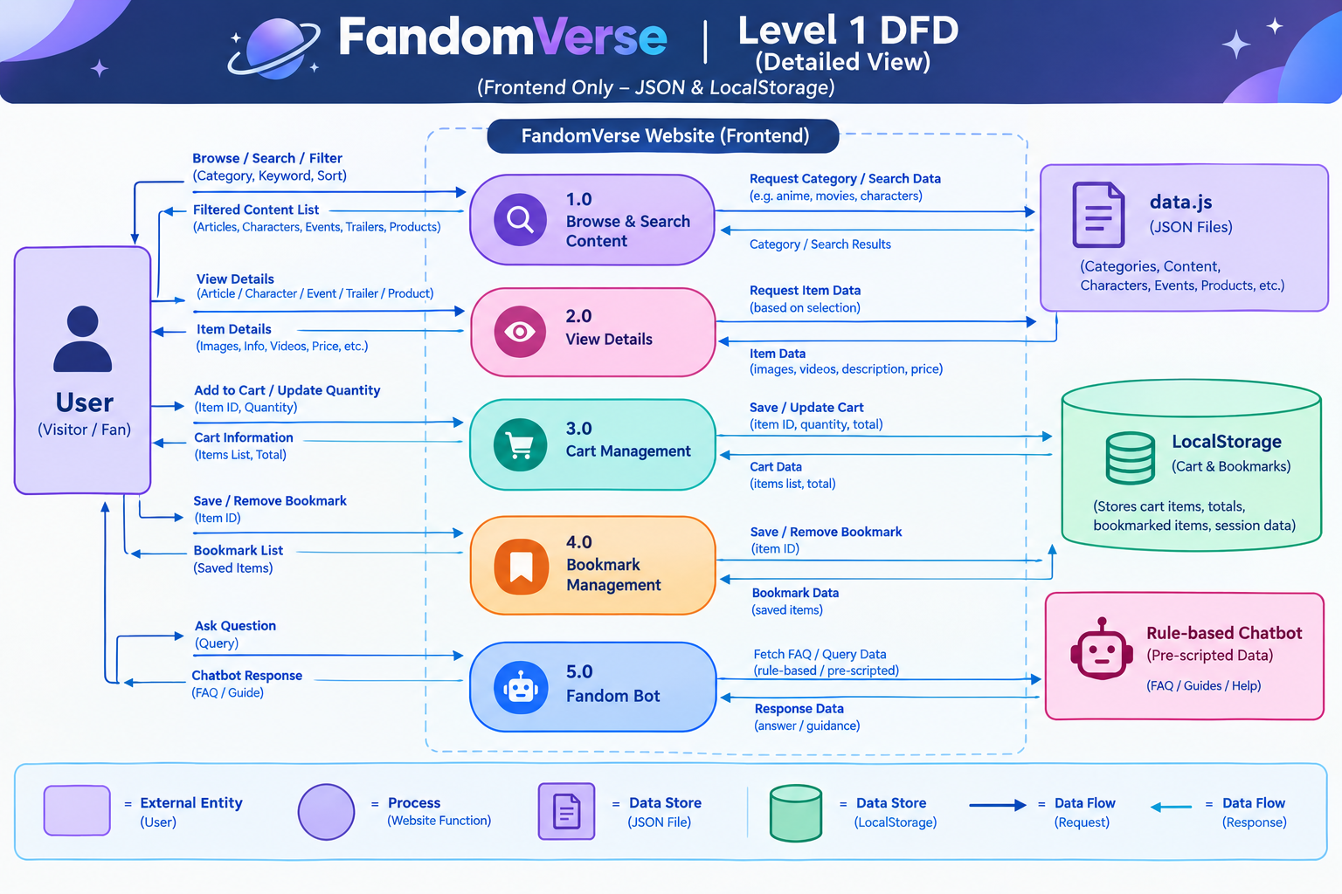

DATA TEST USED IN THE PROJECTS

1. Fandom Categories
Test data was created for different fandom categories, including Anime, Gaming, Movies, TV Shows, K-Pop, Comics, and Manga. Each category contains a name, icon, description, content count, and category identifier. This data was used to test category-based content display and filtering.

2. Fandom Content Data
Sample content was added to represent different types of fandom material, including articles, gallery content, and videos. Each content item contains a title, category, description, image, type, and popularity value. This data was used to test dynamic content rendering, searching, filtering, and sorting.

3. Character Data
Character test data was added with information such as character name, category, series, personality traits, and image. Examples include anime, gaming, movie, and K-Pop characters. This data was used to test character cards, category filters, and character profile interactions.

4. Event Data
Sample fandom events were created with event titles, dates, locations, categories, descriptions, and icons. These records were used to test the events section and ensure that event information could be dynamically displayed from the project data.

5. Product Data
Sample products were included to test the shopping section of Fandom Universe. The product data contains product names, prices, categories, IDs, and images. Examples include T-shirts, hoodies, collector figures, backpacks, mugs, and posters.

6. Cart Test Data
Different products were used to test the cart functionality. Products could be added to or removed from the cart, while the selected cart information was handled through JavaScript and stored using Local Storage. This helped verify that cart data could be maintained during user interaction.

7. Trailer Data
Test trailer records were created for Anime, Gaming, and Movies. Each record contains a trailer title, category, and image. This data was used to test the trailer cards and the interactive trailer preview modal.

8. Gallery Data
A collection of sample image URLs was used to test the gallery section. The gallery data allows multiple fandom-related images to be loaded dynamically rather than placing every image directly into the HTML.

9. Search and Filter Test Data
The different content records were also used to test the website's search and filtering functionality. Users can search by title, description, or category, while additional filters can be applied based on category and content type. The content can also be sorted alphabetically or by popularity.

10. Purpose of the Test Data
The test data was created to verify that the main features of Fandom Universe work correctly with different types of information. It helped test dynamic rendering, searching, filtering, sorting, character display, events, trailers, gallery content, product listings, cart functionality, and Local Storage before treating the frontend as complete.

