Principle component Analysis
on Landsat Image

Authors name Mehak Kanwal
Facultyt of computer science and engineering
Ghulam Ishaq Khan Institue
swabi, Pakistan
Email: u2020231@giki.edu.pk
Authors name Hassan Ibrar
Facultyt of computer science and engineering
Ghulam Ishaq Khan Institue
swabi, Pakistan
Email: u2020306@giki.edu.pk

Authors name Hamna Iftikhar
Facultyt of computer science and engineering
Ghulam Ishaq Khan Institue
swabi, Pakistan
Email: u2020146@giki.edu.pk
Authors name Fatima Ghazenfer
Facultyt of computer science and engineering
Ghulam Ishaq Khan Institue
swabi, Pakistan
Email: u2020129@giki.edu.pk

Abstract: The system proposal in this paper is an advanced and simplified version of Principle Component Analysis on Landsat Image to understand the deep Mathematic Concepts in the form of coding and visualization. We have used python Language to code and its different libraries to perform tasks assigned by our professor. The dataset which we have chosen is taken from this platform: https://earthexplorer.usgs.gov. Our desired location on which we have performed PCA is Siachen, Glaciers which is located in Eastern Karakoram ranges in the Himalayas. PCA is based on 5 components. The detail of each step of components is described in this report in detail. The logical interpretation and how PCA makes complex Mathematics problem so simple by its 5 components without wasting anytime over it to compute it separately through eigenvectors, eigenvalues, covariance and normalization techniques shall be explained in detail. The data that we used contain images and we have performed several operations on the image based on our knowledge such as transformations, crop the image, rotate the image, visualization and concatenation of bands etc.
Keywords: A dimensionality-reduction technique; PCA with 5 main features; covariance, eigenvectors and eigenvalues decomposition, transformation and bands. (Heading 1)

Introduction
In order to reduce the dimensionality of huge data sets, a technique known as principal component analysis, or PCA, is frequently utilized. PCA works by condensing a large collection of variables into a smaller set that nevertheless retains the majority of the information in the larger set.
Accuracy inherently suffers as a data set's number of variables is reduced, but the secret to dimensionality reduction is to trade off some accuracy for simplicity. Because machine learning algorithms can analyze data much more quickly and easily with fewer irrelevant variables to handle, smaller data sets are easier to examine and display. The goal of PCA, in essence, is to minimize the number of variables in a data collection while retaining as much of the data's original meaning as feasible. To understand PCA, first we need to understand the dimensionality reduction concept. So what is dimensionality reduction? So dimensionality reduction is the quantity of information required to generalize properly increases exponentially as the number of characteristics or dimensions increases. Two strategies can be used to decrease dimensionality:

- Elimination of features: We omit some features outright.
- We retain the most significant portion of all the trait while extracting them. PCA is used to do this. Keep in mind that several techniques exist for feature extraction besides PCA.

Methodology

Why do we use PCA on multispectral images?
PCA is one type of dimensionality reduction since it is used to eliminate extraneous spectral data from multiband datasets. In remote sensing, PCA is used to: Condense the amount of original spectral data from several bands into a smaller dataset.

What are the benefits of using PCA?
Unsupervised learning methods like PCA provide a variety of advantages. For instance, PCA helps us to more effectively generalize machine learning models by lowering the dimensionality of the input. This aids in our struggle against the "curse of dimensionality”. The dimension of the data affects the performance of the majority, if not all, algorithms. Models that operate on very high dimensional data may run very slowly, if at all, and use a lot of server resources. Performance may be enhanced by PCA at a very modest cost to model correctness.

Step by step description of PCA and its Components.
After understanding what is PCA and why is it used in the fields of Artificial Intelligence mainly machine learning, we shall now understand its detailed working in the form of its components:

- Step 1: Standardization:
In order for each continuous beginning variable to contribute equally to the analysis, this phase standardises the range of the variables. Standardization is crucial to complete before PCA, notably because the latter is quite sensitive to the variances of the starting variables. That is, if there are significant disparities in the initial variable ranges, the bigger range variables will predominate over the smaller range variables, resulting in biassed findings. Therefore, converting the data to equivalent scales can solve this issue. All of the variables will be scaled to the same value after standardisation is complete.

- Step 2: Covariance on Image Matrix:
The purpose of this stage is to determine the relationship if any between the variables in the input data set and how they differ from the mean in relation to one another. Because variables can occasionally be highly connected to the point where they include duplicated data. We construct the covariance matrix in order to find these associations. The elements of the covariance matrix are symmetric with regard to the main diagonal since the covariance is commutative (Covariance (a, b) = Covariance (b, a)), which implies that the upper and lower triangular parts are equal. Signs tell a lot about covariance of a given matrix. If the outcome is positive, both variables will either rise or decrease (correlated), If negative, one rises while the other lowers (Inversely correlated).

- Step 3: Eigen Vectors & Values Computation:
To identify the primary components of the data, we must compute the linear algebra concepts of eigenvectors and eigenvalues from the covariance matrix. Let's first define major components before moving on to the discussion of these notions. The additional variables created as a result of the basic variables' linear combinations or mixes are known as principal components. These combinations are made in a way that most of the information included in the original variables is condensed or squeezed into the first components, which are the new variables (i.e., principal components), which are uncorrelated. It's crucial to understand that since the primary components are created as linear combinations of the original variables, they lack meaningful significance and are less interpretable.

- Step 4: Final step:
The goal of this final step is to reorient the data from the original axes to those represented by the principal components using the feature vector created using the eigenvectors of the covariance matrix (hence the name Principal Components Analysis). To do this, multiply the feature vector's transpose by the original data set's transpose.

Final result =x (transpose)*standardize X (transpose)

Explanation of our code:
We have implemented Principle Component Analysis on our desired land satellite image by using different libraries such as numPy, pandas, cv2, matplotlib, torch, PIL,
sklearn, and lastly through sklearn we imported PCA library.

- We have downloaded the desired land satellite image from USGS site and then loaded the image by changing its BGR value TO RGB value to apply PCA over it.

- Then we split the RGB bands into separate bands as red, green, blue which is our task 1 basically.

- To normalize the split RGB values we have divided each of them with 255(as 0 is the min value and 255 is the max value) to represent it into 0-1 range.

- After that we have applied PCA on individual components with the help of PCA library and later fit and transform those bands individually. As we have 7611 dimensions for that we have considered only 50 dimensions for PCA.

- Then we have separately found the variance ratio of each component to check how much variation is there in a dataset. It is used as it tells us how much is the importance of each rank in dataset to interpret analysis based on this. This is given by:

- Variance = sum of Eigen values
- Variance ratio = Eigen value of individual component / variance

- Then we plotted the Eigen values of individual components in the form of list. The size of each list must be equal to no. of components selected on which PCA is applied.

- In the next step we reconstructed the image and visualized it after PCA is applied. For this we reverse transformed over image to the original and concatenated the 3 bands which we split individually.

- Then plotted the original image and the reduced image.

- Then we cropped the image from centered using pyTorch library and imported its function torchvision.transforms to perform this operation. Then plotted the original and cropped image.
- Then in the final step we calculated the mean square error of the image on which PCA is applied. Which is given as:

MSE = (square root [original x – reduced x])/n

RESULTS

So after applying PCA we got following results mentioned along with visualization.

- Visualization of different Bands:

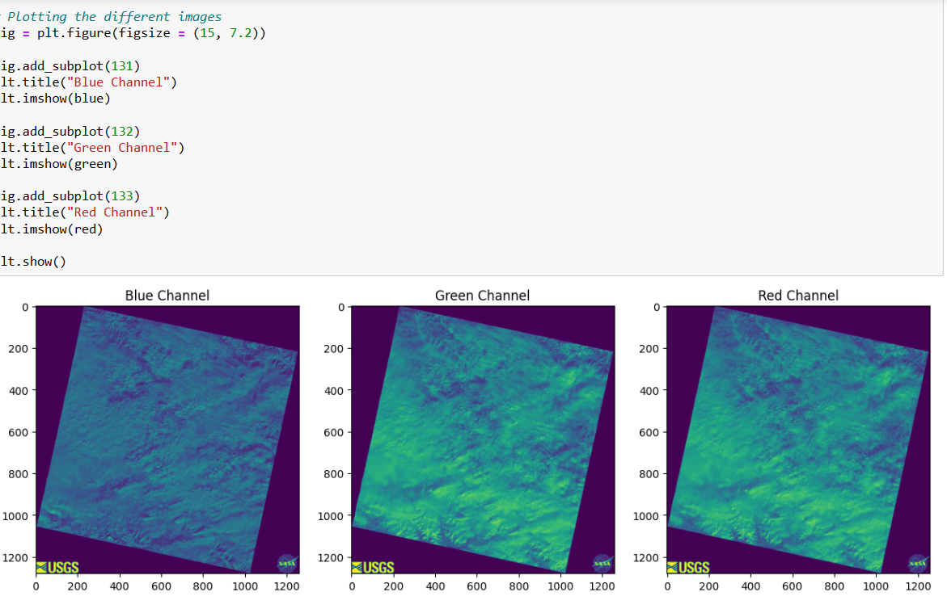

After loading the image we split it into different bands using cv2 library split function. This was done to apply PCA.

- Variation Vs Eigen Values:

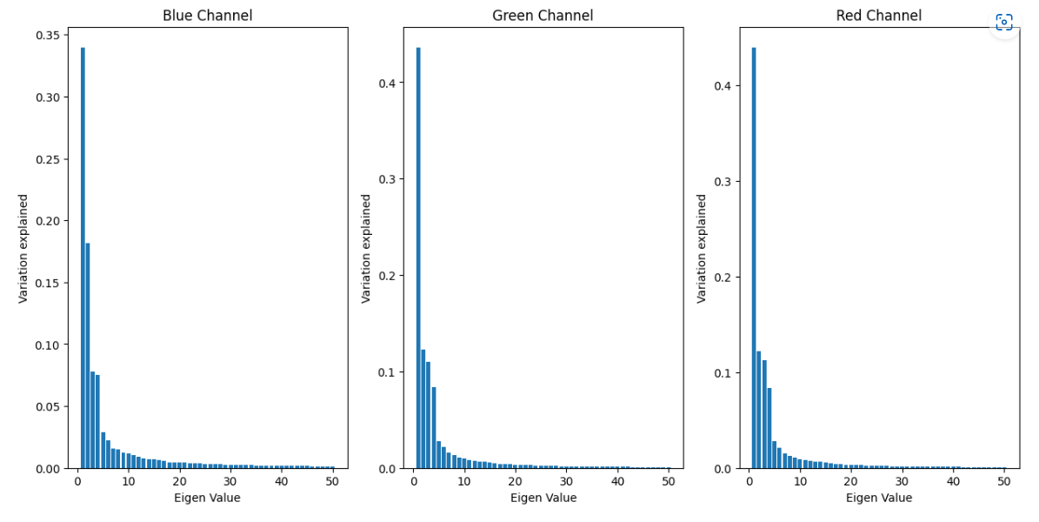
Here we explained variation with respect to Eigen values. We then applied transformation on that principle component (Eigen vector) whose variance is highest.

- Results after Concatenating Bands:

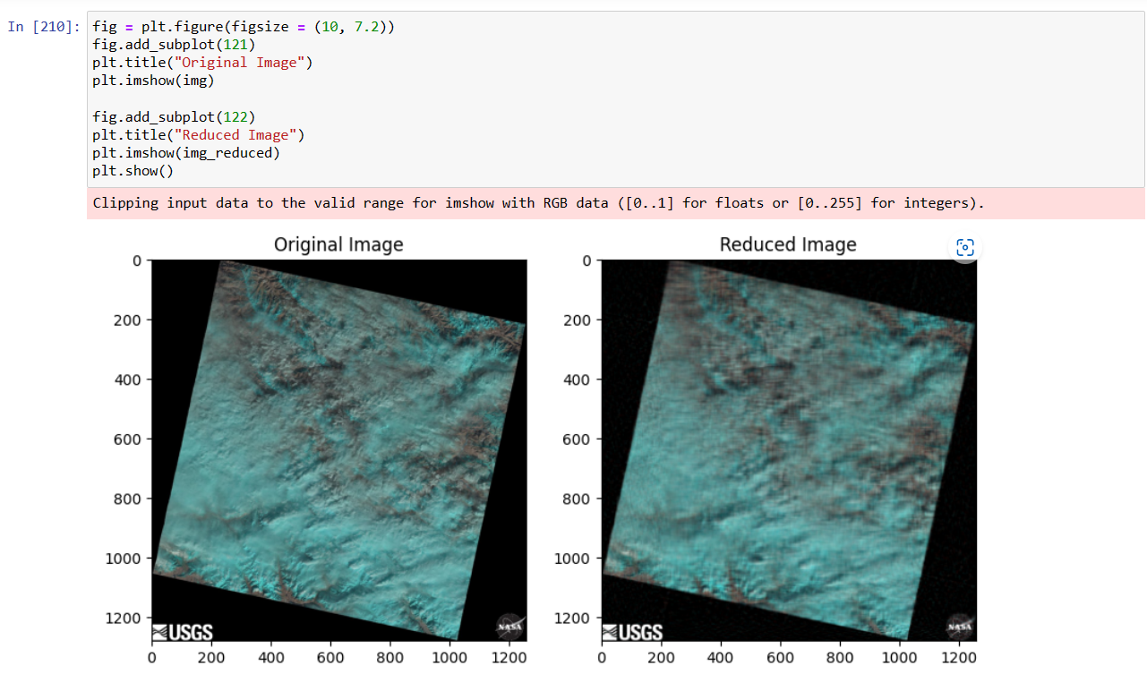
This was the result which we got after applying PCA.

- Cropped Image:

For cropping the image we used torch library and its function center crop.

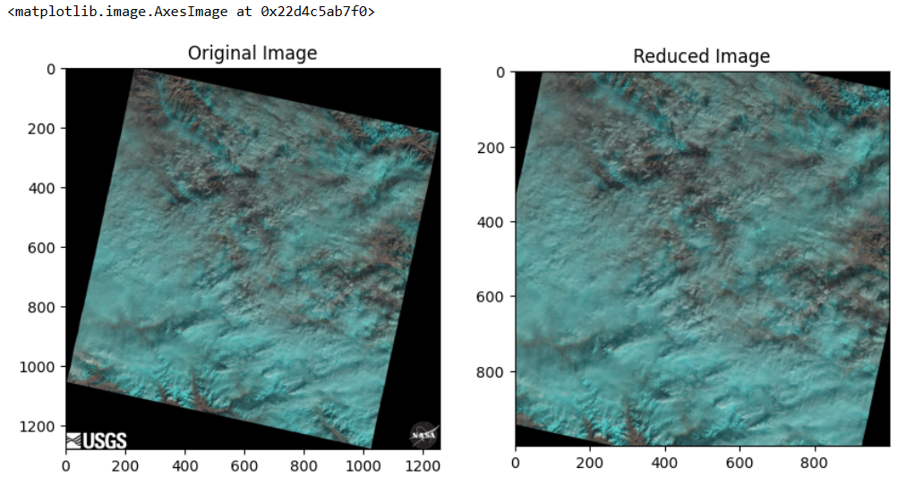

- Error Analysis:

To calculate the error we first changed the image shape from 3D to 2D. After calculating loss we got following results on different components. We got 75% error on 30 components, 21% error on 500 components and lastly 4% error on 1000 components.

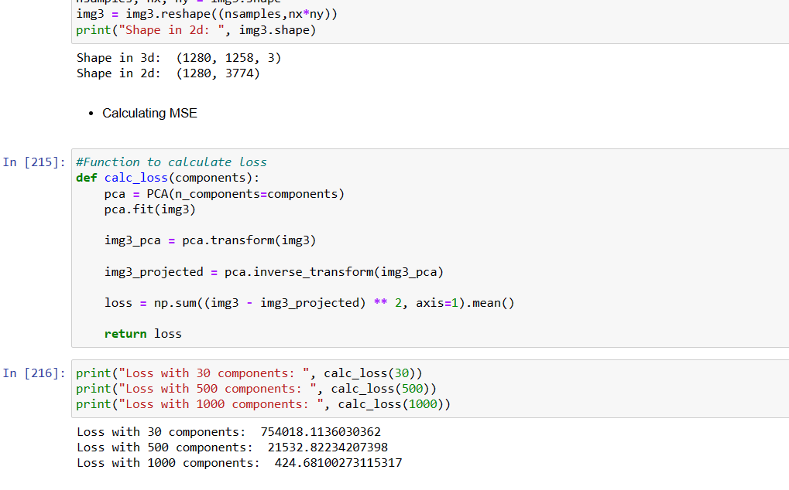

Task DISTRIBUTION

We have worked together as a team of 4 people. Following is our task Distribution:

Mehak Kanwal:
- Task 3: Error Analysis
- Introduction part of report.

Hamna Iftikhar:
- Task 2: PCA.
- Methodology Part of report.

Fatima Ghazenfer:
- Task 1: Concatenation of bands & Visualization of bands.
- Abstract part of report.

Hassan Ibrar:
- Task 1: Crop the image.
- Results part of report.

References

We have taken help in our code from [1]. The understanding of concept of PCA from [2].

- A quick guide to color image compression using PCA in python | by Iqbal Hussain | Towards Data Science

- https://youtube.com/playlist?list=PL_jTZi-bjHgTmTBuqFB-9DK0ka8eASGl-

- https://www.sartorius.com/en/knowledge/science-snippets/what-is-principal-component-analysis-pca-and-how-it-is-used-507186

- https://www.datacamp.com/tutorial/principal-component-analysis-in-python

- https://pub.towardsai.net/principal-component-analysis-pca-with-python-examples-tutorial-67a917bae9aa

- https://builtin.com/data-science/step-step-explanation-principal-component-analysis

