

User Manual
  - Customer Sentiment Dashboard

Prepared for
Lauren Grimm, Director of Marketing

Table of Contents
Installation Guide 1
A. Install Power BI Desktop 1
B. Download and Open the Dashboard 3
C. Connect Dashboard with Data Source 4
Dashboard Overview 9
Section Descriptions 10
Filters 10
Current Customer Sentiment Overview 10
Survey Question Comparison 11
Sentiment Trend Analysis 11
Store Performance Rankings 12
Store Performance Heatmap 12
Word Cloud 13
Monthly Data Update 14

Installation Guide
In this section, you will find directions to complete the following tasks:
- Install Power BI Desktop
- Download and open the dashboard
- Connect dashboard with data source

A. Install Power BI Desktop
Power BI Desktop is the software you will use to view your customer sentiment dashboard. It is a Microsoft product that is free to download and use on one device.
To install Power BI Desktop, complete the following steps:
  - Ensure your device meets these basic requirements:
    - Runs Windows OS
    - Has internet access
  - Go to the Microsoft website
Click on the link above or type the web address (https://www.microsoft.com/en-us) into your browser to open the Microsoft website.
  - Search for “Power BI Desktop”
At the top of the webpage, click on the search bar and type “Power BI Desktop” to search. When the results load, select the link “Download Microsoft Power BI Desktop from Official Microsoft Download Center”.
  - Click “Download”
Click on the blue button labeled “Download”.
  - Open the Power BI Installer
After the software has finished downloading, open the Power BI Installer in the File Explorer.

  - Follow the installation prompts
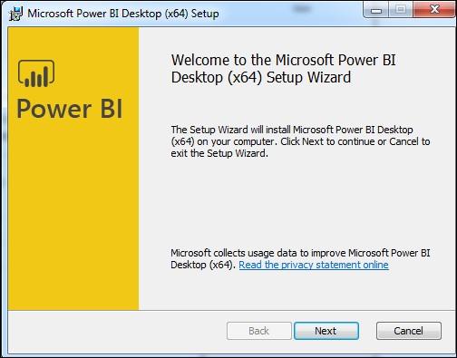
Prompts will walk you through the rest of the download. The image below shows the first prompt you will see.

  - Open Power BI Desktop
Open the app and sign in with a Microsoft account if prompted.

B. Download and Open the Dashboard
To download and open your customer sentiment dashboard, complete the following steps:
  - Save the provided dashboard file to your computer
The dashboard file ends with the file extension “.pbix”.
  - Open Power BI Desktop
  - Click “Open”
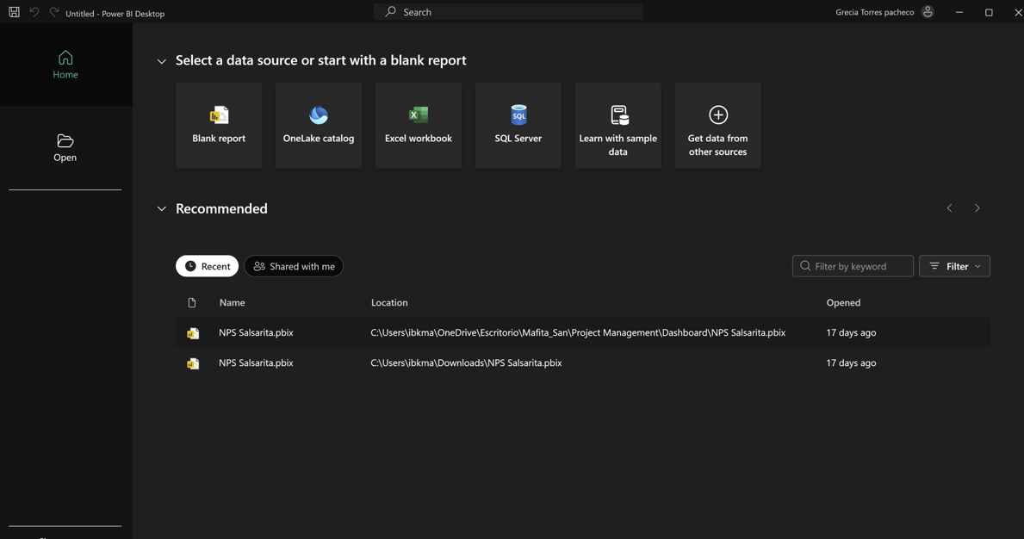
Click the icon indicated by the arrow below. If you have already used Power BI Desktop, the “Open” option may not appear. In this case, select “File” in the top left corner of the screen. Then select “Open”.

  - Click “Browse this device”
  - Locate and select the dashboard file
  - Click “Open” to load the dashboard

Tip: If the file does not load, verify that Power BI Desktop is updated to the latest version.

C. Connect Dashboard with Data Source

To have an operational dashboard, you must connect your dashboard with your data. To do this, complete the following steps:

  - Save customer sentiment data to a folder on your device
Before connecting your data to your dashboard, the Service Management Group (SMG) data must be saved locally on your device. Create a folder that you will only use to store Salsarita’s SMG data.
  - Open the dashboard in Power BI Desktop
For additional directions to complete this step, refer to section B. At this point, your dashboard will appear operational, but you must complete the remaining steps to finish connecting your data.
  - Click “Transform data”
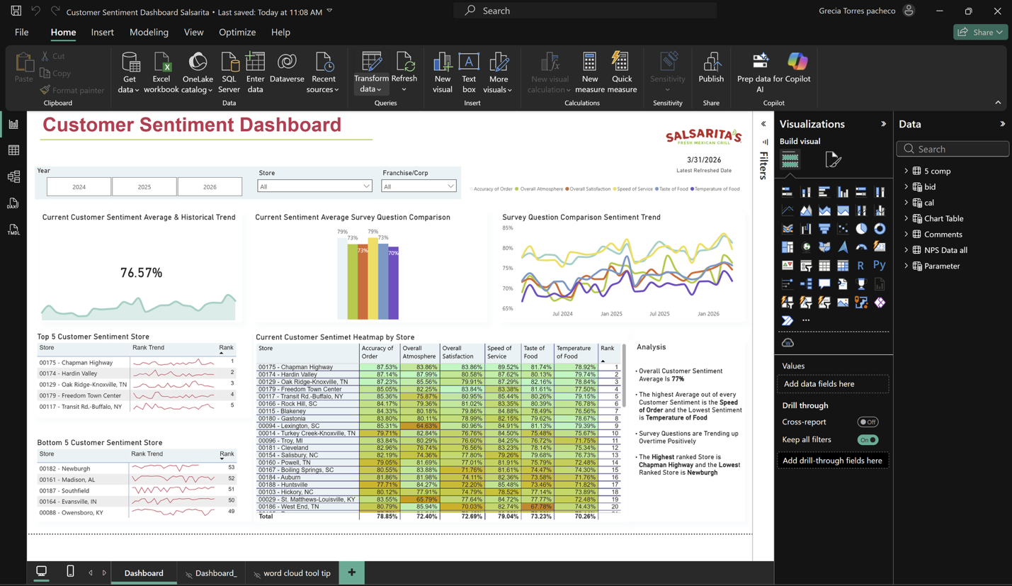
Click on the icon indicated by the arrow below. A new window will appear.

  - Click “NPS Data all”
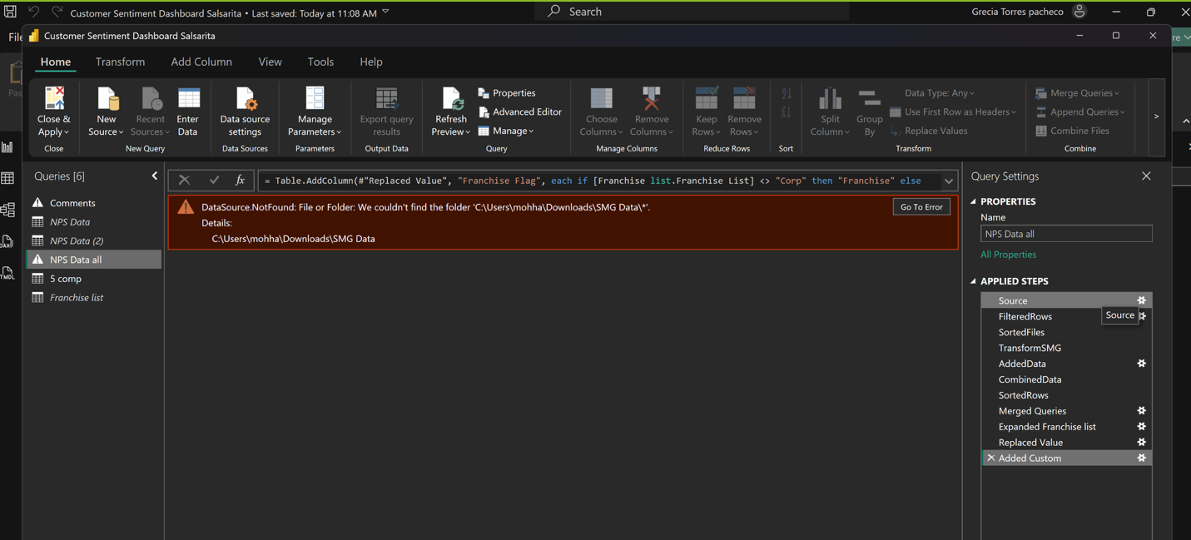
Click the highlighted option indicated by an arrow.

  - Click “Advanced Editor”
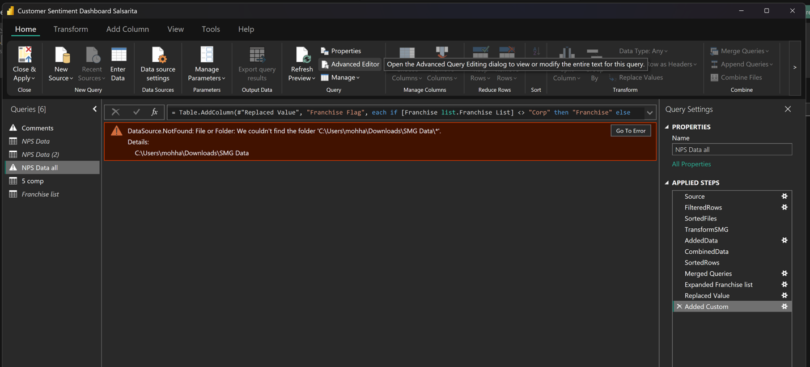
In the same window, click the option indicated by an arrow below. A new window will appear.

  - Copy your folder pathway
Open the File Explorer and locate the folder you created to store SMG data. Right-click the folder and select the option “Copy as path”. Return to Power BI Desktop.
  - Paste the pathway into “Advanced Editor”
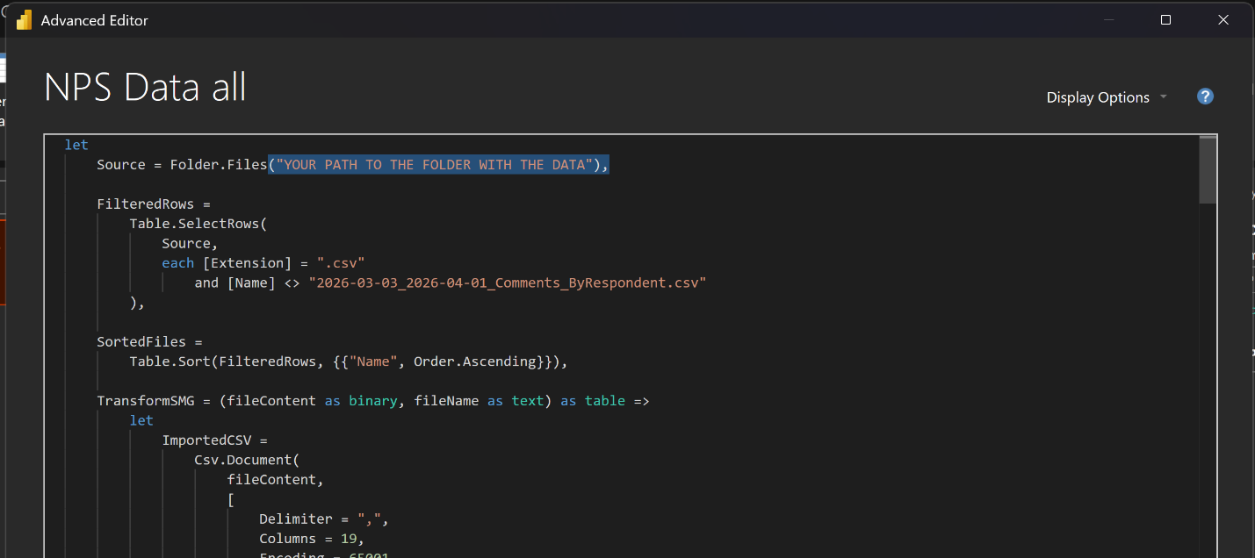
Paste the pathway you copied in the position indicated on the screenshot labeled “YOUR PATH TO THE FOLDER WITH THE DATA”. Replace all text between the parentheses with your pathway. Ensure that the pathway is surrounded by quotation marks (“”) before moving to the next step.

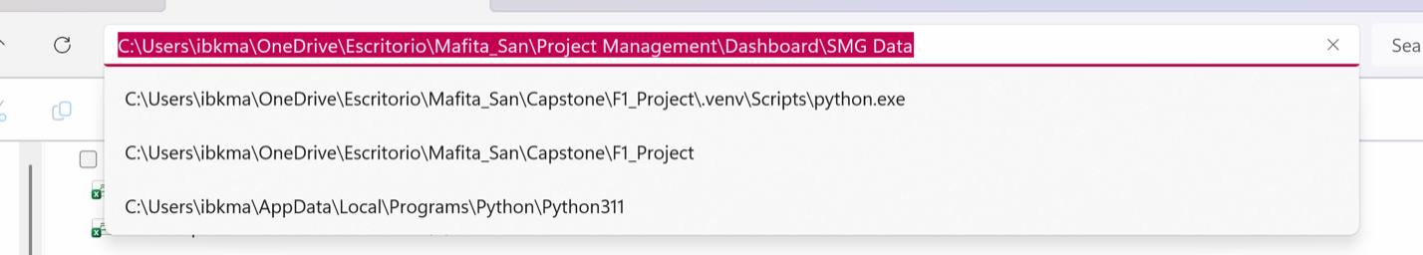
The pathway you pasted will appear similar to the example highlighted below.

  - Click “Done”
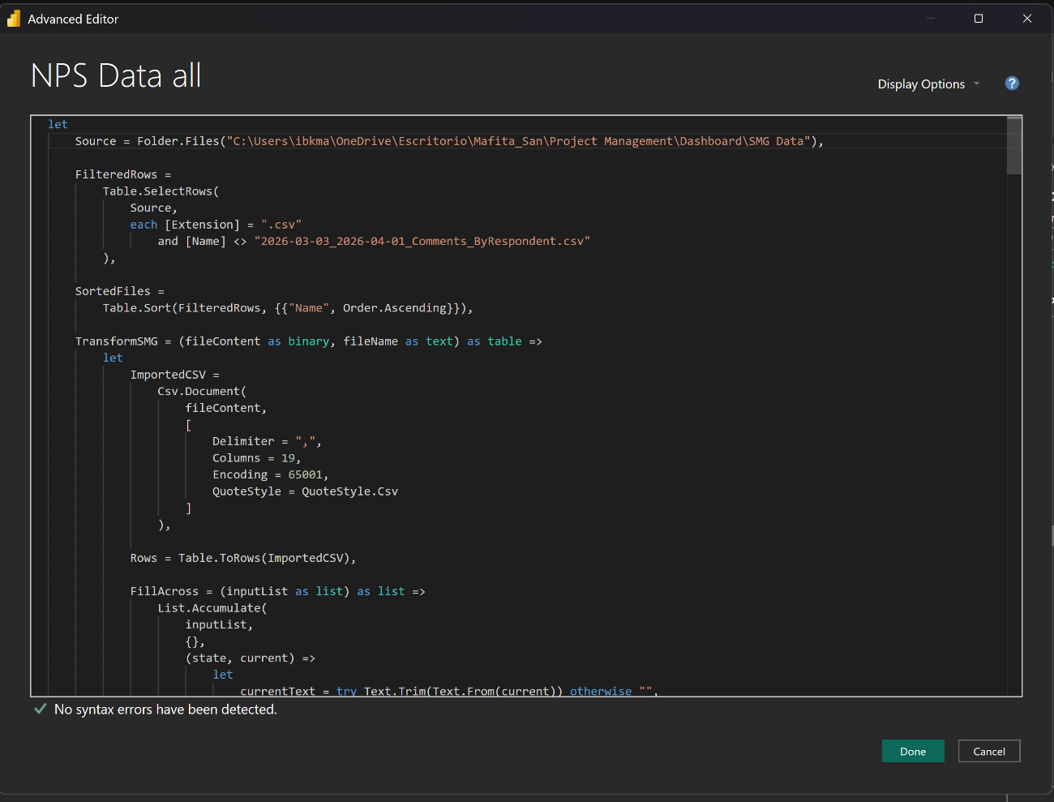
Click the green “Done” button on the bottom right of the window.

  - Repeat steps 4-5 for “Comments”

Click on the section “Comments”. Then open the Advanced Editor. A new window will appear.

  - Copy your folder pathway and paste into the Advanced Editor
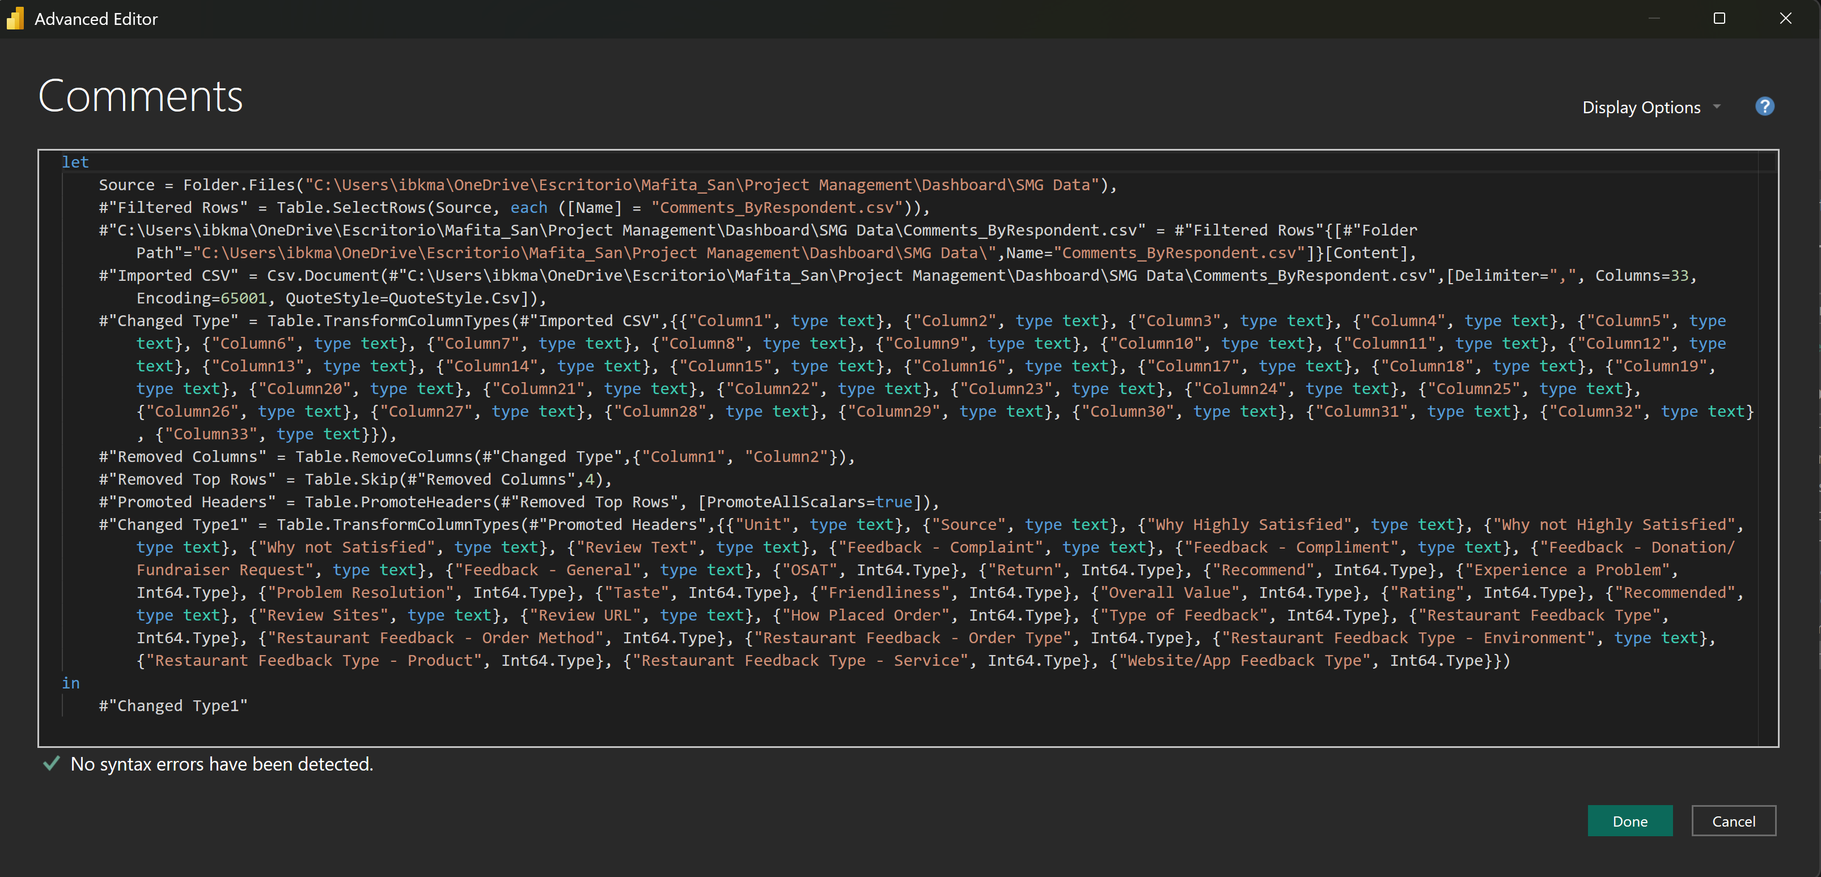
Repeat the process to copy your folder pathway (step 6). Paste it into the two locations circled below. Ensure that the pathway is surrounded by quotation marks (“”) before moving to the next step.

  - Copy your “Comments” file pathway
Ensure your “Comments” file name is named “Comments_ByRespondent” and that it is saved in your dashboard folder. Then repeat the process to copy your folder pathway (step 6) but copy your “Comments” file pathway instead.
  - Paste the “Comments” pathway into the Advanced Editor

Paste the pathway into the two locations circled below. Ensure that the pathway is surrounded by quotation marks (“”) before moving to the next step.
  - Click “Done”
Click the green “Done” button on the bottom right of the window.
  - Click “Close & Apply”
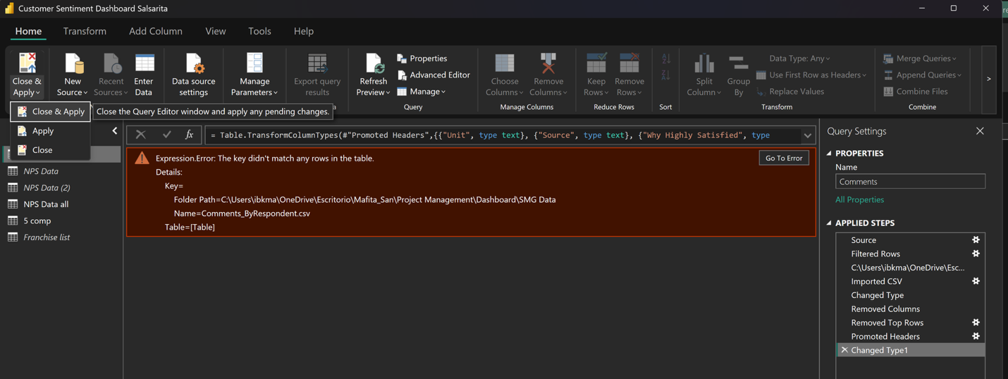
Click “Close & Apply” in the top left corner. Click the option again from the pop-up menu indicated by the arrow.

  - Wait for the data to update. Once completed, your dashboard is ready to use!

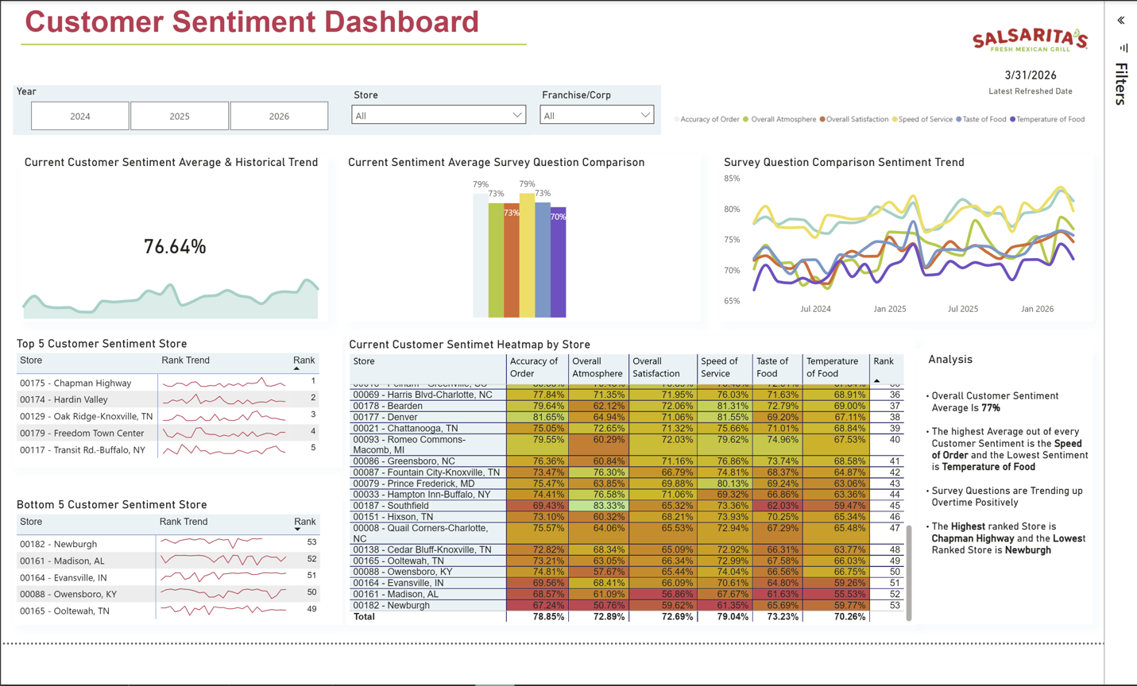
Dashboard Overview
Your Customer Sentiment Dashboard is designed to help you see and evaluate customer survey data results efficiently. You can update the dashboard monthly to get frequent insights into what your customers are thinking, allowing Salsarita’s to address changes in customer sentiment quickly.
This tool allows you to view data by individual store or franchise, as well as across the entire company. It also enables you to see how scores are changing over time, allowing Salsarita’s to have better insights into the effectiveness of interventions.
With the Customer Sentiment Dashboard, you can accomplish the following:
- See store performance scores from survey data
- Use charts to track changes over time
- Identify top and bottom performing stores
- Analyze results on a store, franchise, or company basis
- Learn high-level insights about survey data
Read the next section for an in-depth look into the dashboard features.

Section Descriptions
This section includes descriptions of each feature on the Customer Sentiment Dashboard.

Filters

There are three filters you can use to select the information displayed:
Year Selector: Allows you to filter dashboard data by year (e.g., 2024, 2025, 2026). Selecting a year updates all visuals to reflect data for that time period.
Store Filter: Allows you to view data for a specific store or all stores. This is useful for analyzing individual store performance or comparing across locations.
Franchise Filter: Allows you to view data by franchise. Also allows you to view corporate owned stores.
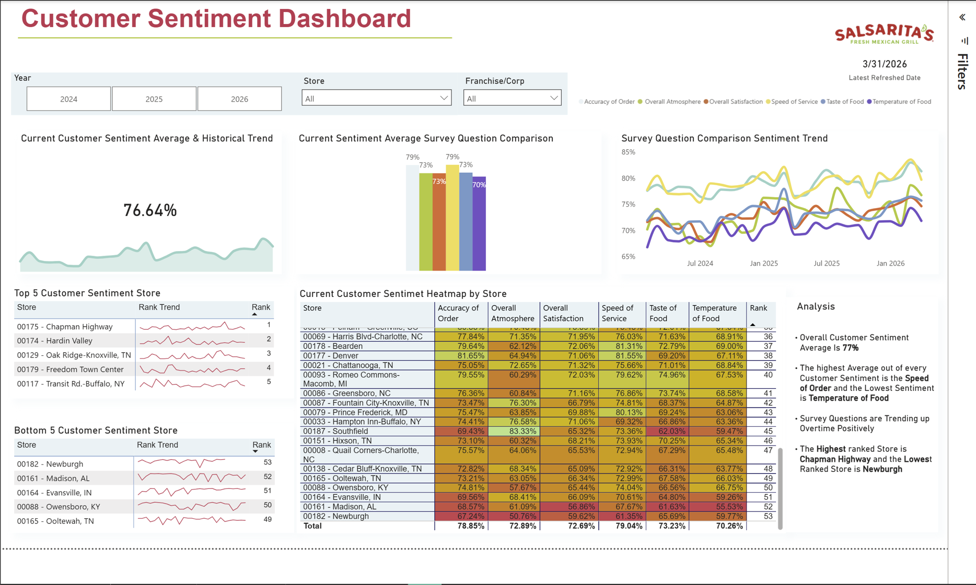

Current Customer Sentiment Overview

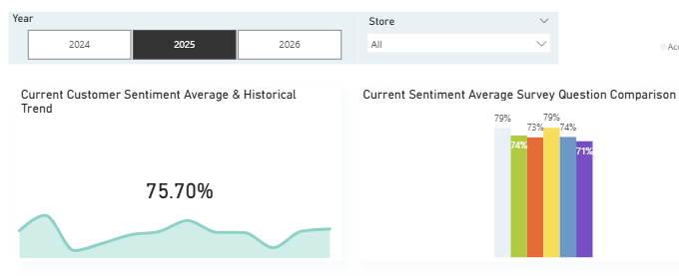
This section displays the current customer sentiment average and the historical trend.
The average helps you quickly understand overall performance and the trend offers a visual for identifying whether sentiment is improving or declining.
historical trend
current customer sentiment average

Survey Question Comparison

The Current Sentiment Average Survey Question Comparison feature compares performance across the following survey categories:
- Accuracy of Order
- Overall Atmosphere
- Overall Satisfaction
- Speed of Service
- Taste of Food
- Temperature of Food
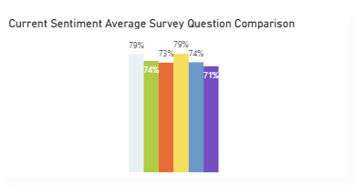
This comparison allows you to identify strengths and weaknesses across service areas based upon the filters you select. Each survey question is represented by a color. A key is provided in the top right corner of the dashboard.

Sentiment Trend Analysis

The Survey Question Comparison Sentiment Trend feature shows how each survey category changes over time, helping you identify seasonal patterns and areas where performance is improving or declining.
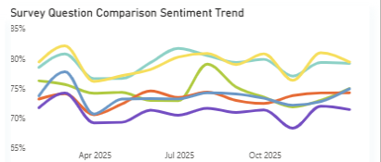
store rating
date

Store Performance Rankings

This section includes charts indicating the Top 5 Customer Sentiment Stores and the Bottom 5 Customer Sentiment Stores. Each chart displays the top- or bottom-performing stores based on their sentiment average. The categories display the following information:
- Store name and store number
- Store ranking trend over time
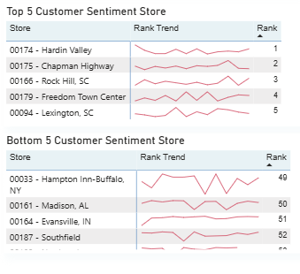
- Store rank

Store Performance Heatmap

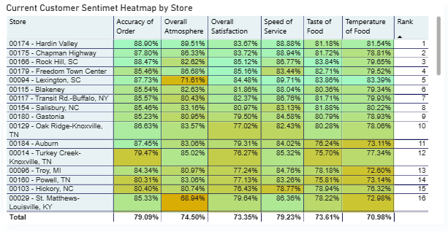
The Current Customer Sentiment Heatmap by Store section displays detailed performance metrics for each store across all survey categories. It uses color gradients to highlight high and low performance areas. The highest scores are green and the lowest scores are red. With this tool, you can compare stores side-by side, identify problem areas, and spot high-performing categories.

Word Cloud

The Word Cloud feature displays a collection of words when you place your cursor over a store rating. This tool shows the most used words from commenting customers who reported that they were highly satisfied with their experience. The larger the word, the more often it appeared in surveys.

This tool is useful for determining what is working well in a location. It will change when you update comment data, keeping it relevant as time passes.

total customer responses

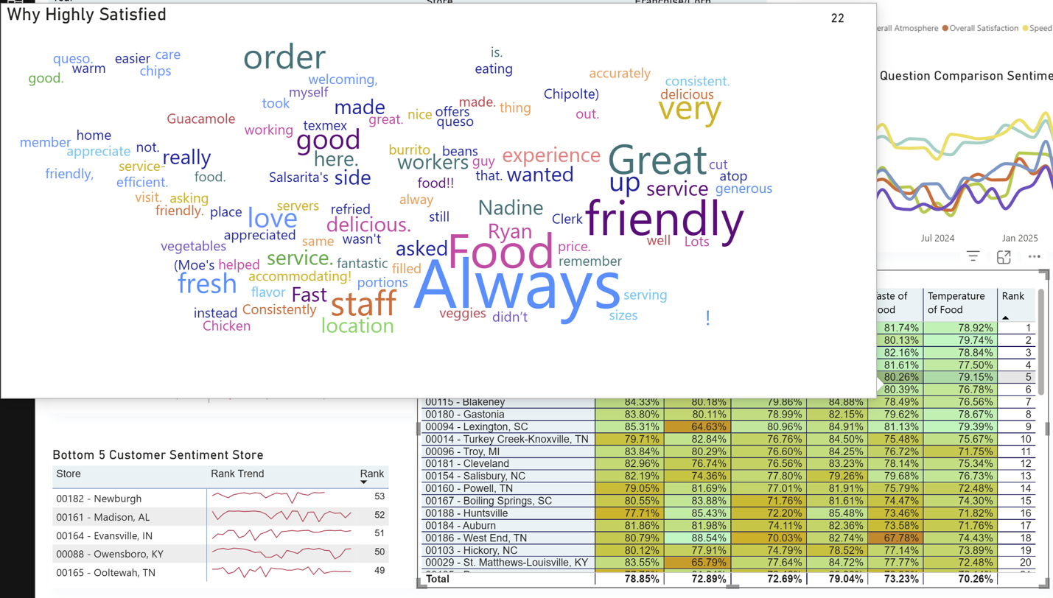

Monthly Data Update
The dashboard uses customer survey data exported from the SMG system. To keep the dashboard current, you must update the data monthly. Complete the following steps to update your dashboard:
- Download data for the new month
Save the new month’s SMG file to your dashboard folder. Make sure the file name follows the name style of the existing files in the folder. This should be formatted like the following example: “2024-10 October”.
To update your comments data, save the updated comment data to your device. Override the existing comments file named “Comments_ByRespondent” with the current comment data and ensure that the file name has not changed.
- Open the dashboard
Open the customer sentiment dashboard in Power BI Desktop.
- Click “Refresh”
Click the refresh icon on the Home tab to update all visuals with the latest data.

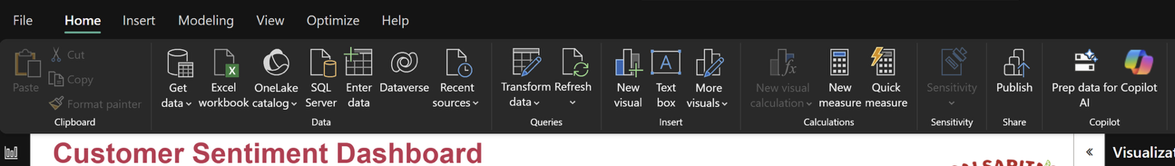
- Verify the refresh
Confirm that the dashboard reflects the most recent data by checking updated dates, trends, and store performance metrics.

